M J B
Cheiroarithropathy in Diabetic Patients Babylon Province

Labeed AL. Sheikh

Marjan Teaching Hospital, Hilla, Babylon, Iraq.

Abstract
Cheiroarthropathy was assessed in 100 diabetics (50 Type I DM , 50 Type II DM) and (50 non diabetic control ) matched for age and sex, according to clinical examination (sign and symptoms).
The are to study the prevalence of cheiroarthropathy in diabetic patients (both TYPE I DM and TYPE II DM) and evaluate association between this sequel and the duration of the disease.
Prevalence of Cheiroarthropathy in TYPE I DM vs. TYPE II DM was (56% vs. 36%)
There was significant statistical difference (P< 0.05) between TYPE I DM and TYPE II DM regarding this sequel. In which it is higher in TYPE I DM.
Cheiroarthropathy occurs more frequently in both TYPE I DM and TYPE II DM than in the control group (P<0.05); its occuance appeared to be direcly related to disease duration
تحدد حركة مفاصل اليد عند مرضى السكر
الخلاصة
دراسة لمعرفة نسبة انتشار تحدد حركة مفاصل اليد تم فحص مائة مريض من مرضى السكر(خمسون من نوع (1)وخمسون من نوع( اا)وخمسون من الأشخاص الأصحاء) والذين تم اختيارهم تناسقا مع العمر والجنس لمرضى السكر اعتمادا على الأعراض والعلامات السريرية.وكذلك معرفة العلاقة بين تقادم المرض وظهور هذه العقبولة.
وكانت النتائج:
نسبة انتشار تحدد حركة مفاصل اليد عند المرضى نوع ( ا)ونوع ( اا)هي: 56% مقابل 36%.
ومن خلال هذا البحث ظهرت هنالك فوارق ذات أهمية إحصائية بين مرضى السكر نوع(ا)والمرضى المصابين بمرض السكر نوع( اا)حيث أن مرض تحدد حركة مفاصل اليد أكثر انتشارا في مرضى السكر نوع (1)وكذلك ظهرت هنالك علاقة مباشرة بين تأريخ المرض وظهور هذه العقبول
ـــــــــــــــــــــــــــــــــــــــــــــــــــــــــــــــــ

Introduction
Cheiroarthropathy is most commonly seen in adult type I diabetes and also type II diabetes mellitus, it affects predominantly the small joints of the hand, its incidence as been reported to be 35% , LJM leads to stiffness of skin mainly of the dorsal aspect of the hand [7]. Cheiroarthropathy is generally painless and seldom treated until hand deformity is severe enough to interfere with daily life because cheiroarthropathy is correlated with microvasculare complication of diabetes; patient with hand syndrome should be carefully investigated for neuropathy, retinopathy and nephropathy[8-11].

Aim of the study
To study the prevalence of cheiroarthropathy in diabetic patients TYPE I DM and TYPE II DM) and its relation to disease duration .

Patients and Methods
One hundred patients (50 TYPE I DM and 50 TYPE II DM) attending the Diabetic Clinic at marjan Teaching hospital , between July 2006 and June 2007, were examined , their ages at the time of the study ranged from (30-59) years, mean (44.6) years for TYPE I DM and (45 -60) years , mean (47.6) years for TYPE II DM , their sex was (28 male- 22 female) and (30 male-20 female) respectively, 50 randomly selected (age and sex matched) healthy individual were included.
To demonstrate joint mobilitry of the fingers the patients were examined by :
Table top test [3] (Figer 1)
The patients is asked to place both hands, palms down, on a table with fingers fanned out and the examiners views the hands at a table level to see the contact of the palmar surface to the table, any abnormalities detected may be made more obvious by asking the patients to perform the prayer manoeuvre .Figer 3 shows normal test, while Figer 4 shows abnormal one
The presence of puckering of the skin over the involved fascia was noted to distinguish between early dupuytrens and flexor tenosynovitis.

Statistical analysis
Data were analyzed using chi-square and Z-test.

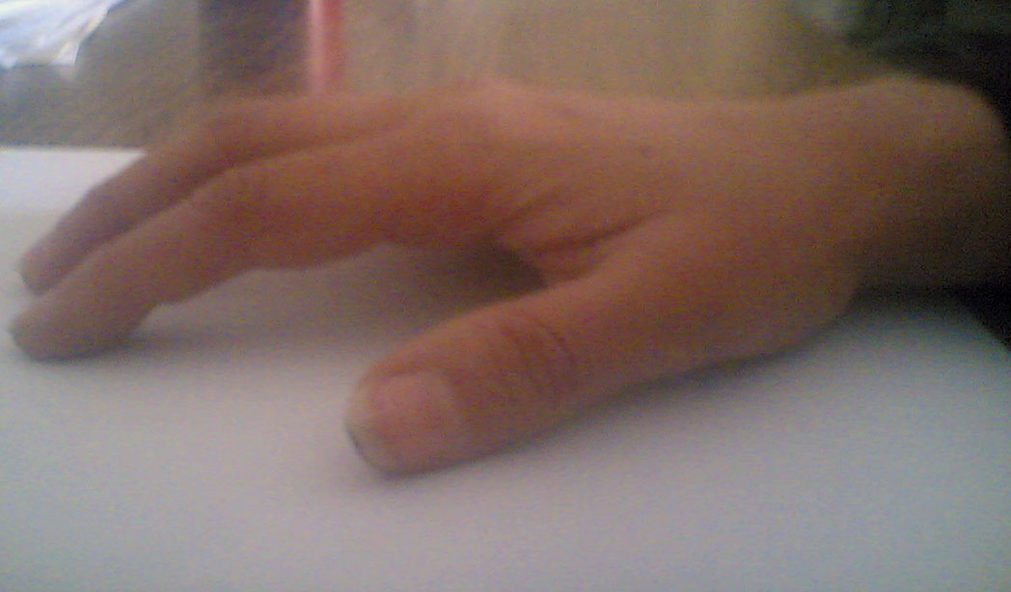
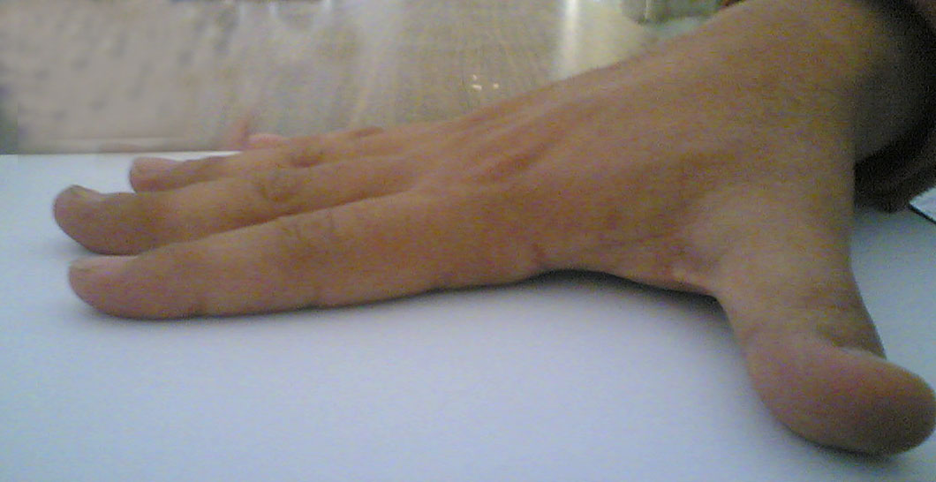

Figure 1 Normal Figure 2 positive table top test



Figure 3 Normal Figure 4 Inability to bring together the

palms of the hand ( prayer sign )
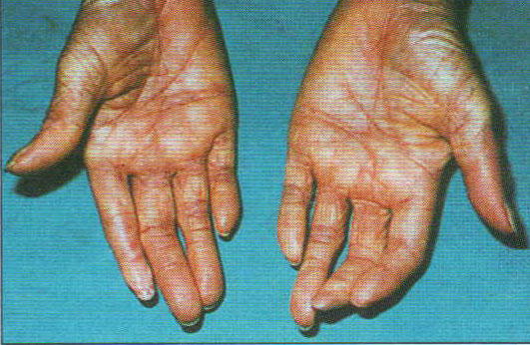

Figure 5 Limted joint mobility in the hand

Results
Demographic characteristics of the patients with diabetes mellitus and control group are shown in Table ( 1).
The prevalence of cheiroarthropathy in insulin dependent diabetes mellitus (TYPE I DM) was (56%) (28/50), two patients ( 7.1%) developed this sequel during (1-4 years) from the onset of the disease, six of those (28) patients (21.4%) developed this sequel during (5-8 years) and the last 20 patients (71.4%) developed cheiroarthropathy during (10 years) and above.
While the prevalence of cheiriarthropathy in TYPE II DM was (36%) (18/50) which less frequent than TYPE I DM with was asignificant atatistical reference (P<0.05), two patients (11.1%) developed LJM during (1-4 years) from the onset of DM , five patients, (27.7%) during (5-9 years) and 11 patients (61.1%) developed this sequel during (10 years )and more. (Table 2).

Table 1 Characteristics of patients and control group

(TYPE I DM) (TYPE II DM) (Control) (P-value)

Number 50 50 50
Male:female 28:22 30:20 26:24
Age(mean) 30-59 45-60 35-57
(44.6) (47.6) (45.3)

Cheiroarthropathy 28(56%) 18(36%) 5(10%) <0.05

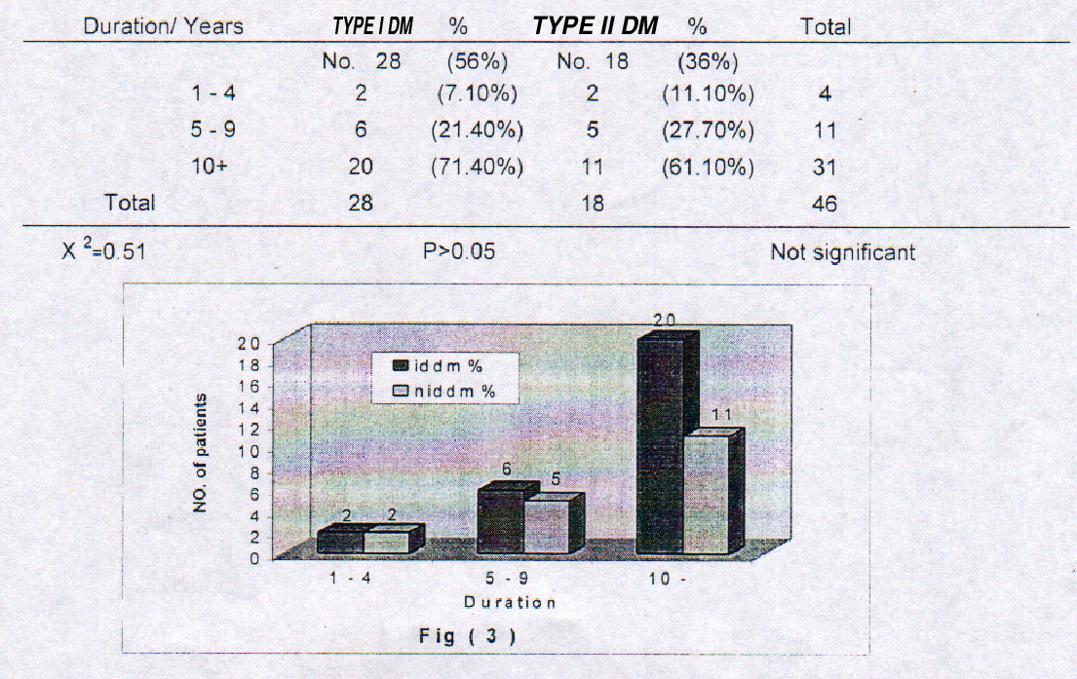
Table 2 Duration of Diabetes Mellitus Limited Joint Mobility( chiroarthropathy )

Discussion
A variety of rheumatic disorders have been described in patients with diabetes mellitus and these conditions are more prevalent in diabetics than in general population, but are not unique to patients with diabetes [12-14].
In our study and in congruence with other reports, we have found higher prevalence of cheiroarthropathy in diabetes than in controls (P<0.05).
Cheiroarthropathy was more prevalent in TYPE I DM (56%) than in TYPE II DM (36%) with significant statistical difference (P<0.05) in contrast to other studies in our country [14], where LJM was more prevalent but with significant statistical difference between TYPE I DM and TYPE II DM; other reports that agree with our finding was mentioned by Dr. Taner 1996 [5].
The development of cheiroarthr-opathy (LJM)was found to be directly related to disease duration in both TYPE I DM and TYPE II DM which was agreed upon by Dr. Khider [14]

In conclusion, LJM occurs more frequently in both TYPE I DM and TYPE II DM than in control, its occurance appear to be directly related to disease duration.

Referances
Deal C endocrine system In Maddison P J,Isenberg D A ,Wco P Oxford textbook of rheumatology, 2nd, Oxford, Oxford university preesss 1998,1:284-5
2-Y11S,Johnson G, Moneim Ms Etiology of Dupuytren contracture Hand clin 1999,15(1):43-51
3-Chammas M.BosquerP Renard E,Poirier JI Jaffoil C ,Allien Y Dupuytren disease ,carpal tunnel syndrome,trigger finger and diabetes mellitus.J Hand Surg (AM):109-14
4-Bridgman F. Penarthritis of the shoulder and diabetes mellitus .Ann Rheum Dis 1972:31:69-71
5-Taner Damic,MD and Zeynep Ersanli MD.SKia and connective tissue disorders in diabetes mellitus.Diabetes Reviews International 1996 ;9-12
6-Blyth Mj.,ROSS Dj.Diabetes and trigger finger .J Hand Surg (Br) 1996. 21(2):244-5.
7-Aoki-Y: Yazaki-K: Shirotori-K: Yanagisawa Stiffeaing connective tissue in elderly diabetic patients. Diabetologia 1993-36(1).79-83.
8- Arkkila PE,kantola IM ,Viikari JS.Limited joints Mobility in non- insulin dependant diabetic patients and other diabetic complication Jdiabetes complication 1997;11(4)208-17
9-Arkkila PE ,Kantola IM ,Viikari JS.Limited Joint mobility in type 1 diabetic patients correlation to other diabetic complications J intern Med 1994;236(2)215-23
10-Al Jahlan M,Lee KC. Toth E, Limited joint mobility in diabetes ,postgrad, Med1999, 105(2); 99-101. 105-6
11-Yosipovitch G,Yosipovitch Z,Karp M.Trigger finger in young pationts with DM, J Rheumatol 1990; 17 (7); 981-2
12-Arkila PE ,Kantola IM ,Viikari JS Ronnemaa T. Shoulder capsulitis in type 1 and 11 diapetic patients associated with diabetic complication and related disease,Ann Rheum Dis 1996;55(12):907-14
13-Gamstedr A,Holm Glad J.Ohlson CG,Hand abnormalities are strongly associated with the duration of diabetes mellitus .J Inter Med 1993.234(2);189-93
14-AL.Izzi K M .Khider AA. Limeted Joint mobility (cheiroarthropathy)in Iraqi diabetic pationts.J Fac Med Baghdad,1994;36:59-68.

