M J B
CD4/CD8 Ratio, CEA and Ca15-3 As A Battery for
Diagnosis of Women Breast Cancer

Ibrahim M.S. Shnawa Kasim F.A. al-Maliky Huda Daher Al-Mersomy
Dept. of Biology, College of Science, University of Babylon, Iraq.

Abstract
Thirty five breast cancer women (BCW) and fifteen normal subject women (WSW) were investigated for total leucocytes count, total lymphocyte count, CD4 and CD8 markers, as well as for the tumor marker carcinoma-embryonic antigen (CEA) and breast cancer antigen 15-3 (Ca15-3). Subnormal CD4 counts was noted in 9: 35 (25.7%). Likewise subnormal CD4/CD8 ratios was noted in 24: 35 (68.5%) of BCW. For tumor markers, however, CEA 9:35 (25.7%) and Ca15 -3 11:35(31.14%) showed abnormal high concentrations among BCW in contrast to normal values noted among NSW. A battery of CD4/CD8 ratio, CEA and Ca-15-3 is recommended as diagnostic battery for BCW.
نسبة عنقود التمايز الرابع CD4 الى عنقود التمايز الثامن CD8 مستضد السرطاني المضيغي ومستضد سرطان الثدي CA15-3 بوصفها عدة تشخيصية لسرطان الثدي عند النساء
الخلاصة
جرى اختبار 35 مريضة لسرطان الثدي وخمسة عشر انثى سوية بوصفها مجموعة سيطرة خضعت كل من المريضات والسويات الى تعداد الخلايا البيض الكلي، تعداد الخلايا اللمفية الكلي، تعداد عنقود التمايز CD4 وعنقود التمايز CD8 في الخلايا اللمفية المحيطية وفحصت امصال هؤلاء النسوة عن المستضد الورمي المضيغي ومستضد سرطان الثدي Ca15-3. فوجد ان هنالك انخفاضا" (85.7%)35: 8 CD4 من المريضات وانخفاض في نسب CD8/CD4 في (68.5%) 35: 24 من المريضات. اما بالنسبة لتركيز مستضد الورمي المضيغي توجد تراكيز عالية في (25.7%) 35: 9 ومستضد سرطان الثدي بتراكيز عالية في (31.14%) 35: 11 وبخلافه فان نتائج هذه الفحوصات كانت بالحدود الطبيعية في السويات. وبناءاً عليه توصي الدراسة باستخدام عدة CD8/CD4 و CEA و Ca15-3 في تشخيص سرطان الثدي من النساء.
ـــــــــــــــــــــــــــــــــــــــــــــــــــــــــــــــ

Introduction
Human neoplasia are benign and malignant. They are multi factorious conditions in which tissue cells undergo continuous uncontrolled growth either confined to certain locality and non injurious (Benign) or spread to other organ systems with injurious effects (malignant). The etiology in both cases can be biological, genetic[1] and/or environmental [2-5]. In malignant, however, cells became of embryonic morphology, loosing some of their own antigens and acquire other tumor associated antigens and tumor specific antigens [6,7]. Parallel to this, in neoplastic human host, there are numbers of tumor markers secreted in vivo like alphafeto protein, carcinoembryonic antigen (CEA), peptide tumor antigen (PTA)[8]. These markers can be of use in the following situations: 1) Screening, 2) early diagnosis, 3) following up and, 4) prognosis of individual cases[9]. Cases of breast cancer in women are somewhat prevailing among other malignant diseases in this country and others[10]. Thus the objectives of the present work are:
1- Checking natural cellular immunity of BCW & NSW.
2- Determinating of CD4, CD8 counts and CD4/CD8 ratios of BCW and NSW.
3- Detection CEA and Ca15-3 antigens both in BCW and NSW.

Materials and Methods
Solutions
White blood cell counting solution phosphate, buffer solution and glycerin solution were supplied by Vaccine and sera institute Baghdad. Acetion solution swise made used as fixative leishman staine was prepared as in(11):
Lymphocyte Separation medium
This medium was made by flow lab (Irvine)
Standard Immune Sera:
Monoclonal mouse antihuman CD4, CD8 FITC conjugates kits (Chemicon Europe Co.).
Carcenoemberyonic antigen (CEA made by Institute of isotope LTD Budapest.
An enzyme immune assay for quantitative determination of breast cancer antigen 15-3 (Biocheik-INC). The four kits types were used for patients and control subjects.
Patients and Controls, Thirty-five
Breast cancer women (BCW) were diagnosed on clinical background, the attendants of Kademiah Teaching Hospital with age range of 35-65 years. Mostly maitatained an Tomoxifen chemotherapy with glucose saline. Fifteen normal women subject (NSW) served as control.
Blood Samples
Blood samples were collected in 2.5ml amounts without anticoagulants ad 2.5ml amounts with anticoagulants from both patients and controls.
Immunological Studies
Total white cell counts and differential count were made as in Lewis et al.,[11].
Sera were separated from blood without anticoagulant for detection of CEA and Ca15-3. Blood with heparin as anticoagulant for CD4, CD8 T cell assays.
The separation of lymphocyte was made by flow laboratories technique. CD4, and CD8 T lymphocyte counts were made using florescent antibody following the method of chemieon Int. Gesrmary CFA determinations were made by immunoradiometric assay using I¹²⁵ antibody for capturing CEA epitope (Institute of Isotope LTD Budapest Co.) in mg/ml sera. In anzyme immanosorbant of solide phose type Ca15-3 specific antibody reaction with horseradish peroxides (Biocheik-INC). T-statistics was made as in[12]. Index of sensitivity, index of specificity, positive and negative value were calculated as in [13].

Results
I- Normal values
The term of normal value seems to gain importance in delineating subnormal, normal and abnormal values of various immunologic tests used for cancer diagnosis. The lower limits of range values tend to be higher in total than europian levels except in case of CD4/CD8 ratio (Table 1).
II- Scoring Immunologic tests
Since the control population is somewhat small. matching subnormal, normal and subnormal levels were in accordance with Europain value.
III- Immune cells (Table 1)
III-1 Leucocytes
The total leucocytes counts of the breast cancer women (BCW) ranged between 3800-8500 cell/ml in contrast to normal subjects women (NSW) ranged from 6000-9000 cell/ml.
III-2 Lymphocyte
The total lymphocyte counts of BCW ranged between 1134-2670 cell/ml while it ranged between 1440-3200 cell/ml in NSW.
III-3: CD4 T cells
The numbers of CD4 T cells/ml in BCW ranged between 476-1284 cell/ml as they are compared to 633-1080 cell/ml in NSW.
III-4: CD8 T cells
The numbers of CD8 T cells among BCW ranged between 306-924 cell/ml while NSW ranged 446-1082 cell/ml.
III-5 CD4/CD8 ratio
The CD4/CD8 ratio among BCW ranged between 1.0856 to 2.15 in control to NSW ranged 1.5 to 3000.
IV Tumor Markers (Table 2)
IV-I CFA
The concentration range of CEA among BCW ranged between 0.73-283.6 mg/ml compared to NSW ranged between 0.8-2.8 mg/ml.
IV-2 Ca15-3
The Ca15-3 concentration ranges in U/ml among BCW ranged between 10 to 145 U/ml while it was between 9 and 31 u/ml in NSW.

V- Herd innate cellular Immunity among BCW and NSW
Total leucocyte and total lymphocyte count per ml were used to map the herd natural and adapted immunity among BCW and NSW (Fig. 1and 2).
VI- T lymphocyte marker abnormalities
Subnormal CD4 counts were noted in 9: 35 (25.71%) among BCW. Likewise subnormal CD4/CD8 ratios were noted in BCW in 25: 35 (71.42%). While no subnormal value noted among NSW (Table-1).
VII- Tumor Marker abnormalities
Abnormal CEA high concentrations were noted among BCW in 9: 35(20%) while, for Ca15-3 the abnormal high concentrations noted among BCW was 11: 35(31.14%). The rates of BCW were showing base concentration for both CEA and Ca15-3. (Table 1,2).
VIII-The overall immunologic abnormalities
The overall collection immunologic abnormalities noted among BCW were 20: 35(57.1%).
IX-Immune Diagnostic Battery;
A battery of CD4, CD8 ratio (2435), Ca15-3(1135) and CEA (9: 35) Diagnose 25 one of 35 BCW among the clinically diagnoses BCW. Such battery may be of help in BCW diagnosis. (Tables 1-4)

Table 1 The cellular immune state among BCW and /NSW

A | Normal Values
A | Local |  | Eurpian
Leucocytes | *6000-9000 |  | 4000-11000
Lymphocyte | *1440-3200 |  | 1000-4000
CD4 T cells | *633-1080 |  | 600-1500
CD8 t cells | *446-1080 |  | 300-1000
CD4-CD8 ratio | *1.332-2.310 |  | 1.5-3.000
B- Clinical values; the immune cells among BCW
 | Mean | Median |  |  | Range
Leucocytes | 5475 | 5200 |  |  | 3800-8500
Lymphocyte | 1703 | 1540 |  |  | 1134-2670
CD4 T cells | 732.514 | 687 |  |  | 476-1284
CD8 t cells | 529.4 | 487 |  |  | 306-924
CD4-CD8 ratio | 1.415 | 1.17 |  |  | 1.088-2151
C- Major immune all abnormalities among BCW W
 | Percentage |  |  | Expression
CD4 T cells | 9: 35(25.7%) |  |  | Subnormal
CD4-CD8 ratio | 24: 85(68.75%) |  |  | subnormal
* Biometry using "t" statistics between counts in BCW and NSW were non significant.
Table 2 Humoral immune state among BCW and NSW

A | Normal Values
A | Local |  |  | Eurpian
CEA | *0.8-2.5 |  |  | 3 ng/ml
CA15-3 | *9-31 |  |  | 5-35 u/ml
B- Clinical values; the immune cells among BCW and NSW
Entity | CEA |  | No. |  |  |  | Ca15-3 | No.
Baseline concentration | *0.73-3.0 |  | 26
Clinical concentration | 3-2885 |  | 9 |  |  |  | 10-145 | 11
C- Quality controls
Parameters |  | CEA |  |  |  | CA15-3
Index of sensitivity |  | 25.11% |  |  |  | 31.42%
index of specificity |  | 100% |  |  |  | 100%
Positive Predicative value |  | 100% |  |  |  | 100%
Negative Predictive value |  | 36.58% |  |  |  | 38.61%
D- Major immune all abnormalities among BCW and NSW
Entity | Percentage |  |  |  | Expression
CEA concentration | 9: 35(25.7%) |  |  |  | Abnormally high
Ca15-3 | 11: 35(31.14%) |  |  |  | Abnormally high
* Biometry using "t" statistics between counts in BCW and NSW were non significant.

Table 3 T lymphocyte markers abnormalities among BCW

Patient seq. | CD4 | CD8 | CD4/CD8 RATIO
1 | 737 | 611 | 1.206↓
2 | 8161 | 795 | 1.083↓
3 | 500 | 358 | 1.404↓
4 | 889 | 819 | 1.085↓
5 | 631 | 492 | 1.282↓
6 | 697 | 504 | 1.201↓
7 | 768 | 639 | 1.201↓
8 | 572↓ | 352 | 1.625
9 | 554↓ | 435 | 1.273↓
10 | 518↓ | 460 | 1.1261↓
11 | 505↓ | 462 | 1.093↓
12 | 632 | 595 | 1.17↓
13 | 665 | 525 | 1.260↓
14 | 615 | 480 | 1.28↓
15 | 561 | 386 | 1.45↓
16 | 476↓ | 306 | 1.55
17 | 638 | 449 | 1.42↓
18 | 638 | 478 | 1.42↓
19 | 434 | 638 | 1.46↓
20 | 481↓ | 383 | 1.255↓
21 | 1242 | 918 | 1.35↓
22 | 594↓ | 528 | 1.25↓
23 | 1003 | 924 | 1.085↓
24 | 1080 | 816 | 1.323↓
↓ = lower than N.V.

Table 4 Tumor markers abnormalities among BCW
Patients seq. | CEA ng/ml | Ca15-3u/ml
1 | 137.2↓ | 70
2 | 5.8↓ | 39
3 | 283.6↓ | 145
4 | 5.5↓ | 61↓
5 | 203.9↓ | 137↓
6 | 1.7 | 37↓
7 | 5.2↓ | 63↓
8 | 14↓ | 62↓
9 | 1.3 | 13.5↓
10 | 2.4 | 62↓
11 | 6.4↓ | 19
12 | 8.1↓ | 62↓
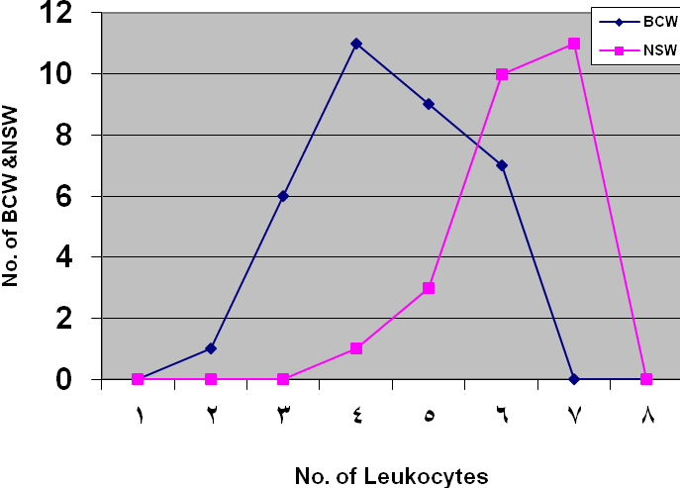
Figure1 Leukocytes counts among BCW &NSW
1= 2000-2900 3=4000-4900 5=6000-6900 7=9000-9900
2=3000-3900 4=5000-5900 6=7000-790 8-10000-
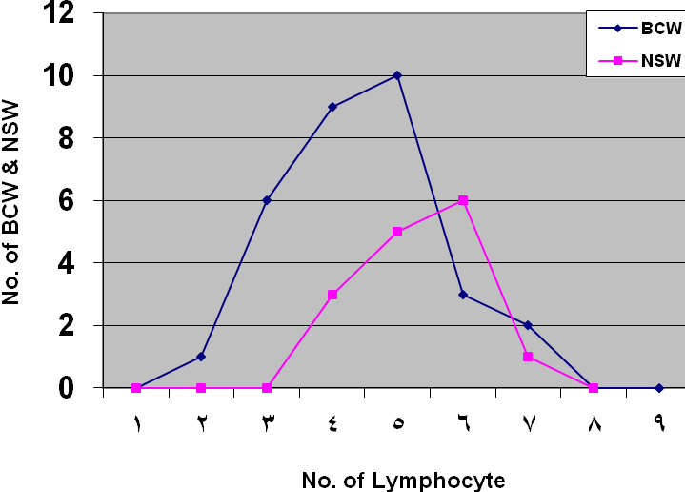
Figure 2 Lymphocyte counts among BCW & NSW
1= 500-900 3=1200-1300 5=1600-2700 7=3000-3900
2=1000-1100 4=1400-1500 6=2600-2900 8-4000-

Discussion
Although the total leucocyte counts among BCW and NSW are with normal count ranges, they tend to be coherent within their lower limits reaching up to 5800 cell/ml while in the case of NSW they were coherent with the range of 6000 up to 9000 cell /ml. BCW results can be attributed to Tomaxifen treatment[14]; likewise, the total lymphocyte count tend to be coherent with up to 2000 cell/ml in BCW. While, in NSW it reaches up to the range of 2000-2900 cell/ml, this might be attributed to chemotherapy [14,15].
Lower CD4 counts were noted among 24: 35 (68.57%) of BCW when the low limits of Europian value was taken as 600 cell/ml.
However, different CD4 count limits designated as normal values were noted at the different parts of the world [16-20].
So efforts should be made to build up collaborative multicentric normal values for CD4, CD8 and CD4/CD8 ratios for Iraqis. The normal human subject CD4/CD8 ratios are 1.5-3.0. It decreases in Aids to 0.1 and Kaposi sarcoma to 0.1 1.0 [21] as it is compared to 1.085 in BCW (Table 4). This may account for lowering T cell mediated immunity among BCW. Twelve out of 35 BCW revealed high concentrations of CEA and /or Ca15-3 of which eight for both and four with either of them. CEA scors nine and Ca15-3 scors eleven. While , 24: 35(68.57%) were diagnosed by CEA, Ca15-3 and CD4/CD8 ratio (tables 1-4). Thus a battery of CEA, Ca15-3, CD4/CD8 is recomonded for immunodiagnosis and fallow up of BCW. Meantime, Ca15-3 secretion by breast cancer women was proved [22]. and considered to be best marker among the other markers(10). For specific diagnosis combined use of CEA and Ca15-3 was recommended [23,24,25,26].
So for the results (tables 1-4) indicate one can derive the immune features as;
1- Low limits of the total leucocyte and the lymphocyte counts.
2- Subnormal CD4 lymphocyte count in 25.71% of BCW.
3- Subnormal CD4/CD8 ratios in 68.57% of BCW.
4- Abnormal high CEA and Ca15-3 values as 25.7% and 31.42% respectively and the rest were within the baseline.
5- A battery of CEA, Ca15-3, CD4/CD8 ratio can serve for immunodeagnosis of BCW patients.

References
1- Nokad, J.A. and Ghedirian, P. J. Canc. Res. 2005. 21(2): 80-175.
2- Rao, C.V. 2000. An introduction to Immunology Narasa Publishing New Delhi.
3- Liotto, L.A. and Clair, T.J. Nature 2000. 405: 287-288.
4- Robert, G.F. and Dan L.L. 2005. C ell biology of cancer in kasper D.L. and others (eds.). Harrison's Principles of Internal Medicine 16th ed. McGraw Hill. Inc.U.S.A.
5- Leot, L.A.J. Cans. Res. 2001, 61: 3230-3239.
6- Clavins J.V. J. Ann. Clin. Lab. Sci. 1982a. 12: 331-332.
7- Clavins, J.V. Canc. Det. Prev. 1982b. 5: 88.
8- Robeson and Roitt , I.R. 2000. Really essential Medical Imminology , Blackwell Scientific publishing, 191-195.
9- Anthony, W; Butch, H. Nicole, A.; Massoll, S.; Alex, A. Michel, L.B. Janet, L.D. and Edward , P.F. 2000. Clinical chemistry 4th ed. Lippincott Williams Wilkins, Philadelphia .
10- Clinton, S.K.; Beason, R.L.; Pryant, S. and Johnson J.T. J. Biol. Med. Sci. instrum. 2003. 39: 14-408.
11- Ramink, S. (1987). Medical Laboratory Technology method and interpretations New Delhi.
12- Al-Rawi, Kh.M.; Khallallah A.Z. (2000). Agricultural Experimental Design, Mosul University Press, Mosul Iraq.
13- Stities, D.P.; Stobo, J.D.; Wells J.V. 1987. Basic and clinical immunology. 6th ed. Appleton and lange California.
14- Maslin , A. and Powles, T.J. 1999. Breast cancer. Oxford university Press , Oxford.
15- Sporn, M.B. and Lippmans, S.M. 2000. Cheruoprevention. In Bast, RC. Kufe D.W.; Pollock, R.F.; Weichselbown, R.R.; Holland, J.F.; Ferrill, E. and Ganster I.E. (eds.) Cancer medicin 5th De Decker, Canada.
16- Kathleen, D.P. and Timothy, J.P. 2001. CEA in Mosby's Diagnosis and Laboratory Test Reference 5th ed. Mosby Inc. USA.
17- Yaman, A.; Continer, S.; Kibar, F.; Tasora, Y/.; Sevdaglu, G. and Dundan, T.H. Turk. J. Med. Prin. Pract. 2005, 14(3).
18- Vithavasai, V.; Sirisanthana, T.; Sakonwasun, C. and Suvanpivasiri, C. J. All. Immunol. 1997. 15(3):6-141.
19- Uppal, S.S.; Verma, S. and Dhot, T.S. J.B. Clin. Cytom. 1997. 52(1): 6-32.
20- al-Howurani, K.M.F. 2006. Progression AIDS and its relation to some hematological . Immunological and Biochemical markers in some Iraqi HIV infected patients M.Sc. Thesis Baghdad University.
21- Al-Balahi, S. 1987(ed.). AIDS, symposium medical city 3rd June. Ministry of Health Board of Prophylaelzi Service. Iraq.
22- Anthony, S.F. (2005). Disorder of growth differentiation. In, Dennis, L.R.; Danil, L.L.; Cugene, B.D.; Stephen, L.H.; and Larry, L. (eds) Harrison Principle of Internal Medicine. McGraw Hall Inc. USA.
23- Omar, X.J.; Behbehan, A.F.; and Al-Nagueeb, N., J. Biol. Marker 1987. 3:12 -20.
24- Duffy, M.J.; Duggan; Keane, R.R.; McDermott, E.; Crown, J.O.; and Higgins. N.J.B. Cancer Clin. Chem. 2004. 50(3): 563-589.
25- De-Rocio, E.; Shanche, z.; Mireles G.; Enriquez, M. and Valverde, C.N. J. Clin. Rev. Invest. 2004. 55(4): 408-412.
26- Ebeling , F.G.; Stieber, P.; Uneteh, M.; Nagel, D.; Konecng, G.F.; Schmitt, U.M.; Fateh, M.A. and Seidd, D.J.B. Cancer 2002. 86(8): 1217-1222.
27- Lewis, S.M.; Bain, B.J.; I. 2001. Daci and Lewis Practical Hematology 9th ed. Churchill Livingstone, London.
28- Goldsby, R.A.; Kindt, T.J. and Osborn, B.A. 2000. Kuby Immunology. 4th ed. W.H. Freeman and company, New York, 539-562.

