M J B
Antibiotics Resistance of Pseudomonas aeruginosa Isolated from Clinical Cases in Hilla City *

Habeeb Sahib Naher Lena Fadhil Hamza

College of Medicine, University of Babylon, Hilla, Iraq.

* Selected from MSc. Thesis

Abstract
This study was carried out for the isolation and identification of Pseudomonas aeruginosa from 260 patients who were suffering from: burns, chronic otitis media and urinary tract infections (UTI). Detection of the isolates susceptibility for 23 antibiotics was also studied. Moreover, chemical substance like ethylene diamine tetra acetate (EDTA) was added to some antibiotics in an attempt to enhance their effects.
The total number of P.aeruginosa isolates accounted for 30 of 260 samples, the distribution of those isolates were: 10 from 32 burn samples,10 from 58 otitis samples and 10 from 170 UTI samples.
The results showed high degree of resistance for most antibiotics being used in this study. Also results were indicated for extended-spectrum beta-lactamases production by this bacteria by using EDTA as indicator and the positive results were observed in 9(30%) isolates with ampicillin and 12(40%) isolates with cefixime.
مقاومة المضادات الحيوية لبكتريا الزوائف الزنجارية المعزولة من حالات سريريه في مدينة الحلة
الخلاصة:
أجريت هذه الدراسة بهدف عزل و تشخيص البكتريا الزنجاريةPseudomonas aeruginosa من 260 مريض شملت التهاب المجاري البولية ، حالات التهاب الأذن الوسطى والحروق وبيان مدى حساسيتها ل(23) مضادا حيويا. أضيفت لبعض المضادات بعض المواد الكيميائية المتمثلة بمادة ethylene diamine tetra acetate (EDTA) وتم اختبار فعاليتها تجاه العزلات .
بلغ عدد عزلات P.aeruginosa التي تم تشخيصها 30 عزلة من مجموع (260) عينة بواقع 10من أصل (32) عينة حروق ,10 من أصل (58) عينة قيح أذن 10 من أصل (170) عينة إدرار. تم اختبار فعالية (23) مضادا حيويا تجاه العزلات البكتيرية لتحديد مدى مقاومتها لها وتبين أن العزلات البكتيرية أبدت مقاومة عالية نسبيا لمعظم المضادات فيد التجربة.
وتم خلال البحث الكشف عن أنتاج أنزيمات(Extended-spectrum-beta-lactamases) من قبل هذه البكتريا باستعمال مادة (EDTA) وكانت النتيجة موجبة لـ(9) عزلات باستعمال (ampicillin) و(12) عزلة باستعمال(cefixime).
ـــــــــــــــــــــــــــــــــــــــــــــــــــــــــــــــ

Introduction
The major species of the genus Pseudomonas associated with human infections is Pseudomonas aeruginosa. It is found sporadically in moist areas of the skin and in the intestinal tract of about 10% of healthy individuals as part of the resident microflora [1].
In recent years it has become the major causative agent of nosocomial infections resulting in severe and complicated diseases with a high mortality rate. P.aeruginosa is an opportunistic organism that is able to cause infections mainly in compromised hosts (i.e. with impaired local or systemic defense mechanisms). The medical problem resulted by this organism is it’s ability to resist almost all antibacterial agents, leading to predominance this organism when sensitive organisms are suppressed by those agents [2,3].
This study was suggested and designed for isolation and identification of P.aeruginosa from different clinical cases (burns, chronic suppurative otitis media and urinary tract infections UTIs) in Babylon Province, determination of the susceptibility of P.aeruginosa isolates to different antibiotics, and for the detection of the synergistic action of EDTA compound added to selected antibiotics against P.aeruginosa isolates.

Materials and Methods
In this study, 260 patients were investigated, since 260 clinical swabs were collected from both sexes of different ages who referred to Surgical Teaching Hospital in Hilla, through October/ 2004 to May/ 2005.Thirty clinical swabs were positive for P.aeruginosa, ten of those swabs were from burns, the other ten from chronic suppurative otitis media and the other last ten from UTI. Hence the specimens–swabs were burns exudates, ear exudates and urine respectively. Those swabs were taken according to the methods suggested by [4]. The grown colonies on the nutrient agar with characterized diffusible pigments were selected for further diagnostic tests. The results of the following experiments regarding diagnosis of P.aeruginosa were recorded according to [5,6] using cultural characteristics and conventional biochemical tests.
Antibiotic Disks
The antibiotic disks shown in Table- 1, were used for detection the susceptibility of the P.aeruginosa isolates to these antibiotics. The potency of these antibiotics was checked first towards gram–positive and gram–negative isolates represented by Staphylococcus aureus and E.coli respectively. The results of this experiment were recorded according to the standard guidelines recommended by National Committee for Clinical Laboratory Standards [7].
Synergistic Effect of EDTA with Some Antibiotics on P.aeruginosa Isolates
In this experiment two different techniques were used as follows:
A-The Minimum Inhibitory Concentration (MIC):
Serial dilutions by two-fold dilution method were prepared from the initial concentration of ampicillin ranged 128,64,32,16,8,4 µg/ml and cefixime with concentrations ranged 32,16,8,4,2,1 µg/ml as recommended by [8,9]. Mueller-Hinton agar was used, concentrations of antibiotic agents were incorporated into agar plates ,one plate for each concentration to be tested. The isolates to be tested were diluted to a slightly greater turbidity than that of a McFarland standard tube No.0.5. Each plate contained 1ml of diluent’s antibiotic agent and 14ml of agar. After the plates dried, inoculated with a cotton swab by streaking method and incubated for 24 hours at 37°C. The lowest concentration of the antibiotic that allows a slight growth was recorded as the MIC.

Table 1 Antibiotic Disks used in this Study
Antibiotic agent * | Symbol | Concentration µg/disk | Diameters of inhibition zones (mm)
Antibiotic agent * | Symbol | Concentration µg/disk | resistant | intermediate | susceptible
Penicillins:-
Penicillin | P | 10 ** | ≤11 | 12-21 | ≥22
Ampicillin | Am | 10 | ≤11 | 12-13 | ≥14
Piperacillin | PRI | 100 | ≤17 | - | ≥18
Carbencillin | PY | 100 | ≤13 | 14-16 | ≥17
Ticarcillin | Tc | 75 | ≤14 | - | ≥15
Cephalosporins:-
Ceftizoxime | ZOX | 30 | ≤14 | 15-19 | ≥20
Cefixime | CFM | 5 | ≤15 | 16-18 | ≥19
Cefotaxime | CTX | 30 | ≤14 | 15-22 | ≥23
Cefepime | FEP | 30 | ≤14 | 15-17 | ≥18
Monobactams:-
Aztreonam | ATM | 30 | ≤15 | 16-21 | ≥22
Aminoglycosides:-
Amikacin | AK | 30 | ≤14 | 15-16 | ≥17
Gentamicin | CN | 10 | ≤12 | 13-14 | ≥15
Tobromycin | TOB | 10 | ≤12 | 13-14 | ≥15
Fluoroquinolone:-
Ciprofloxacin | CIP | 5 | ≤15 | 16-20 | ≥21
Norfloxacin | NOR | 10 | ≤13 | 14-16 | ≥17
Tetracyclines:-
Tetracycline | TE | 30 | ≤14 | 15-18 | ≥19
Doxycycline | DO | 30 | ≤12 | 13-15 | ≥16
Macrolide:-
Erythromycin | E | 15 | ≤13 | 14-22 | ≥23
Azithromycin | AZM | 15 | ≤13 | 14-17 | ≥18
Dichloroacetic acid derivative:-
Chloramphenicol | C | 30 | ≤12 | 13-17 | ≥18
Polymyxins
Colistin | CT | 10 | ≤18 | 9-10 | ≥11
RifamycinB derivative:-
Rifampin | RA | 5 | ≤16 | 17-19 | ≥20
Sulfonamide derivative:-
Co-trimoxazole | SXT | 25 | ≤10 | 11-15 | ≥16
- All disks above from Bioanalyse company (Turk.). ** Express concentration by International Unit (IU)/ disk.

B- The Agar–Well Diffusion Method
- The culture media (Mueller–Hinton agar) plates were prepared by the routine method.
- The bacterial suspension was prepared as follows. With a sterile loop, 4-5 isolated colonies from overnight pure culture were transferred to a tube containing 5 ml of BHI broth. The broth was incubated at 37°c for 4-6 hours. Then, the turbidity of bacterial suspension match with the turbidity of the McFarland tube No.0.5 by using the normal saline.
- Sterile cotton swab was dipped into the bacterial suspension and streaked the dried surface of the Mueller–Hinton plates in 3 different planes.
- The wells on the Mueller-Hinton plates were prepared by using Pasture pipette(wide end) with diameters of 4 mm. The appropriates concentrations of the antibiotics 64,32,16,8 μg/ml for ampicillin and 16,8,4,2 μg/ml for cefixime were dropped in the wells (0.1ml from each concentration)and the EDTA in a concentration of 50 mg/100 ml with an amount 0.1 ml in the specific well.
- The plates were incubated at 37°c for 24 hours, then the activity of the mixture was detected by determining the inhibition zone around the wells as recommended by [10 ].

Results and Discussion
The organisms included in this study were identified according to the routine diagnostic tests specific the Pseudomonas aeruginosa[4,5,9,11].
Results shown in figure (1) revealed a remarkable increase in Pseudomonal resistance to beta-lactam antibiotics represented by penicillin, ampicillin, carbencillin, cefixime, cefotaxime, ceftizoxime, ticarcillin, piperacillin and cefepime, since the level of resistance accounted for the first four antibiotics (100%) to for (90%) , (86.7%), (80%), (76.7%)and (70%) for cefotaxime, ceftizoxime, ticarcillin, piperacillin and cefepime respectively. The resistance to the penicillins and cephalosporins has become an important issue in most hospitals in which resistance rates have reached greater levels. These results were in agreement with those results being obtained by other studies of [12,13].
The beta-lactamases have been reported to hydrolyze all antipseudomonal agents. Moreover,P.aeruginosa cells particularly in patients with chronic infections can develop a biofilm, in which bacterial cells are enmeshed into a mucoid exopolysaccharide becoming more resistant to beta-lactams as well as decreasing the outer membrane permeability that enables bacteria to gain resistance development [14]. The problem with P.aeruginosa is that, the use of a single antipseudomonal agent, even when P.aeruginosa is sensitive, is associated with the development of resistance during therapy [15]. Resistance mediated by P.aeruginosa can be attributed both to an inducible, chromosomally mediated beta-lactamases that can render broad–spectrum cephalosporins inactive, and to a plasmid–mediated beta- lactamases that can lead to resistance to several penicillins and older cephalosporins [16].
The results with regard to other antibiotics represented by tetracycline, doxycycline, erythromycin, rifampin, chloramphenicol, co-trimoxazole, gentamicin, colistin, aztreonam and tobromycin were variable and the resistance of P.aeruginosa against these antibiotics ranged from (100%) for the first five antibiotics to (56.7%) for the tobromycin. The resistance toward co-trimoxazole, gentamicin, colistin and aztreonam accounted for (90%) , (86.7%) , (63.3%) and (60%) respectively, while P.aeruginosa isolates showed resistance with less percentages to other antibiotics represented by ciprofloxacin, norfloxacin, amikacin and azithromycin accounted for (26.7%), (26.7%) , (20%) and (20%) respectively.
P.aeruginosa resistance can be conferred by the outer membrane which provides an effective intrinsic barrier to accessing the targets which are located either in the cell wall or cytoplasmic membrane or within the cytoplasm and modifications in outer membrane permeability via alterations in porin protein channels representing a component of many resistance mechanisms. In addition, inactivating enzymes released from the inner membrane can function more efficiently within the confines of the periplasmic space. The mechanisms by which intracellular concentrations of drugs are limited include decreased permeability through the outer membrane, decreased uptake through the cytoplasmic membrane and active efflux back out across the cytoplasmic membrane [17].

Am P Py Cfm Te Do C E Ra Ctx Sxt Zox Cn Tc Prl FEP Ct Atm Top Cip Nor Ak Azm
Antibiotics

Figure 1 Rates of Resistance of P.aeruginosa for Antibiotics.

From these records one can conclude that the azithromycin, amikacin, norfloxacin and ciprofloxacin are the most effective antibiotics against P.aeruginosa and confidently can be suggested for treatment to overcome this bacteria. The results described above were compared with other results reported by [18-20] and were in relative satisfactory accordance, although some other results being reported by other studies [13,21] were in contrast somewhat.
Synergistic Effect of EDTA with some antibiotics on P.aeruginosa isolates :
Egorov, (1985) stated that using antibiotics in combination with other preparations may help in preventing the development of antibiotics-resistant microorganisms such as some biologically active compounds referred to the ethylene diamine tetra acetate. He supposed that such compound may decrease the resistance of bacteria to be antibiotics, perhaps by prevention of drug resistance factor (DRF) to be transferred through bacteria by conjugation and/or transformation. The results of the present study showed that P.aeruginosa isolates were able to produce the metallo-beta-lactamases (MBLs) and this phenomenon has been clearly and extensively demonstrated [23].
The results of the present study showed that positive results for MBLs included a total in of 9(30%) isolates from the (30) isolates when followed by the agar dilution method. These were 7(23.3%) isolates of burns and 2(6.7%) isolates of UTIs. The growth of these isolates was inhibited by ampicillin in concentration 32μg/ml with the presence of EDTA while these isolates had not been inhibited by ampicillin when using the (4) four concentrations (64,32,16,8)μg/ml in absence the EDTA. When cefixime was used instead of ampicillin with the concentrations (16,8,4,2)μg/ml showed positive result for MBLs included a total in of 12(40%)isolates from the all (30) isolates. These were 10(33.3%) of burns isolates and 2(6.7%) of UTI isolates. The growth of these isolates were inhibited by cefixime in concentration 8μg/ml with the presence of EDTA but were not inhibited if EDTA are removed.
From these MBLs positive isolates, the burn isolate (No.12) was selected to experiment using the same antibiotics (ampicillin and cefixime) with the same concentrations by well-agar diffusion method. This isolate exhibited a significant zone size enhancement with a mixture of EDTA plus ampicillin in concentration 16μg/ml and with a mixture of EDTA plus cefixime in concentration 4μg/ml, results outlined in Table-3, Figure-2 and figure-3. MBLs enzymes belong to the group of beta-lactamases divalent cations of zinc as co-factor for enzyme activity. They have potent activity not only against carbapenems group but also against other beta-lactamases [24]. MBLs are not inhibited by the commercially available inhibitors such as sulbactam and tazobactam [28], but the production of MBL was detected by EDTA, because EDTA can interact with P.aeruginosa LPS, since the EDTA can remove ions from its LPS sites, whereas the antibiotic molecules being cationic ,would compete with these ions for these sites [24].
There are reports on MBLs production in P.aeruginosa from various countries like Brazil, Korea ,Singapore and France. MBL was first reported as a zinc dependent enzyme in Bacillus cereus in mid 1960s [23] and since it had been described in different gram-negative bacteria. All these enzymes were produced by chromosomal genes. However ,in 1991, the first plasmid–mediated MBLs from P.aeruginosa have been reported from Japan, while another type of acquired beta-lactamase was first reported from Italy in 1999 [23] . MBL production is a significant problem in hospital isolates of P.aeruginosa. The mobility of beta-lactamase genes associated with integrons and being disseminated throughout bacterial populations is of great concern to microbiologists and physicians alike [24]. So the rapid detection of MBL-positive gram-negative bacilli is necessary to aid infection control and prevent their dissemination.

Table 3 Susceptibility of Burn Isolate No.12 to Ampicillin and Cefixime with and without EDTA.

Antibiotic agent | Concentration µg/ml | Diameter of the inhibition zone(mm)
Antibiotic agent | Concentration µg/ml | Without EDTA | With EDTA
Ampicillin | 8 | 0 | 13
Ampicillin | 16 | 0 | 14
Ampicillin | 32 | 6 | 20
Ampicillin | 64 | 7 | 23
Cefixime | 2 | 0 | 16
Cefixime | 4 | 0 | 19
Cefixime | 8 | 8 | 26
Cefixime | 16 | 8 | 27

0.1ml mixture
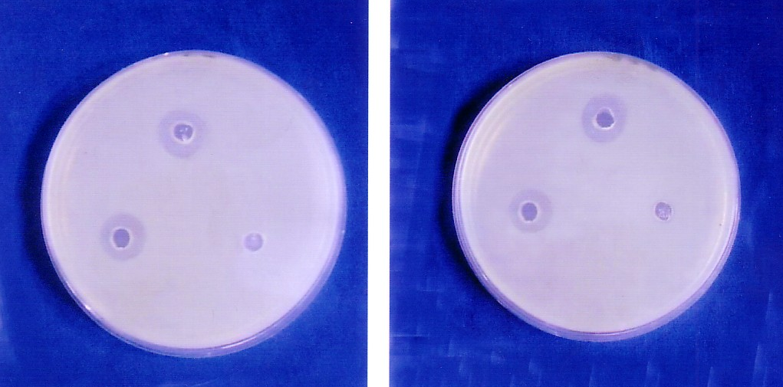

an
0.1ml 0.1 ml
EDTA antibiotic

0.1ml antibiotic 0.1 ml EDTA

8 µg /ml 16 µg /ml

0.1 ml mixture
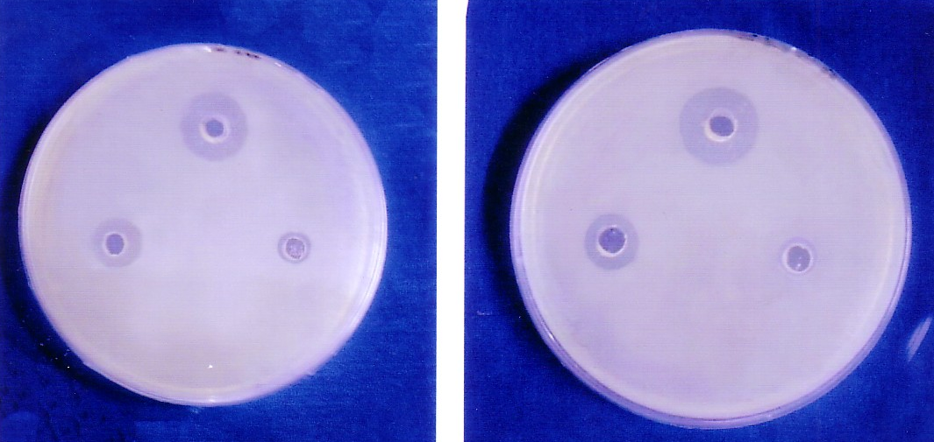

0.1ml 0.1 ml
EDTA antibiotic

0.1 ml antibiotic 0.1 ml EDTA
32 µg /ml 64 µg /ml
Figure 2 Synergistic effect of EDTA plus ampicillin with different concentrations on P.aeruginosa .

0.1 ml mixture
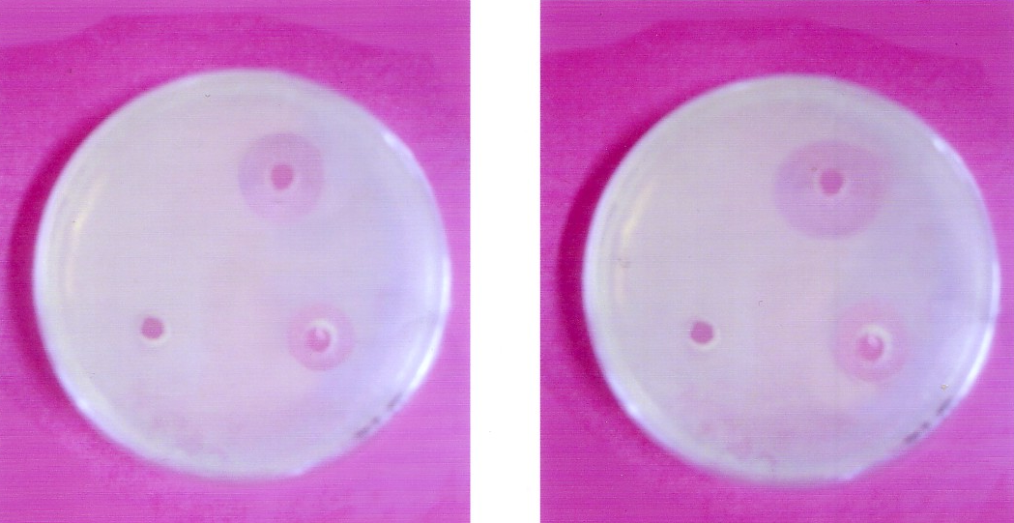

0.1ml
antibiotic 0.1m
EDTA

0.1 ml EDTA 0.1 ml antibiotic
2 µg /ml 4 µg/ml

0.1 ml mixture
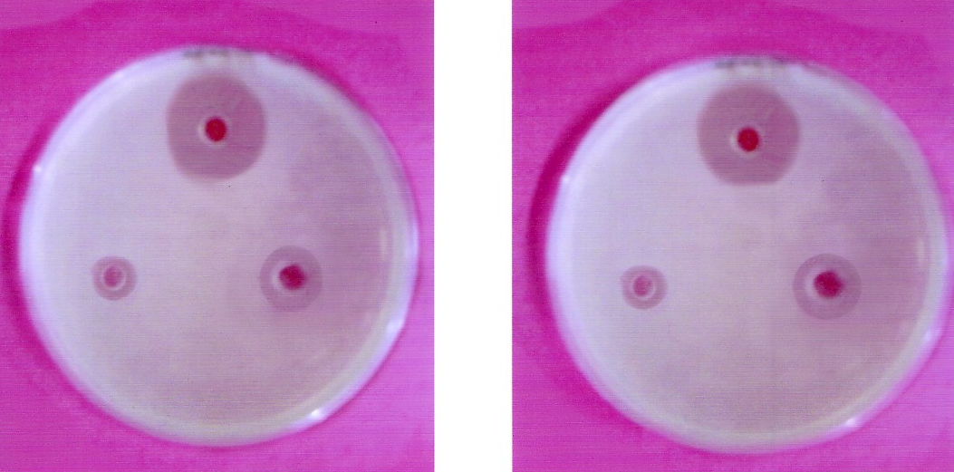

0.1ml 0.1ml
antibiotic EDTA

0.1 ml EDTA 0.1 ml antibiotic
8 µg /ml EDTA 16 µg /ml antibiotic

Figure3 Synergistic effect of EDTA plus cefixime with different concentrations on P.aeruginosa .

References
- Hugh,R. and Gilardi,G.L.(1974). Pseudomonas .In manual of Clinical Microbiology .2nded. Ed. E.H.Lenntte,E.H. Spaulding and J.P.Truant. Washington D.G.:American Society for Microbiology .p.250-69.
- Cohn, I. and Bronside,H.(1984). Infectious .In principles of surgery,4th ed. Ed. S.I. Sohwartz, G.T. Shires, F.G . Spencer and E.H. Storer . New York : Gram–Hill Book company.p.165-198.
- Cunha,B.A. (2000). Antibiotic Resistance. Medical clinics of North America. Antibiotic Therapy , Part 1. 84 (6) :1407 – 1421.
- Collee, J.G .; Fraser,A.G. ; Marmion,B.P. and Simmons,A.(1996). Mackie and Mecartney . Practical Medical Microbiology. 14th ed .,Churchill Living stone, USA. p.413 – 424 .
- MacFaddin,J.F.(2000) .Biochemical tests for Identification of Medical Bacteria 3rd ed .p. 689 – 691 .The Williams & Wilkins Co.,USA.
- Murray,P.R.; Baron,F.J.; Ellen,J. and James,H. (2003). Manual of Clinical Microbiology .8th ed.Vol.1. Lippincott.Asm press, Washington, D.C.p.719-728.
- National Committee for Clinical Laboratory Standards(NCCLs).(2003). Performance standards for Antimicrobial susceptibility testing. 9th ed., informational supplement, Wayne, Pa.
- Garrod,L.P.; Reeves,D.S.; Phillips,I.; Williams,J.D. and Wise,R. (1978) . Laboratory Methods in Antimicrobial Chemotherapy. Churchill Livingstone, New York .p31-49.
- Baron,Et.; Peterson,L.R. and Finegold,S.M.(1994). Bailey and Scott 's Diagnostic Microbiology . 9th ed., the C. V. Mosby, Co.,USA. p. 386 – 403.
- Aulton,M. E. (1988 ) . Pharmacentics, The Science of Dosage from Design. 1st ed .Churchill Livingstone ,London. P. 494 – 496.
- Brooks,G.F. ;Butel,J.S. and Morse,S.A. (2001). Jawetz, Melnik and Adelberg’s. Medical Microbiology. 22nd ed . p. 229–231. Medical East ed ; Appleton Large.
- Mehta, M.; Punia,J.N. and Joshi,R.M. (2001). Antibiotic Resistance in P.aeruginosa Strains Isolated from Various Clinical Specimens .Indian J.Microbiol. 19 :232 – 240.
- Nihad ,A.; Wa’ad,M. and Sheelan,A. (2002). Prevalence and Antibiogram Profile of P.aeruginosa Isolated from Patients Attending STH At Tikrit city . The Medical J. of Tikrit University. 8 : 61 – 67 .
- Giamarellou, H. and Antoniadou,A. (2001) . Antipseudomonal Antibiotics . Med. Clini. of North America 85 (1) : 90-95.
- Kaye,K.S.; Fraimow,H.S. and Abrutgn,E. (2000) . Antibacterial Therapy . Infec. Dis. Clini. of North America . 14 ( 2 ) :62-65.
- Eltahawy, A.T. and Khalaf,R.M. (2001) . Antibiotic Resistance Among Gram–Negative Non-Fermentative Bacteria at a Teaching Hospital in Saudi Arabia . J. Chemother.13 ( 3 ) :260 – 264 .
- Po-Ren,H.; Mei-Ling,C.; Chun-Chuan,S.; Wen,H.C.; Hui,J.; Li-She,Y.; Shan-Chwen,C.; Shen,W.H.; Chin,Y.; Wei-Chuan,H. and Kwen,T. (2002) .Antimicrobial drug resistance in Pathogens causing nosocomial infections at a university Hospital in Taiwan 1981 – 1999 .8 (1) : 74-77.
- Suzuki,Y.; Ishii,Y; Ishihara,R.; Nakazawa,A ; Deguchi,K. ; Matsumoto,Y. ; Nishinari,C. ; Nakane,Y. and Fukumoto,T. (1997) . Antimicrobial activities of clarithromycin against recent obtained clinical isolates. Jpn–J-Antibiot. 50 (9):776-793.
- Burns,J.L.; Saiman,L.; Whittier,S.; Larone,D.; Krzewinski,J.; Liu,Z..; Marshall,S.A. and Jones,R.N. (2000). Comparison of Agar Diffusion Methodologies for Antimicrobial Susceptibility Testing of P.aeruginosa Isolates. J. of Clini. Microbio. 38 (5) : 1818 – 1822 .
- Sorberg, M.; Farra,A.; Ransjo,U. ; Gardlund,B. ; Rylander,M.; Wallen,L. ; Kalin,M. and Kronvall,G. (2002). Longterm antibiotic resistance surveillance of gram–negative pathogens suggest that temporal trends can be used as a resistance warning system . Scand-J-Infect-Dis. 3 (5):372-378.
- Boubaker,B.B.; Boukadida,J.; Triki,O.; Hannachi,N. and Ben-Redjeb,S. (2003) .Outbreak of Nosocomial Urinary Tract Infections due to a Multidrug Resistant P. aeruginosa . Pathol-Biol-(Paris). 51 ( 3 ) : 147–150 .
- Egorov,N.S. (1985). Antibiotics A Scientific Approach. 1st ed. Churchill Livingstone. London. p.390-392.
- Hemaltha,V.; Sekar,U. and Kamat,V. (2005). Detection of Metallo-Beta lactamase Producing P.aeruginosa in Hospitalized Patients . Indian J. Med. Res. 122 : 148 – 152 .
- Poirel,L.;Rotimi,V.O.;Mokaddas,E.M.;Karim,A. and Nordmann,P.(2001).VEB-1-Like extended-spectrum B-lactamases in P.aeruginosa,Kuwait. Past Issue. J.of Emerg. Infec. Dis. 7(3): 83-85.

22-27.

