M J B
The Cytotoxicity and Inhibitory Effect of Ortho-Amino Phenyl Mercury(II) Chloride against Growth of Some Bacteria (invitro)

Shaker. A.N.Al-Jadaan Eman T.Ali* Zainab.S.Wrewsh*

Dept. of Pharmaceutical Chemistry, College of Pharmacy, University of Basrah, Basrah, Iraq.
*Dept. of drugs and Toxicology, College of Pharmacy, University of Basrah, Basrah,Iraq

Abstract
It was found that 0.2g of Ortho-Aminophenylmercury(II)chloride (OAPMC) dissolved in HCl/water added in to Muller-Hinton Agar medium, inhibited the growth of three reference strains bacteria [Escherichia coli ATCC25922, Pseudomonas aeruginosa ,ATCC27853 and Staphylococcus aureus, ATCC25923] in addition to five clinical isolates (Staphylococcus aureus , Streptococcus Pyogenes, Pseudomonas-aeruginosa, Escherichia-coli and Klebsiella aerogenes). Higher concentrations of (OAPMC) solution into the medium inhibited growth of bacteria under study was more strongly. The minimal inhibitory concentration (MIC) and the cytotoxicity of (OAPMC) were studied against human blood and it was found that it had no hemolytic effects at different concentrations. Antibiotic sensitivity was tested for (OAPMC) and the results were evaluated: a susceptible intermediate and resistant respectively.
ألسميه الخلويه والتأثير المثبط للمركب أورثو أمينو فنيل كلوريد الزئبق ضد نمو بعض انواع البكتيريا (مختبريا).
الخلاصة
وجد ان 0.2g من المركب (OAPMC) المذاب في مزيج من الماء و(HCL) قد ثبط نموثلاث سلالات مرجعيه بالاضافه الىخمس عزلات سريريه كماوجد ان التراكيز العالية من المركب المضاف الى الوسط الزرعي يؤدي الى تثبيط النمو بشكل اكثر.
تمت دراسة التركيز الادنى المثبط وكذلك السمية الخلوية لكريات دم الانسان ووجد انه لايوجد تحلل لكريات الدم عند تراكيز مختلفة من المركب.كماتم دراسة الحساسيه الدوائيه لعشرة انواع مختلفه من المضادات الحيويه ومقارنته بأقل تركيزمن المركب (OAPMC) حسب الجدول العالمي لشركة (Bioanalysis).
وتعتبر هذه الدراسة هي الخطوة الاولى لدراسة هذا المركب الجديد والذي يمكن الاستفادة منه كدواء في المستقبل.
ـــــــــــــــــــــــــــــــــــــــــــــــــــــــــــــــــ

Introduction
Mercury is one of the hazardous metals found in the environment; it can be found chemically as elemental Hgº, inorganic as [Hg(I) and Hg(II)], and organic [mostly as Hg(II)] forms[1]. Some of the organic compounds having mercury have been found to be potent antiseptic agents; in these compounds mercury is found to be covalently bonded to the organic molecule[2]. These compounds are found to be bacteriostatic in action by inhibiting sulphydryl SH-containing enzymes of bacteria and less toxic than inorganic mercurial[3]. The commonly used inorganic mercurial are yellow mercuric oxide, mercuric oxide eye ointment; some of the important organic mercurial are Thiomersol and Nitromersol; their dilute aqueous solutions are powerful antiseptic used for disinfecting the skin before surgical operations and sterilizing surgical instruments; it is used as antiseptic for irrigation purpose, it is used in ophthalmology, it is used as an eye ointment employed in conjunctivitis, corneal ulcers; etc [4]. Phenyl mercury acetate; borate and nitrate, these compounds are used in many commercially available spermicidal creams; these have antibacterial and antifungal properties and are used as preservatives for injections[5]. Because of the above important uses, we tried in this study to use (OAPMC) which classified as organic amino mercury compound to evaluate the inhibitory effect of them against growth of three reference strains of bacteria and five clinical isolates, MIC and cytotoxicity, in addition to evaluate the drug sensitivity with ten types of antibiotics which prove its comparison with the results of(OAPMC).

Materials and Methods
Ortho-Amino Phenyl mercuric chloride was prepared according to the literature method of A.N.Nebmeyanov [6]. Standard solution (0.05M) of (OAPMC) was prepared by dissolving (0.2g) of (OAPMC) in 10ml of HCl/H₂O. Different concentrations (0.04, 0.03, 0.02, 0.01 and 0.005)M of (OAPMC) were used.
Antibacterial Activity
For this purpose three standard strains were used [E.coli ATCC25922, Pseudomonas aeruginosa ATCC 27853, Staph. aureus ATCC 25923] and five clinical isolates gram positive [Staph. aureus and Strep. pyogenes] from vaginal swab, and gram negative [E.coli from urine, Pseudomonas aeruginosa and Klebsiella aerogenes from blood culture]. The (OAPMA) activity was tested against clinical isolates and standard strains by disc diffusion method [7] by using Muller-Hinton agar medium (Difco) of a depth of 4mm (90mm) diameter Petri dish inoculated with 10⁵ CFU/ml bacterial suspension by dispersion method (according to McFarland standard scale) [8] then the Petri dishes were left after inoculation for (15-30) minutes, six units of sterilized paper disc (5mm) diameter saturated with above concentrations of (OAPMC) were put in the bottom of Petri dishes, slightly touching each disc with sterile inoculating forceps to make sure that it was in good contact with agar surface incubated upside down at 37Cº for 24 hours to measure the inhibition zone (IZ). Five Petri dishes were used as an experimental unit and the trial was repeated twice.
Cytotoxicity
The cytotoxicity test of (OAPMC) against Red Blood Cell (R.B.C) for human by using[9] is used in which 38ml of Ringer solution was mixed with 2ml of blood added in Anti-Coagulaut tubes with [potassium EDTA (K₃)], from this mixture, 2ml was put in sterilizer test tube to which different concentrations of (OAPMC) were prepared in five test tubes (0.04, 0.03, 0.02, 0.01 and 0.005)M respectively. After incubation at 37Cº for 8 hours each one hour the test tube were noticed and examined if there is any hemolytic effect for the (R.B.C) and the results were recorded.
Antibiotic Susceptibility
The antibiotic susceptibitity was tested [10] using Muller-Hiton agar medium (Difco) of a depth of 4 mm (90 mm) diameter Petri dish inoculated with 10⁵ CFU/ml bacterial suspension by dispersion method according to MacFarland standard scale, then the Petri dishes were left after inoculation for 15-30 minutes. Ten types of antibiotic discs (Bioanalyse) were put in the bottom of Petri dishes lightly touch each disc with sterile inoculating forceps to make sure that it was in good with agar surface incubated upside down at 37Cº for 24 hours to measure the inhibition zone (IZ). Accordingly, the results were evaluated susceptible intermediate and resistant respectively, and comparative with the (IZ) of sensitivity discs table.

Table1 Antibiotics used in the study of antibiotic sensitivity and the company provided it.
Company | Disc Content/mg | Disc Symbol | Antibiotic
Bioanalyse | 10 | AM | Ampicillin
= | 30 | TE | Tetracycline
= | 15 | E | Erythromycin
= | 10 | P | Pencillin
= | 10 | S | Streptomycin
= | 25 | AX | Amoxcillin
= | 30 | K | Kanamycin
= | 75 | AZL | Azlocillin
= | 02 | DA | Clindamycin
= | 30 | DO | Doxycycline

Results and Discussion
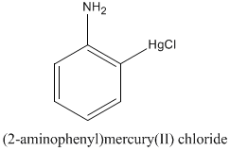

The (OAPMC) as shown above was prepared and identified according to the literature[6] and it was characterized by elemental analysis which gave good results to confirm the above structure.

Elemental analysis :- calculated C : 21.96 H : 1.84 N : 4.27
Found C: 21.93 H : 1.81 N : 4.24

Generally the data given in (Table 2) confirm very high inhibitory active of (OAPMC) at 0.05M concentration. According to (table 2), the minimal inhibitory concentrations level of (OAPMC) against standard strains, Escherichia coli ATCC25922, Pseudomonas aeruginosa ATCC 27853 and Staphylococcus aureus ATCC25923 was 0.005M and the inhibition zones were (38,48 and 48mm) in diameter respectively (Table 2) Fig(2-G). For the clinical isolates the inhibition zones of Escherichia coli, Klebsilla aerogenes, Pseudomonas aeruginosa, Staphylococcus aureus and Streptococcus pyogenes were 48, 40, 55, 55 and 60 mm in diameter respectively at 0.05M concentration of (OAPMC) Fig.(1-F) while at 0.005M concentration the inhibition zones for the same isolates were 35, 20, 30, 34 and 38 mm in diameter. The mechanism of antimicrobial action of (OAPMC) was not known, but one can suggest that the OAPMC at bacteristatic, bactericidal level disrupt cell metabolism by binding through hydrogen bond with amino acids and proteins including enzymes or by coordination of amino acids and proteins including enzymes with mercury atom through available vacant orbital, also may be by destruction of the pathogen cell wall [11]. Some studies shows that a significant reduction in percentages of labeled iodothyronines was demonstrated to suggest that mercurial may caused a coupling defect in the synthesis of iodothyronines and protein was apparently denaturized at 8x10⁻³ M concentration of inorganic mercury suggesting that thyroglobulin may carry a large binding capacity against organic and inorganic mercurial; furthermore, the blood thyroxin levels estimated by radioimmunoassay were quite reduced in the in organic mercurial treated group and also moderately reduced in the organic mercurial treated group, indicating that hormone secretion was affected by mercurial[12]. In contrast it was found that mercury inhibited the production of T4 but didn't interfere with conversion of T4 to T3[13]. Mercury can damage a fetus by interfering with the selenoenzymes and thyroid hormones[14]. Mercury was bound to the thyroid as well as the other tissues[15], high amounts of histochemically demonstrable mercury were observed in the liver, thyroid gland and kidney[16]. The results show different inhibitory effect of (OAPMC) on clinical isolates, the most Gram negative bacteria isolate affected at low concentration (0.005M) is Escherichia coli with inhibition zone 35mm fig.(1-E ), then Pseudomonas aeruginosa with inhibition zone 30mm fig.(1B), and Klebiella aerogenes with inhibition zone 20mm fig. (1-A ) at the same concentration. For gram positive bacteria isolates Staphylococcus aureus and Streptococcus pyogenes the inhibition zones at (0.005M) concentration of (OAPMC) were 38 and 34mm respectively figs. (1-C, 1-D). The (OAPMC) shows also high ability in inhibited at all concentrations for all clinical isolates, (table-3-) and that demonstrated it have broad spectrum.
The results of cytotoxicity test against red blood cell (R.B.C) for human show that the OAPMC has no hemolytic at different concentrations and there are no hemolytic for the R.B.C during experimental period (8 hr) . This results is the first step to continues study and work with this compound to produce new drug which may be used in future.
The results of drug sensitivity for clinical isolates showa good proof for the ability of (OAPMC) in inhibited the clinical isolates under study more strongly, (table-4-). Staphylococcus aureus isolate show multi-resistance for antibiotics (AZL, S, DO, DA, TE, AX, AM and P) and sensitivity for antibiotics (K) and the inhibition zone (18) mm respectively, while it shows sensitivity against OAPMC and the inhibition zone at 18.23 mg is 38mm, table (4). Pseudomonas aeruginosa record sensitivity against P, K and DO and the inhibition zones between 20-25mm and shows multi-resistance against TE, E, S, AX, AZL, DA and AM, but it was more sensitive against OAPMC which gave inhibition zone 30mm at 18,23 mg, table (4). For Klebsiella aerogenes isolate it shows high sensitivity against AZL, DO, DA and gave inhibition zones between 30-40mm, while it shows multi-resistance against the other antibiotics, but it show sensitivity against OAPMC and the inhibition zone is 20mm at 18.23mg, table (4). For Streptococcus pyogenes it shows sensitivity against,S and AZL and resistance for the other antibiotics, but it show high sensitivity against OAPMC and the inhibition zone at 18.23 mg is 34 mm. Escherichia coli isolate shows high sensitivity against TE, E, P, S, K, AZL, and DO and resistance to DA and AM and sensitive against OAPMC, inhibition zone at 18.23 mg is 35mm. On comparison the results in Table-3- and table-4- at low concentration, i.e.(18.23mg) the compound OAPMC gave high activity at minimal inhibitory concentration and that which could be attributed to the presence of amino group which act as hydrogen bond with other amino acids in addition to the presence of mercury element- which is poisonous for microbial cell- in which the high electron density tend to increase the bond strength which increase the efficiency of the compound in inhibiting the microbial growth[17]ditional studies and experiments required to prove the importance of this compound OAPMC before it is used as drug in future.

Table 2 The diameter inhibition zones(in mm) for standard strains at different concentrations of (OAPMC).
0.005M | 0.01M | 0.02M | 0.03M | 0.04M | 0.05*M | Standard strain
38 | 40 | 40 | 40 | 48 | 50 | Escherichia coli ATCC25922
48 | 50 | 50 | 50 | 50 | 55 | Pseudomonas aeruginosa  ATCC27853
48 | 46 | 47 | 48 | 48 | 50 | Staphylococcus aureus  ATCC25923
* Standard

Table 3 The sensitivity test of clinical isolates against (OAPMC) using paper disc method after 24 hr from bacterial growth at different concentrations.
0.005M | 0.01M | 0.02M | 0.03M | 0.04M | 0.05*M | Clinical isolates
35 | 40 | 40 | 40 | 40 | 48 | Escherishia coli
20 | 25 | 30 | 30 | 40 | 40 | Klebsiella aerogenes
30 | 37 | 45 | 47 | 55 | 55 | Pseudomonas aeruginosa
34 | 48 | 50 | 55 | 55 | 55 | Streptococcus pyogenes
38 | 40 | 40 | 40 | 45 | 60 | Staphylococcus aureus

Table4 The sensitivity of isolates against different antibiotics compared with (OAPMC)according to Bioanalysis table.
Staphylococcus aureus | Streptococcus pyogene | Pseudomonas aeruginosa | Klebsiella aerogenes | Escherishia coli | Antibiotic | Disc symbol | Disc content
38 | 34 | 30 | 20 | 35 | --------- | OAPMC | 18.23mg
10 R | 10R | 16R | -- R | -- R | Ampicillin | AM | 10 mg
13 R | 05R | 02R | 17 I | 31 S | Tetracycline | TE | 30 mg
03 R | 08 R | --R | -- R | 40 S | Erythromycin | E | 15mg
06 R | 05 R | 25S | -- R | 40 S | Pencillin | P | 10mg
22 S | 05 R | --R | 12 I | 25 I | Streptomycin | S | 10mg
05 R | 10 R | --R | -- R | 37 S | Amoxycilline | AX | 25mg
11 R | 18S | 20 S | R -- | 25 S | Kanamycine | K | 30mg
S 20 | R 07 | R 01 | S 30 | S 45 | Azlocilline | AZL | 75mg
-- R | 05R | 01 R | 40 S | -- R | Clindamycline | DA | 02mg
-- R | --R | 25 S | 35 S | 35 S | Doxycycline | DO | 30mg

R=Resistaint
I= Intermediate
S= Susceptible
---= No (IZ)

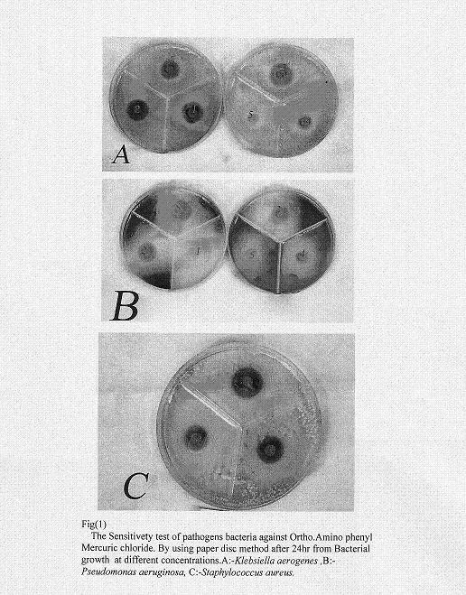

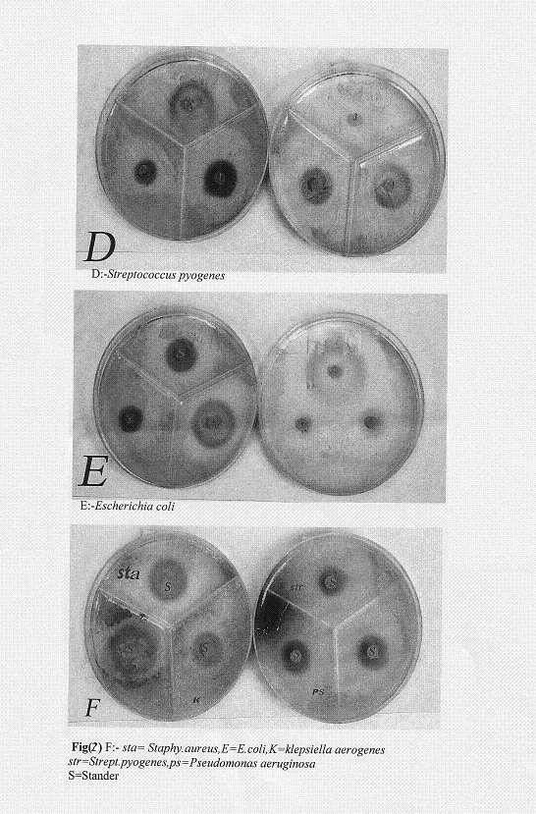

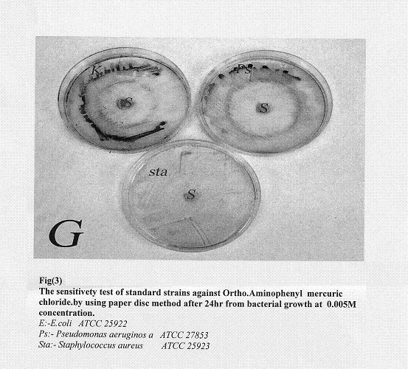

References
1- David. A. Atwood, "Recent Developmemts in mercury Science", Sprenger-Verlag, Berlin, Heidelberg, pp.1-3 (2006).
2- George Bartome and Patricia Trepanier " Toxicology and Applied Pharmacology", 65,92-99 (1982).
3- Jayashree Ghosh " A Text book of pharmaceutical Chemistry" S.Chand and Company LTD. Ram Nagar, New Delhi. (2003).
4- M. Rosette and Roat Malone '' Bioinorganic Chemistry'' Wiley Interscience. pp. 260 (2002).
5- Daniel Lednicer and Lester A. Mitscher. ''The Organic Chemistry of drug synthesis'' Volume 1, John wiley and Sons,Inc. (1977).
6- A.N.Nebmeyanov and A.V.Kocheshov,''Methodes of Elements-Organic Chemistry''. First (ed). Northland Publishing Company-Amisterdam (1967
7- H.W.Bauer, W.M.Kirby, J.C.Sherris and M.Turck, Antibiotic susceptibility testing by standard single disc method. Am.J.Clin.Pathol. 45, 494-496 (1966). 8- J.McFarland,; The Nephelometer; an instrument for estimating the number of bacteria in suspensions used for calculating the opsonic Index and for vaccines , J.Amer.Med. Assoc. 49, 1176 (1907). In : Practical Immunology,L.Hudson and F.C.Hay, 3rd ed. Blackwell Scientific Publications, Oxford, pp 1-496 (1989).
9- M.G.Nair, A.R.Mishar, M.H. Musks, W.H.Taft, J.E.Kesller, J.R. Miller, P.P.Zhn, J.D.Meinhart and D.G.Lynm. Faerifumgin, anew broad spectrum antibiotic from Streptococcus griseus var autotrophicus. J.Natural products 52, 779-809 (1989).
10- J. Colle, A. Fraser, B. Marmion and A. Simon. ''Practical Medical Microbiology 14th ed. Churchill Liverstone New York pp 978 (1996).
11- Rosa M. Claramunt, M.Angeles Garcia, Concepcion Lopez, and Jose Elguero. ARKIVOC (vii), 91-101 (2005).
12- J.Kawada, M. Nishida, Y.Yoshimura and K.Mitani, J.Pharmacobiodyn, 3 (3), 149-50 (1980).
13- M. Nishida, T. Yamamoto, Y. Yoshimura and J. Kawada, J Pharmacobiodyn. 9(4), 331-8(1986).
14- C. Watanabe, K.Yoshida, Y. Kasanuma and H. Satoh. Environ.Res. 80(3), 208-14(1999).
15- M. Nishida, H. Matsumoto, A. Sano, K. Umazume, Y. Yoshimura and J. Kawada, Chem. Pharm. Bull.(Tokyo), 38(5), 1412-3(1999).
16-J.C.Hansen, E. Reske-Nielson, O. Thorlacius-Ussing, J.Rungby and G.Danscher. Sci. Total Environ. 78, 23-43(1989).
17- R.Annuniziata, M. Benaglia, M. Cinauini, F.Cozzi and L.Raimondi, J.Org.Chem. (1998).

