Characterization of Burkholderia cepacia Isolated from Clinical Samples, in Hilla City, Iraq. *
Hasanain F. AL-Dahash Alaa H. AL-Charrakh Jawad K. AL-Khafaji
Dep. of Microbiology, College of Medicine, University of Babylon, Hilla-Iraq.

M J B

Abstract
This study involved 250 sputum samples collected from patients suffering from respiratory tract infections. Who attended tuberculosis center-Hilla city-Babylon province during the period from October 2011 to January 2012. The results of morphological properties and biochemical tests revealed that only four isolates (1.6%) were belonged to Burkholderia cepacia species. The results revealed that all isolates had the ability to produce protease, phospholipase C, β-lactamase, urease, gelatinase, and hemolysin. All isolates had capsule that plays an important role in resistance to phagocytosis. They also had the ability to produce bacteriocin which consider as competitive factor that enables them to survive by secreted this material outside the cell. The results also revealed the ability of B. cepacia to hydrolyze the amino acid lysine and oxidize glucose. Results of gel electrophoresis confirmed that all B. cepacia isolates in this study had plasmid more than 3000 bp.
*This paper is an extracted material from M.sc thesis for the first author.
الخلاصة
تضمنت الدراسة التحري عن وجود بكتريا Burkholderia cepacia من 250 عينة قشع جمعت من المرضى الذين يعانون من امراض الجهاز التنفسي والمراجعين لمركز التدرن الرئوي في مدينة الحلة- محافظة بابل خلال الفترة من تشرين الاول 2011 ولغاية كانون الثاني 2012. أظهرت نتائج النمو على الاوساط الانتقائية والصفات المظهرية والفحوصات الكيموحيوية عائدية اربعة عينات فقط الى النوع Burkholderia cepacia، بنسبة 1.6% .
اكدت نتائج التحري عن عوامل الضراوة امتلاك جميع العزلات القدرة على انتاج انزيمات البروتييز, الفوسفولايبيز, البيتالاكتاميز, اليورييز, الجلاتينييز فضلا عن الهيمولايسين. وأوضحت الاختبارات امتلاك البكتريا للمحفظة capsule)) والتي تعتبر من العوامل التي تساعد البكتريا على مقاومة البلعمة, كما تمتلك البكتريا القابلية على انتاج البكتريوسين bacteriocin)) والذي يعد من عوامل التنافس حيث تساعد البكتريا على البقاء من خلال افرازها لهذه المواد خارج الخلية. أظهرت التجارب قدرة البكتريا على تحليل الحامض الاميني اللايسين (lysine) وكذلك اكسدة سكر الكلوكوز. اظهرت نتائج الترحيل على هلام الاكاروز امتلاك كافة العزلات للبلازميد , حيث كانت العزلات تمتلك بلازميد بحجم اكبر من 3000 قاعدة نيتروجينية.
ــــــــــــــــــــــــــــــــــــــــــــــــــــــــــــــــــــــــــــــــــــــــــــــــــــــــــــــــــــــــــــــــــــــــــــــــــــــــــــــــــــــــــــــــــــــــــــــــــــــــــــــــــــــــــــــــــــــــــــــــــــــــــــــــــــــــــــــــــــــــــــــــــــــــــــــــــــــــــــــــــــــــــــــــــــــــــــــــــــــــــــــــــــــــــــــــــــــــــــــــــــــــــــــــــــــــــــــــــــــــــــــــــــــــــــــــــــــــــــــــــــــــــــــــــــــــــــــــــــــــــــــــــــــــــــــــــــــــــــــــــــــــــــــــــــــ

Introduction
Burkholderia cepacia is fastidious Gram negative bacillus that belongs to the family Pseudomonadaceae [1].
Although rarely causes disease in healthy persons, most infections occurs in compromised hosts or only when they reach tissues outside the intestinal tract, particularly the urinary tract, biliary tract, meninges, lung, eye, kidney, ear, intestine and damaged or burned skin, causing inflammation at these sites only when normal host defense are inadequate, particularly in early infancy, in old age, in terminal stages of other diseases, in patients with immunodeficiency or neutropenic malignancies and chronically debilitated patient [2].
Some of the potential virulence factors currently under investigation are the cable pili, protease, lipase, phospholipase C (PLC), hemolysin, a melanin-like pigment and flagella. The virulence factors potentially involved function in a variety of ways that could be useful for establishing an infection in the lungs of a cystic fibrosis patient. The cable pili of B. cepacia bind the 55-kDa epithelial cell protein cytokeratin 13, which could be important for the initial stages of an infection [5]. Different bacterial activities are also encoded by plasmids which are: production of antibiotics, degradation of complex organic compounds, production of colicins, production of enterotoxins and finally production of restriction and modification enzymes, chromosomal antibiotic resistance could be developed as a result of spontaneous mutation in a locus that controls susceptibility to a given antibiotic. The presence of antibiotic serves as a selecting agent to suppress susceptible organisms and favor the growth of drug-resistant mutants. Mechanisms of antibiotic resistance for these bacteria were determined by plasmids generally found similar to those in enteric bacteria [6].

Materials and Methods
This study included 250 clinical samples (sputum). The clinical samples were collected from patients suffering from respiratory tract infection, who attending Tuberculosis center in Hilla city, Iraq. The distribution of patients was as in table (1).
All samples were inoculated on MacConkey agar and Nutrient agar, then incubated at 37ºC for 48-72 hrs. Burkholderia cepacia were identified by routine diagnostic tests including cellular, cultural and biochemical characteristics [3, 13].
Virulence factors as found in ( Table 3) was doing according to [3, 7, 13].
Plasmid DNA extraction of gram negative bacteria was performed using Geneaid kit, the steps of the method was according to the manufacturing company (Geneaid kit, USA) and plasmid profile was carried out by electrophoresis according to [7].

Results and Discussion
Out of the 250 sputum samples, only 4 (1.6%) isolates belonged to B. cepacia (Table-2), while the percentage of positive isolates from sputum samples was found 3.64% according to [11].
Production of virulence factors:
All isolates were able to produce different virulence factors (Table-3)
In case of phospholipase C, the results showed that all isolates were able to produce this enzyme [8], these results were resemble that reported by [15, 10].
In case of siderophore production, the results showed that all isolates had the ability to produce siderophore, this result confirmed by [4, 11].
In case of protease, the results showed that all isolates were able to produce this enzyme. In case of urease, the results showed that all isolates were able to produce this enzyme. In case of bacteriocin production, the results showed that all isolates had the ability to produce bacteriocin, the results above were resemble the result by [11].
In case of capsule detection, the results showed that all isolates had capsule. In case of gelatinase, the results showed that all isolates were able to produce this enzyme. These two virulence factors ( gelatinase and capsule detection) were not doing by other researchers.
In case of blood hemolysis. The result showed that all isolates were β-hemolytic, this result was revealed by [12].
Plasmid profile of isolates:
The Results of plasmid content revealed that all isolates harbored large (mega) plasmid with large (huge) molecular weight that cannot be detected using 3000 bp size marker (ladder) used in the present study (Figure 1), this result was resembled the result by [11].

References
- Ferguson, D., Cahill, O. J. and Quilty, B. 2006. Phenotypic, molecular and antibiotic resistance profiling of nosocomial Pseudomonas aeruginosa strains isolated from two Irish Hospitals. J. Med. Bio.l Sci. Volume1, Issue 1. fibrosis. Infect. Immun., 58:1489–1495.
- Jones, J. B.; Song, J. J.; Hempen, P. M.; Parmigiani, G.; Hruban, R. H.; Kern, S. E. 2001. Detection of mitochondrial DNA mutations in pancreatic canceroffers a massive advantage over detection of nuclear DNA mutations. Cancer. Res., 61:1299 - 1304.
- Forbes, B. A., Daniel, F. S. and Alice, S. W. 2007. Baily and Scotťs Diagnostic microbiology. 12thed. Mosby. Elsevier Company, USA.
- Lutter, E., Lewenza, S., Dennis, J. J., Visser, M. B., and Sokol, P. A. 2001. Distribution of Quorum-Sensing Genes in the Burkholderia cepacia Complex. J. Infect. Immun., 69(7):4661–4666.
- Sajjan, U.S., Sylvester, F.A. and Forstner, J.F. 2000. Cable-piliated Burkholderia cepacia binds to cytokeratin 13 of epithelial cells. Infect. Immun., 68:1787-1795.
- Livermore, D. M. 1995. β-Lactamases in laboratory and clinical resistance. Clin. Microbiol. Rev., 8: 557–584.
- Sambrook, J. and Rusell, D. W. 2001. Molecular cloning. A laboratory manual. Third ed. Cold Spring Harbor (NY): Cold Spring Harbor Laboratory Press, N.Y.8 (15):31-45.
- Weingart, C.L. and Hooke, M.A. 1999. Regulation of expression of the nonhemolytic phospholipase C of Burkholderia cepacia. Curr. Microbiol., 39:336-341.
- Ouchi, K., Abe, M., Karita, M., Oguri, T. and Nakazawa, T.1995. Analysis of strains of Burkholderia (Pseudomonas) cepacia isolated in a nosocomial outbreak by biochemical and genomic typing. J. Clin. Microbiol., 33:2353–2357 .
- Darling, P. M., Chan, A. D., Cox, and Sokol, P. A. 1998. Siderophore production by cystic fibrosis isolates of Burkholderia cepacia. Infect. Immun., 66(2): 874.
- Abdul-Latif, M.2004. Biological and genetic study on Burkholderia cepacia. M.Sc. Thesis, Baghdad University, Iraq.
- Nicholls, T. M., Morgan, A. S. and Morris, A. J. 2000. Nosocomial blood stream infection in Auckland Health care hospitals. N. Z. Med. J. 113(1106): 96-98. (Abstract).
- MacFadden, J.F. 2000. Biochemical tests for the identification of medical bacteria. 3rd Ed. The Williams and Wilkins- Baltimor, USA.

Table 1 Distribution of patients according to sex and residence:
Residence  Urban Rural |  | No. of Patients  (%) | Sex
69 | 80 | 149 (59.6%) | Male
46 | 55 | 101 (40.4%) | Female
115 (46%) | 135 (54%) | 250(100%) | Total

Table 2 Biochemical and Physiological tests of Burkholderia cepacia isolates
Isolate No. |  |  |  | Biochemical / Physiological test
S4 | S3 | S2 | S1 | Biochemical / Physiological test
K/A | K/A | K/A | K/A | TSI
+ | + | + | + | Catalase
+ | + | + | + | Oxidase
_ | _ | _ | _ | Indole
+ | + | + | + | Citrate utilization
_ | _ | _ | _ | MR
_ | _ | _ | _ | VP
_ | _ | _ | _ | Growth at 42 ºC
+ | + | + | + | glucose oxidation test
+ | + | + | + | Lysine decarboxylase
+ | + | + | + | Motility

Table 3 Virulence Factors of Burkholderia cepacia isolates.
Isolate No. |  |  |  | Virulence factor
S4 | S3 | S2 | S1 | Virulence factor
+ | + | + | + | Phospholipase C
+ | + | + | + | Protease (casein hydrolysis)
+ | + | + | + | Urease
+ | + | + | + | Siderophore Production
+ | + | + | + | Capsule Detection
+ | + | + | + | Bacteriocin Production
+ | + | + | + | Gelatinase
Β | β | β | β | Hemolysis on blood agar

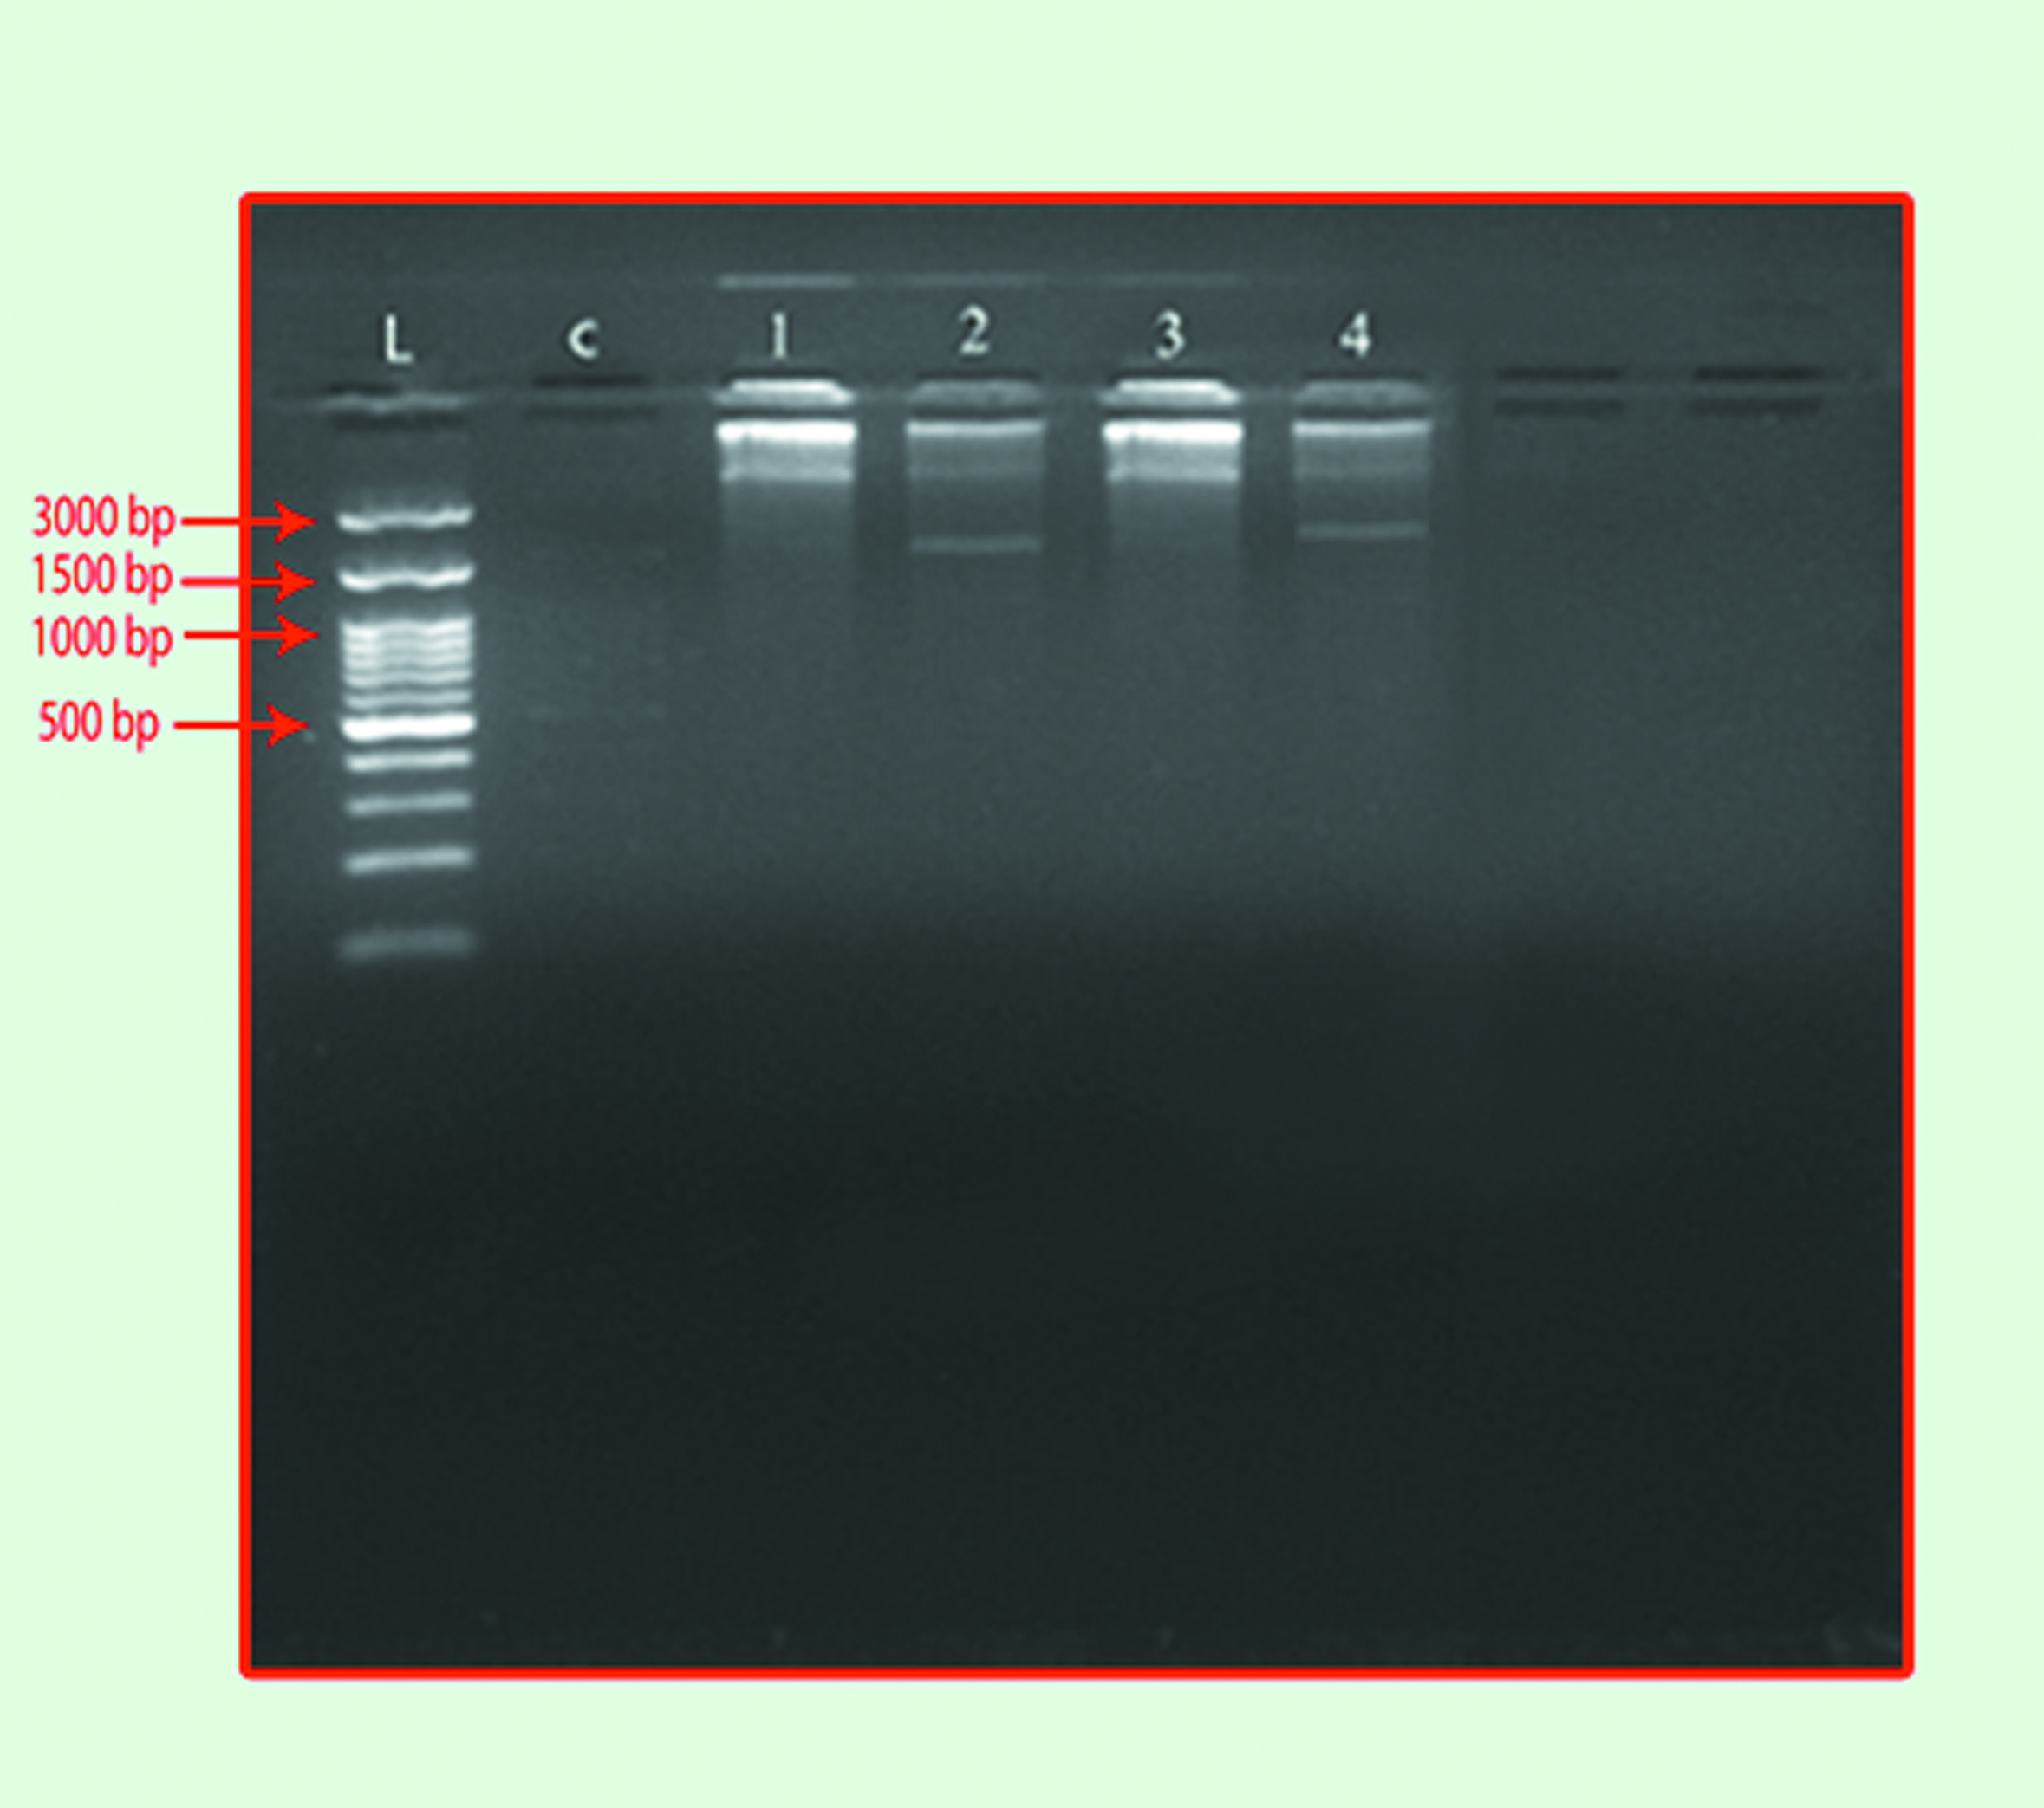

Figure 1 Gel electrophoresis of plasmid DNA content of B. cepacia isolates (1:30) hr. at (60) voltage.
Lane (L): DNA molecular size marker (3000-bp ladder).
Lane (C): negative control (E. coli standard strain MM294).
Lanes(1,2,3 and 4): show Burkholderia cepacia isolates (S1), (S2), (S3) and (S4).

