Genotyping and Detection of Some Virulence Genes of Klebsiella pneumonia Isolated from Clinical Cases

Mhammad S. Abdul Razzaq Jawad Kadhim Trad Esraa H. Ker-Alla Al-Maamory
College of Medicine University of Babylon, Hilla, Iraq.

M J B

Abstract
A total of 158 samples were collected from different clinical materials (urine ,sputum, wounds and burns swabs) during the period from January to June 2012, Only 46(29.1%) isolates were identified as Klebsiella pneumonia.
The molecular detecting of capsular polysaccharide gene (cps)was investigated by using PCR specific primer .It was found that only 43 isolates were positive for this marker ,whereas 3 isolates were negative to it.
Genotyping of these isolates was indicated also carried out by using K1,K2 specific PCR primers.
PCR technique was shown that 8 isolates were positive to K1 serotype , 14 isolates to K2 serotype, 3 isolates were positive for both K1 and K2 so they were designated as K1/K2 and 18 isolates were negative for both markers. The mag A gene was investigated, and it was found that 21 isolates were positive for mag A marker.

Also ,rmpA,rmpA1 and rmpA2 markers were investigates. rmpA is found in 21 isolates, whereas rmpA₁and rmpA2 were positive in 19 isolates .
التنميط الجيني والكشف الجزيئي لبعض عوامل الضراوة لبكتيريا Klebsiella pneumonia المعزولة من حالات سريريه
الخـلاصة
تم جمع (158)عينه اخذت من عينات سريريه مختلفه (الادرار,ومسحات الجروح,ومسحات الحروق,وعينات القشع, خلال الفتره من كانون الثاني 2012 الى حزيران .2012وخلال هذه الدراسه تم عزل وتشخيص( 46) عزله من بكتريا الكلبسيلا الرئويه Klebsiella pneumonia.
اظهرت نتائج الكشف الجزيئي لجين متعدد السكرايد باستخدام تقنيه سلسله التفاعل لانزيم البلمره (PCR) و بادى خاص لهذا الجين( ( CPSان 43 عزله موجبه لهذا الجين في حين كانت 3عزلات غير محتويه على هذا الجين.
وتم عمل التنميط الوراثي لهذه العزلات باستخدام بادى جيني لكل من النمط المصلي للكبسوله (K2,K 1 ) وقد اظهرت النتائج ان ( 8)عزلات موجبه للنمط المصلينK1 14,عزله موجبه للنمط المصلي k2 وثلاثه عزلات موجبه لكل من النمط المصلي (K1,K2)في حين ان ( 18)عزله كانت سالبه لكلا النمطين.
تم التحري عن جين الزوجه (magA)وقد اظهرت النتائج بان (21)عزله موجبه ,كما تمت دراسه الجينات المسؤوله عن تنظيم الزوجه والماده المخاطيه باستخدام ثلاثه انواع من الموشرات الوراثيه (rmpA ,rmpA1,rmpA2) وقد أظهرت النتائج بأن جين rmpA موجود في (21)في حين باقي الموشرات(rmpA1,rmpA2)موجودين في (19)عزله فقط.
ــــــــــــــــــــــــــــــــــــــــــــــــــــــــــــــــــــــــــــــــــــــــــــــــــــــــــــــــــــــــــــــــــــــــــــــــــــــــــــــــــــــــــــــــــــــــــــــــــــــــــــــــــــــــــــــــــــــــــــــــــــــــــــــــــــــــــــــــــــــــــــــــــــــــــــــــــــــــــــــــــــــــــــــــــــــــــــــــــــــــــــــــــــــــــــــــــــــــــــــــــــــــــــــــــــــــــــــــــــــــــــــــــــــــــــــــــــــــــــــــــــــــــــــــــــــــــــــــــــــــــــــــــــــــــــــــــــــــــــــــــــــــ

Introduction
An important nosocomial pathogen, causes a wide range of infections, including pneumonia, bacteremia, urinary tract infection, and life-threatening septic shock [1]. Clinically isolated K. pneumonia strains usually produce a large amount of capsular polysaccharide (cps), which confers not only a mucoid phenotype to the bacteria but also resistance to engulfment by professional phagocytes or to serum bactericidal factors [2] .Among at least 77 K serotypes distinguished, K. pneumonia strains belonging to serotypesK₁ and K₂, Animal studies have shown that K₁and K₂ isolates are more virulent than other serotypes [3].virulence gene magA (mucoviscosity associated gene) was identified in pathogenic strains from Taiwan causing liver abscess[4].magA is described as a novel virulencefactor responsible for the increased virulence of certain K. pneumonia strains [5,6]. On the other hand rmpA plays a minor role in virulence compared with the presence of serotype K₁ or K[(7]
However, K. pneumonia is still considered as weak pathogen according to the virulence factors because some strains have no complete virulence genes [3].
Aim of study:
Genetic study of genes responsible for capsular polysaccharides such as, K₁, K₂, K₁/K₂, non K₁/K₂(mag A ,rmpA,rmpA₁,rmpA₂) by using molecular methods (PCR).
Patients:
A total of 158 clinical sample were collected from patients admitted to the main two hospitals in Hilla city/Babylon province (Teaching Hospital of Hilla and Teaching Merjan Hospital) the period of collecting extendied from January ,2012 to June,2012.
DNA extraction:
DNA was extracted by using a Promega DNA purification kit and in accordance with the manufacturer's protocols.
Polymerase chain reaction (PCR):
Polymerase Chain Reaction(PCR) were performed in a total volume of 25 μl containing 2.5 μl of both the forward and the reverse of the primer, 12.5 μl master mix, 2.5 μl free water nuclease and 5 μl of the extracted DNA (as DNA template), then DNA amplification was carried out with the thermal cycler.
primers: the primers used in this study are indecated in Table (1).

Table 1 the primers used in the present study

Markers | Oligonucleotide Sequences 5'- 3' | Size of amplicon | Thermal cycler conditions
cps- F  cps- R | GTCGGTAGCTGTTAAGCCAGGGGCGGTAGCG  TATTCATCAGAAGCACGCAGCTGGGAGAAGCC | 418 | 95ºC for 4 min  94ºC for 30sec  59ºC for 30sec 30 cycles  72ºC for 30sec  72ºC for 5min
MagA- F  MagA –R | TAGGACCGTTAATTTGCTTTGT  GAATATTCCCACTCCCTCTCC | 1282 | 95ºC for 4 min  94ºC for 30sec  57ºC for 30sec 30 cycles  72ºC for 30sec  72ºC for 5min
K₁ –F  K₁-R | GTAGGTATTGCAAGCCATGC  GCCCAGGTTAATGAATCCGT | 1283 | 95ºC for 4 min  94ºC for 30sec  57ºC for 30sec 30 cycles  72ºC for 30sec  72ºC for 5min
K₂ -F  K₂ -R | GGAGCCATTTGAATTCGGTG  TCCCTAGCACTGGCTTAAGT | 646 | 94ºC for 3min  94ºC for 2min  65ºC for 1min 28 cycles  72ºC for1min  72ºC for7min
rmpA - F  rmp A –R | GCAGTTAACTGGACTACCTCTG  GTTTACAATTCGGCTAACATTTTTCTTTAAG | 553 | 95ºC for 2.5 min  94ºC for30sec  55ºC for 1min 30 cycles  72ºC for30sec  72ºC for7min
rmpA₁-F  rmpA₁-R | CTGTGTCCACATTGGTGGG  GATAGTTCACCTCCTCCTCC | 448 | 95ºC for 2.5 min  94ºC for30sec  55ºC for 1min 30 cycles  72ºC for30sec  72ºC for7min
rmpA₂-F  rmpA₂-R | 5-TGGCAGCAGGCAATATTGTC-3  5-GAAAGAGTGCTTTCACCCCCT-3 | 496 | 94ºC for 3min  94ºC for 2min  65ºC for 1min 28 cycles  72ºC for1min  72ºC for7min

Preparation of 1% agarose gel:
After the complication of electrophoresis is complete, the molecules in the gel can be visible by UV-transilluminator. Ethidium bromide, in the analyte molecules fluoresce under ultraviolet light, a photograph can be taken of the gel under ultraviolet lighting conditions.

Results and Discussions
Identification of Klebsiella pneumonia:
A total of 158 clinical samples were collected from different infections, only 46 isolates (29.1%) of Klebsiella pneumoniae were identified according to morphological characterization and biochemical tests of which 43 isolates were confirmed by detection of cps gene.
Detection of Cps gene in K.pneumoniae by PCR:
Capsular polysaccharide gene (cps)was investigated through specific primer for 46 isolates that identified by biochemical test .It was found that 43 isolates of Klebsiella pneumonia gave positive results for this gene whereas 3 isolates gave negative results, this will confirm that these three isolates may be not belonging to Klebsiella pneumonia for that they are excluded from other experiments.
In fact, the presence of cps genes are correlated with the presence of capsule in K. pneumoniae, and the overproduction of mucoid phenotypes may correlate with the presence of rcs genes which are chromosomally located and rmpA genes which are mostly plasmid encoded gene cps may have a large role in resistance of action of phagocytosis and serum resistance. This result is in agreement with the result of [8)] who stated that cps genes are available in most K. pneumonia isolates. Also, [9] found that cps of K. pneumonia is mostly responsible for serotype K. pneumonia capsular polysaccharide.
Besides, [10] found that cps of K. pneumonia is mostly responsible for serotype K. pneumonia capsular polysaccharide, cps is considered as the major determent for K. pneumonia infections that could protect the bacteria from phagocytosis and killing by serum factors ,Also cps help the bacteria to colonize the tissues and Biofilm formation [11].

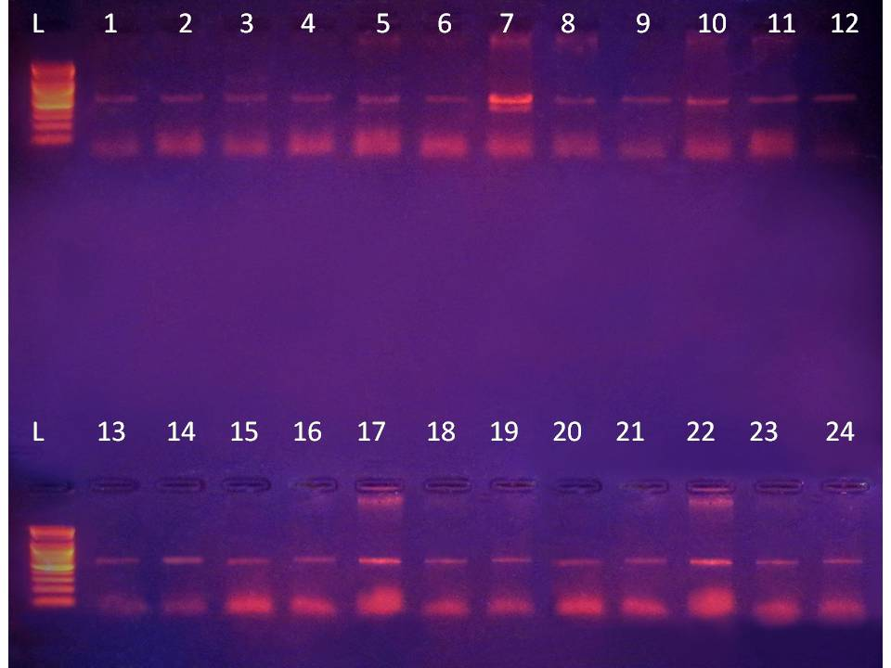
418
418
Figure 1 Agarose gel electrophoresis of PCR for detecting of Capsular polysaccharide (cps) gene amplicon product in Klebsiella pneumoniae. Lane 1-12 refer to isolates' number .L Allelic ladder

The presence of cps in most isolated bacteria means that all these isolates may contain the genes of cps biosynthesis ( rcs A and rcs B ) as mentioned by[ 13].
However, the presence of cps reduces the binding of antimicrobial peptides to bacterial surface and this will promote the bacterial resistance to antibiotics [14].
Genotyping of K. pneumonia isolates PCR primers of K₁ and K₂ antigens were used for Genotyping of K. pneumonia into K₁ group, K₂ group, K₁ /K₂ group and non K₁/K₂ group. It was found that only [8]isolates gave positive PCR products for K_{1,} [14] isolates gave positive with K₂, [3] isolates with K₁/K₂, and the rest (non K₁/K₂) was 18 isolates, It was seen that the prevalence of K₂ isolates were higher than K1 isolates.
However ,25 isolates gave positive for K₁ and K₂ antigen which ensure that isolates are highly virulent than other as mentioned by [15].So, Klebsiella isolates were distributed according to their serotypes int[13] who showed that K₁ and K₂ isolates more virulent than other serotypes. K₁ and K₂ isolates were found to be significantly more resistant to phagocytosis than non K₁ / K₂ isolates. However This results is disagreement with [14] who found that K₁ serotype is striking that general prevalence of the K₁ serotype is significantly higher.
This result unlike [15] who found that K₁ most common serotype found in community acquired and nosocomial K. pneumonia.
On the other hand ,[21] isolates where classed as non K₁/K₂ these isolates may be belonging to other serotypes such as K₅, K1₄ , K₂₀ [14].

Table2 distribution of Klebsiella pneumonia genotyping.

Klebsiella pneumonia (43)genotyping isolates

nonK₁/K₂
(18)

K₁/K₂
(3)

K

K₁
(8)

K₂
(14)

However, all K. Pneumonia isolates reveal mucoid phenotype regardless of genotype polysaccharide (cps) is very important tool identifying and in genotyping of these bacteria indicates that genotype strongly associated with high invasive disease. Where large numbers of cases have been reported in geographically very wide spread [(15].
Genotyping of K. Pneumonia is very important tool to know the prevalence of bacteria, genotypes particularly K1 and K₂ which are common in our province. However non K₁ /K₂ could not be classified into other K antigen groups rather them K₁ or K₂.
Serologically, K. pneumonia belonging to serotypes K₁ and K₂ which are the most common types that are highly virulent [ 16]
According to the results obtained by this study, only [22] isolates were found to be positive for K₁ or K₂ or K₁/K₂ that give an indicator that these isolates are highly virulent than the other [13].
Also, Regarding to this study, K₂ was found to be more prevalent than K_{1.}this is in agreement with [17] who have indicated that K₂ was more predominant in human infections but is very rarely identified in the natural environment.
In addition to that, three isolates were found to have K_{1,} and K₂ and these isolates are considered as h[18] and the presence of both antigen may be due to gene transfer mechanisms [12]
Furthermore, no specific pattern for differentiation of K. pneumoniaeK₁ or K₂ isolates from urinary tract infection or from respirator aspirates could be detected pyogenic UTI or RTI caused by K. pneumonia with distant metastasis to UT, RT may be due to virulent capsule or host factors which could not be found in this study. Further analysis of the cps gene and host factors may provide due to understanding the pathogenesis of K. pneumonia UTI , RTI [16].

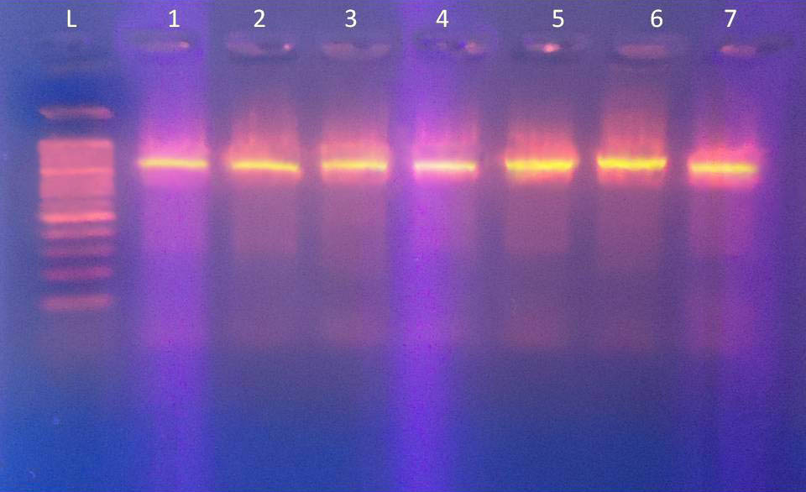
1283
Figure 2 A garose gel electrophoresis of PCR products for detection of K1 gene amplicon product in Klebsiella pneumonia lane 1-7 refer to isolates' number..L Allelic ladder

To differentiate between UTI, RTI ,burns ,wounds capsular of K. pneumonia serotypes K₁, K₂ and non K₁/K₂ to compare phagocytic rate between them ,there are no significant difference of phagocytic of non K₁/K₂ was absorbed in all sample but in K₁ ,K₂ there are significant phagocytic in all sample isolated for K. pneumonia [5]
Many studies have shown that K. pneumonia isolates belong to serotypes K₁ and K₂ are the most virulent [5] ,[17] .
However, the predominance of serotypes of K₁ and K₂ in pyogenic suggests that those serotypes have more invasive capsular antigen.

Figure 3 A garose gel electrophoresis of PCR products fo detection of K2 gene amplicon product in Klebsiella pneumonia ,lane 1-7 refer to isolates' number. Allelic ladder
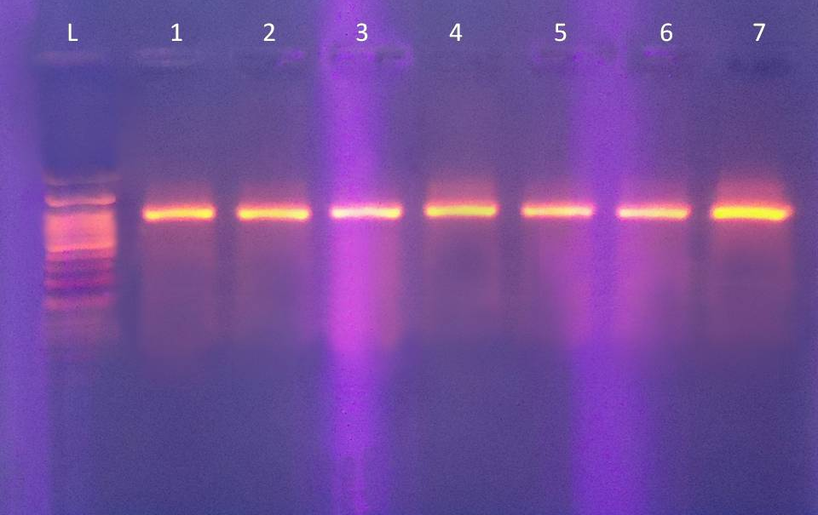
646

This result is in agreement with [7] who showed that has been demonstrated that strain with capsule such as (K₁, K₂) were virulent to human. whereas serotypes without capsule are less virulent or without virulent.
Molecular detection of magA gene (mucoviscosity associated gene A):
A total of 43 isolates of K .pneumonia , the molecular detection for magA gene by PCR was also investigated, it was found that only(21) isolates were positive for this gene where 16 positive found among K₁ serotypes results 4 in non K₁/K₂ isolates and only one in K₂ serotypes,
through using specific primer .
Although this gene is high important for Klebsiella pneumonia which confirm the bacteria mucoid viscosity ,but is prevalence and among Klebsiella pneumonia local isolates is not high .this means that there are other means play a role in formation the mucoid viscosity.

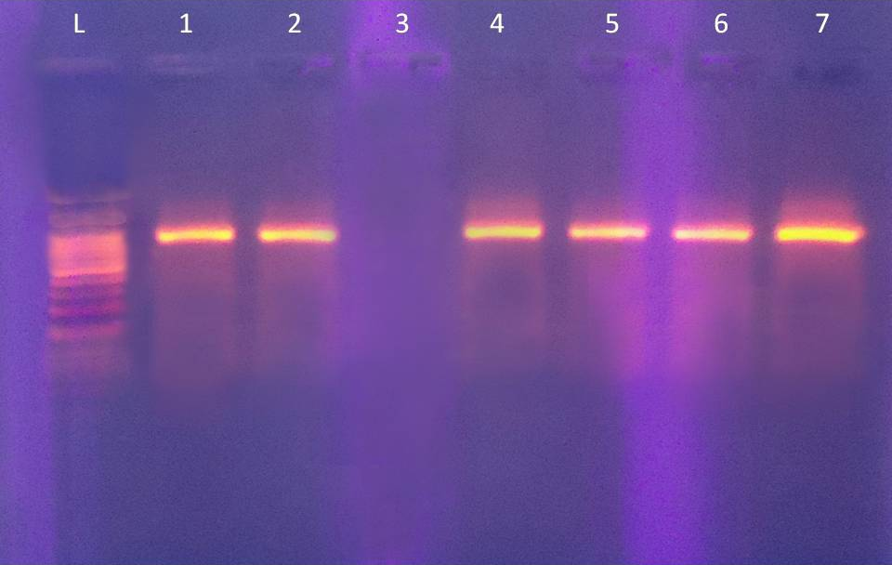
1282
Figure 4 A garose gel electrophoresis of PCR products fo detection of (Mag A) gene amplicon product in Klebsiella pneumonia lane 1-7 refer to isolates' number..L Allelic ladder

Also , (3) found that magA gene was not prevalent in K₂ serotype but high prevalent in K₁ that may be attributed that mag A is located in cps gene cluster K₁ of Klebsiella pneumonia and it is restricted to serotype K₁ isolates .

Table 3 Distribution of mag A according to the serotypes :
Serotypes | mag A
K1 | 16
K₂ | 1
Non (K1 / K₂) | 4
Total | 21

Molecular detection of rmpA marker in Klebsiella isolates :
rmpA, rmpA₁and rmpA₂ were detected by using PCR markers, It was found that rmpA gave the present in (21) isolates and absent in (22) isolates, also rmpA₁ was found to be available in 19 isolates and absent in 24 isolates, and the results were the same for rmpA₂ where 19 isolates were positive, for this gene and 24 were negative for it.
rmpA gene encodes for the regulation of mucoid phenotype which may be located on bacteria chromosome or on plasmid and so the of absence a such genes may be related where these genes are located in Klebsiella genome( 19).
According to serotypes it was found that rmpA₁ and rmpA₂ was prevalent more in K₂ than and also in non K₁/K₂ isolates this will enhance the severity of Klebsiella pneumoniae isolates are shown in table (3-5) .

Table 4 Distribution of rmpA , rmpA₁ and rmpA₂ according to the serotypes:
K. pneumoniae | rmpA | rmpA₁ | rmpA₂
K1 | 1 | 2 | 1
K₂ | 16 | 12 | 13
Non (K1 / K₂) | 4 | 5 | 5
Total | 21 | 19 | 19

Also, The multi-copy plasmid carrying rmpA restored cps production in the rmpA1 or rmpA₂ mutant but not in the rcsB mutant. Transformation of rmpA detection mutant with an rcsB carrying plasmid also failed to enhance cps production suggesting that a cooperation of rmpA with an rcs gene is required for regulatory activity. This was further corporated by the demonstration of interaction between rmpA and rcsB using two hybrid analysis. The express of rmpA is regulated by the availability of iron and is negatively controlled by [20].

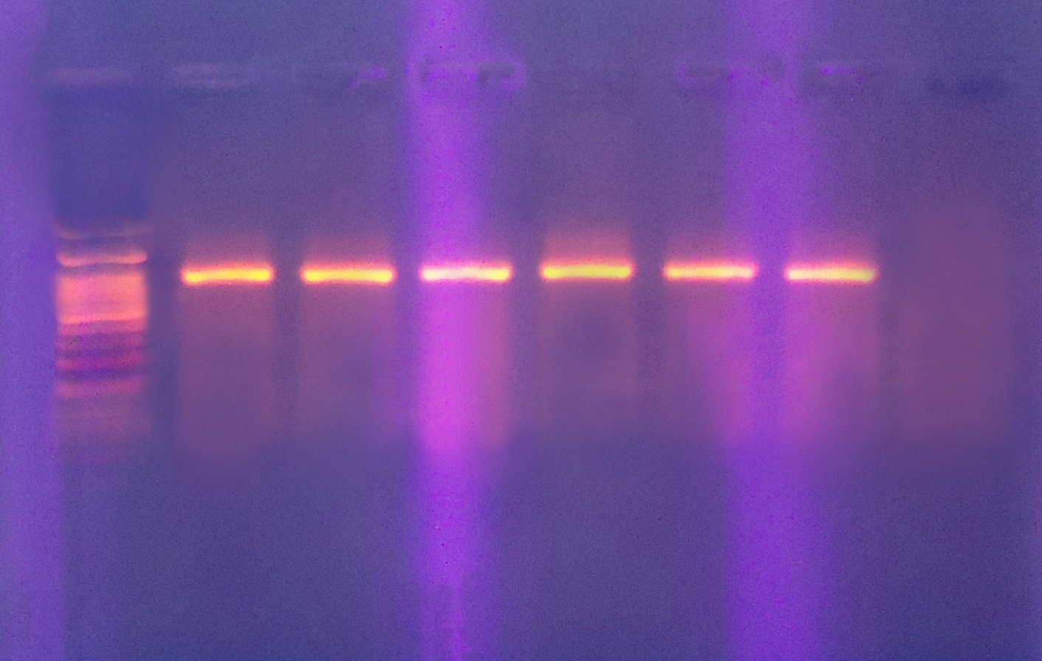
553
Figure 5 A garose gel electrophoresis of PCR products fo detection of (rmp A ) gene amplicon product in Klebsiella pneumoniae, lane 1-7 refer to isolates' number. LAllelic ladder

However The deletion of rmpA₁ reduced capsular polysaccharide (cps) biosynthesis result decreased colony mucoid and virulence.

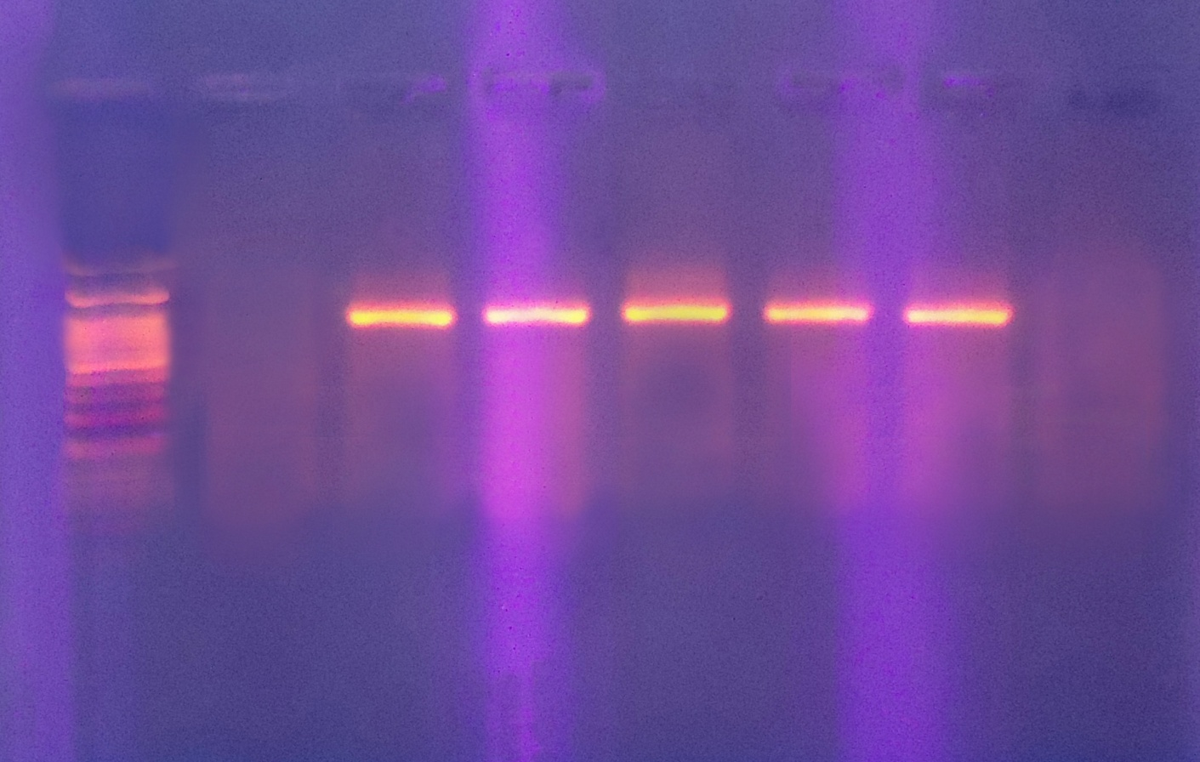
448
Figure 6 A garose gel electrophoresis of PCR products fo detection of (Rmp A1) gene amplicon product in Klebsiella pneumonia lane 1-7 refer to isolates' number..L Allelic ladder
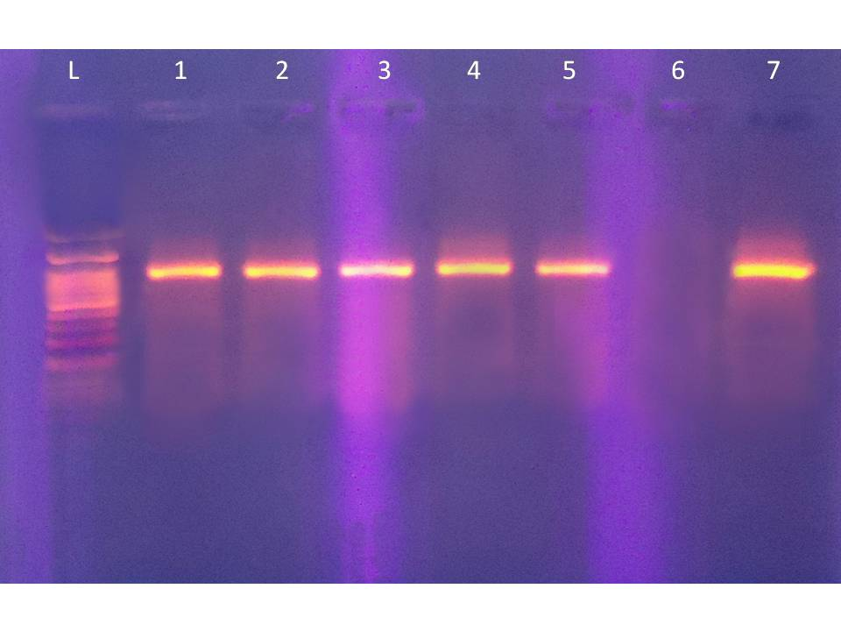
496 pb
Figure 7 Agarose gel electrophoresis of PCR products for detection of (rmp A2 ) gene amplicon product in Klebsiella pneumonia lane 1-7 refer to isolates' number..L Allelic ladder

Although, previous study on rmpA were restricted to serotype K₂ strain. This study showed that rmpA also exists in serotype, other than K₂.
Besides, among rmpA positive isolates, the K₁ or K₂ group has more significant phagocytosis resistance rate and high lethality than the non K₁/K₂ group.
This difference may be related to a higher prevalence of virulent serotypes in certain regions. Rapid detection of the virulent K₁serotype will be most helpful in diagnosis and treatment to decrease the risk of severe metastatic infections, aswell as inepidemiological studies. Traditional sera-typing is cumbersome and requires access to high quality antisera. Our results show that magA is restricted to isolates of the K₁ serotype. We therefore suggest detection of magA by hybridization or PCR analysis as an easy, fast and highly specific diagnostic method for identification of the K. pneumonia K₁ capsule serotype. Klebsiella pneumonia usually causes urinary tract infections, pneumonia, and other infections in hospitalized persons whose immunity is compromised by underlying diseases.

References
1. Alves, M. S; Dias, R. C. D. S; DeCastro A. C. D; Riely, L. W. and Moreira, B. M. (2006). Identification of clinical isolates of indole-positive and indole negative Klebsiella spp. J. Clin. Microbiol. 44: 3640-3646.
2. Bach, S ; De Almeida A. and Carniel, E. (2000). The Yersinia high-pathogenicity island is present in different members of the family Enterobacteriaceae. FEMS Microbiol. Lett. 1:83-28-35.
3.Fang, C. T; Y. P. Chuang, C. T. Shun, S. C. Chang, and J. T. Wang. (2004). A novel virulence gene in Klebsiella pneumoniae strains causing primary liver abscess and septic metastatic complications. J. Exp. Med. 199:697–705.
4.Rahn, A; Drummelsmith, J. & Whitfield, C. (1999). Conserved organization in the cps gene clusters for expression of Escherichia coli group(1) K antigens: relationship to the colanic acid biosynthesis locusand the cps genes from Klebsiella pneumoniae. Bacteriol 181: 2307–231.
5.Jazani ,N. H; Ghasemnejad- Berenji, H. and Sadegpoor, S. (2009). Antibacterial effects of Iranian Menthapulegium essential oil on isolates of Klebsiella sp. Pakistan. Journal of Biological Sciences. 12(2):183-185.
6.Pan, Y. J; Fang, H. C; Yang, H. C; Lin, T. L; Hsieh, P. F; Tsai, F. C; Keynan, Y. & Wang, J. T. (2008). Capsular polysaccharide synthesis regions in Klebsiella pneumoniae serotype K57 and a new capsular serotype. J. Clinical Microbiology. 46: 7-9
7.Rozalski, A. (2007). Potential virulence factors of Klebsiella pnemouniae bacilli Microbiol. Mol. Biol. 61:65-89.
8.DebRoy, C; Fratamico, P. M; Roberts, E; Davis, M. A. & Liu, Y. (2005). Development of PCR assays targeting genes in O-antigen gene clusters for detection and identification of Escherichia coli O45 and O55 serogroups. Appl. Environ Microbiol. 71:4919–4924.
9.Lin ,C.T; Chien, C. W; Yu, S. C; Yi, C. L; Chia, C; Jing, C.L; Yeh, C; Hwei, L. P.(2011). Fur regulation on the capsular polysaccharide biosynthesis andiron-acquisition systems in Klebsiellapneumoniae CG43. Microbiology (Reading, England). 157(Pt 2): 419-429.
10.Lodish, H; Matsudaira, A; Kaiser, C. and Darnell, J. (2003). Molecular cell biology. 5th ed. W. H. Freeman and Company. New York.
11. Lodish, H; Berk, A and Matsudaira, P. (2004). Molecular Cell Biology (5th ed.). W. H. Freeman: New York, PP:978-980.

12.Chen ,Y. T; Tsai, L. L; Keh, M. W; Tsai, L. L; Jing, J. Y; Min, C. L; Yi, C. L; Yen, M. L; Hung, Y. S; Jin, T. W; Ih, J. S; Shih, F. T.(2009). Genomic diversity of citrate fermentation in Klebsiella pneumoniae. BMC Microbiology, 9:168-173.
13.Mizuta, K; Ohta, M; Mori, M; Hasegama, T; Nakashima, I. and N. Kato. (1983).Virulence for mice of Klebsiella strains belonging to the O1 group: relation to their capsule (K) types. Infect. Immun. 40: 56-61.
14.Kyong, R. P; Jae, H. S.(2008). Evidence for Clonal Dissemination of the Serotype K1 Klebsiella pneumonia Strain Causing Invasive Liver Abscesses in Korea. J. Clinic. Microbiol.37: 4061–4063.
15. Turton, J. F; Hatice, B; Siu, L. K; Mary, E. K. Tyrone, L. P. (2008). Evaluation of multiplex PCR for detection of serotypesK₁, K₂ and K₅ in Klebsiellaspp. and comparison of isolates within these serotypes. FemsMicrobiolLett 284, 247–252.

16.Hansen, D. S; R. Skov, J. V. Benedi, V. Sperling, and H. J. Kolmos. (2002). Klebsiella typing: pulsed-field gel electrophoresis (PFGE) in comparison with O:K-serotyping. Clin. Microbiol. Infect. 8:397–404.
17.Whitfield, C. and Roberts, I.S. (1999). assembly and regulation of expression of capsules in Escherichia coli. Mol. Microbiol. 31:1307–3019.
18. Karach, H; Russmann, H; Schmidt, H; Schworzkopf, A. and Hessmann, J. (1995). Lang term sheding and clonal turnover of EHEC0157 indiarrheal disease. J. Clin. Microbiol. 33:1602 – 1604.
19.Brisse, S; S. Issenhuth-Jeanjean, and P. A. Grimont. (2004). Molecular serotyping of Klebsiella species isolates by restriction of the amplified capsular antigen gene cluster. J. Clin. Microbiol. 2: 3388–3398.
20.Brisse, S. and Duijkeren, E. (2005). Identification and antimicrobial susceptibility of 100 Klebsiella animal clinical isolates. Vet. Microbiol. 105: 307-312.

