Association of Toll-Like Receptor 4 Gene Oolymorphism with Trichomonas vaginalis Infection in Iraqi Women
Fatima Abood Chaloob¹ Ausama Saadi Abdul-Mohsen²
¹ Dept. of Nursing Technical Institute of Al-Dewanyia-Iraq,
² Dept. of Urology, Al-Nahrain University, College of Medicine, Baghdad, Iraq.



Received 9 September 2013 Accepted 20 November 2013
Abstract
Background: Trichomonas vaginalis is a world-wide sexually transmitted protozoan, which induces inflammatory response by stimulating toll-like receptor 4 (TLR4).
Objective: This study aimed to investigate the association of TLR4 polymorphism with the incidence of T. vaginalis infection among Iraqi women.
Subjects and methods: Blood samples were obtained from 139 married women (87 infected with T.vaginalis, and 52 healthy controls). DNA was extracted, and TLR4 gene was amplified using specific primers. Restriction fragment length polymorphism technique was used for genotyping. Two single nucleotide polymorphisms (SNPs) (Asp299Gly and Thr399Ile) were investigated in their relation with T. vaginalis infection.
Results: There is insignificant association between both Asp299Gly and Thr399Ile with T. vaginalis infection (OR=2.647, 95%CI= 0.718-9.835, p= 0.163 and OR== 1.558, 95%CI= 0.463-5.238, p=0.494 respectively).
Conclusion: The SNPs Asp299Gly and Thr399Ile may not be considered as a risk factor that increases susceptibility to T. vaginalis infection.
Key words: Trichomonas vaginalis, Toll-like receptor 4, polymorphism, Asp299Gly, Thr399Ile.
العلاقة بين تعدد الاشكال الجينية لجين Toll-like receptor 4 مع الاصابة بطفيلي المشعرات المهبلية في النساء العراقيات
الخلاصة
خلفية الدراسة: طفيلي المشعرات المهبلية هو احد الاوليات الواسعة الانتشار التي تنتقل عن طريق الاتصال الجنسي. يسبب هذا الطفيلي استجابة التهابية من خلال تحفيز مستقبلات Toll-like receptor 4.
هدف الدراسة: استهدفت هذه الدراسة تقيييم العلاقة بين تعدد الاشكال الجينية لجين TLR 4 مع نسبة حدوث الاصابة بطفيلي المشعرات المهبلية لدى النساء العراقيات.
المواد وطرائق العمل: جمعت عينات دم من 139 امرأة متزوجة ( 87منهن مصابة بالمشعرات المهبلية ، و 52 نساء سليمات). تم استخلاص الحامض النووي الديوكسي رايبوزي DNA ومضاعفة جين TLR4 باستخدام بادئات صممت لهذا الغرض. استخدمت طريقة القطع الانزيمي في تحديد التركيب الجيني، ودرست العلاقة بين طفرتان نقطيتان هما Asp299Gly و Thr399Ile من حيث علاقتهما بالاصابة بالمشعرات المهبلية.
النتائج: أظهرت النتائج علاقة غير معنوية بين كل من طفرتي Asp299Gly و Thr399Ile ومدى انتشار الاصابة بطفيلي المشعرات المهبلية ، اذ بلغت نسبة الارجحية 2.647 ﺒ %95 فترة ثقة =9.835-0.718 (p=0.163) ونسبة ارجحبة 1.558 ﺒ%95 فترة ثقة =5.238-0.463 (p=0.494) على التوالي.
الاستنتاجات: قد لاتعد الطفرتان النقطيتان Asp299Gly و Thr399Ile أحد عوامل الخطورة التي تزيد من امكانية الاصابة بطفيلي المشعرات المهبلية.
الكلمات المفتاحية: المشعرات المهبلية ، مستقبلات Toll-like receptor4، تعدد الاشكال الجينية ، Asp299Gly و Thr399Ile.
ــــــــــــــــــــــــــــــــــــــــــــــــــــــــــــــــــــــــــــــــــــــــــــــــــــــــــــــــــــــــــــــــــــــــــــــــــــــــــــــــــــــــــــــــــــــــــــــــــــــــــــــــــــــــــــــــــــــــــــــــــــــــــــــــــــــــــــــــــــــــــــــــــــــــــــــــــــــــــــــــــــــــــــــــــــــــــــــــــــــــــــــــــــــــــــــــــــــــــــــــــــــــــــــــــــــــــــــــــــــــــــــــــــــــــــــــــــــــــــــــــــــــــــــــــــــــــــــــــــــــــــــــــــــــــــــــــــــــــــــــــــــــــــــــــــــ

Introduction
Trichomonas vaginalis is a sexually transmitted parasitic protozoan known to be responsible for an estimated 180 million new infections per year, making it the most prevalent non-viral sexually transmitted pathogen world-wide [1]. Infection of women with this parasite can lead to vaginitis with burning, itching, discharge, infiltration of leukocyte and inflammation of the vaginal epithelium [2-3].
The innate immune system is involved in the recognition of conserved pathogen associated with molecular patterns present on the pathogen [4]. This recognition is facilitated by a group of receptors called toll-like receptors (TLRs), which results in the synthesis and release of pro-inflammatory cytokines, and thereby augment the local inflammatory response [5].
An important member of the TLRs is toll-like receptor 4 (TLR4), a transmembranous receptor that recognizes a range of ligands including lipopolysacchrides (LPS) of gram negative bacteria and some heat shock proteins [6]. Zariffard et al. [7] showed that T. vaginalis infection in women is associated with the presence in the genital tract of substance, or substances that interact with TLR4, which indicates that this protozoan stimulates the inflammatory response via this type of TLRs.
Two single nucleotide polymorphisms in TLR4 gene; Asp299Gly and Thr399Ile have been shown to cause hyporesponsiveness to LPS, reduced epithelial TLR4 density, and reduced inflammatory cytokines response [8].
This study aimed to investigate the association of these two SNPs with the incidence of T. vaginalis infection in Iraqi women.

Subject and Methods
Vaginal swabs were taken from 120 married women who attended the department of gynecology in AL-Kadhumyia Teaching Hospital/Baghdad during the period from September 2012 to April 2013.These women were suffering from vaginal discharge and itching. Wet smears were prepared from each swab and examined microscopically for the trophozoite of T. vaginalis. From the 120 examined women, 87 gave positive results for T. vaginalis. Their age range from 21 to 32 years (mean=27±1.26), and they represent patients group. Vaginals swabs also taken from other 60 women who attended pregnancy care unit in the same hospital. These women did not suffer from any symptoms related to vaginitis. Wet mount was prepared from each swab and examined microscopically for T. vaginalis trophozoite. None of the examined smear gave positive result. However, eight women were excluded from the study because they mentioned that they had previously suffered from vaginitis, though it was not confirmed as trichomonosis. Evantually 52 (23-37 years old, mean 29±2.1) women represent the control group.
Blood samples
Five milliliters of venous blood was taken from each participant in EDTA tubes which were kept at -20 until be used for DNA extraction.
DNA extraction and genotyping of TLR4 gene
DNA was extracted from blood samples using ready kit (gSYNCTM DNA Mini Kit Whole Blood Protocol/ Geneaid/ Korea) according to the manufacturer's instructions. The primers used for amplification of TLR4 gene (Bioneer/Korea) are shown in table 1.
Template DNA (10 µL) from each sample and primers (5 µL from each) was added to each master-mix tube (50 µL PCR master-mix, Bioneer/Korea). The mixture then put in shaker and spinner for 10 cycles for better mixing. After mixing, the master-mix tubes were transferred to the thermocycler (MyGenie 32 thermal block/Bioneer/Korea) which is previously programmed with certain protocol according to gene to be amplified.
For Asp299gly gene , cycling conditions were an initial denaturation for 5 min at 95 ºC, followed by 28 cycles of denaturation at 95 ºC for 40 sec , annealing at 58 ºC for 30 sec, extension at 72 ºC for 50 sec, followed by final extension at 72 ºC for 10 min. For Thr399Ile gene, cycling conditions were an initial denaturation for 5 min at 95 ºC, followed by 28 cycles of denaturation at 95 ºC for 40 sec , annealing at 62 ºC for 40 sec, extension at 72 ºC for 50 sec, followed by final extension at 72 ºC for 10 min.
Restriction Fragment length polymorphism
One μg amount DNA from Asp299Gly and Thr399Ile PCR products was mixed with a 5μl 10X NEB buffer (50mM NaCl, 10mM Tris-HCl, 10mM MgCl₂, 1mM dithiothreitol, pH 7.9), and 1μl of Nco I and Mfe1 (10U) restriction enzyme ((New England Biolabs Inc./USA) was added respectively. The reaction was adjusted to 50μl using sterile deionized H₂O. The solution was mixed by flicking, followed by spinning in microcentrifuge at 5000 rpm for 30 sec, and then incubated at 37 ºC for 60 min.
Agrose gel electrophoresis
Gel was prepared by dissolving 2 gm of agarose (Biobasic/Canada) in 100 mL of 1x Tris Borate EDTA (TBE) (Biobasic/Canada. Ten µL aliquot of PCR product was mixed with 2 µL loading dye and loaded into the wells. Power supply was adjusted into 100 volt and run for 1 hour. The gel then was stained with ethidium bromide (Biobasic/Canada) (0.5 μg/mL) for 20 min and examined using U. V. transilluminator with camera. The amplified products were determined by comparison with a commercial 1000 bp ladder (Kappa Biosystem/USA).
Statistical analysis
The Statistical Package for the Social sciences (SPSS, version 14.0) was used for statistical analysis. Risk association between the genotype and PCa susceptibility was estimated by the calculation of odds ratio and 95% confidence intervals. Genotype and allele frequency differences between the groups, and deviation of genotype distribution from Hardy-Weinberg equilibrium were tested using Chi-square test with one degree of freedom. A p-value < 0.05was considered statistically significant.

Results
Asp299Gly PCR-RFLP
Figure (1) shows the result of digestion of TLR4 gene Asp299Gly PCR products with NcoI enzyme. This enzyme identifies the sequence CCATGG [9]. For the homozygous wild genotype (AA), a single band (249 bp) appeared, as there was no cutting. For homozygous mutant genotype (GG), the enzyme identified the mutant, and the PCR product will appear as a double band of (223 bp and 26 bp). Finally, the heterozygous genotype (GA) appears as three bands (249, 223, and 26 bp). However, the small band (26 bp) was not visible on the gel because of its small size, but we can deduce the result from the absence of 249 bp band in the homozygous mutant genotype, and the presence of 223 bp band in the heterozygous genotype.
The prevalence of AA, AG, and GG genotypes among women infected with T. vaginalis was 85.05%, 13.79%, and 1.15% respectively, compared to 94.23%, 5.77% and 0% respectively in control group with no significant difference (OR= 2.647, 95%CI= 0.718-9.835, p= 0.163)(table 2). Of note, there was only one woman among patients group who carries homozygous mutant genotype (GG), and none among control carries this genotype. Similarly, chi-square test for alleles distribution of this SNP revealed insignificant difference between patient and control group; the frequency of A and G alleles among patients was 91.95% and 8.05 respectively, compared to 97.12% and 2.82% respectively in control group (OR= 2.734, 95% CI= 0.803-9.3, p=0.123) (Table 1).
Thr299Ile PCR-RFLP
The result of digestion of TLR4 gene Asp299Gly PCR products with NcoI enzyme is shown in figure 2. This enzyme identifies the sequence GANTC [9], and accordingly, it cuts PCR product of homozygous mutant genotype (TT) into two bands (377 and 29 bp), while heterozygous genotype (CT) is cut into three bands (406, 377, and 29 bp), whereas, homozygous wild genotype is not affected (the band size is 406 bp).
Although the frequency of heterozygous genotype (CT) is higher in patients group (11.49%) than control (7.69%), the difference is insignificant (OR= 1.558, 95%CI= 0.463-5.238, p=0.494). Furthermore, there is no TT genotype neither among patients nor among control. Parallel to aforementioned results, C and T allele frequencies among patients (94.25% and 5.75% respectively) did not differ significantly from that of control (96,15% and 3,85% respectively) (OR= 1.522, 95%CI=0.465-4.982, p=0.494). Chi-square test revealed that alleles' distribution in both SNPs is within Hardy-Weinberg equilibrium.

Discussion
Toll- like receptors have been discovered as the most important class of pattern recognition receptors, involved in the host defense against bacteria, viruses, fungi, and protozoa [10].
Historically, these two SNPs seem to have originated in Africa in an environment where malaria represented a major evolutionary pressure, first the SNP Asp299Gly and later on the SNP Thr399Ile [11]. In Plasmodium-infested environment, the SNP Asp299Gly induced protection against malaria associated mortality, but individuals carrying this SNP who migrated to Europe became more susceptible to septic shock, especially during plague, typhoid fever, and influenza outbreak [12]. Hence, it seems there will be some necessity for the correction of the situation especially there was no malaria in this new environment. Therefore, the addition of Thr399Ile mutant allele reduced the risk of septic shock [13]. Therefore, it is reasonable to assume that these SNPs may associate with the incidence of T. vaginalis infection, since the two microorganisms (Plasmodium and Trichomonas) are protozoan, despite that the former is blood parasite, and the latter infects the genito-urinary tract. However, this study didn't revealed the hypothesized association, may be because the relative small size of the sample.
Chen et al. [14] found a positive effect of SNP Asp299Ile on the association between T. vaginalis infection and risk of prostate cancer. They suggested that this variant renders the innate immunity of its carrier less effective against T. vaginalis infection which results in prolonged infection. However, these workers enrolled relatively large numbers of subjects in their study (700 patients and 700 controls), which makes their results more confident.
Although the positive result of microscopic examination confirmed the infection with T. vaginalis, the presence of other causative agents of vaginitis (bacterial, viral, and fungal), wasn't ruled out. Many microorganisms of these types are prevalent among Iraqi women patients. Nevertheless, the presence of T. vaginalis in the genitor-urinary tract even with the other microorganisms does not abolish pathological effects of this protozoan. Therefore, studies like ours may assist to illustrate the effect of innate immune response to T. vaginalis infection.
It is worth mention that the homozygous variant genotypes of both SNPs are very rare among Iraqi women, which may indicate the few African origin people among Iraqi population, since the SNP Asp299Gly is supposed to be originated in Africa, and letter followed by Thr399Ile in Europe [11].

References
1- Eshete, A.; Mekonnen, Z. and Zeynudin, A. (2013). Trichomonas vaginalis infection among pregnant women in Jimma University Specialized hospital, South-west Ethiopia. Infec. Dis., 2013:1-5.
2- Sardana, S.; Sodhani, P.; Agarwal, S. S.; Sehgal, A.; Roy, M.; Singh, V.; Bhatnagar, P. and Murthy, N. S. (1994) Epidemiological analysis of Trichomonas vaginalis infection in inflammatory smears. Acta Cytol., 38: 693-696.
3- Levine, W. C.; Kivait, N. B.; Paavonen, J. A.; Brockway, J.; Critchlow, C. W.; Brunham, R. C.; Stevens, C. E.; Stamm, W. E.; Kuo, C. C.; DeRouen, T. and Holmes, K. K. (1998). Cytologic manifestation of cervical and vaginal infections. JAMA, 253:989-996.
4- Aderem, A. and Ulevitch, R. (2000). Toll like receptors in the induction of innate immune response. Nature. 406:782-787.
5- Akira, S.; Takeda, K. and Kaisha, T. (2001). Toll like receptors critical proteins linking innate and acquired immunity. Nature Immunol., 2:675-680.
6- Garza-Gonzales, E.; Bosques-Padilla, F. J.; Mendoza-Ibarra, S.; Flores-Gutierrez, J. P.; Maldonado-Garza, H. J. and Perez-Perez, G. I. (2007). Assessment of toll-like receptor 4 Asp299Gly, Thr399Ile, and Interleukin-8-251 polymorphisms in the risk for the development of distal gastric cancer. BMC cancer, 7:70-74.
7- Zariffrad, M. R.; Harwani, S.; Novak, R. M.; Graham, P. J.; Ji, X. and Spear, G. T. (2004). Trichomonas vaginalis infection activates cells through toll-like receptor 4. Clin. Immunol., 111:103-107.
8- Schroder, N. W. and Schumann, R. R. (2005). Single nucleotide polymorphism of toll like receptors and susceptibility to infectious disease. Lancet Infec. Dis., 5:156-164.
9- Chen, L.; Lin, M.; Zhan, L. and Ping, X. (2012). Analysis of TLR4 and TLR2 polymorphisms in inflammatory bowel disease in a Guangxi Zhuang population. World J. Gastroenterol., 18:6856-6860.
10- Dean, M.; Carrington, M.; Winkler, C.; Huttley, G. A. and Smith, M. W. et al. (1996). Genetic restriction of HIV-1 infection and progression to AIDS by a deletion allele of the CKR5 structural gene. Hemophilia growth and development study, multicenter AIDS cohort study, multicenter hemophilia cohort study, San Francisco city cohort, Alive study. Sci, 273:1856-1862.
11- Ferwarda, B.; Matthew, B. B.; McCall, B. and Alonso, S. et al. (2007). TLR4 polymorphisms, infectious diseases, and evolutionary pressure during migration of modern humans. Proc. Natl. Acad. Sci. USA, 104:16645-16650.
12- Ferwarda, B.; McCall, B.; Verheijen, K.; Kullberg, B.; van der Ven, A. van der Meer, J. and Netea, M. G. et al.(2008). Functional consequences of toll-like receptor 4 polymorphisms. Mol. Med., 14:346-352.
13- Manolakis, A. C.; Kapsoritakis, A. N.; Tiaka, E. K.; Sidiropoulos, A. and Gerovassili, A. et al. (2011). TLR4 gene polymorphism: evidence for protection against type 2 diabetes but not for diabetes-associated ischaemic heart dieases. Eurp. J. Endocrinol., 165:261-267.
14- Chen, Y. C.; Huang, Y. L.; Platz, E. A.; Alderate, J. F. and Zheng, L. et al. (2013). Prospective study of effect modification by toll-like receptor 4 variation on the association between Trichomonas vaginalis serostatus and prostate cancer. Cancer Causes Control, 24:175-180.

Table 1 Specific polymerase chain reaction primers and restriction enzymes for the two SNPs
SNP | Primers (5'→3') | Product (bp) | Enzymes
Asp299Gly | F:GATTAGCATACTTAGACTACTACCTCCATGR:GATCAACTTCTGAAAAAGCATTCCCAC | 249 | Nco I
Thr299Ile | F:GGTTCGTGTTCTCAAAGTGATTTTGGGAGAAR:ACCTAAGACTGGAGAGTGAGTTAAATGCT | 406 | Hinf I

Table 2 Genotypes and allele frequencies in T. vaginalis infected women and control
TLR4 SNPs  ID | Cases  n=87 | Control  n=52 |  | P-value | OR(95%CI)
Asp299Gly  Genotype  AA  AG  GG  Allele  A  G | 74(85.05%)  12(13.79%)  1(1.15%)  160(91.95%)  13(8.05%) | 49 (94.23%)  3(5.77%)  0  101(97.12%)  3(2.88%) | 1.944  2.381 | 0.163  0.123 | 1.0  2.647(0.718-9.835)  1.0  2.734(0.803-9.3)
Thr299Ile  Genotype  CC  CT  TT  Allele  C  T | 77(88.51%)  9 (11.49%)  0  164(94.25%)  10 (5.75%) | 48(92.3%)  4 (7.69%)  0  100(96.15%)  4 (3.85%) | 0.467  0.467 | 0.494  0.494 | 1.0  1.558(0.463-5.238)  1.0  1.522(0.465-4.982)
TLR: toll-like receptor, SNP: single nucleotide polymorphism, n: number

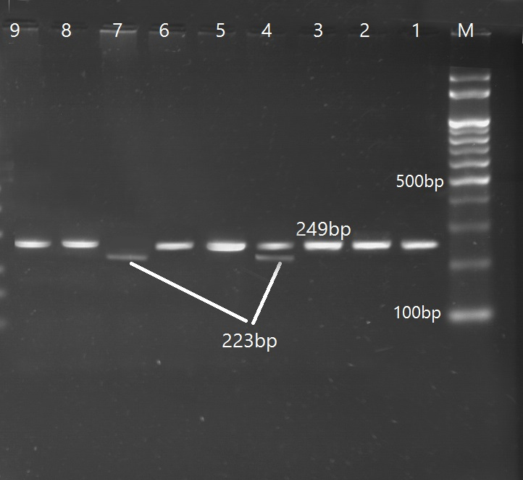
Figure 1 the 3% agarose gel electrophoresis showing the restriction digestion patterns of Asp299Gly polymorphisms of TLR4 gene using Nco I enzyme. M: DNA marker. Lanes 1,2, 3,5,6,8,9: homozygous wild type (AA). Lane 4: heterozygous genotype (AG). Lanes 7: homozygous mutant genotype (GG).
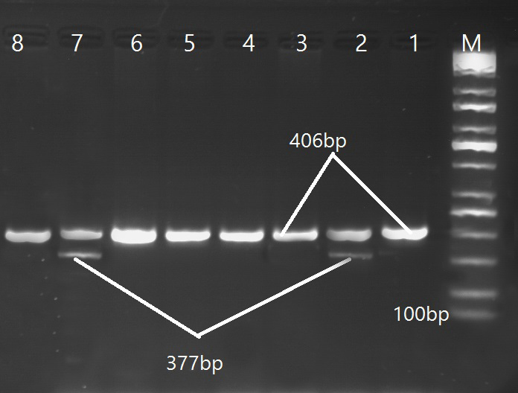
Figure 2 the 3% agarose gel electrophoresis showing the restriction digestion patterns of Thr399Ile polymorphisms of TLR4 gene using Hinf I enzyme. M: DNA marker. Lanes 1,3-6,9: homozygous wild type (CC). Lane 2,7: heterozygous genotype (CT).

