Impact of Sewage Water on the Water Quality of Tigris River in Maysan Province and their Possible Health Risks and Removal by Using Granular Activated Carbon and Sand

Ali. H. Amteghy
Dept. of Environmental Marine Chemistry, Marine Science Centre, Basrah University, Basrah, Iraq.



Received 14 November 2013 Accepted 5 December 2013
Abstract
The objective of this research was to know range effect Sewage water on physico-chemical quality of Tigris river water in Maysan province of Iraq and to estimate the environmental status of the river. Water samples were collected seasonally during 2009-2010 from eight sites on the river in Maysan province. Samples were collected before and after entering the river to Al-Ammarh city, in addition to two samples from sewage water through the two pipes of discharge, as well as, four samples, before and after the two pipes. The physical and chemical parameters of water were included the temperature (T), hydrogen activity (pH), electric conductivity (EC), salinity, total dissolved solids (TDS), total suspended solids (TSS), dissolved oxygen (DO), biological oxygen demand(BOD), total hardiness(TH), sodium adsorption ratio (SAR), calcium (Ca) concentration, Magnesium (Mg), sodium (Na), potassium (K), Chloride (Cl), Sulfate (SO₄), nitrate (NO₃), total nitrogen (TN), ammonia (NH₃), phosphate (PO₄),total phosphor (TP), silicate (SiO₃), manganese (Mn), Iron (Fe), Copper (Cu),Vanadium (V), Nickel (Ni), Cobalt (Co) and Lead (Pb).
Results of present study were showed that the pH of the studied area varies from neutral to weak basic, and showed high conductivity (Total salinity) in addition to increase the concentration of TDS, TH, Ca, Mg, Na, K, Cl, SO₄, and NO₃ in the sewage water according to the drinking water criteria of (WHO), and Iraqi limits. Whereas, SAR in the water samples was less than (10), while the mean of TH was above the international limits therefore it’s classified as hard water. Also, present study was compared between activated carbon, activated carbon-sand filters, sand - activated carbon filters and sand filter respectively to obtain the difference for removal according to average flow rate is 10 m/sec. the study proves that activated granulated carbon was more efficient than carbon –sand, sand-carbon and sand respectively. The removal efficiency for major content ion and trace metals were observed in the order of Mg⁺² < Cl⁻ < K⁺ < Ca₂⁺² < PO4⁻³ <NO₃⁻ and Mn< Fe <Cu< V< Ni <Co<Pb.
So as to make the concentrations of these for major content ion and trace metals within accepted level of the river and did not exceed the limits of subtraction, which shows the removal of efficiency by filters.
الخلاصة
تهدف الدراسة الى بيان مدى تأثير مياه الصرف الصحي على الخواص الفيزيائية والكيميائية لمياه نهر دجلة ضمن محافظة ميسان و تقيم الوضع البيئي لنهر دجلة خلال فصلي الصيف والشتاء لموسمين 2009-2010, حيث اختيرت ثمان مواقع على طول نهر دجلة منها عينتان الاولى قبل دخول نهر دجلة الى مدينة العمارة والثانية بعد خروجها عند قلعة صالح .فضلا عن عينتان من مياه الصرف الصحي التي تطرح بشكل مباشر الى النهر وبدون معالجة من خلال انبوبي التصريف .اما العينات الاربعة اثنان منهما قبل وبعد الانبوب الاول واثنان قبل وبعد الانبوب الثاني. وتضمنت الدراسة قياس الخواص الفيزيائية والكيميائية لنماذج المياه و درجات حرارة المياه و الأس الهيدروجيني والتوصيل الكهربائي والملوحة و المواد الصلبة الذائبة الكلية و المواد الصلبة العالقة الكلية والاوكسجين المذاب والمتطلب الحيوي للأوكسجين والعسرة الكلية والكالسيوم والمغنيسيوم والنترات و الامونيا والنتروجين الكلي والفوسفات والفسفور الكلي و السيليكات والبوتاسيوم و الصوديوم ونسبة الامتزاز (SAR) والكلوريد والكبريتات والرصاص والنيكل , النحاس والكوبلت والفناديوم والحديد والمنغنيز. اظهرت الدراسة الحالية ان قيم الاس الهيدروجيني متعادلة تميل الى القاعدية الضعيفة ضمن منطقة الدراسة ,كما لوحظ الزيادة الواضحة في قيم العسرة الكلية و الكالسيوم والمغنسيوم والكلور و الرصاص و الحديد والمنغنيز لمياه الصرف الصحي مما يؤكد تأثير تلك المياه على نوعية مياه نهر دجلة ومتجاوزة بذلك محددات البيئة المحلية والدولية المسموح بها حيث تصنف مياه نهر دجلة بانها مياه عسرة جدا,كان معدل نسبة امتزاز الصوديوم في عينات مياه النهر اقل من (10) وبذلك تكون مياه نهر ممتازة لأغراض الري من حيث محتواها من الصوديوم. لذا يتطلب التقليل من تأثير الزيادة في قيم التركيز وذلك عن طريق استخدام أربع مرشحات أحادية وثنائية الوسط المتكونة من (الكاربون الحبيبي المنشط و الرمل المحلي) لمعالجة مطروحات مياه الصرف الصحي باتجاه نهر دجلة باعتبارها ابرز وأكثر تأثير في النهر والتي تحتوي على نسب عالية من الملوثات العضوية واللاعضوية, وقد تم إمرار المطروحات الخام في كل من المرشحات الأربعة وبعد التعرف على خصائص المطروحات الخام من خلال إجراء فحوصات الفيزيائية والكيميائية على عدد كبير من النماذج تم اعتمادا على تركيز في موقع السادس كنموذج للمعالجة .كما تم إجراء مقارنة مابين الكاربون المنشط والرمل المحلي ومرشحي الكاربون المنشط والرمل المحلي ,لمعرفة الفرق في الإزالة وبالاعتماد على معدل سرعة جريان 10م|ساعة. و قد اثبت مرشح الكاربون الحبيبي المنشط اكثر كفاءة في الإزالة من مرشح الرمل –كاربون وكاربون-رمل والرمل على التوالي اذ وصلت كفاءة الإزالة للايونات الموجبة والسالبة كانت حسب الترتيب :
Mg⁺² < Cl⁻ < K⁺ < Ca₂⁺² < PO4⁻³ <NO₃⁻وكان اعلى معدل لإزالة المعادن الثقيلة حسب الترتيب التالي: Mn< Fe <Cu< V< Ni <Co<Pb. وذلك لجعل تركيز تلك العناصر ضمن تراكيز محددات الطرح للنهر ولم تتجاوز حدود الطرح مما يظهر كفاءة المرشحات في الازالة.
ــــــــــــــــــــــــــــــــــــــــــــــــــــــــــــــــــــــــــــــــــــــــــــــــــــــــــــــــــــــــــــــــــــــــــــــــــــــــــــــــــــــــــــــــــــــــــــــــــــــــــــــــــــــــــــــــــــــــــــــــــــــــــــــــــــــــــــــــــــــــــــــــــــــــــــــــــــــــــــــــــــــــــــــــــــــــــــــــــــــــــــــــــــــــــــــــــــــــــــــــــــــــــــــــــــــــــــــــــــــــــــــــــــــــــــــــــــــــــــــــــــــــــــــــــــــــــــــــــــــــــــــــــــــــــــــــــــــــــــــــــــــــــــــــــــــ

Introduction
Pollution of land, rivers and streams by sewage has become one of the most crucial environmental problems of the 21st century. The rapid development of urbanization and industrialization led to the rising use of sewage for agricultural land, irrigation and water pollution.[1-3]. Tigris river is considered one of the most important source for fresh water in southern part of Iraq which many agricultural and industrial activities were existed upon its banks. Tigris undergoes drainage activities from waste exposures throughout its passage in Maysan city to a large quantities of agricultural and domestic and industrial wastes including paper industry wastes, plant oils, hospitals wastes and energy generation waste [4]. In addition high quantities of sewage wastes are discharge to Tigris river through the discharge point without treatment. These waste are considered a big problem as the total discharge reaches 66355828 liter / day compared to the consumed liquids by Al-Amarah city (88711000 liter /day) (irrigation administration 2009,2010). These wastes considered the main pollution to surface water [5].The main discharge that producing pollution are sewage water, which were not pretreated before discharge and contain many inorganic, organic and microbiological pollutants. It is proved that sewage water were not treated when discharged to the Tigris in many Iraqi sites. Such activities are considered dangerous to the public as threading source for human health, especially when reached to drinking water as the sewage water contain a large quantity of microorganisms such as bacteria ,viruses and parasites which caused the incidence of diseases such as cholera, typhoid and polloi [6,7], The heavy element enter the ecosystem by many chemical reactions including complexation, precipitation and adsorption. These reactions are inflecting by removing element from water. Moreover, these pollutant (the non-commercial heavy metal) bonded with silicon structure in precipitate, such compounds are derived originally from polluted water in addition the commercial fertilizers contain an appreciable amount of heavy metal [8]. Consequently , the physical, chemical and biological properties which lead to clear changes , in water properties, in a form that affecting the aqueous environment which mish affect the balance of environmental balance, and affecting the ecosystem of the city, and eventually lead to the increase of levels of environmental determinant compared to accepted level locally and internationally ;therefore requires treatment of sewage water discharged in to the river water directly to decrease the influence of pollutants and its impact on river properties and the coexistence within the environmental limitations by using filtration and adsorption. Where Multi –filtration system is considered one of the method for liquid waste treatments and the idea of filtrate is considered principally by using Different adsorbent so as to increase the efficiency of filtration. The use of these adsorbent in the treatment of drinking water for removal pollutant viruses, disease and bacteria. Recently, in the sewage treatment and organic pollutant removal and toxic material, the adsorbing material (filters) was found to be more homogenous and give less of charge[9]. The wastes in sewage water is considered one of the most dangerous for Maysan river. Organic pollutant and non-organic are considered more Toxic. Sand is mentioned that its one simple of the common medium for filtration and removal of organic and inorganic pollutant. Activated carbon is considered one of the most adsorbent material that used to remove cations and anions, existing in river water that contain organic compound, metal chlorine and other heavy metal have been removed by using activated carbon[10]. The removal of pollutant is effected by temperature , nature of solution, surface area, effect of composition of pollutant and pH [11].The subject of pollution of Tigris river received a special attention of different workers to the large effect on safety and health aspect of millions of citizen in Iraq, living in thin area. Ibtihag and coworkers [12] investigated the effect of discharging sewage of Baghdad on the water quality of Tigris river. This study include the distribution of pollutants (BOD,TDS,T.H.,SO₄,Na and turbidity). Recently, Kareem .H. Khwedim [13] studied the influence of sewage water on water quality of Diyala river in Baqubah city. The study showed that trace element (Pb, Cd, Zn,Cu and Ni) were above the international limits according to the drinking water criteria of (WHO) and were found normal (Zn and Cu). The high pollution level were explained due to the sewage water and domestic waste which discharge directly to Diyala river without treatment. Abbass et al. [14] published a work on removal of lead and copper ions using granular activate carbon in Batch and fixed bed adsorber. The result showed that film-pore diffusion model used for fixed bed adsorbers, its provided a good description of the adsorption process, for adsorption of metal ions Pb(II) and Cu(II) onto activated carbon in fixed bed adsorbers. Ahmed [15] used the waste of date palm to study the removal of heavy metal cations (Cu, Cd and Zn). The date palm mentioned gave 90% removal of Cu, 57.5 % for Cd and 37.5% for Zn. In Mosul city, Abawy and Co-workers [16] used different media filter consists of activated carbon, ceramic, sand in order to remove pollutant from Nineveh Drugs industry. The study proves showed that filter (activated carbon–sand) was more effective than filter (ceramic-sand).Removal efficiency onto (activated carbon–sand) at lowest and highest organic load respectively reached to (92% and 73%) for SS and (%58, % 40) for COD( 85% and 56%) for lead. Lead was the most effective removal among heavy metal. Multimedia filter is gave most effective removal efficiency at lowest and highest organic load respectively (95%, 92%) for S.S and (% 73 % 58 ) for COD and (87.5 %, 73%) for lead. The effluent casting to river except cadmium was within limits. COD value was within limits of casting to river at low organic load and exceed limits at high organic load. Current velocity at rate 5 m/hr is most effective.

Aim of Study
This study was conducted during January 2009 to March 2010 at eight different selected sampling sites along the Tigris river stream, The objectives of the present work were to (1) To assess physico-chemical characteristics of water of Tigris river within Maysan province in four different seasons (2) Establish the correlation between the parameters and the seasons. (3) Determine the effect of effluent sewage water discharge on physico-chemical properties of Tigris river by identifying and evaluating the levels of major contamination it receives. (4) Find treatment methods, using filtration by local sands and adsorption by activated carbon granular and compared to use local sand and activated carbon. These media were being used to remove organics and inorganics, particularly heavy metals from sewage water in Tigris river with flow rate of 10 m/hour. (5) Determine the environmental limitations at Tigris river compared to local and international limits, and finally compare the concentration of outside pollutants with respect to the permitted level.

Materials and Methods
Study area
The Tigris river is one of the largest rivers in the Middle East stretching for over 1900 km, of which 1415 km flow within Iraq, with a catchment area of 235000 km², sharing with Euphrates river as the main sources for man use, especially for drinking water since they through the major cities in Iraq [17]. Eight sites were selected at Tigris river in the south of Iraq is branched from Tigris river in Maysan province (Figure 1 ). The details of sampling sites are presented in Table (1).

Table 1 The Sampling Sites and Distances on Tigris River During Study Period.

sites  number | Distance  (Km) | sampling sites | GPS positions
sites  number | Distance  (Km) | sampling sites | E | N
1 | 0.0 | Before the entrance of Amarah city | 698212 | 3530340
2 | 10.2 | Before the first point discharge | 703203 | 3524378
3 | 0.77 | At the first point discharge | 703332 | 3523613
4 | 1.5 | After first point discharge | 703277 | 3522139
5 | 1.5 | Before the second discharge point | 703262 | 3520587
6 | 0.26 | At the second point discharge | 703356 | 3520338
7 | 5.79 | After second point discharge | 703358 | 3515465
8 | 38.5 | After the Qalat Salih outlet | 716637 | 3490525

Table 2 Water Level and Flow Rate of Tigris River at Different Gauging Sites

Qalat salis | AL Amarah | Tigris | ALI AlGharbi | Water level (cm)  Flow(Q)(m³/sec) | Data
4.35 | 4.51 | 5.38 | 6.72 | Water level | 15-1-2009
10 | 23 | 85 | 115 | Flow rate | 15-1-2009
3.26 | 5.17 | 6.04 | 7.15 | Water level | 3-8-2009
29 | 40 | 102 | 120 | Flow rate | 3-8-2009
3.57 | 5.59 | 6.06 | 7.44 | Water level | 15-1-2010
56 | 66 | 131 | 157 | Flow rate | 15-1-2010
3.20 | 5.28 | 6.31 | 7.36 | Water level | 3-8-2010
50 | 59 | 120 | 133 | Flow rate | 3-8-2010

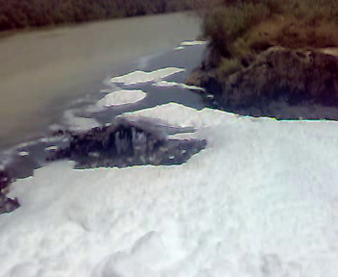

A

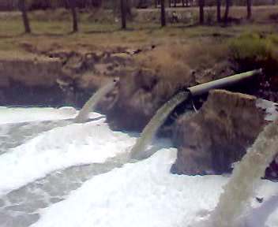

B

Photo 1 A&B Tigris River at Discharge Sewage Water Point.( site 6)

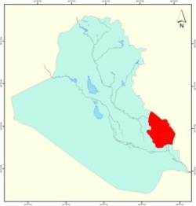
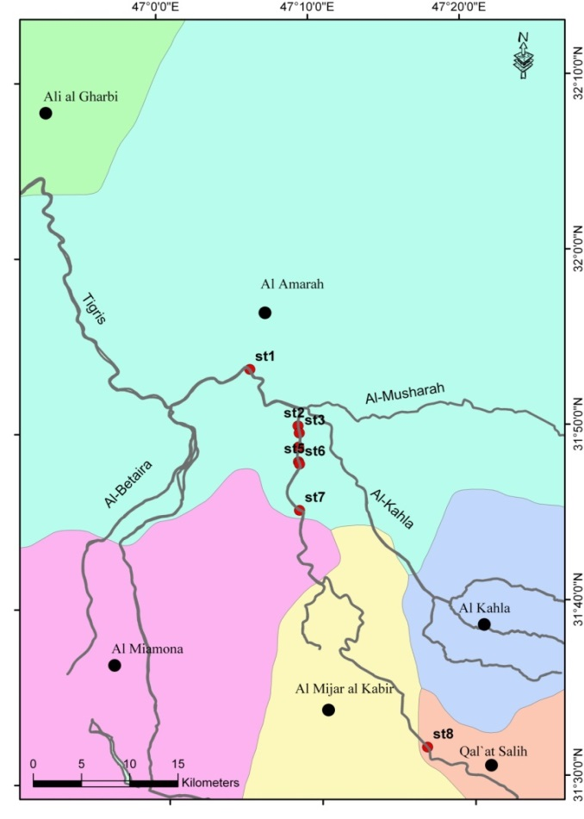
St4

Figure 1 Map showing the studied area with sampling sites

Samples Collection and Procedures
Water samples were collected Seasonally by clean polyethylene bottles(5 L capacity) , 30 cm depths at selected eight sites alongside Tigris river during winter and summer 2009 and 2010, Water samples were kept into a five-liter polyethylene bottle in ice box and analyzed in the laboratory .Some of the physicochemical parameters including the electrical conductivity of the water samples, pH, water temperature (°C), dissolved oxygen (D.O), total dissolved solids (TDS) and salinity were measured in the field with portable Multimeter HANNA Model (HI 9811-5). The other water parameters [biological oxygen demand (BOD5), Nitrate (NO₃), Ammonia (NH₃), Total Nitrogen (TN), phosphate ( PO₄), TP, SiO₃⁻², Chloride (Cl), Sulphate (SO₄), Ca²⁺, Mg²⁺, Na⁺, and K⁺ were measured in the laboratory according to standard specifications presented by the American public health association [17,18]. Furthermore, some trace elements were determined. The digestion of water samples were carried out by taking 100 ml of water sample in a clean glass beaker congener with distilled water then add to 5 ml of concentrated nitric acid to each sample independently, and then placed over a Hot plate until evaporation to dryness, then repeated again using 5 ml of conc. nitric acid and evaporation continued again until dryness and then completed to the original volume of 50 ml with distilled water and kept in refrigerator prior to analysis [19].
In addition this is carried out through experiment, depending on four glass filters cylindrical from with 6cm diameter, and 120 cm height, the first filter formed from granular activated carbon, granular activated carbon obtain from (BDH) with diameter (0.15-2.0) mm. height (60) cm. The second filter composed of sand export from (Al-Nawafth company) with the average grain size was (0.6-1.2) mm and thickness (60) cm .the third filter composed of two similar layers the upper composed of granular activated Carbon and the lower composed of sand, each media was with thickness of (30) mm. The fourth filter composed of two similar layers upper of sand lower was composed of granular activated carbon can with well (30)mm. 5 liter of sewage water was passed through each filter with rate of flow (10mm)/ sec. and connect for the end of lower filter, plastic tube guarded by mechanic valve of flow. All experimental were carry out in 27°C and pH (7-7.5).

Results and Discussion
The results of the physical and chemical parameters studied for water samples in the selected eight sites are listed in Table 3. It showed that the present study exhibit the seasonal and sites variation in all the studies variations. The results show observed increase through summer compared to winter seasons 2009-2010 except for dissolved oxygen as they recorded variable results as gave high results through winter season. The increase were at sites 3 and 6 compared to other sites .in the measured parameters except for dissolved oxygen which recorded lowest value at sites 3 and 6 compared to other sites.

Table 3 Physicochemical parameters and trace metal of the Tigris river water during summer and winter 2009-2010.
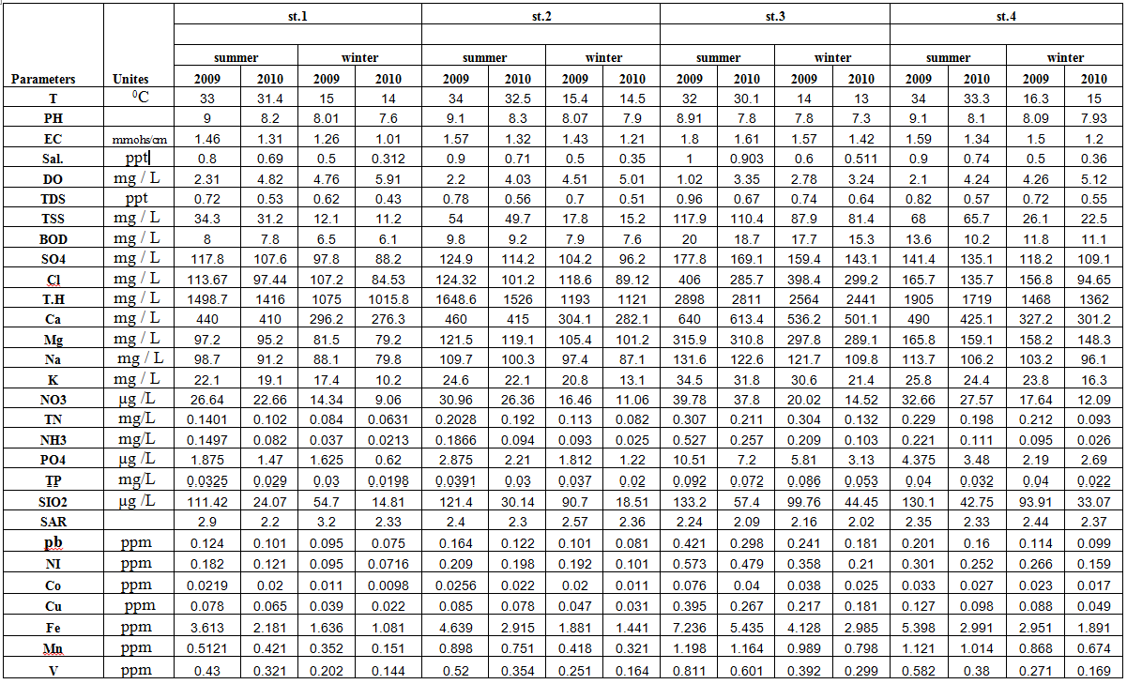
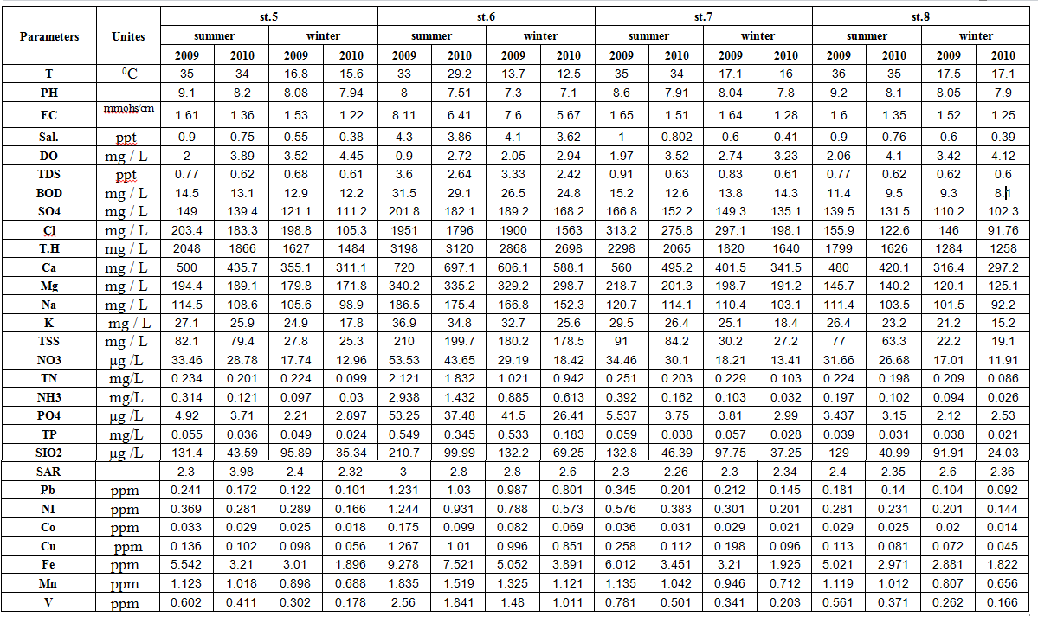

Temperature is a critical water quality parameter, since it directly influences the amount of dissolved oxygen that is available to aquatic organisms [20].Temperature during the sampling of different seasons was found to vary from (12.5-36°C) (Table 3). The overall range in water temperature was minimum in winter and maximum in summer , seemingly these values followed almost identical seasonal cycles.
The pH values of the present investigation lie in the alkaline side of neutrality and ranged between (7.2-9.2) (Table 3). The highest pH value was recorded during summer 2009. This could be resulted in an increase in both photosynthetic activity and sewage disposal loaded with high concentration of detergents [21]. A slight drop in pH value was observed at the sampling sites 3 and 6. This may be attributed to the discharge of effluents sewage waters entering the river which loaded with a large amount of organic acids. The pH values of all studied water during the studied period were within the desirable levels recommended by WHO, 2006 [22] and USEPA, 2004 [23]. Electrical conductivity values of Tigris river ranged from (1.01- 8.11) mmohs/cm during the investigation period Table 3. The results of electrical conductivity analyzed were higher in the summer season than in the winter season. At various sampling sites, point sources sewage waters were affecting the river water conductivity. The maximum values were recorded at sites 3 and 6 which receive the effluents of sewage water to the river directly through discharge points compared to other sites. EC of Tigris river within the WHO and standard Iraq acceptable limit.
The salinity, TDS and TSS in Tigris river water were found to be high during summer season and low during the winter season. The recorded higher values could be attributed to the low amount of rainfall, higher rate of evaporation and consequently lead to the increase of concentration of salt and in particular chloride ,calcium and magnesium and these results agreed with [24]. While there is slight decrease in salinity, TSS and TDS through winter and summer for 2010 due to little increase in water levels and drainage which works as diluents to the river. The values of saintly, TDS and TSS were found at all sites during four seasons, These values at site 1 were (0.312-0.8,0.43-0.72 and 11.2-34.3) respectively, then the increase was given at site 2 which was at distance from the site 1 by(10.22 km) to reach (0.511-1,0.64-0.96and 81.4-117.9) at site 3 respectively. then the values decreased after by 1.5 km between at sites 4and 5, then salinity ,TSS and TDS started increase at site 6 and this away of site 5 by 260m to reach (3.62-4.3,2.42-3.6 and 178.5-210) respectively ,then started by decrease at site 7 which was at site 6 by 5.79 km to reach (0.41-1,0.61-0.91 and 27.2-91) respectively and last point at site 8 which was 43.389 km from the point of second discharge by (0.39-0.9,0.6-0.77 and 19.1-77) respectively and such value will be equal to value at site 1. From the results there are variations sites in salinity, TSS values and TDS is belonging to the variations in sewage water in sewage discharged to the Tigris river [25], which contain different values of salt and proportional to different ions, that means increase of chloride, sulphate, sodium, potassium, calcium and magnesium concentrations [26], and then effect gives substantially increase in salinity TSS values and TDS at site 6, compared with other sites. The clean river is characteristics by high concentration of dissolved oxygen, in present study the most values of dissolved oxygen is <7 mg. L-¹,The DO values were higher in winter compared to summer in all sites Table 3 . The seasonal fluctuation in DO concentration was due to the effect of temperature on the solubility of oxygen in water [27]. Oxygen is generally reduced in the water due to respiration of biota, decomposition of organic matter, oxygen demanding wastes and inorganic reductant such as hydrogen sulphide, ammonia, nitrites, ferrous iron, etc.[28]. The relatively lowest DO values at sites 3 and 6 compared to other sites can be attributed to the amounts of sewage water discharged to the Tigris river. The DO values obtained in the present study for all the samples in both summer and winter seasons are within recommended standards. Biochemical Oxygen Demand (BOD₅) values were high during summer, Table 3. The real cause is the presence of organic biodegradable matter that are consumed by bacteria. Biochemical Oxygen Demand values show approximately different values. Increased organic matter results in the excess oxidation of organic matter to carbon dioxide and the water creates an atmosphere of oxygen depletion and results in high BOD levels. The highest value of BOD was recorded at sites 3 and 6. Higher values can be attributed to the increased effluents discharged into the Tigris river. Similarly, higher contents of organic load as well as the high proliferation of microorganisms are the causative factors for maximum BOD levels. The values obtained for BOD in this study for all the samples in both summer and winter seasons are within the recommended standards [29,30].
Total Hardness (TH) was calculated using the following equation [31]: TH = 2.497 Ca+4.115 Mg. TH is the parameter of water quality used to describe the effect of dissolved minerals mostly Ca and Mg, determining suitability of water for domestic, industrial and drinking purpose attributed to presence of bicarbonates, sulphates, chloride and nitrates of calcium and magnesium [32].The values of TH were ranged 1015.829-3197.763 mg/L during Four seasons 2009 and 2010 respectively (Table 3). This indicates that waters are very hard according to Todd [31]. The observed elevation of hardness is due to the impact of sewage discharge which drain directly in to the Tigris river and also can be attributed to the increase of calcium and magnesium derived from the decay of calciferous rocks on to the river water[33]. The seasonally variations of Ca²⁺ and Mg²⁺ in Tigris river water during drought period are present in Table (3). The ranges of Ca²⁺ and Mg²⁺ concentrations were found to be 276.3–720 and 79.2 – 340 mg/l respectively at different sites during four seasons. All the concentration of calcium were higher than magnesium concentration among most of the study period at all sites, that probably due to high abilities of calcium ion to react with dioxide carbon more than for magnesium [34,35]. The highest values of Ca⁺² and Mg ⁺² at sites 3 and 6 may be attributed to the quantities of sewage water discharged to the Tigris river, in addition to the height or decrease in water levels because the existence of intersecting braches and its impact on speed and the lowest precipitation averages or the temperature effects and weather factors such as rains and evaporation rates and dust storms Which from the calcium compounds 40% [36]. Although the infiltration rate of water into soil is a function of many parameters including the quality of the irrigation water and the soil factors such as structure, compaction and the organic content, the permeability and infiltration hazard typically occurs when high sodium ions decrease the rate at which irrigation water enters the soils lower layers. The reduced infiltration rate starts to show negative impacts when water cannot infiltrate to the roots of the crop to the extent that the crop requires. Hence, these salts start to accumulate at the soil surface. When the crop is not able to extract the required amount of water from the soil, it is not possible to maintain an acceptable yield and the agricultural production is reduced.
The most common water quality factor that influence the normal rate of infiltration of water is the relative concentrations of sodium, magnesium and calcium ions in water that is also known as the sodium adsorption ratio (SAR). The SAR value of irrigation water quantifies the relative proportions of sodium (Na⁺¹) to calcium (Ca⁺²) and magnesium (Mg⁺²) and is computed as : SAR= Na/√(Ca+ Mg /2).
In this equation, the concentrations are expressed as mille equivalents per liter. [37] The average ratio of SAR (Table 3), therefore; the river water according to the extracted values which are suitable for irrigation purposes. The increase of sodium ions in river water which leads to reduce permeability in the soil and consequently will reduce the freedom of movement of liquid through soil [31]. Cations of sodium and potassium values ranges between 79.8-186.5 and 10.2-36.9 mg/l respectively at different sites during four seasons, Table 3. The fluctuation of sodium in all stations during different seasons is indicated that different quantities that added to the river from the wastes of sewage and contain different quantities of detergents, as it arises from the decrease of sodium concentrations in some study regions, to remove this element by adsorption of adsorbing materials or the consumption of microorganisms. The sodium values are ranged from to within the allowed levels, at all studies sites. While results showed the potassium exceeded above the permitted values which showed clear variations at sites 3 and 6, The high concentration of sewage, chemical fertilizers and industrial waste may be the cause of high concentration of potassium [38]. The potassium ions are existing by concentration which is less more than sodium ions. Due to Tigris river water within Maysan poivenic are the accepted values and do not contain higher concentrations of this element. This is attributed to the difficulty of release of the element from the rock compared to siliceous material containing sodium [39]. Concentrations of chloride and sulphate varied between 84.53 - 1950.65 and 88.2-201.8 mg/l at all sites during four seasons, where the maximum values were recorded at sites 3 and 6 during winter and summer respectively(table 3 ).The high values of Cl⁻ and SO4⁻⁻at sites 3 and 6 are strongly attributed to high concentrations of Cl⁻ and SO4 ⁻² in the sewage water which discharge without treatment to the river [40], but these concentrations remain within the allowable Iraqi standards (250,400ppm) respectively at all the study region. Nitrate and ammonia are the most common forms of nitrogen in aquatic systems [41]. Ammonia is excreted by animals and produced during decomposition of plants and animals, thus returning nitrogen to the aquatic system. Nitrate is often the limiting element restricting biological productivity of Tigris river water [42].
NO₃⁻-N values varied from 9.06 to 53.526 µg /L, while NH₃-N values ranged from 0.0213 to 2.9382 mg/L, while TN values ranged from 0.0631 to 2.1213 mg/L. Seasonally, the highest NO₃⁻ -N ,NH₃-N and TN values were observed in summer in all sites (Table 3). that probably due to increase in oxidation of ammonia to nitrate by rise of temperature [43]. Additionally the decrease of water levels and rise of temperature which contribute to the increase in evaporation of average and consequently to the increase of total nitrogen ,ammonia and nitrate through 2009 with slight increase in water levels through 2010 .such factors is affecting as diluting to river which contribute to the total nitrogen, ammonia and nitrate concentration through summer and winter seasons. The highest value total nitrogen, Ammonia and Nitrate at sites 3 and 6 during four seasons. may be attributed to sewage water which are rich in nitrogen content which is discharged directly to the river water without treatment and eventually contributed substantially to raise the levels of total nitrogen ,ammonia and nitrate [44,45]. PO4 ⁻³-P and TP values showed similar variations between both seasons and sites. The highest PO4⁻³-P and TP values, were observed in sites 3 and 6 in summer, compared to their concentration in winter(Table 3). Due to the rise of temperature that leads to increase evaporation rate of water which contribute to the increase of total phosphor and phosphate, while results showed high concentrations at sites 3 and 6 compared with other sites. This may be attributed to the discharge to the river water without treatment, this is a major reason for increase of phosphate derived from detergents and other industrial activities. The silicate content was higher than that of the other nutrients at all sites during four seasons (Table 3) and high values of silicate through the summer that may be because of the decay of diatoms by high temperature [46] or by increase in the solubility of metal salts in water [47], this result agrees with many studies in Iraqi aquatic systems[48-50]. Also the Silicate concentration was high in sites 3 and 6 in adjusting effluent discharge during summer. Our findings coincide with [51]. It had been deduced that high water temperature serve in changing insoluble SiO₃ to soluble state [52]. Decomposition of diatomic shells, which associate with elevated temperatures, also adds substantial proportion of silicate to the environment [53,54].
Generally the Heavy metal concentration( Fe, Mn, Co, Cu, Pb, Ni and, V) was high in summer seasons in water of Tigris rivers than the winter season, The concentration of the metals were observed in the order of Fe>Mn> V>Ni>Pb>Cu>Co. (Table 3). This may be as a result of slow current of water in summer season giving room for the particles to settle down. In addition to the rise of temperature will leads to evaporation rate of water which contribute to the increase of trace metal in aqueous environmental through summer. The clear increase in value of heavy metal concentration, particularly at the two sites 3 and 6 compared with other sites that leading to sewage water. the waste from Al- sadir general. Al-zahrawy hospitals and the close oil refinery which lead to the river .The additional pesticides, industrial waste, etc, or by decomposition of plankton, diatoms and benthic organism [55].
The present study showed from table (3) value of heavy metal for Tigris river , (Co, Cu, Pb , Ni, V, Mn, Fe), and compared with determinant and standard criteria, For subjecting waste to the river according to the Iraqi standard number (417,2000), the level of (Fe, Mn, and Pb )in Tigris river exceeded the permitted level at all seasons and at all sites and in particular sites 3,and6. the level of cupper was not exceeded the accepted level at winter season (2009 and 2010),while it exceeded at summer season (2009 and 2010) at site 6.For cobalt, results showed that concentration of cobalt was less than the permitted level value, throughout winter (2009-2010) and summer 2010, and all sites except sites 6. While it exceeded at summer season 2009 at sites 3 and 6. For Nickel, results showed that concentration of Nickel was less than the permitted level through seasons winter and summer 2010,and all sites except sites 3,6 and 7 during winter season and sites 1and 2 during summer season. While it exceeded at summer and winter season 2009 and all sites except sites 1 and 2 during winter season and sites 1 during summer season.
A large numbers of samples exceed the (32) sample, then depending the high value of sewage water was taken at site 6 for treatment by using filtration by on sand locally and absorption by granular activated carbon. After process using filtration and adsorption, then taking reading average. The percent chemical parameters removal efficiency was calculated as follows: RP( %) =[(Ci–Ct)/Ci] x 100. Where RP removal percentage (%), Ci and Ct are the initial concentration and the concentration of chemical parameters (ppm) after treatment. It has been found that using granular activated Carbon filter which the removal efficiency from carbon /sand filter and sand/Carbon filter and sand filter consequently. The concentration of the metals were observed in the order of Mn< Fe <Cu< V< Ni <Co<pb. ( Table 4).

Table 4 shows the conc. of removed material before treatment and conc. after treatment at Site 6 and at a rate of 5 m/h and removal rates

Test | Blank | Filter1 | Filter2 | Filter3 | Filter4 | Removal percentage %
 |  |  |  |  |  | Filter1 | Filter2 | Filter3 | Filter4
NO3 | 53.52 | 1.1 | 13.5 | 18.5 | 21.5 | 97.95 | 74.78 | 65.44 | 59.83
PO4 | 53.25 | 9.5 | 22.5 | 29 | 35 | 82.16 | 57.75 | 45.54 | 34.28
Ca | 720 | 300 | 400 | 510 | 580 | 58.33 | 44.44 | 29.16 | 19.44
Mg | 340.2 | 155 | 200 | 260 | 290 | 54.43 | 41.21 | 23.57 | 14.75
K | 36.9 | 12 | 16 | 22 | 28 | 67.47 | 56.63 | 40.37 | 24.11
CL | 1950.65 | 950 | 1100 | 1300 | 1650 | 51.29 | 43.61 | 33.35 | 15.41
pb | 1.231 | 0.001 | 0.334 | 0.443 | 0.665 | 99.91 | 72.86 | 64.01 | 45.94
Co | 0.175 | 0.002 | 0.065 | 0.088 | 0.112 | 98.85 | 62.85 | 49.71 | 36
Ni | 1.244 | 0.133 | 0.566 | 0.788 | 0.866 | 89.3 | 54.5 | 36.65 | 30.38
V | 2.56 | 0.34 | 1.33 | 1.67 | 1.88 | 87.89 | 48.04 | 34.76 | 26.56
Cu | 1.267 | 0.221 | 0.669 | 0.889 | 0.955 | 82.55 | 47.19 | 29.83 | 24.25
Fe | 9.278 | 1.99 | 5.1 | 6.77 | 7.22 | 78.55 | 45.03 | 27.03 | 22.18
Mn | 1.835 | 0.899 | 1.224 | 1.551 | 1.599 | 51 | 33.29 | 15.17 | 12.88

It has been observed, that the higher removal percentage was with Nitrate as the removal efficiency reached 97.95 % for first filter and 74.78 %for second filter and 65.44 % for the third filter and 59.83 % for the fourth filter. The efficiency of phosphate reaches to 82.16% . For the first filter and57.75 % for the second filter and 45.54%for the third filter and 34.28 %for the fourth filter. The efficiency of calcium reaches to 58.33 % .for the first filter and44.44 % for the second filter and 29.16 %for the third filter and 19.44 %for the fourth filter. The efficiency of magnesium reaches to 54.43 % .for the first filter and41.21 % for the second filter and 23.57 %for the third filter and 14.75 %for the fourth filter. The efficiency of potassium reaches to 67.47 % .for the first filter and 56.63 % for the second filter and 40.37 %for the third filter and 24.11 %for the fourth filter .The efficiency of chloride reaches to 51.29 % .for the first filter and 43.60 % for the second filter and 33.35 %for the third filter and 15.41 %for the fourth filter.
The concentration of the content major were observed in the order of Mg⁺² < Cl⁻ < K⁺ < Ca₂⁺² < PO4⁻³ <NO₃⁻.It has been observed that the highest heavy metal removal Dawn for lead reaches to 99.91% for the first filter and 72.86 % for the second filter and 64.01 % for the third filter and 45.94 %for the fourth filter . For Cobalt, the efficiency was 98.85% for the first filter, 62.85% for the second ,49.71% for the third, and 36.0% for the fourth.. The Efficiency of Nickel was 89.30%for the first and 54.50% for the second and 36.65% for the third and 30.38% for the fourth. The Efficiency of Vanadium was 87.89%for the first and 48.04% for the second and 34.76% for the third and 26.56% for the fourth. then copper which the removal efficiency was 82.55% for the first filter and 47.19% for the second and 29.83% for the third 24.25% for the fourth filter. The Efficiency of iron removal was 78.55% for the first , and 45.03% for the second and 27.03% for the third and22.18% for the fourth. The efficiency of manganese was reaches to 51% for the first filter and 33.21% for the second filter and 15.17% for the third filter and 12.88% for the fourth filter .The difference in removal efficiency between for some chemical properties and trace metal for sample sewage water at sites 6. these related to trace metal , and Distribution of element and distribution of two phase and suspension [56-57]. The removal of trace metals, by filtration, and sedimentation, and adsorption. The suspended part of waste which were removal by sand in column filtration and the soluble metal removed by adsorption on activated carbon [58].

Conclusions
1. The results indicate that the water in the study sites were ranged between hard and very hard.
2. Tigris river was polluted with heavy metals (Fe, Mn, Ni, pb,Cu,Co and V) resulting from the impact of sewage wastewater that should be treated before direct discharge into the river especially at the sites 3 and 6
3. The mono medium filter made of activated granular carbon is proved to be more efficient compared to di medium filter made of activated granular carbon and local sand and mono medium filter made of sand local for the removal of cations and anionic and trace elements from sewage water.in order to produce water within quality comparable to that let by WHO.

References
1. Abdel-Sabour, M.F. (2003), Impact of wastewater reuse on cobalt status in Egyptian environment. J. Environ.Sci. 15(3): 388 – 395.
2. Zhang, Y.L., Dai, J.L., Wang, R.Q. and Zhang, J. (2008), Effects of long-term sewage irrigation on agricultural soil microbial structural and functional characterizations in Shandong, China. Eur.J. Soil Biol. 44(1): 84 – 91.
3. Maldonado, V.M. (2008), Heavy metal content in soils under different wastewater irrigation patterns in Chihuahua, mexico. Int. J. Environ. Res. Public Health 5(5): 441-449.
4. DouAbul, A. A. Z.; J. K. Abaychi; M. K. AL – Saadi and H. AL – Awadi. 1987. Restoration of heavily polluted branches of the shatt AL – Arab River, Iraq. Water Res., 21 (8): 955 – 960.
5. Szymanowska, A.; A. Samecka and A. J. Kempers. 1999. Heavy metals in three lakes in west Poland Ecotoxical – Envi. Saf. ; 43 (1): 9 – 21.
6. Dianon Abdulazez, Study the effects of seasonal issues on the quality of waste water from the Tigris River and its suitability for irrigation, drinking and industry, MSc. thesis, Mosul University, 1984.
7. Taha, Dakel Nasser, 2001, the analytical study of the remnants of the Maternity and Children Hospital in Babylon, the first scientific symposium of environmental pollution in the province of Babylon
8. 1991. New York Department of Environmental Conservation, DRAFT Cleanup Policy and Guidelines, Volume II-Appendix, Appendix D: Clean-up Criteria for Aquatic Sediments. Cleanup Standards Task Force.
9. Al-Rawi, S.M "turbidity removal of drinking water by dual media filtration" thesis
submitted to civil engineering Dep, Feb, 1987.
10. Speech, V& Gainho, A"Powder Activated carbon in an Activated Sludge treatment Plant"Water Res, 18(2): 133-137(1984).
11. Houshold water supplies"pollutions presentation and wastewater technologies "section7, activated carbon Adsorption, 2001
12. Ibtihaj A. Abdul Razzak and Abbas H. Sulaymo, Effects of Discharging Sewage of Baghdad To Tigris Riveron The Water Quality ,Eng.Tech. Journal, 27, 16, 2009.
13. Kareem Hussein Khwedim ,Influence of sewage water on the water quality of Diyala River in BaqubahCity ,Iraqi journal of science, Vol.53, No.1, 2012, pp.113-124
14. Abbass H. Sulaymon, Balasim A. Abid& Jenan A. Al Najar Removal of Lead and Copper Ions onto Granular ActivatedCarbon in Batch and Fixed Bed A Dsorber, Eng.&.Tech.Journal,vol.27,No. 19,2009
15. Layla A. A.Ahmed , Removal of Heavy Metals From Waste Water By Date Palm Tree Wastes Eng.&.Tech.Journal,vol.28,No. 1,2010
16. Abawi, S. A., Alhashemi Z. F., and Shehab S.M. The Use of Multi Media Filter for removing pollutants from Nineveh Drugs Industry, Eng. &. Tech. Journal, 28, 13, 2010.
17. J. Rzoska, "Euphrates and Tigris, Mesopotamia Ecology and Destiny," The Hague, Boston, London, p. 122, 1980.
18. APHA (American Public Health Association), "Standard Methods for the Examination of Water and Wastewater," 20th edition, Washington, DC, 1998.
19. Chapman, H.D. and Pratt D.F. (1961). Methods of analysis of soils, plants and water. University of California, Davies, Division of Agr. Sci., p. 309.
20. APHA, A. D. Eaton, American Public Health Association,Mary Ann H. Franson, American Water Works Association (Ed.), “Standard Methods for the Examination of Water & Wastewater,” 2005.
21. Maulood, B.K. and Hinton, G.C.F. (1979): Thychoplanktonic diatoms from a stenothermal spring in Iraqi Kurdistan. Bri. Phyco. J.14: 175-183.
22. World Health Organization (WHO) (2006). Guidelines for Drinking-Water Quality. 3rd Ed., Vol. 1, Geneva, pp.417-434.
23. Univ. of Glasgow. U.K. United States Environmental Protection Agency (USEPA) (2004): Office of Water, EPA 816-F-04-017.
24. Arndt , S. E. and Al-Saadi , H. A.(1975) Some hydrological characteristics of the Shatt Al- Arab and adjacent areas . Wess. Zeit. Univ. Restock, Math. Nat. Reih., 24 : 789 - 796 .
25. Al - Rekabi , K. M. (1996) Environmental factors in Euphrates river water in Nassiryah city . Al - Qadisiya J . 2 (1) : 61- 65 .
26. Hem, J. D. 1985. Study and interpretation at the chemical analysis of natural water, 3rd addition U.S.G.S. water supply paper: 254- 263.
27. Karaer F. and Küçükballı A. (2006). Monitoring of water quality and assessment of organic pollution load in the Nilüfer Stream, Turkey. Environmental Monitoring and Assessment, 114, 391–417.
28. BK Sahu; RJ Rao; SK Behara; RK Pandit. Effect of pollutants on the dissolved oxygen concentration of the river Ganga at Kanpur. In: Pollution and biomonitoring of Indian rivers (Ed.: R.K. Trivedy), ABD Publication, Jaipur, India, 2000; 168-170.
29. Chandaluri, S. R.; Sreenivasa, R. A.; Hariharann, V. L. N.; Manjula, R., Determination of water quality index of some areas in guntur district andhra pradesh. IJABPT, 2010, 1: 79-86.
30. Shukla GS, Kant R and Tripathi BD (1989). Ecological investigation of physico-chemical characteristics and phytoplankton productivity of river Ganga at Varanasi. Geobios 16: 20-27.
31. Todd, D. K., 1980: Ground water hydrology (2nd ed.). John Wiley and sons, N. Y., USA, P. 535.
32. Taylor, E.W., (1949), The examination of water and water supplies. J. and A Churchill Ltd, London.
33. Sawyer, C.N. and McCarty, P.L.,1978. Chemistry for Environmental Engineering, 3rd ed. McGraw-Hill Companies, United States of America.
34. Munawar, M. (1970)."Limnological studies on fresh water ponds of Hyderabad India". I. The biotope hydrobiologia 35(1): 127-162.
35. Al-Saadi H A and Antoine S E, Effect of pollution on phytoplankton in the Ashar Canal, a highly polluted canal of the Shatt al-Arab Estuary at Basrah, Iraq Hydrobiologia, 15, 1983, 99,3: 189-196
36. APHA (American Public Health Association).(2003).Standard methods for examination of water and waste water , 20th,Ed. Washington DC,USA.
37. Ayers, R.S., & Westcot, D.W.(1985). "Water quality for agriculture", FAO Irrigation and Drainage Paper No.(29), Rev.(1), U.N. Food and Agriculture Organization, Rome.
38. Mashkor S, K.(2002), The impact of heavy industrial water for the city of Samawah on the Euphrates River water pollution, Journal of Qadisiyah 7 (2) :29-38.
39. Al-Mussawy,S.N. and Salman, H. H.(1989) Heavy metals distribution in Khour Al-Zubair Sediments N.W Arabian Gulf .Marina Mesopotamica.4(2):309-318
40. Mustafa, O.M., 2006: Impact of sewage waste water on the Environment of Tanjero River and its Basin within Sulaimani city/ NE-Iraq, M.Sc. thesis, University of Baghdad, College of Science, P. 144.
41. APHA, A. D. Eaton, American Public Health Association, Mary Ann H. Franson, American Water Works Association(Ed.), “Standard Methods for the Examination of Water & Wastewater,” 2005.
42. D. Chapman, D. E., “Water Quality Assessments.A Guide to the Use of Biota, Sediments and Water in Environmental Monitoring,” 2nd Edition, Chapman& Hall, London, 1996.
43. U.S. Environmental Protection Agency (EPA). 1993. Manual—Nitrogen control. EPA/626/R-93/010. Office of Research and Development, Washington, DC.
44. Bashar J. J. AL-Sabah .Study physico-chemical behavior of the elements of metal contaminated water and sediments in Shatt Al-Arab. PhD thesis - College of Agriculture - University of Basra, 2007.
45. Husain S. Ali, Organic sources of pollution in inland waters and the possibility of Iraqi control and re-use. Journal of Wady Alrafidain for Marin Science, 2001.16,(1),489-505.
46. Wetzel R G and Likens G E, Limnological analyses 3rd Ed Springer-Verlag NewYork, 2000, 432.
47. Goldman C R and Horne A J, Limnology-Megraw Hillint. B. Co., U.S.A., 1983.
Brower, Z.U.E. (1990): Field and Laboratory Methods for General Ecology. Wm. C. Brown publishers. www.bio.uci.edu.
48. Hassan F M, J Sci., 1997, Alimnological study on Hilla river . Al-Mustansiriya , J. Sci. 8 (1) : 22 – 30
49. Hassan F M, Limnological features of Diwanyia river J Um Salama for Science, 2004 1(1), 119-124.
50. Al-Saadi, H A, Al-Lami, A A, and Kassim, T I, Algal ecology and composition in the Garmat ali river, Iraq, Regulated Rivers-Research &Management, 1996, 12(1), 27-38
51. Hillibricht, A. and Simn, A.T.(1988) Spatial pattern of temperature, oxygen and nutrient concentration in two lakes of different heated-water discharge. J. poll. 20 (60): 165-182p.(Abst)
52. Reid, G.K.(1961). Ecology of Inland water and estuaries. D.van. Nostrand Co. New York: 375.
53. Happy-Wood, C.M. and Priddle, J.(1984). The ecology of epippelic algae of five welsh lake with special reference to volvocalean green flagellate. Chlorophyaceae. J. Phycol.20:109-124.
54. Klarer, D.M. and Hickman, M.(1975). The effect of thermal effluent upon the standing crop of an epiphytic algal community Int.Revue.Hydrobiol.60(1):17-62.

55. Nakanishi Y, Sumita M, Yumita K, Yamada T and Honjo T, Heavy-metal pollution and its state in algae in Kakehashi river and Godani river at the foot of Ogoya mine, Ishikawa Prefecture. Anal Sci., 2004, 20,73.
56. Lester,J.N(1987).Heavy metals in waste water and sludge treatment processes Vol. I.sources analysis ,and legislation.CRCpress.Inc.,Florida, USA, 183.
57. Hussein, A. N., Alnajjar, H. H. Saad H.T. Yousef, O. H., Sabunji, A. A. (1991). Shatt al-Arab basic scientific study, Publications Marine Science Centre, University of Basrah, 392.
58. Harne ,K.R.(2004).Treatment of domestic waste water by constructed wetlands in tropical's conditions. ph. D. Degree Uni. of Roorkee. India.

