Histopathological Effect of Partial Purification Aerolysin Extracted from Aeromonas hydrophila on Internal Organs of Experimental Mice

Iman Jawad Kadhim
Technical Collage in Al Musayib, Foundation of Technical Education, Musayib, Iraq. E-mail: imanaljamaly@yahoo.com



Received 17 September 2013 Accepted 20 October 2013
Abstract
Eighty samples were collected from wound swabs, five isolates ( 6.25 %) were obtained and diagnosed as Aeromonas hydrophila. All strains had the ability to production of the aerolysin . The strain AH4 had highest hemolytic activity 1024 HU/ml. The aerolysin was extracted and purified partially by precipitation with ammonium sulphate (60%), the gel filtration was done by sephacryl S-300 with specific activity, numbers of purification and percentage of recovery reached 94208 unit\ mg protein, 1.363 times and 5 respectively, for the isolate AH4 which was the best in aerolysin production. The histopathological effect of the aerolysin on the internal organs (spleen, liver, kidney and lung ), the effect of the aerolysin was obvious in all histological samples.The histopathological observation results manifested that the damage of partial purification of aerolysin to the spleen, liver, kidney and lung of experimental mice is the most serious.
Keywords: Aeromonas hydrophila, Aerolysin, Histopathology
التأثيرات المرضية النسجية لسم الـ Aerolysin المنقى جزئيآ من بكتريا Aeromonas hydrophila على الاعضاء الداخلية للفئران المختبرية
الخلاصة
جمعت 80 عينة من مسحات الجروح. وقد تم الحصول على 5 عزلات بكتيرية أي بنسبة عزل (6.25%) تعود للنوع Aeromonas hydrophila . واظهرت جميع العزلات قابليتها على انتاج سم الـ Aerolysin. اعطت العزلة AH4 اعلى فعالية للسم ( 1024 HU\ ml ). تم استخلاص وتنقية سم الـ Aerolysin بوساطة الترسيب بكبريتات الامونيوم 60% )) ثم الترشيح الهلامي بـ Sephacryl S-300 بفعالية نوعية وعدد مرات تنقية ونسبة استرداد للفعالية بلغت 94208 وحدة/ ملغم بروتين, 1.363 مرة, 5 على التوالي وذلك بالنسبة للعزلة AH4 التي كانت افضل عزلة في انتاج سم الـ Aerolysin. درست التأثيرات المرضية النسجية لسم الـ Aerolysin المنقى جزئيآ في اعضاء الفئران المختبرية ( الطحال, الكبد, الكلية, الرئة ) اذ اظهرت النتائج اضرار واضحة في جميع انسجة الاعضاء.
ـــــــــــــــــــــــــــــــــــــــــــــــــــــــــــــــــــــــــــــــــــــــــــــــــــــــــــــــــــــــــــــــــــــــــــــــــــــــــــــــــــــــــــــــــــــــــــــــــــــــــــــــــــــــــــــــــــــــــــــــــــــــــــــــــــــــــــــــــــــــــــــــــــــــــــــــــــــــــــــــــــــــــــــــــــــــــــــــــــــــــــــــــــــــــــــــــــــــــــــــــــــــــــــــــــــــــــــــــــــــــــــــــــــــــــــــــــــــــــــــــــــــــــــــــــــــــــــــــــــــــــــــــــــــــــــــــــــــــــ

Introduction
Members of the genus Aeromonas are medically important, Gram negative, rod-shaped microorganisms and are present in a wide range of habitats [1-3]. A. hydrophila have been found in different sites in both freshwater and brackish water, and some strains seem to be resistant to the chlorination of drinking water [4,5]. They also occur in untreated and treated drinking-water. Moreover, these bacteria is usually isolated from different terrestrial ecosystems, such as food like (fish, milk, red meats, vegetables, and poultry) [6-8].
Among various Aeromonas species, A. hydrophila is most commonly involved in causing human infections, including gastroenteritis, septicaemia, pneumonia, sepsis, peritonitis, urinary tract infections, respiratory tract infections, severe muscle degeneration, cellulitis, bullous lesions, ecthyma gangrenosum, and wound necrosis. [9-15]. The pathogenesis of A. hydrophila infection is complex and multifactorial. The bacteria produce a variety of virulence factors, including cytotoxic and cytotonic enterotoxins, S-layers, aerolysins, haemolysins, proteases, haemagglutinins, lipases, amylase, chitinase, elastase, nuclease, gelatinase, lecithinase, lipopolysaccharide (LPS), S-layer, capsules, flagella, dermonecrotic factors and are invasive to cultured cell lines [16-19].
One of the major virulence factors is a toxin aerolysin (a protein), which possesses hemolytic activity against erythrocytes, cytotoxic activity against Vero cells and enterotoxigenicity in the suckling mouse test. Aerolysin is one of the best-characterized bacterial channel-forming toxin [20-23]. Which play a key role in the pathogenesis of A. hydrophila infection [24,25]. Aerolysin is one of the major virulence factors had been produced by A.hydrophila, a human pathogen that produces deep wound infection and gastroenteritis [ 26 ]. The occurrence of A. hydrophila wound infections in healthy hosts after water- associated injury is being reported more frequently [ 8,22 ]. The A. hydrophila plays a significant role in wound infection with necrotization. Moreover, there are reports of fatal sequelae, including septicemia and myonecrosis [ 27 ].
The lethal effects of the extracellular products of A. hydrophila have been reported in several experimental animals without description of any histological lesions, specially for aerolysin on experimental mice . So, the aim of the present study was to isolate of A. hydrophila from wound infection, partial purification of aerolysin, and study histopathological effect of aerolysin on experimental mice.

Material and Methods
Isolation and identification
A total of 80 samples were collected from patients who had infected with wound infection in Al- Musayib Hospital of Babylon city, and during March - May 2013. Swab samples of skin infection were plated onto blood agar, Mac Conkey agar, and Thiosulphate- Citrate- Bilesucrose agar (TCBS) plates. for 24 hour incubation at 37 ºC, oxidase-positive colonies were further identified. Biochemical tests were used for further identification, and the strains were identified according to the classification of [6,28, 29,30], and were presumptively confirmed by a miniaturized API-20E system.
Biochemical tests
Biochemical tests including the following tests ( growth on triple sugar iron agar,
fermentation of lactose, sensaitivity to O/129 ( 150 µg ), voges-proskauer reaction, methl red, citrate utilization, catalase, oxidase, urease, elastase, dnase, protease, casienase, gelatinase, lipase, argininedihydrolase, ornithine decarboxylase, esculin hydrolysis, lysine decarboxylase ).
Growth conditions for aerolysin production.
Bacterial strians were grown in brain heart infusion broth at 37ºC with shaking (200 r.p.m.) log-phase (18 hour ), then centrifuged with 4000g for 15 minutes at 4ºC. Supernatants were concentrated and sterile-filtered (0.22 µm filter), and the extracellular contents of the bacteria released into medium was measured for hemolytic activity [31 ].
Measurement of Hemolytic activity
Aserial twofold dilution of samples (culture supernatants) 1 ml for each supernatant were diluted in 0.1M phosphate buffer, pH 6.8, containing 0.9% sodium chloride. Each dilution was mixed with an equal volume of 1% suspension of human erythrocytes . The mixture was incubated at 37 ºC for 1 hour following which the unlysed cells and debris were removed by centrifugation at 1000 g for five minutes at 4°C and the absorbance was measured at 550 nm in a spectrophotometer . One hemolytic unit (HU) was defined as the inverted value of the dilution of toxin that showed complete hemolysis [ 32 ].
Partial Purification of aerolysin
Ammonium sulfate was added to the culture supernatant ( 400 ) until a final saturation of 60% was achieved. The pH was adjusted to pH 6.8, and the supernatants were stored at 4°C for 4 hour. The precipitate was isolated by centrifugation at 10,400 x g for 30 min, and the pellets were redissolved in 0.1M (molar) phosphate buffer and adjusted to pH 6.8 and dialyzed against the buffer. The clear solution was stored at 4°C with 0.02% sodium azide [ 33 ].
Gel filteration chromatography
The dialyzed solution ( 5 ml ) was applied to a Sephacryl S-300 column (2.5 x 90 cm), and prepared according to the directions of the supplied company, and equilibrated with 0.1M phosphate buffer, pH 6.8 and eluted with the same buffer at flow rate of 60 ml/hr. The column was washed with 80 ml of the same buffer. The elutions were collected in 80 separated tubes each filled with 3 ml eluent. Fractions which possessed Hemolytic activities were pooled and stored at 4°C. Toxic fractions eluted from the column were designated as a partially purified toxin.
Protein determination
The protein concentration in steps of purification of the aerolysin was determined by the Bradford protein assay [ 34 ] .
Management of experimental animals
Albino male mice were used to carry out the investigations of the present study. Their ages were ranged from 8 to 9 weeks, and their weight was 23-27 grams at the beginning of experiments. They were caged in the animal house of the supplier, in which the temperature was 26-30ºC, and light: dark periods of 10:14 hours/day.
The animals had free excess to diet (standard pellets) and drinking water during all experiments.
Inoculation of partial purification of Aerolysin
A dose of 0.1 ml of aerolysin (Toxic fractions have 1024 HU/ml) was inoculated intraperitoneally into three mice. These mice were killed after 24 hours later. Three mice were inoculated with 0.1 ml of phosphate buffer saline ( PBS ) as control group and two of them were killed after 24 hours . Following the necropsy, tissue samples from liver, kidney, spleen and lung were taken for histopathological examination [ 32 ].
Histopathology.
Samples for histopathological examination were fixed in 10% of neutral buffer formalin and then embedded in parafin following routine tissue processing. Tissue sections in 5-6 μm width were stained with haematoxylin-eosin using standard protocols and evaluated under light microscope [ 35 ].

Results
Isolation and identification of bacterial strains
Eighty samples were collected, five isolates ( 6.25 %) were obtained and diagnosed as A. hydrophila. The A. hydrophila strains were identified by Gram’s staining which showed gram-negative bacilli. They were inoculated on blood agar, and MacConkey agar. Heavy growth of beta hemolytic colonies were seen on blood agar and non-lactose fermenting colonies on MacConkey Agar. They were motile, both catalase and oxidase positive. They grew at 37ºC . Colonies were buff-colored and did not grow on TCBS. The strians were tested for sensitivity to the vibriostatic agent 2,2-diamine- 6,7-diisopropylpteridine phosphate (O/129) with 150 mg disks. A. hydrophila resistant to the vibriostatic agent O/129 (150 mg). They were an aerogenic and produced acid from glucose, maltose, mannitol, mannose, arabinose, sucrose but not from lactose, sorbitol and salicin. They reduced nitrate, hydrolyzed esculin, decarboxylated lysine, dihydrolysed arginine, produced hydrogen sulphide and indole on sulphide indole motility media. The Voges- Proskauer’s test was positive. They did not utilize citrate as a sole source of carbon. They did not have urease and phenylalanine deaminase activity. Based on these phenotypic characteristics, the strians were identified as A. hydrophila.
Aerolysin production
The production of aerolysin was tested in liquid culture ( brain heart infusion broth) by used twofold dilution method. All strains had the ability to produce the aerolysin (Table 1). The strain AH4 had highest hemolytic activity 1024 HU/ml. So, the strain AH4 was use for partial purification of aerolysin.

Table 1 Aerolysin production from A. hydrophila by twofold dilution method.

Hemolytic activity (HU/ ml) | Strains
128 | AH1
256 | AH2
16 | AH3
1024 | AH4
64 | AH5

Partial purification of aerolysin
The aerolysin was purified from a culture supernatant of A. hydrophila strain AH4. The hemolytic activity was always found in the third protein peak (figure 1). The concentrated solution of a pool of the fractions between 39 and 50 was used as a partially purified toxin. The partially purified toxin possessed an hemolytic activity of 4096 HU\ml . The recoveries and specific activities at each step are shown in (Table 2).

Table 2 Partial purification for aerolysin producing from A.hydrophila strain AH4.

% Recovery | Purification fold | Specific activity  ( U/mg ) | Protein concentration (mg/ml ) | Total activity  ( unit) | Activity  (unit/ml) | Volume  ( ml ) | Purification  step
100 | 1 | 6912 | 6.75 | 409600 | 1024 | 400 | Culture  supernatant
7.5 | 1.259 | 8704 | 4.25 | 30720 | 2048 | 15 | Ammonium sulfate then  dialyzed
5 | 1.363 | 94208 | 2.30 | 20480 | 4096 | 5 | Gel filteration by used sephacryl S-300

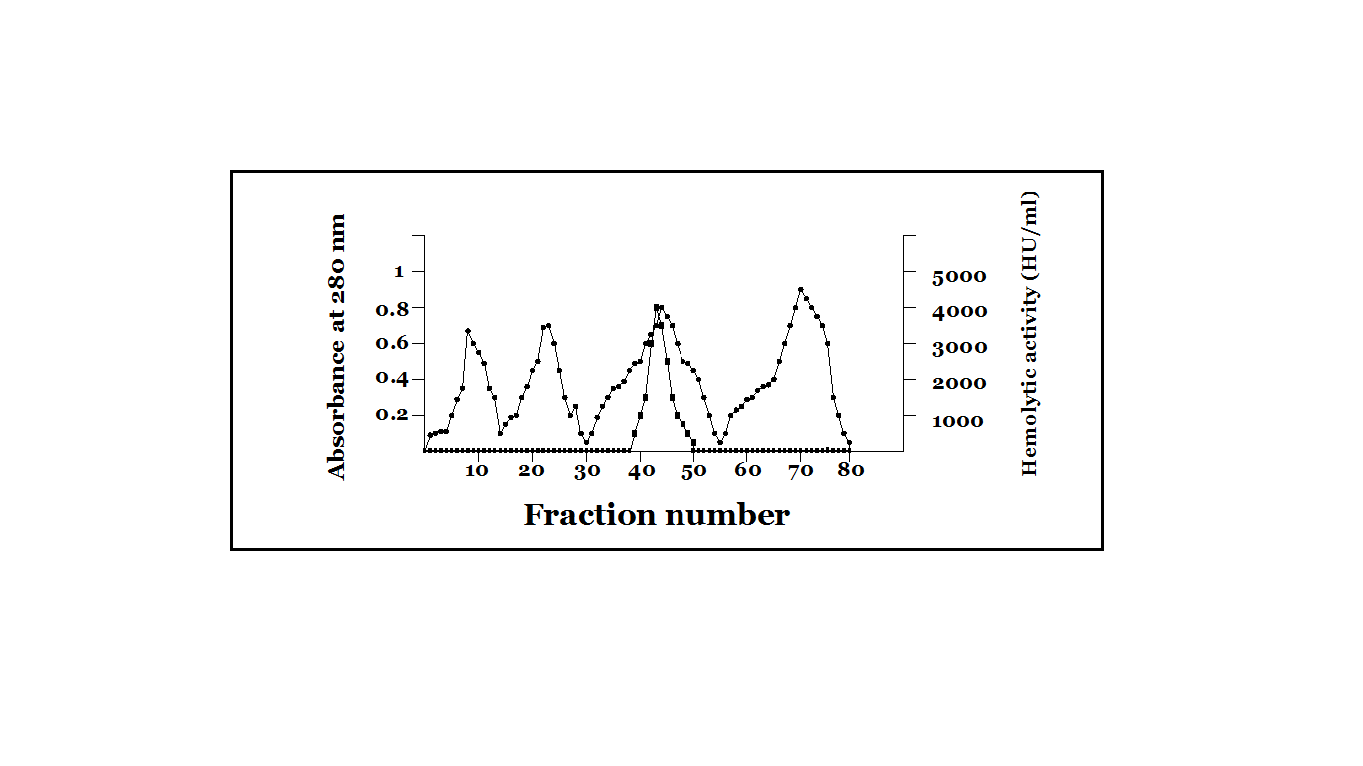
Fraction number
Figure 1 Gel filteration chromatography by used sephacry S-300. Column (2.5 x 90 cm) forpartial purification aerolysin from A.hydrophila strain AH4. The column equilibrated with 0.1M phosphate buffer, pH6.8 and eluted with the same buffer at flow rate, 1 ml\ min, tube volume, 3ml per fraction. Symbols: ●, protein concentration ■, hemolytic activity.

Histopathological effect
The histopathological effect in spleen,liver,kidney and lung of experimental mice which killed after inoculated of partial purification of aerolysin, was observed by routine paraffin section and H.E.staining.The obtained results showed that spleen with extramedullary hemopoiesis and white pulp hyperplasia (Figure 2). While the liver section had marked prominent kupffer cell hyperplasia with Several inflammatory cells were seen in the sinusoids (Figure 3). Damages in kidney were characterized by periarteriola with chronic inflammatory cell infiltration.Mild interstitial hemorrhage with chronic pyelonephritis and necrosis of renal tubular epithelial cells (Figure 4 ). In addition, chronic bronchopneumonia occurred in lung with vascular congestion and parenchymal hemorrhage (Figure 5). The above histopathological observation results manifested that the damage of partial purification of aerolysin to the spleen,liver, kidney and lung of experimental mice is the most serious. These in vivo data pointed to a disseminative role of the aerolysin in the infected animals. This study is the first report that indicate the histopathological effect from aerolysin on internal organs of experimental mice.

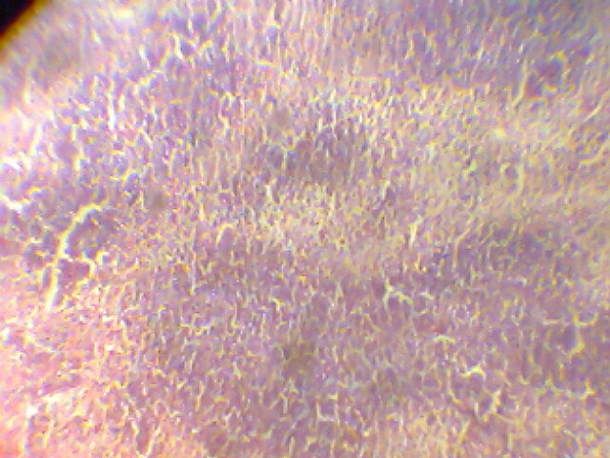

Figure 2 Section in spleen tissue for experimental mouse after injected intraperitoneal by partial purification aerolysin at concentration 1024 U\ml. (Hematoxylin and eosin,magnification 400x ).
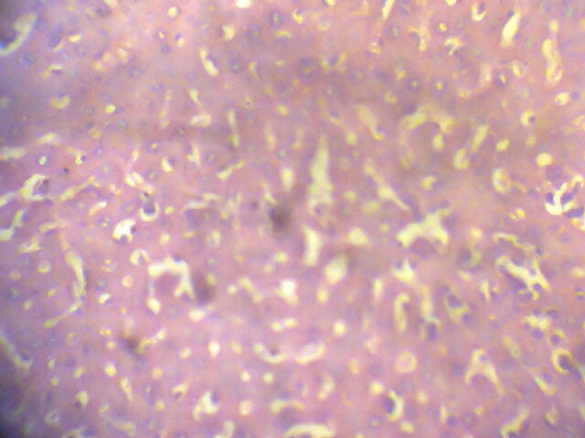

Figure 3 Section in liver tissue for experimental mouse after injected intraperitoneal by partial purification aerolysin at concentration 1024 U\ml. (Hematoxylin and eosin,magnification 400x ).
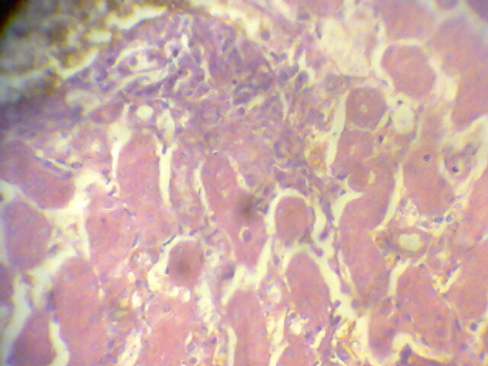
Figure 4 Section in kidney tissue for experimental mouse after injected intraperitoneal by partial purification aerolysin at concentration 1024 U\ml. (Hematoxylin and eosin,magnification 400x ).
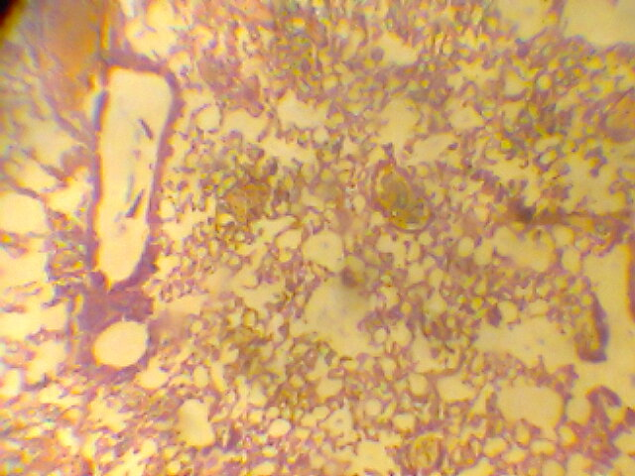
Figure 5 Section in lung tissue for experimental mouse after injected intraperitoneal by partial purification aerolysin at concentration 1024 U\ml. (Hematoxylin and eosin,magnification 200x ).

Discussion
Wound infections are the second most common site for A. hydrophila isolation . Aeromonas species can be associated with a variety of skin and soft tissue infections ranging from mild topical problems such as pustular lesions to serious or life-threatening infections [36]. Fatal Aeromonas wound infections in healthy adults have also been reported [28 ].Recently, Okumura et al. [7] revealed that Aeromonas was isolated in 6.9% of cases from wound infection. While Hiransuthikul, et al. [37] revealed the most common organisms isolated were A. hydrophila 16.2%. In addition, Wang et al. [1 ] reviewed that 9.9% A. hydrophila isolates. A. hydrophila was the most common pathogen identified, accounting for 22.6% of all isolates recovered from 396 persons with skin and soft tissue infections [38]. Aeromonas wound infections have an incubation period of 1-2 days and may be even as short as 8 hours. It resembles streptococcal infection due to its rapid progression. Tissue adherence, cytotoxins, enterotoxin production and extracellular substances contribute
Towards its pathogenecity [27].
Aerolysin gene was detected in 85% of the isolates during the study of [24]. Bhowmik et al. [ 16 ] reviewed that the majority (71 %) of the environmental isolates of A. hydrophila produced aerolysin. While Subashkumar et al. [2] revealed among the 21 isolates, aerolysin producers were 95 % . Among bacterial species isolated from humans, 90% of strains produce aerolysin [ 38 ]. A total of 670 samples activities were observed in 43% of the tested strains [ 29 ]. From 21 isolats of A. hydrophila tested 20 (95.2%) of them were haemolysin producers [2]. Aerolysin gene presented in (72%) for the clinical isolates [ 39 ].
Aerolysin is a channel-forming protein secreted by virulent Aeromonas spp. Some eucaryotic cells, including T-lymphocytes, are sensitive to very low concentrations of the toxin (<10⁻⁹ M). Here we show that aerolysin binds selectively and with high affinity to the glycosylphosphatidylinositol (GPI)-anchored surface protein Thy-1, which is found on T-lymphocyte populations as well as in brain [ 40 ]. Aerolysin is clear that it destroys erythrocytes by breaching the permeability barrier [39,41]. However, at low toxin concentrations, other causes of death may be more important [42]. Aerolysin may have several advantages as a component of molecules targeted to cancer cells., may represent an important new approach to cancer therapy [43].The aerolysin is a main effector of Aeromonas-inducedbarrier impairment, as bacteria, supernatants, or aerolysin alone caused similar barrier effects . Aerolysin is lethal to mice, that immunization against the toxin leads to protection than the parental strain in a mouse model [31,40]. The infectious dose of aerolysin was 11·95 μg/g fish and contained 1·6 HU per fish [32]. Aerolysin is capable of killing mammalian cells at picomolar concentrations [43].
Aerolysin is a well-known pore-forming toxin that was first purified from A. hydrophila [17]. The aerolysin was purified from the extracellular products (ECPs) of A. hydrophila ZN1 strain by affinity chromatography with McAb 3C12B11 and eluted with glycine [44]). Aerolysin was purified by use Hydrophobic column chromatography (phenyl-Sepharose) [33].Aerolysin was purified from Aeromonas sobria AB3 . Briefly, the concentrated supernatant. loaded onto an anion-exchange column with fast protein liquid chromatography apparatus [45] By 60% saturated ammonium sulfate, and chromatographed on a cation exchanger, SP-Toyopearl the toxin was purified [ 21 ].
The mouse organs (lungs, liver, and spleen) were histopathologically analyzed. In the mice infected with A. hydrophila, the lung section had marked vascular congestion, alveolar hemorrhage, and widening of the interstitium. The liver section showed prominent coagulative necrosis of the hepatic parenchyma. Several inflammatory cells were seen in the sinusoids. In the spleen section of mice, the splenic follicle exhibited necrosis and apoptotic cells in the red pulp in proximity to the lymphoid follicle [46].
Furthermore, it is also observed in a study [7] about A. hydrophila infection for fishes. Major histopathologic findings of the disease were observed in liver and kidney tissue. Haemorrhage in liver with degenerative changes in liver and necrosis of pancreatic cells and hyperemia . Focal necrosis of hepatocytes and lymphocyte infiltration. Severe hyperemia in kidney and degenerative changes in tubule epithels. Haemorrhage in kidney and necrosis at tubule epithelial . Internally, the liver and kidneys are target organs of an acute septicemia. These organs are apparently attacked by bacterial toxins and lose their structural integrity. In liver, sinusoids were enlarged and Remak cords were dissociated, observation of focal necrosis in hepatocytes and pancreas cells. The reason of the lipidosis and necrosis of the liver was reported to be associated with toxins and extracellular products such as hemolysin, protease, elastase produced by A. hydrophila .
The extracellular products induce mainly the degeneration of haematopoietic cells, including erythrocytes, giving them a rounded, hyaline appearance, particularly in the kidney and spleen. Most of the mediators of the immune-inflammatory response induced by A hydrophila and/or its toxins through its interaction with mammalian leucocytes have been described in fish. The extracellular products induced milder haemodynamic changes but more severe in tissue changes than the bacteria [32]. Wang and others [1] suggested that the cause of the cytotoxicity of Aeromonas species and their extracellular products may be multifactorial and that the products (haemolysins, aerolysin, enterotoxins, proteases and RNases) may be acting either alone or in concert. The intraperitoneal inoculation of A. hydrophila strain KJ99 into tilapia hybrids and white cachama produced haemodynamic changes similar to those observed in the septicaemic process in mammals. The bacterium itself seems to play a significant role in initiating the pathological process, particularly in inducing inflammation. However, some of the extracellular products released during the infection could also play an important role in the pathogenesis, probably inducing degeneration and necrosis. A wide range of biological functions related to the aerolysin of A hydrophila has been described, including haemolytic and proteolytic activities lethal to fish [32].

References
1-Wang, G.; Clark, C.G.; Liu, C.; Pucknell, C.; Munro, C.K.; Kruk, A.C.; Caldeira, R.; Woodward, D.L. and Rodgers, F.G. (2003). Detection and Characterization of the Hemolysin Genes in Aeromonas hydrophila and Aeromonas sobria by Multiplex PCR. Journal of Clinical Microbiology. 41(3): 1048–1054.
2-Subashkumar, R.; Thayumanavan, T.; Vivekanandhan, G. and Lakshmanaperumalsamy, P. (2006). Occurrence of Aeromonas hydrophila in acute gasteroenteritis among children. Indian J Med Res.123: 61-66.
3-Yousr, A.H.; Napis, S.; Rusul, G.R.A. and Son, R. (2007). Detection of Aerolysin and Hemolysin Genes in Aeromonas spp. Isolated from Environmental and Shellfish Sources by Polymerase Chain Reaction. ASEAN Food Journal. 14 (2): 115-122.
4-Bertuccio, M.P.; Picerno, I. and Scoglio, M.E. (2012). Adherence of Aeromonas hydrophila strains to human enterocyte-like cells pre-infected with Rotavirus. J prev med hyg. 53: 165-168.
5-Roger, F.; Marchandin, H.; Jumas-Bilak, E.; Angeli Kodjo, A. and Lamy, B. (2012). Multilocus genetics to reconstruct aeromonad evolution. MC Microbiology.12:62- 67.
6-Moran, Y.; Fredman, D.; Szczesny, P.; Marcin Grynberg, M. and Technau, U. (2012). Recurrent Horizontal Transfer of Bacterial Toxin Genes to Eukaryotes. Mol. Biol. Evol. 29(9):2223–2230.
7-Okumura, K.; Shoji, F.; Yoshida, M.; Mizuta, A.; Makino, I. and Higashi, H. (2011). Severe sepsis caused by Aeromonas hydrophila in a patient using tocilizumab: a case report. Journal of Medical Case Reports. 5: 499-504.
8-Chen, R.; Zhou, Z.; Cao, Y.; Bai, Y. and Yao, B. (2010). High yield expression of an AHL-lactonase from Bacillus sp. B546 in Pichia pastoris and its application to reduce Aeromonas hydrophila mortality in aquaculture. Microbial Cell Factories. 9:39-46.
9-2Khan, S. J.; Reed, R. H. and Rasul, M. G. (2012). Thin-film fixed-bed reactor for solar photocatalytic inactivation of Aeromonas hydrophila: influence of water quality.BMC Microbiology. 12:285- 288.
10-Vilches, S.; Jimenez, N.; Toma´s, J.M. and Merino, S. (2009). Aeromonas hydrophila AH-3 Type III Secretion System Expression and Regulatory Network. Applied and Environmental Microbiology. 75(19): 6382- 6392.
11-Aberoum, A. and Jooyandeh, H. (2010). A Review on Occurrence and Characterization of the Aeromonas Species from Marine Fishes. World Journal of Fish and Marine Sciences. 2 (6): 519-523.
12-Fujii, Y.; Tsurumi, K.; Masaaki Sato, M.; Eizo Takahashi, E. and Okamoto, K. (2008). Fluid Secretion Caused by Aerolysin-Like Hemolysin of Aeromonas sobria in the Intestines Is Due to Stimulation of Production of Prostaglandin E2 via Cyclooxygenase 2 by Intestinal Cells. Infection and Immunity. 76(3): 1076–1082.
13-McCoy, A.J.; Koizumi, Y.; Toma, C.; Higa, N.; Dixit, V.; Taniguchi, S.; Tschopp, J. and Suzuki, T. (2010). Cytotoxins of the human pathogen Aeromonas hydrophila trigger, via the NLRP3 inflammasome, caspase-1 activation in macrophages. European Journal of Immunology. 40(10): 2797–2803.
14-Zheng, W.; Cao. H. and Yang, X. (2012). Grass carp (Ctenopharyngodon idellus) infected with multiple strains of Aeromonas hydrophila . African Journal of Microbiology Research. 6(21):4512-4520.
15-Cantas, L.; Midtlyng, P.J. and Sørum, H. (2012). Impact of antibiotic treatments on the expression of the R plasmid tra genes and on the host innate immune activity during pRAS1 bearing Aeromonas hydrophila infection in zebrafish (Danio rerio). BMC Microbiology. 12:37-41.
16-Bhowmik, P.; Bag, P. K.; Hajra, T.K.; De, R.; Sarkar, P. and Ramamurthy, T. (2009). Pathogenic potential of Aeromonas hydrophila isolated from surface waters in Kolkata, India. Journal of Medical Microbiology . 58: 1549–1558.
17-Song, T.; Toma, C.; Nakasone, N. and Iwanaga, M. (2004). Aerolysin is activated by metalloprotease in Aeromonas veronii biovar sobria. Journal of Medical Microbiology. 53: 477–482.
18-Jangid, K.; Kong, R.; Patole, M.S. and Shouche, Y.S. (2007). luxRI homologs are universally present in the genus Aeromonas. BMC Microbiology. 7: 93-99.
19-Galindo, C. L.; Sha, J.; Fadl, A. A.; Pillai, L. and Chopra, A. K. (2006). Host immune responses to Aeromonas virulence factors. Curr Immunol Rev. 2: 13–26.
20-Zhu, D.; Li, A.; Wang, J.; Li, M. and Cai, T. (2007). Cloning, expression and characterization of aerolysin from Aeromonas hydrophila in Escherichia coli. Indian Journal of Biochemistry& Biophysics. 44:204-208.
21-Abrami, L.; Fivaz, M.; Glauser, P.; Sugimoto, N.; Chiara Zurzolo, C. and Goot, F.G. (2003). Sensitivity of Polarized Epithelial Cells to the Pore-Forming Toxin Aerolysin. Infection and Immunity. 71(2): 739-746.
22-Sha, J.; Kozlova, E.V. and Chopra, A.K. (2002). Role of Various Enterotoxins in Aeromonas hydrophila-Induced Gastroenteritis: Generation of Enterotoxin Gene-Deficient Mutants and Evaluation of Their Enterotoxic Activity. Infection and Immunity. 70(4): 1924-1935.
23-Zhang, D.; Pridgeon, J.W. and Klesius, P. H. (2013). Expression and activity of recombinant proaerolysin derived from Aeromonas hydrophila cultured from diseased channel catfish. Veterinary Microbiology. 165: 478–482. 24-Singh, V.; Rathore, G.; Kapoor, D.; Mishra, B.N. and . Lakra, W.S. (2008). Detection of aerolysin gene in Aeromonas hydrophila isolated from fish and pond water. Indian Journal of Microbiology. 48(4): 453-458.
25-Szczesny, P.; Iacovache, I.; Muszewska, A.; Ginalski, K.; and Goot, F.G. (2011) Extending the Aerolysin Family: From Bacteria to Vertebrates. PLoS ONE. 6(6): 563-568.
26-Popoff, M.R. (2011). Multifaceted Interactions of Bacterial Toxins With the Gastrointestinal Mucosa.Future Microbiol.6(7):763-797.
27-Easow, J.M. and Tuladhar, R. (2007). Aeromonas hydrophila wound infection following a tiger bite in nepal. Southeast Asian J. Trop. Med. Ppblic Health. 38(5): 867-870.
28-Vally, H.; Whittle, A.; Cameron, S.; Dowse, G. K. and Watson, T. (2004). Outbreak of Aeromonas hydrophila Wound Infections Associated with Mud Football. Clinical Infectious Diseases. 38:1084–1089.
29-Rahman, M.; Huys, G.; Albert, J.; Kuhn, I. and Mollby, R. (2007). Persistence, Transmission, and Virulence Characteristics of Aeromonas Strains in a Duckweed Aquaculture-Based Hospital Sewage Water Recycling Plant in Bangladesh. Applied and Environmental Microbiology. 73(5): 1444–1451.
30-Pridgeon, J. W.; Klesius, P. H.; Song, L.; Zhang, D.; Kojima, K. and Mobley, J. A. (2013). Identification, virulence, and mass spectrometry of toxic ECP fractions of West Alabama isolates of Aeromonas hydrophila obtained from a 2010 disease outbreak. Veterinary Microbiology. 164: 336–343.
31-Bücker, R.; Krug, S.M.; Rosenthal, R.; Gu¨ nzel, D.; Fromm, A. and Zeitz, M. (2011). Aerolysin From Aeromonas hydrophila Perturbs Tight Junction Integrity and Cell Lesion Repair in Intestinal Epithelial HT-29/B6 Cells. The Journal of Infectious Diseases. 204:1283– 1292.
32-Rey, A.; Verján, N.; Ferguson, H.W. and Iregui, C. (2009). Pathogenesis of Aeromonas hydrophila strain KJ99 infection and its extracellular products in two species of fish. Veterinary Record.164:493-499.
33-Rose, J.M.; Houston, C.W.; Coppenhaver, D.H.; Dixon, J.D. and Kurosky, A. (1989). Purification and Chemical Characterization of a Cholera Toxin-Cross-Reactive Cytolytic Enterotoxin Produced by a Human Isolate of Aeromonas hydrophila. Infection and Immunity. 57(4): 1165-1169.
34-Bradford, M. M. (1976). A rapid and sensitive method for the quantitation of microgram quantities of protein utilizing the principle of protein-dye binding. Anal. Biochem. 72:248-254.
35-Humason, C.L. ( 1972 ). Animal tissue techniques (3rd edition ).W.H. Freeman and Company. P. 641.
36-Huang, L.W.; Wang, J. D.; Huang, J.A.; Hu, S.Y.; Lee-Min Wang, L.M. and Tsan, Y. T. (2012). Wound infections secondary to snakebite in central Taiwan. The Journal of Venomous Animals and Toxins including Tropical Diseases. 18 ( 3): 272-276.
37-Hiransuthikul, N.; Tantisiriwat, W.; Lertutsahakul, K.; Vibhagoo, A. and Boonma, P. (2005). Skin and Soft-Tissue Infections among Tsunami Survivors in Southern Thailand. Clinical Infectious Diseases . 41:93–96.
38-Janda, J.M. and Abbott, S.L. (2010). The Genus Aeromonas: Taxonomy, Pathogenicity, and Infection. Clinical Microbiology Reviews. 23(1): 35–73.
39-AL-fatlawy, H.N.K. and AL-ammar, M.H. (2013). Molecular study of Aeromonas hydrophila isolated from stool samples in najaf ( Iraq). International Journal of Microbiology Research. 5 (1): 363-366.
40-Shimada, H. and Kitada, S. (2011). Mega assemblages of oligomeric aerolysin-like toxins stabilized by toxin-associating membrane proteins. J Biochem. 149 (1): 103-115.
41-Fennessey , C.M.; Ivie, S.E. and Mark S. McClain, M.S. (2012). Coenzyme depletion by members of the aerolysin family of pore-forming toxins leads to diminished ATP levels and cell death. Mol. BioSyst.8: 2097-2105.
42-Gonzalez, M.R.; Bischofberger, M.; Frêche, B.; Ho, S. ; Parton, R.G. and Goot, F.G. (2011). Pore-forming toxins induce multiple cellular responses promoting survival. Cellular Microbiology. 13 (7): 1026–1043.
43-Osusky, M.; Teschke, L.; Wang, X.; Wong, K. and Buckley, J.T. (2008). A Chimera of Interleukin 2 and a Binding Variant of Aerolysin Is Selectively Toxic to Cells Displaying the Interleukin 2 Receptor. The Journal of Biological Chemistry. 283(3): 1572–1579.
44- Hui, G.; TianLong, L.; ChangAn, X.; XiaoPei, Z. and XianLe, Y. (2009). Purification of aerolysin of Aeromonas hydrophila by affinity chromatography and analysis of its hemolytic activity. Chinese Journal of Zoonoses. 25(5): 422-425.
45-Chakraborty, T.; Schmid, A.; Notermans, S. and BENZ, R. (1990). Aerolysin of Aeromonas sobria: Evidence for Formation of Ion- Permeable Channels and Comparison with Alpha-Toxin of Staphylococcus aureus. Infection and Immunity. 58(7): 2127-2132.
46-Sha, J.; Erova, T.E.; Alyea, R.A.; Wang, S.; Olano, J.P.; Pancholi, V. and Chopra, A.K. (2009). Surface-Expressed Enolase Contributes to the Pathogenesis of Clinical Isolate SSU of Aeromonas hydrophila. Journal of Bacteriology. 191(9): 3095–3107.
47-Yardimci, B. and Ydin, Y. (2011). Pathological findings of experimental Aeromonas hydrophila infection in Nile tilapia (Oreochromis niloticus). Ankara Üniv Vet Fak Derg. 58: 47-54.

