Designing A Model of Induced-Benzhexol Addiction In Male Rats
Selman Mohammed Selman¹ Abdul Al-Razzak Abdul Latif¹
Husam Hasson Ali²
¹ College of Medicine, Babylon University, Babylon, Iraq.
E-mail : selman_mohammed@yahoo.com
² The Iraqi Council of Medical Specializations, Baghdad, Iraq.



Received 13 April 2014 Accepted 12 May 2014
Abstract
Background: Benzhexol hydrochloride ( Trihexyphenidyl ) is a potent anticholinergic agent. Abuse of benzhexol has been noted with increasing frequency in recent years By reviewing the relevant literature, no model for benzhexol addiction in rats was found.
Aim of the study: to designing a model of induced benzhexol addiction in male rats.
Materials and methods: Thirty two male, adult, Albino rats were enrolled in this experiments. The animals were randomly divided into 4 g.oups, eight rats for each group. Each rat of group 1 received normal saline (N.S.) in equal volume to the benzhexol dose, twice daily (b.d.), orally (p.o.) by gastric tube for 10 days. Each rat of group 2,3 and 4 received benzhexol 0.1mg, 0.2mg and 0.4mg respectively, b.d., p.o. by gastric tube for 10 days. On the 11th day, each rat was placed in the open-field chamber for 15 minutes and all behaviors (withdrawal symptoms) of the animals were recorded by video camera.
Results and conclusion: Withdrawal symptoms such as rooming, wet dog shakes, head shakes, abdominal constriction, facial fasciculation, ptosis and piloerection significantly increased (P<0.05) in group 3 and 4 as compared with control group and model of benzhexol addiction in male rats can be induced by administration of 0.2 or 0.4 mg/kg of benzhexol, pd, po, for 10 days

Keywords: Benzhexol, withdrawal symptoms, grooming, wet dog shakes, head shakes, , abdominal constriction, facial fasciculation, ptosis, piloerection and irritability.
تصميم موديل لادمان البنزهكسول المستحدث في ذكور الجرذان
الخلاصة
يعتبر البنزهكسول هايدروكلورايد (الارتين) دواءً فعالاً مضاداً للكولينرجك, و ان اساءة استعمال هذا الدواء زاد بشكل مضطرد في السنوات الاخيرة, حيث تشير البيانات المتوفرة الى عدم وجود موديل للادمان على هذا الدواء في الجرذان. هدفت هذه الدراسة الى تصميم موديل لادمان البنزهكسول المستحدث في ذكور الجرذان. تم استعمال اثنان و ثلاثون جرذا ذكرا و قسموا عشوائيا الى اربعة مجاميع, ثمانية حيوانات في كل مجموعة. اعطيت المجموعة الاولى نورمال سلاين, اما المجموعات الثانية و الثالثة و الرابعة فقد اعطيت عقار االبنزهكسول بجرع 0.1 و 0.2 و 0.4 ملغم/كغم حسب التوالي مرتين يوميا لمدة 10 أيام عن طريق الفم. ان نتائج هذه الدراسة تشير الى حصول زيادة بالغة الاهمية بالاعرض الانسحابية كالصقل, انتفاضة الكلب المبلل, اهتزاز الرأس, تقلصات عضلات الوجه, تهدل الاجفان, و تقلصات عضلات البطن في المجموعتين الثالثة و الرابعة. يستنتج من نتائج هذه الدراسة انه يمكن استحداث ادمان البنزهكسول في ذكور الجرذان باعطائها عقار البنزهكسول بجرعة 0.2 ملغم/كغم مرتين يوميا لمدة 10 أيام عن طريق الفم.
ـــــــــــــــــــــــــــــــــــــــــــــــــــــــــــــــــــــــــــــــــــــــــــــــــــــــــــــــــــــــــــــــــــــــــــــــــــــــــــــــــــــــــــــــــــــــــــــــــــــــ

Introduction
Benzhexol hydrochloride ( Trihexyphenidyl ) is a potent anticholinergic agent [1]. It causes reversible blockade of cholinomimetic action at muscarinic receptors [2]. It characterized by a higher affinity for the neuronal (M1) muscarinic receptor than other subtypes of (M2 and M3) muscarinic receptors [3]. Benzhexol can be used for Parkinson's disease [4,5], extrapyramidal side effects, such as tradive dyskinesia, occurring during antipsychotic treatment [6,7,8], dystonia [9,10], tremor [11,12], excessive salivation [13,14] , spasmodic torticollis [15,16].
Abuse of benzhexol has been noted with increasing frequency in recent years [17,18,19,20]. By reviewing the relevant literature, no model for benzhexol addiction in rats was found.
Two drugs, opioids and alcohol, provide classic examples of rodent somatic signs of withdrawal and served as models for measures of withdrawal per se. The somatic signs of withdrawal are an index of dependence and provide a quantifiable measure by which to assess the level of dependence [21].
Opioid withdrawal signs in rodents include weight loss, grooming, , wet dog shakes, abdominal constrictions, facial fasciculation/teeth chattering, ptosis, abnormal posture, diarrhea and irritability[22].
For alcohol, withdrawal signs characterized by hyperactivity, tail tremors, tail stiffness, head tremors, general tremors, wet shakes, teeth chattering, akinesia, spastic rigidity, and convulsions [23].
Aim of the study: to design a model of induced benzhexol addiction in male rats.
Materials and methods
- Animals:
Thirty two male, adult, Albino rats were enrolled in this experiments. Their weights were 150-200 g. The rats were housed in the Animal House of the College of Medicine/Babylon University, and kept on 25ºC and 12 hours light –dark cycle with water and food ad libitum. After two weeks of adaptation, the animals were randomly divided into 4 g.oups, eight rats for each group.
- Drug
Benzhexol HCL (Parkizol tablet, 5mg, PHARMALINE, Lebanon) was dissolved in 50 ml of normal saline (N.S.), so the final product contained 0.1 mg of benzhexol in each ml.
- Experimental protocol
- Each rat of group 1 received N.S. in equal volume to the benzhexol dose, twice daily (b.d.), orally (p.o.) by gastric tube for 10 days
- Each rat of group 2,3 and 4 received benzhexol 0.1mg, 0.2mg and 0.4mg respectively, b.d., p.o. by gastric tube for 10 days.
- On the 11th day, each rat was placed in the open-field chamber for 15 minutes and all behaviors (withdrawal symptoms) of the animals were recorded by video camera.
- Open-field box
A glass chamber (40 cm x 30 cm x 30 cm) was made by the researcher (Picture 1). The rats were placed in this chamber and their activities were recorded by video camera.

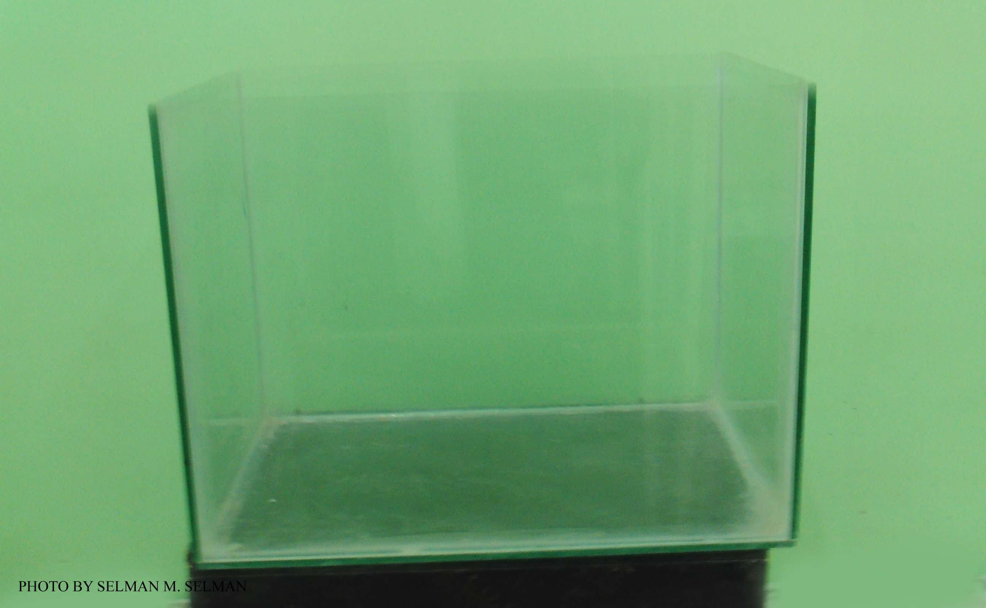
Picture 1: Open-field box.

- Video camera
Digital Video Camera, (SONY, Japan) was used in this experiment to record the behaviors of animals
- Statistical data
The results were expressed as mean ± standard error of the mean (SEM). Statistical analysis was carried out by using one way ANOVA. Differences were considered statistically significant if the p value is lower than 0.05. The data of the research were carried out by using 17th edition of IBM® SPSS® statistics for Windows® 7.

Results
- Number of grooming
There is no significant difference (P>0.05) in the number of grooming (Pictures 2 and 3 ) between control group and group 2, while number of grooming significantly increased (P<0.05) in group 3 and 4 as compared with control group. Number of grooming in group 3 and 4, also, significantly increased (P<0.05) as compared with group 2, while there is no significant increase between groups 3 and 4 (P>0.05) (Figure 1) .

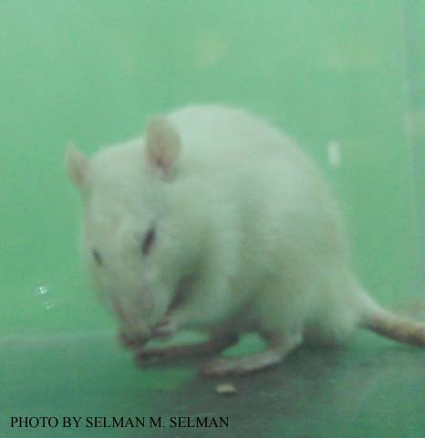
Picture 2: Forelimbs grooming

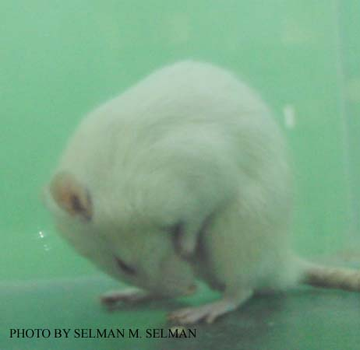
Picture 3: Penile grooming
Figure 1: Mean of the grooming, wet dog shakes, and head shakes of all groups for 10 days following benzhexol withdrawn; group 1 (control group) and group 2 ( benzhexol 0.1 mg/kg), group 3 ( benzhexol 0.2 mg/kg), and group 4 ( benzhexol 0.4 mg/kg).

- Number of wet dog shakes
There is no significant difference (P>0.05) in the number of wet dog shakes between control group and group 2, while number of wet dog shakes significantly increased (P<0.05) in group 3 and 4 as compared with control group. Number of wet dog shakes in group 3 and 4, also, significantly increased (P<0.05) as compared with group 2, while there is no significant increase between groups 3 and 4 (P>0.05) (Figure 1) .
- Number of head shakes
There is no significant difference (P>0.05) in the number of head shakes between control group and group 2, while number of head shakes significantly increased (P<0.05) in group 3 and 4 as compared with control group. Number of head shakes in group 3 and 4, also, significantly increased (P<0.05) as compared with group 2, while there is no significant increase between groups 3 and 4 (P>0.05) (Figure 1) .
- Other withdrawal symptoms
There is no significant difference (P> 0.05) in the percentage of occurrence of abdominal constriction, facial fasciculation, Piloerection (Picture 4 ) and ptosis (Picture 5 )between group 2 and control group, while they significantly increased in groups 3 and 4 as compared with control group.
Also there is no significant difference (P> 0.05) in the percentage of occurrence of abdominal constriction, facial fasciculation, ptosis, piloerection, and irritability between groups 3 and 4, and control group (Table 1)

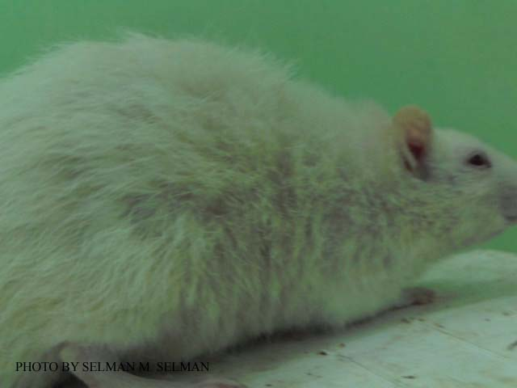
Picture 4: Piloerection

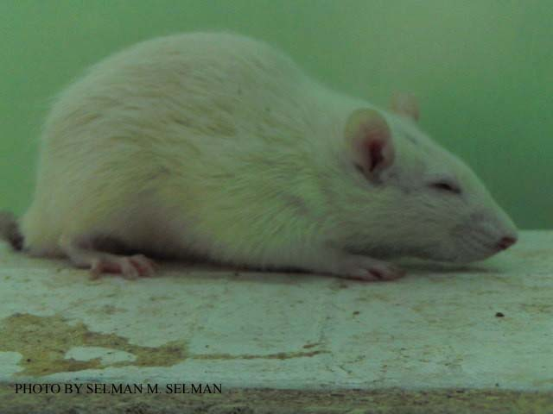
Picture 5: Ptosis
Table 1: Percentage of occurrence of abdominal constriction, facial fasciculation, ptosis, and piloerection in different groups ( group 1:control group; group 2: benzhexol 0.1 mg/kg ; group 3: benzhexol 0.2 mg/kg; and group4: benzhexol 0.4 mg/kg).
 | Abdominal constriction | Facial  Fasciculation | Ptosis | Piloerection
Group 1 | 0 % | 12.5 % | 0 % | 0 %
Group 2 | 0 % | 25% | 12.5 % | 0 %
Group 3 | 100 % * | 100 % * | 87.5 % * | 75 %
Group 4 | 100 % * | 100 % * | 100 % * | 75 %
*P<0.05

Discussion
With this study, statistical analysis revealed that withdrawal symptoms such as grooming, wet dog shakes, head shakes, abdominal constriction, facial fasciculation, ptosis, piloerection, and irritability did not occurred after termination of 0.1mg/kg of benzhexol, pd, for 10 days, but occurred after termination of 0.2 mg/kg and 0.4 ,mg/kg of benzhexol, pd, for 10 days. These withdrawal symptoms are the classic withdrawal symptoms of other drugs in rodents [21] (Koob, 2011).
By reviewing the relevant literature, no specific animal model for benzhexol addiction was found. Benzhexol withdrawal symptoms which occur in this study agree with those reported in opioids and alcohol withdrawal symptoms [21,22] ((Koob, 2011; Gellert and Holtzman, 1978).
Conclusion
Model of benzhexol addiction in male rats can be induced by administration of 0.2 or 0.4 mg/kg of benzhexol, pd, po, for 10 days
References
- Stephens D.A. (1967) Psychotoxic effects of benzhexol hydrochloride (Artane). British Journal of Psychiatry; 113:213-218
- Doods H.N.(1987) selectivity of muscarinic antagonists in radioligand and in vivo experiments for the putative M1,M2, and M3 receptors. J. Pharmacol. Exp. Ther. ; 242:257
- Montage E., Ladinsk H., Giraldo E. and giachetti A. (1986) Finding and functional profiles of the selective M1 muscarinic receptor antagonists trihexyphenidyl and dicyclomine. Br. J. pharmacl.; 89(1): 83-90
- Quin N (1995) Treatment of Parkinson's disease. Br. Med. J.; 310-575
- Lees A., Costa J., Sampaio C. and Katzenschlager (2003) Anticholinergics for symptomatic management of Parkinson's disease. Cochrane Database Syst. Rev.;(2): CD003735
- Bartzokis G., Cummings J.L., Freidengerg D.L. and Wirshing W.C. (1989) Effects of anticholinergic agents on patients with tradive dyskinesia and concomitant drug-induced parkinsonism. J. Clin. Psychopharmacol.;9(6):407-411
- Gardos G. Casey D.E., Cole J.O., Perenyi A., Kocsis, E., Arato M., Samson J.A. and Conley C. (1994)Ten-year outcome of tradive dyskinesia. Am. J. Psychiatry; 151: 836-841
- Ndambuki D., owiti p., manguro G and Atwoli L. (2009)Neurileptic induced tradive dyskinesiain patient on treatment for schizophrenia: case report. East Afr. Med. J.; 86(7):354-356
- Soman T. and Appendino J.P. (2008) Correspondence on "Prospective open-label clinical tria of trihexyphenidyl in children with secondary dystonia due to cerebral palsy". J. Child. Neurol.; 23(7): 846-847
- Bressman S. and Lubarr N. (2011) Treatment of generalized dystonia. Curr. Treat.Opions Neurol.; 13(3): 274-289
- Shih P.Y. and Liou L.M. (2006) Successful treatment of rubral tremor by high-dose trihexiphenidyl: a case report. Kaohsiung J. Med. Sci;22(3): 149-153
- Hsu E. and Packard M.G. (2007) Medial prefrontal cortex infusions of bupivacaine or AP-5 block extinction of amphetamine conditioned place preference. Neurobiol. Learn. Mem.; 89: 504-512
- Aggarwal A., Garg A. and Jiloha R.C. (2009) Trihexyphenidyl (benzhexol) in clozapin-induced nocturnal enuresis and sialorrhea. Indian J. Med. Sci.; 63(10): 470-471
- Sinha V.K., Khanande R.V., Sarkhel S. and Praharaji S.K. (2010) Complete resolution of clozapine-induced sialorrhea with low dose trihexyphenidyl. Psychopharmacol. Bull.; 43(4):73-75
- Scherokman B., Jabbari B., Gunderson C.H., Miller J.M. and Rappaport H.L. (1986) Trihexyphenidyl and torticollis. Neuroloy; 36(12): 1626-1631
- Smith F.W., McFadyen M., sharp P.F., Gemmell H.G., Embeier K.P. and Besson J.A. (1988) Brain imaging and treatment response in spasmodic torticollis. Br. J.psychiatry; 153: 399-402
- Neil B., Anthony W. and Prue K. (2000) Misuse of anticholinergic drugs by people with serious mental illness. Psychiatry Serv.; 51: 928-929
- Quershi N.A. (1992) Trihexyphenidyl (artane) abuse among Saudi psychiatric patients. Annals of Saudi Medicine; 12:391-394
- Reggio P., Pradel V., Saillard C., Debruyne D., Natali F., Chanut C., Thirion X., Frauger E. and Micallif J. (2003) misuse of trihexyphenidyl ( Artane, Parkinane ): recent trands. Therapie.; 58(6): 541-547
- Nappo S.A., de Oliveira L.G., Sanchez Zv. And Carlini Ede A. (2005) Trihexyphenidyl (Artane): a Brazilian study of its abuse. Subst. use Misuse; 40(4): 473-482
- Koob G.F. (2011) Animal models of drug dependence: motivational perspective. In Addiction medicine science and practice, ed by Bankole A. Johnson editor; 333-359, Springer
- Gellert V.F. and Holtzman S.G. (1978) Development and maintenance of morphine tolerance and dependence in the rat by scheduled access to morphine drinking solutions. J. Pharmacol. Exp. Ther.; 205: 536-546
- Majchrowicz E. (1975) Induction of physical dependence upon ethanol and the associated behavioral changes in rats. Psychopharmacologia; 43:245-254

