Benzhexol Causes Conditioning Place Preference in Male Rats
Selman Mohammed Selman¹ Abdul Al-Razzak Abdul Latif¹
Husam Hasson Ali²
¹ Department of Pharmacology, College of Medicine, Babylon University, Babylon, Iraq.
² The Iraqi Council of Medical Specializations Baghdad, Iraq.
E-mail: selman_mohammed@yahoo.com



Received 13 April 2014 Accepted 12 May 2014
Abstract
Background: Benzhexol hydrochloride ( Trihexyphenidyl ) is a potent anticholinergic agent. Abuse of benzhexol has been noted with increasing frequency in recent years
Aim of the study: to determine the conditioning place preference of benzhexol administration in the male rats.
Materials and methods: Sixteen male, adult, albino rats were useded in this experiments. The animals were randomly divided into 2 groups, eight rats for each group. Each rat of group 1 was placed in the control compartment and once the rat enter the drug compartment, the animal received N.S. in equal volume to the benzhexol dose,, orally (p.o.), by gastric tube. Each rat of group 2 was placed in the control compartment and once the rat enter the drug compartment, the animal received benzhexol 0.2 mg/kg, p.o., by gastric tube. Previous two steps were repeated twice daily for 10 days. On 11th day, each rat in was placed in the control compartment for 10 minutes and all behaviors of the animals were recorded by video camera.
Results and conclusion: In group 2 (benzhexol 0.2 mg/kg), the time which spent in the drug chamber (white and brown color) significantly increased (P<0.05) as compared with the time which spent in the control chamber. This study reported that administration of 0.2 mg/kg of benzhexol, twice daily (pd), for 10 days caused conditioning place preference in the rats.
Keywords:Benzhexol, conditioned place preference test, rat

عقار البنزهكسول يسبب تفضيلا شرطيا للمكان في ذكور الجرذان
الخلاصة
يعتبر البنزهكسول هايدروكلورايد (الارتين) دواءً فعالاً مضاداً للكولينرجك, و ان اساءة استعمال هذا الدواء زاد بشكل مضطرد في السنوات الاخيرة . هدف البحث هو لبيان تفضيل المكان الشرطي لعقار البنزهكسول في ذكور الجرذان باستعمال اختبار تفضيل المكان الشرطي.تم استعمل ستة عشر جرذا ذكرا, قسمت ال مجموعتين بواقع ثمانية حيوانات في كل مجموعة وقد وضع كل جرذ من المجموعة الاولى في قسم السيطرة و في حال دخوله قسم الدواء يعطى الحيوان حجما من النورمال سلاين مساويا لجرعة البنزهكسول, مرتين يوميا عن طريق الفم بواسطة انبوبة المعدة. و قد تم وضع كل جرذ من المجموعة الثانية في قسم السيطرة و في حال دخوله قسم الدواء يعطى الحيوان 0,2 ملغم/كغم من البنزهكسول , مرتين يوميا عن طريق الفم بواسطة انبوبة المعدة. كررت الخطوتين السابقتين مرتين يوميا لمدة عشرة ايام. في اليوم الحادي عشر من الدراسة ان الوقت الذي قضته حيوانات المجموعة الثانية في قسم الدواء قد ازداد زيادة ذو قيمه (P<0.05) نسبة الى الوقت الذي قضته الحيوانات في قسم السيطرة .اثبت هذا البحث ان اعطاء 0,2 ملغم/كغم من البنزهكسول, مرتين يوميا عن طريق الفم للجرذان لمدة عشرة ايام سبب تفضيلا شرطيا للمكان.

Introduction
Conditioned place-preference paradigm is a behavioral paradigm which has been used extensively in the study of the neural mechanisms of addiction [1].
In experiments involving conditioned place-preference paradigm, rats repeatedly receive a drug in one compartment ( the drug compartment ) of a two-compartment box. Then during the test phase, the rat is placed in the box drug-free, and the proportion of time it spends in the drug compartment, as opposed to the equal1-sized but distinctive control compartment, is measured. Rats usually prefer the drug compartment has been associated with the effects of the drugs to which humans become addicted [2].
Benzhexol hydrochloride (Trihexyphenidyl ) is a potent anticholinergic agent [3]. It causes reversible blockade of cholinomimetic action at muscarinic receptors [4]. Benzhexol can be used for treatment of Parkinson's [5], extrapyramidal side effects, such as tradive dyskinesia, occurring during antipsychotic treatment [6,7,8], dystonia [9], tremor [10], excessive salivation [11], spasmodic torticollis [12].
Abuse of benzhexol has been noted with increasing frequency in recent years [13,14,15,16].
Aim of the study: to determine the conditioning place preference of benzhexol administration in the male rats.

Materials and methods
1- Animals
Sixteen male, adult, albino rats were useded in this experiments. Their weights were 150-200 g. The rats were housed in the Animal House of the College of Medicine/Babylon University, and kept on 25ºC and 12 hours light –dark cycle with water and food ad libitum. After two weeks of adaptation, the animals were randomly divided into 2 groups, eight rats in each group.
2-Drug
Benzhexol HCL (Parkizol tablet, 5mg, PHARMALINE, Lebanon) was dissolved in 50 ml of N.S., so the final product contained 0.1 mg of benzhexol in each ml.
3-Conditioned place-preference box
As described by John (2000), a box ( 60 cm x 20 cm x 40 cm ) was made by the researcher and a plate ( containing a small opening allowing the rat to transferred freely from one compartment to another ) divided a box in to two equal compartments ( Picture 1 ). One of the compartments was white and brown in color and the other was brown. The white and brown compartment was considered as a drug compartment ( rats repeatedly received a drug in this compartment ), while the brown compartment was considered as a control compartment. During the test, the rats were placed in the control compartment, and the proportion of the time which was spent in the drug compartment was measured (John, 2000).

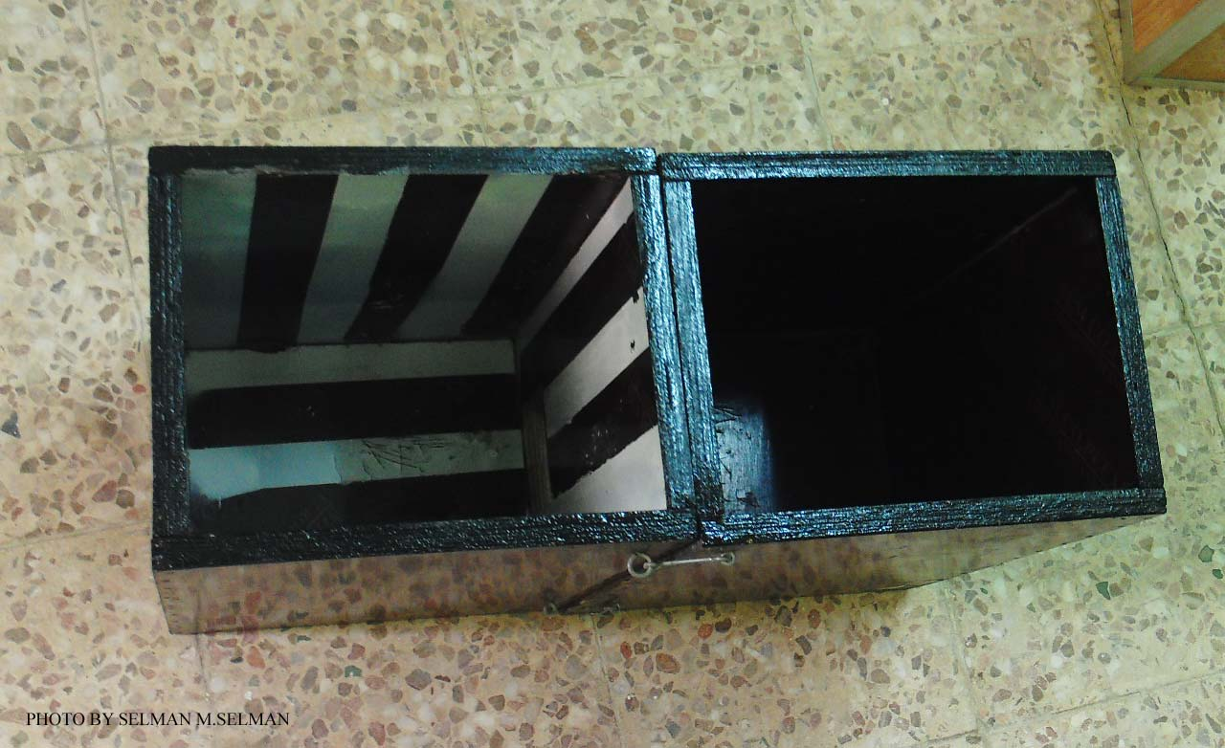
Picture 1 Conditioned place-preference box

4- Procedure
- Each rat of group 1 was placed in the control compartment and once the rat enter the drug compartment, the animal received N.S. in equal volume to the benzhexol dose,, p.o., by gastric tube.
- Each rat of group 2 was placed in the control compartment and once the rat enter the drug compartment, the animal received benzhexol 0.2 mg/kg, p.o., by gastric tube.
- Previous two steps were repeated twice daily for 10 days.
- On 11th day, each rat was placed in the control compartment for 10 minutes and all behaviors of the animals were recorded by video camera.
Statistical analysis
The results were expressed as mean ± standard error of the mean (SEM). Statistical analysis was carried out by using one way ANOVA. Differences were considered statistically significant if the p value is lower than 0.05.
Statistical analysis was carried out by using 17th edition of SPSS® statistics for Windows®

Results
In control group, there is no significant difference (P>0.05) between the time which spent in the drug chamber and the time which spent in the control chamber, while in group 2 (benzhexol 0.2 mg/kg), the time which spent in the drug chamber (white and brown color) significantly increased (P<0.05) as compared with the time which spent in the control chamber (brown color) (Picture 2 and Figure 1)

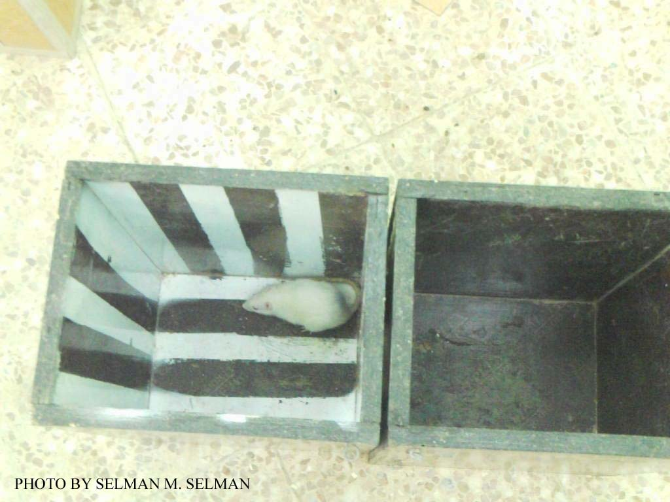
Picture 2 Rat from group 2 in drug chamber (white and brown color) of the conditioned lace preference test.
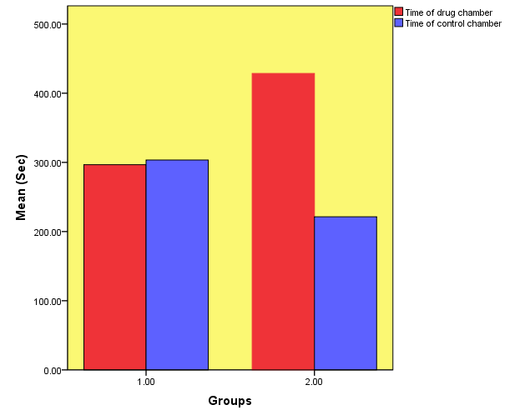
Figure 1 Mean of the times which spend in the drug chamber (red color) and control chamber (blue color)in the conditioned place-preference test in two groups; group 1 (control group) and group 2 ( benzhexol 0.2 mg/kg).

Discussion
This study reported that administration of 0.2 mg/kg of benzhexol, pd, for 10 days caused conditioning place preference in the rats. Up to our knowledge, no previous data were found about the conditioning place preference of benzhexol. However, this finding agrees with other studies which reported that all addictive drugs have conditioning place preference. Bardo et al (1984) reported that animals displayed condition place preference as a significant increase in duration spent within morphine-associated environment [17]. The results of Nomikos and Spyraki study (1988) showed that place preference conditioning procedure to be a valid test for evaluating rewarding properties of cocaine [18]. Shoaib et al (1993) published a report of conditioned place preference produced by nicotine [19].
Conditioned place preference, has been used extensively to probe the psychological [20] and neurobiological [21] mechanisms underlying the rewarding properties of addictive drug.

Conclusion
Benzhexol has reward effect in male rats.

References
- John P. J. Pinel ( 2000 ). Drug addiction and reward circuits in the brain. Biopsychology, 13: 343-370, Allyn and Bacon press, USA.
- Tzschentke T.M. (1998)Measuring reward with the conditioning place preference paradigm: a comprehensive review of drug effects, recent progress and new issues. Prog. Neurobiol. ;56: 613-672.
- Stephens D.A. (1967) Psychotoxic effects of benzhexol hydrochloride (Artane). British Journal of Psychiatry; 113:213-218
- Doods H.N.(1987) selectivity of muscarinic antagonists in radioligand and in vivo experiments for the putative M1,M2, and M3 receptors. J. Pharmacol. Exp. Ther. ; 242:257
- Quin N (1995) Treatment of Parkinson's disease. Br. Med. J.; 310-575
- Bartzokis G., Cummings J.L., Freidengerg D.L. and Wirshing W.C. (1989) Effects of anticholinergic agents on patients with tradive dyskinesia and concomitant drug-induced parkinsonism. J. Clin. Psychopharmacol.;9(6):407-411
- Gardos G. Casey D.E., Cole J.O., Perenyi A., Kocsis, E., Arato M., Samson J.A. and Conley C. (1994)Ten-year outcome of tradive dyskinesia. Am. J. Psychiatry; 151: 836-841
- Ndambuki D., owiti p., manguro G and Atwoli L. (2009)Neurileptic induced tradive dyskinesiain patient on treatment for schizophrenia: case report. East Afr. Med. J.; 86(7):354-356
- Bressman S. and Lubarr N. (2011) Treatment of generalized dystonia. Curr. Treat.Opions Neurol.; 13(3): 274-289
- Shih P.Y. and Liou L.M. (2006) Successful treatment of rubral tremor by high-dose trihexiphenidyl: a case report. Kaohsiung J. Med. Sci;22(3): 149-153
- Sinha V.K., Khanande R.V., Sarkhel S. and Praharaji S.K. (2010) Complete resolution of clozapine-induced sialorrhea with low dose trihexyphenidyl. Psychopharmacol. Bull.; 43(4):73-75
- Smith F.W., McFadyen M., sharp P.F., Gemmell H.G., Embeier K.P. and Besson J.A. (1988) Brain imaging and treatment response in spasmodic torticollis. Br. J.psychiatry; 153: 399-402
- Neil B., Anthony W. and Prue K. (2000) Misuse of anticholinergic drugs by people with serious mental illness. Psychiatry Serv.; 51: 928-929
- Quershi N.A. (1992) Trihexyphenidyl (artane) abuse among Saudi psychiatric patients. Annals of Saudi Medicine; 12:391-394
- Reggio P., Pradel V., Saillard C., Debruyne D., Natali F., Chanut C., Thirion X., Frauger E. and Micallif J. (2003) misuse of trihexyphenidyl ( Artane, Parkinane ): recent trands. Therapie.; 58(6): 541-547
- Nappo S.A., de Oliveira L.G., Sanchez Zv. And Carlini Ede A. (2005) Trihexyphenidyl (Artane): a Brazilian study of its abuse. Subst. use Misuse; 40(4): 473-482
- Bardo M.T., Miller J.S. and Neisewander J.L. (1984) Conditioned place preference with morphine: the effect of extinction training on the reinforcing CR. Pharmac. Bioch. Behav.; 21(4): 545-549
- Nomikos G.G., Spyraki C. (1988) Cocaine-induced place preference conditioning: importance of route of administration and other procedural variables. Psychopharmacol. (Berl); 94(1): 119-125
- Shoaib M., Benwell M.E., Akbar M.T., Stolerman I.P. and Balfour D.J. (1994) Behavioural and neurochemical adaptations to nicotine in rats: influence of NMDA antagonist. Br. J. Pharmacol.; 111(4): 1073-1080
- Pelloux Y., Costentin J., and Duterte-Boucher D. (2004) Differential effects of novelty exposure on place preference conditioning to amphetamine and its oral consumption. Psychopharmacology; 171: 277-285
- Bardo M.T. and Bevins R.A. (2000). Conditioned place preference: what does it add to our preclinical understanding of drug reward?. Psychopha-rmacol.; 153(1): 31-43

