The Effects of Estradiol and Progesterone Therapy on Rat Uterine Tube Epithelium. Transmission Electron Microscope Study

Hussein Abbas Jarullah ¹ Haider AR Ja'afar² May F. Alhabib²
¹ Dept. of Anatomy, College of Medicine, University of Babylon, Hilla, IRAQ.
² Dept.of Anatomy, College of Medicine, Al-Nahrain University, Baghdad, IRAQ.



Received 9 February 2014 Accepted 20 May 2014
Abstract
The uterine tubes are the female structures that transport the ova from the ovary to the uterus, beside their function in the transport the fertilized egg to the uterus for implantation.
Transmission electron microscope (TEM) study revealed that ciliated cells showed abundant elongated cilia in addition to the existence of mitochondria and rough endoplasmic reticulum within their cytoplasm. These findings were more evident in metestrousphase. In the treated group; T III and T II groups reveal very long and more abundant cilia, also the basal bodies of the cilia were enlarged and more obvious. Moreover, some of the ciliated cells displayed cytoplasmicvacuole like structures (probably lipid droplets).
The secretory cells showed secretory granules of high electron dense homogenous matrix and they were more evident in metestrous phase. While in the treated group, especially T III group; the secretory granules strikingly abundant compared to that of control group, revealed highly electron dense matrix, different sizes and occupied the whole cytoplasm of the secretory cells. In the control group cytoplasmic vacuoles were more evident in the metestrous phase. While in the treated group, especially TIII, they appeared larger in size and seemed to be coalesced with each other. Many secretory cells showed cytoplasm protrusion from their apices. These cytoplasmic protrusions were more obvious in T III group.
The administration of progesterone which was preceded by estradiol was capable of producing complete differentiation and secretory function in the uterine tube epithelium, which may be due to the up-regulation of progesterone receptors by estradiol.
تأثيرات علاج الاسترادايول والبروجستيرون على ظهارة الانبوب الرحمي للجرذ. دراسة باستخدام المجهر الالكتروني النافذ
الخلاصة
كشفت الدراسة التركيبية الدقيقة للانبوب الرحمي للجرذ الابيض، باستخدام المجهر الالكتروني النافذ، أن الخلايا المهدبة في منطقة الانبورةتظهر أهداب متطاولة وفيرة بالإضافة إلى وجود المايتوكوندريا و الشَّبَكَةُ الاندوبلازمية الخَشْنَة داخل السايتوبلازم. وكانت هذه النتائج أكثروضوحا في الطور الأصفري (تلية الوداق). اما مجموعة المعالجة؛ مجموعتي T III و T II فقد اظهرت أهداب طويلة جدا و أكثر وفرة، اضافة الى ان بعض الخلايا المهدبة اظهرت بنيات تشبه الفجوات (من المحتمل قطرات دهنية) داخل السايتوبلازم.
أظهرت الخلايا الإفرازية في بطانة الانبوب الرحمي لمنطقة الانبورة وجود حبيبات إفرازية متوسطة الحجم ذات كثافة الكترونية عالية و كانت أكثر وضوحا في طور تلية الوداق. بينما في مجموعة T III، فان الحبيبات الإفرازية وفيرة بشكل لافت للنظر، وذات كثافة الكترونية عالية، وأحجام مختلفة و تحتل كل سايتوبلازم الخلايا الإفرازية .
في مجموعة السيطرة كانت الفجوات السايتوبلازمية أكثر وضوحا في طور تلية الوداق. بينما في مجموعةTIII ، فتميزت بحجم أكبر وبدت ملتئمة مع بعضها البعض . وأظهرت العديد من الخلايا الإفرازية نتوء سايتوبلازمي من قممها. كانت هذه النتوءات السايتوبلازمية أكثر وضوحا في مجموعة T III.
ـــــــــــــــــــــــــــــــــــــــــــــــــــــــــــــــــــــــــــــــــــــــــــــــــــــــــــــــــــــــــــــــــــــــــــــــــــــــــــــــــــــــــــــــــــــــــــــــــــــــــــــــــــــــــــــــــــــــــــــــــــــــــــــــــــــــــــــــــــــــــــــــــــــــــــــــــــــــــــــــــــــــــــــــــــــــــــــــــــــــــــــــــــــــــــــــــــــــــــــــــــــــــــــــــــــــــــــــــــــــــــــــــــــــــــــــــــــــــــــــــــــــــــــــــــــــــــــــــــــــــــــــــــــــــــــــــــــــــــــــــــــــــــــــــــــ

Introduction
The mammalian uterine tube is a steroid-responsive tissue that serves for the transport of gametes and embryos between ovary and uterus. In addition, it provides the necessary environment for gamete transport, fertilization, and early embryonic development [1,2]. In rats the uterine tubes are small, coiled ducts and their cranial end forms a capsule that completely encloses the ovary, called the ovarian bursa, it directs the movement of the ovum as it emerges out of the ovary during ovulation into these tubes [3].
Many detailed electron microscopic observations on mammalian uterine tube epithelial cells have been published. Nayak and Wu [4], have examined, using electron microscopy, tissues from the infundibulum region of the uterine tube of guinea pigs, cattle, sheep, and swine. They found, in all specimens, cilia and ciliary rootlets were present in variable numbers in the ciliated cells during both the follicular and the luteal phases of the estrous cycle. Also, they have reported frequent presence of polyribosomes, microfilaments, microtubules, and electron-opaque fibrous granules in the cytoplasm of these ciliated cells.
During the development of the uterine tube, ciliated cell differentiation was manifested by the production of large numbers of cilia on the surface of each cell. These cilia were first generated circularly at the periphery of the cell and later appear in the center, producing daisy-like structures [5].
Cilia are usually classiﬁed into; primary cilia and motile cilia according to the components of their axonemal microtubules [6]. The motile cilia extend from the basal bodies, in multiciliated cells, of the ciliated epithelium in the trachea and uterine tube. The basal body is a short cylinder 0.2 μm in length, composed of nine triplet microtubules[7]. The primary cilia or solitary cilia usually extend from the apical surface of the secretory cells. The stromal cells in the lamina propria of the human uterine tube mucosa were considered as unique cells that could be differentiated into decidual cells during tubal ectopic pregnancy. Investigation of human uterine tube stromal cells, with TEM and immunohistochemistry, revealed that these cells had ultrastructural features similar to myofibroblast and expressed alpha-smooth muscle actin, a marker used to identify myofibroblasts. These findings showed that the connective tissue-stromal cells in the human uterine tube mucosa are myofibroblasts. Therefore, they are considered to play an important role in the transport of oocytes by bringing about contraction of the mucosal folds [8].
Thecytoplasm of the ciliated cells contains large lipid complex, abundance of polyribosomes, well developed Golgi apparatus, tubular endoplasmic reticulum and large number of mitochondria. Moreover, the presence of fibrous granules, basal bodies, and ciliary buds indicates the process of ciliogenesis in the bat uterine tube[9].
TEM displayed different ultrastructural features of ciliated and non-ciliated cells along the mare uterine tube. Ciliated cells were predominant in the three different segments of the uterine tube and their percentage increased from fimbriae to ampulla and significantly decreased in the isthmus [10]. Other researchers [11], had demonstrated that most of the ciliated cells showed normal morphology, having many elongated cilia and mitochondria, in both the fimbrial and ampullar epithelia during the follicular phase, while in the chinesemeishan pig, during the luteal phase, many of the ciliated cells possessed immature cilia and swollen mitochondria. Also they found that cells undergoing ciliogenesis were frequently observed in the fimbriae and ampulla, and occasionally in the isthmus.
The non-ciliated secretory cells of ampulla showed balloon-like bulges which contain secretory granules. These cells were characterized by well-developed rough endoplasmic reticulum, numerous polyribosomes and secretory granules of varied size, shape, and density. The presence of numerous mitochondria, a well-developed Golgi apparatus and rough endoplasmic reticulum in both the ampulla and the isthmus indicates that tubal epithelium was responsible for the synthesis of protein secretion [9]. Furthermore, the non-ciliated secretory cells were darkly stained and had short thick microvilli. The intercellular junctions between these cells were large and wavy. Also, free floating protrusions having mitochondria and cytoplasmic granules were evident [12]. Furthermore,the secretory cells exhibited two phases of secretion, one in which vesicles were seen to bleb from their surfaces at estrus and another in which dense granules accumulated at the apices of the cells at metestrous, only to disappear by the following day [13].
Electronmicroscopy studyof the uterine tubefrom postmenopausal women demonstrated an interesting finding represented by the gradual formation of microplicae-like structures on the surface epithelium. These microplicae-like structures, associated with other regressive changes, represent an important adaptation of the epithelium of uterine tube; these were likely induced by the physioalogical process of aging, thus better withstanding hormonal changes associated with the initiation of the menopause. As well, gradual shortening of microvilli and deciliation have been observed[14].

Aim of the Study
Study and compare the ultrastructure characterizations of the epithelial cells of the rat uterine tube ampulla, using Transmission Electron Microscope (TEM), between treated and non-treated (control) groups.

Materials and Methods
Animal housing and sampling:
Sample of thirty adult healthy female albino rats (RattusRattusnorvegicusalbinos) weighing between 200-280g, and having an estrous cycle of 4 days period, were used for this study. These animals were housed in plastic cages, 3 animals per cage, at room temperature (22 ± 2⁰C) and were fed standard pellet diet and fresh tap water available ad libitum.
Drugs and Treatment:
- B-Estradiol 17-acetate (Sigma-Aldrich) 1g, in a solid form, was dissolved at a concentration of 20µg/ml sesame oil.
- Primolute Depot (Bayer Schering Pharma AG/Germany) in form of Hydroxyprogesteronecaproate 250mg/1ml in oily solution.
- Purified Sesame oil used as a vehicle for dilution of both hormones. The total quantity of the oil used was adjusted to be fixed in every daily dose or doses to be a net of 0.5 ml.
The animals were divided into 2 main groups; a Control group (6 rats) and Treated group which further divided into 3 subgroups namely; T I, T II and T III (8 rats for each) according to the dose of Estradiol (Table 1) which was given in three different dosages (1, 4 and10 µg/day) for a period of two successive estrous cycles (i.e. 8 days).The Progesterone hormone was given in a dose of 4 mg/kg body weight, for all the 3 subgroups, on the third and fourth days of the two successive estrous cycles.The drugs were given daily, in the morning, as a subcutaneous injection at the gluteal region of the rats.
The study was done in the college of medicine / Al-Nahrain University, through the period of October 2011 – May 2013.

Table 1 The Protocol for drug administration of the Treated Groups.
Group | 1st  Day | 2nd day | 3rd  Day | 4th  Day | 5th  day | 6th  Day | 7th  day | 8th  day
T I | 1µg E₂ | 1µg E₂ | 1µg E₂  4mg/kg P | 1µg E₂  4mg/kg P | 1µg E₂ | 1µg E₂ | 1µg E₂  4mg/kg P | 1µg E₂  4mg/kg P
T II | 4µg E₂ | 4µg E₂ | 4µg E₂  4mg/kg P | 4µg E₂  4mg/kg P | 4µg E₂ | 4µg E₂ | 4µg E₂  4mg/kg P | 4µg E₂  4mg/kg P
T III | 10µg E₂ | 10µg E₂ | 10µg E₂  4mg/kg P | 10µg E₂  4mg/kg P | 10µg E₂ | 10µg E₂ | 10µg E₂  4mg/kg P | 10µg E₂  4mg/kg P
Explanation: E₂ = Estradiol, P = Progesterone.

Determination of Rat Estrous phases:
Daily vaginal smears were collected from the experimental animals to check the length of the estrous cycle and to identify the estrous phases for the rats depending on the criteria of vaginal cytology study.
Obtaining the Uterine Tubes:
The sacrificed animals were terminated 24 hours after the last dose of drugs. At first the animal being anesthetized with Chloroform, and then cervical dislocation had been done to achieve termination. Dissection of the anterior abdominal wall, identification and resection of the genital system were done,then with the aid of the dissecting microscope (Zeiss, West Germany) separation, uncoiling and resection of the uterine tubes were attained (figure 1). Then after, identification and dissection of the ampullary part of the uterine tube were done.
Preparations and Staining of Ultrathin Sections:(according to Hayat, [15])
- Fixation: uterine tube ampullary region,(0.2-0.3 cm length) was fixed in 2.5% Gluteraldehyde in phosphate buffer (pH7.2) with tannic acid for 4-24 hours.
- Washing with cacodylic buffer (pH7.2) for 3 times.
- Treating the samples with osmium tetroxide for 1.5 hours, followed by washing with distilled water for 5 minutes.
- Dehydration: (at 4 ºC) and this was done by transferring the sections into upgraded concentrations of ethyl alcohol baths (30%, 50%, 70%, 80%, 90% and 95%) 20 minutes for each, then two changes in absolute alcohol (30 minutes for each).
- Acetone(100%): Samples were treated with acetone (100%) for 15 minutes for two times. The acetone and araldite mixed in equal volumes and shacked for 1.5 hour, and then put in an opened tube with pure araldite to let the acetone to evaporate.
- Embedding:Samples were embedded in araldite capsules in 60°C for 48 hours.
- Sectioning: Tissue capsules were sectioned at 60-90 nm ultrathin by glass knives, using Riechert Jung ultra-cut microtome.
- Staining for TEM: The ultra-thin section, silver to gray (60-90 nm) was lifted on copper grids. The sections were stained in 0.2% uranyl acetate (prepared in 70% ethanol) for 30 minutes. Then thoroughly washed in 70% ethanol, and stained for 45 minutes with lead citrate, according to the method of Reynolds ⁽¹⁶⁾. The sections were lastly washed in filtered distilled water, dried, and were examined in Philips CM10 electron microscope operating at 60Kv.

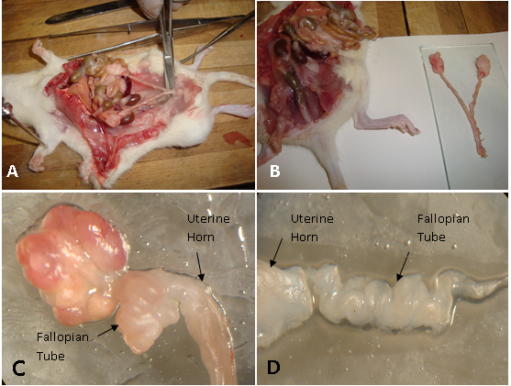
Figure 1 The process of separation (A) and resection (B) of the fallopian tubes from the peritoneal cavity. Photograph (C) shows the coiled fallopian tube attached to the uterine horn distally and ovary proximally. (D); the uncoiled fallopian tube after fine dissection.

Results
Ciliated Cells:In the Control Group these cells, throughout all the phases of estrous cycle, gave us an idea about their normal morphology of being large cell characterized by their abundant elongated cilia, with their basal bodies, that cover the whole cell apices, in addition to the existence of mitochondria and elongated rough endoplasmic reticulum within their cytoplasm (Figure 2& 3).

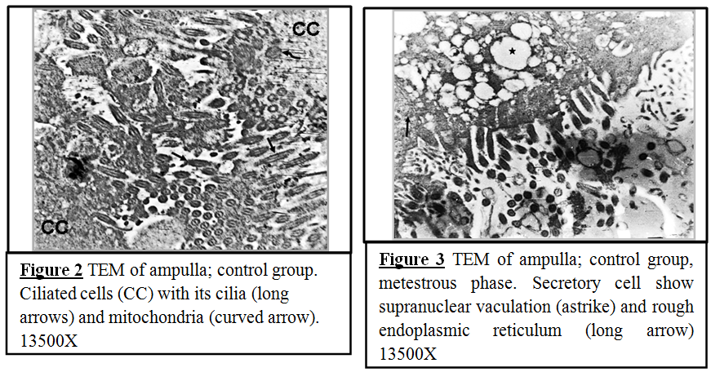

In the Treated Group (Figure 4 & 5); some of the ciliated cells were demonstrated with a luminal surface having short blunted microvilli distributed in between the cilia. In addition, these cilia were, strikingly, very long and more abundant compared to those of the control group. These findings were obvious in T III and T II groups. Furthermore, the basal bodies of the cilia (which located within the lower end of these cilia at their attachment site to the luminal surface of the ciliated cells) were more obvious and seemed to be enlarged, especially in T III group (Figure 4), compared to those of control group (Figure 2).Moreover, the ciliated cells showed intracytoplasmic vacuole like structures (probably lipid droplets). These vacuoles were more evident in T II (Figure 5).

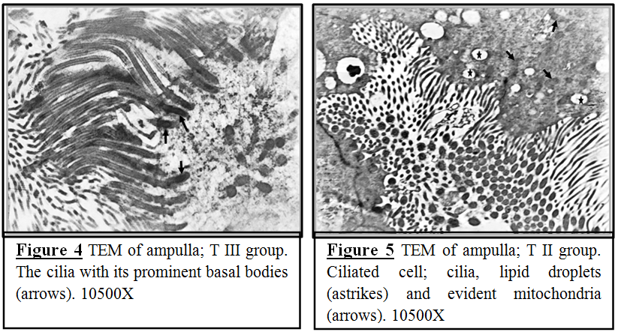

Secretory Cells: In the current study; the secretory cells of the uterine tube epithelium could be easily identified by the presence of the predictable secretory granules. These secretory granules were differing in size and translucency.
In the Control Group; the secretory granules were more evident in the sections of metestrous phase. They characterized by their medium sized electron-dense homogenous matrix and occupying the apical part of cytoplasm (Figure 6). Sections obtained from animals at the proestrous phase show secretory granules of about the same size and location inside the secretory cell but they had moderate electron-dense appearance (Figure 7).
In the Treated Group; the secretory granules showed a striking increase in their number compared to that of control group. On the other hand, the presence of these granules within the secretory cells was found to be differing from that of the control group. Sections of T III group showed granules characterized by their different size, mainly of an electron-dense matrix, and occupied the whole cytoplasm (mainly the supranuclear portion) (Figure 8).
Furthermore, the secretory cells have showed vaculation, within their cytoplasm, especially in the supranuclear region. In the Control Group; these vacuoles were more evident in the metestrous phase (Figure 3). While in the Treated Group, especially those of TIII group(Figure 9), these vacuoles were larger in size, as they appeared to be coalesced with each other, compared to those of the control group.

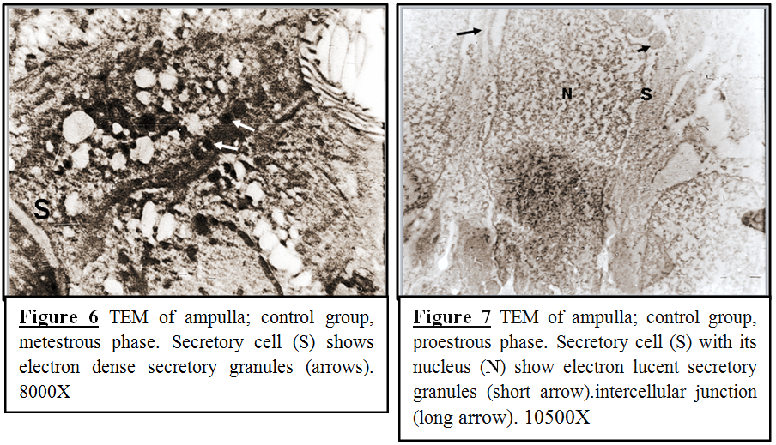
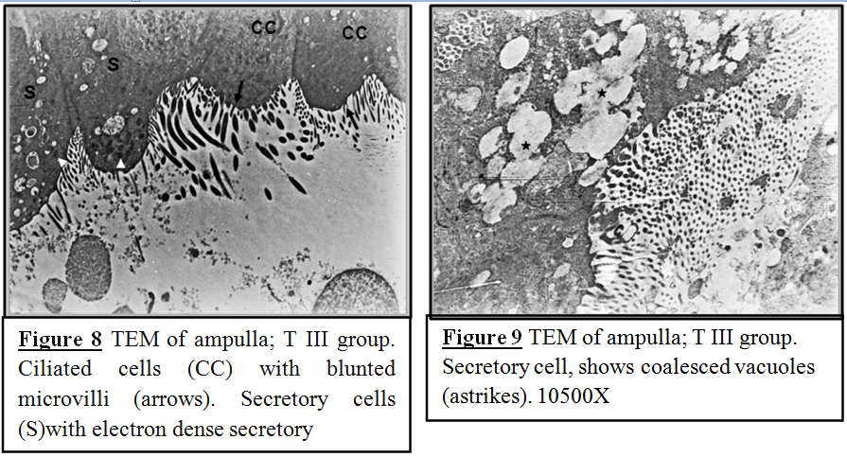

Cytoplasmic Protrusions: These morphological events occurred when the cytoplasm was pinched off and protruded from the apices of many secretory cells. These cytoplasmic protrusions included secretory granules and or electron-lucent vesicles. Furthermore, these protrusions had microvilli which emerged from their luminal surface. These findings were more evident in sections of Control Group at the metestrous phase and they contained a large number of moderate electron-dense granules and little number of vesicles (Figure 10).While in the Treated Group these cytoplasmic protrusions were more obvious in T III group, and they contained a homogenous electron-dense granules and abundant vesicles (Figure 11).
The expelled nuclei with other cytoplasmic organelles were detected in the lumen of the uterine tube in both the control and treated groups, although they were more apparent in the group treated with high dose of estrogen.
In this study; the evaluation of the exact cilia number per cell was found to be difficult since each ciliated cell carried a large number of cilia which resulted in obscuring the cell boundaries besides the changing in the orientation of these cilia in the sections (Figure 4). As well the measurement of the cells height could not be achieved due to the assortment in the nuclei level of epithelial cells that made the distinguishing between epithelial cells boundaries difficult, although an apparent increase in cell height of the treated group compared to those of the control group was detected subjectively.

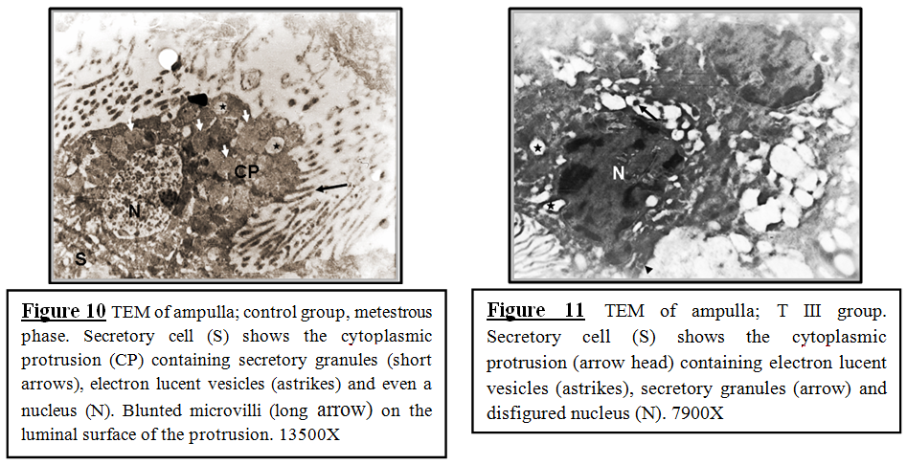

Discussion
Ciliated Cells:
In the current study; the control group reveals ciliated cells characterized by abundant elongated cilia that cover the whole cell apices, in addition to the existence of mitochondria and rough endoplasmic reticulum within their cytoplasm. These findings were more evident in the luteal phase (metestrous) as compared to other phases of the estrous cycle. These findings matched with Correret al. [14] have reported that the uterine tube of early perimenopause women revealed the cytoplasm of ciliated and microvillous cells (secretory cells) contains pleomorphic mitochondria and short cisternae of the rough endoplasmic reticulum. Also, the ciliated cells showed mature cilia with striated rootlets.
Administration of combined estrogen and progesterone to the experimental animals, used in the current study, observed the presence of short blunted microvilli, in between cilia, on some of the ciliated cells. In addition, T III and T II groups revealed very long and more abundant cilia, compared to those of the control group. Furthermore, the basal bodies of the cilia were more obvious and seemed to be enlarged. These results were found to be consistent with Lauschova [17], who found that application of steroid ovarian hormones generally induced acceleration of the development of uterine tube epithelial cells in sexually immature mice. He stated that estradiol administration influenced both ciliated and secretory cells and stimulated their proliferation and differentiation, while progesterone administration alone resulted in ultrastructural marks of increased secretory activity and degeneration of ciliated cells. He verified that ultrastructural changes of the uterine tube epithelium exposed to exogenous estrogen and progesterone showed distinct regional differences.
What is more, in the current work, was the observation of some ciliated cells displaying lipid droplets, within their cytoplasm, in sections of T II group. These results were agreed with Odor and Augestine[18], who observed lipid droplets in the ciliated cells of the fimbrial epithelium in the baboon uterine tube.
We suggested that steroid hormone therapy (specifically estradiol) could results in ciliogenesis directly by inducing growth and differentiation of the existing cilia and indirectly by creation of microvilli on the luminal surface of ciliated cells that may assist afterward in the process of ciliogenesis.
Secretory Cells:
Abe and Oikawa [19] demonstrated that the ampullary secretory cells contained many moderately electron-dense secretory granules in the apical cytoplasm, and most of these cells contained extensive rough endoplasmic reticulum and a well-developed golgi apparatus in their cytoplasm. These results support the findings of the current work which displayed that the secretory granules were seen as medium sized of high electron dense homogenous matrix in the apical portion of cytoplasm and they were more evident in the sections of metestrous (luteal) phase. However, in contrast to these results, Nayak and Ellington [20] have found that maximum secretory cell differentiation was apparent during the follicular phase, at which time these cells were characterized by having a well-developed, rough endoplasmic reticulum with dilated cisternae, numerous ribosomes, and secretory granules of varied size and density.
While in the treated group, especially T III group; the secretory granules strikingly abundant compared to that of control group, revealed highly electron dense matrix, different sizes and occupy the whole cytoplasm of the secretory cells (mainly the supranuclear portion). In agreement with these results Verhageet al. [21] found that six days of estradiol administration resulted in abundant periodic acid Schiff (PAS)-positive secreting granules at the apex of the secreting cells. Furthermore Nayaket al.[22]have demonstrated that the presence of a well-developed endoplasmic reticulum and numerous secretory granules during estrus indicate that secretion in the ewe uterine tube is presumably under the control of circulating high plasma concentrations of estrogen.
Additionally, this study showed the presence of vacuolation within the cytoplasm of the secretory cells. In the control group these vacuoles were more evident in the metestrous phase. While in the treated group, especially those of TIII group, they appeared larger in size and seemed to be coalesced with each other. These results were in agreement with Abe [23], who reported the presence of many large structures, resembled lipid droplets, in the fimbrial non ciliated cells in the rat uterine tube and occasionallyit appeared that their contents were released by an exocytosis-like mechanism.
Thus, the primary conclusion of this study was that the administration of progesterone which is preceded by estradiol is capable of producing complete differentiation and secretory function in the uterine tube epithelium, and this might be due to the up-regulation of progesterone receptors by estradiol.
Many authors have previously described the presence of cytoplasmic protrusions in the oviduct epithelium of different species. Desantiset al.[10] reported that in the mare oviduct ampulla and isthmus the majority of non-ciliated cells showed apical blebs provided or not with short microvilli and these blebs (apical protrusions) of ampulla displayed two types of secretory granules as well as occasional electron-lucent vesicles. Also, Abe and Hoshi [11] found that cytoplasmic protrusions containing variable numbers of ciliaryaxonemal complexes occurred in the fimbrial and ampullar epithelium in the Chinese Meishan pigs at the luteal phase. While Lauschova [17] observed that the pinched apical parts of the cytoplasm, containing secretory granules, electron-lucent vesicles, tubules of the rough endoplasmic reticulum, ribosomes and isolated mitochondria in the epitheliumof the mice. Likewise Abe and Oikawa [25] found them in the oviducts of a pig during the luteal phase, and used the term “pinching off” for this process. These findings, regarding cytoplasmic protrusions, were matched with the findings of current work which displayed many secretory cells with their cytoplasm pinched off and protruded from their apices. These cytoplasmic protrusions contained secretory granules and or electron- lucent vesicles. Moreover, current results were more evident in the metesterous (luteal) phase of the control group. However, treated groups showed more obvious cytoplasmic protrusions (especially T III group) which contain electron-dense granules and abundant vesicles.
Hence, from the observed results; we suggest that the cytoplasmic protrusion may be a feature of apocrine secretory function of uterine tube epithelium and it is under the effect of endogenous hormones (mainly progesterone) and exogenous ovarian hormone, specifically estrogen.

References
- Abe, H. The mammalian oviductal epithelium: regional variations in cytological and functional aspects of the oviductal secretory cells. Histol Histopathol, 1996, 11, 743-768.
- Murray, M.K. Epithelial lining of the sheep ampulla oviduct undergoes pregnancy–associated morphological changes in secretory status and cell height. Biology of Reproduction, 1995,53, 653-663.
- Wingerd, Bruce D. Rat Dissection Manual. London: The Johns Hopkins University press (1988), pp. 67.
- Nayak, R.K. & Wu, A.S. Ultrastructural demonstration of cilia and ciliary rootlets in mammalian uterine tube epithelium in different functional states. Am J Vet Res.,1975, 36(11),1623-30.
- Dirksen, E. R. Ciliogenesis in the mouse oviduct: A Scanning Electron Microscope Study.J Cell Biol., 1974, 62, 899-904.
- Satir, P. & Christensen, S.T. Overview of structure and function of mammalian cilia. Annu Rev Physiol, 2007,69, 377–400.
- Tanaka, K., Sutani, A., Uchida, Y., Shimizu, Y., Shimizu, M. & Akita, M. Ciliary ultrastructure in two sisters with Kartagener’s syndrome. Med MolMorphol, 2007,40, 34–39.
- Hagiwara, H., Ohwada, N., Aoki, T., Suzuki, T. &Takata, K. Immunohistochemical and electron microscopic observations of stromal cells inthe human oviduct mucosa. Med Mol Morphol., 2008,41(4), 221-6.
- Nerkar, A.A. & Gadegone, M.M. Ultrastructural features of the Fallopian tube epithelium of bat, Taphozouslongimanus (Hardwicke). (2013)http://dx.doi.org/10.1016/j.jobaz.2013.07.006
- Desantis, S., Zizza, S., Accogli, G., Acone, .F, Rossi, R. & Resta, L. Morphometric and ultrastructural features of the mare oviduct epithelium during oestrus. Theriogenology, 2011, 75 (4), 671–678
- Abe, H. & Hoshi, H. Morphometric and ultrastructural changes in ciliated cells of the oviductal epithelium in prolific Chinese Meishan and Large White pigs during the oestrous cycle. Reprod Domest Anim., 2008,43(1), 66-73
- Kumar, S., Singh, G., Nagpal, S.K. & Luthre, R.A. ultrastructure of fimbria and ampulla of buffalo oviduct during follicular and luteal phases. Haryana Vet., 2010, 49, 11-14.
- Shirley, B. & Reeder, R. L. Cyclic changes in the ampulla of the rat oviduct. J. Exp. Zool., 1996,276 (2), 164-73.
- Correr, S., Makabe, S., Heyn, R., Relucenti, M., Naguro, T. &Familiari, G. Microplicae-like structures of the fallopian tube in postmenopausal women as shown by electron microscopy. HistolHistopathol, 2006, 21, 219-226.
- Hayat, M.A. Basic technique for transmission electron microscopy. London: Acad. Press Inc. Harcourt Brace Jovanovich(1986) pp. 226-231.
- Reynolds, E.S. The use of lead citrate at high pH as an electron-opaque stain in electron microscopy. J. Cell biol.,1963, 17, 208-212.
- Lauschova, I. Influence of Estrogen and Progesterone on Ultrastructural Indices of Oviductal Epithelium in Sexually Immature Mice. Acta Vet. Brno, 1999,68, 13-21.
- Odor, D.L. & Augustine, J.R. Morphological study of changes in the baboon oviductal epithelium during the menstural cycle. Microsc. Res. Tech.,1995, 32, 13-28.
- Abe, H. & Oikawa, T. Regional differences in the ultrastructural features of secretory cells in the golden hamster (Mesocricetusauratus) oviductal epithelium.J. Anat., 1991, 175, 147-158.
- Nayak, R.K. & Ellington, E.F. Ultrastructural and ultracytochemical cyclic changes in the bovine uterine tube (oviduct) epithelium. Am J Vet Res., 1977,38(2), 157–168.
- Verhage, H. C., Abel, J. H., Tietz, JR. W.J., JR., &Barrau, M.D. Estrogen-Induced Differentiation of the Oviductal Epithelium in Prepubertal Dogs. Biology of Reproduction, 1973, 9, 475-488.
- Nayak, R.K., Albert, E.N. &Kassira, W.N. Cyclicultrastructural changes in ewe uterine tube (oviduct) infundibularepithelium.Am J Vet Res., 1976, 37(8), 923-33.
- Abe, H. Regional variations in the ultrastructural features of secretory cellsin the rat oviduct epithelium. Anat. Rec., 1994,240, 77-85.
- Abe, H. & Oikawa, T. Examination by electron microscopy of oviductal epithelium of the prolific Chinese Meishan pig at follicular and luteal phases. Anat. Rec., 1990,233, 399-408.

