The Effects of Estradiol and Progesterone Therapy on Markers Expression of Vimentin and Desmin in Rat Uterine Tube. Immunohistochemical Study

Hussein Abbas Jarullah ¹ Haider AR Ja'afar² May F. Alhabib²
¹ Dept. of Anatomy, College of Medicine, University of Babylon, Hilla, IRAQ.
² Dept.of Anatomy, College of Medicine, Al-Nahrain University, Baghdad, IRAQ.

Received 9 February 2014 Accepted 20 May 2014
Abstract
Background: Estrogen and progesterone are ovarian hormones that can be used as oral contraceptive pills (in combined formula) in addition to their use ashormonal replacement therapy in menopause.
Methods: A sample of 30 animals having an estrous cycle of 4 days period was used. The animals were divided into 2 main groups; a control group (6 rats) and treated group which further divided into 3 subgroups; T I, T II and T III (8 rats for each) according to the dose of Estradiol which was given in three different dosages (1, 4 and10 µg/day) for a period of two successive estrous cycles (i.e. 8 days).The Progesterone hormone was given in a dose of 4 mg/kg body weight, for all the 3 subgroups, on the third and fourth days of the two successive estrous cycles. Immunohistochemical study was done through the applicationof Vimentin and Desmin markers.Staining procedure: (using Labelled Strept-Avidin Biotin LSAB™+/HRP kit, code number K0697 detection system). Aperio Positive Pixel Count Algorithm software (modified) was employed, in the study
Results:The demonstration of desmin was apparent mainly in the smooth muscle cells of the oviductal wall and highest immunoreactivity was found to be in the proestrous phase.In the treated group; high decline in the staining reactivity was found, especially in T I group.
The demonstration of vimentin reaction was evident mainly in the lamina propria stromal cells and the tunica muscularis of the rat oviduct. The immunoreactivity was found to be high in the proestrous phase.In the treated group; profound reduction in the staining reactivity of the lamina propria and smooth muscle cells was found,especially in T Igroup and little immunoreactivity for vimentin receptors in treated groups. This due to effect of combine hormonal therapy(estrogen and progesterone) on alternation immunogenic configuration of vimenin and desmin intermediate filaments of rat oviduct cells.
Conclusion:The combined therapy reveals thatdesmin and vimentin are essential for cell integrity and apply as indicator for metaplastic activity of cells.
Key words: Vimentin, Desmin, Estradiol, progesterone.

تأثيرات علاج الاسترادايول والبروجستيرون على التعبير عن واسمات الفايمنتين والدسمين في القناة الرحمية للجرذ. دراسة كيميانسجية مناعية
الخلاصــة
يعتبر الاستروجين والبروجسترون من الهرمونات المبيضية والتي يمكن أن تستخدم، بصيغتها المشتركةِ، كحبوب مانعة للحمل عن طريق الفم بجانب استخدامها كعلاج بالهرمونات البديلة أثناء وبعد سن اليأس.
اظهرت التفاعلية المناعية للفايمنتين وضوحا وبشكل رئيسي في خلايا انسجة الصفيحة الاصيلة و الغلالة العضلية للانبوب الرحمي للجرذ. وكانت هذه التفاعلية المناعية عالية في طور مقدمات الوداق. اما في مجموعة المعالجة ، فقد وجد انخفاض عميق في التفاعلية التلونية للصفيحة الاصيلة و خلايا العضلات الملساء ، وخاصة في مجموعة T I .
كانت مظاهر الدسمين تظهر بشكل رئيسي في خلايا العضلات الملساء في جدار الانبوب الرحمي ووجدت اعلى تفاعلية مناعية في طور مقدمات الوداق. اما في مجموعة المعالجة؛ فقد وجد انخفاض عالي في التفاعلية التلونية، وخاصة في T I.
لقد كشف العلاج المشترك باستخدام الاسترادايول والبروجستيرون ان الدسمين والفايمنتين ضروريان لسلامة الخلية كما ويمكن استخدامهما كمؤشر للنشاط الحؤولي (الاستحالي) للخلايا.
في هذه الدراسة استخدم برنامج (Aperio positive pixel count algorithm) المعدل لغرض تقييم وتحديد توزيع الدسمين والفايمنتين في منطقة الانبورة للانبوب الرحمي للجرذ.
ــــــــــــــــــــــــــــــــــــــــــــــــــــــــــــــــــــــــــــــــــــــــــــــــــــــــــــــــــــــــــــــــــــــــــــــــــــــــــــــــــــــــــــــــــــــــــــــــــــــــــــــــــــــــــــــــــــــــــــــــــــــــــــــــــــــــــــــــــــــــــــــــــــــــــــــــــــــــــــــــــــــــــــــــــــــــــــــــــــــــــــــــــــــــــــــــــــــــــــــــــــــــــــــــــــــــــــــــــــــــــــــــــــــــــــــــــــــــــــــــــــــــــــــــــــــــــــــــــــــــــــــــــــــــــــــــــــــــــــــــــــــــــــــــــــــ

Introduction
V
imentin is a type III intermediate filament (IF) protein that is expressed in mesenchymal cells, hence it is considered as the major cytoskeletal component of mesenchymal cells. For this reason, vimentin is often used as a marker of mesenchymally-derived cells or cells undergoing an epithelial-to-mesenchymal transition (EMT) during both normal development and metastatic progression [1].
Vimentin plays a major role in supporting and anchoring the position of the organelles in the cytosol. It is attached to the nucleus, endoplasmic reticulum, and mitochondria, either laterally or terminally [2]. In general, it is accepted that vimentin is the cytoskeletal component responsible for maintaining cell integrity and it was found that cells without vimentin were extremely delicate when disturbed with a micro-puncture [3].
Desmin is, also, type III intermediate filament found in skeletal, smooth and cardiac muscle tissues [4]. Lazarides& Hubbard [5] were the first who described desmin. It is only expressed in vertebrates; however homologous proteins are found in many organisms.Desmin considered as one of the earliest protein markers for muscle tissue in embryogenesis as it was detected in the somites. However, its expression was at low levels, but increases as the cell be near terminal differentiation [6].
Desmin is also important in muscle cell architecture and structure since it connects many components of the cytoplasm. The sarcomere is a component of muscle cells composed of actin and myosin motor proteins which allow the cell to contract. Desmin forms a scaffold around the Z-disk of the sarcomere and connects the Z-disk to the subsarcolemmal cytoskeleton (the cytoplasmic part of the muscle cell plasma membrane) [7]. Furthermore, Bäret al.[6] have demonstrated that desmin links the myofibrils laterally by connecting the Z-disks and through its connection to the sarcomere it connects the contractile apparatus to the cell nucleus, mitochondria, and post-synaptic areas of motor endplates.

Aim of the Study
To estimate the Immunohistochemical markers expression of Desmine and Vimentin throughout the ampullary region of rat uterine tube in response to estrogen and progesterone therapy.

Materials and Methods
Animal housing and sampling:
Sample of thirty adult healthy female albino rats (RattusRattusnorvegicusalbinos) weighing between 200-280g, and having an estrous cycle of 4 days period, were used for this study. These animals were housed in plastic cages, 3 animals per cage, at room temperature (22 ± 2 °C) and were fed standard pellet diet and fresh tap water available ad libitum.
Drugs and Treatment:
- B-Estradiol 17-acetate (Sigma-Aldrich) 1g, in a solid form, was dissolved at a concentration of 20µg/ml sesame oil.
- Primolute Depot (Bayer Schering Pharma AG/Germany) in form of Hydroxyprogesteronecaproate 250mg/1ml in oily solution.
- Purified Sesame oil used as a vehicle for dilution of both hormones. The total quantity of the oil used was adjusted to be fixed in every daily dose or doses to be a net of 0.5 ml.
The animals were divided into 2 main groups; a Control group (6 rats) and Treated group which further divided into 3 subgroups namely; T I, T II and T III (8 rats for each) according to the dose of Estradiol (Table 1) which was given in three different dosages (1, 4 and10 µg/day) for a period of two successive estrous cycles (i.e. 8 days).The Progesterone hormone was given in a dose of 4 mg/kg body weight, for all the 3 subgroups, on the third and fourth days of the two successive estrous cycles.The drugs were given daily, in the morning, as a subcutaneous injection at the gluteal region of the rats.
The study was done in the College of Medicine / Al-Nahrain University, through the period of October 2011 – May 2013.

Table 1 The Protocol for drug administration of the Treated Groups.
Group | 1st  day | 2ndday | 3rd  day | 4th  day | 5th  day | 6th  Day | 7th  day | 8th  day
T I | 1µg E₂ | 1µg E₂ | 1µg E₂  4mg/kg P | 1µg E₂  4mg/kg P | 1µg E₂ | 1µg E₂ | 1µg E₂  4mg/kg P | 1µg E₂  4mg/kg P
T II | 4µg E₂ | 4µg E₂ | 4µg E₂  4mg/kg P | 4µg E₂  4mg/kg P | 4µg E₂ | 4µg E₂ | 4µg E₂  4mg/kg P | 4µg E₂  4mg/kg P
T III | 10µg E₂ | 10µg E₂ | 10µg E₂  4mg/kg P | 10µg E₂  4mg/kg P | 10µg E₂ | 10µg E₂ | 10µg E₂  4mg/kg P | 10µg E₂  4mg/kg P
Explanation: E₂ = Estradiol, P = Progesterone.

The Ampullary region of the uterine tubes samples were fixed in 10% neutral buffer formalin and then transferring into graded more concentrated ethyl alcohol baths reaching the absolute alcohol for 2 hours. Furthermore, transferring them into baths of xylene (BDH, Analar); two exchange done 1 hour for each to ensure a good tissue transparency.
ImmunohistochemicalTechnique:
The followingmarkers had been used in this study (DakoCytomation Denmark):
- Monoclonal Mouse Anti-Vimentin, Clone: V9, Code Number: M 0725.
- Monoclonal Mouse Anti-Human Desmin, Clone: D33, Code Number: M 0760.
Dewaxing, dehydration, washing (with distilled water) and thenPre-treatment of tissues with heat induced epitope retrieval in MicroWaveOven was done prior to staining.
Immunohistochemical staining: Staining procedure: (using Labelled Strept-Avidin Biotin LSAB™+/HRP kit, code number K0697 detection system). The staining procedure follows dakocytomation technique.

Results
The Immunohistochemical Study:
Aperio Positive Pixel Count Algorithm software (modified) was employed, in the present study, to evaluate and quantify the distribution of Desmine and Vimentin in the ampullary region of rat oviduct. The staining reactivity had been represented by calculating the mean of the positivity percentage in the paraffin sections for both the control and treated groups.
The results for desminreaction were summarized in bar chart shown in Figure 1.
In the Control Group; the demonstration of desmin was apparent mainly in the smooth muscle cells of the oviductal wall, although it showed weak reaction in the cytoplasm of the epithelial cells in addition to the stroma cells. The cells of the lamina propria show a negative staining reactivity. The immunoreactivity was found to be high in the proestrous (Figure 2) and the metestrous phases, the mean positivity percentages were 77±0.577 and 45.33±0.881 respectively. While the lowest reaction was found in the estrous phase (Figure 3), the mean positivity percentage was 0±0.
In the Treated Group; high decline in the staining reactivity was found, as compared to the control group, and the highest positivity percentage value among the treated animals was seen in T III group (3±1.732), while the lowest value (1.33±1.583) was found in T I group (Figure 4). The staining pattern of the treated group sections was found to be restricted to the smooth muscle cells in a scattered form.
Vimentin is a type III intermediate filament, in the current study monoclonal mouse Anti-Vimentin clone V9 (Dakocytomation) was used for its detection in the ampullary region of rat oviduct. The results for vimentinimmunoreactivity were reviewed in Figure 5.
In the Control Group; the demonstration of vimentin reaction was evident mainly in the lamina propria stromal cells and the tunica muscularis of the rat oviduct. The immunoreactivity was found to be high in the proestrous (Figure 6) and the metestrous phases, the mean positivity percentages were 67.33±1.763 and 39±5.196 respectively. While the lowest reaction was found in the diestrous phase, the mean positivity percentage was 24.67±2.027.
In the Treated Group; profound reduction in the staining reactivity of vimentin in the lamina propria and smooth muscle cells was found, as compared to the control group, and the highest positivity percentage value among the treated groups was seen in T III group (5.33±0.333), while the lowest positivity percentage value (0.66±0.524) was seen in T I group (Figure 7).

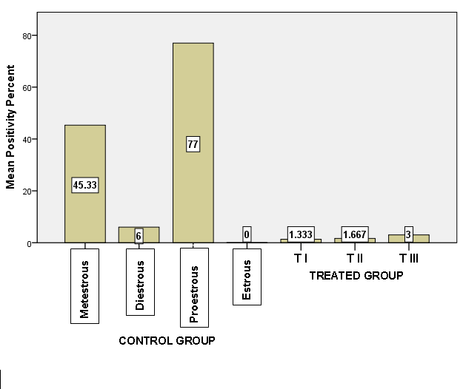
Figure 1: Bar chart show the distribution of the mean positivity percent for Desmin in the rat oviduct wall, ampullary region, among the control and treated groups.

age

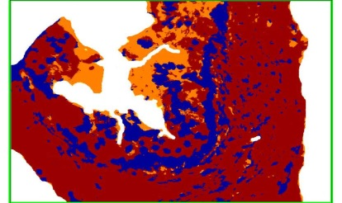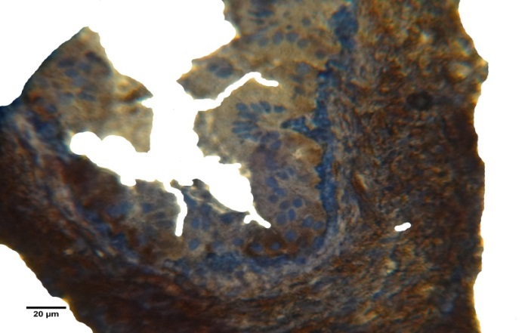
A
B
Figure 2: (A): Cross section of rat oviduct, ampullary region for the control group (proestrous phase); show strong reactivity of Desmin(deep brown colored area) in the oviductal wall especially the muscular layer and negativity in the lamina propria. IHC (Anti-Human Desmin). 600X
(B): snap shoot for section (A) as analyzed by Aperio Positive Pixel CountAlgorithm software; brown color = strong positive, orange = positive, yellow & blue = negative

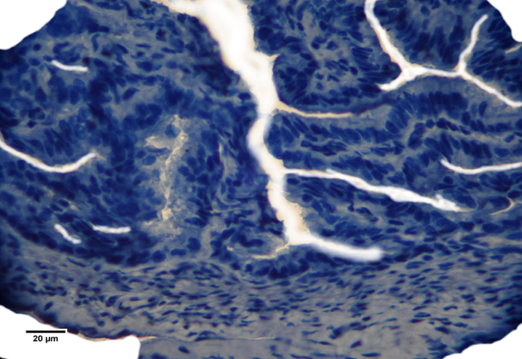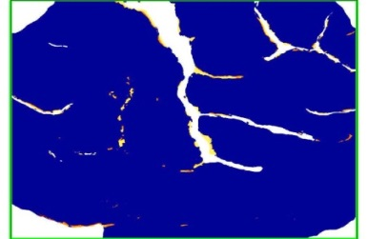
A
B
Figure 3: (A): Cross section of rat oviduct, ampullary region for the control group (estrous phase); show negative reactivity of Desmin in the oviductal wall. IHC (Anti-Human Desmin). 600X
(B): snap shoot for section (A) as analyzed by Aperio Positive Pixel Count Algorithm software; orange = positive, yellow & blue = negative

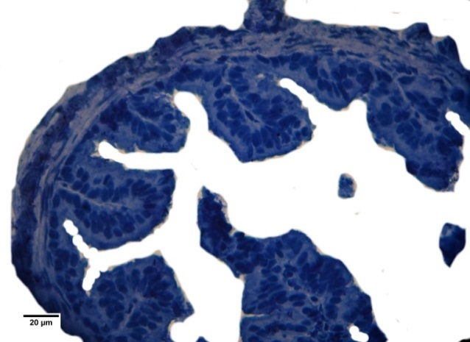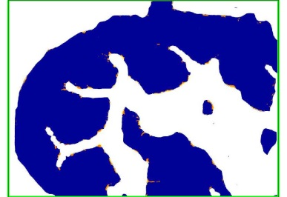
A
B
Figure 4: (A): Cross section of rat oviduct, ampullary region for the Treated group (TI); show negative reactivity toward Desmin in the mucosal epithelium, lamina propria and the smooth muscle layer. IHC (Anti-Human Desmin). 600X (B): snap shoot for section (A) as analyzed by Aperio Positive Pixel Count Algorithm software; brown color = strong positive, orange = positive, yellow & blue = negative

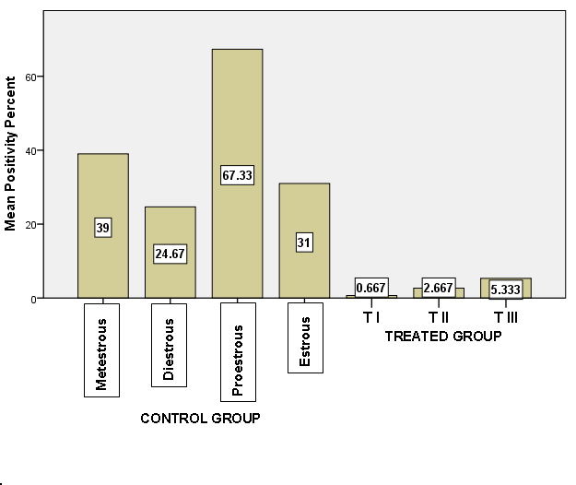
Figure 5: Bar chart shows the distribution of the mean positivity percent for Vimentinin the rat oviduct wall, ampullary region, among the control and treated groups.

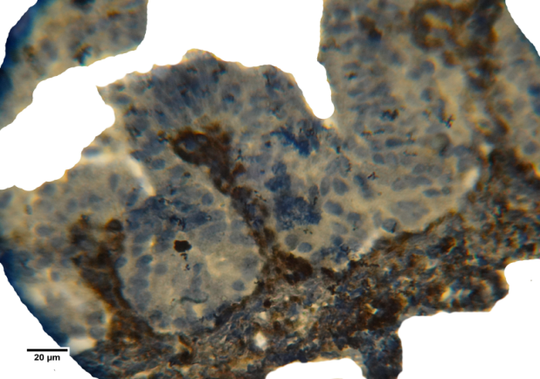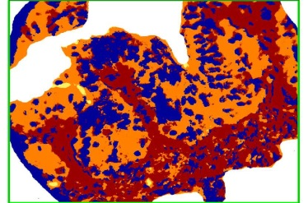
A
B
Figure 6 (A): Cross section of rat oviduct, ampullary region for the control group (proestrous phase); show strong reactivity of Vimentin(deep brown colored area) in the lamina propria of the tunica mucosa and tunica muscularis. IHC (Anti-Human Vimentin). 600X
(B): snap shoot for section (A) as analyzed by Aperio Positive Pixel Count Algorithm software; brown color = strong positive, orange = positive, yellow & blue = negative

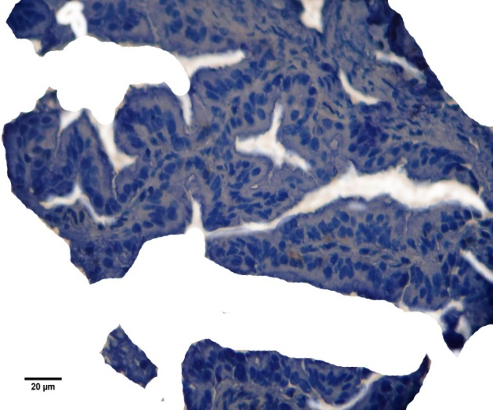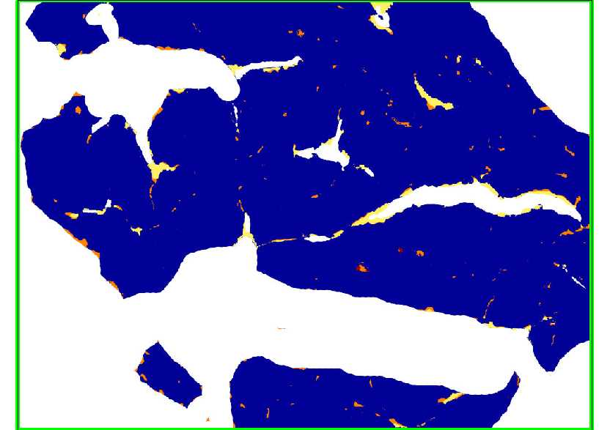
A
B
Figure 7: (A): Cross section of rat oviduct, ampullary region for the Treated group (TI); show negative reactivity toward Vimentin in the mucosal epithelium, lamina propria and the smooth muscle layer. IHC (Anti-Human Vimentin). 600X(B): snap shoot for section (A) as analyzed by Aperio Positive Pixel Count Algorithm software; brown color = strong positive, orange = positive, yellow & blue = negative

Discussion
Desmin is a type III intermediate filament found in skeletal, smooth and cardiac muscle tissues [4]. Desmin considered as one of the earliest protein markers for muscle tissue in embryogenesis as it was detected in the somites.It is only expressed in vertebrates; however homologous proteins are found in many organisms [6]. Moreover, desmin plays an essential role in maintaining cell cytoarchitecture, positioning and functioning of organelles, and the intercellular signaling pathway [8].
In the present study the results showed that the immunoreactivity, for desmin, was high in the proestrous and the metestrous phases of control group, While the lowest reaction seen in the estrous phase. This outcome was consistent with Madekurozwa[9], who reported that the smooth muscle cells forming the tunica muscularis and vascular tunica media of the immature and mature Japanese quail oviduct displayed strong desmin and smooth muscle actin immunostaining. In addition, Selstamet al., [10] have studied the changes in the ovarian intermediate filament desmin during the luteal phase of the adult pseudopregnant rat. They found that desmin filaments were found in muscle cells of all types, including vascular smooth muscle cells. They stated that probably, all desmin in the ovary was localized to smooth muscle cells with the possible exception of the corpus luteum where very few muscle cells have been identified.
Hagiwara et al., [11] have reported that investigation of human uterine tube stromal cells with transmission electron microscopy and immunohistochemistry revealed ultrastructural features similar to myofibroblasts and expressed alpha-smooth muscle actin, a marker used to identify myofibroblasts. These results are consistent with the current findings which reveal the presence of weak immunoreactivity toward desmin in the stromal cells of the uterine tube, specifically of mucosal folds. Consequently, we suggest that the presence of positive immunoreactivity in the stromal cells of the mucosal folds, may indicate the presence of smooth muscle cells in these folds, supported by Hagiwara et al., [11], which assist in movement of these folds by the action of these muscle in order to move gametes and embryos, beside ciliary movements and muscle layers contraction of the oviductal wall. These suggestions were also reinforced by other researchers [12] who designated ultrastructural and immunohistochemical studies for stromal cells in lamina propria of human uterine tube ampullar mucosa. They identified three types of stromal mesenchymal cell; one of these types wasconsisted of overt smooth-muscle cells (SM cells): they were rich in myofilaments, had a lamina and were desmin positive and alpha-smooth muscle actinpositive.
The existing results of animals treated with combined estrogen and progesterone showed a high decline in the staining, as compared to that of the control group, and the highest positivity percentage was seen in T III group, while the lowest value was seen in T I group. These outcomes agreed with Fenget al. [13], who have found that the expression of desmin in animals treated with high dosage of estrogen was higher than that of low dose treated group. They conclude that the endogenous and exogenous estrogen could improve antioxidant capability in vivo, so that reduced muscle damage and accelerated muscle regeneration post gastronemius muscle strain injury in rat.
Vimentin is a type III intermediate filament (IF) protein that is expressed in mesenchymal cells. It plays a major role in supporting and anchoring the position of the organelles in the cytosol. It is attached to the nucleus, endoplasmic reticulum, and mitochondria, either laterally or terminally. Furthermore, vimentin is often used as a marker of mesenchymally-derived cells or cells undergoing an epithelial-to-mesenchymal transition (EMT) during both normal development and metastatic progression [2].
In this study, the vimentinimmunohistochemical reactions, of the control group sections, were seen mainly in the stromal cells, including lamina propria, and tunica muscularis. The staining reactivity was found to be high in the proestrous and the metestrous phases, while the lowest reaction was found in the diestrous phase. Results from previously mentioned study ofMadekurozwa[9], have matched our findings. He reported that fibroblasts and vascular endothelial cells in the lamina propria of the oviductal regions studied exhibited strong vimentinimmu-nostaining reactivity. In addition, his study had shown that the immunolocalization of vimentin in the Japanese quail varies depending on the uterine tube region, as well as the developmental stage of the oviduct. Likewise, Fernándezet al. [14], have found that most mesenchymal cells contain vimentin as the main intermediate filament-forming protein in bovine prostate. They demonstrated that vimentin, was clearly marked all studied groups after antigen retrieval techniques and its immunostaining highlighted the relative increase in mesenquimal elements in the castrated animals.Also, Ikeda et al. [15], have showed that vimentin was detected as filaments localized within a portion of the inner cell mass of the bovine blastocyst, and its expression levels varied among the embryos.
We conclude that vimentin expressed in cells of mesenchymal origin (like lamina propria) and its immunoreactivity was more evident in these tissues of the rat uterine tube.
The current results showed that the application of hormonal therapy (estrogen and progesterone) for the experimental animals revealed absent or decreased immunohistochemical reactions for the tissues of the uterine tube compared to that of the control group. These results were agreed with Upadhyayet al. [16], who stated thatImmunoprecipitation studies showed marked absence of phosphorylated vimentin in stages VII-VIII of rat spermatogenesis in animals treated with 17β-estradiol. However,Horner et al. [17], have demonstrated that immunohist-ochemical study, concerning the inner ear, showed down-regulation of vimentin within the lateral wall and upregulation within the spiral limbus as an effect of chronic administration of estradiol.
Satelli& Li [18] have verified that Vimentin's overexpression in cancer correlates well with accelerated tumor growth, invasion, and poor prognosis; however, the role of vimentin in cancer progression remains obscure. They also stated that in recent years, vimentin has been recognized as a marker for epithelial-mesenchymal transition (EMT). Consequently, we concluded that combined hormonal replacement therapy (estrogen and progesterone) may lead to disassembly of vimentin filaments in the uterine tube tissues and hence it can be used as indicator for any metaplastic changes that may occur in these tissues identified by its overexpression.

References
1-Leader, M., Collins, M., Patel, J. & Henry, K. Vimentin: an evaluation of its role as a tumor marker. Histopathology, 1987,11 (1), 63–72.
2-Katsumoto, T., Mitsushima, A. &Kurimura, T.The role of the vimentin intermediate filaments in rat 3Y1 cells elucidated by immunoelectron microscopy and computer-graphic reconstruction. Biol Cell, 1990,68 (2), 139–46.
3-Goldman, R. D., Khuon, S., Chou, Y., Opal, P. &Steinert, P. The function of intermediate filaments in cell shape and cytoskeletal integrity. J Cell Biol., 1996,134 (4), 971–83.
4-Li, Z., Mericskay, M., Agbulut, O., Butler-Browne, G., Carlsson, L., Thornell, L.E., Babinet, C. &Paulin, D.Desmin Is Essential for the Tensile Strength and Integrity of Myofibrils but Not for Myogenic Commitment, Differentiation, and Fusion of Skeletal Muscle. J. Cell Biol., 1997,139 (1), 129–44.
5-Lazarides, E. & Hubbard, B.D. Immunological characterization of the subunit of the 100 A filaments from muscle cells. Proc. Natl. Acad. Sci. U.S.A., 1976, 73 (12), 4344–8.
6- Bär, H., Strelkov, S.V., Sjöberg, G., Aebi, U. & Herrmann, H.. The biology of desmin filaments: how do mutations affect their structure, assembly, and organisation?. J. Struct. Biol., 2004,148 (2), 137–52.
7-Paulin, D. & Li, Z.Desmin: a major intermediate filament protein essential for the structural integrity and function of muscle. Exp. Cell Res.,2004, 301 (1), 1–7.
8-Pawlak, A., Gil, R.J., Grajkowska, W., Nasierowska-Guttmejer, A.M., Rzezak, J. &Kulawik, T. Significance of low desmin expression in cardiomyocytes in patients with idiopathic dilated cardiomyopathy.Am J Cardiol.,2013,111(3), 393-9.
9-Madekurozwa, M.C. Immunolocalization of Intermediate Filaments and Laminin in the Oviduct of the Immature and Mature Japanese Quail (Coturnixcoturnix japonica). AnatHistolEmbryol.,2013, Jun 3
10-Selstam, G., Nilsson, I. &Mattsson, M.O. Changes in the ovarian intermediate filament desmin during the luteal phase of the adult pseudopregnant rat.ActaPhysiol Scand., 1993,47(1), 123-9.
11-Hagiwara, H., Ohwada, N., Aoki, T., Suzuki, T. &Takata, K. Immunohistochemical and electron microscopic observations of stromal cells in the human oviduct mucosa.Med Mol Morphol., 2008, 41(4), 221-6.
12-Yamazaki, K. &Eyden, B.P. Ultrastructural and immunohisto-chemical studies of stromal cells in lamina propria of human fallopian tube ampullar mucosa: the recognition of 'CD34 positive reticular network' and its putative function for immune surveillance. J Submicrosc Cytol Pathol., 1996,28(3), 325-37.
13-Feng, X., Li, G.Z. & Wang, S. Effects of estrogen on gastrocnemius muscle strain injury and regeneration in female rats. ActaPharmacol Sin.,2004, 25(11),1489-94.
14-Fernández, P.E., Sanguinetti, H. R., Portiansky, E.L., Barbeito, C. G. &Gimeno, E.J. Detection of illegal estrogen administration through immunohistochemical markers in the bovine prostate. Pesq. Vet. Bras. ,1999,19 n.3-4
15-Ikeda, S., Sugimoto, M. &Kume, S. Dynamic expression of vimentin in bovine blastocysts in extended in vitro culture. ReprodDomest Anim.,2010, 45(2),295-301.
16-Upadhyay, R., D'Souza, R., Sonawane, S., Gaonkar, R., Pathak, S., Jhadav, A. &Balasinor, N.H. Altered phosphorylation and distribution status of vimentin in rat seminiferous epithelium following 17β-estradiol treatment.Histochem Cell Biol., 2011,136(5), 543-55.
17-Horner, K.C., Troadec, J.D., Dallaporta, M. &Pio, J. Effect of chronic estradiol administration on vimentin and GFAP immunohistoc-hemistry within the inner ear. Neurobiol Dis.,2009, 35(2), 201-8.
18-Satelli, A. & Li, S. Vimentin in cancer and its potential as a molecular target for cancer therapy.Cell Mol Life Sci.,2011, 68(18), 3033-46.

