Socio-Economic Factors Affecting Household Nutrition in Some Parts of Rivers State, Nigeria

Adikema, N. A.ª٭ Hart, A. D. ^{b}
ª Department of Medical Laboratory Science, Rivers State University of Science and Tecnology, Nkpolu-Oroworukwo, P O Box 5080 Port Harcourt, Nigria.
^{b} Department of Food Science and Technology, Rivers State University of Science and Technology, Nkpolu-Oroworukwo, Port Harcourt, Nigria.
٭ Corresponding author, Email: adikemandu@yahoo.com



Received 17 November 2013 Accepted 30 March 2014
Abstract
Factors affecting household nutrition in Rivers State Nigeria were studied using structured questionnaires. Two hundred and seventy households were randomly selected in four local government areas (LGAs) of Rivers State namely: Ahoada East, Khana, Asari Tolu, and Port Harcourt City. The LGAs were selected to represent the geographical nature of Rivers State which has both upland and coastal areas. Response was obtained from the household heads with regard to socio-economic factors which included house hold population, monthly food expenditure, monthly income, drinking water source , toilet waste disposal methods, domestic waste disposal methods, and educational level of household heads Results showed that at the most, 27% of households spent between N11, 000 to N18, 000 monthly on foods, 38.5% of households earned N20, 000 monthly ,39% of households disposed toilet wastes in nearby bushes, 64% of households disposed domestic waste in bushes and 37% of households obtained water from dug out wells and rain falls. Inadequate socio-economic and sanitary conditions of the population studied are indicated. The findings point to need for the improvement of the underlying socio-economic and environmental factors which contribute to malnutrition at the household level.
Key words: Socio-economic, Factors, Household malnutrition, Rivers State.
ـــــــــــــــــــــــــــــــــــــــــــــــــــــــــــــــــــــــــــــــــــــــــــــــــــــــــــــــــــــــــــــــــــــــــــــــــــــــــــــــــــــــــــــــــــــــــــــــــــــــــــــــــــــــــــــــــــــــــــــــــــــــــــــــــــــــــــــــــــــــــــــــــــــــــــــــــــــــــــــــــــــــــــــــــــــــــــــــــــــــــــــــــــــــــــــــــــــــــــــــــــــــــــــــــــــــــــــــــــــــــــــــــــــــــــــــــــــــــــــــــــــــــــــــــــــــــــــــــــــــــــــــــــــــــــــــــــــــــــــــــــــــــــــــــــــــــــــــــــــــــــــ

Introduction
Household nutrition is an aspect of household food security, which is defined as the availability and accessibility of adequate food in terms of quantity and quality that is safe, nutritious and acceptable to all household members throughout the year [1]. Socio-economic factors have been identified as being among the underlying causes of household malnutrition with dire health consequences, especially for children under the age of five. Large family size, which is one of such factors, is an acceptable way of life in some cultural settings in developing countries including Nigeria, even when the food production is not keeping pace with the increase in population. The resultant effect is malnutrition typified by inadequate food intake [2]. In attempting to meet the food requirement of the family, a high percent of family income goes into procurement of food. The percentage of total personal expenditure on food for some selected countries is Nigeria (48%), India (52), Canada (11%), and United States (10%) [3].
Basic education of household heads, which is affected by the prevailing socio – economic status of the home, is another factor that affects the nutritional status of the households. Household income and expenditure on food has also been identified as important components of for improving nutrition which is an integral part of the Millennium Development Goal [4]. Other socio economic factors which form part of the underlying causes of malnutrition include toilet and domestic waste disposals methods used and drinking water sources. Improvement of these socio- economic factors impacts positively on the nutritional status of household members [5]. This study, which is an aspect of a research on household nutrition [6], was aimed at identifying some the socio-economic factors prevailing in some parts of Rivers State, Nigeria which impact negatively on household nutrition.

Materials and Methods
A total of two hundred and seventy households were randomly selected for this study in four local government areas ( LGAs) of Rivers State, namely, Ahoada East, Khana, Asari Tolu and Port Harcourt City. The LGAs were selected to represent the geographical nature of Rivers State which has both upland and coastal communities. Ethical approval was obtained from the local government councils before the date of visit for the LGAs. In addition, the households selected excluded those with less than three and more than seventeen members (including house maids and other relations). Questionnaires were used to obtain relevant information from the households by requesting household heads (fathers or mothers as the case may be) to respond to pertinent questions. Local guides who spoke the languages of the communities visited were part of the investigating team. Permission was also obtained from the community chiefs who were briefed on the purpose of the visits before the households were approached. Households which were willing to participate, after receiving adequate information, were selected by random sampling. The questions were designed to elicit response on the living conditions generally, and socio- economic factors of the households in particular. Among areas of interest covered in the cross-sectional survey are house hold size, household expenditure on food, total household monthly income, sources of drinking water, methods of disposing toilet and domestic refuse from households and formal education of household heads

Results
The results obtained from the investigation of household size, monthly food expenditure, household monthly income, source of drinking water, toilet waste disposal methods, domestic waste disposal methods, and formal education of household heads, are presented in Figures 1 to 7, respectively.

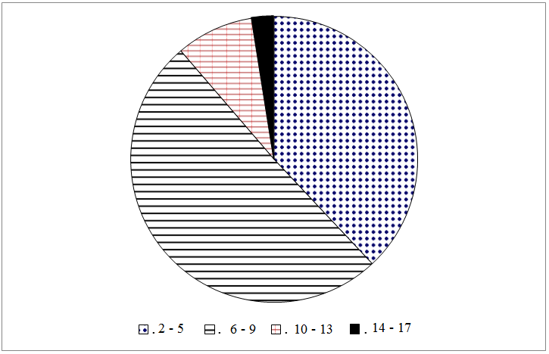
Figure 1 Household size

Figure 2 Household Monthly Food Expenditure

Figure 3 Household Monthly Income

Figure 4 Toilet waste disposal

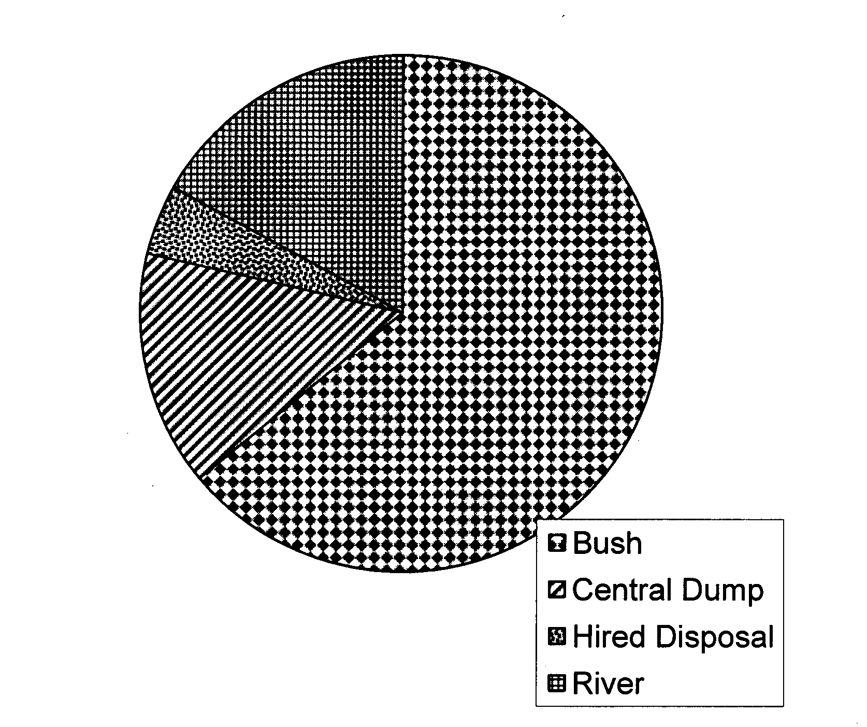

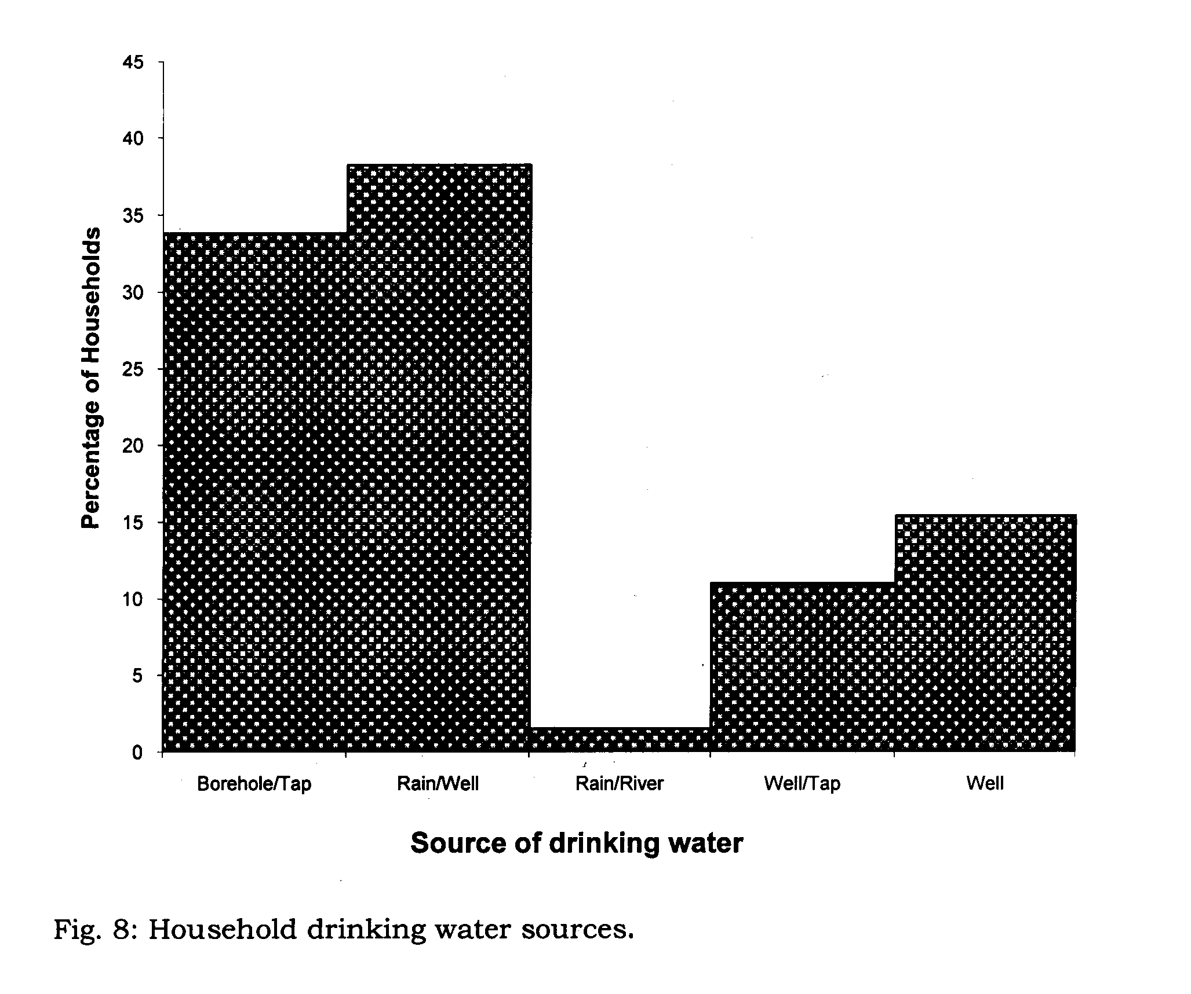
Figure 5 Domestic Refuse Disposal Methods

Figure 6 Sources of drinking water
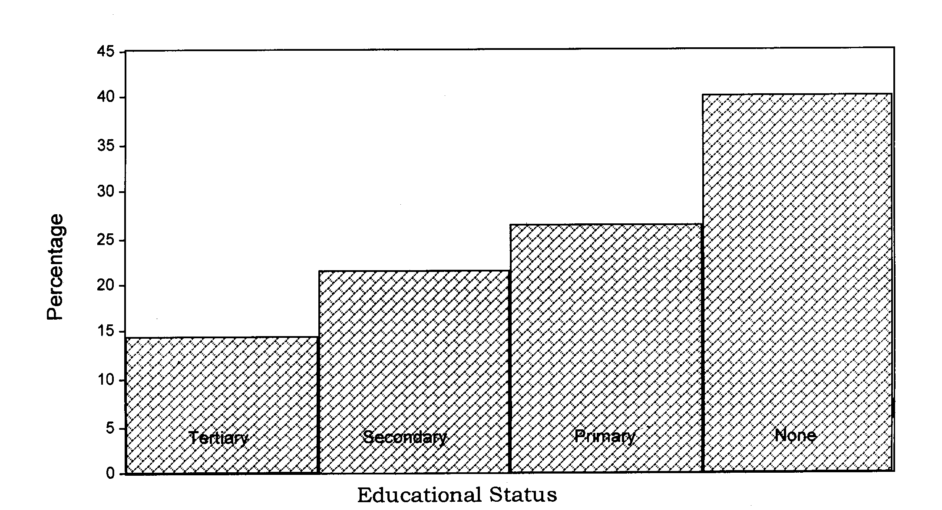

Figure 7 Formal education of household heads

The highest percentage on household feeding from the same kitchen had 6 to 9 members (Fig.1). On household monthly expenditure on food, 27% of respondents spent between N11, 000 and N18, 000 (Fig. 2). Households whose total monthly income was above N20, 000 formed 38% of the respondents. On breastfeeding practice .It was also found that 48% of household heads received education beyond the primary school level (Fig.7). The investigation also showed that 39% of households used nearby bushes for the disposal of toilet waste (Fig.4). Nearby bushes also served as places for the disposal of domestic wastes for 64% of the households (Fig.5).

Discussion
The finding that about half of the households visited had between 6 to 9 (Fig.1). This finding is comparable to literature report of 49% of households in Nigeria having between 3 to 5 members [7]. The rapid population growth results largely from improvements in preventive and curative medicine and community health care, all of which have helped to reduce infant mortality and prolonged life expectancy [8]. The population increase, calls for increase in advocacy by State agencies and non-governmental organizations for the control of family size. This is because high household population is a contributing factor to low nutritional intake. The expenditure on foods by households visited was generally low (Fig. 2). This may be as a result the low income level with 27% of the households earning between N11,000.00 and N16,000 .00 monthly (Fig. 3). The low income level is responsible for mothers not being able to breastfeed babies as recommended by
WHO [9,10]. Another consequ-ence of the socio-economic conditions in the home is that mothers are compelled to stay away from their babies almost all day while they engage in income generating activities [11]. This often results in childhood malnutrition as the babies may be placed on starchy, poor- protein food supplements all day [6] .
The finding that 39% of the households visited used nearby bushes to dispose toilet i.e for defecation (Fig.4) is an indication of poor economic status of the households who cannot afford more convenient and hygienic toilets. Domestic waste disposal in nearby bushes by 64% of the households (Fig. 5) also indicates the gross inadequacy of facilities put in place for the removal domestic wastes in the communities visited. The services of the environmental sanitation agencies are restricted to the cities where mobile trucks have been provided by government. Treated pipe borne water supply appeared to be a luxury which most of the households could not afford. As a result of this the house holds made do with drinking water from bore holes, rain, dug- out wells, and water obtained from nearby streams and rivers which are often polluted( Fig. 6). Illiteracy which affected 40% of the house holds was found in the course of the study (Fig. 7). The percentage of households who were privileged to obtain education up to primary (25.5%) and beyond primary up to secondary school level (20.5%) was also not encouraging. There is thus ample room for improvement to enable more households understand the import of any programs mounted for the enhancement of house hold nutrition.

Conclusion
In conclusion, this study has highlighted the inadequacies in the socio-economic life of some households in Rivers State, Nigeria. The findings point to an urgent need for improvement of the status of households viewed from various perspectives. This can be achieved by changes in the government policies which at the moment seem to be centered on increase in agricultural production. The findings also call for members of households to drop old habits and practices and embrace modern methods as in the disposal of toilet and domestic wastes. This will minimize the incidence of diarrhea, cholera, and other water-borne diseases; eliminate the breeding grounds for rodents and reduce environmental pollution generally. Primary Health Care Units of the State Ministry and other health care providers should do more to create a greater awareness on the need to improve the situation. Nutrition education in schools should be broadened to include the socio-economic factors outlined in this paper. Addressing household nutrition as suggested will go a long way towards the achievement of the Millennium Development Goals on Nutrition in Rivers State.

References
1. Tanzania Food and Nutrition Centre. Household Food and Nutrition Society. www.tfn.or.tz/eng/focus/hfns.htm (2006), (Accessed 4/11/2013)
2. Berck, P and Bigman D. Food Security and Food Inventories in Developing Countries. CAB International, (1993), Oxford, U K.
3. WHID. Hunger: Uprooted Peoples BWHID 3rd Annual report on the state of world hunger Bread of the World Institute on Hunger and Development (1993), Washington DC.
- Wikipedia,en.wikipedia.org/wiki/Milleniun –Development- Goals online (accessed 4/11/2013)
- Adikema N A Micronutrient and Immune Status of Mothers and Children in Parts of Rivers State. A PhD dissertation (2006), Rivers State University of Science and Technology, Port Harcourt, Nigeria.
- Okaka, J C, Akobundu, E N T., Okaka, A N. Human Nutrition: An Integrated Approach; (2002). 2nd Ed. Ocjanco Academic Publishers, Enugu p 5-26.
7. International Institute of Tropical Agriculture (Nigeria Food Consumption and Nutrition Survey 2001-2003; Summary. Maziya-Dixas B, Akinyele I O and Harris E. Eds. (2004), International Institute of Tropical Agriculture (IITA) Ibadan.
8. Idachaba, F S Good intentions are not enough: A collections of essays on Government and Nigerian Agriculture (2006), Vol. 1. Agricultural Policy Process; p48 University Press PLC, Ibadan.
9. WHO/MH (2002). Iproving Health Outcomes of the poor. The report of the working Group 5 of the Commission on Macroecomics and Health. Online http://www.e.whoint/whosis/cmhpapers/e/pdf/wg5-summary.pdf.
10. UNS/SCN News Meeting the challenge to improve complementary feeding (2003), SCN News No.27.
11. Pelto G H, Levitt E, Thairu L. Improving Feeding Practices: Current patterns, common constraints, and the design of interventions. Food and Nutrition Bulletin, (2003). Vol. 24 no. 1 United Nations University.

