Effect of Apium graveolens Leaves and Stalks in Reducing
the Side Effects of Doxorubicin in Male Rabbits

Haider Ridha Salman^{1,2} Batool Amein Al-Khafaji Nisreen J. Mohammed¹
¹Dept. of Pharmacology and Toxicology, College of Medicine, University of Babylon, Hilla, Iraq.
²pharmacist_iraq@yahoo.com

M J B

Abstract
The aim of the present study is to evaluate the potential protective effect of Apium graveolens (A. graveolens) against cumulative DOX-induced toxic effects to the heart, liver and blood components in male rabbits. DOX was administered intraperitoneally (i.p.) to the rabbits at a dose of (4mg/kg) four times within 14 days (cumulative dose 16 mg/kg). A. graveolens was given orally (7.5 g/kg/day) for 14 days. The results indicated that the concurrent use of A. graveolens with DOX significantly (p<0.05) protected against DOX-induced toxicities as evidenced by significant increase in RBC, WBC, Hb, and neutrophiles levels (p<0.05). No significant changes in monocytes, lymphocytes, eosinophiles and basophiles percentages were noticed in all groups of treatment. Also, Coadministration of A. graveolens significantly ameliorated the DOX-induced elevation in serum levels of malondialdehyde (MDA), lactate dehydrogenase (LDH), Alanine Transaminase (ALT), Aspartate Transaminase (AST) and bilirubin as well as inhibited DOX-provoked serum glutathione (GSH) depletion (p<0.05). No significant alterations in serum albumin level and catalase (CAT) activity were observed in all groups of treatment. Furthermore, the histopathological sections showed that the DOX caused significant structural changes in hepatic and cardiac tissues like necrosis and inflammation which were attenuated with combined use of A. graveolens. The study conclude that A. graveolens has the potential in protecting against DOX -induced cardiac, hepatic and hematological damage through a mechanism related to direct and indirect antioxidant property.
الخلاصة
تهدف هذه الدراسة الى تقصي تأثير نبات الكرفس على التأثيرات السمية التراكمية المستحثة لعقار الدوكسوروبيسين في القلب والكبد وعناصر الدم لدى ذكور الارانب. لقد تم استخدام عقار الدوكسوروبيسين بجرعة (4 ملغ/كغم) داخل البريتون اربع مرات في اربعة عشر يوما ( الجرعة التراكمية 16 ملغ/كغم), اما نبات الكرفس فقد تم اعطائه عن طريق الفم بجرعة (7,5 غم/كغم) في اليوم لمدة اربعة عشر يوما. دلت النتائج على ان الاستخدام المتزامن لنبات الكرفس مع عقار الدوكسوروبيسين ادى الى تقليل التاثيرات السمية المستحثة بواسطة هذا العقار وقد استدل على ذلك من خلال الزيادة المعنوية في اعداد كريات الدم الحمر وكريات الدم البيض وكريات الدم العدلة وكذلك الزيادة المعنوية في مستوى تركيز الهيموغلوبين في الدم. ولم تحدث اي تغيير في نسب كريات الدم الاحادية واللمفاوية والحمضة والقعدة في اي مجموعة من المجموعات في هذه الدراسة. وكذلك, فقد وجد ان استخدام الكرفس مع الدوكسوروبيسين ادى الى تقليل الزيادة الحاصلة في مستويات اكسدة الدهون (MDA) والإنزيمات (LDH وAST و (ALTوالبليروبين في مصل الدم بشكل معنوي كما ثبط من الانخفاض الحاصل في فعالية الكلوتاثايون في مصل الدم بشكل معنوي ولم يحدث اي تغيير في مستوى الالبومين او فعالية انزيم (CAT) في مصل الدم في اي مجموعة من المجاميع في هذه الدراسة. علاوة على ذلك, فان المقاطع النسيجية اظهرت ان عقار الدوكسوروبيسين سبب تغييرات تركيبية واضحة في نسيجي القلب والكبد للارنب كالتنخر والالتهاب والتي تحسنت بشكل واضح مع استخدام نبات الكرفس. تستنتج الدراسة أن نبات الكرفس يمتلك القابلية في توفير الحماية ضد الاضرار المسببة بواسطة الدوكسوروبيسين في القلب والكبد والدم , بطريقة تعود بصورة مباشرة و غير مباشرة الى الخاصية المضادة للاكسدة.
ـــــــــــــــــــــــــــــــــــــــــــــــــــــــــــــــــــــــــــــــــــــــــــــــــــــــــــــــــــــــــــــــــــــــــــــــــــــــــــــــــــــــــــــــــــــــــــــــــــــــــــــــــــــــــــــــــــــــــــــــــــــــــــــــــــــــــــــــــــــــــــــــــــــــــــــــــــــــــــــــــــــــــــــــــــــــــــــــــــــــــــــــــــــــــــــــــــــــــــــــــــــــــــــــــــــــــــــــــــــــــــــــــــــــــــــــــــــــــــــــــــــــــــــــــــــــــــــــــــــــــــــــــــــــــــــــــــــــــــــــــــــــــــــــــــــــــــــــــــــــــــــ

Introduction
Doxorubicin (DOX) is an anthracycline (ANT) antibiotic that possesses a potent and broad spectrum antitumour activity against a variety of human solid tumors and hematological malignancies [1, 2]. It is commonly used against ovarian, breast, lung, uterine and cervical cancers, soft tissue sarcomas as well against several other cancer types [3, 4]. It is known in the medical world as Adriamycin [5]. The preferential target of DOX is the DNA of dividing cells; the drug intercalates within DNA strands causing cell cycle blockage in the G₂ phase [6] and inhibition of the activity of some nuclear proteins, such as DNA and RNA-polimerase and DNA-topoisomerase II [7, 8]. Unfortunately, DOX use has been limited largely due to its diverse toxicities, including cardiac, hepatic and hematological damages [9, 10]. The mechanism of the organ toxicity is unclear. It is believed that oxidative stress and the formation of free radicals, which also involves a reaction of DOX with iron, play a crucial role in the mechanism of DOX induced toxicities [11-14].
Nevertheless, many researchers have tried to find ways to reduce the adverse effects associated with DOX therapy. There are promising preclinical results in protecting against DOX induced toxicity through application of medical herbs and different natural products, such as as antioxidants from natural sources may be useful in the protection of DOX induced toxicity [4, 15, 16]. Apium graveolens (A. graveolens) is a herbal member of the Apiaceae family commonly knonwn as celery. It is an annual or biennial plant native to Mediterranean regions [17, 18]. A review of the literature indicates that A. graveolens has been cultivated for the last 3.000 years [19- 21]. Its root, fresh leaves, and seeds are used as food, spice, and at various times consumed as a medicine [21, 22]. Studies have documented that A. graveolens possess broad range of biological activities including antioxidant [23, 24] antimicrobial [25, 109], anticancer [20, 26, 36, 112], hypolipidemic [27- 29], hypoglyceamic [77, 106], hepatoprotective, [20, 26, 77] , anti-inflamatory and analgesic effects [106, 107, 108, 110]. Actually, A. graveolens is used in the treatment of bronchitis, asthma, liver and spleen diseases and valuable in weight loss diets [30]. It can lower blood pressure and regulate heart function [31]. Potassium and sodium ions in A. graveolens juice helps to regulate body fluid and stimulate urine production [105]. Further, A. graveolens have a significant attenuating effect in reducing calcium deposits from renal tissues [41]. In addition to carminative, diuretic and uricosuric activities, A. graveolens exhibit also spasmolytic and sedative properties, which opens new possibilities of using A. graveolens in modern phytotherapy [111, 32].
Multiple benefits of A. graveolens are propaply caused by its rich compositions of several bioactive substances [13]. In fact, this vegetable has rich minerals and vitamins and contains nutritional fiber, essential oils and other secondary metabolites numbered to polyphenols among which flavonoids, phenolic acids, phthalides, coumarins, furanocoumarins and sterols can be distinguished [33, 34]. A. graveolens leaves and a purified component from this, Apiin, inhibits inducible nitric oxide and nitric oxide production in vitro [35]. Limonene of this plant protects against cell mutations [20, 26] and phthalides constituents have shown to inhibit benzopyrene-induced forestomach cancer in mice [36]. Luteolin, apigenin and quercentin flavonoids could be found in many plants including A. graveolens [37]. Previous research has shown dramatic protection of flavonoids against DOX induced bone marrow peroxidation [13, 38]. Besides, flavonoids protect against side effects on blood, hepatic and cardiac tissues in animals treated with anticancer drugs [39, 40].
Materials and Methods
Drug
DOX vial (50mg/25mL) was obtained from (Ebewe, Australia). The drug was administered in a dose of (4mg/kg i.p.) four times in 14 days to obtain treatments with cumulative doses of 16 mg/kg according to Kolarovic et al. [13] with few modification.
Plant
Fresh plant materials of A. graveolens were purchased from a local market in Hilla city /Iraq. A. graveolens was administered in a single oral dose of (7.5 g/kg/day) for 14 days, added to the animals food according to Al Jawad et al. [41] with few modification. Fresh A. graveolens leaves and stalks was used in this study.
Animals
Twenty four male adult rabbits were enrolled in this study. The animals were obtained from the Animal House of College of Science in Kufa University. Their weight was in range of (1500 to 2000 g). The rabbits were housed in Animal House of Babylon Medical College, under controlled temperature around 25 °C and 12 hours light-dark cycles in cages (3 rabbits in each cage). They were fed a standard diet and allowed free access to tap water [42].
Experimental design
After 2 weeks of adaptation, the rabbits were divided randomly into four groups, each group consist of six animals; group I was the control group and received 5mL/kg of 0.9% NaCl solution intraperitoneally (i.p.) four times in 14 days; group II received DOX (4mg/kg i.p.) four times in 14 days; group III given an oral dose of (75 g/kg/day) of A. graveolens in addition to four equal injections of 0.9% NaCl (5 ml/kg i.p.) in 14 days and group IV given an oral dose of (75 g/kg/day) of A. graveolens and received DOX (4mg/kg i.p.) four times in 14 days. On day 17, blood samples were collected from each rabbit, then all animals were sacrificed by overdose of anesthesia, livers and hearts were removed and homogenized and experimental parameters were measured.
Preparation of Serum samples
Blood samples were taken from each animal before starting drug treatment by direct heart puncture and on the day 17 of treatment (3 days after the last dose of DOX) by the same manner. Four ml of blood were collected from each rabbit by intracardiac puncture, one ml of blood was put in EDTA (1.2mg) tubes for hematological analysis including: Hb, RBC and total and differential WBC levels. Three ml of fresh blood was placed in test tube and left for 30 minutes at 37 °C in incubator to allow clotting. The serum was prepared by centrifugation at 3000 rpm for 10 minutes to determine levels of GSH, MDA, CAT, ALT, AST, LDH, bilirubin and albumin.
Estimation of Haematological Parameters
RBC counts were carried out using the improved Neubauer haemacytometer as described by Lewis et al. [43]. The counting chamber (neubaur hemocytometer ) was filled by holding the pipette at an angle 45 degree and touching the space between the coverslip and the chamber by the point of the of the pipette , an appropriate drop of the mixture is allowed to run under the coverslip by capillary action . The chamber is examined under 40X objective lens of the microscope to count in RBC counting area of the chamber ( in the four corners and center tertiary squares of the RBC) ,and the depth of the field is 0. 1 mm [43]. Estimation of total WBC count has been carried out using Neubaur improved chamber slide and 2% acetic acid solution as a diluents in about 1:20 ratio of dilution to dissolve RBC membrane according to [43]. Hb concentration was assessed by Sahli method which is based on converting Hb to acid hematin and then visually matching its color against a solid glass standard [44,45]. Differential leucocytes counts had been calculated in Leishman’s stained blood films. A total of 100 leucocytes per each slide are examined to count neutrophils, lymphocytes, monocytes, eosinophiles and basophiles percentages [46].
Estimation of Biochemical Parameters
MDA the end product of lipid peroxidation was analyzed according to Burtis and Ashwood [47]. The principle depends on spectrophotometric measurement of the purple color generated by the reaction of thiobarbituric acid (TBA) with MDA. GSH was evaluated as described by the method of Burtis and Ashwood [47] which is based on on the reduction of the Ellman’s reagent by the SH group (GSH) to form 5,5-dithio-2-nitrobenzoic acid in phosphate buffer. Serum catalase (CAT) activity was determined spectrophotometrically by the decrease in absorbance due to H₂O₂ consumption according to the principle of Aebi [48]. Biochemical analysis of the serum enzymes for ALT and AST was performed by the colorimetric method of Reitman and Frankel [49]. LDH was assayed according to the method of Howell and Coll [50] which is dependent on the conversion of pyruvate to lactate. Albumin level in serum was measured according to Doumas [51]. Albumin in the presence of bromcresol green at a slightly acidic pH produce a color change of the indicator. The intensity of the color formed is proportional to the albumin concentration in the sample. Total serum bilirubin was determined by sulfanilic acid method according to Walter and Gerarde [52]. The principle of this method depends on colorimetric measurement of azobilirubin that is formed from the reaction between bilirubin and diazotized sulfanilic acid.
Histopathological examination
The liver and heart tissues were excised and immediately fixed in 10% buffered formalin at the end of the experiment. The tissue specimens were embedded in paraffin after being dehydrated in alcohol and subsequently cleared with xylene [53]. Five-micrometer thick serial histological sections were obtained from the paraffin embedded blocks, dewaxed in xylene for 6 minutes and hydrated by decreasing concentrations of ethanol followed by distilled water for 2 minutes. Then, sections were stained with hematoxylin and eosin (H&E) and subsequently examined under light microscope to evaluate pathological changes and photomicrographs were taken.
Statistical Analysis
All values were expressed as Mean ± Standard error (SE). The data were analyzed by using of computer SPSS versin 17 and taking P-value less than 0.05 as the lowest limit of significant. Analysis Of Variance (ANOVA) test was used to examine the differences between different groups [54].

Result and Discussion
Table (1) showed that the RBC count, WBC count and Hb concentration were within the normal range in all groups before treatment. Howevr, the animals of DOX group showed a significant decrease in RBC count as compared with control group (P<0.05), while the animals of A.graveolens group and the animals of DOX with A. graveolens showed a significant increase in RBC count as compared with control group (P<0.05). Data also revealed a significant decrease in WBC count and Hb concentration in animals received DOX as compared with the control group and with their count before treatment (P<0.05). Besides, there was non-significant changes in these parameters in animals received A. graveolens alone or with DOX as compared with the control group (P>0.05), but there was a significant differences in both groups as compared with the group of DOX (P<0.05).
Actually, the depression in RBC, WBC and Hb levels recorded in the present work (Table 1) could be attributed to disturbed hematopoiesis and suppression of marrow cells mediated by DOX toxicity. It is well established that DOX was myelosupressent and thereby affecting erythropoiesis and leucopoiesis [55]. Bone marrow toxicity is primarily on the rapidly dividing early progenitor cells and it takes approximately 2 weeks before the peripheral blood count decrease becomes fully manifested [56, 57]. In addition, blood cells are under DOX mediated oxidative stress. This oxidative stress might resulted in free radical formation and membrane lipid peroxidation. Two different ways of free radical formation by DOX have been described, the first implicates the formation of a semiquinone free radical which yields O₂−• radicals and the second way produces DOX-iron complex that can reduce O₂ to H₂O₂ and other active species [58]. The decrease in Hb level may thus be associated with decrease in the total content of body iron as a result of forming DOX-iron complex. This could be another reason for decreasing hematological values [59, 60]. These finding were in agremeent with Al-Harbi et al. [61] and Parabathina et al. [55] who have concluded that DOX caused significant reduction in RBC, WBC and Hb levels in serum of expermental animals administred DOX antibiotic. Similarly, Piura and Rabinovich [62] showed that treatment of patients with advanced uterine sarcoma with a combination of DOX and ifosfamide had hematological toxicity represented in leukopenia in (80%), neutropenia in (80%), and anemia in (20%) of the patients.

Table 1 A comparison of RBC count, WBC count and Hb concentration after two weeks treatment of normal rabbit with DOX, A. graveolens and their combination.
Group | RBC count (x10¹²)/ L ± SE
Group | Before treatment | After treatment
Control | 5.1 ± 0.74 | 5.22 ± 0.77
DOX | 5.0 ± 0.55 | 3.52 ± 0.67*
A. graveolens | 5.0 ± 0.73 | 6.02 ± 0.72*
DOX with A.graveolens | 4.8 ± 0.58 | 6.60 ± 0.65*
Group | WBC count (x10⁹)/L ± SE
Group | Before treatment | After treatment
Control | 4.9 ± 1.51 | 5.0 ±1.22
DOX | 5.4 ± 1.14 | 3.3 ±1.31*
A. graveolens | 5.4 ± 1.14 | 5.4 ± 0.36
DOX with A.graveolens | 5.1 ± 1.08 | 4.8 ± 1.31
Group | Hb (mg/dL) ± SE
Group | Before treatment | After treatment
Control | 10.32±0.42 | 10.64±0.62
DOX | 10.53±0.40 | 6.64 ± 0.54*
A. graveolens | 10.40±0.58 | 11.04± 0.45
DOX with A.graveolens | 10.71±0.45 | 9.81±0.35

Nevertheless, it is evident from the results of the present study in DOX with A. graveolens group as campared to DOX group that the A. graveolens plant could prevent myelosuppression induced by DOX, as seen by a significant increase in RBC counts and Hb concentrations, which is suggestive of positive erythopoisis; as well as significant increase in WBC counts which suggests induction of the immune system defensive mechanism [63] (Table 1). The protective effect of A. graveolens could be mediated through several mechanisms since the plant itself is a complex mixture of many chemicals. Obviously, A. graveolens is rich in several bioactive components with antioxidant and anti-inflammatory properties such as flavanoids (apigenin, quetiricin), phenolic acids, phthalides, coumarins, furanocoumarins and sterols [34]. Flavonoids and other polyphenols have powerful antioxidant activities, being able to scavenge a wide range of reactive oxygen and nitrogen species and chelate transition metal ions, often decreasing the pro-oxidant activity of metal ions [64]. They might also function to inhibit the activity of pro-oxidant enzymes, such as cyclooxygenase, lipoxygenase, xanthine oxidase, inducible nitric oxide, and NADPH oxidases and induction of antioxidant enzymes, such as superoxide dismutase and glutathione S-transferase (65), thus protecting blood tissues from DOX toxic actions. A. graveolens also contains a variety of various minerals and nutrients such as tryptophan, folate, nutritional fiber, molybdenum, manganese, phosphorus, potassium, calcium, magnesium and iron [66, 67]. Among vitamins, complex of vitamins B and C as well as β-carotene are worth mentioning [68]. These phytocon-stituents have antioxidant and anti-inflammatory activitie [20, 66].
Yet, these findings agree wih Khuon [69] who observed that the oral administration of aqueous extract of A. graveolens has resulted in increasing of RBC, WBC and Hb levels significantly in female rats subjected to the hematotoxicity induced by CCl₄. However, this study match with Abd El-Ghany et al. [67] who observed that A. graveolens plant has resulted in a significant increase in RBC and WBC counts in animals groups treated with nephrotoxic dose of gentamicin antibiotic. Also, Parabathina et al. [55] showed that the flavonoids rutin, quercetin and vitamin E could impede the down regulation of erythropoiesis and leukopoiesis induced by DOX.
Result in Table (2) showed that there was significant decrease in neutrophile percentage in animals received DOX as compared with the control group and with its percentage before treatment (P<0.05) whereas the percentages of monocytes, lymphocytes, eosinophiles and basophiles remained unaffected in all groups of treatment (P>0.05). The present findings did not match with Parabathina et al. [55] who found that DOX was resulted in significant decrease in monocytes, lymphocytes, eosinophiles and basophiles counts while maintained normal neutrophiles levels in treated rabbits. Still, this controversy may be attributed to the differences in the expermental design and duration of tratment. A decreased percentage of neutrophile indicates suppression of neutrophiles production from bone marrow as a result of cumalative DOX doses [70]. Therefore, an increased percentage of neutrophiles in A. graveolens treated animals, as observed in the present study, suggests that A. graveolens is capable of impeding the down regulation of neutrophils induced by DOX and might be having a good potentiality to boost immune system [63]. A. graveolens contains a highly large amount of vitamin C which act to prevent the free radical formation and protect neutrophils and differential leucocytes from the ROS overproduction and thus may be responsible for heamatoprotective activities of A. graveolens. Regarding the effects of A. graveolens on monocytes and lymphocytes percentages, Khuon [69] studied the effect of the same plant against the hematotoxicity induced by CCl₄ and showed similar findings. Up To our knowledge, there is no available study to compare with it for the A. graveolens effect on eosinophiles and basophiles percentages.

Table 2 A comparison of monocyte, lymphocyte, neutrophile, eosinophile and basophile percentages after two weeks treatment of normal rabbit with DOX, A. graveolens and their combination.
Group | Monocyte % ± SE
Group | Before treatment | After treatment
Control | 4.8 ± 0.83 | 5.0 ± 0.70
DOX | 4.8 ± 0.89 | 4.8 ± 0.83
A. graveolens | 4.6 ± 0.89 | 4.0 ± 0.70
DOX with A.graveolens | 5.0 ± 0.70 | 4.8 ± 0.83
Group | Lymphocyte % ± SE
Group | Before treatment | After treatment
Control | 31.8 ± 1.14 | 29.6 ± 4.93
DOX | 31.8 ± 1.51 | 29.6 ± 2.70
A. graveolens | 31.6 ± 1.51 | 21.8 ±1.78
DOX with A.graveolens | 31.6 ±1.14 | 21.6 ± 5.94
Group | Neutrophile % ± SE
Group | Before treatment | After treatment
Control | 61.6 ±1.51 | 60.2 ± 0.44
DOX | 61.6 ±1.14 | 33.4 ± 2.07 *
A. graveolens | 62.6 ±1.34 | 60.6 ± 2.70
DOX with A.graveolens | 61.4 ±1.14 | 61.0 ± 1.64
Group | Eosinophile % ± SE
Group | Before treatment | After treatment
Control | 2.2 ± 0.44 | 2.0 ± 0.84
DOX | 2.4 ± 0.54 | 2.2 ± 0.83
A. graveolens | 2.2 ± 0.44 | 2.3 ± 0.65
DOX with A.graveolens | 2.4 ± 0.54 | 3.0 ± 0.87
Group | Basophile % ± SE
Group | Before treatment | After treatment
Control | 0.5 ± 0.08 | 0.6 ± 0.13
DOX | 0.6 ± 0.20 | 0.5 ± 0. 15
A. graveolens | 0.5 ± 0.14 | 0.6 ± 0.28
DOX with A.graveolens | 0.6 ± 0.22 | 0.7 ± 0.17

Table (3) showed that A. graveolens cause non significant increase in serum MDA (P>0.05). In contrast with DOX which cause significant increase in serum MDA as compared with the control group or with its level before treatment (P<0.05). The combination of A. graveolens with DOX cause significant decrease in serum MDA as compared with DOX group (P<0.05). Additionally, the result revealed that DOX decreased serum GSH level significantly (P<0.05), whereas A. graveolens alone or with DOX increased serum GSH level significantly (P<0.05) as compared with DOX group, with the control group or with its level before treatment.

Table 3 A comparison of MDA, GSH and CAT levels in serum after two weeks treatment of normal rabbit with DOX, A. graveolens and their combination.
Group | MDA in serum (mol /L) ± SE
Group | Before treatment | After treatment
Control | 4.73 ± 1.31 | 4.68 ± 1.28
DOX | 5.45 ± 1.93 | 13.63 ± 1.99*
A. graveolens | 4.17 ± 0.79 | 5.46 ± 3.55
DOX with A.graveolens | 4.06 ± 0.85 | 6.82 ± 0.43*
Group | GSH in serum (mol/L) ± SE
Group | Before treatment | After treatment
Control | 0.48 ±0.13 | 0.45 ± 0.07
DOX | 0.44 ±0.07 | 0.20 ± 0.08*
A. graveolens | 0.46 ± 0.11 | 1.42 ± 0.39*
DOX with A.graveolens | 0.47 ± 0.09 | 1.50 ± 0.18*
Group | CAT (IU/L) ± SE
Group | Before treatment | After treatment
Control | 0.055±0.006 | 0.056±0.008
DOX | 0.054±0.006 | 0.049±0.003
A. graveolens | 0.057±0.005 | 0.060±0.005
DOX with A.graveolens | 0.057±0.004 | 0.054±0.002

The increased levels of MDA might indicated excessive formation of the free radicals by DOX and activation of the lipid peroxidative process resulting in oxidative damage to the heart and liver tissues in rabbits subjected to DOX stress [12, 60]. Moreover, The depletion of GSH recorded in the present study signifies that free radicals and oxidative stress are increasing due to a toxic cumulative doses of DOX (16 mg/kg), and this might be attributed to a direct action of DOX on the GSH synthesis pathways, and/or an indirect function of the overwhelming response of DOX-stimulated generation of ROS [71]. Indeed, the observed decline in the level of GSH seems to be a prime factor that permits lipid peroxidation [72] and excessive lipid peroxidation causes increased GSH consumption [73]. Even so, the administration of A. graveolen significantly prevented the DOX induced elevation in serum MDA levels suggesting its protective activity. This could explain that the protective effects of A. graveolens may be attributed to its antioxidant and lipid-lowering properties that could directly eliminated free radicals and helped in the support of healthy cholesterol levels, thereby protecting the cardiac and hepatic cells from lipid peroxidation resulting in membrane stabilization [74, 75]. Further, the elevated levels of GSH could effectively provide thiol group for the possible GSH mediated detoxification reactions of glutathione S-transferase and glutathione peroxidase [76]. Also, A. graveolens contains large amounts of vitamin C which is a known immune system booster and reduces the free radicals in the body [77, 78]. On the other hand, metal chelating activity was claimed as one of the antioxidant activity mechanisms, since it reduced the concentration of the catalyzing transition metals in lipid peroxidation [79].
Nontheless, the use of A. graveolens could demonstrate effective capacity for iron binding, suggesting that its action as antioxidant may be related in part to its iron-binding capacity [80]. These findings were in agreement with findings reported by previous researches in which A. graveolens has resulted in decreased intensity of lipid peroxidation and enhanced GSH concenteration in animals treated with DOX, CCl₄ or Di-2- ethylhexyl phthalate [13, 74, 81].
With respect to serum CAT, the present study showed non-significant changes in activity of this enzyme in all groups of treatment (P>0.05) (Table 3). Similar results were obtained by Kolarovic et al. [13] who suggested that cumulative DOX dose (6 mg/kg), A. graveolens leaves juice, and their combinatoin showed no significant influence on serum CAT activity in experimental animals. While Alshabanah et al. [59] and Mohan et al., [82] found that serum CAT activity notably lowered after DOX treatment, Raskovic et al. (16) concluded that CAT activity increased significantly in serum after DOX treatment. Conversly, Abd El-Ghany et al. [67] found that A. graveolens consumption had resulted in a significant elevation in serum CAT activity. This contraversy may be due to that CAT and other antioxidant enzymes other than GPx have been shown to be relatively less sensitive to oxidative stress [83] or it may be due to the differences in species variation, dose or duration of treatment.
Data in Table (4) demonstrated that A. graveolens caused non-significant decrease in serum levels of ALT, AST and LDH enzymes (P>0.05), in contrast with DOX which cause significant increase in activities of ALT, AST and LDH in serum as compared with the control group or with its level before treatment (P<0.05). The combination of A.graveolens with DOX caused significant decrease in serum ALT, AST and LDH as compared with DOX group (P<0.05). DOX in the form of DOX semiquinone has been suggested to play a major role in its hepatotoxic action. Semiquinones are unstable under aerobic conditions thereby generating ROS by reacting with molecular oxygen [82]. Hepatocytes are the likely targets of ROS attack in the failing liver. It is conceivable that free radicals cause damage at their formation. Serum transaminases have long been considered as sensitive indicators of liver injury (84). DOX induced oxidative damage to hepatocytes alters their transport function and membrane permeability, leading to leakage of enzymes from the cells [82, 98]. This leakage causes a decrease in the levels of ALT and AST in hepatic cells but increase in levels of ALT and AST in serum (82). ALT is a more liver specific enzyme. Increase in AST activity is also roughly proportional to the extent of cardiac damage [16]. This indicate that DOX could not showed adverse effects at the hepatic level only, but also the possibility of significant damage of the heart function [11, 85].
Interestingly, A. graveolens prevents the increase in ALT and AST during its administration in combination with a cumulative dose of DOX and restored them towards normal side (Tables 4). These results suggested that A. graveolens may have protective effect against DOX-induced cardio and hepatotoxicity. This protective effect might be due to its ability for stabilizing of the cell membrane as well as repairing the hepatic and cardiac tissue damage by A. graveolens with the consequent decrease in the leakage of these enzymes.

Table 4 A comparison of ALT, AST and LDH levels in serum after two weeks treatment of normal rabbit with DOX, A. graveolens and their combination.
Group | ALT in serum (mmol/ L) ± SE
Group | Before treatment | After treatment
Control | 39.0 ±2.3 | 38.0 ± 1.04
DOX | 39.6 ±1.6 | 164 ± 6.5*
A. graveolens | 39.0 ± 1.1 | 38.4 ± 1.6
DOX with A.graveolens | 38.0 ± 2.0 | 103.8 ± 2.4*
Group | AST in serum (mmol/ L) ± SE
Group | Before treatment | After treatment
Control | 33.5± 4.47 | 33.3± 3.36
DOX | 31.2± 7.14 | 169.6± 5.23*
A. graveolens | 31.2± 2.66 | 30.6± 13.11
DOX with A.graveolens | 33.2± 4.42 | 93.1± 5.76*
Group | LDH in serum (IU/L) ± SE
Group | Before treatment | After treatment
Control | 591.7± 51.42 | 587 ± 43.76
DOX | 576.8± 37.40 | 1494.9± 74.6*
A. graveolens | 563.1± 42.33 | 572.4± 31.99
DOX with A.graveolens | 578.5± 29.91 | 1046.6± 58.8*

A. graveolens probably does so by the free radical scavenging which has been established in the in vitro studies indicating its antioxidant activity [74]. These results are in agreement with previous findings, which have also reported significant prevention into the rise of serum, ALT and AST levels by A. graveolens plant in animals treated with various hepatotoxin supporting the anti-hepatotoxic action of A. graveolens by virtue of membrane stabilizing activity [77, 26].
Similarlly, the dramatic augmentation of the LDH activity (Table 4) could suggest the great permeability of the hepatic cell membrane. Further, LDH is not specific for hepatic injury individually; the rapid cell swelling of sub-sarcolemmal bulbs and injured myocardium could facilitate the loss of intracellular enzymes in DOX group [12, 86]. It was previously known that the heart is very sensitive to ROS induced damage because of its highly oxidative metabolism and fewer antioxidant defenses compared to other organs [87]. This might be the possible mechanism for marked elevation of LDH concentration in serum after multi-dose administration of DOX. Nevertheless, LDH activity significantly decreased after A. graveolens treatment (Table 4) suggesting amioleration the toxicity of DOX not only at the level of liver but also at the level of other organs that house LDH intracellulary including heart. This result is in agreement with Prisacaru and Burlacu [88] who confirm the antitoxic potentials of A. graveolens volatile oil and other extractive solutions against acrylamide intoxication .
Non-significant (P>0.05) changes in serum albumin activity in all groups of treatment are shown in (Table 5). Albumin is the most abundant blood plasma protein and is produced in the liver and forms a large proportion of all plasma protein [89]. It might take a longer time for DOX to affect liver synthetic function (as albumin synthesis). Similar results were obtained by Firat et al. [90]. However, serum albumin level was not significantly affected after A. graveolens treatment (Table 5). The same findings have been observed by Abd El-Ghany et al. [67]. However, Prisacaru and Burlacu [88] suggested a possible correlation between antitoxic effect of phthalides from A. graveolens plant and the hyperalbuminemia of the acrylamide intoxication. This controversy might due to differences in the dose, duration of A. graveolens supplementation or different species variation.

Table 5 A comparison of Albumin and total bilirubin levels in serum after two weeks treatment of normal rabbit with DOX, A. graveolens and their combination.
Group | Albumin in serum (g/L) ± SE
Group | Before treatment | After treatment
Control | 3.3 ± 0.73 | 3.6 ± 0.52
DOX | 3.1 ± 0.80 | 3.5 ± 0.22
A. graveolens | 3.2 ± 0.29 | 2.8 ± 0.68
DOX with A.graveolens | 3.1 ± 0.33 | 3.1 ± 0.27
Group | Bilirubin (mmole/L) ± SE
Group | Before treatment | After treatment
Control | 0.399±0.024 | 0.401±0.033
DOX | 0.389±0.036 | 1.477 ± 0.27*
A. graveolens | 0.402±0.027 | 0.388± 0.042
DOX with A.graveolens | 0.376±0.040 | 1.102±0.21*

In fact, analysis of data in (Table 5) also showed that there were non-significant changes in serum total bilirubin concentration in all groups before treatment. Conversely, there was significant increase in bilirubin concentration in animals received DOX as compared with the control group and with its concentration before treatment (P<0.05). Since the liver is responsible for clearing the blood of bilirubin, so increasing the total serum bilirubin level indicated a reduction in the excretory capability of the liver as a consequence of liver injury [91]. This finding is in accordance to the results of Anandakumar et al. [92] and Alshabanah et al. [59] who suggested that increase in bilirubin is a clear marker of DOX induced hepatic dysfunction. Furthermore, there was non-significant changes in serum level of total bilirubin in animals received A. graveolens alone as compared with the control group (P>0.05), but there was a significant differences in its level in animals which received A. graveolens in combination with DOX as compared with the control group (P<0.05). This result may be due to the enhancement of bile acid excretion that may induced by A. graveolens and its active constituents indicating the improvement effects of th plant on liver function [77, 81].
Histopathological Findings
Histological Changes Induced by DOX and A. graveolens in Hepatic Tissue
Light microscopic observation revealed that the control and A. graveolens groups showing normal hepatocytes as illustrated in Figure (1) and Figure (2) respectively. Conversely, the hepatic sections from rabbits administered DOX exhibited a significant distribution of feathery degeneration of hepatocytes as summarized in Figure (3), moderate inflammatory cell infiltratation around portal tract, marked piecemeal necrosis, interlobular inflammatory cell infiltrate, and bridging necrosis, as recapitulated in Figure (4). However, the histopathological examination of hepatic tissues of DOX with A. graveolens group showed a mild degenerative changes as briefed in Figure (5).

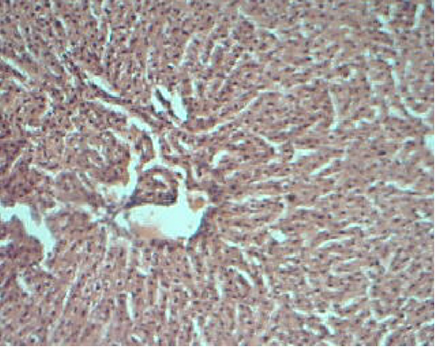
Figure..1 Histological section of hepatic tissue of control group showing normal hepatocytes. Magnification: 100X (H & E stain).

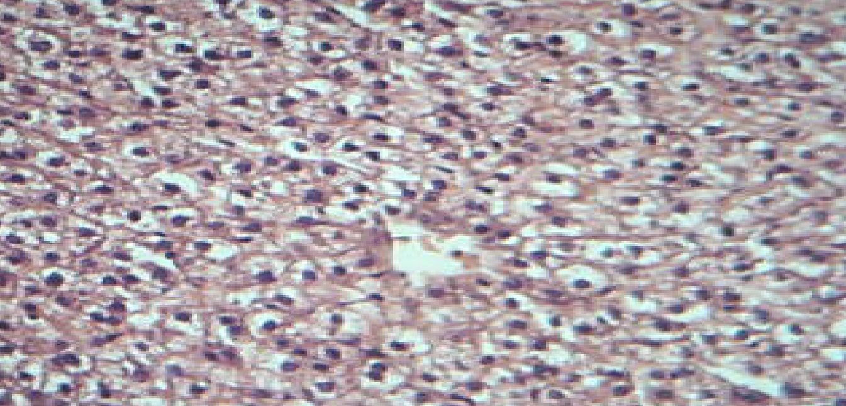
Figure 2 Histological section of hepatic tissue of A. graveolens group showing normal hepatocytes. Magnification: 200X (H & E stain).

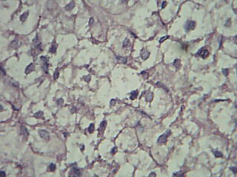
Figure 3 Histological section of DOX group showing feathery degeneration of hepatoctes. Magnification: 400X (H & E stain).

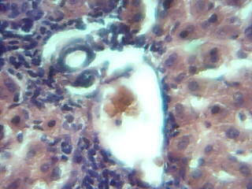 (A) 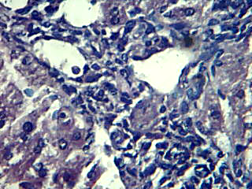 (B)

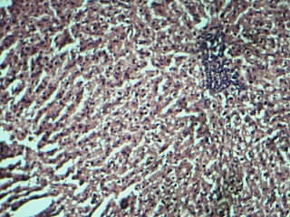 C 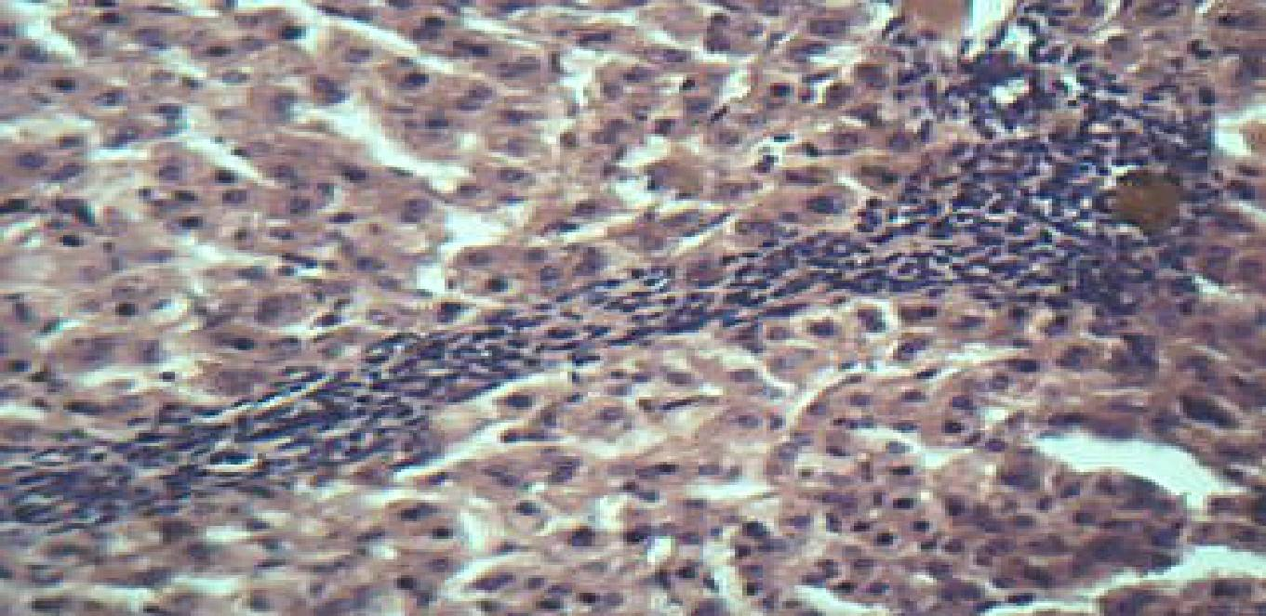 D
Figure 4 Histological section of hepatic tissue of DOX group showing: (A) Moderate portal inflammation (B) Marked piecemeal necrosis (C) Interlobular inflammatory cell infiltrate (D) bridging necrosis. Magnification: A:100X, B:400X, C:40X, D:40X (H & E stain).

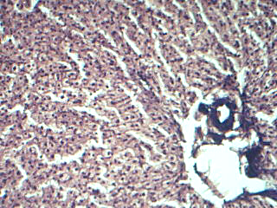
Figure 5 Histological section of hepatic tissue of DOX with A. graveolens group showing mild degenerative changes Magnification: 100X (H & E stain).

B. Histological Changes Induced by DOX and A. graveolens in Cardiac Tissue
The histopathological examination of cardiac tissues of the control and A. graveolens groups exhibited normal cardiac myocytes as briefed in Figure (6) Figure (7) respectively. In contrast, light microscopic observation revealed that the heart sections from rabbits received DOX showed a significant distribution of myocarditis with focal chronic inflammatory cells infiltration as summarized in Figure (8) and marked vascular congestion in between cardiac myocytes as recapitulated in Figure (9). Though, histological sections of cardiac tissue of DOX with A. graveolens group revealed intact myocardiam as illustrated in Figure (10).

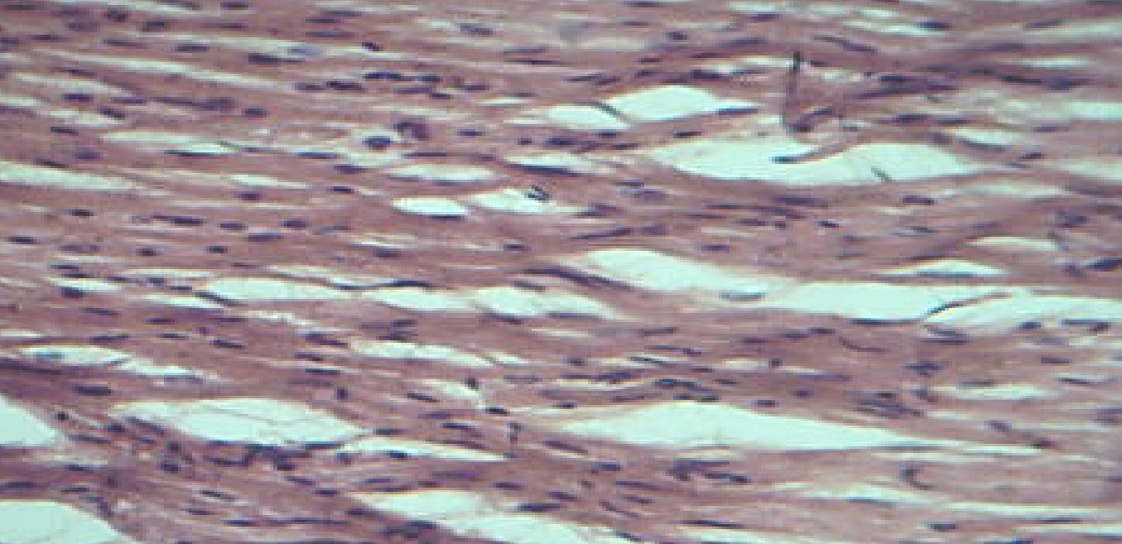
Figure..6 Histological section cardiac tissue of control group showing normal cardiac myocytes. Magnification: 40X (H & E stain)

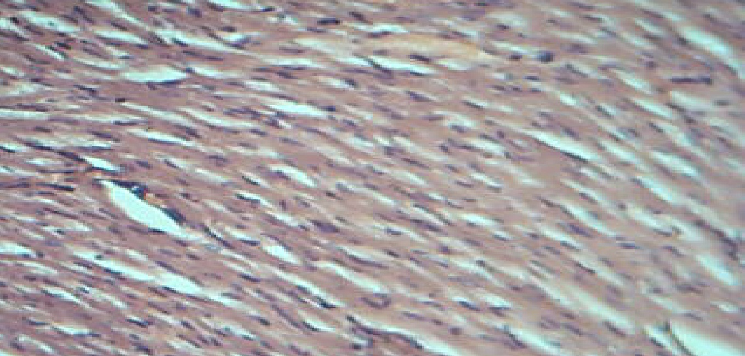
Figure..7 Histological sections of cardiac tissue of A. graveolens group showing normal cardiac myocytes. Magnification: 40X (H & E stain).

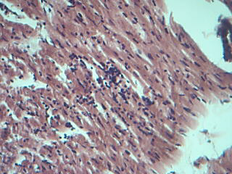
Figure..8 Histological sections of cardiac tissue of DOX group showing mycardiatis with inflammatory cells infiltration.
Magnification: 40X (H & E stain)

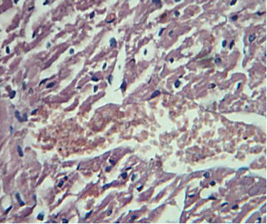
Figure.9 Histological sections of cardiac tissue of DOX group showing marked vascular congestion. Magnification: 200X (H & E stain).

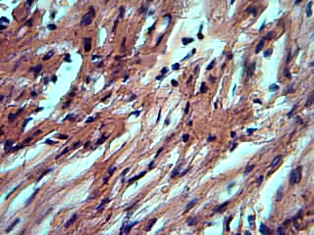
Figure..10 Histological sections of cardiac tissue of DOX with A. graveolens group showing intact myocardiam.
Magnification: 200X (H & E stain).

The different patterns of cell death and inflammation noticed in the present study might be due to DOX induced heptocellular injury and intrahepatic cholestasis resulting from cumlative drug administration. These findings were in agreement with Rasha and Abdella [93] and Ibrahim et al. [94] who observed portal and interlobular inflammation in hepatic sections isolated from DOX treated animals. Also, Abbas [95] and Mohan et al. [82] conclude that animals subjected to DOX stress showed histological alterations in many organelles including feathery hepatocyte degeneration, piecemeal necrosis and 4 necrosis.
Besides, myocarditis is an inflammation of the myocardium associated with cardiac dysfunction, it is frequently characterised by the evolution in dilated cardiomyopathy [96] and most often results from infectious agents, hypersensitivity responses, or immune-related injury [97]. Actually, DOX associated myocarditis developed in a dose-dependent fashion, and myocyte damage on biopsy has a linear relation with cumulative dose [98]. Thus, the histological cardiac lesions observed in the current study might result as a response of cellular injury and electrolyte abnormalities mediated by DOX cumulative administration. Increased free radicals and reduced endogenous antioxidants, with subsequent increase in oxidative stress lead to loss of myofibrils and vacuolization of myocardial cells [99]. Moreover, there is a strong association between oxidative stress and the cardiac inflammatory response, including cytokine release after DOX administration [93, 100]. In that regard, DOX is known to induce NFK-B activation and COX-2 expression in cardiomyocytes [101]. Also, it was reported that DOX induced changes in the properties of membrane bound ATPases of cardiac cells affect cardiac function and may be a relevant mechanism leading to lethal myocardial cellular injury [102]. In addition to that, DOX mediated vascular congestion may contribute to this pathogenesis [103]. The resulting peripheral release of vasoactive and pro-inflammatory neurohormones from the stretched endothelium and from the perivascular congested tissue may promote the development and progression of heart failure and thus compromising organ function [104]. These histopathological changes were found to be in a good agreement with the work of other authors such as [71, 93, 102].
Interestingly, combined supplementations of A. graveolens plant along with DOX antibiotic in this study resulted in significant reduction in histological changes that were induced by DOX in liver and heart tissues as summarized in Figures (4-5) and (4-10) respectively. This might explain the ability of A. graveolens to attenuate the DOX-related toxic effects via more than one mechanism including the powerful scavinging of ROS, the inhibition of lipid peroxidation, the decrease of the inflammatory response and the stimulation of the synthesis of cellular antioxidants that protect hepatic and cardiac cells from DOX induced liver and heart injuries. Similar results were observed by Sultana et al. [66] and Jain et al. [81] who studied the effect of A. graveolens on isolated hepatic sections. However, there is no available study to compare with for the effect of A. graveolens on isolated cardiac sections.

Conclusions
It seems that the cardiotoxic, hepatotoxic and hematototoxic effects of DOX might be attributed to the combination of free radical oxidative stress, and lipid peroxidation. A. graveolens coadministration significantly protected against DOX -induced toxicities on heart, liver, and blood component; thus suggesting its administration as a supportive care agent during anticancer treatment. The protective mechanism of A. graveolens may involve direct and indirect antioxidant activity against DOX-induced cardiac, hepatic and hematological damage.

Recommendations
The following can be recommended for the next studies :
1. Further studies could be carried out to evaluate the possible beneficial effects of A. graveolens against DOX toxicity on other organs like kidney, testis and ovary.
2. Clinical investigations are needed to determine the beneficial effect of A. graveolens-DOX combination against DOX-induced toxicities in human.
3- Investigating the effects of A. graveolens on cardiac output, ECG changes and troponine level.

References
1. Khan, M.; Shobha, J.C.; Mohan, I.K.; Naidu, M.U.R.; Challa Sundaram, C.; Singh, S.; Kuppusamy, P. and Kutala, V.K. (2005). Protective Effect of Spirulina Against Doxorubicin -Induced Cardiotoxicity. Phytother. Res. 19: 1030-1037
2. Abo-Salem, O.M. (2012). The Protective Effect of Aminoguanidine on Doxorubicin-Induced Nephropathy in Rats. J Biochem Molecular Toxicology, 26 (1): 1-9.
3. Saalu, L.C.; Osinubi, A.A.; Jewo, P.I. and Ajayi, G.O. (2010). An Evaluation of Influence of Citrus paradisi Seed Extract on Doxorubicin-Induced Testicular Oxidative Stress and Impaired Spermatogenesis. Asian Journal of Scientific Res, 3 (1): 51-61.
4. Pereira, G.C.; Silva, A.M.; Diogo, C.V.; Carvalho, F.S.; Monteiro, P. and Oliveira, P.J. (2011). Drug-induced Cardiac Mitochondrial Toxicity and Protection: From Doxorubicin to Carvedilol. Current Pharmaceutical Design, 17: 2113-2129.
5. Ascensao, A.; Oliveira, P.; and Magalhaes, J. (2011). Exercise as a beneficial adjunct during doxorubicin treatment. Role of mitochondria in cardioprotection., Int J Cardiol, 1-7.
6. Vendramini, V.; Sasso-Cerri, E. and Miraglia, S.M. (2010). Amifostine reduces the seminiferous epithelium damage in doxorubicin-treated prepubertal rats without improving the fertility status. Reproductive Biology and Endocrinology, 8 (3): 1-13.
7. Simunek, T.; Stirba, M.; Popelova, O.; Adamcova, M.; Hrdina, R. and Gersl, V. (2009). Anthracycline-induced cardiotoxicity: Overview of studies examining the roles of oxidative stress and free cellular iron. Pharmacological Reports, 61 (1): 154-171.
8. Hynek, D.; Krejcova, L.; Zitka, O.; Adam, V.; Trnkova, L. and Sochor, J. (2012). Electrochemical Study of Doxorubicin Interaction with Different Sequences of Double Stranded Oligonucleotides, Part II, Int. J. Electrochem. Sci., 7: 34-49.
9. Gillick, J.; Giles, S.; Bannigan, J. and Puri, P. (2002). Cell death in the early adriamycin rat model. Pediatr. Surg. Int. 18: 576-580.
10. Yilmaz, S.; Atessahin, A.; Sahna, E.; Karahan, I.; and Ozer, S. (2006). Protective effect of lycopene on adriamycin- induced nephrotoxicity. Toxicology., 218: 164-171.
11. Injac, R.; Perse, M.; Boskovic, M.; Djordjevic-Milic, V.; Djordjevic, A. and Hvala, A. (2008). Cardioprotective effects of fullerenol on a single dose doxorubicin induced cardiotoxicity in rats with malignant neoplasm. Technol Cancer Res Treat. 7: 15-26.
12. Injac, R.; Perse, M.; Cerne, M.; Potocnik, N.; Radic, N. and Govedarica, B. (2009). Protective effects of fullerenol C₆₀(OH)₂₄ against doxorubicin-induced cardiotoxicity and hepatotoxicity in rats with colorectal cancer. Biomaterials 30: 1184 96.
13. Kolarovic, J.; Popovic, M.; Mikov, M.; Mitic, R. and Gvozdenovic, L.J. (2009). Protective effects of celery juice in treatment with doxorubicin. Molecules, 14: 1627-1638.
14. Kolarovic, J.; Popovic, M.; Zlinská, J.; Trivic, S. and Vojnovic, M. (2010). Antioxidant activities of celery and parsley juices in rats treated with doxorubicin. Molecules 15, 6193-6204.
15. Wouters, K.A.; Kremer, L.C.M.; Miller, T.L.; Herman, E.H. and Lipshultz, S.E. (2005). Protecting against anthracycline-induced myocardial damage: a review of the most promising strategies. British Journal of Haematology, 131 (5): 561-578.
16. Raskovic, A.; Stilinovic, N.; Kolarovic, J.; Vasovic, V.; Vukmirovic, S. and Mikov, M. (2011). The Protective Effects of Silymarin against Doxorubicin-Induced Cardiotoxicity and Hepatotoxicity in Rats, Molecules, 16: 8601-8613.
17. Vovlas, N.; Lucarelli, G.; Sasanelli, N.; Troccoli, A.; Papajova, I.; Palomares-Rius, J.E. and Castillo, P. (2008). Pathogenicity and host-parasite relationships of the root-knot nematode Meloidogyne incognita on celery. Plant Pathology, 57: 981-987.
18. Shaimaa, M.E.; Glala A.A. and Safia, M.A. (2011). Response of Two Celery Cultivars to Partial or Complete Organic Nitrogen AlternationStrategies. Australian Journal of Basic and Applied Sciences, 5 (10): 22-29.
19. Momin, R.A. and Nair, M.G. (2001). Mosquitocidal, nematicidal, and antifungal compounds from Apium graveolens seeds. J. Agric. Food Chem., 49 (1): 142-145.
20. Momin, R.A. and Nair, M.G. (2002). Antioxidant, cyclooxygenase and topoisomerase inhibitory compounds from Apium graveolens Seeds. Phytomedicine, 9: 312-318.
21. Baananou, S.; Piras, A.; Marongiu, B.; Dessi, M.A.; Porcedda, S.; Rosa, A. and Boughattas, N.A. (2012). Antiulcerogenic activity of Apium graveolens seeds oils isolated by supercritical CO2. African Journal of Pharmacy and Pharmacology 6 (10): 756-762.
22. Asif, H. M.; Akram, M.; Akhtar, N.; Shah, P. A.; Uzair, M.; Rehman, R. (2011). Monograph of Apium graveolens. L. Journal of Med Plants Res, 5 (8): 1494-1496.
23. Kuhn, M. A.; Winston, D.; Marderosian, D.A.H. (2000). Herbal therapy and supplements: a scientific and traditional approach. Lippincott, Philadelphia, pp. 430
24. Wen, T.Q.; Lu, W.; Chen, F.X.; Song, H.S.; Zhao, C.P.; and Yu, T. (2006). Apium graveolens accelerating differentiation of neural stem cells in vitro. J. Shanghai Univ.,10 (1): 89-94.
25. Sipailiene, A.; Venskutonis, P.R.; Sarkinas, A. and Cypiene, V. (2005). Composition and antimicrobial activity of Apium graveolens leaf and root extracts obtained with liquid CO₂. Acta Hortic., 677: 71-77.
26. Ahmed, B.; Alam, T.; Varshney, M. and Khan, S.A. (2002). Hepatoprotective activity of two plants belonging to the Apiaceae & Euphorbiaceae family. J. Ethnopharmacol., 79 (3): 313-316.
27. Tsi, D.; Das, N. P. and Tan, B. K. (1995). Effects of aqueous celery (Apium graveolens) extract on lipid parameters of rats fed a high fat diet. Planta Med., 61: 18-21.
28. Tsi, D. and Tan, B. (2000). The mechanism underlying the hypocholesterolaemic activity of aqueous celery extract, its butanol and aqueous fractions in genetically hipercholesterolaemic rico rats. : Life Sci., 66: 755-767.
29. Mansi, K.; Abushoffa, A.M.; Disi, A. and Aburjai T. (2009). Hypolipidemic Effects of Seed Extract of Celery (Apium graveolens ) in Rats. Pharmacogn Mag 5: 301–305.
30. Shad, A.A.; Shah, H.U.; Bakht, J.; Choudhary, M.I. and Ullah, J. (2011). Nutraceutical potential and bioassay of Apium graveolens grown in Khyber Pakhtunkhwa-Pakistan. Journal of Medicinal PlantsResearch, 5 (20): 5160-5166.
31. Appel, L.J. and Moore, T.J. (1997). A clinical trial of the effects of dietary patterns on blood pressure. N. Engl. J. Med., 336: 1117-1124.
32. Bursac M.; Popovic, M.; Mitic, R.; Jakovljevic, V. and Kaurinovic, B. (2006). Antipyretic effect of celery (Apium graveolens) extracts in mice. Pharmaceutical Biology, 44 (8): 581-584.
33. Wolski, T. and Dyduch, J. (2000). Importance of vegetables and fruit in civilisation-related therapy. Ann. Univ. Mariae Curie-Sklodowska, 8: 19-38.
34. Wolski, T.; Najda, A. and Mardarowicz, M. (2001). Analysis of essential oil of the fruits of there cultivars of Apium graveolens, Supl. IX, 203-211.
35. Mencherini, T.; Cau, A.; Bianco, G.; Loggia, R.; Aquino, R.P. and Autore, G. (2007). An extract of Apium graveolens: structure of the major constituent, apiin, and its anti-inflammatory properties. J Pharm Pharmacol, 59: 891-897.
36. Zheng, G.Q.; Kenney, P.M.; Zhang, J.; and Lam, K.T. (1993). Chemo-prevention of benzopyrene-induced forestomach cancer in mice by natural phthalides from celery oil. Nutr. Cancer, 19: 77-86.
37. Verma, S.K.; Jain, V.; Verma, D.; Khamesra and Oxyacantha, R.C. (2007). A Cardioprotective Herb. J. Herbal. Med. Toxicol., 1: 65-71.
38. Bast, A.; Kaiserova, H.; Hartog, G. and Vijgh, W. (2007). Protectors against doxorubicin-induced cardiotoxicity: Flavonoids. Cell Biol Toxicol; 23: 39-47.
39. Lahouel, M. and Fillastre, J.P. (2004). Role of flavonoids in the prevention of hematotoxicity due to chemotherapeutic agents. Haema., 7: 313-320.
40. Lahouel, M.; Boulkour, S.N.; and Fillastre, J.P. (2004). Protective effect of flavonoids against the toxicity of vinblastine, cyclophosphamide and paracetamol by inhibiting lipid peroxidation and increased hepatic glutathione. Path. Biol., 52: 314-322.
41. Al Jawad, F.H.; Al Razzuqi, R.A. and Al Jeboori, A.A. (2011). Apium graveolens accentuates urinary Ca+² excretions in experimental model of nephrocalcinosis. Int J Green Pharm; 5 (2): 100-102.
42. Reeves P.G., Nielson F.H. And Fahey G.C., (1993). Ain-93 Purified Diets For Laboratory Rodents. Journal Of Nutrition, 123: 1939-1951.
43. Lewis, S.M.; Bain, B.J. and Bates, I. (2006). Dacie and LEWIS Practical haematology .10th (ed.) Churchill Livingstone Elsevier, Germany.
44. Sahli, H. (1909). Lehrbuch d. klin. Untersuchungs Methoden, Leipsic, 5th ed., pp. 846.
45. Sharma, S. (2007). Experiments and techniques in Biochemistry, Haematology determination. Galgotia, (New Delhi), 90-100.
46. Wallach, J. (2000). Interpretation of diagnostic tests, 7th ed. Philadelphia, pa: lippincott williams & wilkens.
47. Burtis, C. A. and Ashwood, E. R. (1999). Tiets Text Book of Clinical Chemistry, 3rd ed., Philadelphia, W. B. Saunders Co.
48. Aebi, H. (1984). Catalase in vitro. Method enzymol, 105:121-126.
49. Reitman, S. and Frankel, A. (1957). A colourimetric method for the determination of serum glutamic oxaloacetate and glutamic pyruvic transaminases. Am. J. Clin. Pathol., 28: 56-59.
50. Howell, B.F. and Coll. (1981). Clin. Chem. 25, 269. Commission Enzymologie - SFBC –Inform Sci - Biol, 5.
51. Doumas, B.T. (1971). Albumin standards and the measurement of serum albumin with bromocresol green. Clin. Chem.: Acta., 31: 87-96.
52. Walter, M. and Gerarde, H. (1970). Microchem J., 15: 231-243.
53. Drury, R. and Wallington, E.A. (1980). Carleton's Histological Technique .5th Ed. New York: Oxford University Press.
54. Daniel, (1999). Biostatistic: A foundation for Analysis in the Health Sciences.7th (ed.), John Wiley. Philadelphia, pp. 83.
55. Parabathina, R.K.; Muralinath, E.; Lakshmana Swamy, P.; Hari Krishna, V.V.S.N. and Shanthi Sree, K. (2011). Effects of Vitamin-E, Morin, Rutin, Quercetin against Doxorubicin in Rabbits: A Hematological Study. Research Journal of Pharmaceutical, Biological and Chemical Sciences, 2 (3): 74-84.
56. Marroquin, L.D. (2011). Identification of Key Kinases Associated with Bone Marrow Toxicity. San Diego St. Univ., 1-42.
57. Torres, V.M and Simic, V.D. (2012). Doxorubicin-Induced Injury of Cardiomyocytes – Do We Have Right Strategies for Prevention?. Cardiotoxicity of Oncologic Treat., 89-130.
58. El-Sayed, E.M.; Abd El-azeem, A.S.; Afify, A.A.; Shabana, M.H.; and Ahmed, H.H. (2011). Cardioprotective effects of Curcuma longa extracts against Doxorubicin-induced cardiotoxicity in rats. Journal of Medicinal Plants Research, 5 (17): 4049-4058.
59. Alshabanah, O.A.; Hafez, M.M.; Al-Harbi, M.M.; Hassan; Z.K.; Al Rejaie S.S.; Asiri, Y.A. and Sayed-Ahmed, M.M. (2010). Doxorubicin toxicity can be ameliorated during L-carnitine supplementation, Oxidative Medicine & Cellular Longevity, 3(6): 428-433.
60. Alshabanah, O.A.; Aleisa, A.M.; Hafez, M.M.; Al-Yahya, A.A.; Bakheet, S.A.; Al Rejaie, S.S.; Al-Harbi, M.M.; and Sayed-Ahmed, M.M. (2012). Desferrioxamine Attenuates Doxorubicin -Induced Acute Cardiotoxicity through TFG-β/Smad p53 Pathway in RatModel. Oxidative Medicine and Cellular Longevity, 1-7.
61. Al-Harbi, M.M.; Al-Gharably, N.M.; Al-Shabanah, O.A.; Al-Bekairi, A.M.; Osman, A.M. and Tawfik, H.N. (1992). Prevention of doxorubicin-induced myocardial and haematological toxicities in rats by the iron chelator desferrioxamine. Cancer Chemother. Pharmacol. 31: 200-204.
62. Piura, B. and Rabinovich, A. (2005). Doxorubicin and ifosfamide-mesna in advanced and recurrent uterine sarcomasl. Europ. J. of Gynaecological Oncology, 26 (3): 275-278.
63. Mishra, N. and Tandon, V.L. (2012) Haematological effects of aqueous extract of Ornamental plants in male Swiss albino mice. Veterinary World, 5(1): 19-23.
64. Shirai, M.; Kawai, Y.; Yamanishi, R.; Kinoshita, T.; Chuman, H. and Terao, J. (2006). Free Radic. Res. 40:1047-1053.
65. Halliwell, B. (2008). Are polyphenols antioxidants or pro-oxidants?. Archives of Biochemistry and Biophysics, 476: 107-112.
66. Sultana, S.; Ahmed, S.; Jshangir, T. and Sharma, S.C. (2005). Inhibitory effect of celery seeds extract on chemically induced hepatocarcinogenesis: Modulation of cell proliferation, metabolism and altered hepatic foci development. Cancer Lett. 221: 11-20.
67. Abd El-Ghany, M.A.; Ramadan, A.M. and Ghozy, S.F. (2012). Nutraceutical Effects of Curcuma, Ginger, Celery, Yeast and Honey on Side Effects of Gentamicin Induced Nephrotoxicity in Rats. World Applied Sciences Journal, 16 (5): 646-655.
68. Belal, N. M. (2011). Hepatoprotective Effect of Feeding Celery Leaves Mixed With Chicory Leaves and Barley Grains to Hypercholesterolemic Rats. Asian Journal of clinical Nutrition 3 (1): 14-24.
69. Khuon, O.S. (2012). Role of Aqueous Extract of Apium graveolens Seeds Against the Haematotoxicity Induced by Carbon Tetrachloride in Female Rats. Journal of College of Education Thi-Qar University, Iraq, 2 (6): 10-23.
70. Krysko, D.V.; Kaczmarek, A.; Krysko, O.; Bogaert, P.; Magez, S.; Bachert, C. et al. (2011). TLR-2 and TLR-9 are sensors of apoptosis in a mouse model of doxorubicin induced acute inflammation. Cell Death and Differentiation 18: 1316-1325.
71. Elbaky, N.A.A; Ali, A.A. and Ahmed, R.A. (2010). Cardioprotective Effect of Simvastatin on Doxorubicin-Induced Oxidative Cardiotoxicity in Rats. Journal of Basic and Applied Sciences, 6 (1): 29-38.
72. Kimura, T.; Fujita, I.; Itoh, N.; Muto, N.; Nakanishi, T.; Takahashi, K.; Azuma, J. and Tanaka, K. (2000). Metallothionein acts as a cytoprotectant against doxorubicin toxicity. J. Pharmacol. Exp. Ther. 292: 299-302.
73. Mohamed, H.E.; El-Swefy, S.E. and Hagar. H.H. (2000). The protective effect of glutathione on doxorubicin -induced cardiac toxicity in rats. Pharmacol. Res. 42: 115-121.
74. Popovic, M.; Kaurinovic, B.; Trivic, S.; Mimica-Dukic, N. and Bursac, M. (2006). Effect of celery (Apium graveolens) extracts on some biochemical parameters of oxidative stress in mice treated with CCl4. Phytother Res., 20 (7): 531-537.
75. Ahmed, Q.S. and Sayedda, K. (2012). Effect Of Celery (Apium Graveolens) Seed Extract On Protease Inhibitor (Ritonavir) Induced Dyslipidemia. NJIRM, 3 (1): 52-56.
76. Hozayen, W.G. (2012). Effect Of Hesperidin and Rutin On Doxorubicin Induced Testicular Toxicity in Male Rats. International Journal Of Food and Nutrition Science, 1 (1): 31-42.
77. Singh, A. and Handa, S.S. (1995). Hepatoprotective activity of Apium graveolens and Hygrophila auriculata against paracetamol and thioacetamide intoxification in rats. J of Ethnopharmacology 49 (3): 119- 126.
78. Abdou, H.S.; Salah S.H.; Hoda Booles, F. and Abdel Rahim E.A. (2012). Antioxidant effect of celery against carbontetrachloride induced hepatic damage in rats. African Journal of Microbiology Research, 6 (27): 5657-5667.
79. Senevirathne, M.; Kim, S.H.; Siriwardhana, N. and Lee, K.W. (2006). Antioxidant potential of ecklonia cavaon reactive oxygen species scavenging, metal chelating, reducing power and lipid peroxidation inhibition. Food Sci. Technol. Int., 12: 27-38.
80. Jung, W. S.; Chung, I. M.; Kim, S. H.; Kim, M. Y.; Ahmad, A. and Praveen, N. (2011). In vitro antioxidant activity, total phenolics and flavonoids from Apium graveolens leaves. Journal of Medicinal Plants Research, 5 (32): 7022-7030.
81. Jain, G. C.; Pareek, H.; Khajja, B. S.; Jain, S.K.; Jhalani, S. A. and Sharma, S. (2009). Modulation of di-(2-ethylhexyl) phthalate induced hepatic toxicity by Apium graveolens extract in rats. African Journal of Biochemistry Res., 3 (5): 222-225.
82. Mohan, M.; Kamble1, S.; Satyanarayana, J.; Nageshwar, M. and Reddy, N. (2011). Protective effect of Solanum torvum on Doxorubicin- induced hepatotoxicity in rats. Int. J. Drug Dev. & Res., 3 (3): 131-138.
83. Lores, A.S.; Llesuy, S. and Cutrin, J.C. (1995). Oxidative stress by acute acetaminophen administration in mouse liver. Free Radic Biol Med; 19: 303–310.
84. Kanaujia, V.K.; Irchhaiya, R.; Singh, H.K.; Kailasiya, D.; Verma, M.; Yadav, R.D. and Shivhare, D. (2011). Evaluation of hepatoprotective activity on the leaves of Ficus benjamina Linn. Journal of Natural Product and Plant Resources, (3): 59-69.
85. El-Shitany, N.A.; El-Haggar, S. and El-Desoky, K. (2008). Silymarin prevents doxorubicin induced cardiotoxicity and nephrotoxicity in rats. Food Chem. Toxicol. 46: 2422-2428.
86. Swamy, A.V.; Gulliaya S, Thippeswamy, A.; Koti, B.C. and Manjula, D.V. (2012). Cardioprotective effect of curcumin against doxorubicin-induced myocardial toxicity in albino rats. Indian J Pharmacol; 44 (1): 73-77.
87. Abou El Hassan, M.A.; Verheul, H.M.; Jorna, A.S.; Schalkwijk, C.; Vijgh, W.J.; van Bezu, J. and Bast, A. (2003). The new cardioprotector Monohydroxyethylrutoside protects against doxorubicin-induced inflammatory effects in vitro. Br. J. Cancer., 89: 357-362.
88. Prisacaru, C. and Burlacu, A. I. (2009). Evaluation of the Antitoxic Effect of Phthalides from Apium graveolens in Acrylamide Intoxication Not. Bot. Hort. Agrobot. Cluj, 37 (2): 129-133.
89. Suzuki, T.; Matsuura, T.; Ohkawa, K.; Miyamura, T.; Okazaki, I.; Watanabe, T. and Suzuki, T. (2006). All-trans retinoic acid down-regulates human albumin gene expression through the induction of C/EBPbeta-LIP". Biochem. J., 397 (2): 345-53.
90. Firat, O.; Kirdok, O.; Makay O.; Caliskan, C.; Yilmaz, F. and Ilgezdi, S. (2009). Can hyperbaric oxygenation decrease doxorubicin hepatotoxicity and improve regeneration in the injured liver? J Hepatobiliary Pancreat Surg; 16: 346-52.
91. Nyblom, H.; Björnsson, E.; Simrén, M.; Aldenborg, F.; Almer, S. and Olsson, R. (2006). The AST/ALT ratio as an indicator of cirrhosis in patients with PBC. Liver Int., 26 (7): 840-845.
92. Anandakumar, P.P.; Malarkodi, S.P.; Sivaprasad, T.R. and Saravanan, G.D. (2007). Antioxidant alpha lipoic acid as an attenuator of doxorubicin induced hepatotoxicity in rat model. Indian J. of Experimental Biology, 45: 1045-1049.
93. Rasha, A.R and Abdella, E.M. (2010). Modulatory Effects of Rosemary Leaves Aqueous Extract on Doxorubicin-Induced Histological Lesions, Apoptosis and Oxidative Stress in Mice. Iranian Journal of Cancer Prevention, 3 (1): 1-22.
94. Ibrahim, S.S.; Barakat, M.A. and Helmy, H.S. (2010). Modulating Effect of Carvedilol on Doxorubicin-Induced Cardiomyopathy and Hepatic Damage. Journal of American Science, 6 (12): 20-32.
95. Abbas, E. K. (2011). Histopathological changes caused by Doxorubicin in laboratory mice. J Pak Med Assoc, 61 (11): 1008-1010.
96. Calabrese, F. and Thiene, G. (2003). Myocarditis & inflammatory cardiomyopathy: microbiological and molecular biological aspects. Cardiovascular Res, 60: 11-25.
97. Calabrese, F.; Angelini, A.; Carturan, E. and Thiene, G. (2006). Myocarditis and Inflammatory Cardiomyopathy: Histomorphological Diagnosis. Ernst Schering Foundation Symposium Proceedings, 55: 305-321.
98. Dogan, I.; Sonmez, B.; Turker, O.; Ucar, U. and Yarar, S. (2010). Decreased Myocardial Tl-201 Uptake in Rats: Early Sign of Doxorubicin Induced Myocardial Damage and the Relation to Inflammation., Eur J Gen Med; 7 (1): 43-49.
99. Rajasekaran, M. and Kalaimagal, C. (2012). Cardioprotective Effect of a Medicinal Mushroom, Ganoderma lucidum Against Adriamycin Induced Toxicity. International Journal of Pharmacology, 8 (4): 252-258.
100. Bien, S.; Riad, A.; Ritter, C.A.; Gratz, M.; Grube, M.; Krieg, T.; Felix, S.B.; Staudt, A.; and Kroemer, H.K. (2007). The endothelin receptor blocker bosentan inhibits doxorubicin-induced cardiomyopathy. Cancer Res. 67: 10428-10435.
101. Li, L.; Takemura, G.; Miyata, S.; Esaki, M.; Okada, H.; Ogino, A.; Fujiwara, H. et al. (2006). Preventive Effect of Erythropoietin on Cardiac Dysfunction in Doxorubicin-Induced Cardiomyopathy. Circulation; 113: 535-543.
102. Ragavendran, P.; Sophia, D.; Arulraj, C. and Gopalakrishnan, V.K. (2012). Cardioprotective effect of aqueous, ethanol and aqueous ethanol extract of Aerva lanata (Linn.) against doxorubicin induced cardiomyopathy in rats. Asian Pacific Journal of Tropical Biomedicine, 212-218.
103. Singal, P.K. and Iliskovic, N. (1998). Doxorubicin -induced cardiomyopathy. The New England Journal of Medicine, 339: 900–905.
104. Colombo, P.C. and Jorde U.P. (2010). The Active Role of Venous Congestion in Decompensated Heart Failure. Rev Esp Cardiol.; 63 (1): 5-8.
105. Nilsson, A. (2009). Effects of GI and content of indigestible carbohydrates of cereal-based evening meals on glucose tolerance at a subsequent standardised breakfast. Eur J Clin Nutr; 60: 1092-9.
106. Mimica-Dukic, N. and Popovic, M. (2007). Apiaceae Species. A promising sources of pharmacologically active compounds and Petrosellinum crispum, Apium greveolens and Pastinaca sativa. In Govil, J.N., Singh, V.K., Eds.; Phytopharmacology and Therapeutic Values III, LLC: Houston, USA, 21: 132-133.
107. Al-Hindawi, M.; Al Deen, I.; Nabi, M. and Ismail M. (1989). Antiinflamatory activity of some Iraqi plants using intact rats. J Ethnopharmacol, 26: 163-168.
108. Mencherini, T.; Cau, A.; Bianco, G.; Della Loggia, R.; Aquino, R.P. and Autore, G. (2007). An extract of Apium graveolens: structure of the major constituent, apiin, and its anti-inflammatory properties. J Pharm Pharmacol, 59:891–897.
109. Friedmen, M.; Henika, P.R. and Mandrell, R.E. (2002). Bactericidal activities of plant essential oils and isolated constituents against Campylobacter jejuni, Escherichia coli, Listeria monocytogenes and Salmonella enterica. J Food Prot 65:1545–1560.
110. Al-Howiriny, T.; Alsheikh, A.; Alqasoumi, S.; Al-Yahya, M.; ElTahir, K. and Rafatullah, S. (2010). Gastric antiulcer, antisecretory and cytoprotective properties of celery (Apium graveolens) in rats, 48 (7): 786-793.
111. Tucakov J (1990): Herbal Drugs and Phitopharmaceuticals. Stuttgart, Mediapharm Scientific Publishers, 301–347.
112. Pei-Wen, Z.; Lien-Chai, C. and Chun-Ching, L. (2005). Apigenin induced apoptosis through p53-dependent pathway in human cervical carcinoma cells. Life Sci 76: 1367-1379.

