Magnetic Resonance Imaging Finding in Comparism with Arthroscopic Finding in Mensceal Tear

Hassanain Ahmed Jasim Al Bayati^{(a)} Usama Ayad Abd Alsatar^{(a)}
Mohamed Khalil Mula Mohawish^{(b)}
^{(a)}College of Medicine, University Babylon, Hilla, Iraq.
^{(b)} Hilla Teaching Hospital, Hilla, Iraq.

M J B

Abstract
Objective: mri study of od different knee condition to assess the mensci and compare it with the arthroscopic finding
Material and Method: 91 patients where studied complain of different knee problems ; mainly mensci ; & to some extent ligments ;;& and an associated symptoms using Phillips MRI machine ;saggital ;axial ; coronal ; T1W ;T2W ;T2W STIR; sequences; slice thickness 3mm ;42SLICE FOV 160 x 160 X79 MATRIX 512;VOXEL SIZE 0.6 RL (MM);were it perform in patient supine with 15 degree of external rotation;1; matrix were used on Hilla Teaching Hospital since October 2010 till June 2011.
Results: MRI is the most preferable diagnostic tool in diagnosis of mensceal tear its specfity may reach 82.9%& sensitivity of 90% in both medial & lateral mensceal tear with positive predictive value of 86.5%& negative predictive value of 87.1% withsmall different between lateral &medial mensci in specifity& sensitivity of diagnosis
Conclusion: MRI is the study of choice in diagnosis of mensceal tear &planning for treatment & arthroscopic surgical intervention
الخلاصة
المقدمة: فحص الغضروف الهلالي للركبة بواسطة الرنين المغناطيسي قبل أي تدخل جراحي بعد الفحص ألسريري
طريقة العمل :تم دراسة 91 مريض يعانون من إعراض مختلفة في الركبة أكثرهم يعانون من إعراض تلف الغضاريف باستخدام جهاز الرنين المغناطيسي نوع فلبس وبمقاطع مختلفة
النتائج: إن استخدام الرنين المغناطيسي في تشخيص إصابة الغضاريف يكون مفضلا لدرجة تصل إلى 82,9% في الدقة و 90% في الحساسية وكفاءة ايجابية تصل إلى 86.5% وكفاءة سلبية تصل إلى 87.1%مع وجود فارق نسبي بين قليل بين الغضاريف وتم التوصل إلى هذه النتائج من خلال مقارنة النتائج في الرنين المغناطيسي مع نتائج الفحص الناظوري للركبة
الاستنتاج:فحص الرنين المغناطيسي هو الفحص الأمثل في تشخيص حالات الغضروف الهلالي والتخطيط للعلاج من خلال ناظور الركبة
ـــــــــــــــــــــــــــــــــــــــــــــــــــــــــــــــــــــــــــــــــــــــــــــــــــــــــــــــــــــــــــــــــــــــــــــــــــــــــــــــــــــــــــــــــــــــــــــــــــــــــــــــــــــــــــــــــــــــــــــــــــــــــــــــــــــــــــــــــــــــــــــــــــــــــــــــــــــــــــــــــــــــــــــــــــــــــــــــــــــــــــــــــــــــــــــــــــــــــــــــــــــــــــــــــــــــــــــــــــــــــــــــــــــــــــــــــــــــــــــــــــــــــــــــــــــــــ

Introduction
Most of the orthopedition decide to start arthroscopy on clinical assessment the accuracy is in between 35-70 % [2-4]
Anatomy of menisci ;
The menisci of the knee are two semi lunar c shape fibro cartilaginous disks that sit on the peripheralmarginsof essentially flat tibialplateu ;both mensci measure approximately 4 to 10mm in height the periphery & 1mmm or less the free edges.the peripheral one third contain the neurovascular structures where the remaining two thirds is strictly fibrocartilgenous.
Lateral mensci has the same width throughout approximately 7 to10 mm; its shape like a three-quarter circle.
The medial meniscus is shaped more like half acircle although it posterior horn athached to the tibia just posterior lateral meniscus attachment ;its anterior horn attaches far anteriorly ;approximately 10to14mm anterior to anterior horn of lateral mensus the width of the medial meniscus in contrast t the lateralgradualytaperedfronm posterior to anterior [6]
Pit falls on MRI study of menscealtear ; A- normal variant simulating tears ;
1-superior recess on posterior horn of medial meniscus
2-popleteal hiatus
a-hiatus of popletealtendonsseparat-eslateral meniscus from the joint capsule
3-transverse ligament;
5-menscofemoral ligaments
6-soft tissue between capsule+medial meniscus
B-healed meniscus ;grade II signal persist at least up to 6months &S\P menscectomy( false positive type IV finding )
c-degenerative changes
d-diskoid meniscus
MRI appearance ;
MRI show not only the surfaces of the intraarticular structures but also changes within the mensci have been graded 0-III fig 1 ;
Fluid or myxoid degenerationin the meniscus is seen as aband of increase signal intensity on T2w &STIR images in the body of mensci (gradesI-II).if the signal extent to the menscal surface (grade3)lesion;grade I-II can become time grade III[7].
Another classification is of
Table 1
gradeIfocal;globularintrasubstance increase in signal intensity without extension to the articular surface
gradeII horizontal ‘linear intrasubstance increase in signal intensity without extenson to the articular surface
gradeIII increase signal intensity that extends to at least one articular surface
gradeIV complex tear wth macerated meniscus
onlygradeIII&IV are true menisceal tears;9
Classification of tears and degeneration (excludes the discoid meniscus)
Meniscal injuries can be classified on their appearance, location, shape, extent and origin. It should be noted that some tears are known by a variety of names and it is not always clear if various writers use terminology consistently.
Vertical or Longitudinal (concentric) tears. Vertical or longitudinal tears occur in the line with the circumferential fibres of the meniscus and parallel to the outer margin of the meniscus. Most longitudinal tears of the medial meniscus occur in the middle and posterior thirds. In the lateral meniscus it is common to find acute, complete or incomplete longitudinal tears of the posterior horn when the ACL is ruptured.
Peripheral tears. Peripheral tears are vertical or longitudinal tears, found in the peripheral one third of the meniscus. Stable vertical longitudinal tears which tend to be found in the peripheral, vascular portions of the menisci have good potential for self healing.
Bucket handle tears are an exaggerated form of a longitudinal tear where a portion of the meniscus becomes detached from the tibia and the end result is a dislocated central part of the meniscus looking like a bucket handle. They are 3 times more common in the medial meniscus than the lateral and may be associated with acute ACL tears. Bucket handle tears are commonly seen in young adults with a history of locking, extension block or slipping of the joint.
Radial tears are vertical tears which also occur often at the junction of the posterior and middle thirds and extend from the inner free margin toward the periphery. They are more common in the lateral meniscus and are often associated with ACL tears. If they reach the periphery it transects the entire meniscus. Radial tears which occur in the avascular inner one-third of the meniscus have little potential for healing. They are commonly traumatic and occur in younger, physically active patients.
Horizontal, cleavage or fish-mouth tears are common in older people and extend from the inner free margin to the intrameniscal substance where myxoid degeneration may be present. These tears divide the meniscus into superior and inferior flaps. They have little or no healing capacity.
Oblique tears are also known as flap or parrot beak tears; they are oblique vertical cleavage tears and usually occur at the junction of the posterior and middle thirds of the meniscus.
Complex degenerative tears are common in older subjects. The tears occur in multiple planes and are combinations of the above.
Displaced tears are fragments of a torn meniscus partially attached to the meniscus and migrating to any position within the joint. Displaced meniscal fragments are often clinically significant lesions requiring surgery because of pain and knee locking. Any shape of a meniscal tear can result in a displaced fragment.
Root tears are tears in the posterior or anterior central meniscal attachment. ‘Traumatic tears’ is a term used to describe tears that are believed to arise predominately as a result of a specific, traumatic injury event and include vertical, bucket handle and radial tears. Traumatic tears normally occur in younger sports-active people with or without associated cruciate ligament injury; the meniscus typically splits in a longitudinal direction. The central part of the meniscus may dislocate centrally and cause locking of the knee. Traumatic injury is considered more frequent in the medial meniscus.
‘Degenerative tears’ is a term used to describe tears that arise predominately due to degenerative processes and include horizontal, flap and complex tears as well as meniscal degeneration and destruction17. According to Strobel11 degenerative lesions are among the most common of the meniscal lesions. There appearance at arthroscopy is highly variable and includes fraying of the free edge, central degeneration, centrally located horizontal tears, fringe tags, degenerative flap tears and extensive fibrillation of the entire meniscus.

Material and Methods
91 patient where an arthroscope and before an MRI study done to them of true positive 45 & false positive 7& false negative 5& true negative 34 range their age from 20 -45years ; where diagnosed as medial mensceal tear & diagnosed as lateral mensceal tear by ; most of the mensceal tear where grade III && lateral mensci from II TO III;

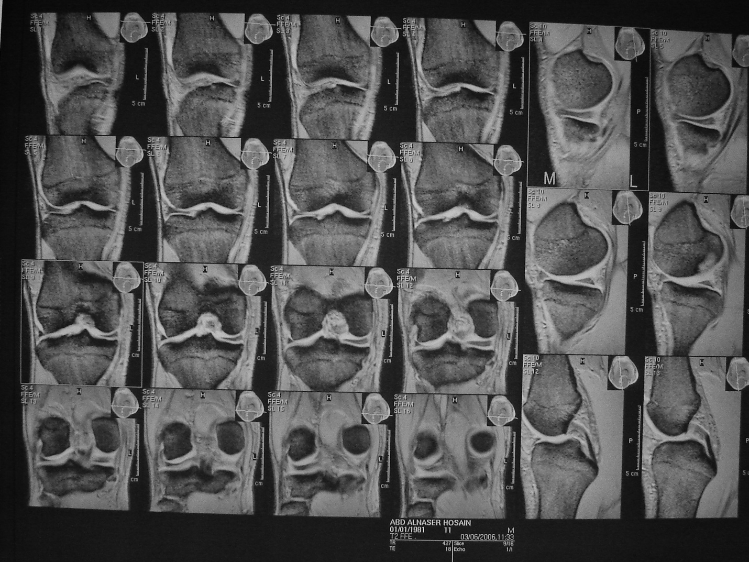
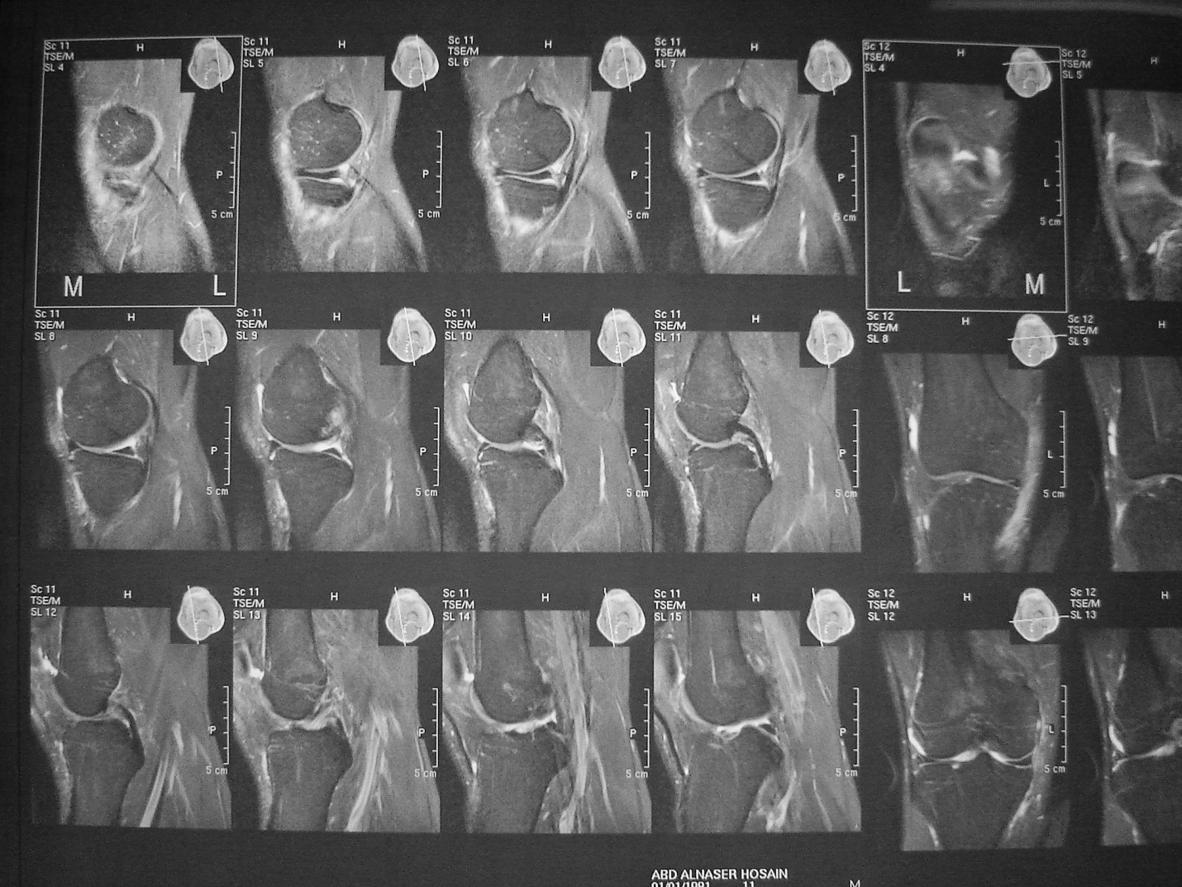

Results
specificity ;sensitivity where;
sensitivity is of 90%&specifity is of 82.9%with positive predictive value is of 86.5%& -ve predictive value of 87.1%
tear of medial meniscus sensitivity 95%specifity 88%accuracy 59-92%& lateral meniscus sensitivity 81%;specifity 96%; accuracy 87-92% [8]

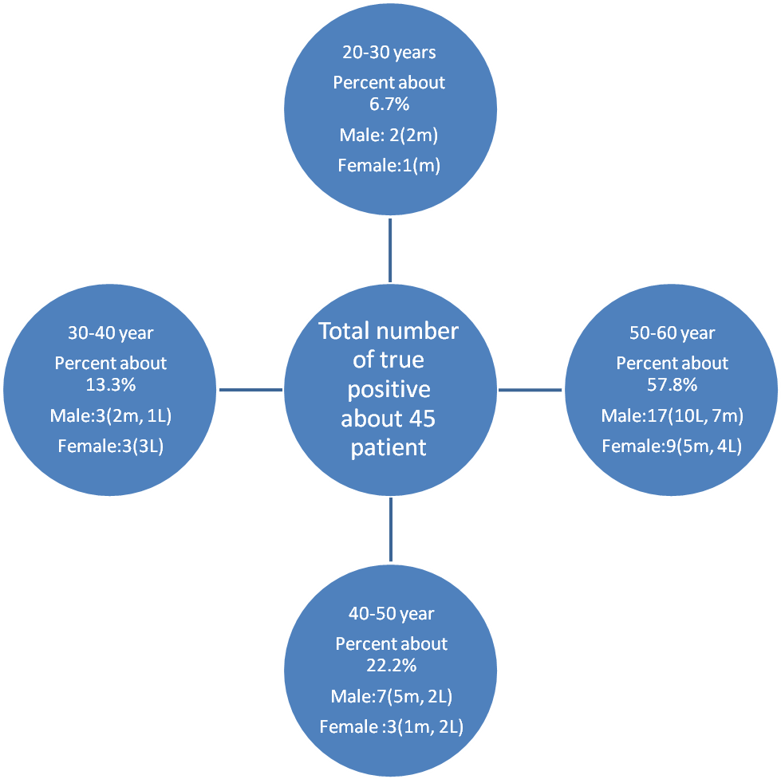

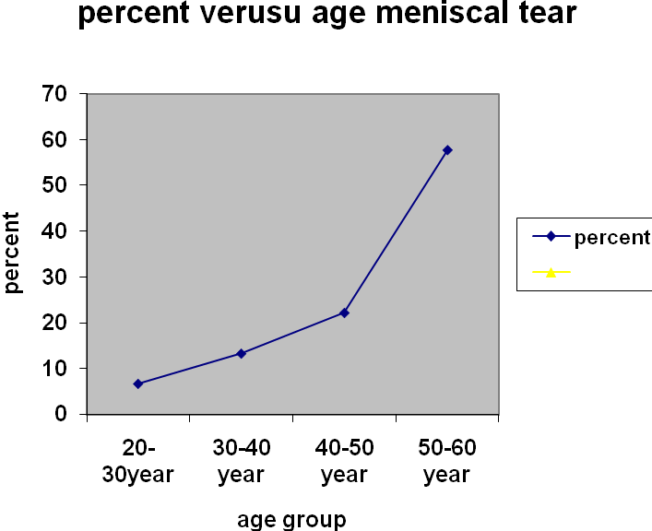
Table 1 of age versus types of meniscal injuries.
Type of tear | <40 year | =>40 year
horizontal | 2 | 15
complex | 1 | 2
flap | 2 | 3
radial | 2 | 6
Bucket handle | 1 | 1
longitudinal | 1 | 9

Table 2Type of tear versus mean age at arthroscopy
Tear type | Mean age at arthroscopy
Vertical longitudinal | 27
Radial tear | 29
Horizontal | 32
flap | 36

Main results
Several lines of evidence for the classification of tears into traumatic and degenerative types are reviewed by considering their occurrence and association with
Age
Anterior cruciate ligament injuries (ACL injuries)
Other specific traumatic events
Occurrence in symptomatic and asymptomatic knees
Body mass index
Osteoarthritis (OA)
Outcomes after meniscectomy
Specific occupations.
The summarised evidence is as follows:-
Age : There is high quality evidence from which shows that tears and meniscal degeneration increase in frequency with age. This evidence is supported by a range of cases series studies including histological studies and direct observation at surgery covering populations in many different countries. Degenerate tears are extremely common in the general population. The prevalence of grade 2 MRI signal changes, indicative of early degeneration was already 24.1% at the posterior horn of the medial meniscus in a young population. Grade three changes indicative of frank tearing had a prevalence of 76% on older asymptomatic subjects (mean age 55) and reached 91% in those with symptomatic osteoarthritis (91%).
ACL injuries: There is good evidence, consistent across a range of case series studies that 70 to 90% of tears associated with acute ACL injuries are traumatic type tears -peripheral, longitudinal tears. The percentage of degenerative tears found (flap and horizontal tears) is small.
Other traumatic events (not specifically ACL).
Occurrence in symptomatic and asymptomatic knees: There is some evidence that degenerate tears occur with high frequency bilaterally, in the symptomatic knee and the asymptomatic knee of the same person, whereas traumatic tears are more commonly found unilaterally in the symptomatic knee.
Body mass index: There is good evidence that prevalence of tears is strongly associated with BMI. These tears are likely to be mainly degenerate in nature.
Osteoarthritis (OA): There is excellent evidence from a variety of studies that degenerative tears particularly horizontal tears, complex tears and degenerate menisci are more strongly associated with the presence of OA than other tears. In our study the percentage of horizontal tears increased from 18.4% where no OA was present to 61.5% for grade 3 OA.
Degenerative changes in the meniscus are well under way in many subjects under 40 years of age and that by 50 to 60 years of age, full, degenerative tears are common place in at least one third of subjects and in some populations’ prevalence is over 50%. Unless these changes are associated with the presence of OA, such degeneration is often but not always asymptomatic and disability is not obvious.
There is excellent evidence that degenerate tears are strongly associated with the presence of OA and in this case associated with significant pain and disability. The degenerate tear is in fact so common in the elderly with moderate OA it has been suggested that it is pointless to conduct an MRI to prove their presence.
The prevalence of meniscal tears in a population randomly selected from those 20 to 60 years, In total 91 subjects were surveyed of whom 57% were female. They found that the prevalence of a meniscal tear or meniscal destruction in the right knee as detected on MRI ranged from 19% among women 20 to 40 years of age to 56% among men 50 to 60 years of age. Overall prevalence of meniscal damage was 35% and meniscal tear 31%. Of those with tears 51% had a medial tear, 49% lateral and 10% both lateral and medial. In knees with one or more tears the tear involved the posterior horn of the medial or lateral meniscus in 66% of the cases, the body segment in 62% and the anterior horn in 11%. Most of the tears were classed as degenerative; 38% of the knees with meniscal tears had horizontal tears, 7% complex, 11% oblique, 18% radial, 22% longitudinal tear. Prevalence of tears increased with age in both sexes (p<.001 ). The most frequent location of horizontal tears was the posterior horn of the medial meniscus.

Discussion
MRI is the best modality for assessment of the mensceal injuries
Meniscal tears: Out of 91 patients,show true positive of 45 patient &false positive of 7patients & false negative 5 patients &truenegative of 34 patients of sensitivity 90%&specifity 82.9%of positive predictive value of 86.5%&negative predictive value of 87.1% which show that medial mensceal tear is as twice as lateral mensci& it is going with another study which give the same result [11].
Out of 45patients of medial meniscal tears, most common tear location was at posterior horn. In our study, we found posterior horn tear. On arthroscopy posterior horn tears were seen in posterior horn of medial meniscus as true positive finding& patients of lateral meniscus tears posterior horn tears was seen most commonly,. On Arthroscopy posterior horn tears were seen in patients
Out of 45 patients, Grade III tear of medial meniscus was seen as the mostcommon grade of mensceal tear .
The occurrence of the false positive meniscal tears at MRI imaging has been noted earlier. There are explanations for this apparent discrepancy between findings at MR Imaging and arthroscopy[4].
- Misinterpretation of normal anatomy like Meniscofemoral ligaments etc.
- The presence of intrasubstance tears which are not seen on arthroscopy.
- The operator dependence of Arthroscopy
- The presence of loose bodies
.. The degeneration and tears of menisci demonstrated as high signal intensity were due to imbibed synovial fluid
In our study, we found that the t2w sequences is of much helpful in the diagnosis & this is supported by another study12.
Medial collateral ligament was found to be torn in four patients, which was also seen on MRI in both the patients
arthroscopy, two patient out of seven patient was falsely reported as positive on MRI which was probably due to pseudotear appearance of lateral meniscus caused by Meniscofemoral ligament. No tears werefound on arthroscopy. Gr I and II tears which are considered as precursors for formation of meniscal tears, are overlooked on arthroscopy. Raunestet al[13} reported that arthroscopic and arthrographic surface evaluations are insensitive to Gr I and II intrasubstance degenerativechanges

References
1-text book of medical imaging of Diagnostic Radiology;edited by ; R.G.Grainger;D.J Allison A.Adam;A.K.Dixon ;volume 7 4th edition p2030
2 -Berquist TH. Magnetic resonance techniques in musculoskeletal diseases. Rheum Clin North Am 1991; 17: 599-615.
3-Gentili A, Seeger LL, Yao L, DoHM. ACL tear:Indirect sign at MRI: Radiology 1994; 193: 835-840.
4-Fischer SP, Fox JM, Del Pizzo W et al . Accuracy of diagnosis from magnetic resonance imaging of the knee: a multi centre analysis of one thousand and fourteen patients. J Bone Joint Surg (AM) 1991; 73A: 2-10.
5-Mink JH, Levy T, Crues JV. Tears of the ACL and menisci of the knee: MR evaluation. Radiology 1988; 167: 769-774.
6-CT & MRI of the whole body;Johmr.Haaga;Charlesf.Lansieri;RobertC.Gilekeson 4th edition volume 2 chapter 48 page 1871;2002
7- Text book of radiology &imaging David Sutton section 5sekeletal system p.1237 ; 7th edition 2002
8-radiology review manual ;6th edition Wolfgang Dahnert volume 1 p.118;2007
9-Kaplan PA,DussaultR, Anderson MW, Major NM; musculoskeletal MRI philadelphia W.B.Saunders,2001
10-Mink JH, Levy T, Crues JV. Tears of the ACL and menisci of the knee: MR evaluation. Radiology 1988; 167: 769-774.
11. La Prade RF, Burnett QM, Veenstra MA, Hodgman CG. The prevalence of abnormal MRI findings in asymptomatic knees. Am J Sp Med 1994; 171: 761-766.
12- Rubin DA, Kneeland JB, Listerud J, Underberg E, Davis SJ. MR diagnosis of meniscal tears of the knee: value of FSE vsconv SE pulse sequences. AJR 1994; 162: 1131-1138
13- Raunest J, Hotzinger H, Burrig KF. MRI and arthroscopy in detection of meniscal degenerations. Arthroscopy 1994; 10: 624-630.

