In vitro and in vivo Activity of Selected Antibacterial Agents ; Alone and in Combination Against Multi Drugs Resistant Pseudomonas aeruginosa Isolated from Burns Infections

Zahraa Kais Saleman Habeeb S. Naher
Microbiology Dept., College of Medicine, University of Babylon, Hilla, Iraq.

M J B

Abstract
This study included (70) swabs being collected from burned patients of both sexes ,males and females of different ages attending to burned unit at AL- Hilla Teaching Hospital in AL-Hilla city during a period of three months from October to December 2012. The results indicated that 26/70(37.01 %) of samples were Pseudomonas aeruginosa and 44/70(62.9%) revealed others types of bacteria. The susceptibility of Pseudomonas aeruginosa towards 6 antibiotics included in this study by Disk Diffusion Test showed that P. aeruginosa isolates (100%) exhited resistance for Rifampen,Gentamycin , Pipracillin , Tobramycin .While they were presently sensitive to Meropenem and Amikacin.In addition, P.aeruginosa revealed remarkable susceptibility toward natural products, Garlic Vinegar but it did not affected by Garlic Oil. According to these results the 6 antibiotics were employed for in vivo experiments , since they were used for treatment of experimentally infected animals alone and in combination .The response of experimentally infected animals in recovery from experimentally burned infection was remarkable when combined antibiotics were used for treatment in relation to the use of single antibiotics ,which indicated for synergy reaction as well and the results were in according with well diffusion method.
الخلاصة
تضمنت هذه الدراسة (70) مسحة بكتيرية جمعت من مرضى الحروق من كلا الجنسين ,ذكور وإناث من مختلف الفئات العمرية الراقدين في وحدة الحروق بمستشفى الحلة التعليمي في مدينة الحلة خلال ثلاثة أشهر للفترة من أكتوبر إلى ديسمبر 2011.أظهرت النتائج أن جميع العينات التي تمت دراستها كانت موجبة للزرع البكتيري. واظهرت نتائج العزل و التشخيص ان 26/70(37.01%) هي بكتريا Peudomonas aeruginosa و 44/70(62.9 %) شملت أنواع أخرى من البكتريا تم الكشف خلال الدراسة على مدى حساسية بكتريا Pseudomonas aeruginosa تجاه ستة مضادات حيوية تم اختيارها والتركيز عليها على أساس أستخدامها في علاج هذه البكتريا و ذلك بواسطة إستخدام طريقة الفحص الأنتشار بالأقراص Dis Diffusion Test (DD Test) حيث أظهرت نتائج هذا الفحص إن (100%) من عزلات بكترياPseudomonas aeruginosa كانت مقاومة للريفامبين rifampen,الجينتاميسين gentamycin,البيبراسيلينpipracillin,التوبراميسين tobramycin لكنها كانت حساسة للميروبينيم meropenem والأميكاسين amikacin .بالأضافة أن Pseudomonas aeruginosa لديها حساسية ملحوظة تجاه خل الثوم ولم تتأثر بزيت الثوم. وعلى ضوء هذه النتائج تم إختيار المضادات الميروبينيم meropenem, البيبراسيلين pipracillin , التوبراميسين tobramycin, الجينتاميسين gentamycin و الأميكاسين amikacin في علاج الحيوانات المصابة مختبريا˝ بحروق تجريبية مفردة و مركبة.أظهرت نتائج التجربة المختبرية للأرانب إستجابة الحيوانات المصابة تجريبيا˝ للشفاء بفترة زمنية قياسية عند أستخدام المضادات الحيوية كتراكيب متحدة.
ــــــــــــــــــــــــــــــــــــــــــــــــــــــــــــــــــــــــــــــــــــــــــــــــــــــــــــــــــــــــــــــــــــــــــــــــــــــــــــــــــــــــــــــــــــــــــــــــــــــــــــــــــــــــــــــــــــــــــــــــــــــــــــــــــــــــــــــــــــــــــــــــــــــــــــــــــــــــــــــــــــــــــــــــــــــــــــــــــــــــــــــــــــــــــــــــــــــــــــــــــــــــــــــــــــــــــــــــــــــــــــــــــــــــــــــــــــــــــــــــــــــــــــــــــــــــــــــــــــــــــــــــــــــــــــــــــــــــــــــــــــــــــــــــــــــ

Introduction
Burn injury and infection of wounds are a serious problems that leads to death. Burns predispose the patient for microbial infection due to a damage protective skin barrier, facilitating the entry of saprophytes, opportunists and pathogens, leading to infection accompanied by systemic immunosuppression[1]. P. aeruginosa also carries many intrinsic and acquired antimicrobial resistance traits make burns wound infection difficult to treat [2,3]. There are limited numbers of antimicrobial agents including the anti-pseudomonal Penicillins, Cephalosporin, Carbapenems, Aminoglycosides and Fluoroquinolons with reliable activity against it [4].Also the medically importance of this organism is attributed to its ability to produce a variety of toxins, extra cellular enzymes including elastases, proteases and hemolysins [5].

Materials and Methods
Patients
A total of (70) samples of infection burns were taken from patients of different ages and both sexes who were admitted to the burns unit of AL-Hilla Teaching Hospital during a period of three months from October to December 2010.
Laboratory animals
Nine healthy rabbits (Island, albino) were used. Four of these rabbits were males and five females , their weight ranged between 1.5-2 kg.
Specimen collection
Seventy burns swabs were collected from patients . Information about their (gender, age and antibiotics usage) were taken into consideration. These specimens were transported by transport collection swabs containing ready made media to maintain the swab wet until reach to laboratory and collected with the help of physicians to avoid any accidentally contamination. Each specimen was inoculated on Nutrient agar , Blood agar, MacConkey agar and Pseudomonas selected agar plates. All plates were incubated aerobically at 37°C for 24 hrs.
Identification
The grown colonies on the culture media with characterized diffusible pigments were selected for further diagnostic tests. The P. aeruginosa isolates were identified according to biochemical tests that recommended by [6].
Affect of Garlic oil and vinegar (garlic juice )
In this study , two wells first one is contain garlic oil and another is contain vinegar oil were made on Mueller Hinton agar plates inoculated with P . aeruginosa and incubated at 37C° for 24 hrs showed that there is no effect for garlic oil on the bacterial culture while the garlic vinegar get inhibition zone measured 22 mm in diameter .
Antibiotics susceptibility test
Disc Diffusion test (DDT )
The Kirby- Bauer method is a standardized method for this test that takes all variables into consideration .It is sanctioned by the United States FAD and Subcommittee on Antimicrobial Susceptibility Testing of the NCCLS and [7]. Antibiotics inhibition zones were measured using a transparent ruler .Zone size was compared to the standard zones of the CLIS [8]to determine the susceptibility of organism to each antibiotic.
Well diffusion method
In this method ,on Mueller – Hinton agar plates wells (6mm) were prepared by cork poorer, then the plates were inoculated with cotton swab dipping into screw tube containing bacterial suspension being compared with (0.5)McFarland standard tube and streaked over the surface of plates. After this, Mueller - Hinton agar wells were filled with 50 µl of prepared concentrations for each single antibiotics and combined antibiotics and incubated the plates at37C°for 24 hr.The susceptibility to these antibiotics was determined by measuring the inhibition zone around the wells for each concentration[9].
Minimum inhibition concentration (MIC)
The MIC was detected by Agar Dilution Procedure (Wadsworth Method) and it was employed according to [10].
Defining values of MICs for single and combination antibiotics
For this experiment the methods being recommended by CLSI[8] and [11] were employed with some modification according to the condition of the study.The results of this experiment were reported, compared with DDT results, and the last result showed resistant and sensitive of P . aeruginosa to these antibiotics. Also, showed the synergistic, additive and antagonism effect of these antibiotics.
In vivo experiments
In this experiment nine rabbits were used .Four of these rabbits were males and five females , their weight ranged between 1.5-2 kg. They were kept in separated hutches according to the recommendation of veterinarian of the veterinary hospital in Hilla –city. The animals were prepared for this experiment according to the method being recommended by [12].

Results and Discussion
Samples collection and Laboratory identification of P.aeruginosa
In this study a total of 70 samples were collected from patients with different cases of burns infection who admitted to burn unit at AL-Hilla Teaching Hospital in AL-Hilla city through a period of three months ( from October to December 2011). According to[6] P .aeruginosa isolates were identified by investigation of colonial morphology on blood agar as small, rough , flat, feathered edge with grape like odor and have special diffusible blue-green pigments and the biochemical characteristics were tested incorporating with [6]. Tubes of nutrient broth inoculated with P. aeruginosa and incubated at 37C° for 24 hr, revealed fluorescent pigment which can be observed under ultra violet light as shown in figure (1) ,while this pigment on nutrient agar can be directly observed[13].The biosynthesis of a yellow-green, fluorescent, water-soluble pigment by Pseudomonas spp. occurred only when the bacteria were iron-deficient and was not directly influenced by the nature of the organic carbon source . The pigment formed a very stable Fe³⁺ complex, Pseudomonas spp. produced only one molecular species of fluorescent pigment; however, its ability under mild alkaline conditions led to the formation of several pigmented decomposition products. Both its biosynthesis and its chemical properties (formation of a stable Fe³⁺ complex) suggest that the fluorescent pigment is a desferrisiderophore [14].
P. aeruginosa included in this study grew well on cetrimide agar (Pseudomonas selected agar ) after incubation at 37C°for 24 hr and produced bright yellow –green pigment which is regarded as diagnostic characteristic [13]as shown in figure (2).Pseudomonas selected agar is used as a selective medium for the isolation of Pseudomonas aeruginosa, also used for determining the ability of an organism to produce fluorescein and pyocyanin pigments.Cetrimide (Cetyltrimethyl ammonium bromide) is incorporated in the medium to inhibit bacteria other than Pseudomonas aeruginosa.lt acts as a quaternary ammonium compound, cationic detergent which causes nitrogenand phosphorus to be released from bacterial cells other than Pseudomonas aeruginosa [15].
The effects of garlic vinegar (juice ) and garlic oil on the Pseudomonal isolates were included in this study .The garlic vinegar revealed an inhibition zone of 22mm in diameter when tested in wells made on Mueller – Hinton agar inoculated with P. aeruginosa and incubated for 24 hr at 37 C°,while there was no effect for garlic oil on the same isolates explained that the garlic has an inhibiting and killing functions against many types of bacteria , since itʹs juice has a remarkable bacteriostatic action in vitro ,the average diameter of the inhibition of garlic juice to P. aeruginosa was over 7 mm in diameter.According to [17]whose stated that garlic oil has potential activity against Pseudomonas aeruginosa, therfore can be used for treatment of infections resulted by Pseudomonas, there was no considerable active of this compounds deterted in this study . This can be attributed to either itʹs expiration dilution and/or itʹs purity.
Isolation of Pseudomonas aeruginosa
The results revealed that an the samples (100%) exhabited positive results for bacterial culture .The infection rate in burn patients with P. aeruginosa accounted for 26/70(37.1%) of samples and others bacteria represented of Staphylococcus spp. 23/70(32.9%) and 21/70(30%) Escherichia coli as shown in figure (4). The study focused on P.aeruginosa since it constitutes a high rate infections with burns of hospitalized patients who are immunosuppressed with long stay in hospital ,during which they may be submitted to endotracheal intubation and /or catheterization of blood vessels and bladder in burns ward ,therefore those patients were more susceptible for infections [18,19].
Susceptibility of P.aeruginosa to the antibiotics
Disc diffusion test (DD test )
All P. aeruginosa isolates were fully resistant to Rifampen ,Gentamicin , Pipracillin ,Tobramycin while they were sensitive towards Meropenem and Amikacin as shown in table (1).These results are in agreement with those results obtained by[20], who stated that P. aeruginosa was resistant to the newer β-lactam antibiotics ( Pipracillin). Also P. aeruginosa showed resistance to Aminoglycoside in different percentage, these results were in agreement with the results obtained by [21]. However ,Amikacin revealed considerable activity against Pseudomonas which was exhabited a remarkable sensitivity to it . Resistance mediated by P. aeruginosa can be attributed both to an inducible, and chromosomally mediated beta-lactamases that can render broad–spectrum Cephalosporins inactive, and to a plasmid–mediated beta- lactamases that can lead to resistance to several Penicillins and older Cephalosporins[22]. P. aeruginosa has been reported to have an innate resistance to several antibiotics due to the presence of lipopolysaccharides in the outer membrane, but persistent administration of antimicrobial agents results in the emergence of multi-resistant strains of P. aeruginosa[23].
Minimum inhibitory concentration test (MIC)
Results showed in table(2) indicate high degree of P. aeruginosa sensitivity to these antibiotics, and the values of Minimum Inhibitory Concentration (MIC) of some antibiotics against P. aeruginosa according to[8].P. aeruginosa was fully resistant to gentamicin and itʹs ability to grow in high concentrations of pipracillin , meropenem, amikacin , tobramycin , rifampen and the MICs were 128µg/ml , 64µg/ml , 64 µg/ml, 512 µg/ml and 256 µg/ml respectively .This result is not fully in agreement with some studies as[24] who included aminoglycosides (gentamicin ,amikacin, tobramycin )carbapenems (meropenem) and antipseudomonal penicillins :carboxypenicillins (pipracillin) in the list of antibiotics that have activity against P. aeruginsa. One of the most worrisome characteristics of P. aeruginosa is its low antibiotic susceptibility, which is attributable to a concerted action of multidrug efflux pumps with chromosomally encoded antibiotic resistance genes (e.g., mexAB and mexXY )and the low permeability of the bacterial cellular envelopes[25].
Combination of antibiotics by well diffusion method
The development of resistance to monotherapy is a common problem and dual antimicrobial coverage is often a necessity in Pseudomonas infections[26].Attempts have been made to deal with this problem by using combination therapy[27,28]. In the light of Disc diffusion test and Minimum inhibitory concentration results ,it can be concluded that P.aeruginosa likes a multidrugs resistant because it resist.To detect the response of this organism against double combination of antibiotics ,antibiotics were combined with each other and tested against Pseudomonal isolate included in this study.Accordingly rifampen(64µg/ml), amikacin(4µg/ml), tobramycin(1µg/ml), pipracillin(8 µg/ml) ,gentamycin(2 µg/ml) and meropenem(1 µg/ml) were combined with each other respectively as shown in table(3).The inhibition zone of amikacin combined with gentamycin,rifampen, meropenem ,tobramycin and pipracillin were 39mm, 38mm ,37mm,43mm and 43mm in diameter respectively in compared with 41mm was the inhibition zone of amikacim. This results revealed synergistic effect for amikacin when combined with tobramycin and pipracillin.
Combination of gentamycin with amikacin ,rifampen ,meropenem ,tobramycin and pipracillin revealed an inhibition zones of 39mm 30mm,35mm,25mmand 36mm in diameter respectively compared with zero mm inhibition zone for gentamycin. The results of this experiment showed variation between antagonism and synergism action of gentamycin on the rest antibiotics. It exhibited a synergistic action with pipracillin and meropenem against Pseudomonas ,since the combination resulted in produces a potent bactericidal effect ,which in part is due to enhanced uptake of drug that occurs with inhibition of cell wall synthesis. Among gram negative bacteria ,resistance is most commonly due to plasmid - encoded aminoglycoside modifying enzymes[29].[30]observed that the susceptibility of P. aeruginosa to combined treatment with gentamycin and antibiotics did not differ greatly depending on the physical integrity of the biofilm layer.
On other hand ,combination of rifampen with amikacin , gentamycin ,meropenem , tobramycin and pipracillin resulted in the following inhibition zones ; 38mm , 30mm, 40mm, 27 mm and 28mm in diameter respectively compared with 19mm in diameter for rifampen alone .Combination of rifampen with amikacin and meropenem got synergism effect for both antibiotics.Rifampen binds strongly to the β subunit of bacterial DNA-dependent RNA polymerase and thereby inhibits RNA synthesis. However resistance results from one of several possible point mutations in rpoB ,the gene for the beta subunit of RNA polymerase .These mutations prevent binding of rifampen to RNA polymerase[29].The synergism effect of rifampen with tobramycin agreed with study of[31]who stated when rifampin added to tobramycin, a synergistic interaction was observed,therefore application of combination of tobramycin-rifampin might improve survival in selected patients with serious P. aeruginosa infections.
Meropenem was combined with amikacin ,gentamycin , rifampen ,tobramycin and pipracillin and the inhibition zones were 37mm, 35mm , 42mm, 31mm and 43mm respectively compared with the inhibition zone of 40mm for meropenem alone.Meropenem is a beta lactam antibitics and P.aeruginosa may rapidly develop resistance to meropenem, so simultaneous use of an aminoglycoside is recommended for infections cause by this organism[29].The antagonism effect of meropenem and gentamycin was observed in treatment P.aeruginosa is in contrast with those results reported by[32] who pointed out that meropenem with amikacin resulted in synergy or partial synergy against P.aeruginosa..The results of this study indicate that synergy action against P.aeruginosa, may occur between β-lactams and aminoglycosides although the strains are resistant to the individual antibiotics.
Tobramycin was also combined with amikacin ,gentamycin ,rifampen ,meropenem and pipracillin .The diameter of inhibition zones were 43mm, 25 mm, 27 mm, 42mm and 27mm respectively in compared with mm diameter for meropenem alone. Tobramycin is an aminoglycoside and has synergistic combination with beta-lactam antibiotics. Among gram –negative bacteria ,resistance is more commonly due to plasmid-encoded aminoglycoside modifying enzyme[29].The results of this study showed synergism effect of tobramycin with other antibiotics ,These results are in agreement with those results obtained by[33] who indicated that in vivo and in vitro activity of tobramycin against Pseudomonas was as effective as that of gentamycin.
Finely , pipracillin was combined with amikacin , gentamycin ,rifampen ,meropenem and tobramycin .The inhibition zones observed from this combination revealed an inhibition zones with diameters of 43mm, 25mm, 40mm, 31mm and 27mm respectively ,while pipracillin alone get 14mm in diameter. Pipracillin is antipseudomonal carboxypincillin ,having activity against gram-negative bacteria due to their enhanced ability to penetrate the gram –negative outer membrane .Because of the propensity of P .aeruginosa to develop resistance during single therapy, an antipseudomonal pencillin generally is used in combination with aminoglycoside for pseudomonal infections. These results are [29]in agreement with the study of[34]when showed that the combinations of pipracillin with aminoglycosides (amikacin , tobramycin , gentamycin ) showed synergistic effect for more than 50% of the strains and these results suggest that the combination therapies of pipracillin with aminoglycosides are useful for the clinical treatment of serious infections due to P. aeruginosa.
Antibiotics activity in vivo
According to the doubling combination in well diffusion method , three combinations were selected for in vivo experiments as shown in table (4). The first group was treated by single antibiotics ,the second group was treated by two combined antibiotics and the third group were used as a control group (with out treatment ).Macroscopic evaluation signs of burned skin after burning ,showed pale area .A few minutes later a reddish pink coloration appeared . Odema developed within few hours .After 24hr (day 1) of P.aeruginosa isolate inoculated on the burned area , febrile ,pus and redness appeared in inoculated and adjacent tissues.
Treatment and re-isolation of bacteria
The treatment of infected rabbits started after 72 hr (day 3)of the burned process.These antibiotics were get as solutions by swabbing on burned areas with sterile cotton and antibiotics doses were prepared according to[29].The antibiotics that used for treatment the first group were meropenem (rabbit NO.1),pipracillin (rabbit NO.2), amikacin (rabbit NO.4), tobramycin (rabbit NO.6) ,gentamycin (rabbit NO.8) and second included the antibiotics that used as mixture were meropenem with pipracillin(rabbit NO.3),amikacin with meropenem (rabbit NO.5), tobramyci with amikacin(rabbit NO.8) ,the last group was control group that had burned rabbit with out contaminated by bacteria.The bacteria began itʹs replication immediately in the burned wound area and was detected in blood after 24 hr. For the first and second groups the antibiotics doses and directions were according to[29]as shown in table (5).The bacterial growth was observed on blood agar after 24 hr (day 1) from bacreial inoculation and started decline after of 72 hr (day 3)to 168 hr (day 7).In the first group, in the rabbit no. 3; the bacterial growth declined after 168 hr(day 7) of treatment by 120mg/kg/8hrs of meropenem and 300mg/kg/6hrs of pipracillin. Also , in rabbit no. 5 ;the bacterial growth declined during 168 hr (day 7) of treatment with 120mg/kg/8hr of meropenem and 15 mg/kg/12hr of amikacin. On other hand , rabbit no.7 that treatment with 15 mg/kg/12hr of amikacin and 6mg/kg/8hrs tobramycin lead to bacterial growth decline within 168 hr(day 7). In the second group, rabbits no.2,4 and 6 those treated with pipracillin ,amikacin and tobramycin respectively lead to decline of bacterial growth gradually through 168 hr(day 7) except treatment with gentamycin (rabbit no. 8) had slight decline in bacterial growth, and absent of growth when treatment with meropenem (rabbit no. 10) within the same time . There was no growth in the control group (rabbit no. 9). These results are expected not always that in vivo results identify the in vitro due to their conditions are different according to the conditions of the expirement. Our result was agreement with result by[35],those explained that the combination of two β-lactam antibiotics (meropenem and pipracillin) inhibited growth of P.aeruginosa ,also the combination of meropenem and amikacin inhibited growth of P.aeruginosa.

Conclusions
- Pseudomonas aeruginosa is predominant in burned infections especially those bedding in burn unit.
- P.aeruginosa isolates are resistant to most antibiotics ,while amikacin and meropenem are the most effective.
- P.aeruginosa isolates are resistant mostly to single antibiotics while they show considerable degrees of susceptibility to combined antibiotics .
- The amikacin and meropenem seemed to be more active against P.aeruginosa singly or in combination compared with other antibiotics.
- The results of in vivo and in vitro tests are not completely identify due to different in experimental conditions.

Recommendations
1. Popular health education about contamination by P.aeruginosa should be conducted.
2 . Application of strict roles for visiting the patients by their relative and the same roles for the staff.
3 . Improving a strict hygiene measures and find new way to sterile the departments of burn units to avoid contamination spread by multi drugs resistant organisms.
4 .More investigations and experimental by responsible health centers to develop new drugs for treatment the multi drugs resistsnce P.aeruginos.
5.Use combination therapy as meropenem and amikacin for treating pseudomonal infections to decrease the risks of infection by this organism.

References
1. Mendell,G.L.;Bennett,J.E.;and Dolin,R. (1995). Infectious disease 4th ed.Pp:2761-2763.New York.Churcill Livingsone.
2. Hsueh , P .R. ;Teng ,L.J.;Yang,P.C.;Chen ,Y.C.;Ho,S.W. and Luh, K .T.. (1998) . Persistence of a multidrug - resistant Pseudomonas aeruginosa clone in an intensive care burn unit.J.Clin.Microbiol.36:1347-1351.
3. Lauphland, K., B.;Parkins ,M. D. ; Church ,D. L.; Gregson .D.B.Louie,T.J.;Conly,J.M.;Elsayed,S.and Pitout, J.D.(2005). population-based epidemiological study of infections caused by carbapenem – resistant Pseudomona aeruginosa in the Calgary Health Region : importance of metallo-betalactamase (MBL) - producing strains .J. Infect.Dis.129:1606-1612.
4. Cooper , M . ; Tavankar , G . R . and Williams , H . D . ( 2003 ) . Regulation of expression of the cyanid-insensetive terminal oxidase in Pseudomonas aeruginosa.
5.Brooks, G. F.; Butel, J. S. and Morse, S. A. (2001). Jawetz, Melnik and Adel bergs . Medical Microbiology . 22 nd ed. . Medical East ed. Appleton Large, PP:229-213.
6. MacFadden , J. F. (2000) . Biochemical tests for Identification Medical Bacteria 3rded . The Williams & Wilkins Co. , USA.PP: 689 – 691.
7. Benson, H. J. (2001). Microbiological application ,laboratory manual in general microbiology. 8 ͭ ͪ ed. W. B. Mcgraw Hill.
8. Clinical and laboratory standards institute (CLSI) (2010): informational supplement for standard antimicrobial susceptibility testing. Assorted slandered M 100-S20. 30(1). National Committee for Clinical Laboratory Standards,Wayne .PA. USA.
9. Hangnga , V.U., Lana, F., Washington, J., Dang, T.,Villarreal, C., Rosenblatt, J., Maness, C., Coodheart, R., and Heggers , J.(2002). Burn Wound Infection Susceptibilities to Topical Agent: the Nathanʹs Agar Well Diffusion Technique.
10. Hecht, D .H.; Aldridge, K. E.; Citron, D. M.; Cox, M.; Jacobus, N.; Jenkins, S. G.; Onderdonk, A.; Roe-Carpenter, D.; Rosenblatt, J. E.; Webb, C. D. and Wexler, H. M.(2004). Methods for Antimicrobial Susceptibility Testing of Anaerobic Bacteria; Approved Standard .6 th ed .Clinical and Laboratory Standards Institute . 24(2): 9-16.
11.Yoshikawa, T. T. and Shibata, S. A.(1978). In vitro antimicrobial activity of amikacin and tirarcillin alone and in combination against Pseudomonas aeruginosa . Antimicrobial Agents Chemother. 13:997-999.
12. James, P .; Toombs , T.; Dennist ,T .and Crowe, J. (1985).Operative Techniques in Slatter .Textbook of Small Animal Surgery .1st ed. Philadelphia. Pp:310-340.
13. Collee, J.G.; Fraser, A. G.;Marmion, B. P. and Simmons, A. (1996). Mackie and Mecartney. Practical Medical Microbiology. 14th ed. Churchill Living stone, USA.PP:413 – 424.
14. Meyer, J. M. and Abdallah, M. A.(1978). TheFluorescent Pigment of Pseudomonas fluorescens: Biosynthesis, Purification and Physicochemical Properties. Microbiology.J. 107( 2 ):319-328
15. Lennette, E.H., Ballows, A., Hausler, W.J.Jr., and Shadomy, H.J.(1985). Manual of Clinical Microbiology. 4th ed .Washington D.C.: American society for Microbiology .
16. Wenxi, X.(2010). InhibitoryActivity of Garlic on the Comparison of Different Fungus. Pathogen Biology Laboratory, Guangdong Medical College, Zhanjiang ,China.Chinese J.;Asia-Pacific Traditional Medicine.
17. Tsao, SM. and Yin, MC.(2001). In vitro activity of garlic oil and four diallyl sulphides against antibiotic-resistant Pseudomonas aeruginosa and Klebsiella pneumoniae. Oxford Journals Medicine . Journal of Antimicrobial Chemotherapy. 47( 5 ): 665-670.
18. Oncul, O., Yksel, F., Altunay , H., acikel, C. Ielikz, B. and Iavusl, S. (2002). The evaluation of nosocomial infection during 1 –year period in the burn unit of a training hospital in Istanbul, Turkey .Burn .28 :44-738.
19. Saleh , R.H. (2007). A study of efficacy of disinfectant and bacterial contamination in AL-Hilla Teaching Hospital. M.Sc.Thesis of Medical Microbiology .College of Medicine.Babylon Univ. Pp :10-85.
20. AL-Mamori, H. H. S.(2011). Characterization of Pseudomonas aeruginosa isolated from patients and hospital environment in Hilla city .M. Sc. Thesis of Medical Microbiology .College of Medicine .Babylon Univ. Pp :10-24.
21. Forbes, B.A., Daniel, F.S., and Alice, S.W. (2007). Bailey and Scott's diagnostic microbiology. 12th. ed., Mosby Elsevier company, USA.
22. Eltahawy, A. T. and Khalaf, R. M. (2001). Antibiotic Resistance among Gram–Negative Non-Fermentative Bacteria at a Teaching Hospital in Saudi Arabia. J. Chemother.13 (3):260 – 264.
23. Van Eldere, J. (2003). Multicentre surveillance of Pseudomonas aeruginosa susceptibility patterns in nosocomial infections. J. Antimicrob. Chemother. 51(2): 347-352.
24. Wright, A.; Hawkins, C.; Anggård, E.; Harper, D. (2009). "A controlled clinical trial of a therapeutic bacteriophage preparation in chronic otitis due to antibiotic-resistant Pseudomonas aeruginosa ; a preliminary report of efficacy". Clinical Otolaryngology 34 (4): 349–357.
25. Poole, K. (2004). "Efflux-mediated multiresistance in Gram-negative bacteria". Clinical Microbiology and Infection 10 (1): 12–26.
26. Ling ,TKW; Xiong ,J. ;Yu ,Y.(2006). Multicenter antimicrobial susceptibility survey of Gram –negative bacteria isolated from patients with community –aquired infections in the Peopleʹs Republic of China . Antimicrob Agents Chemother. 50:374-378.
27. George ,ME. ;Robert ,C. ; Moellering ,JR. (1996). Antimicrobial combinations. Antibiotics in Laboratory Medicine 4 th ed. Baltimore :The Williams and Wilkins CO.
28. Tin ,S. ; Kishore , Sakharkar ,K. R.; Lim ,CS. ;Sakharkar ,M. K.(2009).Activity of Chitosans in combination with antibiotics in Pseudomonas aeruginosa .Int .J.Biol. Sci .5:153-160.
29. Katzung, B. G.(2004). A long medical book basic and clinical pharmacology .8th .ed. The McGraw –Hill companies. Pp:733-791.
30. Gunaratnam, C.; Lara Robertson, L. ; So, C. and Tong, M.(2011). Physical Disruption and Antibiotic Treatment of Pseudomonas aeruginosa with Gentamicin and Ciprofloxacin Biofilms has No Effect on the Proportion of Rough Small Colony Variants. Journal of Experimental Microbiology and Immunology (JEMI) 15: 64 – 70.
31. Zuravleff JJ, Yu, VL, Yee, RB. (1983).Ticarcillin-tobramycin-rifampin: in vitro synergy of the triplet combination against Pseudomonas aeruginosa. J Lab Clin Med. 101(6):896-902.
32. Song, W., Lee, K., Kang, H., Shin, D. and Kim, D.(2003). Microbiology aspects of predominant bacteria isolated from burn patients in Korea. Burn 27 :9-136.
33. Vincent, T. Andriole (1974). Antibiotic Synergy in Experimental Infection with Pseudomonas. II. The Effect of Carbenicillin, Cephalothin, or Cephanone Combined with Tobramycin or Gentamicin. Oxford Journals . Medicine . J Infect Dis. 129 (2): 124-133.
34. Yamashiro Y, Ogake N, Takahata M, Minami S.(2000).In vitro interaction of piperacillin and imipenem/cilastatin combined with aminoglycosides against Pseudomonas aeruginosa. Research Laboratories, Toyama Chemical Co., Ltd., Japan. Jpn. J .Antibiot. 53(4):194-200.
35. Oie, S.; Sawa, A.; Kamyia, A. and Mizuna, H.(1999). In-vitro effects of a combination of antipseudomonal antibiotics against multi-drug resistant Pseudomonas aeruginosa. Journal of Antimicrobial Chemotherapy .44:689-691.

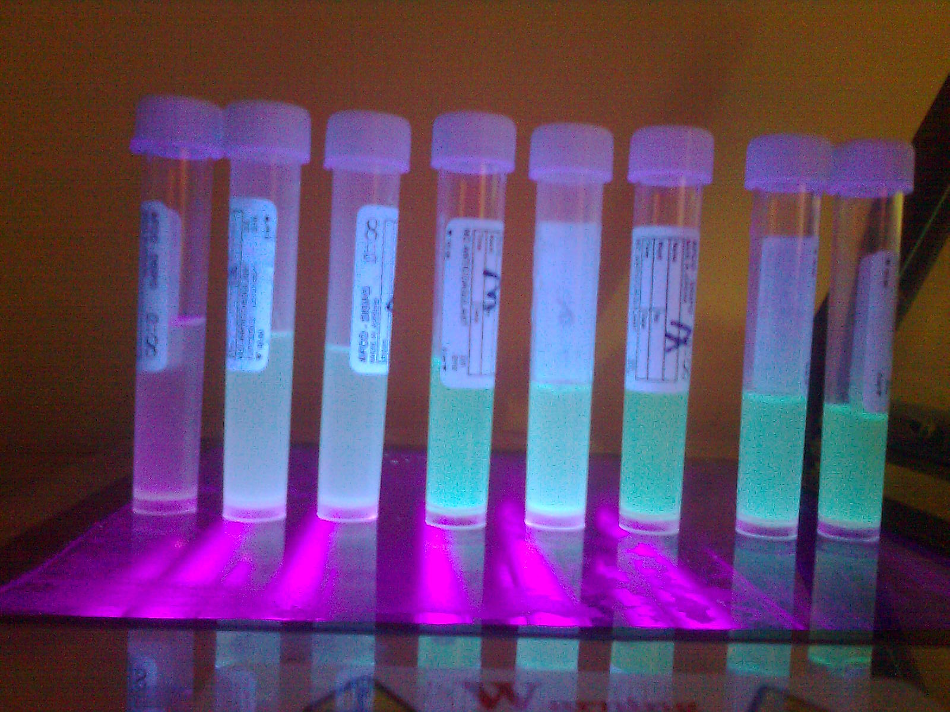
Figure 1 Shown fluorescent pigment.
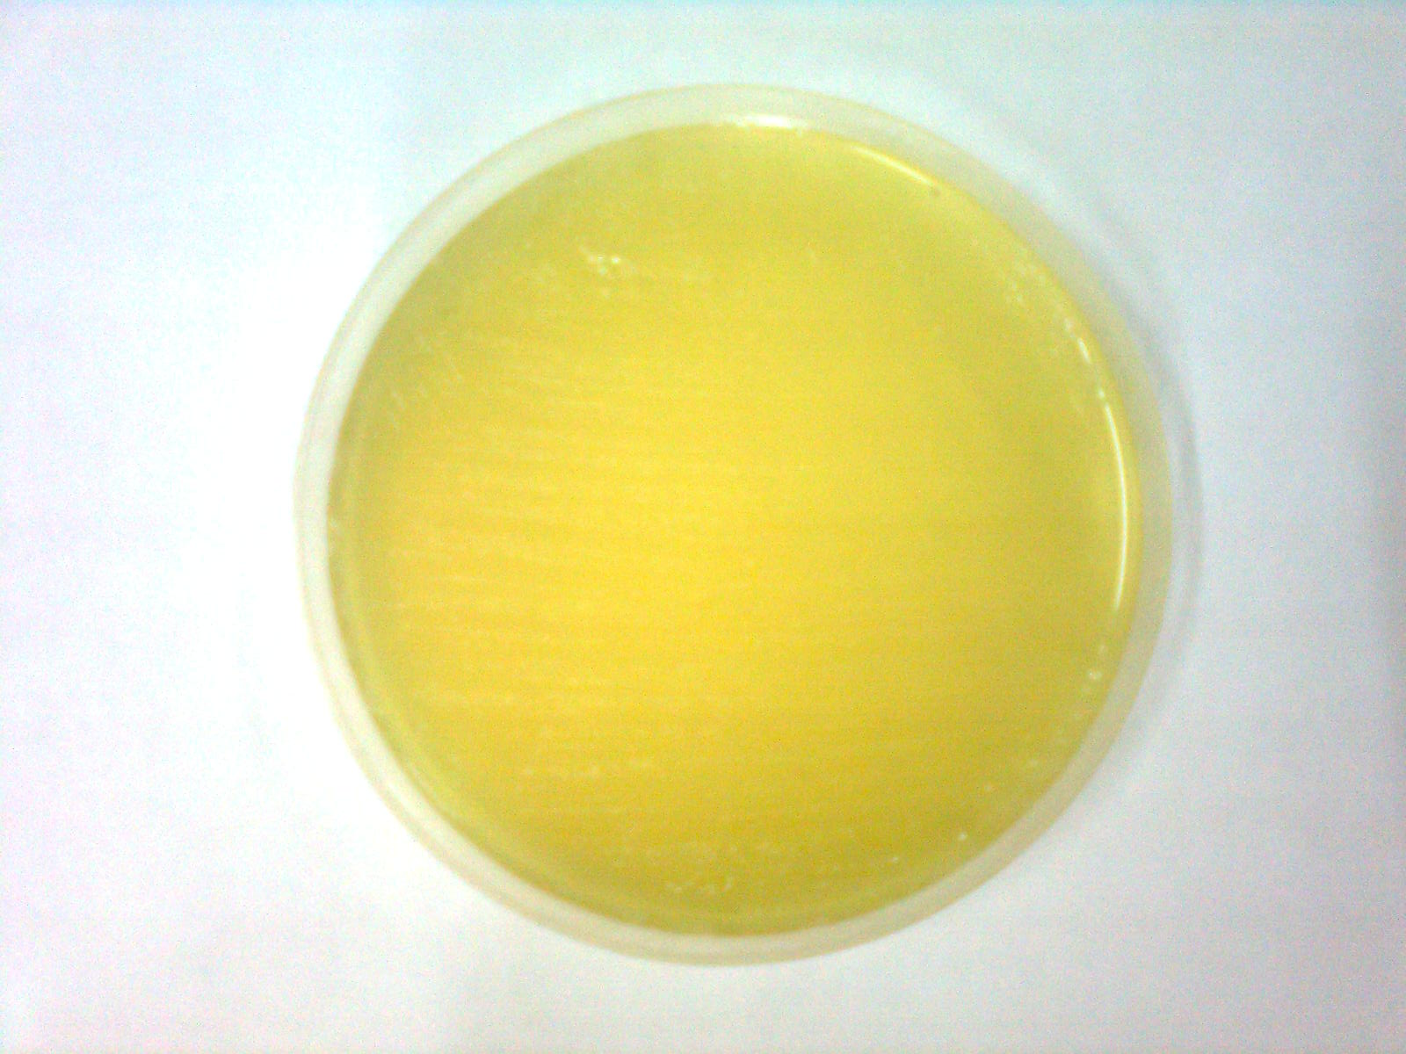
Figure 2 Shows growth on pseudomonas selected agar. .

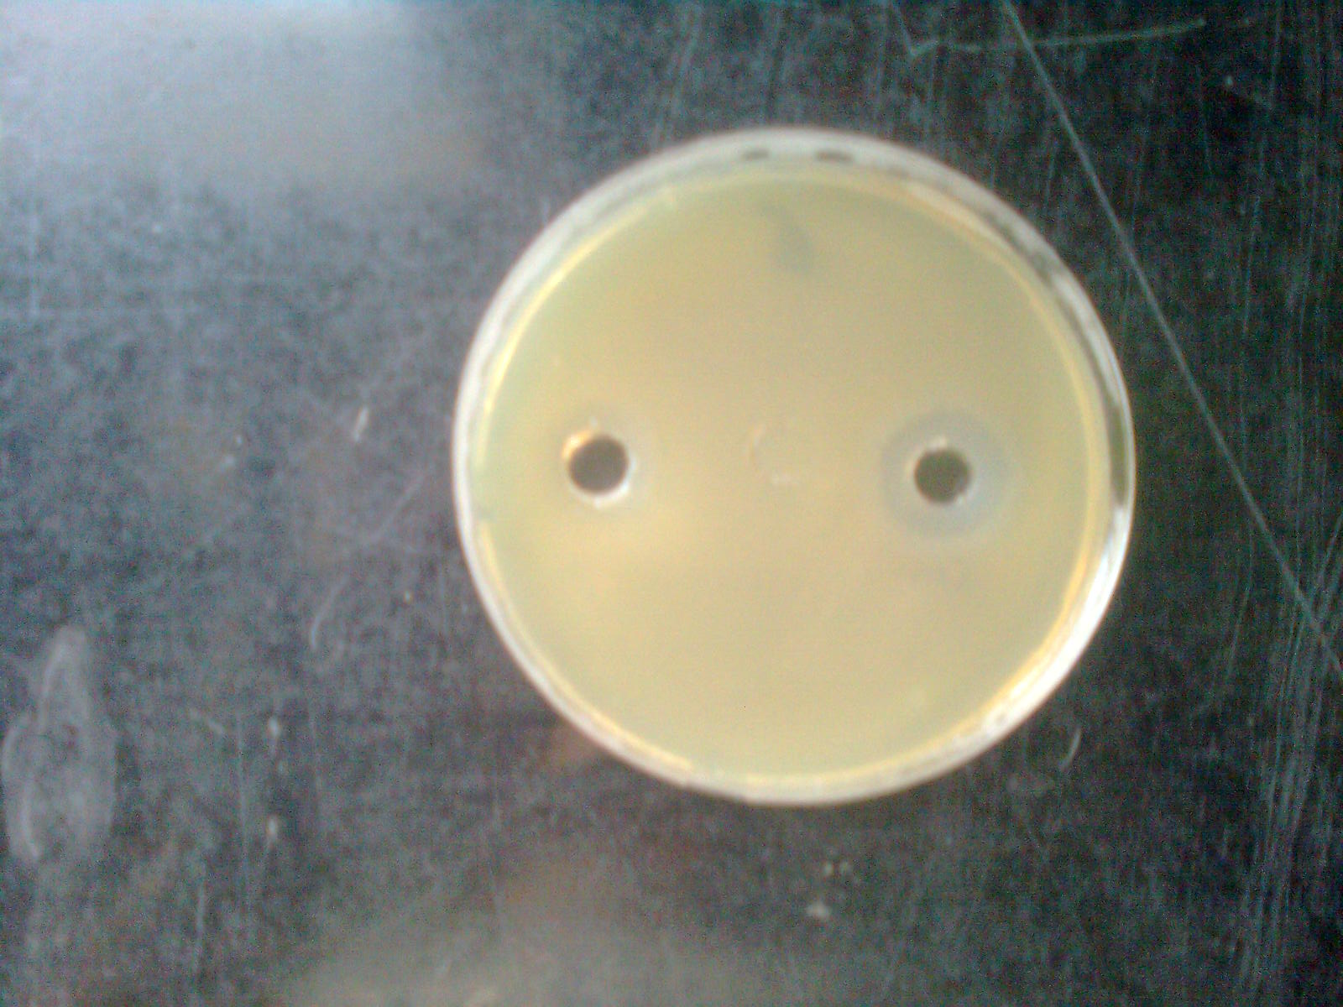
Figure 3 The effect of garlic vinegar on the right and the effect of garlic oil on the left on P. aeruginosa.
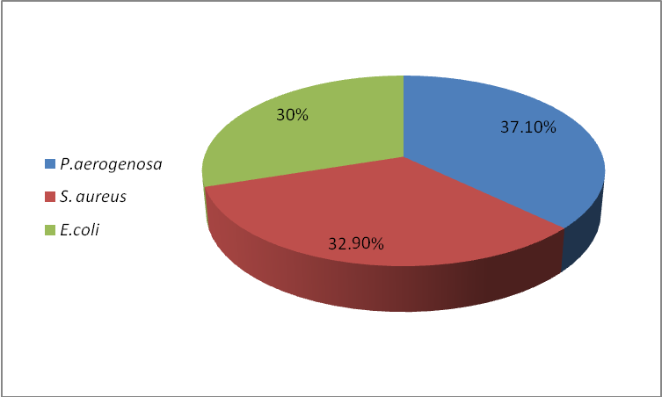
Figure 4 Frequency of bacterial isolates in burns infections.

Table 1 Sensitivity of P. aeruginosa to antibiotics by DD test in comparing with NCLI,(2010).
Antimicrobial agent | Disc content  (µg/ml) | Zone diameter (mm) | Susceptibility | Standard zone diameter(mm)
 |  |  |  | S | I | R
pipracillin | 100 | 9 | R | ≥18 | _ | ≤17
meropenem | 10 | 34 | S | ≥16 | 14_15 | ≤13
gentamicin | 10 | 0 | R | ≥15 | 13_14 | ≤12
tobramycin | 10 | 0 | R | ≥15 | 13_14 | ≤12
amikacin | 30 | 25 | S | ≥17 | 15_16 | ≤14
rifampen | 5 | 0 | R | ≥20 | 17_19 | ≤16
*R : resistant ; I : intermediate ; S : sensitive.
Table 2 MIC of P. aeruginosa towards antibiotics.
Antibiotics | Determinations (µ/ml)* | MIC(µg/ml)
pipracillin | 64-128 | 128
meropenem | 4-16 | 64
gentamicin | 4-16 | No inhibition zone
tobramycin | 4-16 | 512
amikacin | 16-64 | 64
rifampen | 1-4 | 256
*according to NCLI, (2010).

Table 3 doubling combination method.
Antibiotics |  | AK | GEN | RA | MRP | TOB | PRL
Con.  µg/ml |  | 4 | 2 | 64 | 1 | 1 | 8
AK | 4 | AK | GEN+AK | RA+AK | MRP+AK | TOB+AK | PRL+AK
GEN | 2 | AK+GEN | GEN | RA+GEN | MRP+GEN | TOB+GEN | PRL+GEN
RA | 64 | AK+RA | GEN+RA | RA | MRP+RA | TOB+RA | PRL+RA
MRP | 1 | AK+MRP | GEN+MRP | RA+MRP | MRP | TOB+MRP | PRL+MRP
TOB | 1 | AK+TOB | GEN+TOB | RA+TOB | MRP+TOB | TOB | PRP+TOB
PRL | 8 | AK+PRL | GEN+PRL | RA+PRL | MRP+PRL | TOB+PRL | PRL
Table 4 Expiremental groups.
Groups No. | Rabbits No. | Treatment
First groups | Rabbit no. 1 | MRP
First groups | Rabbit no. 2 | PRL
First groups | Rabbit no. 4 | AK
First groups | Rabbit no. 6 | TOB
First groups | Rabbit no. 8 | GEN
Second group | Rabbit no. 3 | MRP+PRL
Second group | Rabbit no. 5 | AK+MRP
Second group | Rabbit no. 7 | TOB+AK
Third group | Control | Without treatment

Table 5 Doses and direction of antibiotics.
Antibiotics | Doses
Meropenem | 120mg/kg/each8hrs
Pipracillin | 300mg/kg/each 6hr s
Amikacin | 15mg/kg/each 12hr
Tobramycin | 5.6mg/kg/each 8hrs
Gentamycin | 2.10mg/kg/once daily

