A Comparative Study of Fine Needle Aspiration and Imprint Cytology with the Histopathology of Cervical Lymphadenopathy Related to the Oral Malignancy

Sabah Abdulaziz Issa Najwa Jamil Abdulrazzak
Al-Shaheed Ghazi Hospital, Medical City, Ministry of Health, Baghdad, Iraq.
Corresponding author: sabahabdulaziz@yahoo.co.uk

M J B

Abstract
Background: In this study we evaluate the way for the diagnosis of lymphadenopathy related to the oral malignancy whether there is metastasis or not. So we used a technique of fine needle aspiration cytology as preoperative diagnosis for the clinically palpable lymph nodes(L.Ns.) and we used a technique of imprint cytology as intra operative diagnosis for the clinically and surgically palpable L.Ns. Their accuracy has been evaluated by comparing their results with the histopathological diagnosis result.
Aims of Study: To use the fine needle aspiration cytology( F.N.A.C.) as a rapid preoperative diagnosis of lymph node metastasis related to the oral malignancy, to use the imprint cytology as intra operative diagnosis of lymph node metastasis (instead of frozen section technique) related to the oral malignancy, to choose the line of treatment for those patients with oral malignancy who may need prophylactic or therapeutic lymphadenectomy and to evaluate the results of F.N.A.C. and imprint cytology by comparing them with the histopathological results to ascertain their diagnosis value.
Materials and Methods: In our study there were (20) patients with oral malignancy with or without cervical lymphadenopathy.
Results: The histopathology of the primary site was mainly Sq.C.C. (70%). For (18) clinically palpable L.Ns. we used F.N.A.C. most of these lymph nodes (61%) were associated with reactive hyperplasia and only (39%) of them were associated with malignant metastasis. There were one false positive and one false negative result. Accuracy rate (88.8%). For (54) L.Ns. which were clinically and surgically palpable L.Ns. we used imprint cytology. Most of these L.Ns. (81.5%) were associated with reactive hyperplasia and only (18.5%) of them were associated with malignant metastasis. Accuracy rate (96.2%).
Key Words: Imprint cytology, fine needle aspiration, and histopathology.
دراسة لمقارنة الرشف الخلوي بالابرة الدقيقة والطبعات الخلوية مع التغيرات المرضية النسيجية للغدد اللمفاوية الرقبية المتعلقة بسرطان الفم
الخلاصة
في هذه الدراسة وضعنا طريقة في تشخيص مرض الغدد اللمفاوية الرقبية المتعلقة بسرطان الفم وفي احتمالية انتقال السرطان لهذه الغدد او عدمه.وبذلك استعملنا طريقة الرشف الخلوي بالابرة القيقة كطريقة تشخشصية قبل العملية على الغدد اللمفاوية الملموسة سريريا,واستعملنا طريقة الطبعات الخلوية كطريقة تشخيصية اثناء العملية على الغدد الملموسة سريريا وجراحيا.دقة هاتين الطريقتين يتم تقيمها وذلك بمقارنة نتائجها مع نتائج التشخيص النسيجي المرضي.في هذه الدراسة يوجد(20)مريضا مصابين بسرطان الفم مع او بدون مرض الغدد اللمفاوية الرقبية.بضمنهم(11)ذكر و(9)انثى.وكان عمر المرضى بين(10-73)سنة.كان التشخيص النسيجي المرضي للموضع الاولي لسرطان الفم بصورة رئيسية سرطان حرشفي الخلايا وبنسبة70%.استعملنا طريقة الرشف الخلوي بالابرة الدقيقة على(18)غدة لمفاوية ملموسة سريريا وكان اغلب هذه الغدد وبنسبة(61%)مصابة برد فعل التكثر النسيجي وفقط وبنسبة(39%)كانت مصابة بانتقال سرطاني من الفم,بضمنها غدة لمفاوية واحدة كانت نتيجتها خطا ايجابي وغدة لمفاوية اخرى مع خطأ سلبي.عند المقارنة بين نتائج الرشف الخلويونتائج التشخيص النسيجي المرضي اظهرت حساسية الرشف الخلوي بنسبة(85,7)وخصوصيتها بنسبة(90%) ومعدل الدقة(88,8).واستعملنا طريقة الطبعات الخلوية على(54 )غدة لمفاوية رقبية كانت ملموسة سريريا وجراحيا.كانت اغلب الغدد وبنسبة(81,5)شخصت برد فعل التكثر النسيجي وفقط(18,5)شخصت بالانتقال السرطاني.عند مقارنة النتائج مع التشخيص النسيجي المرضي اظهرت حساسية الطبعات الخلوية بنسية(90%) وخصوصيتها بتسبة(97,7)ومعدل دقتها(96,2).ومن هذه النتائج نستطيعاعتماد كلتا الطريقتين في البحث التشخيصي للانتقال السرطانيفي الغدد اللمفاوية من سرطان الفم.
ــــــــــــــــــــــــــــــــــــــــــــــــــــــــــــــــــــــــــــــــــــــــــــــــــــــــــــــــــــــــــــــــــــــــــــــــــــــــــــــــــــــــــــــــــــــــــــــــــــــــــــــــــــــــــــــــــــــــــــــــــــــــــــــــــــــــــــــــــــــــــــــــــــــــــــــــــــــــــــــــــــــــــــــــــــــــــــــــــــــــــــــــــــــــــــــــــــــــــــــــــــــــــــــــــــــــــــــــــــــــــــــــــــــــــــــــــــــــــــــــــــــــــــــــــــــــــــــــــــــــــــــــــــــــــــــــــــــــــــــــــــــــــــــــــــــــــــــــــــــــــــــ

Introduction
Oral cavity has a rich lymphatic drainage: approximately one third of all lymph nodes in the body are found on the neck. Oral malignancy frequently spreads to the lymph nodes of the neck; the management of the neck remains controversial, especially in those patients with no palpable lymph node metastasis at presentation [1] Oral malignant tumors constitute 3 to 5% of all body malignancies [2] and in Iraq it forms 4.5-5% of them [3]. Over 90% of oral malignancies are Sq.C.C. [4] F.N.A.C. is a method by which cells or tissues are obtained for microscopical; study using a small gauge needle generally with a vacuum system provided by an air tight syringe[5]. However most publications have focused on the successful diagnosis of metastatic carcinoma in lymph nodes [6]. Accuracy of F.N.A.C. if high and there is no evidence that inserting a fine needle into the L.Ns. spreads the disease or worsens the prognosis. A positive result can be as a definite evidence of nodal involvement and the treatment can be preceded according to this basis. F.N.A.C.with benign results should be further evaluated if high clinical suspicious of malignancy exists [7] the main problem in F.N.A.C. is the conclusive hypo cellular or a cellular sample. Therefore, further cytological investigations applied represented by imprint cytology. Imprint cytology is made by gently touching the freshly cut surface of the L.N. to a clean glass slide. It is a simple method for intra operative fast diagnosis. The microscopic preparation is easily and quickly prepared, it gives excellent cytological clarity and can substitute frozen section technique [8]. In comparison to frozen section, this method is cheaper, faster and requires less interpretive experience. In addition to the fact that it can be performed in equal and sometime better accuracy rates [9].

Materials and Methods
These study includes (20) patients with oral malignancy seen in the consultation clinic of oral and maxillofacial surgery of Al-Shaheed Ghazi hospital for specialized surgeries at medical city center – Baghdad in one year duration. Sex distribution was (11) males and (9) females. The age ranged between 10-73years. Twelve cases presented with cervical lymph nodes swelling each one of these cases presented with one or more than one cervical lymph node swelling were examined using the fine needle aspiration cytology as preoperative diagnosis. All the 20 patients were examined using imprint cytology as intra operative diagnosis.
Equipment:
The basic tools used for F.N.A. cytology and imprint cytology are:
1. (5-10) disposable plastic syringes.2. (21-23) gauge disposable needle. 3. Container for transport slides to the laboratory contained 95% ethyl or methyl for fixation. 4. Glass microscopic slides. 5. Sterile piece of gauze and antiseptic for skin preparation. 6. Diamond pencil used for writing the patient’s name and number of each glass slide. 7. Sharp scalpel used for bisecting the lymph node. 8. Tooth forceps to grasp each halve of lymph node.
Clinical examination and investigation:
- Clinical examination of primary lesion:
Inspection and palpation including its appearance, color, surface, site of the lesion, size, shape, consistency, fixation on palpation.
- Clinical examination of the neck:
Examination of the neck like the examination of the primary lesion by inspection and palpation.
An essential step in examination of any patient suffering from oral cancer is careful examination of the lymphatic fields on both sides of the neck.
- Chest X-ray and Ultrasonic studies for abdominal structure to exclude distant metastasis.
F.N.A.C. for clinically palpable lymph nodes (preoperative diagnosis of lymph node metastasis:
In our study F.N.A. cytology applied on 18 clinically palpable lymph nodes in 12 patients presented with oral malignancy.
Technique: The needle attached to the syringe,and air aspirated to the mark of 2ml (this will facilitate expulsion of the specimen onto glass slide without necessity of disconnecting the needle).The node is grasped firmly&the needle inserted into the node,then negative pressure is created in the syringe with shrp quick strokes and rotated movement in different directions to sample the node in different areas.The plunger of the syringe is released and withdrawal of the needle from L.N.as quickly as possiple.The specimen is expressed onto glass slide and spread it by another glass slide.Tow or four slides were prepared,the slides immediately immersed in fixer solution (95%ethanol solution) for 30 seconds & staind by haematoxyline & eosin (H&E stain). This technique shows from figure 1 ⇒ 6
Imprint cytology for clinically and surgically palpable L.Ns. (Intra operative diagnosis of lymph node metastasis):
The procedure performed in the theater on the excised lymph node during surgical treatment of oral malignancy. In our study and during surgical treatment of 20 patients with oral malignancy who were treated with prophylactic or therapeutic ement in lymphadenectomy (supraomohyoid and radical neck dissection), a touch imprint was done for (54) L.Ns. Includes surgically palpable and all these L.Ns. were sent for histopathological examination then after.
Technique: Freshly biopsied L.N. obtained from surgical specimen was bisected or trisected with sharp scalpel, each piece is grasped by toothed forceps and the cut surface is touched lightly, several times to clean slide. Four to six slides were prepared from each L.N., then immediate fixation in 95% ethyl alcohol for 30 seconds and stained either with H&E stain or papanicolaou stain. This technique shows from figure 7⇒11. Then all L.Ns were labeled& fixed in formalin and send for histopathological results.

1 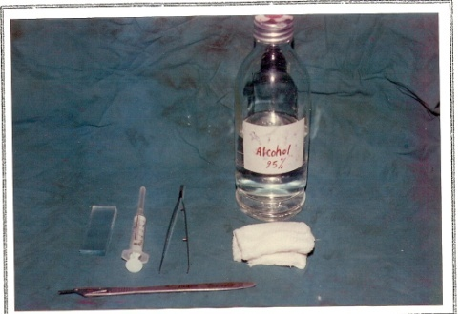 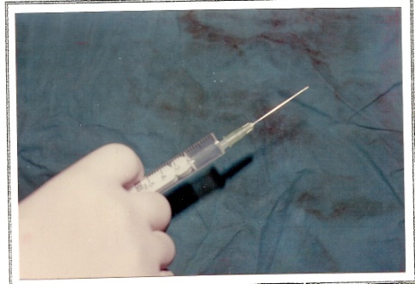 2
Figure 1 equipment for F.N.A. and imprint technique, 2.The syringe was aspirate to the mark of 2 ml.
3 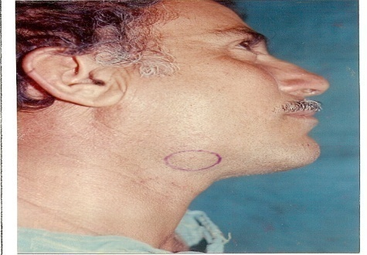 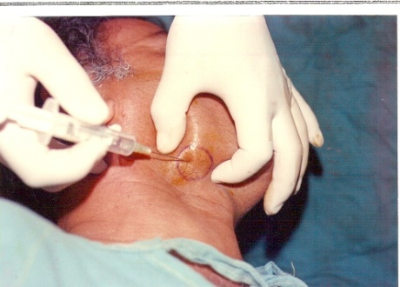 4
Figure 3 Patient with a mass (L.N) in the submandibular region.
Figure 4 The mass was grasped and the needle in the mass.

5 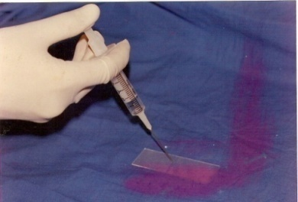 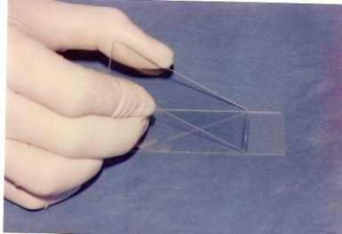 6
Figure 5 the specimen was expressed on to glass slide.
Figure 6 Shows the technique of spread the material by another slide to prepare the smear.
7 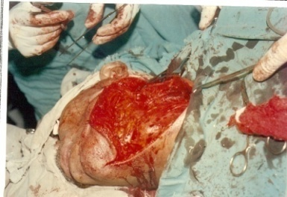 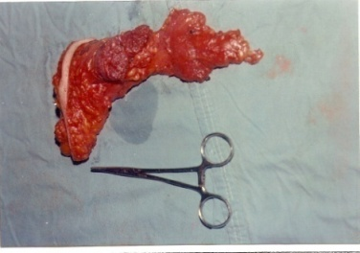 8
Figure 7 lymphadenectomy by prophylactic supra-omo-hyoid- neck dissection for the patient with oral cancer.
Figure 8 surgical specimen with their lymph nodes removed by lymphadenectomy operation.
9 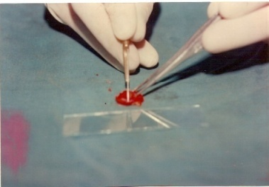 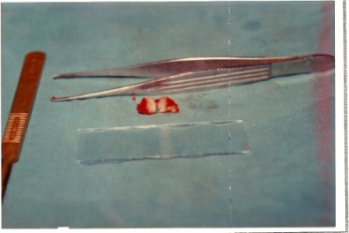10
Figure 9 bisecting of freshly biopsied lymph node with a sharp scalpel,
Figure 10 fresh cutting surfaces of bisected lymph node.
11 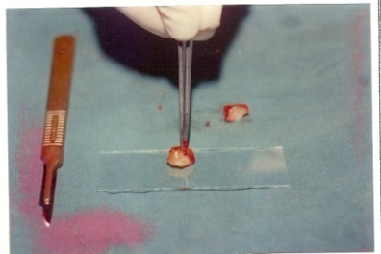
Figure 11 the cut surface of lymph node is touched lightly on to glass slide.

Results
The total number of our patients in this study was (20) patients presented with oral malignancy, the sex distribution was (11) males (55%) and 9 females (45%), in general patients above age of (40) represented (70%) of total no. of patients.
Primary sites and histopathology of oral malignancy
The distribution of oral malignancy by sites was mainly the salivary glands (parotid and submandibular) (25%) followed by the tounge (20%) and alveolar ridge (20%), while the cheek, the palate and the floor of mouth each of them represented (10%) . the lip cancer was the lowest one, (5%)only. The histopathological features of these sites were mainly Sq.C.C. (70%) followed by mucoepidermoid carcinoma (15%), while mixed malignant tumor, osteogenic sarcoma and malignant lymphoma each of them represented (5%).
The size of the primary lesion (T) of our patients was ranged mainly between T2-T3 each of them represented 40% of our cases. Accordingly to the L.Ns.involvement (N),9 cases (45%) with no palpable L.Ns. (N0), 7 cases (35%) with N1,3 cases (15%) with N2 and finally one case (5%) with N3.All the patients in this study were with no distant metastasis (M0).
F.N.A.C. for the clinically palpable L.Ns.
F.N.A.C. for clinically palpable L.Ns. (18L.Ns.) include: (7) L.Ns. (38.8%) were reported as malignant and (11) L.Ns. (61.2%) were reported as free of malignancy. one “false positive” and one “false negative”. The F.N.A.C. and histopathological result from these (11) L.Ns. (which were free of malignancy) were (10) L.Ns. as reactive hyperplasia and one L.N. was T.B. (Langhan’s giant cell seen) (Figure 12).
Imprint cytology for clinically and surgically palpable L.Ns.
The total no. was (54) L.Ns. include (18) L.Ns. where clinically palpable and (36) L.Ns. were surgically palpable. Tenth L.Ns. (18.5%) were cytologically reported as “positive” for malignancy while (44) L.Ns. (81.5%) were reported as “negative” (free of malignancy). Does not mean that the imprint cytology was accurate 100%, because there was one “false positive” and one “false negative” L.N., (Figure12and 13).
Analysis for F.N.A.C.
Sensitivity 85.7%, Specificity of 90.9%, Positive predictive value 85.7%, negative predictive value 90.9%, Accuracy rate 88.8%.
Analysis for the imprint cytology
Sensitivity for clinically and surgically palpable L.Ns. 90%, specificity of imprint cytology 97.7%. Positive predictive value 90%, negative predictive value 97.7%, Accuracy rate of imprint cytology 96.2%. (Figure14).

12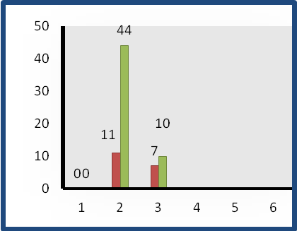 13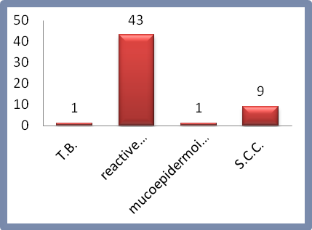
Figure 12 F.N.A.C. and imprint cytology results.
Figure 13 Histopathological results of lymph nodes which include in our study.
A.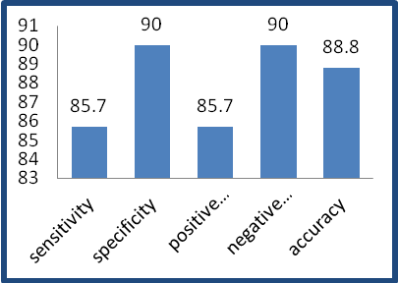 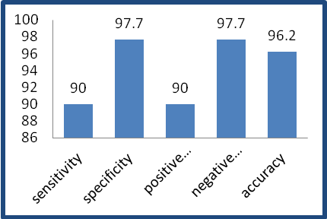B.
Figure14 Statistical analysis of (A) F.N.A.C. (B) imprint cytology.

Discussion
There is high incidence of metastatic spread to lymph nodes in oral cancer. The likelihood of lymph node metastases depend on several factors which include: size, site and grade of histopathology of primary lesion. From which TNM system was applied [1].
F.N.A. cytology
Assessment of metastasis in cervical lymph nodes is an inaccurate process. Crile (1996) recognized that palpable nodes may be inflammatory; impalpable nodes may be carcinomatous. An open biopsy performed prior to block dissection is associated with an increasing risk of local recurrence and distant metastasis. F.N.A.C. is being used increasingly on patients with palpable L.Ns. in the neck suspected to contain tumor .F.N.A.C. particularly attractive for surgeons called to take biopsies of enlarged L.Ns in HIV patients [10]. A traditional surgical biopsy may take 7 to 10 days for diagnosis. Rapid staining of some slides with F.N.A.C. permits a preliminary diagnosis for many lesions. An attractive advantage to F.N.A.C. is its simplicity and low cost. Therefore, in our series we used F.N.A.C. as preoperative diagnosis for the clinically palpable L.Ns. associated with oral malignancy whether there is metastasis or not, and then to put down the line of treatment. In the expert hands the accuracy of cytology is high and there is no evidence that inserting a fine needle into the lymph nodes spreads the disease or worsens the prognosis. [1]. Results of F.N.A.C. for the clinically palpable L.Ns. (18 L.Ns.). There were one false positive and one false negative L.N. accordingly to the opinion of the histopathologist that the cause of false positive was the overlapping of cells which gives a picture of mitosis and the cause of false negative was inadequate aspirate material in tow cases of our sample. The Sq.C.C. of the tongue associated with enlarged jugulodiagastric L.N. and the preoperative F.N.A., a yellowish fluid which was misdiagnosed as branchial cleft cyst [11]. The tendency of the cells to detached and appear as single cells as well as the hyperchromasia and atypical nuclear criteria, indicate the malignant nature of the tumor. Identification of epithelial cells or keratin in F.N.A.C. of L.N. establishes the diagnosis of Sq.C.C. metastasis, (Figure 15). The columnar orientation, eccentric nuclei, the cytoplasmic vascularization and the cystic formation indicated its glandular source (Figure 17). The eleven L.Ns. (61%) which were free of malignancy include (10 L.Ns.) reactive hyperplasia and one L.N. T.B. due to direct response to lesion itself or due to the secondary infection of the primary lesion. The main cytological features of reactive hyperplasia were the presence of germinal center histiocytes (tangible bodies) accompanied by transformed lymphocytes of follicle center origin. (Figure 19). So we need immunochemical staining like immunoperoxidase stain for more specific cytopathological diagnosis of L.N. metastasis even with few no. of malignant cells. There was one case in our series associated with very hard, mobile and palpable L.N. which was diagnosed clinically as L.N. metastasis of oral malignancy, but the F.N.A.C. was T.B. (epitheliod cells and giant cells of Langhan’s type were identified), (Figure 21).On the other hand imprint cytology compared with the histopathology of T.B.L.N.(Figures 22&23). The T.B. L.N. was accidentally associated with oral malignancy. While other study found T.B.lymphadenitis is still the commonest condition in patients presenting with neck swellings [12] Touch imprint was applied intra operatively for the clinically palpable L.Ns. and the clinically impalpable but surgically palpable during prophylactic and therapeutic lymphadenectomy operations. We select and dissect out these lymph nodes to reach this line of treatment which include:
- Touch imprint for the clinically palpable L.Ns. which were positive on F.N.A.C. to confirm the diagnosis of metastasis and doing radical neck dissection.
- Touch imprint for surgically palpable L.Ns. in the patients with prophylactic supra-omo-hyoid neck dissection to give intra operative neck dissection should be done.
In our study the L.N. was sectioned with a sharp scalpel in longitudinal section into three pieces and in horizontal section. By this technique we are increasing the freshly cutting surfaces from two to four surfaces and by this way the touch imprint cytology will involve as possible lymph node structures for probability of few number of tumor cells within the L.N. In our study there were 44 L.Ns. (81.5%) which were free of malignancy and 10 L.Ns. (18.5%) were malignant. There were one false positive and one false negative L.N. According to the histopathological opinion the cause of false positive is due to overlapping of the normal cells forming clump of cells as a result of heavy pressing of smearing during imprint technique. While the cause of false negative was due to early L.N. metastasis associated with few number of malignant cells. Other study found, there is no false positive and accuracy (81.1%), the results were made available to operating surgeon within mean time of 25minutes [13].While other use intra operative imprint cytology of sentinel LNs in breast cancer were the accuracy rate (77.8%), [14] According to the opinion of histopathologist that the imprint cytology is giving better cytological picture than F.N.A.C. in its cellular details, and there are advantages to be gained from the study of cells that have been detached from their normal environment, as certain distinctive features are more readily identified in isolated cells than in an organized cellular aggregation.

Conclusion
- F.N.A.C.:
- F.N.A.C. Is a simple, safe, rapid, cost effective procedure and can give accurate diagnosis of L.Ns. metastasis related to the oral malignancy.
- F.N.A.C. is especially appropriate for the preoperative classification of findings where metastases are suspected; and should be considered in the first-line investigation of masses in the neck related to the oral malignancy.
- F.N.AC. is appropriate for inoperable tumors associated with L.Ns. metastasis for which a histological examination by surgical biopsy would require major surgery; and for follow up in the course of tumor treatment.
- F.N.A.C. generally will save the patients and help the surgeons to avoid fatal mistakes.
- Imprint cytology:
- Imprint cytology is a simple, rapid, and not expensive and give excellent cytological clarity with preservation of cellular morphology.
- Imprint cytology gives a rapid intra operative diagnosis of L.Ns. metastasis of oral malignancy with high accuracy rate and can substitute of frozen section technique.

15 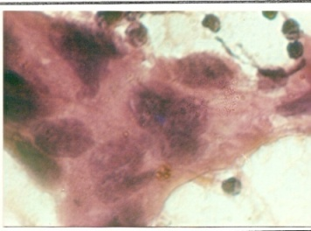
Figure 15 F.N.A. of metastatic Sq.C.C. showing anaplastic with lobulated nuclei and irregular chromatin.
16 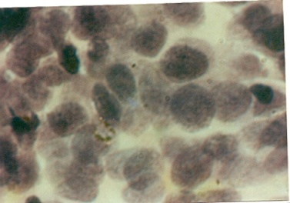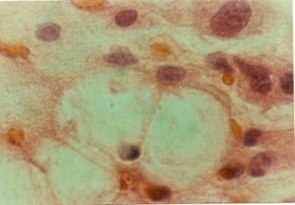17
Figure 16 Imprint of a metastatic Sq.C.C. showing the Malignant epithelial cells with high nuclear/cytoplasmic ratio and irregular chromatin.
Figure 17 F.N.A. of metastatic mucoepidermoid carcinoma, a higher power view showing the cytoplasmic vacuolization.
18 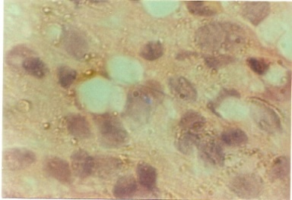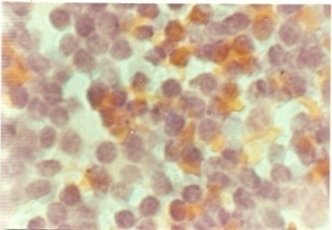19
Figure 18 imprint of metastatic mucoepidermoid carcinoma showing signet-ring cells.
Figure 19 F.N.A. of a lymph node with reactive hyperplasia related to the oral malignancy showing mixed lymphocytic with histocyte.
20 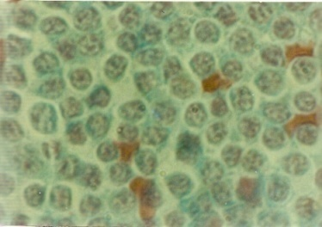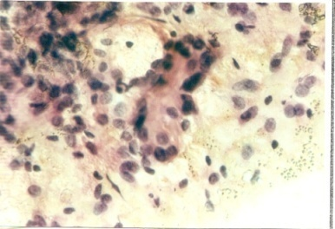21
Figure 20 Imprint of a reactive hyperplastic lymph node related to the oral malignancy showing mixed lymphocytic population.
Figure 21 F.N.A. of T.B. lymph node showing Langhan’s type giant cell.
22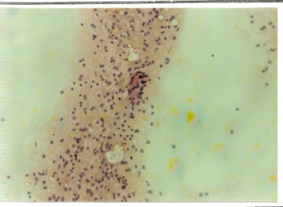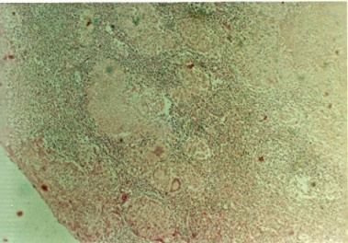23
Figure 22 Imprint of T.B.lymph node showing Langhan’s type giant cell
Figure 23 histological section of T.B. lymph node showing caseating epitheliod granulomata.

References
1-Henk and Langdon.Malignant tumor of oral cavity.The managementof malignant disease series. (1985)
2-Shkler G,P.oral cancer,WB Saunders company,philadephia(1984).
3-Al-saleem T.and Alash N.Cancer in Iraqi medical journal :( 1977)25:No.1-2
4-Cawson.Essential of dental surgery and pathology (1987).Fourth edition, p.283.
5-Wehner and Schettler.Cytological tumor diagnosis in maxillofacial surgery examination using F.N.A.C.Jour.Max.Fac.Surg. (1980):8:17-24.
6-Engzel V.,Jacobsson P.A.,Siguardson A.,and Zaiicek J..Aspiration biopsy of metastatic carcinoma in lymph node of the neck. A review of cases. Acta-oto-Laryng. (1971):72:13:138-147.
7-Mohammed R and Azadeh R.The diagnostic accuracy of F.N.A.C.in neck lymphoid masses.Iranian J.of pathology. (2009)4(4).147-150
8-Holfer-H.A new,simple method for intra operative fast diagnosis.Virchows-Arch.Pathol.Anatom.(1979)382(1):89-94.
9-Alpay D,and Cagatay T..Feasibility of imprint cytology for evaluation of mediastinal lymph nodes in lung cancer.Jpn.J Clin.Oncol, (2006)36(2)76-79
10-Alpay D,and Cagatay T..Feasibility of imprint cytology for evaluation of mediastinal lymph nodes in lung cancer.Jpn.J Clin.Oncol, (2006)36(2)76-79.
11-Ackerman, .Textbook of surgical pathology, (1989)1269-1270.
12-Tariq A, Mohammad N, and Amir Nasir.Fine needle aspiration cytology and neck swelling in surgical outpatient Ayub.Med.Coll.Abbottabad, (2008):20(3).
13-Melissa A.,Bochuir,Gelareh F..Intra operative imprint cytology in assessment of sentinel node for early breast cancer.World J.Surg.(2003)27,430-432.
14-Nirmala P,Wayne J and Michael.Inta operative imprint cytologyof sentinel lymph node in breast cancer.Journal of pathology(2006)vol.38,issue 4.321-327.

