Distribution of Virulence Factors between Typeable and Nontypeable H. influenzae Isolated from Different Clinical Samples in Hilla City,Iraq

Bara'Hamid Hadi Mohammed S. Abdul-Razzaq
Dept. of Microbiology, College of Medicine, University of Babylon, Hilla, Iraq

M J B

Received 7 July 2013 Accepted 6 August 2013
Abstract
Objectives: This study aimed to separate virulence factors like pili, high molecular weight proteins HMW1/2 and H. influenzae adhesin (Hia), haemocin and colanic acid from capsulated (typeable) and uncapsulated (nontypeable) H. influenzae isolates .
Materials and methods: In this study, six isolates of H. influenzae were obtained from different clinical samples (ear, throat, sputum, eye, CSF). These isolates were obtained by PCR based method using P6 gene primer. These samples were collected from the three main hospitals in Hilla city (AL-Hilla Surgical Teaching Hospital, Merjan Medical City and Babylon Hospital for Maternity and Paediatrics) during the period from February 2012 to June 2012. These samples were subjected to traditional bacterial identification methods in addition to presumptive identification using X and V factor tests .Furthermore, molecular method for detection and separation into typeable and nontypeable one using PCR, depending on presence or absence of capsule. Later on ,the detection of virulence factors from typeable and nontypeable H. influenzae isolates was done using specific primers : hifA, hmw1, hmw2, hia. Also, two methods were used to detect haemocin and concentration of colanic acid from these two types of H. influenzae.
Results: Twenty nine isolates were obtained by traditional bacteriological methods, of these , only ten isolates were obtained by presumptive identification method using X and V factors requirement method. Out of these 10 isolates , six isolates were obtained by molecular detection method. These 6 isolates underwent molecular separation into typeable and NTHi . Then the results showed that virulence factors were distributed between these types and found that HMW1 and HMW2 were present in NTHi while Hia was present in two isolates one typeable and the second NTHi besides the presence of hifA in 3 isolates. While haemocin was produced from one isolates and colanic acid was produced in high concentration among capsulated H. influenzae isolates.
Conclusion: 1-Virulence factors are important in pathogenesis of typeable and NTHi .
2-Nontypeable H. influenzae (NTHi) is also an important cause of invasive and severe disease like upper and lower respiratory tract diseases. 3-Haemocin is important virulence factor that is produced by only type b (Hib) H. influenzae. 4-Some virulence genes that are studied are found to be present in both typeable and nontypeable H. influenzae like hifA and hia genes while others like hmw1 and hmw2 are found to be present only in NTHi.
Key Words: H.influenzae , hifA , hmw1, hmw2 , hia
الخلاصة
هدف الدراسة: تهدف هذه الدراسة الى فصل عوامل الضراوة مثل الاهداب والبروتينات ذات الوزن الجزيئي العالي وعوامل الالتصاق والهيموسين وحامض الكولانك بين نوعين من البكتريا المحبة للدم المنمّطة وغير المنمّطة.
المواد وطرائق العمل: في هذه الدراسة تم عزل ستة عزلات من البكتريا المحبة للدم من مختلف العينات السريرية في مدينة الحلة (الاذن، الحنجرة، البلغم، العين، السائل الدماغي الشوكي). وتم عزل هذه العزلات بواسطة عملية البلمرة المتسلسلة PCR بإستعمال بادئة نوعية P6 جين وجمعت هذه العينات من المستشفيات الثلاثة الرئيسة في مدينة الحلة (مستشفى الحلة التعليمي، مدينة مرجان الطبية ومستشفى بابل للولادة والاطفال) للفترة من شباط 2012 الى حزيران 2012. تم اخضاع هذه العينات الى عملية الزرع البكتيري بالإضافة الى التحري التخميني بواسطة عوامل النمو X وV.كذلك استعملت الطريقة الجزيئية للكشف ولغرض فصلها الى نوعين منمّطة وغير منمّطة اعتماداً على وجود او عدم وجود الكبسولة بإستعمال عملية البلمرة المتسلسلة واجري التحري عن عوامل الضراوة بإستخدام المعلمات الوراثية الخاصة hifA, hmw1, hmw2, hia وكذلك تم التحري عن وجود الهيموسين وحامض الكولانك.
النتائج: تم الحصول على 29 عينة بواسطة الطريقة التقليدية للعزل والتشخيص ومنها تم الحصول على عشرة عينات بواسطة العزل والتشخيص التخميني بواسطة استعمال اقراص النمو X و V الدالة على عوامل النمو، بينما تم الحصول على ستة عزلات من أصل عشرة بواسطة التشخيص الجزيئي,كما تم فصلها الى منمّطة وغير منمّطة. بالاضافة الى ذلك تم توزيع عوامل الضراوة حيث وجد بإن عامل الضراوة HMW1 وHMW2 موجود فقط في العزلات غير المحتوية على كبسولة بينما وجود عامل الضراوة Hia في عزلتين واحدة تحتوي على كبسولة واخرى لا تحتوي. أما hifA فوجد في ثلاثة عزلات اما بالنسبة للهيموسين فقط انتج من عزلة واحدة من البكتريا المحتوية على كبسولة وانتج حامض الكولانك بتركيز عالي من العزلات المحتوية على كبسولة.
الاستنتاجات:1- تعد عوامل الضراوة هذات أهمية بالنسبة للامراضية لهذه البكتريا 2-يعد النوع الغير منمّط من الأسباب المهمة للأمراض مثل امراض الجهاز التنفسي العليا والسفلى 3-يعد الهيموسين من عوامل الضراوة المهمة والذي ينتج بواسطة النوع b (Hib) 4-وجد ان بعض عوامل الضراوة التي درست( hifA وhia) كانت موجودة في النوعين المنمّط و الغير منمّط أما (hmw1 وhmw2 ) فقد وجد في النوع الغير منمّط فقط.
ـــــــــــــــــــــــــــــــــــــــــــــــــــــــــــــــــــــــــــــــــــــــــــــــــــــــــــــــــــــــــــــــــــــــــــــــــــــــــــــــــــــــــــــــــــــــــــــــــــــــــــــــــــــــــــــــــــــــــــــــــــــــــــــــــــــــــــــــــــــــــــــــــــــــــــــــــــــــــــــــــــــــــــــــــــــــــــــــــــــــــــــــــــــــــــــــــــــــــــــــــــــــــــــــــــــــــــــــــــــــــــــــــــــــــــــــــــــــــــــــــــــــــــــــــــــــــــــــــــــــــــــــــــــــــــــــــــــــــــــــــــــــــــــــــــــــــــــــــــــــــــــــــــــــــــــــــــــــــ

Introduction
Haemophilus influenzae, a Gram negative coccobacillus whose environmental niche is primarily restricted to the human respiratory tract. [1]. Haemophilus influenzae is classified on the basis of production of polysaccharide capsule, strain types a though f produce antigenically distinct capsules and nontypeable strains produce no capsule [2]. H. influenzae isolates also differ in protein adhesins and surface molecules that shown to be heterogenous in a variety of ways that affect pathogenesis. Most contain genes for one of the adhesin known as H.influenzae adhesin ( Hia ) and High Molecular Weight protein (HMW) , but not both [3]. One of important virulence factor is adhesin and Most bacterial diseases begin with microbial colonization of a particular mucosal surface.So bacterial attachment to the host epithelial cells is a key event in this process and is mediated by specific interactions between microbial adhesins and complementary receptor structures on the epithelial cell surface,of the
adhesive structures are Fimbrial adhesins and group of autotransporter proteins called Hia/Hsf, HMW1, HMW2.Regarding fimbrial adhesins: Fimbriae are the colonization factors of the H. influenzae (i.e) they mediate adherence to human cells, they are found on type b encapsulated and un encapsulated strains of H. influenzae, these fimbriae play a signficant role in infections and adhesion of the microorganism to host cell [4]. Pilus expression is regulated by phase variation, spontaneously switching from piliated to non piliated and vice versa [5]. The H. influenzae pilus shaft consists of repeating Hif A subunits and appears to be double stranded, morphologically similar to filamentous actin like P pili, type 1 pili and a number of other gram negative bacterial adhesive structures, H. influenzae pili are assembled via the chaperone/usher pathway. Hif B is the chaperone and functions in the periplasm, where it stabilize pilus subunits during their transfer from the inner membrane to the outer membrane [6]. Hif C is the usher and is located in the outer membrane, where it presumably facilitates the ordered incorporation of pilus subunits into the growing pilus [7].While the Haemophilus influenzae adhesin and Haemophilus influenzae surface fibrils (Hia /Hsf ) are homologus trimeric autotransporters found in nontypeable and typeable strains of H. influenzae respectively [8]. Hia was first identified in a strains lacking HMW1, HMW2- like proteins but still able to adhere efficiently to epithelial cells. Shortly after the discovery of hia, a similar locus ubiquitous in encapsulated H. influenzae strains was characterized and was designated hsf , for Haemophilus surface fibrils, reflecting the fact that this gene encode short thin surface fibrils. Hia and Hsf are 81% similar and 72% identical with the regions of greateast homology at their N- and C-terminal ends [9]. Regarding the High molecular weight proteins (HMW1 and HMW2), These two secreted highly similar high-molecular weight proteins (HMW₁, HMW₂) were first identified as H. influenzae-associated antigens by their ability to induce robust antibody responses in individuals with acute otitis media [10]. These two HMWs are similar to each other and related to the filamentous hemagglutinin, a well-characterized adhesine from Bordetella pertussis [11]. Other competitive factor called haemocin , is one of the most important virulence factors of type b H. influenzae strain. This small heat stable protein is a type of bacteriocin, produced by over 90% of type b H. influenzae strains and its function is to inhibit the growth of other bacteria belonging to the same or similar species in the site of infection [12]. In fact, haemocin is produced by most type b strain of H. influenzae, including strains determined to be genetically diverse and is toxic to virually all nontypeable b strains of H. influenzae both encapsulated and non encapsulated [13] .Regarding Colanic acid is a heteropolymer containing glucose, galactose and glucuronic acid as monomers which seem to be involved in the protection of bacteria against environment. This exopolysaccharide that synthesized by microbial cells vary greatly in their composition and hence in their chemical and physical properties some are neutral macromolecules, but the majority are polyanionic due to the presence of either uronic acid (d-glucuronic acid) being the comment or ketal-linked pyruvate [14].
Aims of this study: 1- Molecular detection of adhesive factors like pili,, Hia/Hsf, HMW1,HMW2. 2-Studying the effect of haemocin produced by type b H.influenzae isolates as a competitive factor against other typable and nontypeable serotypes.

Materials and Methods
Samples and Bacterial culture
A total of 220 clinical samples were taken from different clinical samples from patients attending the three main hospitals (AL-Hilla Surgical Teaching Hospital , Merjan Medical City and Babylon Hospital for Maternity and Paediatrics ) during the period from February 2012-June 2012. The samples were transported using specific transport media and processed on blood and chocolate agar and tryptic Soya agar sublimated with X, V disc and subjected to standard bacteriological method and incubated in 5% CO₂ at 37 ˚C for 24 hrs., biochemical tests like catalase, oxidase, urease, indole, nitrate reduction, carbohydrate fermentation was done [15].
DNA extraction from Gram negative bacteria
This method was performed according to the genomic DNA purification kit supplemented by a manufacturing company (Promega, USA).
Molecular detection of H. influenzae isolates
H. influenzae isolates were detected by PCR,using p6 gene primer as genetic marker through
20 μl PCR reaction mixture and then differentiated into typeable and nontypeable one by primers specific to detect capsule namely Bex A and Bex B. The amplification products were separated on (1-1.5%) agarose gel containing ethidium bromide for 45 min. at 70 V. The size of the amplicons were determined by comparison to the 100 bp allelic ladder (Promega, USA).
Detection of virulence factors among H.influenzae isolates
The adhesive virulence factors like pili ,Hia and HMW protiens were detected using spesific primers to detect the genes (hif A,hia ,hmw1,hmw2) respectively by 20 μl PCR reaction mixture as shown in table (1).The amplification product were separated on (1-1.5%) agarose gel containing ethidium bromide for 45 min. at 70 V. The size of the amplicons were determined by comparison to the 100 bp allelic ladder (Promega, USA).And the Primers sequences and thermal cycler conditions are illustrated in table (2).While haemocin were detected by cross streaking[16] and wells methods [17]; and colonic acid concentration was estimated according to Dische and Shettles [18], modified by the Al-Saedi [19].

Results
The results yield six isolates of H. influenzae according to molecular detection method as shown in table ( 3) ,and of these six isolates ,two were typeable ( from CSF) and four were NTHi isolated from other sites .The results of virulence factors distribution had shown that hif A gene was present in three isolates as shown in figure (1) ,and hia gene was present in two isolates as shown in figure (2) ,while hmw 1,2 genes were present in three isolates and all were NTHi as shown in figure (3,4) .Regarding haemocin ,the results revealed that it produced by only one isolate of typeable H.influenzae as shown in table( 4) and it inhibit the growth of all NTHi except one isolate which is isolate No.4 as shown in figures (5,6) ,while the results of colanic acid indicated that its production was at high rate among typeable one where its concentration was 95 and 85 µg/ml for isolate No. 1 and 2 respectively while its concentration was 50,4,2 µg/ml among NTHi as shown in figure (7)

Discussion
The results showed that 3 isolates out of 6 were positive for pilus gene hifA by PCR. These isolates were one from typeable and the other two were nontypeable. The hifA gene encodes for the major subunit of haemagglutinating fimbriae of H. influenzae. In another study [20] they found that about (28, 75%) demonstrated the presence of fimbrial gene hifA and of these isolates they found that 13% was of type b and 15% was non type b and nontypeable H. influenzae. The study reveals that the pili of nontypeable H.influenzae were from throat and sputum and the results were in agreement with results obtained in another study[3] where they found that hif genes were significantly more prevalent among NTHi throat isolates than NTHi middle ear isolates. However, other study [21] reported the presence of pili in hib isolates to be about (64%) and 28% in NTHi. This low rate of expression of pili by nontypeable H. influenzae may be attributed to the altered bacterial expression of haemagglutination pili through a process called phase variation which is mediated by slipped-strand mispairing suggesting a mean by which H. influenzae may rapidly adapt to changing environments [2]. Researchers also demonstrated that non capsulated strain isolated from systemic site generally express fimbriae, if a fimbriae gene cluster is present and they revealed that no association between expression of fimbriae and the clinical presentation of disease[21].
Regarding Hia adhesin, the results of this study found that two isolates express hia, one isolate from typeable and one from NTHi . Regarding typeable H.influenzae,the results showed that this gene (hia) is expressed by the non b capsulated H. influenzae and from the isolates that gave negative result regarding HMW protein from NTHi. Generally, the presence of Hia in typeable H. influenzae can be explained by the sequence homology between Hia in NTHi and Haemophilus surface fibrils ( Hsf ) adhesin of typeable H. influenzae where many studies showed that Hia has 72% amino acid identity and 81% similarly to the Hsf adhesin expressed by Hib and other typeable H. influenzae suggesting that they represent an allelic variants [12]. Studies found that hia is expressed in NTHi strains and in some type a, e, and f strains[22]. So,it could be expressed by capsulated non type b H.influenzae. However, another researcher [3] found that NTHi express hia at about 33% and showed that this gene was not expressed by typeable H.influenzae . The results of this study also showed that hia is expressed by NTHi that did not express HMW proteins and this is expected and in consistent with the study that found the expression of Hia on those NTHi that do not express either hmw1 or hmw2 [12].
While HMW1,2 The study revealed that only NTHi express these two adhesins as non pilus adhesins called HMW1and HMW2 proteins and they are not expressed by typeable
H. influenzae whether type b or typeable non b H. influenzae. regarding NTHi, they only expressed by 3 isolates out of 4,they are detected in all isolates except isolates from sputum. This isolate of NTHi that did not expressed this hmw gene ,were found to express another adhesive protein called H.influenzae adhesine (Hia ). A homolog of HMW1/2 previously reported to be present only in NTHi was found in 13.2% of the invasive non type b encapsulated H. influenzae but further studies done on these isolates and they found that they fail to hybridize with cap or IS1016 probes to detect the capsule and they said that these isolates are actually true NTHi strains [23].Alternatively, these hmw⁺ strains may have originated from a non capsulated precursor by acquisition of the encapsulation locus or precursor, hmw-deficient strains may have lost the hmw locus and diverged from hmw⁺ encapsulated precursors at a very early stage in cloned evolution [24].In another study[25] identified hmwA gene that was associated with NTHi strains isolated from middle ears of children with otitis media but was not associated with NTHi strains isolated from throats of healthy children suggesting that it may play a role in virulence in otitis media. It was found that HMW1 and HMW2 are 71%. Identical and and 80% similar and they found that hmw genes have only been detected in nontypeahle strains, and the majority of hmw-positive strains retain both chromosomal loci[10].
The other virulence factor which is haemocin is considered actually as competitive factor against and between these types, In a study [12] evaluating the role of haemocin, found that haemocin produced by type b. H. influenzae at about 90% and is toxic to virtually all non type b strains of H. influenzae both capsulated and non capsulated and found that non type b encapsulated H. influenzae and NTHi cannot produce this lethal protein but are highly susceptible to its lethal activity and so the competitive nature between type b H. influenzae and NTHi in nasopharyneal colonization and infection could be attributed to this small heat stable protein.In another study found that haemocin was produced in 100% by all isolates of Hib and they revealed that gene encoding haemocin is the only non capsular gene found to be specific to type b strains[26].
While the result of colanic acid found that the colanic acid produced at high rate by typeable H. influenzae which can be attributed to the possession of this type to the capsule that lead to secretion of exopolysaccharides extracellularly. Regarding capsulated H. influenzae, it was found that H. influenzae type d and e polysaccharides contain 2-acetamide-2-deoxy-D-manoseuronic acid[27]. On the other hand, non capsulated H. influenzae produced little amount of this exopolysaccharide material. Another researchers [28] reported that colanic and compromises about 11% of capsule polysaccharides. So, the presence of this substance make the typeable H. influenzae more virulent and explain the presence of Hib in patient with meningitis, in addition to the presence of polyribosyl ribitol phosphate (PRP).

Table 1 Contents of reaction mixture
No. | Contents of reaction mixture | Volume ( μl)
1 | Green master mix | 5
2 | Up stream primer | 3
3 | Down stream primer | 3
4 | DNA template | 5
5 | Nuclease free-water | 4
 | Total volume | 20 μl

Table 2 Primers sequences and PCR conditions
Genes | Primer sequence (5'-3') | Size of prduct bp | PCR condition | Reference
HMW1F  HMW1R | 5-CCACCGGTGATGATACCAGAGGTG-3  5-CGGCTTTCCTGGAGCCAAAGGTGA-3 | 923 | 95 ˚C 1 min 1X | [3]
HMW1F  HMW1R | 5-CCACCGGTGATGATACCAGAGGTG-3  5-CGGCTTTCCTGGAGCCAAAGGTGA-3 | 923 | 95 ˚C 1 min  50 ˚C 1 min 35X  72 ˚C 1 min | [3]
HMW1F  HMW1R | 5-CCACCGGTGATGATACCAGAGGTG-3  5-CGGCTTTCCTGGAGCCAAAGGTGA-3 | 923 | 72 ˚C 1 min 1X | [3]
HMW2F  HMW2R | 5-GTCGCCCAGGGCACTGTAACCATT-3  5-CCGCCCAGAATGGATATGTTGTAG-3 | 731 | 95 ˚C 1 min 1X | [3]
HMW2F  HMW2R | 5-GTCGCCCAGGGCACTGTAACCATT-3  5-CCGCCCAGAATGGATATGTTGTAG-3 | 731 | 95 ˚C 1 min  50 ˚C 1 min 35X  72 ˚C 2 min | [3]
HMW2F  HMW2R | 5-GTCGCCCAGGGCACTGTAACCATT-3  5-CCGCCCAGAATGGATATGTTGTAG-3 | 731 | 72 ˚C 3 min 1X | [3]
hiaF  hiaR | 5-CCGCGGCTTGGGCTGGGTCATTTCT-3  5-TCAGCCGTACCGTCAGCATTCAGTTCA-3 | 766 | 95 ˚C 1 min 1X | [29]
hiaF  hiaR |  | 766 | 95 ˚C 1 min  50 ˚C 1 min 35X  72 ˚C 2 min | [29]
hiaF  hiaR |  | 766 | 72 ˚C 3 min 1X | [29]
hifA F  hifA R | 5-ATGAAAAAAACACT(AT)CTTGGTAGC-3  5-TTAT(CT)CGTAAGCAATT(GT) GGAAACC-3 | 650 | 95 ˚C 1 min 1X | [29]
hifA F  hifA R |  | 650 | 95 ˚C 1 min  50 ˚C 1 min 35X  72 ˚C 2 min | [29]
hifA F  hifA R |  | 650 | 72 ˚C 3 min 1X | [29]

Table 3 No. of isolated H. influenzae recovered in this study
Source of isolates | No. of samples | No. of H. influenzae by standard bacteriological method | Using X+V to detect H. influenzae | Using PCR by P6 gene
Throat | 45 | 6 (13.3%) | 2 | 1
Ear | 50 | 8 (16%) | 1 | 1
Eye | 45 | 5(11.1%) | 2 | 1
Sputum | 40 | 4(10%) | 2 | 1
CSF | 40 | 6 (15%) | 3 | 2
Total | 220 | 29 (13.2%) | 10 | 6

Table 4 Haemocin production by typeable H. influenzae
No. of isolates | Haemocin production | Reference isolates (NTHi)
1 | Positive | 3, 5, 6
2 | Negative | None

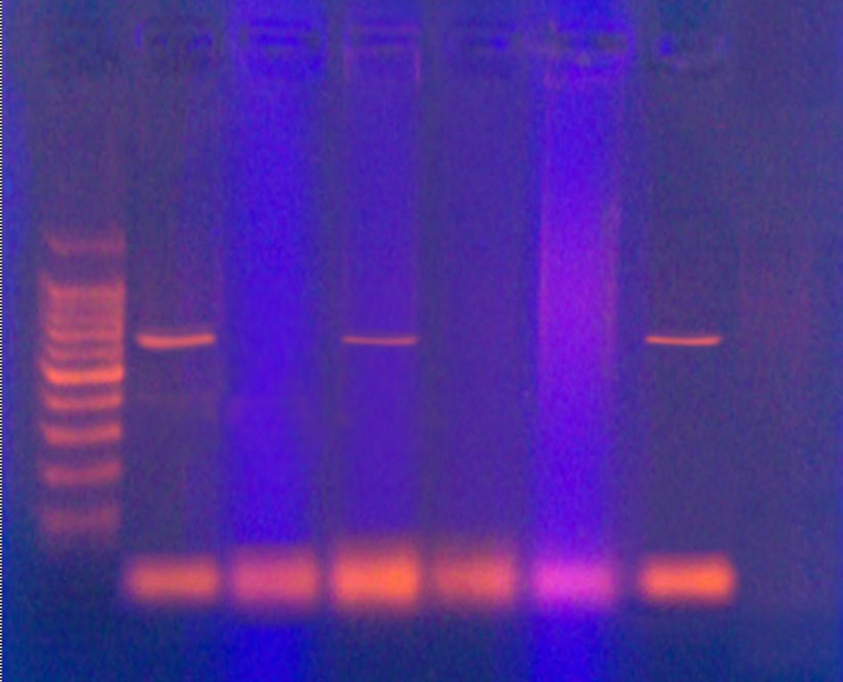
L
1
CSF
2
CSF
3
Throat
5
Eye

6
Sputum

4
Ear
650 bp
Figure 1 Gel electrophoresis of PCR product of hif A gene. Lane of
H. influenzae isolates numbered (1,3,6) were positive.

Clinical site for isolation:

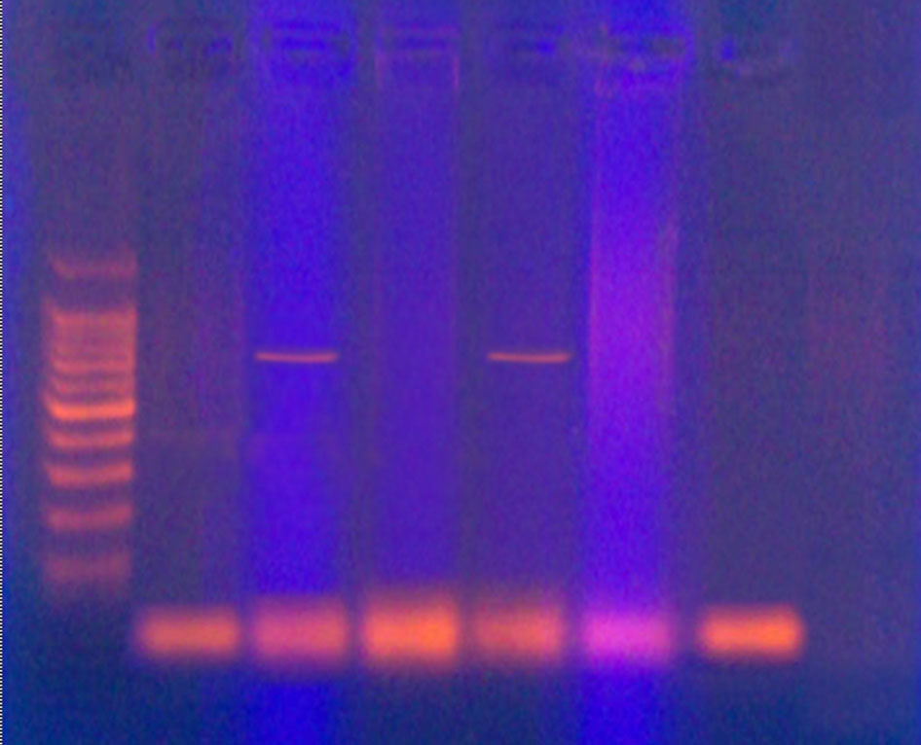
L
1
CSF
2
CSF
3
Throat
5
Eye

6
Ear
4
Sputum
766bp bp
Clinical site for isolation:

Figure 2 Gel electrophoresis of PCR product of hia gene. Lane of H. influenzae isolates numbered (2,4) were positive.

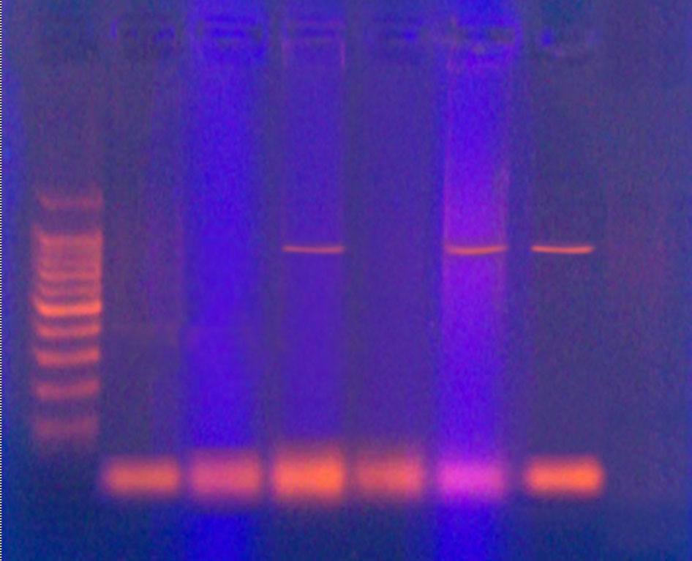
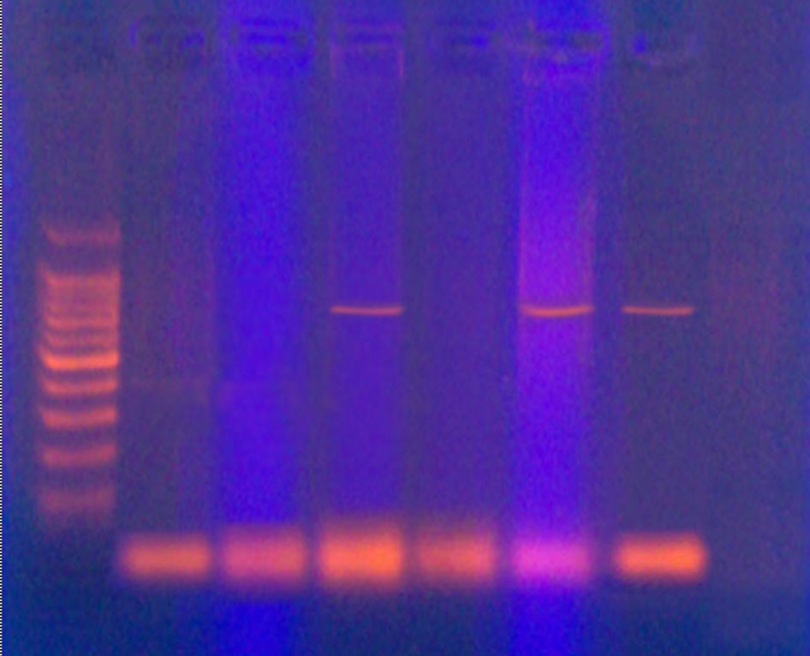
L
1
CSF
2
CSF
3
Throat
5
Eye

6
Ear
4
Sputum
923bp
Figure 3 Gel electrophoresis of PCR product of hmw1 gene. Lane of isolate numbered (3,5,6) were positive.

L
1
CSF
2
CSF
3
Throat
5
Eye

6
Ear
4
Sputum
Figure 4 Gel electrophoresis of PCR product of hmw2 gene. Lane of isolate numbered (3,5,6) were positive.

731 bp
Clinical site for isolation:

Clinical site for isolation:

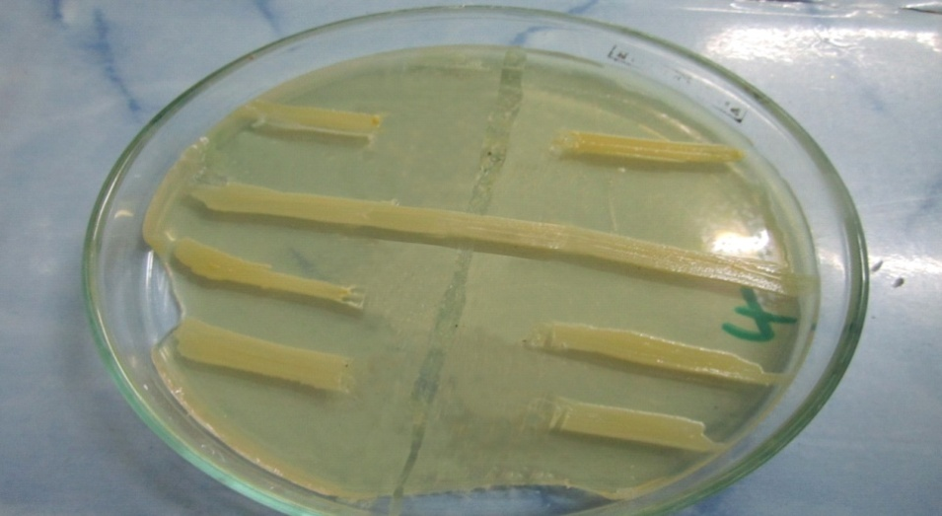
Isolate no.1 (Hib)
NTHi isolate no.3
NTHi isolate no.5
NTHi isolate no.6
NTHi isolate no.4

Figure 5 Haemocin produced by type b H.influenzae (Hib) on Tryptic Soy Agar using
cross- streaking method
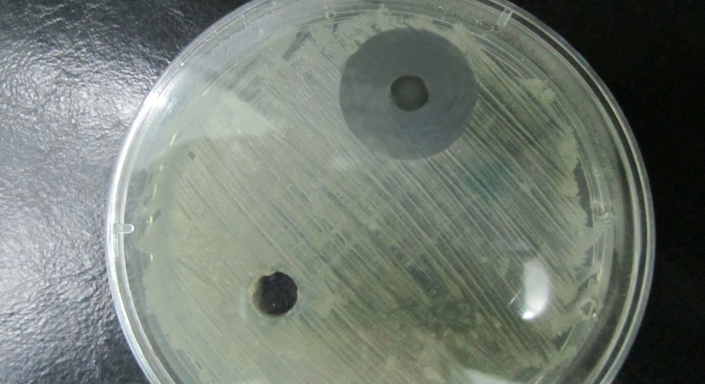
Isolate no.1 (Hib)
Isolate no.2 (capsulated non type b)
NTHi isolate
Figure 6 Heamocin produced by type b H.influenzae (Hib) on Tryptic Soy Agar using
wells method.

Colonic acid (μg/ml)
Isolate No.

Figure 7 Concentration of colanic acid (µg/ml) produced by H. influenzae isolates obtained from clinical samples

References
- Todar, K. (2008). Todar’s online feat book of bacteriology. University of Wisconsin-Madison Department of Bacteriology.
- Gilsdorf, J.R.; Marrs, G.F. and Foxman, B. (2004). Haemophilus influenzae genetic variability and natural selection to identify virulence factors. Infect. Immun., 72 (5): 2457-2461.
- Ecevit, I.Z.; mcCrea, K.W.; Pettigrew, M.M.; Sen, A.; Marrs, C.C. and Gilsdorf, J.R. (2004). Prevalence of the hif BC, hmw1A, hmw2A, hmwc and hia genes in Haemophilus influenzae isolates. J. Clin. Microbiol.; 24: 3065-3072.
- Nakamura, M.; Asaka, T.; Kiruta, A.; Miyazaki, H.; Senda, Y.; Fujita, S. et al (2006). Occurance of fimbria gene HifA in clinical isolates of non encapsulated Haemophilus influenzae. Microbiol. Immunol., 50: 327-329.
- Gilsdorf, J.R. (2001). Role of pili in Haemophilus influenzae adherence, colonization and disease. In: Bacterial adhesion to host tissues. Ed: Wilson, M.; Cambridge University Press, Cambridge UK. In press.
- Krasan, G.P.; Sauer, F.G.; Cutter, D.; Farley, M.M.; Gilsdorf, J.R.; Hultgren, S.J. and StGeme, J.W. III (2000). Evidence for donor strand complementation in the biogenesis of Haemophilus influenzae haemagglutinating pili. Mol. Microbiol.; 35: 1335-1347.
- Mu, X.P, et al (2002). Structure and function of Hib pili from Haemophilus influenzae type b. J. Bacteriol.; 184 (17): 4868-4874.
- Cotter, S.E.; Yeo, H.T.; Juchne, T. and StGeme, J.W. 3rd (2005). Architecture and adhesive activity of the Haemophilus influenzae HSF adhesive. J. Bacteriol.; 187: 4656-4664.
- Meng, G.; St Geme, J.W. 3rd and Waksman, G. (2008). Repetitive architecture of the Haemophilus influenzae Hia trimeric autotransporter. J. Mol. Biol.; 384: 824-836.
- Marrs, C.F.; Krasan, G.P.; mcCrea, K.W.; Clemans, D.L. and Gilsdorf, J.R. (2001). Haemophilus influenzae –human specific bacteria. Frontiers in Bioscience; 6: e41-60.
- Winter, L.E. and Barenkamp, S.J. (2003). Human antibodies specific for high-molecular weight adhesion proteins of nontypeable Haemophilus influenzae medicate opsonopagocytic activity. Infect. Immun.; 71 (12):6884-689.
- Rahman, N.A. (2009). Comparison of virulence determinants of different strains of Haemophilus influenzae . School of Biochemical Science, Curtin University of Technology, Perth WA. P: 1-12.
- Winn, W.; Allen, S.; Janda, W.; Koneman, E.; Procop, G.; Schrehenberger, P. and Woods, G. (2006). Koneman’s color atlas and textbook of diagnostic microbiology, 6th ed. Lippincott Williams and Wilkins, Philadelphia.
- Sutherland, I.W. (2001). Biofilm exopolysaccharides: A strong and sticky framework. Microbiology; 147: 3-9.
- MacFaddin, J.F. (2000). Biochemical tests for the identification of medical bacteria. 3rd ed., The Williams and Wilkins-Baltimore, USA.
- Hall, F.A. (1971). Bacteriocin typing of Klebsiella spp. J. Clin. Pathol.; 24: 712-716.
- Vignolo, G.M.; Suriani, F.; deRuiz, H.; Olgado, A.A.P. and Oliver, G. (1993). Antibacterial activity of Lactobacillus strains isolated from dry fermented sausages. J. Appl. Bacteriol.; 75: 344-349.
- Dische, Z. and Shettles, L.B. (1951). A new spectrophotometric test for the detection of methylpentose. J. Biol. Chem.; 192: 579-582.
- AL-Saedi, I.A. (2000). Isolation and identification of Klebsiella pneumoniae from various infections and detection of some virulence factors associated in their pathogenicity in Hilla city. M. Sc. Thesis. College of Science, Babylon University, Iraq.
- Saikia, K.K.; Das, B.K.; Bewal, R.K.; Kapil, A.; Arora, N.K. and Sood, S. (2012). Characterization of nasopharyngeal isolates of type b Haemophilus influenzae from Delhi, Indian J. Med. Res., 136, November, Pp: 855-861.
- Cerquetti, M.; DegliAtti, M.L.; Renna, G.; Tozzi, A.E.; Garlaschi, M.L. and Group, H.S. (2000). Characterization of nontypeable Haemophilus influenzae strains isolated from patient within invasive disease. J. Clin. Microbiol., 38: 4649-4652.
- Rodriguez, C.A.; Avadhaanula, V.; Buscher, A.; Smith, A.L.; StGeme III, J.W. and Adderson, E.E. (2003). Prevalence and distribution of adhesins in invasive non type b encapsulated Haemophilus influenzae. Infect. Immun., 71 (4): 1635-1642.
- Ogilvie, C.; Omikunle, A.; Wang, Y.; st Geme III, J.W.; Rodriguez, C.A. and Addersen, E.E. (2001). Capsulation loci of non serotype b encapsulated Haemophilus influenzae. J. Infect. Dis., 184: 144-149.
- Feil, E.J.; Holmes, E.C.; Bessen, D.E.; Chan, M.S.; Day, N.P.J.; Enright, M.C.; Goldenstein, R.; Hood, D.W.; Moore, C.E.; Zhou, J. Spratt, B.G. (2001). Recombination with natural populations of pathogenic bacteria: Short term empirical estimates and long term phylogenetic consequences. Proc. Natl. Acad. Sci., USA, 98: 182-187.
- Xie, J.; Juliao, P.C.; Gilsdorf, J.R.; Ghosh, D.; Patel, M. and Marrs, C.F. (2006). Identification of new genetic regions more prevalent in nontypeable Haemophilus influenzae otitis media strain than in throat strains. Department of epidemiology. University of Michigan School of public health.
- Chang, C.C.; Gilsdorf, J.R.; DiRita, V.J. and Marrs, C.F. (2000). Identification and genetic characterization of Haemophilus influenzae genetic island 1. Infect. Immun., 68: 2630-2637.
- Aubrey, R. and Tang, C. (2003). The pathogenesis of disease due to type B Haemophilus influenzae. Methods Mol. Med.; 71: 29-50.
- Firozi, P.; Zhang, W.; Chen, L.; Quiocho, F.A.; Worley, K.C and Templeton, N.S. (2010). Identification and removal of colanic acid from plasmid DNA preparations: Implications for gene therapy. Gene. Therapy; 17 (12): 1484-1499.
- Clemans, D.L.; Marrs, C.F.; Patel, M.; Duncan, M. and Gilsdorf, J.R. (1998). Comparative analysis of Haemophilus influenzae hif A (pilin) genes. Infect. Immun.; 66 (2): 656-663.

