Detection of Sortase Enzymes and Cyl operon A and B of Streptococcus Agalactiae by PCR

Alaq Saleem al-khalidi* Samraa Suhail Al-taee**
Mohammed Sabri Abdul-Razzaq*
* Collage of Medicine, University of Babylon, Hilla, Iraq.
** Gynecologist in Babylon Hospital of Maternity and Pediatrics, Hilla, Iraq.

M J B

Received 4 August 2013 Accepted 24 September 2013
Abstract
In this study , 20 isolates of Streptococcus agalactiae which isolated from women with vaginitis , were involved for this study. Sortase A & C1 genes were detected by PCR . It was seen that all isolates contain Sortase A gene and only three isolates were found to have Sortase C1 gene. Also, Cyl operon A & B genes were identified by PCR . It was found that all isolates contain Cyl A gene and only three were found to have Cyl B gene.
The aims of this study was to detected of Sortase enzyme & Cyl operon A & B in GBS isolates by PCR among clinical isolates of Streptococcus agalactiae.
الخلاصة
في هذه الدراسة تم الحصول على 20 عزلة من المكورات المسبحية من النساء اللواتي يعانين من الامراض المهبلية والمتوقع وجودها لهذه الدراسة. تم استخدام بادئات نوعية (primers) في تقنية تفاعل البلمرة المتسلسل (PCR) للتحري عن الجينات الخاصة بأنزيمات Sortase بنوعيه (A & C₁) وقد أظهرت النتائج حيث لوحظ بان جميع العزلات تمتلك جين Sortase A1 وثلاث عزلات فقط تمتلك جين Sortase C₁ . كذلك تم تشخيص جين Cyl operon (A&B) حيث لوحظ بان جميع العزلات احتوت على جين Cyl A بينما كانت ثلاث عزلات فقط حاوية على جين Cyl B .
الهدف من هذه الدراسة هو لتحديد انزيم Sortase بنوعيه (A & C₁) وكذلك Cyl operon (A&B) في عزلات المكورات المسبحية GBS بواسطة تقنية ال .PCR
ــــــــــــــــــــــــــــــــــــــــــــــــــــــــــــــــــــــــــــــــــــــــــــــــــــــــــــــــــــــــــــــــــــــــــــــــــــــــــــــــــــــــــــــــــــــــــــــــــــــــــــــــــــــــــــــــــــــــــــــــــــــــــــــــــــــــــــــــــــــــــــــــــــــــــــــــــــــــــــــــــــــــــــــــــــــــــــــــــــــــــــــــــــــــــــــــــــــــــــــــــــــــــــــــــــــــــــــــــــــــــــــــــــــــــــــــــــــــــــــــــــــــــــــــــــــــــــــــــــــــــــــــــــــــــــــــــــــــــــــــــــــــــــــــــــــــــ

Introduction

Streptococcus agalactiae or Group B Streptococcus (GBS) is gram-positive coccus which appears in chain or pairs. The organism is found as commensal in the gastrointestinal and the genitourinary tract of up to 30% of healthy adults, GBS is facultative anaerobic, catalase-negative gram-positive cocci, oxidase negative. Their metabolism is mainly fermentative and lactic acid is the predominant end product [1].
Streptococci may display beta-hemolytic, alpha-hemolytic and non-hemolytic reactions on blood agar. Those with beta-hemolytic ability, i.e. to lysate erythrocytes completely in blood agar, were subdivided by their reaction to specific antisera against their group-specific cell wall anchored carbohydrate [2]. GBS described as zoontic organisms, It is a member of the normal flora of the female genital tract, also could be isolated from bovine milk or from vaginal and rectal swab specimens from asymptomatic pregnant women[3].
Many of the prevalence studies looking at colonization have been carried out on pregnant women and from these it is known that colonization rates are higher in sexually active individuals, especially those with multiple sexual partners, and increases with maternal age [4]
The ability of GBS to cause infections is multifactorial. The main virulence associated GBS proteins identified to date are secreted or surface components, including β-haemolysin\cytolysin operon (cyl-operon) which promote enhancing bacterial pathogenecity.
The GBS has β- Hemolysin\ Cytolysin operon which considered as surface-associated toxins that play an important role in virulence of the organism, also this is responsible for the characteristic zone of clearing around GBS colonies grown on blood agar plates[5].
One of the most virulence factors for Streptococcus agalactiae that mediates in wall anchoring are sortase enzymes which have a major role in some diseases such as meningitis and neonatal sepsis.
Among these enzymes are sortase A which is considered as a housekeeping sortases and was shown experimentally to anchor a large number of surface proteins[6].
In addition to sortases A, there are two other specialized sortases, one associated with (fibronectin –binding , collagen binding-t-antigen) refers to sortase B .
While the other recognizes an altered consensus sequence, which is called sortase C [7].
Patients and Methods
Patients:
This study included 84 women patients suffering from vaginitis who were submitted to Hilla Teaching Hospital during a period of three months from October to January2013.
Collection of specimens:
Specimens were collected from patients with vaginitis. The swabs were inserted into the upper part of the vagina and rotated there before withdrawing it, so that exudates was collected from the upper as well as the lower vaginal wall. An endocervical swab must be collected. A vaginal speculum must be used to provide a clear sight of the cervix and the swab was rubbed in and around the introitus of the cervix and withdrawn without contamination from the vaginal wall.
Swabs for culture were placed in tubes containing normal saline to maintain the swab moist until taken to laboratory. The swab has been inoculated on Colombia agar media and incubated aerobically for 24hr. at 37ᵒ C.
Detection of Sortase Enzymes (A&C1) & Cyl Operon (A& B ) by PCR.
Bacterial DNA extract was used as a template in specific PCRs for the detection of virulence genes (Str A, Str C1 ,Cyl A & B). DNA was purified from bacterial cells by using the wizard minipreps DNA Kit(Geneaid-USA). A primer were used for the amplification of a fragment genes according to the references mentioned in tables (1) and (2).

Table 1 Primers sequences and PCR conditions to detect Sortase genes.
Genes | Primer sequence (5ʹ-3ʹ) | Size of product bp | PCR condition | Ref.
Srt A F  Srt A R | TACTTCCAATCCAATGCATCTGCTCAAACGAAATCACATA  TTATCCACTTCCAATGTTAAAATGCTTTTAATATCGACTCAT | 500 | 94ºC 3min 1x | [8]
Srt A F  Srt A R |  | 500 | 94ºC 2min  63ºC 1min 28x  72ºC 1min | [8]
Srt A F  Srt A R |  | 500 | 72ºC 10min 1x | [8]
Srt C1 F  Srt C1 R | AAAGGATCCTCTCACGCCAATATTAATGCTT  AAAGGATCCCTATTGTTGTTGCCTGAAGGTCTT | 370 | 95ºC 2.5min 1x | (8)
Srt C1 F  Srt C1 R |  | 370 | 94ºC 30sec  53ºC 1min 30x  72ºC 30sec | (8)
Srt C1 F  Srt C1 R |  | 370 | 72ºC 7min 1x | (8)
Table 2 Primers sequences and PCR condition to detect Cyl A& B by PCR
Genes | Primer sequence (5ʹ-3ʹ) | Size of product bp | PCR condition | Ref.
CylA F  Cyl A R | GACTCGGGGATTGATAGGC  GCTGCTAAAGCTGCGCTTAC | 688 | 95ºC 5min 1x | [9]
CylA F  Cyl A R | GACTCGGGGATTGATAGGC  GCTGCTAAAGCTGCGCTTAC | 688 | 94ºC 1min  58ºC 1min 28x  72ºC 1min | [9]
CylA F  Cyl A R | GACTCGGGGATTGATAGGC  GCTGCTAAAGCTGCGCTTAC | 688 | 72ºC 10min 1x | [9]
Cyl B F  Cyl B R | CGCCGCGGATCCTAATTATTGGCTCATTGCAGG  CGCCGCGAATTCCTACCGAGCCAATTGAGAG | 428 | 94ºC 5min 1x | [10]
Cyl B F  Cyl B R |  | 428 | 94ºC 1min  56ºC 1min 30x  72ºC 1min | [10]
Cyl B F  Cyl B R |  | 428 | 72ºC 10min 1x | [10]

Results and Discussion
Bacterial isolates:
Only 20 isolates of GBS were obtained in this study which have been isolated from pregnant and non-pregnant women. All isolates have been cultured in Colombia agar media and incubated aerobically for 24hr. at 37ᵒ C.
Detection of sortase A & C1 enzyme by PCR:
Results found that sortase A was observed in 7 isolates of GBS strains( Figure 1).
Its well known that sortase A is housekeeping enzyme that may be present in all Streptococcus strains especially St .agalactiae and St. pyogens in local study, so this results confirms that sortase A is normaly present in this bacteria as a result of its being housekeeping [11].
The Gram positive bacteria including Streptococcus agalactiae assemble pili by distinct mechanism involving a trans peptidase called sortase, regarding to the others , it was found that sortase A was exist in all GBS isolates, this result could prove that sortase A is housekeeping enzyme which involved not only information of pili type sortase, but also anchors pili to the cell wall [12].

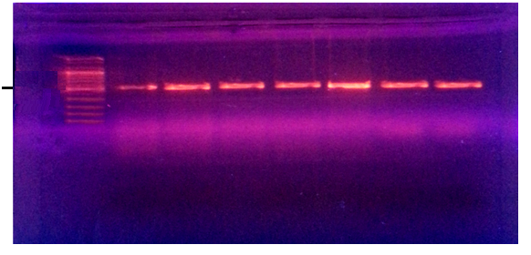
4 5 6 7 Ladder 1 2 3 3

500 bp

Figure 1 Gel electrophoresis of PCR product of sortase
(A) *(1, 2, 3, 4, 5, 6 ,7) GBS isolates with positive result for sortase A

This result is in agreement with the results obtained by other studies [13].
Moreover , Srt C gene which encodes sortase C enzyme, class C sortases are integral membrane cysteine transpeptidases of gram-positive bacteria .
Sortase C1 was identified in this study (SrtC1) in three isolates of GBS as shown in figure (2).
This result is in agreement with results are obtained by other studies where it was reported that this enzyme are present in GBS and responsible for invasive infection in non pregnant adults [14].
Sortase C1 , not as in sortase A , is not classified as housekeeping enzyme, so it's not ubiquitous as sortase A.

2 3 4 5 6 7 1 Ladder
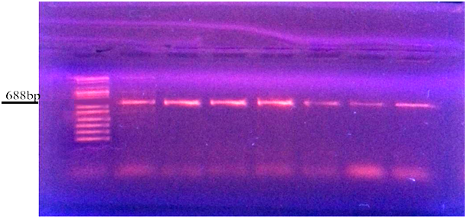

Figure 2 Gel electrophoresis of PCR product of sortase
(C1) produced by Streptococcus agalactiae *( 2, 3,4) positive for sortase C1, (1,5, 6,7) negativefor sortase C1

Specifically, SrtA cleaves the target protein between the threonyl and glycyl residues of the LPXTG motif to form an acyl enzyme intermediate. This is then resolved by the nucleophilic attack of amino groups, usually provided by the lipid II precursor of peptidoglycan, which is subsequently incorporated into the cell- envelope. By contrast, the SrtC enzymes of GBS are located within the PIs, and function to polymerize only those LPXTG proteins located within the same PI (15).
According to data obtained in this study, it was observed that only three isolates have been found to contain all Srt genes and this will increase the anchored product.
Detection of Cyl A & B by PCR:
Molecular detection of cytolycin operon was done using haemolycin primer of Streptococcus agalactiae . it was found that cyl A was observed in all GBS strains as shown in figure(3), while cyl B was found only in three isolates as shown in figure (4).

Ladder 1 2 3 4 5 6 7

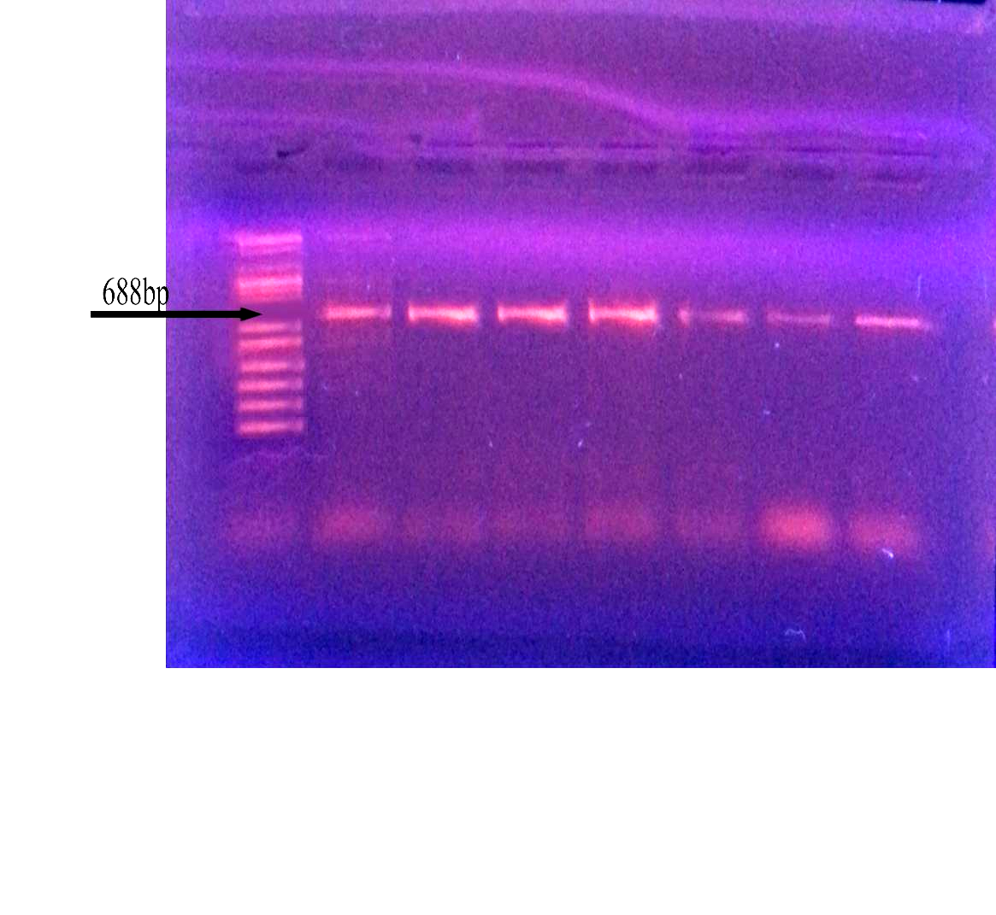

688 bp

Figure 3 Gel electrophoresis of PCR product of S. agalactiae cyl A operon *(1, 2, 3, 4, 5, 6, 7) GBS isolates with positive result
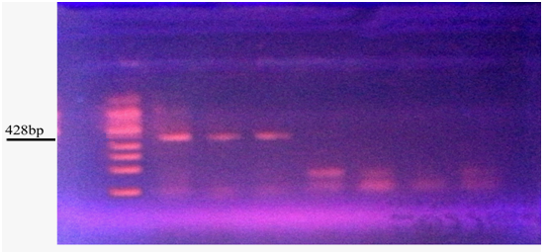

Figure 4 Gel electrophoresis of PCR product of S.agalactiae cyl B *(4, 5, 6,7) GBS isolates with negative result

These result are correlated with results obtained by other studies where it was found that the ABC transporter encoded by this operon (cylA and cylB) was proposed to be required for hemolysin export at the bacterial surface [16].
The β-hemolysin represents an important virulence factor of St . agalactiae , its ability to damage erythrocytes, lung epithelial cells, and brain microvascular endothelial cells is regarded as an initial step in invasive disease .
It was found that the genes cyl A and cyl B display homology to typical ABC transporters , with Cyl A as the ATP-binding domain and Cyl B as the transmembrane protein [17]
Also, other results were obtained by others ,who observed that the ß-hemolysin /cytolysin expressed by GBS is an important virulence factor encoded within a cluster of twelve genes forming the cyl operon , hemolytic activity of GBS is always associated with the synthesis of an orange pigment. [18]
The deduced amino acid sequences of cyl A and cyl B demonstrate significant homologies to prokaryotic and eukaryotic ABC transporters. The typical ABC transporter consists of two transmembrane domains and two highly conserved ATP -binding domains[19].
The transmembrane domains of ABC transporters are highly hydrophobic, and the majority of transporters are predicted to have six membrane-spanning segments per domain. Cyl B codes for a hydrophobic protein with six potential membrane-associated segments.
Both genes, cyl A and cyl B, appear to be required for the hemolytic activity of S. agalactiae wild-type strains, since several naturally occurring non-hemolytic S. agalactiae strains harbor an insertion sequence in the cyl A gene an targeted mutants of cyl B exhibit a non-hemolytic and non-pigmented phenotype that propose that Cyl A and Cyl B constitute a typical ABC transporter catalyzing an ATP-dependent export of hemolysin and pigment.
Both Cyl A and Cyl B are transporters , they are not responsible for synthesis of hemolysin because other Cyl genes may play a role in production of Hly. Such Cyl E is located downstream to Cyl B .
However, the absence of Cyl B from our isolates does not have an effect on Hyl production because Cyl B is just transmembrane protein that Cyl A may give the same function.

Conclusions
The study has arrived at the following conclusions:
- Only twenty isolates of GBS were obtained in spite of all age groups of patients were included.
- Sortase enzymes A, and C_{¹} were detected in some GBS isolates which play a role in anchoring the surface proteins.
- Cyl operon A and B also were detected in some GBS isolates which play a role in ATP-binding domain (ABC-Transporter cassette) .

Acknowledgements
I would like to express my thanks to "Allah" and his prophet "Mohammad.
I am extremely thankful to Dr .Mohammed Sabri Abdul-Razzak for his advice and kindness. Without him I would not have been able to complete this work. I am also grateful to Dr. Samraa Suhail al-taee a gynecologist in Babylon Hospital of Maternity and Paediatrics for providing me with excellent guidance and humour along the way.
References:
1.Whiley, R.A., Hardie, J.M. 2009. Genus I. Streptococcus Rosenbach 1884, 22, In: Vos, P., Garrity, G., Jones, D., Krieg, N.R., Ludwig, W., Rainey, F.A., Schleifer, K.-H., Whitman, W.B. (Eds.) Bergey's Manual of Systematic Bacteriology, Volume 3: The Firmicutes. Springer, Dordrecht, 655-711.
2. Kilian, M. 2010. Streptococcus and Lactobacillus, In: Topley & Wilson's Microbiology and Microbial Infections. John Wiley & Sons, Ltd.
3. Martinez G, Harel J, Higgins R, Lacouture S, Daignault D, Gottschalk M. 2000Characterization of Streptococcus agalactiae isolates of bovine and human origin by randomly amplified polymorphic DNA analysis. J Clin Microbial. 38:71–8.
4.. Rocchetti, T. T., Marconi, C., Rall, V. L. M., Borges, V. T. M., Corrente, J. E. & Da Silva, M. G. 2010. Group B streptococci colonization in pregnant women: risk factors and evaluation of the vaginal flora. Archives of Gynecology and Obstetrics, 283, 717-721.
5. Nobbs AH, Lamont RJ, Jenkinson HF (2009) Streptococcus adherence and colonization. Microbiol Mol Biol Rev 73: 407–450.
6- Berner, R. (2004). Significance, management, and prevention of Streptococcus agalactiae infection during the perinatal period. Expert. Rev. Anti. Infect. Ther. 2, 427–437.
7- Mora, M., G. Bensi, S. Capo, F. Falugi, C. Zingaretti, A. G. O. Manetti, T. Maggi, A. R. Taddei, G. Grandi, and J. L. Telford. 2005. Group A Streptococcus produce pilus-like structures containing protective antigens and Lancefield T antigens. Proc Nat. Acad. Sci. USA 102:15641-15646. 28. Perez-Casal, J., J. A. Price, E. Maguin
8- Baldeep Khare , a Alexander Samal ,a Krishnan Vengadesan ,a K .R. Rajashankar , b Xin Ma,c I –Hsiu Huang , b Hung Ton-Thab and Sthanam v.l. Narayana (2010). Preliminary crystallographic study of the Streptococcus agalactiae sortases, sortase A and sortase c1
9-Creti, R., Imperi, M., Bertuccini, L., Fabretti, F., Orefici, G., Rosa, R., et., al. (2004). Survey for virulence determinants among Enterococcus faecalis isolated from different sources. J. Med. Microbiol. , 53; 13–20.
10- Maguin, E., H. Prevost, S. Ehrlich, and A. Gruss. 1996. Efficient insertional mutagenesis in lactococci and other gram-positive bacteria. J. Bacteriol. 178:931–935.
11- Rafah , F. 2011 . Molecular Study of Sortase Enzymes and Characterization of Some Virulence Factors in Streptococcus pyogenes
Babylon . M.Sc. Thesis. College of Medicine, Babylon university.
12- Swaminathan A, Mandlik A, Swierczynski A, Gaspar A, Das A, et al. (2007) Housekeeping sortase facilitates the cell wall anchoring of pilus polymers in Corynebacterium diphtheriae. Mol Microbiol 66: 961–974.
13- Konto-Ghiorghi Y, Mairey E, Mallet A, Dumenil G, Caliot E, et al. (2009) Dual role for pilus in adherence to epithelial cells and biofilm formation in Streptococcus agalactiae. PLoS Pathog.
14- Khare B, Vengadesan K, Rajashanankar KR, I-Hsiu H, Xin M, Ton-That H, Narayana SV2011. Structural Differences between the Streptococcus agalactiae Housekeeping and Pilus-specific Sortases: SrtA and SrtC1. PloS One. 6e22995.
15- Rosini, R., Rinaudo, C.D., Soriani, M., Lauer, P., Mora, M.,
Maione, D., et al. (2006) Identification of novel genomic islands coding for antigenic pilus-like structures in Streptococcus agalactiae. Mol Microbiol 61: 126–141.
16-Spellerberg B, Pohl B, Haase G, Martin S, Weber-Heynemann J, et al. (1999) Identification of genetic determinants for the hemolytic activity of Streptococcus agalactiae by ISS1 transposition. J Bacteriol 181: 3212–3219.
17- Guilfoile, P. G., and C. R. Hutchinson. 1991. A bacterial analog of the mdr gene of mammalian tumor cells is present in Streptomyces peucetius, the producer of daunorubicin and doxorubicin. Proc. Natl. Acad. Sci. USA 88:8553–8557.
18- Nizet V (2002) Streptococcal beta-hemolysins: genetics and role in disease pathogenesis. Trends Microbiol 10: 575–580.
19- Higgins, C. F. 1992. ABC transporters from microorganisms to man. Annu. Rev. Cell Biol. 8:67–113.

