Effect of Some Antibiotics on Uropathogenic Escherichia coli and Detection of Some Virulence Factors

Haythem Ali Al-Sayigh Hiyam Faez Ahmed Al-Hasson Jwan Ahmed Ali
College of Medicine, University of Babylon, Hilla, Iraq.

M J B

Received 26 March 2013 Accepted 20 May 2013
Abstract
In this study, three hundred urine samples were obtained from patients from both sexes suffering from urinary tract infections (UTIs), who have attending to Hilla Teaching Hospital, one hundred thirty four (134) male (44.6%) and one hundred sixty six (166) female (55.3%) with no age range. Out of the) 300(urine samples, only (47) (15.7%) isolates were found to be related to Escherichia coli. Hemolysin production by E. coli was studied and it was found that (19) (40.4%) out of (47) isolate of E. coli were able to produce hemolysin on blood agar as zone of hemolysis surrounding bacterial colonies, and other isolates of E. coli (28) (59.6%) have able to produce siderophore on M₉ media. Also, the antibiotic sensitivity test was studied on (47) isolates of E. coli and the results show that these isolates were resistance to Clindamycin (97.8%), (63.8%) for Cefotaxime and Cefaxime, Norfloxacine (59.5%), Naldixic acid (51.0%), Gentamycin (45.4%) and Amoxillin (44.6%, and all isolates were sensitive to Amikacin and Nitrofuranation (100%), (85%) for Chloramphenicol, (59.5%) for Streptomycin and Amoxillin (57.4%)
الخلاصة
تم في هذه الدراسه عزل 47 عزله من بكتريا القولون من 300 عينه من مرضى من كلا الجنسين يعانون من التهاب المجاري البوليه. وجد ان من 47 عزله E. coli فقط (19) (%40.4) لها القابليه على انتاج الهيمولاسين على وسط اكار الدم اما باقي العزلات (28) (%59.6) هي تمتلك نظام السايدروفورات.
ايضا درست فعاليه المضادات الحياتية على جميع عزلات E. coli فوجدت انها مقاومه للكلندماسين بنسبة (%97.8 )، سيفاتاكزيم والسيفاكزيم بنسبه (%63.8)، نورفلوكساسين بنسبه (%59.5), (%51) كانت مقاومه للنالدكسك اسد، جنتاماسين بنسبة (%45.4) والاموكسلين بنسبة (%44.6).
كما وجد ان جميع العزلات كانت حساسة للاميكاسين والنايتروفيورانيشن بنسبة (%100) ، (%85) كلومفينيكول ، (%59.5) ستربتوماسين والاموكسلين كانت نسبة الحساسيه (%57.4).
ـــــــــــــــــــــــــــــــــــــــــــــــــــــــــــــــــــــــــــــــــــــــــــــــــــــــــــــــــــــــــــــــــــــــــــــــــــــــــــــــــــــــــــــــــــــــــــــــــــــــــــــــــــــــــــــــــــــــــــــــــــــــــــــــــــــــــــــــــــــــــــــــــــــــــــــــــــــــــــــــــــــــــــــــــــــــــــــــــــــــــــــــــــــــــــــــــــــــــــــــــــــــــــــــــــــــــــــــــــــــــــــــــــــــــــــــــــــــــــــــــــــــــــــــــــــــــــــــــــــــــــــــــــــــــــــــــــــــــــــــــــــــــــــــــــــــــــــــــــــــــــــ

Introduction
Escherichia coli is one of the most important enterobacteriaceae species; it is a gram negative rod, usually motile [1, 2].
E. coli is very important opportunistic pathogen associated with urinary tract infection [3].
Uropathogenic E. coli is bacterial infection of urinary tract in most cases; Uropathogenic E. coli (UPEC) cause 90% of UTIs in anatomically-normal unobstructed urinary tract. The bacteria colonize the feces or perianal region and ascend the urinary tract through the bladder with the aid of specific adhesions. They are able to colonize the bladder [4].
E. coli produces much type of virulence factors such as production of hemolysin and siderophore [5].
Hemolysin is extracellular toxic proteins, which are produced by many gram-negative bacteria (e.g. E. coli, Serratia spp., Proteus spp., Vibrio spp., Pasturella spp. and Pseudomonas aeruginosa), and gram positive bacteria (e.g. Streptococcus spp., Staphylococcus aureus, listeria spp., Bacillus cereus and Clostridium tetani), all of which press a certain pathogenic potential [6].
UPEC strains usually produce siderophore that probably play an essential role in iron acquisition for bacteria during or after colonization [7].
Iron is essential for bacterial growth; the ability to acquire iron from the host is a prerequisite for establishment and maintenance of infections [8, 9].
Resistance to antibiotics is considered as virulence factor of pathogenic microorganisms to cause infection [10].
Multiple antibiotics resistance to useful class of antibiotics including the beta lactam, aminoglycoside and quinolones has generally emerged and this has been increasingly observed among a number of gram negative pathogen such as enterobacteriaceae bacteria [11].

Materials and Methods
In this study, 300 urine samples were collected from patient from both sex suffering from urinary tract infection were admitted to Hilla Teaching Hospital.
Hemolysin production assay:
Hemolysin production was carried out by inoculating a blood agar medium with bacterial isolates at 37ºC for 24 hours. The appearance of a clear zone around the colonies referred to a complete hemolysis (ß- hemolysis). The appearance of greenish zone around the colonies referred to a partial hemolysis (α-hemolysis), whereas no change of zone referred to non-hemolysis (γ-hemolysis)[12].
Siderophore production assay:
M₉ media was prepared, and then supplemented with 2% agar. After sterilization in autoclave at 121ºC for 15 min. and cooling to 50ºC, 0.25% gm/l glucose (sterilize by filtration) and 200µm of dipyridyl were added to it, then organisms were inoculated into this media and incubated for 24 hr. at 37ºC. The results were seen if the growth of microorganism was present or not [13].
Antibiotic sensitivity assay by disk diffusion test:
It was performed by using a pure culture of previously identified bacterial isolate. The most effective antibiotic for each bacterial isolate was determined as recommended by [14].
  - The inoculums to be used in this test were prepared by adding 5 isolated colonies grown on blood agar plate to 5 ml of nutrient broth and incubated at 37ºC for 18 hours and compared with (0.5) McFarland standard tube.
  - A sterile swab was used to obtain an inoculums from the bacterial suspension, this inoculums was streaked on a Mueller-Hinton agar plate and left to dry.
  - The antibiotic discs were placed on the surface of the medium at evenly spaced intervals with flamed forceps or a disc applicator and incubated for 24 hours at 37ºC.
  - Inhibition zones were measured using a ruler and compared with the zones of inhibition determined by the National Committee for Clinical Laboratory Standards.

Table 1 Antibiotic disk
Antibiotic disk | Symbol | Potency (mg) | Antibiotic disk | Symbol | Potency (mg)
Amoxillin | AMC | 30 | Naldixic acid | NA | 30
Cefotaxime | CTX | 30 | Gentamycin | CN | 10
Cefaxime | CFM | 5 | Norfloxacine | NOR | 10
Clindamycin | DA | 2 | Chloramphenicol | C | 30
Streptomycin | S | 10 | Nitrofuranation | F | 300
Amikacin | Ak | 30 | - | - | -

Results and Discussion
In this study, (300) urine samples were collected from patient of both sex that suffering from urinary tract infection were admitted to Hilla Teaching Hospital. These patients were distributed as one hundred thirty four (134) male (44.6%) and one hundred sixty six (166) female (55.3%) with no age range. These samples were subjected for culturing on selective media (EMB) to isolate E. coli.
From (300) urine samples, only 270 samples showed positive culture constituted (90%) whereas no growth was seen in the other (30) samples constituted (10%).
Among (270) isolates, only forty seven (47) (15.7%) isolate were found to be related to E. coli .These bacteria was isolated from (15) sample (32%) male and (32) sample (68%) female. The results were show in Table 2.

Table 2 bacterial E. coli isolate from patient suffering from UTIs
No. of urine sample | Positive culture | M.O isolate | No. of Bacteria | Sex
300 urine sample | 270 (90%) isolate | E. coli | 47 (15.7%) | Male 15 (32%)  Female 32 (68%)

These results agreement with the results obtained by [15], show that a total of 300 urine samples with significant bacteriuria collect were analyses for present of enterobacteriaceae (187) urine samples comprising (68.9%) female and (31.9%) male included E. coli (15.5%), while the other are another microorganism of enterobacteriaceae.
Also reported that (220) urine samples in which E. coli was isolate (191) (87%) had significant bacteriuria, a total of (18) (9.4%) E. coli isolate were lactose fermentation colonies [16].
Who have pointed that E. coli is the determinant facultative bacterium in normal intestine flora[17]. It’s however, responsible for majority of serious extra intestinal infections.
Urinary tract is among the most common site of bacterial infection both in commonly based and hospital patients ^{[17].}
Hemolysin and siderophore production:
Bacteria evolve a number of mechanisms for the question of iron from their environment, one of them is production of hemolysin which acts to release iron complexes to intracellular heme and hemoglobin. Iron can increase disease risk by functioning as a readily a variable essential nutrient for invading microbial and neoplastic cells. To survive and replicate in hosts, microbial pathogens must acquire host iron ^{(18).}
Hemolysin production by E. coli was studied and it was found that (19) (40.4%) out of 47 isolate of E. coli were able to produce hemolysin on blood agar as zone of hemolysis surrounding bacterial colonies, and other isolates of E. coli (28) (59.6%) have able to produce siderophore on M₉ media. These results were showed in Table 3.

Table 3 show the hemolysin and siderophore production
No. of E. coli isolate | Hemolysin production | Siderophore production
47 (15.7%) | 19 (40.4%) | 28 (59.6%)

These results resemble with the results of [19]. How found that many strains of E. coli elaborate hemolysin responsible for zone of hemolysis surrounding bacterial colonies on blood agar. The present results suggest that hemolysin is produced early in the growth cycle, and production of hemolysin is mostly associated with pathogenic bacteria therefore considered important virulence factor [20].
The hemolysin is not essential during early infection but this factor is important at late stages of infection [21].
The hemolytic assay performed as an indicator of the pore forming ability of the toxins by measuring blood cells and lyses them by oligimerizing and forming pores [22].
The siderophore production as virulence factor of E. coli isolate from patients suffering from urinary tract infections. This result suggests that the siderophore production positive strains can be considered as UPEC. Thus, although a great deal has been learned regarding E. coli virulence mechanism in UTI. Much remains to be learned and the practical application of our growing understanding of E. coli virulence factors to the prevention and treatment of UTI has to be continued [23].
In E. coli, the hydroxymate siderophore (aerobactin) is the most effective of the several iron chelation systems employed by the bacteria for iron acquisition. The siderophore (aerobactin) is commonly found in isolates from patients with UTI [24].
IreA and IroN are the recently identified siderophore receptors. Molecular epidemiologic evidence from several studies has demonstrated an increased prevalence of IroN among UTI isolates relative to fecal isolates. This evidence suggests that IroN functions as a siderophore receptor and is an urovirulence factor for UTI [24, 25].
Antibiotic sensitivity test:
The antibiotic sensitivity test was studied on 47 isolates of E. coli and the results show that these isolates were resistance to Clindamycin (97.8%), (63.8%) for Cefotaxime and Cefaxime, Norfloxacine (59.5%) Naldixic acid (51.0%), Gentamycin (45.4%) and Amoxillin (44.6%) as show in Figure (3-1).

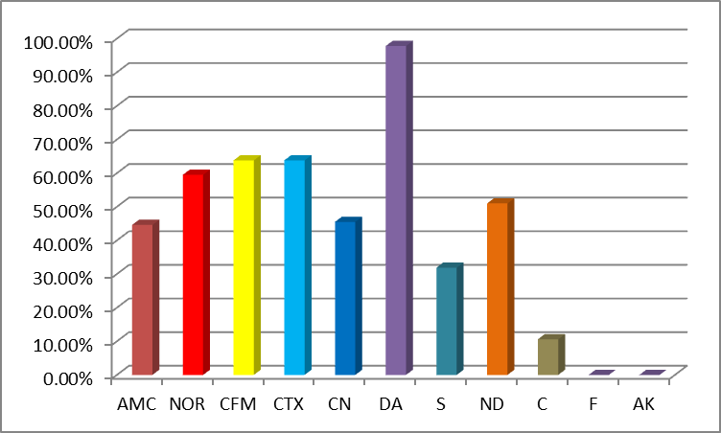
CTX= Cefotaxime, AK= Amikacin, CN= Gentamycin, S= Streptomycin, AMC= Amoxillin,CFM=Cefaxime, DA= Clindamycin, NA= Naldixic acid, NOR= Norfloxacine, C= Chloramphenicol, F= Nitrofuranation.
Figure 1 show antibiotic resistance for E. coli isolates

And some isolates were sensitive to Amikacin and Nitrofuranation (100%), (85%) for Chloramphenicol, (59.5%) for Streptomycin and Amoxillin (57.4%) as show in Figure 2.

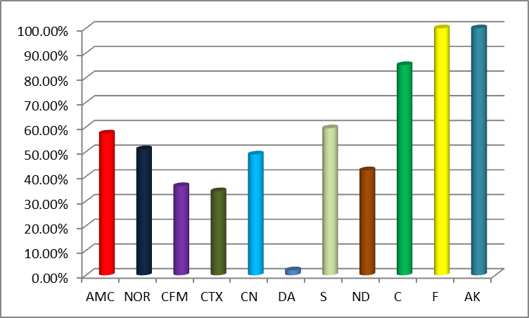
CTX= Cefotaxime, AK= Amikacin, CN= Gentamycin, S= Streptomycin, AMC= Amoxillin, CFM=Cefaxime, DA= Clindamycin, NA= Naldixic acid, NOR= Norfloxacine, C= Chloramphenicol, F= Nitrofuranation.
Figure 2 show antibiotic sensitive for E. coli isolate

The results were resembled to study of [26] who found that the bacterial E. coli isolate from patients suffering from UTIs are resistance to Naldixic acid 88%.
The Norfloxacine intermediate resistance and the most effective antibiotics against E. coli were found to by Streptomycin [27].
But the results in this study not resemble to study by [28] who found that from 102 isolate of E. coli 60-79% were resistance to chloramphenicol.
Amikacin in this result is identical with those obtained [9]. However some reports have mentioned that treatment failure with Amikacin has been attributed to long term treatment [29].
Clindamycin can direct inhibit ribosomal activity and thus would be expected to inhibit synthesis of bacterial protein toxin [30].
Two studies were conducted on the effect of quinolones antibiotics on E. coli; these studies suggest that Naldixic acid cause loss of Pathogenicity Island and investigated the capacity of quinolones to induce partial loss of Pathogenicity Island in Uropathogenic E. coli [31].
The wide spread availability of antibiotics UTI remain the most bacterial infection in human. Antibiotics resistance may develop in uropathogen due to frequent misuse of antibiotics [28].

References
- Smith, H.R. and Scotland, S.M. (1998). Isolation and sexually identification methods for E. coli O157 and other Vero cytotoxic producing strains. J. Clin. Path. 46:10-17.
- Brooks, G.F., Butel, J.S. and Morse, S.A. (2004). Jawetz, Melnick and Ladenburg's medical microbiology. 23rd ed. Lange Medical Brooks. McGraw .Hill.
- Miguel, B., Jesus, B., Alonso, M. and Jorge, B. (1996). Virulence factor and a groups of E. coli isolates from patients with acute pyelonephritis, cystitis and asymptomatic bacteriuria. J. Epidemiol. 12: 191-198.
- Tech, M. and Adhilash, M. (2009). Osmotolerance study of UPEC. J. Aesthetic and Antiaging Medicine. 2(1).
- Zinnah, M., Bari, M., Islam, M., Hossain, M., Rahman, M. and Ruma, R. (2007). Characterization of E. coli isolates from samples of different biological and environmental source.
- Goebel, W., Chakraborty, T. and Kraft, J. (1988). Bacterial hemolysin as virulence factors. Antoine Van leeuwenhoek. 54(5):453-563.
- Todar, K. (2008). Microbial world. Pathogenic E. coli. University of Wisconsin- Madison.: 375-390.
- Braclay, R. (1985).the role of iron infection. Med. Lab. Sci. 42: 166-177.
- Dal, S., Culici, M., Bovio, C. and Braga, P. (2003). Effect of sub inhibitory concentration on various factors affecting bacterial virulence. J. Antimicrobial. Chemother. 21(4): 325-333.
- Akorta, E. and Filgona, J. (2009). Transfer of gentamycin resistance genes among enterobacteriaceae isolated from the outpatients with UTI attending 3 hospitals in Mubi. Sci. Res. J. Acad. 4(8): 745-752.
- Gupta, K., Hooton, T. and Staamm, W. (2001). Increase resistance and management of uncomplicated community acquired UTI. Ann. Int. Med. 135: 41-50.
- De Boy, J., Wachsumth, K. and Davis, B. (1980). Hemolysin activity in enterotoxogenic and non-enterotoxogenic strains of E. coli. J. Clin. Microbiol.12: 193-198.
- Sansonetti, P. (1986). Correlation of virulence of Klebsiella pneumonia K1 and K2 with the presence of plasmid encoding aeobactin. Infect. Immune. 54(3): 603-608.
- National Committee for Clinical Laboratory Standards (NCCLS). (2007). Performance standards for disk susceptibility tests, 8th ed. Approved standard M2-A8.
- Raksha, R., Srinivasa, H. and Macadam, B.S. (2003).Occurrence and characterization of uropathogenic E. coli in urinary tract infections. Indian J. Med. Microbiol. 21(2): 102-107.
- Stephan, B. Houdouin, V. Kurkdjian, P., Farah, M. and Bingen, M. (2006). Comparative prevalence of virulence factors in E. coli causing UTIs in male infects with and without bacteremia. J. Clin. Microbiol. 44(3): 1156-1158.
- Anfora, A., Halladin, D., Haugen, B. and Welch, R. (2008). Uropathogenic E. coli CFTO7 is adapted to acetatogenic growth but does not require acetate during murine UTIs. Infect. Immun. 76(12): 5760-5767.
- Weinberg, E.D. (1998). Pathological implication of microbial acquisition of host iron. Rev. Med. Microbiol. 9:171-9.
- Bhakdi, S., Mackman, N., Menestrina, G., Fray, L., Hugo, F., Segar, W. and Hollabd, I.B. (1988). The hemolysin of E. coli. European J. Epid. 4(2): 135-143.
- Valeva, A., Walev, I., Kemmer, H. Weis, S. and Bhakdi, S. (2005). Binding of E. coli hemolysin and activation of target cell is not receptor – dependent. J. Biological Chem. 280(44):36657-36663.
- Bmggeman, A. (2004). Generation of fluorescent recombinant Listeriolysin O toxin for analysis of interaction with host proteins. PhD thesis Otiostate University, College of Art and Science.
- Vagrali, M. (2009). Siderophore production by uropathogenic Escherichia coli. Indian J. Pathol. Microbiol. 52(1): 126-127.
- Johnson. R. (1991).Virulence factors in Escherichia coli urinary tract infection. Clin. Microbiol. Rev. 4: 81-113.
- Russo, T., McFadden, C., Carlino-MacDonald, U., Beanan, J., Barnard, T.and Johnson, R. (2002). Iron functions as a Siderophore receptor and is a urovirulence factor in an extra intestinal pathogenic isolate of Escherichia coli. Infect Immun.70: 7156-60.
- Barret, S., Savage, M., Rebec, M.,Guyot, A. and Shrimpton, S. (1999). Antibiotic sensitivity of bacteria associated with community – acquired UTIs. J. Antimicrobial. Chem. 44: 359-365.
- Asad, U. and Mohd, S. (2006). Multiple drug resistance patterns in UTI patient in Aligarh. J. Biochem. Res. 17(3): 179-181.
- Montefiore, D., Rotimi, V. O. and adeyemidoro. F. A. (1989). The problem of bacterial resistance to antibiotics among strains isolated from hospital patients in Lagos and Ibadan, Nigeria. J. Antimicrobial. chem. 23:641-661.
- Okesola, A. O. and A. A. Oni. (2009). Antimicrobial Resistance among Common Bacterial Pathogens in South Western Nigeria. Ibadan, Nigeria. American-Eurasian J. Agric. and Environ. Sci. 5 (3): 327-330.
- Yah, M., Frimpong, E., Voravuth, S. and Honda, T. (1999). Effect of sub inhibitory concentrations of antimicrobial agents (quinolones and macrolid) on production of Vero toxin by enterohemorrhagic E. coli. Can. J. Microbiol. 45(9): 732-739.
- Thornsberry, C. and C. yee. (1996). Comparative activity of eight antimicrobial agents against clinical bacterial isolates from the United States, measured by two methods Am. J. Med .100: 265-385.
- Tambeker, D., Dhanorkar, D., Gulhane, V. and Dudhane, M. (2006). Antimicrobial susceptibility of some urinary tract pathogens to commonly used antibiotics. J. Biochem. 5(17): 1562-1565.

