In Iraqi Cirrhotic Patients, Can Oesophageal Variceal Bleeding Make Child Pugh Score more Predictive of outcome and Mortality

Ali A. Alshareefy
College of Medicine , University of Babylon, Hilla, Iraq.

M J B

Received 12 May 2013 Accepted 20 May 2013

Abstract
Background: Variceal bleeding is a leading cause of mortality and morbidity in patients with liver failure (i.e. acute and chronic) cases.
Aim of Study: To evaluate the prognostic value of Variceal bleeding in addition to Child Pugh Score (CPS).
Materials and Methods: A hospital based cross sectional study was carried out on patients with chronic liver failure attending Babylon Gastrointestinal and Hepatology Centre.
Results: A total of 1786 patients with liver diseases were seen at the tertiary hospital, 127 (7.11%) were with chronic liver failure. The overall mean age of those patients with chronic liver failure with bleeding presentation was 47.62 ± 17.14 years and of those patients without bleeding presentation was 49.50 ± 15.10 years. Majority (65.4%) of patients were male and (92.1%) of patients were married. Majority (45.7%) of patients with chronic liver failure were from Al-Hillah city. Majority (55.1%) of patients with chronic liver failure were presenting with abnormal liver tests followed by ascites (24.4%) and bleeding (20.5%). Majority (58.3%) of the patients with chronic liver failure their primary aetiology were viral infection. Meanwhile, HBV was constituted (31.5%) of all primary aetiology followed by HCV (26.8%). Majority (59.0%) of patients with chronic liver failure were class A, meanwhile only (33.9%) and (7.1%) were class B and C, respectively. there were significant associations between haemorrhagic presenting feature with CPC and primary aetiology.
Conclusion: The findings support the importance and significance of the prognostic and predictive value of variceal bleeding in the assessment of patients with chronic liver diseases for further treatment, liver transplantation or the overall mortality. The additive value of variceal bleeding to CPS is still to be defined and formalized and further work is needed to address this important issue.

Key words: CPS, Variceal Bleeding, Chronic liver failure.
الخلاصة
يعد نزف دوالي المرئ من الأسباب الرئيسية المؤدية الى الوفاة والأضرار الطبية الأخرى عند المرضى المصابين بتشمع الكبد0
الغرض من البحث هو تقييم النظم المستخدمة لتقييم درجة تطور المرضى والمخاطر المحتملة له مع التركيز على اعتبار نزف دوالي المرئ مؤشرا مهما يمكن إضافته إلى نظام (Child Pugh) لزيادة قوته التقيمية0
الطريقة: تمت دراسة مجموعه المرضى المصابين بتشمع الكبد وعددهم (127) مريضا من الأعراض والمؤثرات المستخدمة في نظام (Child Pugh) 0
اظهر البحث ان معظم المرضى (58,3) هم من المصابين بالتهاب الكبد الفايروسي المزمن (C+B) وفي المراحل الاولية للمرضى بحسب تصنيف الناتج من تطبيق النظام Child Pugh)) وهم في طبقة (A) اظهر البحث وجود العلاقة المدعمة إحصائيا بين وجود دوالي المرئ النازفة وموقع المرض او المريض في سلم طبقات النظام التقييمي( Child Pugh)
الكلمات الرئيسة: تشمع الكبد, دوالي المرئ , نظام( Child Pugh)
ــــــــــــــــــــــــــــــــــــــــــــــــــــــــــــــــــــــــــــــــــــــــــــــــــــــــــــــــــــــــــــــــــــــــــــــــــــــــــــــــــــــــــــــــــــــــــــــــــــــــــــــــــــــــــــــــــــــــــــــــــــــــــــــــــــــــــــــــــــــــــــــــــــــــــــــــــــــــــــــــــــــــــــــــــــــــــــــــــــــــــــــــــــــــــــــــــــــــــــــــــــــــــــــــــــــــــــــــــــــــــــــــــــــــــــــــــــــــــــــــــــــــــــــــــــــــــــــــــــــــــــــــــــــــــــــــــــــــــــــــــــــــــــــــــــــــــ

Introduction
Chronic liver failure is increasingly considered as an important cause of chronic disease worldwide because of its epidemiological burden, and potential impact on the patient’s health [1–4]. It is a documented cause of direct and indirect medical costs, with huge effects on patients, physical capacity, self-esteem and mental health [5–11].
Liver cirrhosis is the final stage of various chronic liver diseases. It is defined as a diffuse alteration of hepatic architecture ended by the development of portal hypertension [12]. Alcohol was considered the leading cause of cirrhosis. However, viral hepatitis B (HBV) and C (HCV) are recognized as the most important sources. Oher causes include Nonalcoholic Fatty Liver Disease (NAFLD), autoimmune diseases. Most patients are asymptomatic or have nonspecific symptoms until decompensation occurs. Ascites is the most common complication of portal hypertension which can also lead to variceal oesophageal bleeding, hepatic encephalopathy and hepatic-renal syndrome [13]. Variceal bleeding occurs in 30 to 40% of patients with liver cirrhosis. In the recent years and despite the advancement of diagnostic and therapeutic facilities in the field, the mortality rate is remained high. Variceal bleeding can develop during both the early and late stages of cirrhosis that means from Child-Pugh class A to C [14]. It has been reported that about half of cirrhotic patients will develop varices due to portal hypertension and (40%) of them will have variceal bleeding [15 and 16]. huge work has been perfumed to use non-invasive parameters as indicators to predict the presence of oesophageal varices and their risk of bleeding. Those parameters included low platelet counts, prothrombin time, ascites and advanced Child-Pugh class [17 and 18]. The gold standard test for the diagnosis of presence and size of varices remains the oesophagogas-troduedenoscopy (OGD). Cirrhosis is a process of liver parenchymal damage, fibrosis and replacement with regeneration nodules. In the compensated phase the diagnosis can be made by non-specific manifestations or abnormal laboratory findings, whereas in its advance stages the syndrome is obvious by its own and by its complications [19].
It has long been a challenge to produce a universal assessment non-invasive system or score to assess the severity of chronic liver diseases, to predict prognosis and design appropriate treatment strategy. It was evolving the process of production, modification and validation of these scores or systems. The most commonly used models are: the Child-Pugh score [20] and Model for End Stage Liver Disease (MELD) score [21]. Despite its claimed weaknesses and subjectivity of its variables (ascites and hepatic encephalopathy), the Child-Pugh score remains the most widely used one due to its simplified format and applicable blood tests involved. It is current uses include assessment of severity, operative mortality and risk, timing and position of patient with chronic liver diseases in liver transplantation waiting lists. While the Child-Pugh score produces superior results for long periods exceeding a year, the MELD score had been originally validated only to predict three month mortality for patients with chronic liver disease [22- 28]. The fact that patients with chronic liver diseases may ultimately end up with falling most measures to keep the compensation of the liver where the need for liver transplantation comes. The ideal timing of assessment and listing patients in liver transplantation waiting list is crucial to the outcome and patients wellbeing. The lack of liver transplantation service in Iraq has negative impact on patients and their carers with substantial effect on overall organization and quality of training in this vital medical service. This study has been carried out to evaluate the prognostic value of variceal bleeding in addition to Child Pugh Score and to provide a platform for further work to formalize and incorporate variceal oesophageal bleeding into Child Pugh Score.

Materials and Methods

Study design/Study Location
This hospital based cross sectional study was carried out in a tertiary centre.

Study population
All patients with chronic liver failure, seen at the Babylon Gastrointestinal and Hepatology Centre in Merjan Medical City between January 2012 and June 2013 were included in this study.

Instruments and procedures
The outcome variable was the presenting features (presented with haemorrhage and non-haemorrhage) of patients with chronic liver failure and the independent variables were age, gender, marital status, residence, primary aetiology of chronic liver failure and mean and classes of Child Pugh Score (CPS).
Child Pugh Score (CPS)
For decades, CPS has been widely used, for its easy application and usefulness in estimating the prognosis and survival. However, some limitations have been proposed and they are firstly not all variables have an independent effect, secondly it includes subjective variables like ascites and encephalopathy, the cutoff points for quantitative variables are not optimal. More recently much light has been thrown on the impact of renal function on the overall prognosis of patient with chronic liver disease which in turn adds another weakness to the Child Pugh Score as it lacks such reflection [19, 27]. The Child-Pugh score uses five variables: ascites, encephalopathy, bilirubin, prothrombin time and albumin. Patients are graded into three classes as a function of five aforementioned variables. With appropriate score for one to three have been given for each respective variable, three grades A, B and C of patients will be classified as A (5-6), B (7-9) and C (10-15)

Statistical analysis
Statistical analysis was carried out using SPSS version 18. Categorical variables were presented as frequencies and percentages. Continuous variables were presented as means with their 95% confidence interval (CI). The Pearson's chi-square test (x²) test was used to determine the associations between categorical variables. Independent sample t-test was used to compare means between two groups. A p-value of < 0.05 was considered as statistically significant.

Ethical Approval
Approval from the Ministry of Health was received before commencement of the study. Informed consent was also obtained from the each respondent before data was collected.

Results
A total of 1786 patients with chronic liver failure were seen at the Babylon Gastrointestinal and Hepatology Centre in Merjan Medical City from January 2012 and June 2013. Of these 1786 patients with liver diseases, 127 (7.11%) were with chronic liver failure. Table 1 shows the prevalence of chronic liver failure by age, gender and marital status. Out of the total 127 patients with chronic liver failure, 62 patients aged between 40-60 years giving a prevalence of 48.8%. The overall mean age of those patients with chronic liver failure presenting with haemorrhage was 47.62 ± 17.14 years and of those patients without haemorrhage was 49.50 ± 15.10 years. There was no significant difference between two means (t= 0.554, df =125 and p = 0.580). However, (65.4%) of patients were male and (92.1%) of patients were married. Majority (45.7%) of patients with chronic liver failure were from Al-Hillah city followed by (20.5%) from Al-Musaeb, (16.5%) from Al-Hashimea, (6.3%) from Al-Mahaweel. Meanwhile, only (11.0%) of patients with chronic liver failure were from near by provinces (Figure 1).

Table 1 Distribution of patients by socio-demographic characteristics
Variable | n | (%) | Mean ± SD | Range
Age  Age group (years)  < 20 years  20-40 years  40-60 years  > 60 years | 4  30  62  31 | 3.1  23.7  48.8  24.4 | 49.10 ± 15.51 | 4-80
Gender  Male  Female | 83  44 | 65.4  35.5
Marital status  Single  Married | 10  117 | 7.9  92.1
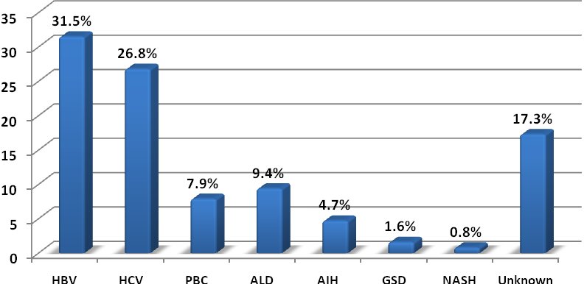
Figure 1 Distribution of patients by primary disease

Disease characteristics

Presenting features
Majority (55.1%) of patients with chronic liver failure were presenting with abnormal liver tests followed by ascites (24.4%) and haemorrhage was (20.5%) (Table 2).

Primary aetiology
Majority (58.3%) of the patients with chronic liver failure their primary aetiology were viral infection (Table 2). Meanwhile, HBV was constituted (31.5%) of all primary aetiology followed by HCV (26.8%), ALD (9.4%), PBC (7.9%), AIH (4.7%), GSD (1.6%), NASH (0.8%) and (17.3%) of patients with chronic liver failure their primary aetiology was unknown (Figure 2).
Child Pugh Score (CPS) and Classes (CPC)
Majority (59.0%) of patients with chronic liver failure were class A, meanwhile only (33.9%) and (7.1%) were class B and C, respectively. The mean CPS was 6.61± 1.56 (Table 2).

Table 2 Distribution of patients’ disease-related factors

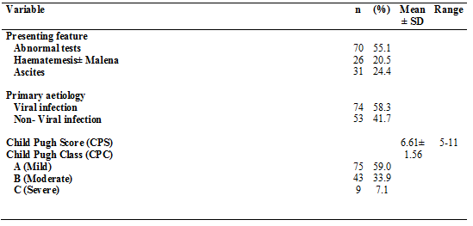

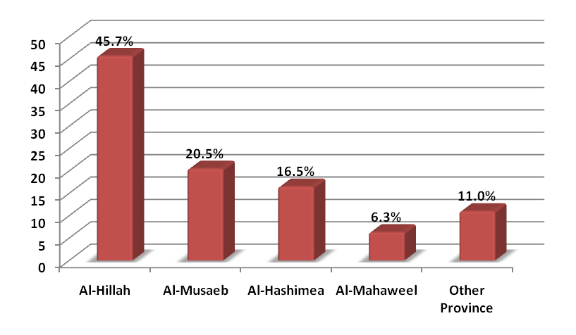
Figure 2 Distribution of patients by Residence

Factors associated with haemorrhagic presenting features
Bivariate analysis showed that there were significant associations between haemorrhagic presenting feature with CPC and primary aetiology (Table 3). The overall mean CPS of those patients with chronic liver failure presenting with haemorrhage was 7.22 ± 1.50 and of those patients without haemorrhage was 6.45 ± 1.55. This difference in the mean CPS was statistically significant (t= 2.308, df =125 and p = 0.023) (Table 4). There was statistically significance difference (F= 68.722, df =124 and p < 0.001) (Figure 3) in overall mean CPS of those patients with chronic liver failure presenting with haemorrhage 7.23 ± 1.53 and of those patients with ascites 8.29 ± 1.37 and 5.64 ± 0.68 for abnormal liver tests.

Table 3 Association between Haematemesis ± Malena with its associated risk factors
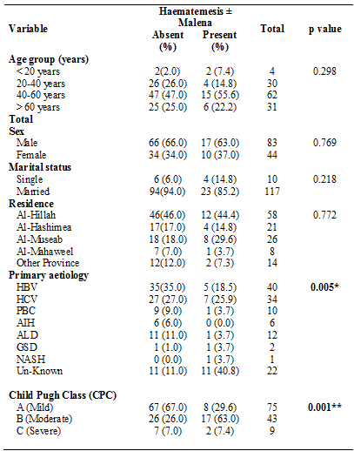
* p value < 0.05 is significant
** p value < 0.01 is significant

Table 4 Mean differences of CPS by presence and absence of Bleeding
CPS | Haematemesis± Malena | N | Mean± SD | t-test | P value
CPS | Absent | 100 | 6.45± 1.55 | 2.308 | 0.023*
CPS | Present | 27 | 7.22± 1.50 | 2.308 | 0.023*
* p value < 0.05 is significant
** p value < 0.01 is significant

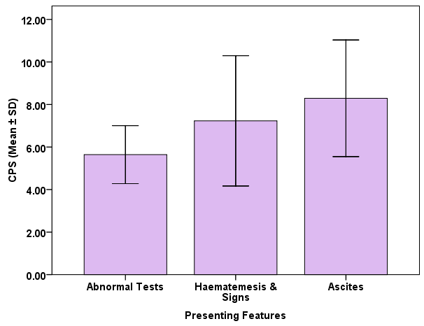
Figure 3 Mean and SD Differences of CPS by presenting features
F=68.722, df= 124, p < 0.001*

Discussion
Liver cirrhosis is the final stage of various chronic liver diseases. Alcohol and HCV are more frequent in men at their fifth and sixth decades of life, according to different studies [29-31]. Recent data have demonstrated that HCV, HBV, and alcoholism remain as common causes of liver cirrhosis are worldwide. They vary by geographic distribution. The finding of this study were in agreement with previous studies where viral hepatitis was the most common cause of liver cirrhosis affecting men in their fourties to sixties. Cirrhosis is often manifested as asymptomatic disease. In the compensated phase the diagnosis can be made by non-specific manifestations or abnormal laboratory findings, whereas in later stages the disease present by its classical features or by its complications [32]. In this study, majority of patients with cirrhosis presented with abnormal laboratory findings, ascites and bleeding (haematemesis and malena). This study has been in agreement with other studies, ascites was the most common complication of liver cirrhosis followed by oesophageal variceal bleeding [33]. Which are usually associated with the advanced stage of Child- Pugh Score [34-36]. While oesophageal variceal bleeding can be seen as another subjective variable in predicting the outcome of cirrhosis patients, efforts have to be made to formalise and structure a grading system whereby oesophageal variceal bleeding can be graded and incorporated into Child Pugh score. The findings of this study which characterize the population of Iraqi patients with chronic liver disease in-terms of patients data and diseases causing their cirrhosis highlight the real scale of the problem and address the need for organized service of liver transplantation with special emphasis on structured triaging in this field and partnership with a respective centre abroad.

Conclusions
Chronic liver disease is a significant medical, social, and economic problem which necessitates the proper design and delivery of dedicated specialty service. The prediction of severity and mortality of patients with chronic liver diseases provide reasonable vision and effective way of resources use. The Child Pugh Score with its proposed weaknesses has been found in this study to be simple, applicable and effective predicting score. Patients with oesophageal variceal bleeding tends to have advance disease with high mortality rate both on first presentation and on re-bleeding. The incorporation of oesophageal variceal bleeding into Child Pugh Score may enhance its predictive capacity. The future work will focus on formulizing and structuring a format where oesophageal variceal bleeding can be graded and incorporated into Child Pugh Score.

References
- Testa MA and Simonson DC. “Assessment of quality-of-life outcomes,” The New England Journal of Medicine, 1996; vol. 334, no. 13, pp. 835–840.
- Dan AA, Kallman JB, Srivastava R et al. “Impact of chronic liver disease and cirrhosis on health utilities using SF-6D and the Health Utility Index,” Liver Transplantation, 2008; vol. 14, no. 3, pp. 321–326.
- Glise H and Wiklund I. “Health-related quality of life and gastrointestinal disease,” Journal of Gastroenterology and Hepatology, 2002; vol. 17, supplement 1, pp. S72–S84.
- Martin LM and Younossi ZM. “Health-related quality of life (HRQL) in chronic liver disease,” Digestive and Liver Disease, 2005; vol. 37, no. 11, pp. 819– 820.
- van der Plas SM, Hansen BE, de Boer JB et al., “Generic and disease-specific health related quality of life in noncirrhotic, cirrhotic and transplanted liver patients: a crosssectional study,” BMC Gastroenterology, 2003; vol. 3, no. 1, article 33.
- Tanikella R, Kawut SM, Brown RS et al. “Health-related quality of life and survival in liver transplant candidates,” Liver Transplantation, 2010; vol. 16, no. 2, pp. 238–245.
- Lam ETP, Lam CLK, Lai CL, Yuen MF et al. “Psychometrics of the chronic liver disease questionnaire for Southern Chinese patients with chronic hepatitis B virus infection,” World Journal of Gastroenterology, 2009; vol. 15, no. 26, pp. 3288–3297.
- Martin LM, Sheridan MJ, and Younossi ZM. “The impact of liver disease on health-related quality of life: a review of the literature,” Current gastroenterology reports, 2002; vol. 4, no. 1, pp. 79–83.
- Rannard A, Buck D, Jones DEJ, James OFW et al. “Assessing quality of life in primary biliary cirrhosis,” Clinical Gastroenterology and Hepatology, 2004; vol. 2, no. 2, pp. 164–174.

- Wong GLH, Law FMY, Wong VWS et al. “Healthrelated quality of life in Chinese patients with primary biliary cirrhosis,” Journal of Gastroenterology and Hepatology, 2008; vol. 23, no. 4.
- Lam ETP, Lam CLK, Lai CL et al. “Health-related quality of life of Southern Chinese with chronic hepatitis B infection,” Health and Quality of Life Outcomes, 2009; vol. 7.
- Ampurdanés S & Bruguera M. Cirrosis hepatica compensada, In: Gastroenterology Hepatology, J. Berenguer, (Ed.), 2001; 643-645, Elselvier Science, Barcelona.
- Serra MA. Consenso para el tratamiento de las hepatitis B and C. Virus de la hepatitis C. Historia natural de la infecciَn por virus C. Gastroenterology Hepatology, 2006; Vol. 29.
- Garcia-Tsao G, Sanyal AJ, Grace ND, Carey W. Prevention and management of gastroesophageal varices and variceal hemorrhage in cirrhosis. Hepatology 2007; 46: 922-938.
- Toubia N, Sanyal AJ. Portal hypertension and variceal hemorrhage. Med Clin North Am 2008; 92: 551-574, viii.
- Merli M, Nicolini G, Angeloni S, Rinaldi V, De Santis A, Merkel C, Attili AF, Riggio O. Incidence and natural history of small esophageal varices in cirrhotic patients. J Hepatol 2003; 38: 266-272.
- Chang MH, Sohn JH, Kim TY, Son BK, Kim JP, Jeon YC, Han DS. [Non-endoscopic predictors of large esophageal varices in patients with liver cirrhosis]. Korean J Gastroenterol 2007; 49: 376-383.
- Thabut D, Trabut JB, Massard J, Rudler M, Muntenau M, Messous D, Poynard T. Non-invasive diagnosis of large oesophageal varices with FibroTest in patients with cirrhosis: a preliminary retrospective study. Liver Int 2006; 26: 271-278.
- Oellerich, M., Burdelski, M., Lautz, H.U., Binder, L. & Pichlmayr, R. Predictors of one-year pretransplant survival in patients with cirrhosis. Hepatology, 1991; vol. 14, No.6.
- Malinchoc M, Kamath PS, Gordon FD et al. A model to predict poor survival in patients undergoing transjugular intrahepatic portosystemic shunts. Hepatology, 2001; vol. 31, No. 4, (Apr), pp. 864-71, ISSN 0168- 8278.
- Mandayam S, Jamal MM & Morgan TR. Epidemiology of Alcoholic Liver Disease. Seminars in Liver Disease, 2004; vol. 24, No. 3.
- Freeman, RB, MELD and liver allocation: continuous quality improvement. Hepatology, 2004, vol. 40, No. 4.
- Adler M, De Gendt E, Vereerstraeten P et al. Value of the MELD score for the assessment of preand post-liver transplantation survival. Transplantation Proceedings, 2005; vol. 37, No. 6.
- D´Amico G, Garcia- Tsao G & Pagliaro L. Natural history and prognostic indicators of survival in cirrhosis: A systematic review of 118 studies. Journal of Hepatology. 2006; vol. 44, No. 1.
- Botta F, Giannini E, Romagnoli et al. MELD scoring system is useful for predicting prognosis in patients with liver cirrhosis and is correlated with residual liver function: a European study. Gut, 2003; vol. 53, No. 1.
- Forman LM & Lucey MR. Predicting the prognosis of chronic liver disease: an evolution from child to MELD. Mayo End-stage Liver Disease, Hepatology, 2001, vol. 33, No. 2.
- Prieto M, Aguilera V, Berenguer M et al. Candidate selection for liver transplantation. Gastroenterologia y Hepatologia, 2007, vol 30, No. 1.
- Durand F & Valla D. Assessment of the prognosis of cirrhosis: Child-Pugh versus MELD. Journal of Hepatology, 2005; vol 42.
- Safdar K & Schiff ER. Alcohol and Hepatitis C. Seminars in Liver Disease, 2004; vol. 24, No. 3.
- Sagnelli E, Stroffolini T, Mele A et al. The Importance of HCV on the Burden of Chronic Liver Disease in Italy: A Multicenter Prevalence Study of 9,997 Cases. Journal of Medical Virology, 2005; vol. 75, No. 4.
- Benvegn L, Gios M, Boccato S et al. Natural history of compensated viral cirrosis: a prospective study on the incidente and hierarchy of mayor complications. Gut, 2004; vol. 53, No. 5.
- Heidelbaugh JJ & Bruderly M. Cirrhosis and Chronic Liver Failure: Part I. Diagnosis and Evaluation. American Family Physician, 2006; vol. 74, No. 5.
- Ginés P, Quintero E, Arroyo V et al. Compensated cirrhosis: natural history and prognosis. Hepatology, 1987; vol. 7, No. 1.
- Samada M, Hernandez JC, Barroso L et al. Identificaciَn de factores de riesgo de presencia de varices esofagicas en pacientes con cirrosis hepatica. Revista Cubana de Medicina Militar, 2008; vol. 37, No. 1.
- Sarwar S, Khan AA, Alam A et al. Non-endoscopic prediction of presence of oesophageal varices in cirrhosis. Journal of the College of Physicians and Surgeons--Pakistan, 2005; vol. 15.
- Dib N, Konate A, Oberti F et al. Non-invasive diagnosis of portal hypertension in cirrhosis. Application to the primary prevention of varices. Gastroenterologie Clinique et Biologique, 2005; vol. 29, No. 10.

