M J B

Extracorporeal Shock Waves in the Treatment of Peyronie's Disease

Murtadha M.S.Majeed Al-Musafer
College of Medicine University of Basrah, Iraq.

Abstract

Background: Peyronie's disease is an acquired disorder of the tunica albuginea characterized by the formation of a plaque of fibrous tissue that may be associated with erectile dysfunction and pain on erection. There may be difficulty of penetration as a result of the curvature. The aim of the study is to evaluate the effectiveness of extracorporeal shock waves in the treatment of patients with stable Peyronie's disease .

Methods: A total of 30 male patients were included in the study from December , 2007 till October, 2010. The mean age ±SD was 42.77 years ±9.38. Detailed medical and sexual history was obtained. Five patients ( 16.66 % ) were diabetics and other 5 patients ( 16.66 % ) had hypertension as well as diabetes mellitus. Thorough physical examination including local examination was performed. All the patients had dorsal plaques. Twenty patients (66.7 %) were presented with dorsal plaques , curvature and erectile dysfunction . The remaining 10 patients ( 33.3 % ) had pain in addition to these features. Extracorporeal shock wave therapy was performed in all cases with low energy shock waves using Wolf lithotripsy machine in Basrah General Hospital.

Results: No serious complications occurred . The average decrease of the plaque length was ( 0. 14 centimeters ) . Pain relief obtained in 6 out of 10 patients who were presented with pain ( 60% ) . Improvement in the sexual function occurred in 15 out of 30 patients ( 50 % ). Improvement in the psychological status obtained in 20 out of 30 patients ( 66.7 % ). No definite cure occurred in the current study in terms of disappearance of the plaque and symptoms.

Conclusion :Extracorporeal shock wave therapy in Peyronie's disease seems to be a safe procedure without severe side effects. It seems to have an effect on penile pain during erection , sexual function and the psychological status of patients with no statistically significant decrease in the plaque length.
Key words: Peyronie's disease ( PD ), extracorporeal shock wave therapy ( ESWT ), plaque.
الخلاصة
إن الهدف من إجراء هذا البحث هو تقييم فعالية العلاج بموجات الصدم الموجهة إلى التليف الحاصل في الأجسام ألكهفيه للقضيب والمسمى بمرض بيروني لدى 30 مريضا 0 لقد تم الاستنتاج بان هذه الموجات لها تأثير ايجابي على الألم الحاصل أثناء الانتصاب وعلى الوضع النفسي للمريض مع وجود نقصان (غير مهم إحصائيا) في طول التليف علما بأنه لم يتم الحصول على حالات شفاء تام من المرض باستخدام هذه الطريقة . لم تحدث أثناء هذه ألدراسة أية مضاعفات مهمة0
ــــــــــــــــــــــــــــــــــــــــــــــــــــــــــــــــــــــــــــــــــــــــــــــــــــــــــــــــــــــــــــــــــــــــــــــــــــــــــــــــــــــــــــــــــــــــــــــــــــــــــــــــــــــــــــــــــــــــــــــــــــــــــــــــــــــــــــــــــــــــــــــــــــــــــــــــــــــــــــــــــــــــــــــــــــــــــــــــــــــــــــــــــــــــــــــــــــــــــــــــــــــــــــــــــــــــــــــــــــــــــــــــــــــــــــــــــــــــــــــــــــــــــــــــــــــــــــــــــــــــــــــــــــــــــــــــــــــــــــــــــــــــــــــــــــ

Introduction
Peyronie's disease (PD), also known as Morbus Peyronie or Induratio Penis plastic (IPP ) or Nodus Penis, is an acquired disorder of the tunica albuginea characterized by the formation of a plaque of fibrous tissue that may be associated with erectile dysfunction ( ED ) and pain on erection. There may be a difficulty of penetration as a result of the curvature [1].
Although the PD has been described centuries before , Francois de la peyronie described the disease that bears his name in 1743 [2] . It is an uncommon condition involving middle- aged men [3]. The prevalence of PD in the population has continuously increased during the last 30 years, and now its prevalence is estimated as between 3.7 and 7.1 % and it is much higher than previously believed. The risk factors for PD including genital & / or perineal injuries, transurethral prostatectomy, cystoscopy, systemic vascular disease, smoking & alcohol consumption in addition to genetic predisposition [4]. The use of medications such as beta- blockers can sometimes result in PD [3].
Peyronie's disease has been reported to occur in association with Dupuytren's contractures , plantar fascial contractures, tympanosclerosis as well as with Paget's disease . It can occur in a familial pattern [5]. Trauma is thought to be the initiating factor and may result in bleeding into the subtunical spaces or tunical delamination. Current research suggests that PD represents localized aberration of the wound healing process. Fibrin deposition is an initial consequence of microvascular injury and it may be the precursor to Peyronie's plaque formation [6-8]. An autoimmune component has also been implicated with PD [9 ].
Peyronie's disease has been previously characterized as a process of gradual spontaneous resolution. However, among patients with PD, of 1 to 5 years duration polled at one institution , 14% of 97 patients reported the disorder as resolving , 40 % considered it progressive & 47% thought that it was unchanged [10].
The treatment of PD should be conservative. Reassurance is all that is necessary in patients with a slight curvature and no erectile dysfunction. Many historic and radical therapies for PD have been attempted . Different modes of energy transfer , including orthovoltage radiation, ultrasound, short wave diathermy, laser therapy, and shock wave lithotripsy, have been used to treat PD [11].
The aim of the current study is to evaluate the effectiveness of extracorporeal shock wave therapy (ESWT) in the treatment of patients with stable Peyronie's disease ( PD).

Patients and Methods
A total of 30 male patients were included in the study during the period from December, 2007 till October, 2010. The patients were from the outpatient department of Basrah General Hospital and the private clinic. The age range was from 30 to 60 years. The mean age ±SD was ( 42.77 years ± 9.38 ) . Detailed medical and sexual history was obtained. Five patients (16.66 % ) were diabetics and other 5 patients (16.66 % ) had hypertension and diabetes mellitus. Thorough physical examination including local examination was performed. All the patients had dorsal plaques. Twenty patients ( 66.7 % ) were presented with dorsal plaques , curvature and erectile dysfunction ( ED ) . The remaining 10 patients ( 33.3 % ) had pain in addition to these features as shown in table I.
Extracorporeal shock wave therapy ( ESWT) was performed with low energy shock waves using Wolf lithotripsy machine in the lithotripsy department of Basra General Hospital. The patient was placed in prone position and the shock waves was directed toward a metal labeled dorsally located Peyronie's lesion as shown in picture I and II . The number of shock waves was in the range of 2500 to 3000 per session. Two to three sessions were given for each patient with two weeks period- free treatment in between . Extra sessions were given on the basis of improvement of patients' symptoms. The average time for each procedure was 30 minutes.

Results

No serious complications like extensive hematoma occurred . A decrease in the plaque length was observed in 14 out of 30 patients (46.7 % ) .The average length was decreased from 2.01 to 1.87 centimeters which was not statistically significant ( P Value ˃0.05 ) . Pain relief obtained in 6 out of 10 patients who presented with pain on erection (60%). Improvement in the sexual function occurred in 15 out of 30 patients (50%). Improvement in the psychological status (the patients were returned to the normal daily activity with a hopeful life) was obtained in 20 out of 30 patients (66.7 %) as shown in table II . The improvements in the sexual function and pain were subjective. No definite cure had been noticed in the current study in terms of absence of the fibrotic plaque, pain and normal erection with satisfactory sexual relationship.

Discussion
There are many frustrations associated with treating a patient who presents with this difficult disorder. There is no available treatment to cure all symptoms of Peyronie's disease in all patients . However, surgery is only indicated in the stable non progressive stage of the disorder. Moreover , not all patients who are candidates for surgical procedures are willing to undergo them and a high number of patients ask for an alternative treatment , especially after unsuccessful drug therapy . ESWT has been tried as a semi-invasive procedure to fill this therapeutic gap[12].
The use of ESWT for PD was first described by Bellorofonte et al in 1989 [13]. despite its wide distribution , the mode of action is not clearly known and the rationale for its use in this fibrotic disorder has not been clarified [14] .There are two hypotheses : one is that there is direct damage to the penile plaque , and the other is that ESWT increases the vascularity of the area by generating heat , which leads to the induction of an inflammatory reaction , resulting in lysis of the plaque and removal by macrophages [11, 15, 16].
In the current study, although the decrease in the plaque length was not statistically significant, it was observed in 14 / 30 patients ( 46.7% ) which is lower than that obtained by Abdel-Salam et al ( 58 % ) [17] and higher than that obtained by Colombo et al ( 41 % ) [18] and Hauck et al ( 43 % ) [19] .
A subjective pain relief was occurred in 6/10 patients ( 60 % ) which is lower than that obtained by Baumann et al ( 89 % ) [20], Colombo et al ( 70% )[18], Hamm et al ( 81 % ) [21] and Hauck et al ( 76 % ) [19] . A change in milieu of the free radicals or a direct disturbance of pain receptors could be the reason for the pain relieving effect. Another possible effect could be analgesia after hyperstimulation of the pain receptors by shockwaves[22] .
The improvement in sexual function was also subjective and was observed in 50 % of patients which is higher than that obtained by Hauck et al ( 26 % ) [19] and lower than that recorded by Abdel-Salam et al ( 58 % ) [17], Baumann ( 55% ) [20] and Hamm ( 71 % )[21]. This can be a reflection of the improvement in the psychological status as well as the pain relief which occurred in those patients .

Conclusion
Extracorporeal shock wave therapy seems in Peyronie's disease to be a safe procedure without severe side effects. It seems to have an effect on penile pain during erection , sexual function and the psychological status of patients. It seems that pain resolves faster after ESWT than during the course of natural history. We recommend further studies with large group of patients.

Table I Characteristics of patients with Peyronie's disease ( no. =30)

 | No. of Patients and Percentage%
Dorsal plaque , curvature,& erectile dysfunction ( ED ). | 20 ( 66.6%)
Dorsal plaque , curvature , ED& pain | 10 (33.3% )
Concomitant Diabetes mellitus ( DM ) only | 5 ( 16.6%)
Concomitant DM with hypertension | 5 ( 16.6%)

Table II Results of treatment of Peyronie's disease with ESWT

Serious complications | 0%
Definite cure* | 0%
Decreased plaque size | 14/30 ( 46.6%)
Average decrease of plaque length after treatment | 0.14 cm
Pain relief | 6/10( 60%)
Improved sexual function | 15/30( 50%)
Improved psychological status | 20/30( 66.6%)
*Definite cure means absence of the fibrotic plaque, pain and normal erection with satisfactory sexual relationship.

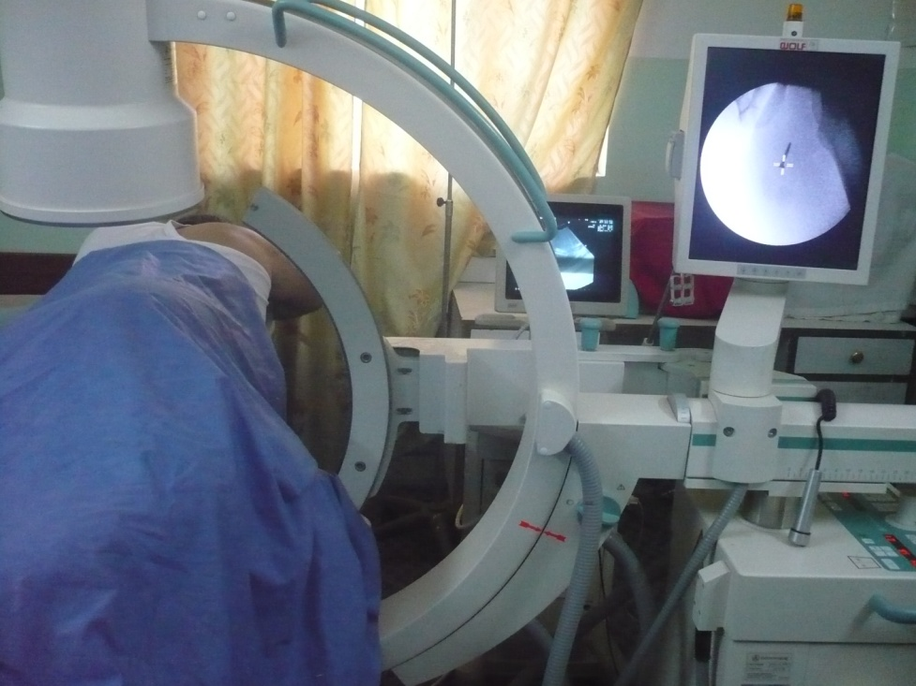

Picture I The patient was placed in prone position using a Wolf lithotripsy machine.

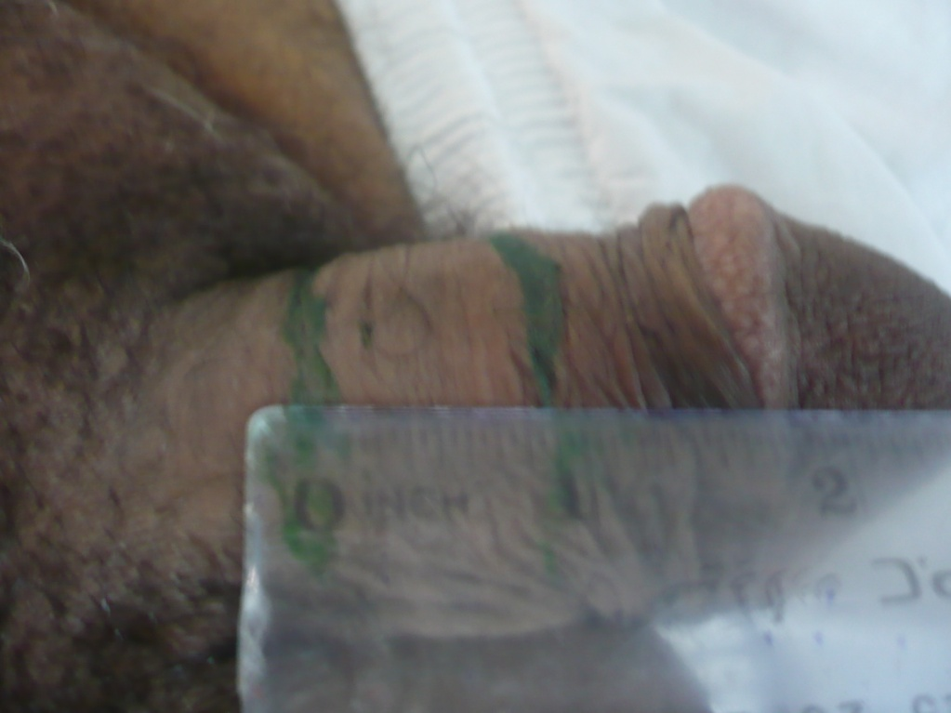

Picture II Plaque length.

References
1.prayor J , Akkus E , Alter G , et al . Priapism , Peyronie's disease , penile reconstructive surgery . In : Lue TF , Basson R , Rosen R , G. Iliano F , Khoury S , Montor F , eds. Sexual medicine , sexual dysfunctions in men and women. Paris :Health publications ;2004 : 383-409.
2.Dunsmuir WD , Kirby RS. Francois de la peyronie ( 1678-1747 ). The man, the disease he described . British Journal of Urology 1996 ; 78 : 613-622.
3. Tunuguntla H.S. Management of Peyronie' s disease- a review . World Journal of Urology 2001 ; 19 (4) : 244-250.
4. Lindsay MB , sehain DM , Grambsch P , Benson RC , Beard M , Kurkland T . The incidence of Peyronie' s disease in Rochester , Minnesota , 1950 through 1984 . Journal of Urology 1991 ; 146 : 1007-1008.
5.Nyberg LM , Bias WB , Hochberg MC , Walsh PC . Identification of an inherited form of Peyronie' s disease with autosomal dominant inheritance and association with Dupuytren 's contracture and histocompatibility B7 cross-reacting antigens. Journal of Urology 1982 ; 128 : 48.
6. Devine C J , Somers KD , Jordan GH , Schlossberg SM. Proposal : trauma as the cause of the Peyronie's lesion . Journal of Urology 1997 ; 157 : 285.
7. Jarow JP , Lowe FC. Penile trauma : an etiologic factor in Peyronie's disease and erectile dysfunction . Journal of Urology 1997 ; 158 : 1388.
8. Somers KD , Dawson DM. Fibrin deposition in Peyronie's disease plaque . Journal of Urology 1997 ; 157 : 311.
9. Schiavino D , Sasso F , Nucera E , Alcini E , et al . Immunologic finding in Peyronie's disease : a controlled study . Urology. 1997 ; 50 : 764.
10. Gelbard MK , Dorey f , James K. The natural history of Peyronie's disease . Journal of Urology 1990 ; 144 : 1376.
11. Shahram S . Gholami , Nestor F. Gonzalez _ cadavid , ching _ shwun Lin . Peyronie's disease : a review . the Journal of Urology 2003 ; 169 ( 4 ) : 1234 – 1241.
12. Levine LA , Lenting EL . a surgical algorithm for the treatment of Peyronie's disease . Journal of Urology 1997 ; 158 : 2149 – 2152.
13.Bellorofonte C , Ruoppolo M , Tura M , et al . Possibility of using the piezoelectric lithotripter in the treatment of severe cavernoufibrosis (in Italian ) . Arch Italian Journal of Urology and Nephrology 1989 ; 61 : 417-422.
14. Iro h , Schneider H , Fodra C , et al . Shock wave lithotripsy of salivary duct stones . Lancet 1992 ; 339 : 1333-1336.
15. Wild C , Khene M , Wanke S .Extracorporeal shock wave therapy in orthopedics . Assessment of an emergency health technology . Int J Technol Assess Health Care 2000 ; 16 : 199-209.
16. Hussain J, Lynn MN , Jones DK , Collins GN , O'Reilly PH. Extra corporeal shock wave therapy in the management of Peyronie's disease : initial experience. British Journal of Urology International 2000; 86 : 849 – 852.
17.Abdel – Salam Y , Budair Z , Renner C , et al . Treatment of Peyronie, s disease by extracorporeal shock wave therapy : Evaluation of our preliminary results . Journal of Endourology 1999 ; 13 : 549 -552.
18. Colombo F , Massimiliano N . Shock waves in the treatment of la Peyronie's disease . Outcomes , evaluation by ultrasonography . La Peyronie's disease ( in Italian) . Arch Ital Urol Androl 2000 ; 72 : 388-391.
19. Hauck EW . Hauptmann A , Bschleipter T , Schmelz Hu , Altinkilic BM , Weidner W. Questionable efficacy of extracorporeal shock wave therapy in Peyronie's disease : results of a prospective approach . Journal of Urology 2004 ; 171 : 269 -299.
20. Baumann M , Bohme H , Tauber R. Extracorporeal shock wave therapy (ESWT) in combination with local verapamil injections in the treatment of IPP (Induratio penis Plastica) (in German ) . Akt Urol 2001 ; 32 ( suppl 1 ) : 61-64.
21. Hamm R , Mclarty E , Ashdown J , Natale S , Dickinson A . Peyronie's disease – the Plymouth experience of extracorporeal shock wave treatment . British Journal of Urology Int. 2001 ; 87 : 849-852.
22. Haupt G. Use of extracorporeal shock waves in the treatment of pseudoarthrosis , tendinopathy and other orthopedic diseases. Journal of Urology 1997 ; 158 : 4-22.

