Electrophysiological changes of Asymptomatic Carpal Tunnel Syndrome in Patients with Rheumatoid Arthritis: Frequency Distribution and Correlation to Disease-Related Factors

Naseer J. Al-Mukhtar Sabah J. Al-Rubaie Thaier K. Al-Husseiny
College of Medicine, University of Babylon, Hilla, Iraq.

M J B

Abstract
Background: Rheumatoid Arthritis (RA) is a chronic systemic inflammatory disease characterized by chronic symmetrical and erosive arthritis with various extra articular manifestations. Of main neurological manifestations of RA is carpal tunnel syndrome CTS.
Objective: To explore the frequency of asymptomatic CTS in patients with RA and relationships to various RA-related factors.
Methods: In this cross sectional case controlled study, fifty consecutive patients with Rheumatoid arthritis were studied at Rheumatologic−Rehabilitation and Neurophysiological departments in Marjan teaching hospital in Hilla city. The study was conducted in the period from January to August 2011. Thirty two healthy individuals, age and gender matched, were included in the study as control. Both patients and control groups had no clinical evidence of carpal tunnel syndrome. Thorough medical history, comprehensive physical examination and nerve conduction study(NCS) of median nerve for CTS were done for both patients and control. Serologic, acute inflammatory response tests, radiographic studies were done for patients.
Results: Seventeen patients (34%) all of them were females, were found to have electrophysiological evidence for CTS, versus one female in control group (3%). Asymptomatic CTS was found more prevalent in patients with positive family history of RA, prolonged morning stiffness and duration of the disease, polyarticular joint involvement, wrist swelling and deformity, restriction of wrist movement, prolonged delay in the initiation of Disease Modifying Anti Rheumatic Drugs (DMARDs) therapy, patients with severe RA according to DAS -28, positive CRP, high ESR , positive RF and positive Anti-CCP antibodies and joint erosion.
Conclusion: Asymptomatic CTS is a common neurological manifestations of RA (34%), exclusively in female gender with severe disease profiles. Therefore, NCS is essential in RA for detection of asymptomatic CTS.
Key words: Rheumatoid Arthritis, Asymptomatic Carpal Tunnel Syndrome, nerve conduction study.
الخلاصة
يعتبر داء المفاصل الرثوي من الامراض الجهازية المزمنة و يمتاز بضرر متواصل في المفاصل مع اختلاطات و أعراض جهازيه غير مفصلية. ان الجهاز العصبي هو احد أهم الأجهزة التي تتأثر بهذا المرض، التناذر الكهفي الرسغي هو من أهم المشاهدات العصبية المرافقة لداء المفاصل الرثوي.
أن هدف هذه الدراسة هو استبيان تردد حصول هذا التناذر الغير معلن او مكشوف سريريا عند مرضى داء المفاصل الرثوي في محافظة بابل.
حيث اجريت دراسة مقطعية لخمسين مريضا من مرضى داء المفاصل الرثوي في مستشفى مرجان التعليمي من شهر كانون الثاني إلى شهر ّاب لسنة 2011 وتم مقارنتهم مع اثنان وثلاثون شخصا من الأصحاء. لم يشمل في هذه الدراسة أي مريض أو شخص لديه أعراض او تقرير سابق أو احد العوامل الممهدة لهذا التناذر.
بعد اخذ التاريخ المرضي والفحص السريري الشامل تم دراسة تخطيط الوظيفي للعصب الوسطي لكلا اليدين ولكلا الفريقين (المرضى والأصحاء) للتحري عن هذا التناذر. كما تم أجراء الفحوص السيرولوجيه و الفحوص المختبرية المبينة لحدة المرض بالإضافة للفحوصات الشعاعية للمفاصل المصابة.
شهدت النتائج بوجود 17 مريضا لهم تخطيط عصبي يشير الى وجود التناذر الكهفي الرسغي الغير ملحوظ سريريا مقارنة بشخص واحد من الاصحاء له نفس التشخيص.
بينت هذه الدراسة بان داء الرثية المفصلي مع هذا التناذر يكون مصحوبا في اغلب الأحيان بالمظاهر السريرية والمختبرية والشعاعية التي تدل على شدة المرض.
نوصي من خلال هذه الدراسة عن الكشف لهذا التناذر من خلال التخطيط الوظيفي للعصب الوسطي لمرضى داء المفاصل الرثوي.
ـــــــــــــــــــــــــــــــــــــــــــــــــــــــــــــــــــــــــــــــــــــــــــــــــــــــــــــــــــــــــــــــــــــــــــــــــــــــــــــــــــــــــــــــــــــــــــــــــــــــــــــــــــــــــــــــــــــــــــــــــــــــــــــــــــــــــــــــــــــــــــــــــــــــــــــــــــــــــــــــــــــــــــــــــــــــــــــــــــــــــــــــــــــــــــــــــــــــــــــــــــــــــــــــــــــــــــــــــــــــــــــــــــــــــــــــــــــــــــــــــــــ

Introduction
Rheumatoid arthritis (RA) is a chronic systemic inflammatory disease of unknown etiology involving primarily the synovial membranes and articular structures of joints causing cartilage damage and erosion of adjacent bone and subsequently causes changes in joint integrity [1-4].The disease is often progressive and results in pain, stiffness, and swelling of joints and with time RA usually affects multiple joints, in symmetrical pattern with variable extra-articular manifestations [1].The neurological manifestations of RA, whether due to vasculopathy, and/or entrapment neuropathy can result in peripheral, autonomic, distal sensory, combined sensory and sensorimotor neuropathy.[5]
Carpal tunnel syndrome (CTS) is probably the most common neurologic manifestation of RA and can occur at any time during the disease course. It is the prototypical injury of the median nerve at the wrist joint which either due to an acute or chronic compressive lesion [6,7]. The carpal tunnel, a narrow, rigid passageway of ligament and bone at the base of the hand, houses the median nerve and tendons. Tenosynovial proliferation of flexor tendons increase the pressure in the carpal tunnel compressing the median nerve resulting in CTS[7].
The clinical findings of syndrome are variable. It is the most common cause of paresthesias, tingling, weakness and numbness in the hands [7,8]. The incidence of CTS in RA varies in many studies ranging from 3.6 % to25% [9-11]. It is often difficult to diagnose early stages of CTS clinically due to overlapping or similarity to symptoms resulting from pain and movement restriction of the wrist joint[7]. Additionally cases of CTS in RA can be asymptomatic, however electrodiagnostic studies can clearly show the existence of sub-clinical neuropathies [7]. Unfortunately there is a shortage in data about the assessment of asymptomatic CTS in patients with RA in this area.
The aim of the current study was to elucidate the frequency, electrophysiological changes of asymptomatic CTS in patients with RA and to determine the relationship with different RA-related factors.

Patients and Methods
A fifty consecutive patients with Rheumatoid Arthritis (8 males, 42 females, age range 23-64 years with mean of 41.86 ±1.48years) were studied at Rheumatology-Rehabilitation and Neurophysiological departments of Merjan teaching hospital in Al- Hilla city. The study was conducted in the period from January to August 2011. The diagnoses of RA were done according to 1987 American College Of Rheumatology (ACR) revised criteria [5] and eligible for inclusion in the study. A thirty-two healthy, age and sex matched volunteers (6 males, 26 females with mean age of 43±2) were included and accepted as a control.
Pregnancy, patients with hypothyrodism, acromegaly, diabetes mellitus, other connective tissue diseases, chronic liver and renal disorders, alcohol or other drugs abuse, history of previous median nerve injury or mechanical problems in the wrists joints like a cyst, tumor compressing the contents of tunnel, repeated use of vibrating hand tools, previous or present history or record suggestive of CTS and females on current contraceptive therapy were excluded from the study.
The controls were considered healthy depending on medical history and physical examination who had normal neurological examination. The consensus of both patients and controls were taken. An expert rheumatologist interviewed and examined all patients and controls. Evaluation include detailed medical history and comprehensive physical examination and nerve conduction study for evidence of CTS.
The disease activity of patients group and the response to therapy was assessed using Disease Activity Score -28 (DAS- 28), which involve counting the number of the swollen and tender (SW,TEN) joints in the upper limbs and the knees and combining these with ESR and the patient's subjective assessment (SA) of his/her general health during the preceding 7 days, on a visual analogue scale between 0 and 100 mm, to generate a numerical score according to the following equation:
DAS-28 = 0.56 X Ln (ESR) + 0. .
The disease activity of the patients can be classified as follow
DAS -28 < inactive.
DAS -28 >5.1 very active [12].
The delay of DMARD therapy institution was measured as the duration of between the onset of the disease and the start of regular DMARD therapy over at least one year (the period of irregular DMARD therapy for any cause was not considered).
The following laboratory tests were done for each patient with RA:
Erythrocyte Sedimentation Rate (ESR), according to the procedure recommended by the International Council for Standardization in Hematology (ICSH 1993) and also by various national authorities based on conventional Westergren Method [13]. Estimation of C- reactive protein (CRP) was done using CRP-latex slide agglutination test, according to the procedure recommended by CRP kit from Spinreact company, Spain [14]. Estimation of Rheumatoid Factor (RF) was done using RF-latex slide agglutination test, according to the procedure recommended by RF kit from Spinreact company, Spain [14]. Estimation of Anti-citrullinated cyclic peptide antibody (Anti-CCP antibodies ) was done using ELISA test kit, according to the procedure recommended by Anti-CCP Antibody kit from Euroimmun company, Netherland [15,16].
Electrophysiological assessment: Nerve conduction study for evidence of asymptomatic carpal tunnel syndrome were done for 100 hands of patients group and 64 hands of control group, according to the electrodiagnostic protocol recommended by American Association of Electrodiagnostic Medicine (AAEM). The nerve conduction studies were performed using a Nicolat Biomedical/USA[7] .
The diagnostic criteria for CTS includes a distal motor latency more than 4.3 ms for median motor nerve; motor or sensory nerve conduction velocity less than 45m/s and of more than 0.5 ms latency difference in comparative test .[7]
Statistical analysis: Analysis of variants independent t-test, ANOVA, and Odds Ratio, tests were used to determine the significance level of difference in our parameters between RA patients with or without CTS and control groups. Statistical Package for Social Sciences (SPSS-17) program version 17.0 for windows was used in this study. All values were expressed as mean ± standard error (SE). The difference was considered significant when the probability (P) was less than 0.05 (P<0.05) or 0.01 (P<0.01), and highly significant when the probability was less than 0.001 (P<0.001).[17]

Results
Of fifty rheumatoid arthritis patients, females were 42 (84%), and males were 8 (16%). Of total patients, 17 (34%), were found to have CTS evident by electrophysiological study, their mean age was 46±2, all of them were females, the remaining (33) patients (66%) were found to have normal electrophysiological study, with mean age was 40±2. The control group consisted of 32 normal healthy people, their mean age was 43±2, females were (26) (81%), and the remaining (6) (19%) were males. Only one female of control group (3%) was found to have electrophysiological evidence of CTS otherwise the remaining 31 persons (97%) were found to have normal NCS study. Figure (1).

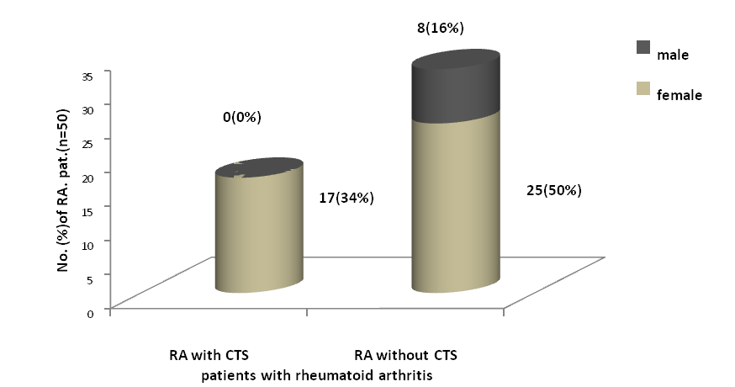Figure 1 Distribution of patients with rheumatoid arthritis (RA) with and without asymptomatic carpal tunnel syndrome (CTS) according to gender.

Regarding family history, only two patients with RA have had positive family history, one of them was female with positive bilateral CTS evident by NCS, the other one was male without asymptomatic CTS. The RA patients with carpal tunnel syndrome were 2 times as likely as those without CTS to have had positive family history (Table 1).
Patients with asymptomatic carpal tunnel syndrome were 3.208 , 3.7 and 3.261 times as likely as those without CTS to have had polyarticular involvement, joint swelling, deformity and movement restriction of the wrist joint, respectively. From clinical point of view, the mono and pauci-articular joint involvement were considered as one category (Table 1).

Table 1 Profile of rheumatoid arthritis patients with and without carpal tunnel syndrome evident by nerve conduction study.
Variable | Rheumatoid arthritis patients( n=50) |  | ªOR ^{b}(95% CI)
Variable | with CTS (n=17) | without (n=33) | ªOR ^{b}(95% CI)
Family history | 6% | 3% | 2 (0.117-34.069)
Polyarticular joint involvement | 11(65%) | 12(36%) | 3.208 (0.946-10.868)
Wrist swelling &deformity | 12(71%) | 13(39%) | 3.76 (1.054-12.96)
Wrist restriction movement | 15(88%) | 23(70%) | 3.26 (0.62-17)
-a=Odds Ratio b=95% Confidence Interval
-CTS= Carpal Tunnel Syndrome

Regarding the mean duration of rheumatoid arthritis (in months)there was no significant difference in both groups of patients (p>0.05).
There was a significant difference in the duration of morning stiffness which was significantly higher in patients with asymptomatic CTS (p<0.05). The duration of delay in the initiation of regular DMARD therapy (the period from disease onset to institution of DMARDs therapy, in months), was a significantly higher in patients with asymptomatic CTS than those without (p<0.01 ) (Table 2).

Table 2 Profile of Rheumatoid Arthritis patients with and without carpal tunnel syndrome evident by nerve conduction study
Variable | Rheumatoid arthritis patients( n=50)
Variable | with CTS (n=17) | without (n=33)
Duration of morning stiffness(minutes) | 108±12 | 62±11**
Duration of rheumatoid arthritis (month) | 120±26 | 89±13
Duration of delay in DMARD therapy(month) | 69.00±19.99 | 19.27±3.13 **
Values are mean ± standard error.
- * (P<0.05)
- ** (P<0.01)
-Values without (*) are insignificant (P>0.05)
- DMARD = Disease Modifying Anti-Rheumatic Drugs
-CTS Carpal Tunnel Syndrome

The severity of RA was divided into three categories according to Disease Activity Score-28 (DAS-28), these were mild, moderate and severe types. Of total patients, 15 patients were found to have mild disease, and 25 patients were found to have moderate RA, the remaining 10 patients were found to have severe form of the disease. Statistically, we considered the first and the second categories as one group (mild to moderate), because they have approximately the same treatment strategy. The results showed that patients with CTS are 4 times as likely as those without CTS to have had severe RA (Table 3) & (Figure 2).

Table 3 Frequency distribution of rheumatoid arthritis patients with and without asymptomatic carpal tunnel syndrome evident by nerve conduction study according to the severity of rheumatoid arthritis (DAS-28).
ªOR^{b} (95% CI) | Rheumatoid Arthritis  patients (n =50) |  |  | Variable
ªOR^{b} (95% CI) | Total | without | with CTS
4  (0.935-16.711) | 40(80%) | 29 (88%) | 11(65%) | Group 1 | severity of Rheumatoid Arthritis by DAS-28
4  (0.935-16.711) | 10 (20%) | 4 (12%) | 6 (35%) | Group 2 | severity of Rheumatoid Arthritis by DAS-28
4  (0.935-16.711) | 100% | 33(100%) | 17(100%) | Total (%) within Rheumatoid Arthritis
-a=Odds Ratio b=95% Confidence Interval
-Group 1:Mild & Moderate Rheumatoid Arthritis.
-Group 2: Severe Rheumatoid Arthritis
-DAS-28: Disease Activity Score-28
-CTS Carpal Tunnel Syndrome
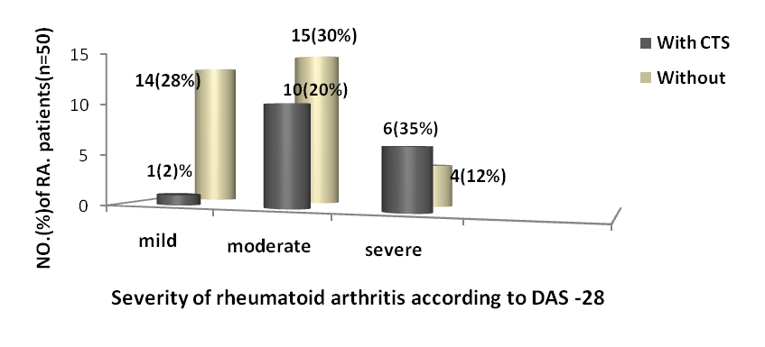
Figure 2 Frequency distribution of Rheumatoid arthritis(RA) patients with asymptomatic carpal tunnel syndrome(CTS) evident by nerve conduction study according to the severity of Rheumatoid arthritis according to DAS -28.

The results of current study showed that the frequency of bilateral CTS involvement was more common than unilateral involvement mainly in moderate and severe type (Figure 3&4).

Figure 3 Frequency and percentage of rheumatoid arthritis (RA) patients with asymptomatic carpal tunnel syndrome (CTS) evident by nerve conduction study (n=17) according to the sides affecting the median nerve
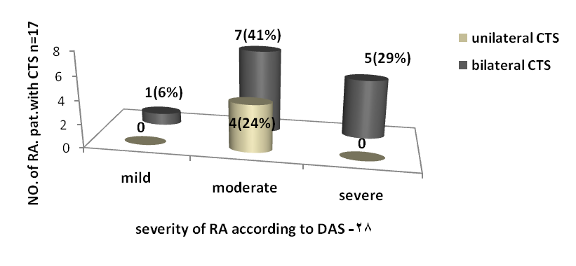
Figure 4 Frequency distribution of asymptomatic carpal tunnel syndrome(CTS) evident by nerve conduction study according to the sides affecting the median nerve in relation to the severity of rheumatoid arthritis (RA)

Regarding laboratory assessment the study showed that the mean ESR of patients with CTS was 59 ±6 in comparison to 41±4 (p <0.05) (Table 4).

Table 4 Distribution of Rheumatoid arthritis patients according to Erythrocyte sedimentation rate values
Variable | Rheumatoid arthritis patients( n=50)
Variable | with CTS (n=17) | without (n=33)
Erythrocyte sedimentation rate | 59±6 | 41±4*
-Values are mean ± standard error.
-* Significant difference at (p<0.05)
-CTS Carpal Tunnel Syndrome

In patients with CTS, positive C-Reactive protein (CRP), Rheumatoid Factor (RF) and Anti-Citrullinated Cyclic Peptide antibodies (Anti- CCP antibodies) were 3.692 , 3.453 , 2. 686 times as likely as those without CTS to have positive CRP ,RF, Anti-CCP, respectively.
Whereas RA patients with CTS are 9 times as likely as those without to have had bone erosion on plain radiographic study (Table 5) .
Radiological finding for bone erosion RA patients with CTS are 9 times as likely as those without to have had bone erosion on plain radiographic study (Table 5).

Table 5 Profile of Rheumatoid arthritis patients with and without asymptomatic carpal tunnel syndrome evident by nerve conduction study
Variable | Rheumatoid arthritis patients( n=50) |  |  | ªOR^{b}(95% CI)
Variable | with CTS(n=17) |  | without(n=33) | ªOR^{b}(95% CI)
C-Reactive  Protein |  | 12(71%) | 13(39%) | 3.69(1.05-12.95)
Rheumatoid Factor |  | 13(77%) | 16(52%) | 3.45(0.93-12.82)
Anti-CCP antibodies |  | 8(62%) | 7(41%) | 2.68(0.52-10.01)
Radiological for bone erosion |  | 15(88%) | 18(56%) | 9(1.76-45.78)
- a=Odds Ratio b= 95% Confidence Interval
-CTS =Carpal Tunnel Syndrome
-Anti- CCP = Anti-Citrullinated Cyclic Peptide anti-body

Electrophysiological changes:
patients had shown significant increase in latency and conduction velocity for sensory and motor nerves and no significant decrease in amplitude for sensory and motor nerves in RA patients with CTS than those without CTS and controls.
pathophysiologically carpal tunnel syndrome in RA usually is sensorimotor demylinating and/or axonopathy. According to the pathophysiology of RA patients with CTS by NCS (n=17), there was (6%) of them developed axonal neuropathy, (82%) had demyelinating neuropathy & the remaining (12%) had mixed demyelinating & axonal neuropathyas. (Figure 5).

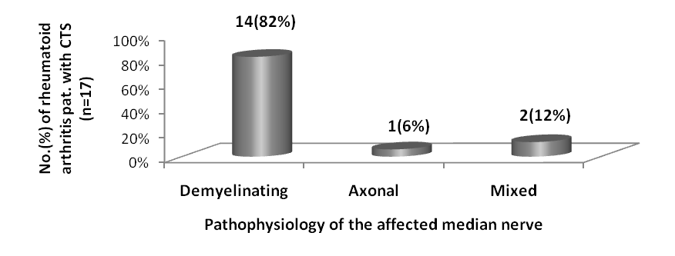
Figure 5 Frequency distribution of rheumatoid arthritis patients with carpal tunnel syndrome according to the pathophysiological process as recorded by nerve conduction study.

Discussion
On data bases the current study showed that the RA patients with asymptomatic CTS were exclusively females which represent (34%) of the study group (n=50).
Rheumatoid arthritis is one of many autoimmune diseases that is predominant in women, with female/male ratio of (2:1 to 3:1) [1,2,18]. Female gender may have an impact on symptoms and functional outcome of the disease [5,19]. Females tend to have more persistent synovitis and more progressively erosive disease than males. Estrogen can enhance production of TNF-α. However, the specific mechanisms responsible for increased susceptibility to RA in women are uncertain [4].Additionally idiopathic CTS is the most common form of peripheral nerve entrapment and is particularly prevalent in middle-aged women [20].Women between the age of 40 to 60 are the most frequent target [21-23] . Apart from the a significant differences between females and males regarding , duration of RA, duration of morning stiffness and delay in the initiation of DMARD therapy which were more in females, otherwise other parameters such as radiological and laboratory investigations were not significantly different. CTS frequency reported by some studies between 3.6-6% in RA patients [9]. In current study, the frequency of CTS in patients with RA was significantly high (34%). this finding was approximately constent with other studies[7,11,23,24]
Family history might predict the severity of established RA , with a greater prevalence of neurological complications in RA patients [4]. In the current study we found that the prevalence of CTS among RA patients with positive family history of RA were approximately 2 times as likely as those without. Severe RA is found approximately four times in first-degree relatives of individual with RA [25].
The study showed that severe RA is 4 times as likely as those with mild and/or moderate disease to have had CTS. This finding is consistent with other studies of Carl et al.,[24] and Karen and Sarah [25].
The frequency distribution of CTS among RA patients was approximately 3 times more in those with multiple joints involvement, (Table 2). The polyarticular involvement implies the presence of more aggressive disease with a greater likelihood of developing progressive joint abnormalities, disability and subsequent neurological complications in RA patients [24-26] .
The current study showed that, patients with joint swelling and deformity at wrist were approximately 4 times as likely as those without to have had CTS. The presence of joint swelling is indication of active synovitis, and joint deformity, decreased range of motion, malalignment, or frank dislocation is indication of joint damage [5,25]. The thick transverse carpal ligament provides significant resistance to decompression, however, the hyperplastic synovium at wrist joints can compress the median nerve and cause carpal tunnel syndrome, often bilaterally [9,27]. But some studies noted that not all cases with carpal tunnel syndrome were explained in view of mechanical compression of median nerve due to joint swelling and/or synovial proliferation [28,29]. Some patients with definite CTS had only minimal synovial swelling, and conversely some with gross synovial swelling had no evidence of median nerve compression [18], in such cases the CTS may best explained on bases of vascular neuropathy.[26] which may explain the presence of cases with bilateral CTS without joint swelling and deformity. When it involves the peripheral nerves, nerve function is impaired. In general, the rheumatoid vasculitis can cause a number of abnormalities in the peripheral nerves, among them is CTS [7]. However, it is often difficult to diagnose these slight or early neuropathies due to pain in the joints and limitation of movement or it can run in subclinical course or even asymptomatic. Nevertheless, it is often possible to show objectively the existence and distribution of even subclinical neuropathies by means of electrophysiological study [29].
Regarding duration of morning stiffness, it was higher in females with asymptomatic CTS than those without. Prolonged morning stiffness is one of the poor prognostic features and the duration is correlate with disease activity [4,5]. Clinically, synovial inflammation causes swelling, tenderness, and limitation of motion. Initially, impairment in physical function is caused by pain and inflammation, this is frequently early feature of aggressive RA and tenosynovitis in flexor tendon sheaths that enter the hand with median nerve under the flexor retinaculum at wrist during the early stages of the disease can compress the nerve and the prevalence of CTS in RA patients is related to the degree of local synovitis which clinically reflected by prolonged morning stiffness [24,25].
There was a significant difference between RA patients with CTS and those without regarding the length of interval between the onset of the disease and time of institution of DMARD therapy. Delaying therapy for as little as a few months after the onset of symptoms can result in worse outcomes in the long term [30]. This result may explain the high frequency of CTS in patients group. Therefore of considerable interest in establishing the most effective, aggressive therapy during earliest stages of the disease can lead to decrease disease activity and preventing joint damage and halting other systemic manifestation of the disease.[30,31] The cause of delay in the initiation of DMARD therapy may be due to the fact that commonest onset of RA is insidious one which usually misdiagnosed in early stages of the disease and because there is currently no laboratory test or single symptom of RA that can lead to a definitive diagnosis [1,2,31] .
Erythrocyte sedimentation rate (ESR) and C-reactive protein (CRP) are useful to help diagnoses and monitor the activity of RA [31]. The mean of ESR in patients with CTS was significantly higher than those without CTS.
Regarding C-reactive protein, the results showed that RA patients with positive CRP test are 3.692 times as likely as those with negative test to have had CTS. The elevated of acute phase reactants reflected the bulk of synovitis and the probable explanation is that a number of features are correlated with a greater likelihood of developing progressive joint damage ,and severity of RA and potentially poor prognosis with extra articular manifestations such as vasculitis [28,32,33].
The current study showed that RA patients with positive Rheumatoid Factor (RF) are 3.453 times as likely as those with negative test to have had CTS, and those with positive Anti-Citrullinated Cyclic Peptide antibodies (Anti- CCP) are 2. 686 times as likely as those with negative one to have had CTS . The presence of Anti-CCP and RF can be of prognostic significance, as the patients with high titers of Anti-CCP and RF tend to have more aggressive and severe progressive joint damage and poorer long-term function with extaarticular manifestations such as vasculitis which make an earlu institution of DMARDs therapy of highly importance [34-36].
Other parameter of disease severity is articular and bone erosion evident by plain radiograph. In the current study the RA patients with CTS are 9 times as likely as those without to have had bone erosion on plain radiographic study. Joint erosions and deformity is an excellent predictor of work disability [4]. Several features of patients with RA appear to have prognostic significance ,and one of these features is the presence of radiographic evidence of erosions at the time of initial evaluation indicates persistent synovitis, with subsequent compressive neuropathy [37]. Persistent elevation of acute-phase reactant and the presence of anti-CCP is most common in patients with aggressive disease, with a tendency for developing bone erosions[38].
Electrophysiological assessment: Electrodiagnostic tests included the conduction studies of median motor and sensory nerves across the carpal tunnel (amplitude, latency and velocity).
In current study and regarding motor part we found a significant increase of motor latency, and decrease of conduction velocity, and a non significant reduction regarding amplitude (CMAP), between RA patients with CTS and those without. Regarding sensory part there was a significant increase in sensory latency (DSL) and decrease of conduction velocity, and also there was a non significant reduction in amplitude (SNAP), between RA patients with CTS evident by NCS and those without.
From the electrophysiological point of view, it is known that slowing may be primarily due to a thinning of the myelin sheath and/or a decrease in the distance between the nodes of Ranvier. Both changes are consistent with damage to the median nerve due to local compression and/or vasculitis [39]. Small vessel vasculitis or occlusive vascular disease in the vasa nervorum was considered to be a cause of the nerve damage resulting in diffuse symmetrical peripheral neuropathy and mononeuritis multiplex manifested for example as a CTS [40].
The study of Choy and Panayi [41] and Mohammad et al. [11] reveals that CTS in RA usually is sensorimotor axonopathy. This statement was conflicting with that of our study because we found that most of RA patients with asymptomatic CTS were demyelinating sensorimotor neuropathy (76%), and (18%) were with mixed (demyelinating and axonal) neuropathy, and the remaining ( 6%) of them were axonal type (Figure 5). And the probable explanation for that is most of RA patients with CTS may be due to compressive neuropathy and not due to vasculopathy, or that most of those patients were with mild and /or moderate severity of CTS , and no reported cases of severe CTS according to NCS, which means that they not reach to the stage of axonal degeneration yet. This is consistent with the study of McCombe et al. [42], who stated that the patients who had evidence of vasculitis may have axonal neuropathy. This proposal was approximately had agreement by [43], who stated that demyelinating sensorimotor neuropathy occurs in the early phase of compressive neuropathy, and this consistent with our study as we found that there was no significant difference regarding amplitude both in motor and sensory study . Neurophysiologic studies in patients with CTS initially show slowing of sensory and motor nerve conductions in the median nerve at the wrist, due to the demyelination which occurs in the early phase of compressive neuropathy. Later in the course of the disease, when axonal damage and loss of nerve fibers have occurred, one can also observe a reduction in the amplitude of sensory and motor conductions [43].

Conclusion and Recommendation
Asymptomatic CTS is a common association in RA, mainly in active progressing disease with poor prognostic factors. NCS is essential study to detect subclinical or asymptomatic CTS in the course of RA.

References
(1) Doherty, M. and Ralston, S.H. Musculoskeletal disease ,Inflammatory joint disease: Davidson's, Principles and Practice of Medicine. Edited by Nicki, R. Colledge; Brian, R. Walker and Stuart, H. Ralston. 21th ed. Churchill Living Stone Elsevier 2010 p. 1088-1098.
(2) Peter E. Lipsky. Rheumatoid Arthritis: in Harrison Principles of Internal Medicine. Edited by:
Anthony S. Fauci, Dan L. Longo, Dennis L. Kasper, and Eugene Braunwald et al., (2008). Mc Grow Hill Medical. 7th ed. 2008. p. 2083.
(3)Majithia V. and Geraci, SA. Rheumatoid arthritis: diagnosis and management. Am. J. Med. 2007; 120 (11): 936–966.
(4) Edward D. Harris Jr.; Gary S. Firestein. part 9 – rheumatoid arthritis. Clinical Features of Rheumatoid Arthritis: in Kelley's, Textbook of Rheumatology. edited by: Gary S. Fire stein, Ralph C. Budd , Edward D. Harris Jr, Iain B. McInnes , Shaun Ruddy and John S. Sergent 8th ed. W. B. Saunders 2008.
(5) Jean-Marc Waldburger and Gary, S. Firestein .Rheumatoid arthritis, Epidemiology, Pathology, and Pathogenesis: Primer on Rheumatic Disease. Edited by: John, H. Klippel; John, H. Stone and Leslie, J. Crofford. 13th ed. Arthritis Foundation, 2007 p.114 -142.
(6)Daniel Bocches Nor, Jefferson Becker, Arthur Ehlers and Irenio Gomes. What symptoms are truly caused by median nerve compression in carpal tunnel syndrome? Clinical Neurophysiology 2005; 116: 275–283.

(7)Mehmet Ufuk, Aluclu Ayse, Dicle Turhanoglu and Mustafa Arif .The Frequency Of Carpal Tunnel syndrome in patients with rheumatoid arthritis. The Internet Journal of Neurology 2006; 45:122-129.
(8)Watts, A. C. and McEachan, J. Carpal tunnel syndrome in men. Current Orthopaedics 2006; 20: 294–298.
(9) Lanzillo B, Pappone N., Crisci C, di Girolamo C,Massini R, and Caruso G. Subclinical peripheral nerve involvement in patients with rheumatoid arthritis. Arthritis Rheum. 1998; 41(7): 1196-202.
(10)Shinoda J, Hashizume H. and McCown, C. et al. Carpal tunnel syndrome grading system in rheumatoid arthritis. J. Orthop. Sci. 2002; 7(2): 188-93.
(11) Mohammad Yazdchi; Ali Asghar Ebrahimi; Haleh Mikaeeli ; Mohammad Ali Aaami ; Reza Khandaghi, The Electrophysiological Evaluation of 70 Iranian Rheumatoid Arthritis Patients. J. Neuro. Sc. 2007; 24( 3): p. 190-196 .
(12) Prevoo, ML. ;Van tkoof, AA.; Van Leeuwen, KHH.; Van De putte and Van Riel . Modified disease activity score that include twenty-eight joints count: Development and validation and in prospective long standing of patients with rheumatoid arthritis. Arth. and Rheum. 1995. 38 (1):44-8
(13) Lewis, S. M.; Bain, B. J. & Bates, I . Dacei & Lewis practical hematology. 10th ed. Churchill Livingstone Elsevier. Germany. 2006.
(14) Chernecky CC. and Berger BJ. Laboratory Tests and Diagnostic Procedures, 5th ed. St. Louis: Saunders. 2008.
(15) Lee and Schur. Clinical utility of the anti-CCP assay in patient with rheumatic diseases .Ann. Rheum. Dis. 2003; 62 :870-874.
(16) Vossenaar, ER.; Van Venrooij, WJ. Anti-CCP antibodies, a highly specific marker for early Rheumatoid arthritis .Clinical and Applied Immunol. Rev. 2004; 4 : 239-262.
(17) Daniel W W. Biostatistics: A foundation for analysis in the health sciences. 7th ed. John Winey. Philadelphia. 1999. P. 55.
(18) Ahmadreza Afshar; Zahra Yekta; and Fardin Mirzatoluei. Clinical Course of the Non-OperateHand in Patients With Bilateral Idiopathic Carpal Tunnel Syndrome. J. of Clinical Neurophysiology 2007; 32A:1166–1170
(19) Bong Cheol Kwon; Kwang-Ik. Jung and Goo Hyun Baek. Comparison of Sonography and Electrodiagnostic Testing in the Diagnosis of Carpal Tunnel Syndrome: The American Society for Surgery of the Hand. 2007; 1006–1013
(20) Barnes, CG. and Currey, HL. Carpal tunnel syndrome in rheumatoid arthritis . A clinical and electrodiagnostic survey. bmj. Rev. 2010; 33 : 5-14.
(21)Kvien TK. Epidemiology and burden of illness of rheumatoid arthritis. Pharmacoeconomics 2004; 22(2):1-12.

(22) El Miedany, Y. M; Aty, S. A. and Ashour, S.: Ultrasonography versus nerve conduction study in patients with carpal tunnel syndrome: substantive or complementary tests? J. Neurol. Sci. 2004; P. 887-895.
(23)Jefferson Becker, Daniel, B. Nora, Irenio Gomes, Fernand, F. Stringari, Rafael Seitensus and Arthur C. Ehlers. An evaluation of gender, obesity, age and diabetes mellitus as risk factors for carpal tunnel syndrome Clinical Neurophysiology 2002; 113 ; 1429–1434
(24) Carl Turesson; Robynl; Teres Christianson, and Eric Matteson. The Swedish Rheumatism Association, and the Swedish Society for Medicine. Rheumatology. Rev. 2005;23; pa.43-48.
(25) Karen Walker-Bone and Sarah Farrow. Clinical evidence of Rheumatoid arthritis. J. Rheuma. 2005; 12: 6–7.
(26) Smith, JB. and Haynes, MK. Rheumatoid arthritis a molecular understanding. Ann. Intern. Med. 2002;136:908-22.
(27) Dimitrios Kostopoulos .Treatment of carpal tunnel syndrome: a review of the non-surgical approaches with emphasis in neural mobilization: J. Bodywork and Movement Therapies 2004;8: 2–8
(28) Rory O’Connor .Musculoskeletal Complications of Neurological Conditions in Rheumatoid Arthritis . Rev.2004; 33 : 5-15. BmJ.

(29) Kissel, JT. and Mendell, JR. Vasculitic neuropathy. Neurol Clin; 1992;10(3): 761 - 81.
(30) Chan, J. K. K.; Kennett, R. and Smith, G. (2008). Posterior interosseous nerve palsy in rheumatoid arthritis: case report and literature review, published online. Vol. 62, Issue 12, Pa. 556-560
(31) Christopher, V. Tehlirian and Joan, M. Bathon .Clini. and Lab. Manifestations: Primer on rheumatic disease, edited by John, H. Klippel; John, H. Stone and Leslie, J. Crofford. 13th ed. Springer Science and Business Media. Arthritis Foundation, 2007. (6):114 -142.
(32) Kroot, E.; van Gestel, A. and Swinkels, H. et al .Chronic comorbidity in patients with early rheumatoid arthritis: a descriptive study. J. Rheum.2001; 28(7):1511-1517 .
(33) Alyce, M. Oliver and William, ST. Clair. Treatment and Assessment: Primer on Rheumatic Disease, edited by John, H. Klippel; John, H. Stone and Leslie, J. Crofford. Springer Science and Business Media. Arthritis Foundation, 13th ed. 2007.Chapter (6) (6):114 -142.
(34) Luime, JJ. Colin, EM. Hazes, JM. Lubberts, E. Does anti-MCV has additional value as serological marker in the diagnostic and prognostic work-up of patients with rheumatoid arthritis? A systematic review. 2009; 69 (2): 337–44
(35) Daniel Aletaha; Neogi, T. and Silman, AJ. et al. rheumatoid arthritis classification criteria: an American College of Rheumatology/European League Against Rheumatism . Arthritis & Rheumatism. An Official Journal of the American College of Rheumatology Ann. Rheum. Dis. 2010; 62( 9): 2569–2581
(36) Giele, H. (2001) . Evidence-based treatment of carpal tunnel syndrome. Mini-Symposium : Nerve Compression Syndromes. Current Orthopaedics 2001;15: 249 - 255
(43) Nishimura, K.; Sugiyama, D. and Kogata, Y. et al. , Meta-analysis: diagnostic accuracy of anti-cyclic citrullinated peptide antibody and rheumatoid factor for rheumatoid arthritis. Ann. Intern. Med. 2007 ; 5;146(11):797-808.
(44)Waaler, E.: On the occurrence of a factor in human serum activating the specific agglutination of sheep blood corpuscles. Acta. Pathol. Microbiol. Scand. 2007; 17: 172–88.
(37) Perry, D.; Stewart, N. and Benton, N. et al. : Detection of erosions in the rheumatoid hand; a comparative study of multidetector computerized tomography versus magnetic resonance scanning. J. Rheuma. 2005; 32: 256–67.
(38) Goodson, N. ; Marks, J. and Lunt, M. et al. .Cardiovascular admissions and mortality in an inception cohort of patients with rheumatoid arthritis with onset in the 1980s and 1990s. Ann. Rheum. Dis. 2005; 64:1595–1601.
(39) Walsh, NC.; Crotti, TN.; Goldring, SR. and Gravallese, EM. Rheumatic Diseases . The effects of inflammation on bone. Immunol. Rev. 2005; 208: 228–251.
(40) Werner, RA. and Andary, M. . Carpal tunnel syndrome: pathophysiology and clinical neurophysiology. Clin. Neurophysiol. ; 2002;113 (9): 1373-81.
(41) Choy, EHS. And Panayi, GS.: Cytokine pathways and Joint inflammation in rheumatoid arthritis Eng. J. Med.2001; 344:907-916.
(42) McCombe, P.A.; Klestov, A.C.; Tannenberg, A.E.; Chalk, J.B. and Pender, M.P. Clinical and experimental neurology. sensorimotor peripheral neuropathy in Rheumatoid arthritis 1991. 28-53.
(43) Kimura, J. Electrodiagnosis in Diseases of Nerve and Muscle: Principles and Practice, 3rd ed. Oxford University Press. 2001

