Detection of ESBLs in Enteropathogenic E. coli (EPEC) Isolates Associated with Infantile Diarrhea in Kut City

Jinan A. Shamki Alaa H. Al-Charrakh Jawad K. Al-Khafaji
Dept. of Microbiology, College of Medicine, University of Babylon, Hilla, Iraq

M J B

Abstract
A total of 325 fecal specimens were collected from children with diarrhea. 28 E. coli isolates (8.6%) were recovered and serotypically identified as EPEC. Results found that the highest numbers of the EPEC isolates were belonging to polyvalent I, with the following serotypes, O111: k58(B4) (54%), O55:k59(B5) (14%).
The antibiotic susceptibility phenotypes of the EPEC isolates were also determined. All isolates (100%) were multi-drug resistants. None of the isolates were found to be resistant to imipenem. All isolates have been found resistant to at least one β-lactam antibiotic and 27 isolates (96.4%) were able to produce extended-spectrum β-lactamases (ESBLs). This study showed that the prevalence of ESBL among EPEC producers is higher than previous studies in Iraq.
Key words: Enteropathogenic E. coli (EPEC), Prevalence, Detection, ESBLs .
الخلاصة
تضمنت هذه الدراسة 325 عينة خروج جمعت من اطفال مصابين بالاسهال. تم الحصول على 28 عزلة عائدة للبكتريا المعوية وبنسبة 8.6% من العينات وشخصت مصليا على انها عائدة للبكتريا المعوية الممرضة. أظهرت النتائج أن أعلى نسبة من العزلات كانت عائدة الى المتعدد المصلى І. تم تحديد الانماط المظهرية للحساسية لعدد من المضادات الحياتية ووجد ان جميع العزلات اظهرت نمط المقاومة المتعدد غير انها كانت جميعها حساسة لقار الاميبينيم. وجد ايضا ان جميع العزلات كانت كانت مقاومة على الاقل لاحد المضادات الحياتية التابعة لمجموعة البيتالاكتام وان 27 منها كانت منتجة لانزيمات البيتالاكتاميز واسعة الطيف . وقد اظهرت هذه الدراسة ان انتاج انزيمات البيتالاكتاميز واسعة الطيف في هذه العزلات كان بنسبة أعلى مما هو مدون في الدراسات السابقة في العراق.
ــــــــــــــــــــــــــــــــــــــــــــــــــــــــــــــــــــــــــــــــــــــــــــــــــــــــــــــــــــــــــــــــــــــــــــــــــــــــــــــــــــــــــــــــــــــــــــــــــــــــــــــــــــــــــــــــــــــــــــــــــــــــــــــــــــــــــــــــــــــــــــــــــــــــــــــــــــــــــــــــــــــــــــــــــــــــــــــــــــــــــــــــــــــــــــــــــــــــــــــــــــــــــــــــــــــــــــــــــــــــــــــــــــــــــــــــــــــــــــــــــــــــــــــــــــــــــــــــــــــــــــــــــــــــــــــــــــــــــــــــــــــــــــــــــــــ

Introduction
Infantile diarrhea is one of the important illnesses with high morbidity and mortality in children. It is caused by a wide range of microbial agents including viruses, bacteria and parasites. Among the bacterial pathogens, diarrheagenic E. coli is the most [1]. There are at least six established or putative categories of diarrheagenic E. coli (DEC): enteropathogenic E. coli (EPEC), enterohemorragic E. coli (EHEC), enterotoxigenic E. coli (ETEC), enteroinvasive E. coli (EIEC), enteroaggregative E. coli (EAEC), and diffusely adhering E. coli (DAEC) [2].
The central mechanism of EPEC pathogenesis is a lesion called 'attaching and effacing' (A/E), which is characterized by adherence of bacteria to the intestinal epithelium. The eae gene, which is located in the ' locus of enterocyte effacement' (LEE) pathogenecity island, and the bfpA gene, located on a plasmid called the EPEC adherence factor (EAF), have both been used for identification of EPEC and for subdivision of this group of bacteria into typical and atypical strains [3].
Although large outbreaks of infant diarrhea due to EPEC have largely disappeared from industrialized countries, EPEC remains an important cause of potentially fatal infant diarrhea in developing countries [4]. EPEC strains were defined as intimin – containing diarrheagenic E. coli (DEC) isolates that posses the ability to form A/E lesions on intestinal cells and do not posses shiga toxin (stx) genes [5].
EPEC resistance to antibiotics is a growing problem [6]. During the last 2 decades, extended-spectrum β-lactamases (ESBLs) found in Gram-negative bacilli have emerged as a significant mechanism of resistance to oxyimino-cephalosporin antibiotics [7]. Organisms producing ESBLs are clinically relevant and remain an important cause for failure of therapy with cephalosporins [8].
In Iraq, so far little information are available on the prevalence of EPEC infection. However, in Kut city, Iraq, there is neither serotyping identification nor categorization of EPEC associated with diarrhea in children younger than two years of age, in addition there is no information regarding the occurrence of ESBL- producing EPEC isolates. Therefore, there is an increasing demand to investigate the role of EPEC in diarrhea in children and identify the prevalence of ESBL production among these isolates. The aim of this study was to investigate the occurrence of EPEC as a cause of infectious diarrhea in children younger than 2 years of age, determine their antibiotic susceptibility, and characterize their ability to produce ESBLs.

Materials and Methods
Patients and Samples collection: A total of 325 stool specimens were collected from children younger than two years suffering from watery diarrhea. Of 325 patients, 167 females, and 158 males were involved in this study. They were admitted to three main hospitals in Kut city, during a period of three months (from November 2010 to January 2011). Fecal specimens were collected from each patient and plated onto MacConkey agar and incubated aerobically at 37 °C overnight. The bacterial isolates were preserved in brain heart infusion broth supplemented with 15% glycerol at -20 ºC for 6-8 months.
Identification of isolates: Isolates were identified to the species level based on the standard biochemical and microbiological methods [9]. The identification was confirmed using Api 20E strips (Biomérieux, France).
Serological examination and confirmatory tests for EPEC
The E. coli positive cultures were set for serological test, by slide agglutination test, according to BioRad procedures, using EPEC polyvalent O antisera for EPEC, (I, II, III, and IV) separately. From the colony which showed a positive reaction with polyvalent antisera, a subculture was prepared and the isolates were retested using EPEC monovalent O:K antisera (Tabel-1). A slide agglutination test was performed on a small amount of bacterial mass from colony of a pure culture transferred onto a glass slide containing two separated drops (50µl each) of saline. The bacterial mass under test was emulsified with a loop in each drop of saline to give a smooth, fairly dense bacterial suspension. An aliquot of (50 µl) of saline was added to one bacterial suspension and mix as a control, to other bacterial suspension another (50 µl) undiluted antiserum was added and mixed. The slide was rocked for one minute. The results were read with the naked eye by holding the slide against a dark background using indirect light source while swaying the slide (tilting it back and forth). Positive results performed by seeing a strong and clearly visible aggregation within one minute with no visible aggregation in control suspension.

Table 1 Agglutinating antisera

Monovalent | Polyvalent
E.coli type O26:K60(B6) | Anti-coli Polyvalent I
E.coli type O55:K59(B5) | Anti-coli Polyvalent I
E.coli type O111:K58(B4) | Anti-coli Polyvalent I
E.coli type O86:K61 (B7) | Anti-coli Polyvalent II
E.coli type O119:K69 (B14) | Anti-coli Polyvalent II
E.coli type O127:K63(B8) | Anti-coli Polyvalent II
E.coli type O125:K70(B15) | Anti-coli Polyvalent III
E.coli type O126:K71(B16) | Anti-coli Polyvalent III
E.coli type O128:K67(B12) | Anti-coli Polyvalent III
E.coli type O114:K90(B) | Anti-coli Polyvalent IV
E.coli type O142:K86(B) | Anti-coli Polyvalent IV
E.coli type O124:K72(B17) | Anti-coli Polyvalent IV

Antimicrobial susceptibility testing:
Susceptibility to some antimicrobial agents for all EPEC isolates was determined by the standard disk diffusion method on Muller-Hinton agar (Oxoid, UK) incubated for 18 hours at 37 ºC. The selection of antibiotic discs was performed according to the guidelines recommended by the Clinical and Laboratory Standards Institute (CLSI, 2010). The following antibiotic disks (Bioanalyse/ Turkey) were used, Ampicillin (10μg), Amoxicillin-Clavulanic acid (30µg), Carbenicillin (100µg), Aztreonam (30µg), Imipenem (10µg), Cephalothin (30µg), Cefamandol (30µg), Cefotaxime (30µg), Ceftazidime (30µg), Cephoxitin (30µg), Cefipim (30µg), Cefixim (5µg), Gentamycin (10µg), Amikacin (30µg), Streptomycin (10µg), Tetracycline (30µg), Ciproflaxacin (5µg), Naldixic acid (30µg), Chloramphenicol (30µg), Co-trimexazol (25µg). After incubation, the diameter of each inhibition zone was measured with a pair of calipers, and recorded in mm. The results then interpreted according to CLSI documentation [10]. Escherichia coli ATCC 25922 was used as negative control (obtained from American Type Culture Collection, USA).
ESBL screening and confirmation by phenotypic methods
The isolates showing resistance to one or more 3rd generation cephalosporins (3GCs) (i.e. cefotaxime and ceftazidime) were tested for ESBL production by Double Disc Synergy Test (DDST) according to CLSI guidelines [10], using four discs cefotaxime (CTX) (30 mg) cefotaxime + clavulanic acid (10 mg), cefatzidime (CAZ) (30 mg), and ceftazidime +clavulanic acid (10 mg). The inoculum and incubation conditions were same as for standard disk diffusion recommendations. A >5 mm increase in zone diameter for either antimicrobial agent tested in combination with clavulanic acid versus its zone when tested alone was designated as ESBL positive.

Results and Discussion
Study population
In the present study, a total of 325 fecal specimens were collected from children with diarrhea from three hospitals in Al- Kut city. It was observed that the number of patients was higher in females 167 (51.38%) compared to males 158 (48.61%).
Higher infection of diarrhea was recorded at age group 7 to 12 months (46.15%) followed by age group since birth up to 6 months (42.77%), while the lowest age group with diarrheic patients was 19 to 24 months (3.4%).
The high infection of diarrhea was recorded in two age groups from birth to 6 months and from 7 to 12 months as they are most groups prone to this disease. The reason of higher infection in these two groups of infants may be due to low immunity, as the amount of tranceplantal antibodies of the child starts dwindling after 6 months of age. Those infants also may not have been breast-fed but bottle- fed instead, which is a source of infection and contamination. This becomes a matter of public health importance because such children may serve as a source of infection in the community. With the time, the child is exposed to pathogens and gets gradual resistance against infection.
The number of E. coli isolates from 325 stool specimens was 145 (44.62%), while E. coli was not detected in 180 (55.38%). The absence of E. coli in high percent due to either the most patients exclusively in this study received antibiotics before admission to hospital or the disease caused by other diarrheal microbial agents.
Detection of EPEC serotypes
In the present study, biochemical characteristics of the E .coli isolates showed that they behaved as typical E. coli when they screened serologically. Out of 145 E. coli isolates recovered from 325 children with diarrhea, only 28 (8.62%) were agglutinated with EPEC polyvalent antisera.
The percentage of infection (8.62%) by EPEC isolates in the present study was higher than that reported by other researchers in Iraq [11, 12] who reported that they isolated these bacteria in less frequency (2.1% and 3.4% respectively) in diarrhea cases of infant patients in Najaf. Alternatively, this increase in distribution of EPEC in the present study might be attributed to decrease in hygiene level in area of the study due to tragedic situation in Iraq due to terrorism, which leads to large numbers of emigrates from different provinces to this safer area of Iraq.
Present study revealed that infection with EPEC was relatively similar to studies conducted in Tehran, Iran (8.4%) [13], and in Kuwait (8.4%) [14] but it was higher than several studies conducted in different countries; Thailand (5.5%) [15], and Western Amazon region (6.1%) [16].
The reservoir of EPEC infection is thought to be symptomatic or asymptomatic children and asymptomatic adult carriers including mothers and persons who handle infants. Numerous studies have documented the spread of infection through hospitals, nurseries and day care centers from an index case [17].
The highest number of EPEC isolated belonged to polyvalent I serogroup with following serotypes O111:K58(B4) (54%) and O55:K59(B5) (14%). The present study found that O111:K58(B4) was the most prevalent EPEC isolates 15 (54%), that represented (4.6%) of all cases of diarrhea in area of study. In previous results conducted by [11] show that the O111:K58 (B4) was the most prevalent EPEC serotype (37.5%) isolated from patients with diarrhea in Najaf. However, the present results were higher than that found in in Bosnia and Herzegovina (2.3%) [17] and in Tehran, Iran (4.7%) [18].
Enteropathogenic E. coli O55:K59(B5) was the second most common serotype isolates that were detected in 4 (14%) of the 28 EPEC isolates, constituting (4.3%) of all diarrheal cases in area of study. However, present results were lower than that conducted in Najaf, Iraq (22.7%) (Al-Hilali, 2010). In agreement with this result, the serotype O55 in South Africa represent 13% [19].
Enteropathogenic E. coli O86:K61(B7) was the third most common serotype isolates that are detected in 3 cases (11%) of the 28 EPEC isolates, constituting (0.9%) of all diarrheal cases in area of study. Present results are lower than to the former results in Bosnia and Herzegovina (21.7%) [17].
Enteropathogenic E. coli O125:K70 and O128:K67 were less common serotype isolates that were each one detected in 2 cases (7%) of the 28 EPEC isolates, constituting (0.6%) of all diarrheal cases in the area of this study. However, these results are similar to the findings obtained in Bosnia and Herzegovina (5.8% and 7.0% respectively) [17].

Table 1 Serotyping identification of EPEC isolated from infant patients with diarrhea in Kut city.
E. coli isolates | Sex | Age/ month | Polyvalent | Monovalent
E. coli S1 | M | 10 | II | O86:K61
E. coli S2 | M | 14 | II | O86:K61
E. coli S3 | F | 2 | I | O111:K58
E. coli S4 | M | 7 | I | O111:K58
E. coli S5 | M | 4 | I | O111:K58
E. coli S6 | M | 8 | I | O111:K58
E. coli S7 | M | 12 | I | O111:K58
E. coli S8 | M | 6 | I | O111:K58
E. coli S9 | F | 10 | I | O55:K59
E. coli S10 | M | 11 | I | O111:K58
E. coli S11 | F | 3 | I | O111:K58
E. coli S12 | F | 3 | I | O111:K58
E. coli S13 | M | 4 | III | O125:K70
E. coli S14 | F | 4 | I | O111:K58
E. coli S15 | F | 8 | I | O111:K58
E. coli S16 | M | 12 | I | O111:K58
E. coli S17 | M | 7 | I | O111:K58
E. coli S18 | F | 3 | IV | O142:K86
E. coli S19 | M | 20 days | I | O55:K59
E. coli S20 | M | 6 | I | O111:K58
E. coli S21 | F | 7 | III | O128:K67
E. coli S22 | F | 7 | I | O111:K58
E. coli S23 | M | 2 | III | O125:K70
E. coli S24 | M | 5 | III | O128:K67
E. coli S25 | M | 3 | I | O55:K59
E. coli S26 | F | 9 | IV | O114:K90
E. coli S27 | M | 5 | II | O86:K61
E. coli S28 | F | 24 | I | O55:K59

The remaining EPEC isolates identified in this study were found to be belonged O114 and O142, each one detected in 1 case (3.5%) of the 28 EPEC isolates, constituting (0.3%) of all diarrheal cases in area of study. These results are disagreement with former study in South Africa (6.5% and 8.1% respectively) [19].
Antibiotics Resistance of EPEC isolates
In the present study, the isolates belonging to EPEC serotypes were tested by diffusion disk, and were interpreted according to Clinical Laboratory Standards Institute guidelines [10], as susceptible, intermediate, and resistant. Out of 28 EPEC isolates, 27 isolates (96.4%) were resistant to at least 12 antibiotics. However, only one isolate (3.6%) was resistant to 10 antibiotics (Fig: 1). According to these results, all EPEC isolates showed high resistance (100%) to most antibiotics tested and they also were multi-drug resistant.
A strain of EPEC is considered as a multi-drug resistant if it was non susceptible to at least three families of antibiotics [20]. However, these results were close to former studies in Iraq. Al-Hilali [12] reported that 90.9% of EPEC isolates in Najaf were multi-drug resistants and Al-Hilli [21] found that all E. coli isolates obtained from Merjan teaching hospital in Hilla, Iraq, were considered as multi-drug resistant.
The continuous used of even a single antibiotic over a period of weeks or months will select bacteria resistant to different kind of antibiotics in addition to the one in use [22]. The usage of antibiotics without antibiotics sensitivity testing, is the most important factor promoting the emergence of multi-drug resistance which lead to selection and dissemination of antibiotic resistant pathogens in clinical medicine [23].
In the present study, all 28 isolates showed 100% resistance to Carbenicillin, Pipracillin, and first and second generation of Cephalosporins (Cephalothin and Cefamandol respectively) (Fig: 1). This results were closely to former study conducted by Al-Hilali [12] in Najaf, who recorded high rates of resistance to Carpenicillin (90.9%) and Pipracillin (86.4%).
All 28 isolates showed 100% resistance to Ampicillin, present study results were higher than former results conducted by El-Metwally et al. [20] in Egypt, who found that the resistance of Ampicillin was 76% and in Kuwait by Albert et al.[14] who found that resistance to Ampicillin was 45.9%.
Antibiotic susceptibility testing of isolates revealed high rate of resistance to 3rd generation cephalosporin including Ceftazidime (89.3%), Cefotaxime (96.4%). These results were higher than former results obtained by Al-Hilali [12] in Najaf, who found that the resistance to Ceftazidime and Cefotaxime was (72.7%) and (68.2%) respectively.
However, it might be possible that this high level of 3rd generation cephalosporin in present study was most probably due to acquisition of β-lactamase which encodes by bla genes by these isolates, possibly during therapy.

Figure 1 antibiotic resistance of 28 EPEC isolates to different antibiotics
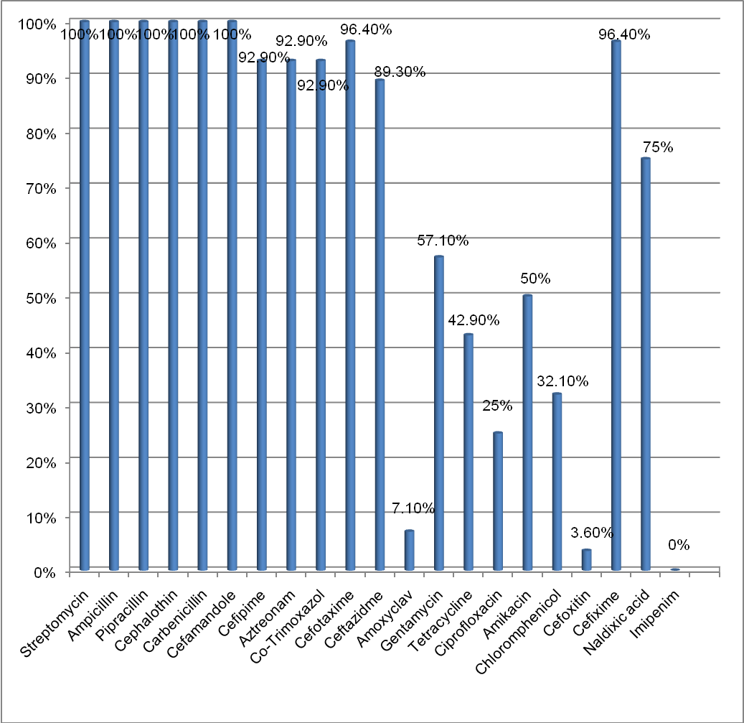

Results of this study revealed low frequency of resistance to Cefoxitin (3.57%) (Fig: 1) which was very low in contrast to previous study conducted by Al-Hilali [12] in Najaf, who found that resistance to Cefoxitin was 90.9%. High susceptibility to Cefoxitin in E. coli may be an indicator to AmpC inactivity.
In present study, resistance to Amoxyclav (Augmentin) was 7.1%, this result disagreed with Al-Hilali [12] who recorded high resistance to Amoxiclav (86.4%). The reason of high susceptibility to Amoxiclav might be due to the strong action of Clavulanic acid by inhibiting β-lactamase enzyme.
High rates of resistance were recorded for 4th generation cephalosporin, Cefipime (92.85%); Aztreonam (92.85%); Methoprim- Trimoxazole (92.85%) and Cefixime (96.4%). In local study, in Najaf by Al-Hilali [12], the rates of resistance to Cefipime, Aztreonam and Trimethoprim were 77.3% , 59.1% and 72.7% respectively.
Results also found that, all 28 EPEC isolates showed 100% resistance to Streptomycin, while resistance to Amikacin and Gentamycin was detected in 50% and 57.14% isolates respectively (Fig: 1). The rates of amino glycosides resistance described in present study disagree with those reported by Al-Mohana [11] in Najaf, Al-Hilli [21] in Hilla, Al-Hilali [12] in Najaf, found that vast majority of E. coli were susceptible to Amikacin.
The rates of resistance to quinolones (Naldixic acid) and fluoroquinolones (Ciprofloxacin) were detected in 75% and 25% isolates respectively (Fig: 1). These results disagreed with previous study in Najaf conducted by Al-Hilali [12], who found all isolates of EPEC were sensitive to Ciprofloxacin. However, Ciprofloxacin and other quinolones are not approved for children because of the risk of damage to immature joints [24].
In agreement with Hadi [25], Al-Hilli [21] and Al-Hilali [12] in Iraq, this study demonstrated that all (100%) EPEC isolates were susceptible to Imipenem (Fig: 1). The high efficiency of these antibiotics may be the usage rarely in studied area and it is expensive drug.
The last two antibiotics that were used in this study Tetracycline and Chloromphenicol, which showed the resistant about 42.85% and 32.14% respectively (Fig: 1). Present results were relatively closer to previous studies in Najaf by Al-Hilali [12], found that the resistance of Tetracycline was 50% and in Kuwait by Albert et al. [14], found the resistance to Tetracycline was 40.5%.
The reason of high resistance of antibiotics in area of study might be to the overuse and misuse of antibiotics in the treatment of diarrhea could lead to an increase of antibiotic resistance
Production of extended spectrum β-lactamases
In this study, the 28 EPEC were further characterized for their ESBL_{S} production. Initial screening for reduced susceptibility to Cefotaxime, Ceftazidime and Aztreonam was done by the standard disc diffusion method. The results of susceptibility to these antibiotic were as follows:
Cefotaxime 27(96.4%), Ceftazidime 25(89.3%) and Aztreonam 26 (92.85%) (Fig: 1).The high rates of resistance might be as markers for the production of ESBL_{S} by these isolates. However, there are very few reports of ESBL production by diarrheagenic E. coli [14, 26].
In studied area, children with diarrhea might be treated with 3rd generation cephalosporin in view of the fact that the majority of EPEC isolates in this study were resistance to the third generation cephalosporins.
The Phenotypic Disc Confirmatory Test (PDCT)
In present study, 27 out of 28 isolates (96.4%) were found to be ESBL producers (Fig: 2). This study showed prevalence of ESBL producers higher than previous studies in Iraq, Al-Hilali [12] found only 13.63% (3 of 22 EPEC isolates) were ESBL producers in Najaf. In this study, using of PDCT result on this method is technically simple and inexpensive.

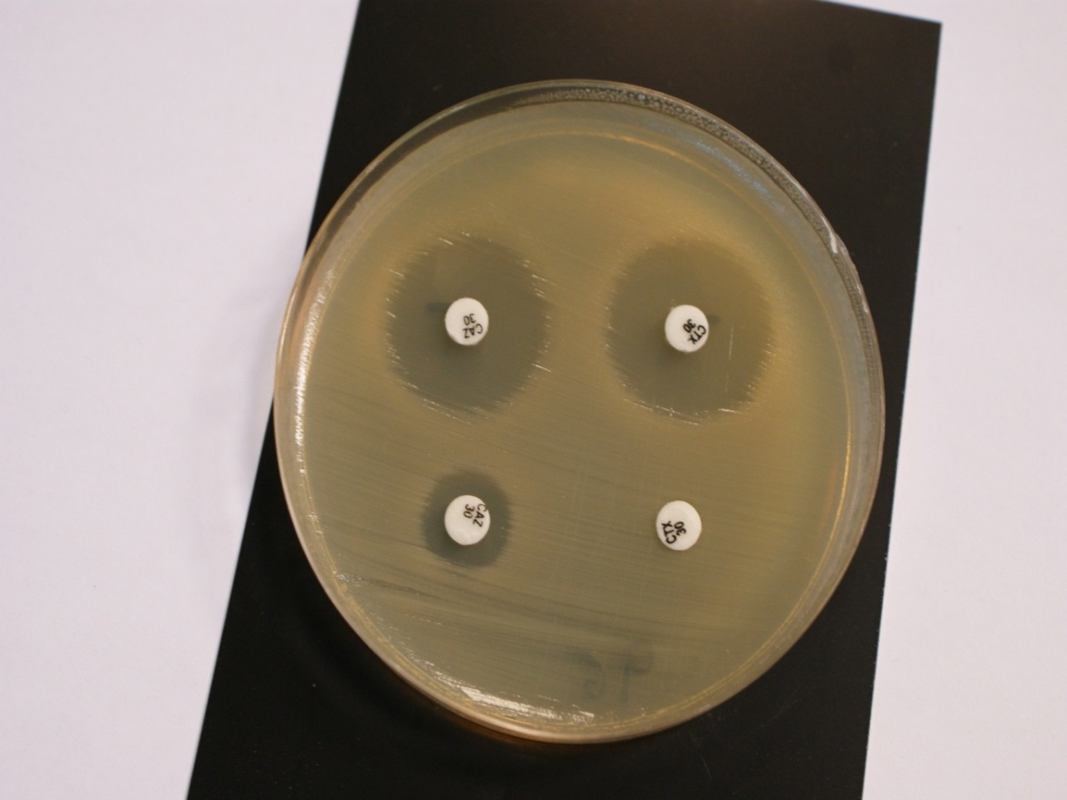
Figure 2 ESBL positive detection by phenotypic disc confirmatory test. CAZ and CTX above containing Clavulanic acid , CAZ and CTX below without.

References
- Asadi, K. M.; Bouzari, S.; Oloomi, M.; Aslani, M.M. and Jafari,A.(2010): Phenotypic and Genotypic characterization of enteropathogenic Escherichia coli (EPEC) strains in Tehran, Iran. Iranian J. Microbiol. 2(1):3-7.
- Ghilardi, A. C. R., Gomes, T.A.T., and Trabulsi, L. R. 2001. Production of Cytolethal Distending toxin and other virulence characteristics of Escherichia coli strains of serogroup O86. Mem. Inst. Oswaldo Cruz, Rio de Janeiro., 96(5):703-708.
- Afset, J. E., Bergh, K. and Benvager, L. 2003. High prevalence of atypical enteropathogenic Escherichia coli (EPEC) in Norwegian children with diarrhea.J. Med. Microbiol., 52: 1015-1019.
- Trabulsi, L.R., Keller, R. and Tardelli Gomes, T.A. 2002. Typical and atypical enteropathogenic Escherichia coli. Emerg. Infect. Dis.,8: 508-513.
- Kaper, J. B. 1996. Defining EPEC. Rev. Microbiol., 27: 130-133.
- Karami, N. and Hannoun, C. 2008. Colonization dynamics of Ampicillin-resistant Escherichia coli in the infantile colonic microbiota. J. Antimicrob. Chemother., 62: 703–708.
- Paterson, D. L., Hujer, K. M., Hujer, A. M., Yeiser, B., Bonomo, M. D. Rice, L. B., Bonomo, R. A. and the International Klebsiella Study Group. 2003. Extended-spectrum β-lactamases in Klebsiella pneumoniae bloodstream isolates from seven countries: Dominance and widespread prevalence of SHV- and CTX-M-type β-lactamases. Antimicrob. Agents Chemother., 47(11): 3554-3560.
- Pitout, J. D. D., Nordmann, P., Laupland. K. B., and Poirel, L. 2005. Emergence of Enterobacteriaceae producing extended-spectrum β-lactamases (ESBLs) in the community. J. Antimicrob. Chemother., 56: 52–59.
- MacFaddin, J. F. (2000): Biochemical Tests For Identification of Medical Bacteria. 3rd Edition. Lippincott Williams and Williams, USA.
- Clinical and Laboratory Standards Institute (CLSI, formerly NCCLS)(2010): Performance standards for antimicrobial susceptibility testing, Seventeenth informational supplement. 27 (1).
- Almohana, A. M. (2004): Prevalence and characterization of verotoxin producing Escherichia coli isolated from patients with diarrhea in Baghdad and Najaf. Ph.D. Thesis. Al-Mustansiryia University.
- Al-Hilali, S. A. M. (2010): Occurrence and Molecular characterization of Enteropathogenic Escherichia coli (EPEC) Serotypes isolated from children with diarrhea in Najaf. M. Sc. Thesis. University of Kufa, College of Medicine.
- Jafari, F.; Shokrzadeh, L.; Hamidian, M.; Ahrabi, S. S. and Zali, M. (2008): Acute diarrhea due to enteropathogenic bacteria in patients at hospitals in Tehran. Jpn. J. Infect. Dis. 61: 269-273.
- Albert, M. J.; Rotimi, V. O.; Dhar, R.; Silpikurian, S.; Pacsa, A. S.; Molla, A. M. and Szucs, G. (2009): Diarrheagenic Escherichia coli are not a significant cause of diarrhea in hospitalized children in Kuwait. BMC Microbiol. 9: 62-67.
- Echeverria, P.; Orskov, F. and Orskov, I.; Knotton, S.; Scheutz, F.; Brown, J. E. and Lexomboon, U. (1991): Attaching and effacing enteropathogenic Escherichia coli as a cause of infantile diarrhea in Bangkok. J. Infect. Dis. 164: 550-554.
- Orlandi, P.; Magalhães, G.; Matos, N.; Silva, T.; Penatti, M.; Nogueira, P. and da Silva L. (2006): Etiology of diarrheal infections in children of Porto Velho (Rondonia, Western Amazon region, Brazil) Braz. J. Med. Bio. Res. 39(4): 507-517
- Dedeić- Ljubović, A.; Hukić, M., Bekić, D. and Zvizdić A. 2009. Frequency and distribution of diarrhoeagenic Escherichia coli strains isolated from pediatric patients with diarrhoea in Bosnia and Herzegovina. Bosnian J. Basic Med. Sciences, 9 (2): 149-155.
- Aslani, M. M. and Alikhani M.Y. (2009): Serotypes of Enteropathogenic Escherichia coli isolated from children under 5 years of age. Iranian J. publ. Health, 38(3): 70-77.
- Galane, P. M. and Roux, M. L. (2001): Molecular epidemiology of Escherichia coli isolated from young South African children with diarrhoeal diseases. J. Health popul. Nutr. Mar. 19(1): 31-38.
- El Metwally, H. A. R.; Ibrahim, H. A. H.; El-Atharnm, M. N. and Arner, M. A. (2007): Multiplex PCR for detection of diarrheagenic Escherichia coli in Egyptian children. J. Med. Sci. 7(2): 255-262 .
- Al-Hilli, Z. B. (2010): Dissemination of β-lactamases in Escherichia coli and Klebsiella spp. isolated from Merjan teaching hospital in Hilla city. M. Sc.Thesis. Kufa University, College of Science.
- Livermore, D. M. (2007): Introduction, the challenge of multi resistance. Int. J. Antimicrob. Agents, 29(3): S1-7.
- Neu, H. C. (1992): The crisis in antibiotic resistance. Sci. 257: 1064-1073.
- Estrada-Garcia, T.; Cerna, J. F.; Paheco-Gil. L.; Velazquez, R. F.; Ochoa, T. J.; Torres, J. and DuPont, H. L. (2005): Drug- resistant Diarrheagenic Escherichia coli, Mexico. Emerg. Infect. Dis. 11(8): 1306-1308.
- Hadi, Z. J. (2008): Detection of extended-spectrum beta-lactamases of Escherichia coli and Klebsiella spp. isolated from patients with significant bacteriuria in Najaf. M. Sc. Thesis. College of Medicine. Kufa University.
- Sonnevend, A.; Al Dhaheri, K.; Mag, T.; Herpay, M.; Kolodziejek, J.; Nowotny, N.; Usmani, A.; Sheikh, F. and Pal, T. (2006). CTX M-15-producing multidrug-resistant enteroaggregative Escherichia coli in the United Arab Emirates. Clin. Microbiol. Infect. 12: 582-585.

