Role of Adenovirus and Immune System in Chronic Tonsillitis

Mohammed A. Muhsin Zainab Waddah Naser Kermash
College of Medicine, University of Babylon, Hilla, Iraq.

M J B

Abstract
The present study included 89 human tonsil biopsies and blood samples collected from patients suffering from chronic tonsillitis who had attended Hilla General Teaching Hospital during the period from October 2010 to January 2011.The age of the patients ranged from (2 to 37 years). Eleven normal un infected people blood sample were taken as control matching of the age groups. The tonsil biopsies were immediately dipped in 10 % formalin.
The results of this study revealed; that the highest IgG titer (3.0) as detected by ELISA was seen in ages (2 -11) years. The titer was decreasing with increasing of age reaching the lowest IgG titer (1.029) in ages (12-37) years. However, there were many episodes of rise due to recurrent infection with adenovirus. Blood flim test was revealed the lymphocytes from patients suffering from chronic tonsillitis show increase in cytoplasm of the cell and were higher in number than control(un infected people).
الخلاصة
هذه الدراسة تضمنت 89 مقطع نسيجي للوزتين وعينات دم جمعت من مرضى يعانون من التهاب اللوزتين المزمن الداخلين من مستشفى الحلة التعليمي العام خلال الفترة من تشرين الاول 2010 الى كانون الثاني 2011. اعمار المرضى تتراوح مابين (2-37) سنة. احد عشر عينة دم كانت ماخوذة من اشخاص غير مصابين كمجاراة سيطرة للمجاميع العمرية العينات النسيجية للوزتين حفضت مباشرة في 10% فورمالين .
نتائج هذه الدراسة بينت ان اعلى عيارية IgG كانت في الأعمار المتراوحة مابين (2-11) سنة. وان المعيارية تقل بإزدياد العمر حتى تصل الى اقل معيارية IgG البالغة 1.029 في الاعمار المتراوحة مابين (12-37).اختبار فلم الدم اظهر الخلايا اللمفاوية من مرضى يعانون من التهاب اللوزتين الزمن يلاحظ زيادة في السايتوبلازم للخلية وكانت اعلى في العدد من السيطرة) الناس غير المصابين(
ـــــــــــــــــــــــــــــــــــــــــــــــــــــــــــــــــــــــــــــــــــــــــــــــــــــــــــــــــــــــــــــــــــــــــــــــــــــــــــــــــــــــــــــــــــــــــــــــــــــــــــــــــــــــــــــــــــــــــــــــــــــــــــــــــــــــــــــــــــــــــــــــــــــــــــــــــــــــــــــــــــــــــــــــــــــــــــــــــــــــــــــــــــــــــــــــــــــــــــــــــــــــــــــــــــــــــــــــــــــــــــــــــــــــــــــــــــــــــــــــــــــــــــــــــــــــــــــــــــــــــــــــــــــــــــــــــــــــــــــــــــــــــــــــــــــــــــــــــــــــــــــ

Introduction
Tonsils are part of the secondary lymphatic organs in the human body, including the lymph nodes,spleen ,and thymus glands. Involved in the maturation and development of the lymphocytes [1].
Lymphocytes remain in the lymphatic organs, but some are released into the blood and carried to other sites, especially when a pathogen invades the body [2].Tonsils tend to reach their largest size near puberty, and they gradually undergo atrophy thereafter. However, they are largest relative to the diameter of the throat in young children. Tonsils can become enlarged or inflamed (tonsillitis). In older patients ,asymmetric tonsils (also known as asymmetric tonsil hypertrophy)may be an indicator of virally infected tonsils, or tumors such as lymphoma or sequamous cell carcinoma. Tonsil enlargement can affect speech, making it hypernasal and giving it the sound of velopharyngeal incompetence [3].
Some times the palatine tonsils and pharyngeal tonsil become so overloaded with bacteria that they must be surgically removed by tonsillectomy ,but this is usually avoided, if possible [2].
There are many times when children and adults experience recurrent infections that result in enlarged, diseased tonsils. For them a tonsillectomy may be necessary. This may be indicated if they obstruct the airway or interfere with swallowing [4]. Indications for a tonsillectomy are based upon the frequency and severity of the infections, the amount of time that is lost from school or work as a result of them, and whether or not there is any secondary airway problems [5].
Viral infections of the oropharynx and nasopharynx are prevalent. Adenoviruses can cause tonsillitis. In fact, 10% of the patients had a fourfold increase in antibodies to adenovirus after tonsillitis. [6]. Adenoviruses are medium-sized (90–100 nm), nonenveloped (without an outer lipid bilayer) icosahedral viruses composed of a nucleocapsid and a double-stranded linear DNA genome. There are 55 described serotypes in humans, which are responsible for 5–10% of upper respiratory infections in children, and many infections in adults as well.
Viruses of the family Adenoviridae infect various species of vertebrates, including humans. Adenoviruses were first isolated in 1953 from human adenoids. They are classified as group I under the Baltimore classification scheme.
Human infected with adenoviruses display a wide range of responses, from no symptoms at all to the severe infections typical of Adenovirus serotype 14 [7]. Most infections with adenovirus result in infections of the upper respiratory tract. Adenovirus infections often show up as conjunctivitis, tonsilitis (which may look exactly like strep throat and cannot be distinguished from strep except by throat culture), an ear infection, or croup [8].Adenoviruses can also cause gastroenteritis (stomach flu). A combination of conjunctivitis and tonsilitis is particularly common with adenovirus infections [9].

Some children (especially small ones) can develop adenovirus bronchiolitis or pneumonia, both of which can be severe [10] . In babies, adenoviruses can also cause coughing fits that look almost exactly like whooping cough [11]. Adenoviruses can also cause viral meningitis or encephalitis. Rarely, adenovirus can cause hemorrhagic cystitis (inflammation of the urinary bladder a form of urinary tract infection with blood in the urine). Most patients recover from adenovirus infections by themselves, but patients with immunodeficiency sometimes die of adenovirus infections, and rarely even previously healthy people can die of these infections [12].

Aims of the Study
This, study was conducted to assess:
1) The role of Adenovirus in the recurrent or chronic inflamation of tonsils through;
- Seroloical- ELISA techniques for specific IgG antibodies.
2) The inflammatory response in biopsy of the tonsils with hematoxylin and eosin staining.
3)The status of inflammatory cells (Neutrophil & Lymphocytes) in biopsy.

Materials and Methods
Patients: This study include 89 patients suffering from Acute recurrent Tonsillitis (indicated for Tonsillectomy) who were admitted to Hilla General Teaching Hospital during the period from October 2010 to January 2011. The patients’ age ranged from (2-37) years. Tonsils biopsy and blood specimens were collected from them. One hundred serum samples were separated and stored at (-20°C ) until processed.
Chemicals and Reagents:
1: Adenovirus coated wells (IgG):12 breakapart 8- well snap – off strips coated with Adenovirus antigen ;in resealable aluminium foil .
2: IgG sample diluent: 1 bottle containing 100 ml sample dilution ;PH 7.2 ± 0.2 coloured yellow; ready to use; white cap.
3: Stop solution: 1 bottle containing 15 ml sulphuric acid, 0.2mol/1 ;ready to use ; red cap.
4: Washing solution (20x con.): 1 bottle containing 50 ml of a 20 – fold concentrated buffer (PH 7.2±0.2) for washing the wells,white cap.
5: Adenovirus anti – IgG Conjugate: 1 bottle containing 20 ml of peroxidase labelled rabbit anti – human IgG antibody ; coloured blue , ready to use ; black cap.
6: TMB substrate solution: 1 bottle containing 15 ml 3,3',5,5' – tetramethylbenzidine (TMB);ready to use ; yellow cap .
7: Adenovirus IgG positive control: 1bottle containing 2ml; coloured yellow ; ready to use ; red cap .
8: Adenovirus IgG cut – off control: 1 bottle containing 3ml ; coloured yellow ;ready to use ;green cap .
9:Anti- adenovirus IgG was measured by using ELISA kit supplied by Novalisa.
10: Adenovirus IgG Negative control: 1 bottle containing 2ml ;coloured yellow ;ready to use ; blue cap.
*contains 0.1% Bronidox L after dilution
*contains 0.2 % Bronidox L
*contains 0.1 % Kathon
Methods:
1. Preparation of Serum Samples:
Blood samples (3-5) ml were drawn aseptically by steril (5ml) syringe and distributed into two tubes (a) with anticoagulant (b)without anticoaggulant (5) ml in around disposable syringe from each individual included in this study[13].
2.Blood film for detection lymphocyte rate : Peripheral blood smear was done by a single drop of blood and then spread by cover slide in a thin layer across a glass slide, dried, and then stained with a special dye such as (Leishman stain )[13].
3. ELISA Test for Detection of Anti-Adenovirus IgG
This test was conducted by a micro-method; the Adenovirus was used as coating agent. The virus suspension was diluted with carbonate-
bicarbonate buffer (pH 9.6) and added in 100 μl volumes per well of microtiter plate (U-shaped bottom). Plates were incubated for 1 hour at 37°C in water bath and held for 16 hours at 4°C, then washed 3 times with washing buffer solution.
Then serum samples were added in a volume of 100 μl per well (positive and negative control sera sample, also included per each plate). The plates were incubated at 37°C for 2 hours followed by removing of excess serum by washing for 3 times as before. After that 100 μl of horse radish peroxidase conjugate [rabbit anti- human IgG antibodies (Biokit laboratory LTD)] diluted 1:51 according to instructions of producing company instructions in conjugate dilution buffer, was added to each well, then,the plates were incubated for 1 hour at 37°C followed by washing step for three successive time with washing solution to remove off un-reacted horse radish peroxidase conjugated antibodies. After that 100 μl of ready to use substrate (TMB) is pipetted in each well, then, the plates were coverd and incubated in a dark place at room temperature for 20 minutes, followed by addition of 100 μl of 1N sulphuric acid (H₂SO₄₎ as stopping reagent to stop the substrate reaction, after mixing thoroughly, the color was stable and reading of the result was performed by using ELISA reader system at 450 nm. Absorbance of the serum sample was more than 10% above the cut-off value. The result was regarded as positive whereas the serum samples gave absorbance 10% below the cut-off value regarded negative and the results in between regarded as questionable.
The mean optical density cut-off value, cut-off value = absorbance of the negative control +0.35 was calculated and it was found to be 0.671. So the higher the optical density, the higher level of anti-Adenovirus immunoglobulin in serum is present, which reflect the higher immune response of the Adenovirus [14].

4.Processing for histopathology [15]
Tonsils specimens were sectioned in preparation specific room and put in Thermo Auto processor which where treated the specimens by…
- Formalin over night 10%.
- Ethanol.
- Xyline.
- Paraffin wax.
After that ,specimens were prepared to make waxy block.
The block section by use microtome technique to make cytology section, (2-4µm) thickness over sterile slides.The slide were diped in water bath for dewaxing of slides by temperature and xylin,then stained with (Hematoxylin and Eosin) as follows:-
- Alchohol absolute and washed with tap water.
- Hematoxylin stain for 5 minuts and washed the slides by running tap water.
- Eosin stain at time 5 minuts and washing the slides by running tap water.
- Alchohol absolute and washed with tap water.
- Xyline for cleaning after 30 minuts.
- Add canada balsam (oil) and cover- slide and examine by light micrscope, with oil immersion.

Results
1:Value of anti–adenovirus IgG antibody using ELISA test
Age group  (year) | Total  no. | IgG titer |  | Precentage (%)
Age group  (year) | Total  no. | Mean | SD | Precentage (%)
≤ 5 | 23 | 2.302 | 0.337 | 26
6 - 10 | 33 | 1.841 | 0.502 | 37
11 - 15 | 18 | 1.549 | 0.37 | 20
16 - 20 | 13 | 1.595 | 0.315 | 15
≥ 20 | 2 | 1.82 | 0.744 | 2

2:Hematoxylin&Eosin staining
In this section we can see the highly infilterated tonsils with lymphocytes and neutrophils due to presence of infections of adenovirus.

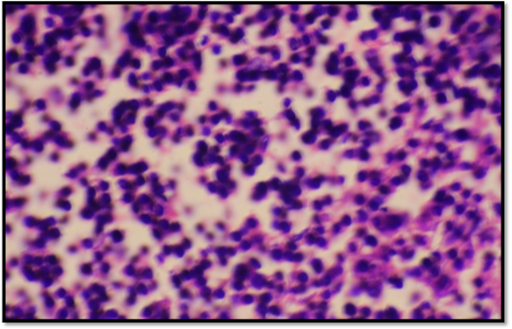
Figure 1 Section in tonsil of a patient affected with inflammation .Light microscopy of tonsils tissue , stained with Hematoxylin and Eosin stain (magnification ,x 1000).
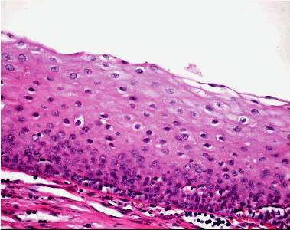
Figure 2 Normal surface epithelium: The stratified squamous nonkeratinized surface epithelium and no lymphocyte. (Hematoxylin-eosin stain).
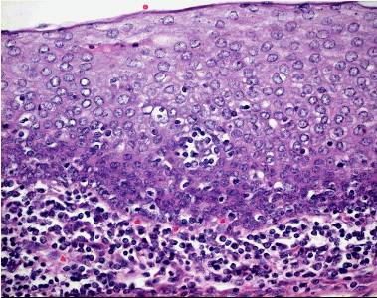
Figure 3 The presence within the surface epithelium of scattered small lymphocyte groups in moderate lymphocyte infiltration in the surface epithelium and lymphocytes in the subepithelial region. (Hematoxylin-eosin stain, original magnification, X 40).

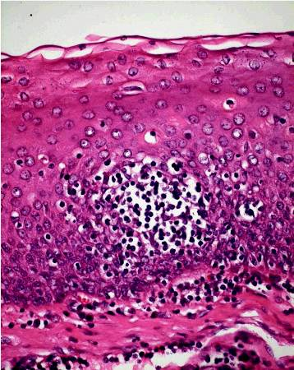
Figure 4 Ugras’s abscess leading to the defect in the surface epithelium (Hematoxylin-eosin stain, original magnification, X 40).

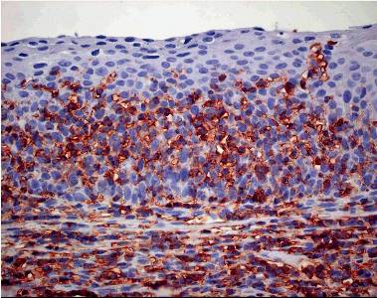
Figure 5 Diffuse lymphocyte infiltration leading to the defect in the surface epithelium (LCA, original magnification x40).

Discussion
Chronic tonsillitis, is a disease with relapsing and remitting acute attacks or a subclinic form of a resistant infection, a poorly treated kind . It is impossible to differentiate chronic tonsillitis from recurrent tonsillitis and these two terms were used to represent the same disease process. Only if a patient’s tonsils returned macroscopically and histologically to normal between episodes could recurrent tonsillitis be differentiated from chronic tonsillitis [16] .
In figure (1) we can see the highly infilterated tonsils with lymphocytes and neutrophils due to presence of infections of adenovirus [17].In figure (2) Normal surface epithelium: The stratified squamous nonkeratinized surface epithelium and no lymphocyte[18].
In figure (3) 1-the presence of slight-moderate lymphocyte infiltration in the surface epithelium (SMLI).
a-The presence of slight lymphocyte infiltration in the surface epithelium is characterized by the presence, within the surface epithelium of the tonsil, of scattered single lymphocytes more than a very few, often surrounded by a halolike clear space. b-the presence of moderate lymphocyte infiltration in the surface epithelium is characterized by the presence, within the surface epithelium, of scattered small lymphocyte groups[19].In figure (4) the presence of abscess leading to the defect in the surface epithelium (Ugras’s abscess). Ugras’s abscess consist of small or large intraepithelial groups of often tightly aggregated lymphocytes located within a vacuole. Microvesiculation can also be observed. In figure (5) the presence of diffuse lymphocyte infiltration leading to the defect in the surface epithelium (DLI)[16]. Anti-Adenoviruse IgG Titer and Age revealed in age group ≤ 5 which was the youngest , the total mean of IgG titers (2.302) which was highest incomparsion to other age groups. In other age groups, the pooled mean of IgG titer was (1.545), whereas two different IgG titer ranges were found in ages <12.
These results were nearly the same as those of [20], which was study carried out/ conducted in Hilla city, who found that the highest IgG titer (3.0) was detected in six year old children also there were different levels of antibody titer among children (1-12 years). This difference may contribute to the less than uniform success of resistence immunity to form antibody(Anti–Adenoviruse human).

References
1.Alatas N.; Baba F.,(2008) . Proliferating active cells,lymphocyte subsets, and dendritic cells in recurrent tonsillitis: their effect on hypertrophy, Arch Otolaryngol Head Neck Surg,
2.Gunstream, S.E. (2006). Anatomy and physiology, 3rd edition lymphatic system and defenses against disease chapter 13. p. 268 – 70.
3.Mora, R.; Jankowska, B.; Mora. F.; Crippa, B.; Dellepiane, M.; Salami, A. (2009). Effects of tonsillectomy on speech and voice. J Voice. 23(5):614-8.
4.Dell’Aringa A. R., Juares A. J., Melo C., Nnrdi J. CKobari, K., Perches Filho R. M. (2005). Histological of analysistonsillectomy and adenoidectomy specimens – Januar2001 to May 2003, Rev Bras Otorrinolaring(Engl Ed),71(1):18–2.
5. Del Mar, C. B.; Glasziou, P. P.; Spinks, A. (2008). Antibiotics for sore throat. Cochrane Database Syst Rev.
6.Kharodawala, M .Z.; Ryan, M.W.; Quinn, F.B.; J.r (2005).(UTMB, Dept. of Otolaryngology).
7.Green, T. D.; Newton, B. R.; Rota, P. A.; Xu, Y.; Robinson, H. L.; and Ross, T. M. (2001). C3d enhancement of antibodies to measles hemagglutinin. J. Virol. 77(6): 350 - 15.
8. Harrison, S. C. (2010). "Virology. Looking inside adenovirus". Science 329 (5995): 1026–7.
9.Thacker, E. E; Nakayama, M.; Smith, B. F.; Bird, R .C; Muminova, Z.; Strong, T .V; Timares, L.; Korokhov, N. (2009). A genetically engineered adenovirus vector targeted to CD40 mediates transduction of canine dendritic cells and promotes antigen-specific immune responses in vivo. Vaccine 27 (50): 7116–24.
10.Fenner, Frank, J.; Gibbs, E.; Paul, J.; Murphy, Frederick A.; Rott, Rudolph; Studdert, Michael J.; White, David O. (1993). Veterinary Virology (2nd ed.). Academic Press, Inc.
11.Amy Burkholder, (2007). "A killer cold? Even the healthy may be vulnerable".http://www.cnn.com/2007/HEALTH/condition /12/19/killer.cold/index.html. Retrieved 2007.
12.Lewis, S. M.; Bain, B. J.; and Bates, I. (2001). Dacie and Lewis Practical Hematology. 9th ed.; Churchill Living Stone, London.
13.Hierholzer ,J.C., Tannock, G.A. Adenoviruses. In: Rose, R.R., Friedman, H., Fahey, J.L.(2000). Manual of Clinical Laboratory Immunology (third edition). AmericanSociety for Microbiology, Washington D.C. 527
14.Mcisaac, W. J.; Kellner, J. D.; Aufricht, P.; Vanjaka, A.; Low, D. E. (2004). Empirical validation of guidelines for the management of pharyngitis in children and adults 291:1587 – 95.
15.Zhang, P.C.; Pang,Y.T; Loh, K.S .(2003). Comparison of histology between recurrent tonsillitis and tonsillar hypertrophy Otolaryngol 28:235-9
16.Napoli, A. M.; Fischer, C. M.; Pines, J. M.; Soe-Lin, H.; Goyal, M.; Milzman, D. (2011). "Absolute Lymphocyte Count in the Emergency Department Predicts a Low CD4 Count in Admitted HIV-positive Patients". Academic Emergency Medicine 18 (4): 385–9.
17.Kliegman, Robert.,Richard M Kliegman; (2006). Nelson essentials of pediatrics. St. Louis, Mo: Elsevier Saunders. ISBN 0-8089-2325-0
18.Heidemann, C.H.; Wallén, M.; Aakesson, M. (2009). Post‐tonsillectomy hemorrhage: assessment of risk factors with special attention to introduction of coblation technique. Eur Arch Otorhinolaryngol. 266(7):1011‐5.
19.Wieland, A.; Belden, L.; Cunningham, M.(2009). Preoperative coagulation screening for adenotonsillectomy: A review and comparison of current physician practices. Otolaryngology– Head and Neck Surgery.140(4):542‐7.
20. Al-Khafaji,Z. A. (2006). Isolation of virus and evaluation of immunological response among healthy and diabetic children. M. Sc. Thesis. College of Medicine, Al-Kufa University,Iraq.

