Evaluate of Malondialdehyde Level and Antioxidant Systems in Asthma Patients

Rana Abd Al-Aly
Chemistry Dept., College of Science, University of Babylon, Hilla, Iraq.

M J B

Abstract
Background: Asthma is a chronic airway inflammation which involves the interplay of different types of inflammatory cells and cytokines in the airway, it is characterized by recurrent cough and wheeze , recent small scale studies have demonstrated that asthma severity may be associated with both airway and systemic inflammation.
Purpose: It is determined that disturbance of oxidant- antioxidant balance in inflammatory disease especially in asthma.
Materials and Methods: Malondialdehyde, super oxide dismutase, catalase & glutathione (GSH) were conducted on 25patients( males) aged 28-45 years compared with 20 males sex and age matched as a healthy control .
Results: Serum malondialdehyde level was shown a significantly increased in asthma patients compared with healthy control, but super oxide dismutase (SOD), catalase (CAT) & glutathione (GSH) were significantly decreased for asthma patients compared with healthy control.
الخلاصة
نظرة عامة: الربو هو من أكثر الأمراض المزمنة انتشار يَتضمّنُ تفاعلَ الأنواعِ المختلفةِ للخلايا التحريضيةِ في المنفذ الهوائي وهو مُمَيَّزُ بالسعالِ والأزيزِ المتكرّرِ، لقد بَيّنَت الدِراساتُ بأنَّ شدَّةَ الربو قَدْ تُرتَبطُ بكلأ من المنفذ الهوائي والنظام الالتهابي.
الغرض: دراسة تاثير الاجهاد التاكسدي وبعض مضادات الاكسدة على مرضى الربو ومقارنتها مع الاصحاء.
العينات: تم تقدير المالون داي الديهايد كناتج لعمليات الاكسدة وكلا من السوبراوكسيد دسميوتيز ’الكاتليزوالكلوتاثايون كمضادات اكسدة لخمسة وعشرين مصاب من الذكور فقط تتراوح اعمارهم بين 28-45 سنة مقارنة مع عشرين شخصا صحيحا كمجموعة سيطرة من نفس الجنس والفئة العمرية.
النتائج: بينت النتائج حصول ارتفاعا معنويا في مستوى الملون داي الديهايد ونقصانا معنويا في مستويات كلا من السوبر اوكسيد دسميوتيز ’الكاتليزوالكلوتاثايون لدى المرضى مقارنة بالاصحاء.
ـــــــــــــــــــــــــــــــــــــــــــــــــــــــــــــــــــــــــــــــــــــــــــــــــــــــــــــــــــــــــــــــــــــــــــــــــــــــــــــــــــــــــــــــــــــــــــــــــــــــــــــــــــــــــــــــــــــــــــــــــــــــــــــــــــــــــــــــــــــــــــــــــــــــــــــــــــــــــــــــــــــــــــــــــــــــــــــــــــــــــــــــــــــــــــــــــــــــــــــــــــــــــــــــــــــــــــــــــــــــــــــــــــــــــــــــــــــــــــــــــــــــــــــــــــــــــــــــــــــــــــــــــــــــــــــــــــــــــــــــــــــــــــــــــــــ

Introduction
Asthma is a complex disorder involving autonomic, immunologic, infectious, endocrine and psychological factors in varying degrees in to airway narrowing, is unclear[1]. Both environmental and hereditary factors are important in the pathogenesis of asthma ,despite an inconclusive debate about whether the enhanced oxidative stress observed in asthma subjects caused by inflammation or is a causative factor in the pathogenesis of the disease [2]. Moreover many recent reports have supported the critical role of oxidative stress in the development of various chronic immunologic diseases [3]. Reactive oxygen species (ROS) such as hydrogen peroxide (H₂O₂) transfer stimulating signals as a critical intracellular second messenger, resulting in the modulation of immune responses [4]. Increased oxidative stress in the environment may contribute to allergic airway inflammation by inducing a break in immune tolerance in genetically predisposed individuals whose antioxidant systems are unable to handle the oxidative stress burden imposed on immune cells Fig.1 [5,6] .

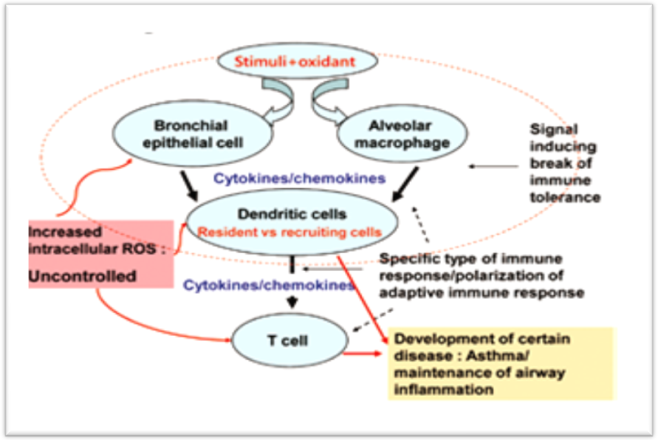
Figure 1 Losing control of intracellular oxidation [5]

Malondialdehyde (MDA) is a marker of lipid peroxidation, it has a strong correlation with asthma suggesting that oxidative stress occurs simultaneously on lipid peroxidation [7]. Lipid peroxidation has been established as a major mechanism of cellular injury in many biological systems, the mechanism involves a process whereby unsaturated lipids are oxidized to form additional radical species as well as toxic by-products that can be harmful to the host system, polyunsaturated lipids are especially susceptible to this type of damage when in an oxidizing environment and they can react to form lipid peroxides[8,9].
During attack asthma, defense systems include enzymatic antioxidants such as superoxide dismutase (SOD) and catalase (CAT) lining the pulmonary fluids and interstitial spaces of the lung and is present in blood vessels and airways[10].SOD reduces O₂.– to H₂O₂, which is then converted to H₂O by the action of catalase [11].
Non-enzymatic antioxidants such as glutathione(GSH) redox system
is a major protective antioxidant in the lungs that also has a role in regulation of inflammatory responses [12] . GSH plays a central role in the defense against a variety of diseases, its function includes the detoxification of carcinogens, free radicals and peroxides, regulation of immune function and maintenance of protein structure [13].

Material and Methods

Patients:

25males suffered from asthma disease, aged 28-45 years and 20 males aged 28-45 years, as a controls group, blood samples were collected from patients and control. After clotting, serum was separated by centrifugation, the analytical determinations described below were either performed immediately, or serum was stored at -20°C and used within 72 hours.
Determination of malondialdehyde (MDA):

To 150 μl of serum, 1 ml of 17.5% TCA , 1 ml of 0.6% TBA and 70% TCA was added.The supernatant was measured at 532 nm against reagent blank [14] .
Determination of superoxide dismutase(SOD):
To 50µL of serum,75mM of tris-HCL buffer,30 mM of EDTA and 2mM of pyrogallol were added. An increase in absorbance was recorded at 420nm for 30 min. The activity of SOD is expressed as U\ml of serum [15].
Determination of catalase activity (CAT):
Catalase was assayed calorimetrically at 620 nm and expressed as µmoles of H₂O₂ consumed min\ml of serum described by Sinha [16]. The reaction contain 1.0ml of 0.01M phosphate buffer with 0.1ml of serum and 0.4ml of H₂O₂, the reaction was stopped by the addition of 2ml of dichromate acetic acid reagent.

Determination of glutathione(GSH):
Serum GSH was determined by using a modified procedure utilizing Ellman’s reagent (DTNB) that is readily reduced by sulfhydryl group of GSH to produce an intensely yellow compound, The reaction contain100µL of serum, 800µL D.W, 100µL TCA, then 400 µL supernatant was taken and added 800µLtris-EDTA buffer,20 µL DTNB reduced chromogen has maxmum absorbance at 412 [17-19].

Statistical Analysis:

The results were expressed as mean ± Standard Deviation, comparison between patients and controls were performed by the student’s t-test. Person’s correlations were used to determine relationship between parameters studied taken P≤ 0.05 as the level of significant.

Results and Discussion
Asthma is a chronic inflammatory disease of the respiratory tract with an unknown etiology where inflammation is often associated with an increased generation of reactive oxygen species (ROS) [20,21], that is lead to activate inflammatory cells produce large amounts of (ROS) into the airways and increasing by product of lipid peroxidation (MDA) levels [22]. To evaluate the change in MDA concentration between asthma patients and healthy control, significant rises were obtained for MDA (p=0.00) in patients when compared with healthy control. (Table1).

Table1 Measurement of serum malondialdehyde(MDA) concentration in asthma Patients and healthy Control.
Subject | Mean± SD (µmol/l) | P-value | Sign.
Control  Patients | 1.447 ± 0.481  4.025±1.163 | ------  0.00 | -----  Sign.

Excessive ROS production lead to alteration in key enzymatic and non-enzymatic antioxidants, oxidant-antioxidant imbalance in airways leads to pathophysiological effects associated with asthma [23]. In this work the results shown obviously SOD inactivation in asthma patients compared with healthy control (p=0.001) (Table2). SOD is a first-line antioxidant essential to aerobic life, loss of enzyme-specific activity undoubtedly potentiates extracellular matrix damage and tissue injury through increased formation of reactive oxygen and nitrogen species due to airway epithelial cells of asthmatics have decreased intracellular SOD activity [24,25].

Table 2 Effect of superoxide dismutase(SOD)(U\ml)level on asthma patients and healthy control .
Subject | Mean± SD | P-value | Sign.
Control  Patients | 0.627 ± 0.052  0.124 ± 0.037 | ------  0.001 | -----  Sign.

While catalase is responsible for detoxification of H₂O₂, that formed by SOD and other processes is scavenged by catalase that catalyzes the dismutation of H₂O₂ into water and molecular oxygen [26]. Significantly decrease for catalase activity in asthma patients compared with healthy control (p=0.004) shown in (Table 3).
When hydrogen peroxide could not be detoxified as a result catalase activity was decreased due to hydrogen peroxide possibly convert to hydroxyl radical by iron in asthma patients [27].

Table 3 Catalase activity (Katal) in asthma patients and healthy control.
Subject | Mean± SD | P-value | Sign.
Control  Patients | 0..262 ± 0.059  0.138 ± 0.028 | ------  0.004 | -----  Sign.

Reduced levels of glutathione (GSH) have been observed in patients with asthma compared with healthy control as shown in (Table4).

Table 4 The levels of glutathione (GSH) in asthma patients and healthy control .
Subject | Mean± SD (µmol/l) | P-value | Sign
Control | 52.733 ± 7.211 | ------
Patients | 24.073 ± 5.216 | 0.00 | Sign.

Glutathione is a critical substrate in the enzymatic machinery and it is major constituent of the non enzymatic antioxidant defense therefore it is a key molecule in the antioxidant system; it catalyzes the reaction [28].

$$H_{2}O_{2} + 2\text{GSH} → \text{GSSG} + 2H_{2}O$$

These changes in enzymatic and non-enzymatic antioxidants can disrupt homeostasis of ROS in bronchial cells that is lead to decrease activity of this enzyme and increased H₂O₂ production [29].
The concentration of GSH in(µmol/L) was calculated depended on the calibration curve that is shown in Figure (2).

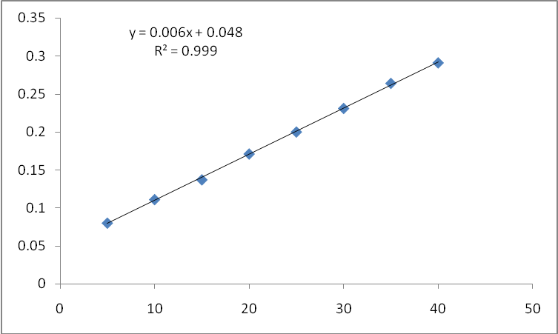
Figure 2 calibration curve of glutathione

Conclusion
Oxidative stress is increased in the asthmatic airway but enzymatic and non enzymatic antioxidant decreased , these changes may play a role in the pathogenesis of asthma.

References
- M .Sly, R.E. Behrman, R.M.Kliegman and H.B. Jenson , Nelson textbook of Pediatrics. 16th ed. Philadelphia, W.B. Saunders's Co, ( 2000); pp 664.
- M. Sheila and S. Mike, Forfar and Arneils Textbook of Pediatric. 5th ed. New York, Churchill Livingstone, (1998); pp. 536.
- H. Sugiura and M. Ichinose, Antioxid Redox Signal, ( 2008);10:785.
- M.A .Riedl and A.E. Nel , Curr Opin Allergy Clin Immunol, (2008);8:49.
- J.R. Stone and S. Yang, Antioxid Redox Signal, ( 2006);8:243.
- L.Tamer, M. Calikogl, N.A Ates, H.Yildirim, B. Ercan, E. Saritas, A. Unlu, and U. Atik , Respirology J. (2004); 9,493.
- P.J. Barnes, Free Red Biol Med., (1990); 235, 43.
- F.Nielsen , B.B .Mikkelsen, J.B. Nielsen, H.R. Andersen and P.Grandjean , Clin Chem., (1997); 43(7):1209.
- A.A . Andreadis, S.L .Hazen, S.A. Comhair, and S.C. Erzurum, Free Radic Biol Med.,( 2003);35:213.
- S.L. Marklund , J Clin Invest., (1984);74:1398.
- V.L . Kinnula, J.D. Crapo and K.O. Raivio, Lab Invest, ( 1995);73:3.
- J.E. Repin, A. Bast and I. Lankhorst , Am Respir Crit Care Med. (1997); 156:341.
- J.P. Richie, L. Skowronski, P. Abraham, and Y. Leutzinger, Clin. Chem., ( 1996); 42: 46.
- K.M. Raad, S.A.Marwan and M.Y.Oda, National Journal of Chemistry, (2002);139, 5.
- S. Marklund and C. Marklund, Eru.J.Biochem, (1974); 47: 474.
- K.A . Sinha, Anal.Biochem, (1972); 47: 389.
- L. Stryer, Biochemistry, 4th ed., New York, Freeman W. H. and Company,( 2000).
- G.L. Ellman, Arch. Biochem. Biophys., (1959); 82: 70.
- J. Sedlak and R.H. Lindsay, Anal.BIOCHEM.,(1968);25:192.
- A. Nadeem, A. Masood, N. Siddiqui, Ther Adv Respir Dis.,( 2008); 2:215.
- G. Toro and P.G. Aackermann, Practical Clinical Chemistry. Boston: Little, Brown and company,( 1975); pp. 634.
- A. Antczak, S.A . Kharitonov and P. Montuschi, J. Respiration, (2005);72:594.
- A. Nadeem, J Saga,( 2008 ); 2 : 4 215.
- H.R. De Raeve, F.B.J.M .Thunnissen and F.T. Kaneko, vivo. Am J Physiol, (1997); 272: 148.
- D. Salvemini, Z.Q.Wang and J.L. Zweier, J Science, ( 1999); 286:304.
- Y. Kono, Arch Biochem Biophys, (1978);186:189.
- R.A. Aly, Journal of Kufa,(2010);1(1):99.
- L. Eldjarn, Pihl, J. Biol. Chem., (1957); 225: 499.
- L.G. Wood, P.G. Gibson and M.L. Garg, Eur. Respir. J.,( 2003), 21, 177.

