In Vivo Efficacy of Nigella Sativa Aqueous Seed Extract Against Metacestode of Echinococcus Granulosus

Kasim Sh. Al-Mayah Nada M. Al-Bashir Bader M. Al-Azzawi*
Medical Research Unit, College of Medicine, Al-Nahrain University, Baghdad, Iraq. * College of Science – Al-Mustansiriya University, Baghdad, Iraq.
To whom Correspondence should be addressed.: kasim19672003@yahoo.com

M J B

Abstract
Hydatidosis is an endemic disease of human and animals which is difficult to treat. Experimental studies indicated that Nigella sativa seeds had an efficiency against various parasitic infections. This study aimed to evaluate the in vivo efficiency of Nigella sativa aqueous seeds extract against hydatidosis . A total of 40 white albino mice were divided into 4 equal groups . Each mouse in the first, second, and third groups were injected intraperitoneally (IP) with 2000 protoscolices, whereas mice in the fourth group were left as non-infected control. Four months post infection, mice in the second and third group treated with 12 and 25mg of Nigella sativa aqueous seeds extract respectively in every other day for one week. Mice in the first group were untreated and considered as infected control group. Morphological and histopathological changes in cysts and infected organs were studied . Enzyme activities of adenosine deaminase (ADA) and alkaline phosphatase (ALP) were recorded in each mouse . Mice from treated groups with either concentration had lower number and diameter of cysts and higher cyst reduction percentage than infected control group. Histological sections of the liver from mice treated with either concentration showed degeneration and necrosis of hydatid cysts . An elevation of ADA and dropping in ALP activities was recorded in treated mice especially with 25 mg .
كفاءة المستخلص المائي لبذور الحبة السوداء Nigella sativa في علاج الاصابة بالاكياس المائية : دراسة في الجسم الحي
الخلاصة
داء الأكياس المائية من الأمراض المتوطنة الصعبة العلاج والتي تصيب الإنسان والحيوان على حد سواء . أشارت العديد من الدراسات التجريبية الى كفاءة بذور الحبة السوداء في قتل وتثبيط أنواعا مختلفة من الطفيليات . استهدفت هذه الدراسة تقييم كفاءة المستخلص المائي لبذور الحبة السوداء ضد الاصابة التجريبية بالاكياس المائية .استخدم 40 فأرا قسمت الى اربع مجاميع متساوية . حقنت الفئران في المجكوعة الاولى والثانية والثالثة ﺑ 2000 رؤيس اولي / فأر فيما تركت المجموعة الرابعة كمجموعة سيطرة غير مخمجة. بعد اربعة اشهر من الاصابة عولجت الفئران في المجموعة الثانية والثالثة ﺑ 12 ملغم و 25 ملغم من المستخلص المائي لبذور الحبة السوداء على التوالي بين يوم واخر لفترة اسبوع فيما تركت المجموعة الاولى كمجموعة سيطرة مخمجة. درست التغيرات المظهرية والنسيجية للاكياس المائية والاعضاء المصابة بها . كما تم قياس الفعالية الانزيمية لانزيمي Adenosine deaminase(ADA) و Alkaline phosphatase(ِِِALP). أظهرت الفئران المعالجة بالمستخلص بأي من التركيزين اعدادا ومعدل اقطار للاكياس المائية اقل من فئران مجموعة السيطرة المخمجة ، فيما أظهرت المقاطع النسيجية للكبد للفئران المعالجة تنكس وتنخر جدار الكيس المائي . سجل ارتفاع في النشاط الانزيمي لانزيم ADA وانخفاض في النشاط الانزيمي لانزيم ALP في الفئران المعالجة لاسيما تلك التي عولجت بتركيز 25ملغم/مل.
ـــــــــــــــــــــــــــــــــــــــــــــــــــــــــــــــــــــــــــــــــــــــــــــــــــــــــــــــــــــــــــــــــــــــــــــــــــــــــــــــــــــــــــــــــــــــــــــــــــــــــــــــــــــــــــــــــــــــــــــــــــــــــــــــــــــــــــــــــــــــــــــــــــــــــــــــــــــــــــــــــــــــــــــــــــــــــــــــــــــــــــــــــــــــــــــــــــــــــــــــــــــــــــــــــــــــــــــــــــــــــــــــــــــــــــــــــــــــــــــــــــــــــــــــــــــــــــــــــــــــــــــــــــــــــــــــــــــــــــــــــــــــــــــــــــــــــــــــــــــــــــــ

Introduction
Hydatidosis , or echinococcosis, is a zoonotic infection of human and domestic animals caused by the larval stage (metacestode) of the cestode Echinococcus granulosus . Hydatidosis is endemic in rural areas in many countries. In Iraq and some other Arabic countries the disease is considered hyperendemic [1].
Current treatment of hydatidosis is mainly surgery, and to less extend percutaneous aspiration and medicinal treatment using benzimidazole compounds [2]. In some cases, surgery may not be possible because of the patient’s condition, location of the cyst(s), or when there are multiple cystic loci. Even when surgical operation is done, some risk factors may associated such as recurrence [3] massive peritoneal dissemination, long-stay hospitalization and biliary fistula [4] , aside from the high economical cost of the operation [5]. Percutaneous drainage is relatively a new treatment method for hydaditosis and it has provided a useful alternative to surgery. Rupture of cyst is considered as one of the most important risk factor of this alternative [4].
The effect of benzimidazole derivatives is due to their metabolites which reach a definite serum concentration and passes to the hydatid fluid. However, some of these metabolites are potentially toxic or cause transient abnormality of the liver function test [5,6], aside from resumption of cystic growth following cessation of treatment [7]. Some reports pointed out serious adverse reactions due to albendazole usage such as encephalitis syndrome, influenza-like syndrome, allergic purpura, and rash [8,9].
It is because these risks, researchers continued to seek safe alternative medicinal plants to treat this fastidious disease . large numbers of medicinal plants and their purified constituents have been shown beneficial therapeutic potential against Echinococcus granulosus protoscolices [10-13]. Seeds of Nigella sativa , a dicotyledon of the Ranunculaceae family, have been employed as a traditional medicine for the treatment of variety of ailments . Recently , the seeds have been reported to exhibit many pharmacological effects against Giardia, Blastocyst hominis, Trichomonas, malaria, and some nematode and cestode [14-18]. This study aimed to evaluate the efficiency of aqueous solution of this seed in the treatment of hydatidosis in vivo.

Materials and Methods
1. Parasite materials
Eight fresh Echinococcus granulosus hydatid cysts were obtained from patients who carried hepatic and pulmonary cysts after surgical extripation in Al-Kadhimiya , Ibn-El-Nafees, and Al-Kindy hospitals .The cysts were wrapped carefully in clean plastic bags to the Medical Research Unit / College of Medicine / Al-Nahrain University .The outer surfaces of the cysts were sterilized with 70% ethanol before being dissected. Protoscolices were extracted according to Smyth [19].
Extracted protoscolices were preserved in a sterile medium made of a mixture of Kerb’s Ringer solution (KRS) and hydatid cyst fluid (4:1). The viability of protoscolices was confirmed prior to experiments. It was determined by body movement under light microscope and vital staining with 0.1% methylene blue [20]. Crystalline penicillin G and streptomycin sulfate were added to the mixture to keep it free from bacterial contamination.
2. Plant collection and extraction:
Seeds of Nigella sativa were bought from local market. After washing several times with water, the seeds were dried in shed at 25˚C for one week with frequent turning over. They were then pulverized in a grinder to obtain fine powder [21]. Aqueous seeds extract was prepared by mixing 100 gm of the powder with 200 mL of distilled water using magnetic stirrer . The mixture was then filtered and lyophilized . Stock solution was prepared by dissolving 600 mg of lyophilized powder in 10 mL of distilled water . From this solution , 12 and 25 mg/mL concentrations were prepared for in vivo study .
3. Animals:
A total of 40(4-6 week old) white albino mice (17males and 23 females) were divided into 4 groups each with 10 mice. Mice in the first, second, and third groups were injected (IP) with 2000 protoscolices/ mouse (equivalent to 1 mL) , whereas each mouse in the fourth group was injected IP with 1mL of normal saline and represented as non-infected control group . After 4 months of infection , mice in the first and second group were respectively injected IP with 12 and 25mg (equivalent to 1mL) of aqueous extract of Nigella sativa seeds in every other day for 7 days ( a total of 4 doses) . Mice in the third group were not treated and were considered as an infected control group.
4. Biochemical tests:
Blood samples were taken only once from mice in non-infected and infectede control groups four months post infection , and from treated mice (second and third groups) 60 days post treatment .The samples were drawn directly from the heart after the animals were anesthetized . Serum was separated from each sample and stored at -20C̊ to be used later for the estimation of activity of adenosine deaminase (ADA) where Giusti method [22] was used, and Alkaline phosphatase (ALP) where alkaline phosphatase ready kit (sera and vaccines institute )was used .
All animals were weighted and sacrificed 60 days post treatment and the internal organs of which were examined for infection with hydatid cysts. Number and diameter of secondary hydatid cysts were determined in each animal. Reduction percentage of secondary hydatid cysts was calculated as following:

Average number of hydatid cyst in infected control ــــ Average number of hydatid cyst in treated group
ـــــــــــــــــــــــــــــــــــــــــــــــــــــــــــــــــــــــــــــــــــــــــــــــــــــــــــــــــــــــــــــــــــــــــــــــــــــــــــــــــــــــــــــــــــــــــــــــــــــــــــ x 100 [23]
Average number of hydatid cyst in infected control

5. Liver and spleen hypertrophy indicator:
Liver and spleen were removed from each mouse and weighted. An organ hypertrophy indicator for these organs was calculated as follow:

Organ weight
Organ Hypertrophy Indicator = ـــــــــــــــــــــــــــــــ x1000 [24]
Animal weight

6. Histopathological study:
Sections from liver, spleen and kidney from infected mice were prepared and examined histologically.
7. Statistical analysis:
Data were expressed as mean value ± standard deviation and tested with one way ANOVA followed by least significant difference for multiple comparisons. Statistical probability of 0.05 was considered significant.

Results
1-Number, diameter, and reduction percentage of cysts:
Dissecting of mice in positive control group revealed the presence of secondary hydatid cysts in liver, peritoneal membrane, diaphragm, and spleen. In the liver (which was especially infected), cysts either partially embedded in the parenchyma or attached to the surface (figure 1). Protoscolices viability test from these cysts revealed 100% viability.
Cysts in treated mice (with either concentration) were found in the visceral organs especially the liver, however, viability test revealed no viable protoscolices. Dissecting of mice in negative control group showed no hydatid cysts.

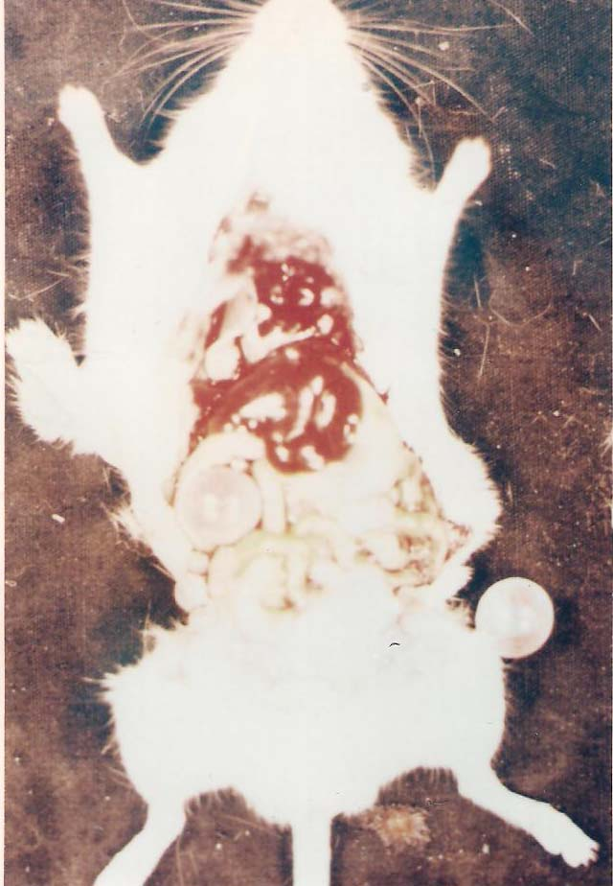
Figure 1 Secondary hydatid cysts in mouse from infected control group

Table 1 shows number, diameter, and reduction percentage of secondary hydatid cysts in the studied groups. Mice treated with 12 and 25 mg have less average number of cysts (2.33±2.59 and 2.55±1.01 respectively) than infected control mice (4.12±1.8) with significant difference, while there were no significant differences in average diameter of cyst between these group despite the lower diameter in treated mice with either concentration than infected control mice. While cyst reduction rate in infected control mice was zero, it was 43.44 and 62.37 in mice treated with 12mg and 25mg respectively with significant difference between the two groups.
2- Liver and spleen hypertrophy indicators:
Mice treated with 12 and 25mg had lower liver hypertrophy indicator (54.01±3.04 and 50.45±7.67 respectively) than infected control group (61.79±3.11) with significant difference. Whereas, there is no significant difference between mice treated with 25mg and negative control group (40.29±8.72).
Mice treated with 25mg had the least spleen hypertrophy indicator (5.92±0.82) and differed significantly from mice in infected control group (7.21±0.6) and un-significantly from mice treated with 12mg (6.68±0.76) .

Table 1 The effect of aqueous Nigella sativa seed extract on number, diameter and size reduction rate of hydatid cyst in mice .

Groups | No. of mice | No. of Death | Total No. of cysts | Average No. of cyst /mouse±S.D | Average diameter of cysts ± S.D | Reduction rate
Infected control | 10 | 2 | 33 | 4.12±1.8ª | 3.87±2.41ª | 0
Treated with 12mg | 10 | 1 | 21 | 2.33±1.59^{b} | 2.66±2.64ª | 43.44
Treated with 25mg | 10 | 1 | 14 | 2.55±1.01^{b} | 2.77±1.71ª | 62.37
Non-infected control | 10 | 1 | 0 | 0 | 0 | 0
Note: different letters indicate significant differences

3-Histopathologic changes:
Histopathologic section of liver from infected control mice showed infiltration with neutrophil, lymphocyte, and macrophage in between hepatocytes with portal area was infiltrated with lymphocyte and monocyte. Some hepatocytes underwent balloon degeneration (figure2). Sections of spleen from these mice revealed undistinguished white and red pulp, epitheloid histiocyte infiltration, and extramedullary hemopiesis (figure 3).
Histological sections of the liver from treated mice with either concentration show hyperplasia, infiltration of inflammatory cells and degeneration of some hepatocytes. Hydatid cyst wall has undergone degeneration and/or necrosis (figure 4). Sections of spleen show distended white pulp and infiltration of macrophages with foci granuloma formation (figure 5).
4-Biochemical changes:
Table 3 shows enzyme activity of ADA and ALP in the studied groups. After 4 months of infection, enzyme activity of ADA in infected control mice was 0.71±0.12 U/L compared with 1.89±0.03 U/L in non-infected control mice with significant difference. Sixty days post treatment, mice treated with 25 have higher ADA activity (1.46 ± 0.05 U/L)than either mice treated with 12mg (0.84±0.07U/L) or infected control group with significant difference.

Table 2 The effect of aqueous Nigella sativa seed extract on liver and spleen hypertrophy in mice infected with hydatid cyst .

Groups | No. of mice | Average body wt(g)± S.D | Average spleen wt(g)±S.D | Average liver wt(g)±S.D | Spleen hypertrophy indicator±S.D | Liver hypertrophy indicator±S.D
Infected control | 8 | 30.96±3.6 | 0.22±0.02 | 1.91±0.27 | 7.21±0.6ª | 61.79±3.11ª
Treated with 12mg | 9 | 31.46±6.41 | 0.21±0.04 | 1.71±0.41 | 6.68±0.76^{a,b} | 54.01±3.04^{b}
Treated with 25mg | 9 | 32.17±5.27 | 0.19±0.03 | 1.64±0.46 | 5.92±0.82^{b} | 50.45±7.67^{b,c}
Non-infected control | 9 | 30.24±2.82 | 0.15±0.01 | 1.23±0.35 | 4.91±0.62^{c} | 40.29±8.72^{c}
Note: different letters indicate significant differences

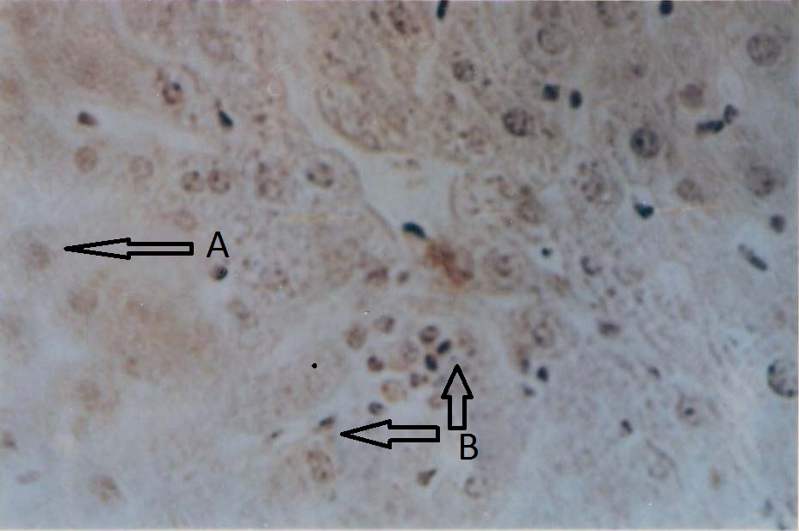
Figure 2 histological section of liver from mouse in infected control group.
(A) degenerated and swelled hepatocytes .(B) infiltrated inflammatory cells (100X).
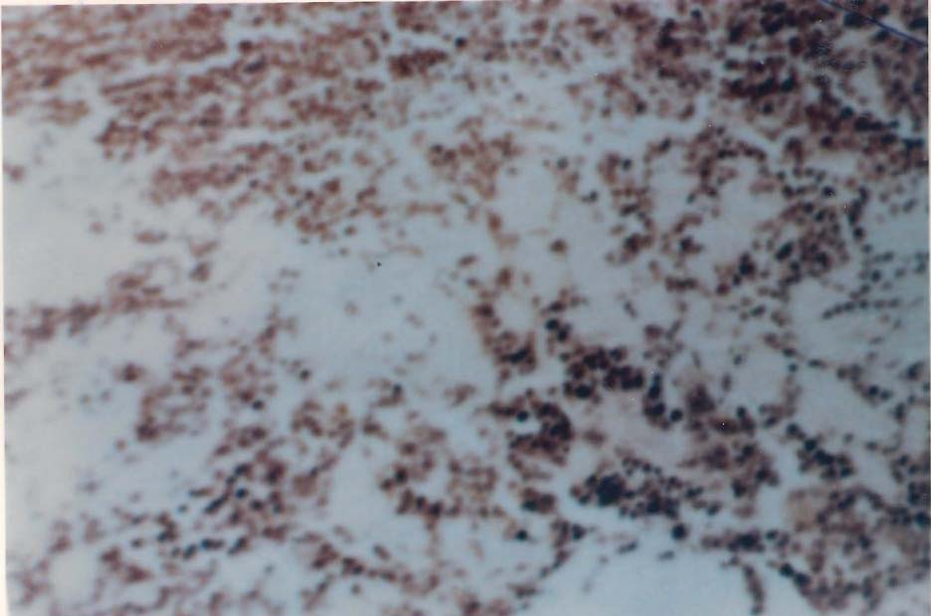
Figure 3 Histological section of spleen from mouse in infected control groupe showing un-distinct white and red pulp (500X) .

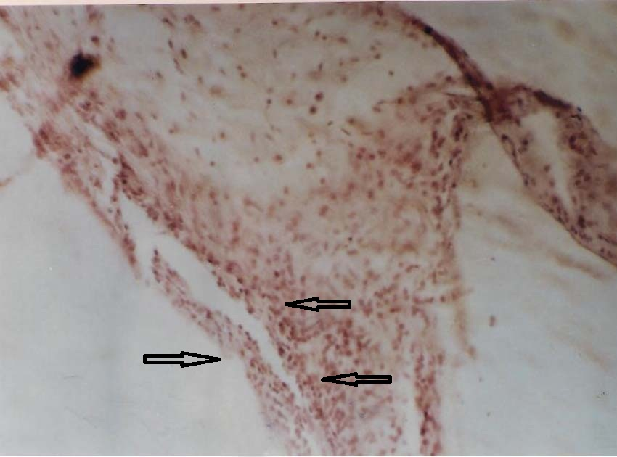
Figure 4 Histological section of liver from mouse treated with 25mg/mL of Nigella sativa seed extract showing degeneration and necrosis of the cyst wall (arrows) (500X) .

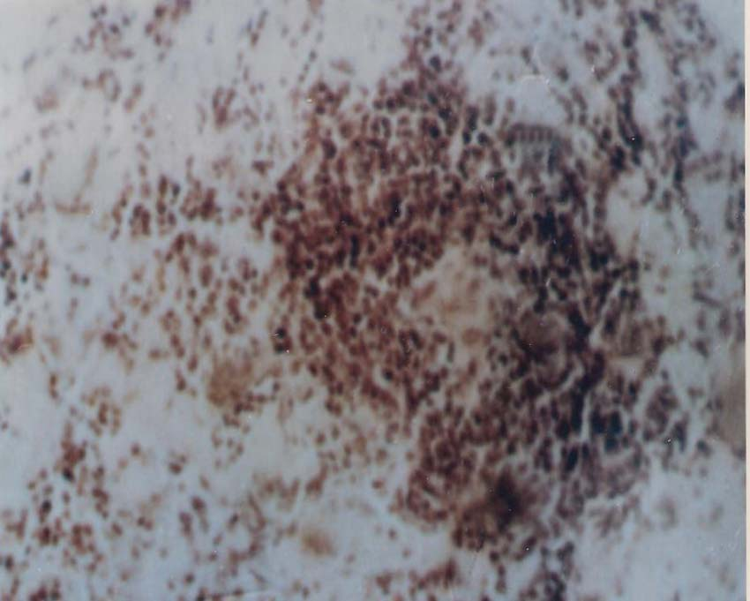
Figure 5 Histological section of spleen from mouse treated with 25mg/mL of Nigella sativa seed extract showing distended white pulp (500X) .

Table 3 Enzyme activity of ADA and ALP in treated and control mice
Groups | Enzyme activity of ADA U/L ±S.D | Enzyme activity of ALP U/L ± S.D
Infected control | 0.71 ± 0.12ª | 63.83 ± 3.75ª
Treated with 12 mg | 0.84 ± 0.07ª | 53.10 ± 4.47^{b}
Treated with 25 mg | 1.46 ± 0.05^{b} | 46.76 ± 3.93^{c}
Non-infected control | 1.89±0.03^{c} | 21.33±1.12^{d}
Note: different letters indicate significant differences

Two months after infection, enzyme activity of ALP in non-infected and infected control groups were 21.33 ± 1.12U/L and 63.83 ± 3.75U/L respectively. Sixty days post treatment , the activity of this enzyme were 53.10 ± 4.47U/L and 46.76 ± 3.93U/L in mice treated with 12 and 25mg respectively with significant differences among the four groups.

Discussion
Recently, there are trends for using plants in therapy (back to the nature) as a result of side effects and complications of chemotherapies and surgery. N. sativa seeds are folk medicinal plants used for centuries to treat various illnesses. The two concentrations of N. sativa seed extract were determined according to previous work (unpublished data).
The study showed high efficiency of aqueous N. sativa seed extract especially with 25mg concentration against E. granulosus metacestode. The possible explanation of the mechanism of this extract can be interpreted in different ways; Dixon [25] detected two immunoregulatory, cytokine-like factors, in the metacestode of E. granulosus, one of which appears to influence T-suppressor cells and the other macrophage activity. As long as the cyst integrity is maintained, the host-parasite relationship appears to be sustained in a dynamic equilibrium between parasite growth and acquired immunity. Many workers have shown that N. sativa seeds have potential immunomodulatory effects among which, it enhances production of interleukins and alters macrophage activity [26, 27]. El-Kadi et al. [28] found that the majority of subjects treated with N. sativa seeds for 4 weeks showed a 53% increase in CD4 to CD8 T cell ratio and 30% increases in natural killer cell function. As a consequence these effects might give some impact on the host-parasite relationship [29].
Many other workers attributed this action of the seeds to their alkaloids, saponins, and thymoquinone constituents [30,31]. Alkaloids were found to have immunostimulatory effect for both humoral and cell mediated immunity and exhibit an efficiency against E. granulosus protoscolices in vitro [32].
Saponins contain a steroidal or triterpenoid aglycone to which one or more sugar chains are attached. Steroid saponins are common in plants used as herbs or for their health-promoting properties .According to Fenwick et al.[33], saponin have the ability to modulate the cell mediated immune system as well as to enhance antibody production also induce strong cytotoxic CD8+ lymphocyte responses and potentiate the response to mucosal antigens. The mechanisms of immune-stimulating action of saponins have not been clearly understood, but it induces production of cytokines such as interleukins and interferons that might mediate their immunostimulant effects [34].
Thymoquinine possess reprodu-cible anti-oxidant effects through enhancing the oxidant scavenger system, which as a consequence lead to antitoxic effects induced by several insults[26], but this constituent is fat soluble, so the effect of N. sativa in this study can’t be attributed to thymoquinine.
Hydatid cyst as a foreign harmful antigen induces inflammatory response represented by infiltration of lymphocyte, neutrophil and macrophage to the site of injury. This inflammatory response was highly reduced in mice treated with N. sativa. The anti-inflammatory effect has reported by Al-Ghamdi [35] and has been found to be hepatoprotective when liver injury is induced in mice by carbon tetrachloride [36] and this may explain the minor inflammatory infiltration and less hypertrophy indicator in the liver and spleen from mice treated with the extract.
Adenosine deaminase is an enzyme involved in the catabolism of purine base. Its plasma activity is found to be elevated in disease eliciting a cell-mediated immune response [37] . Earlier studies showed increase in ADA activity in liver diseases and is proposed to reflect the amplified phagocytic activity of macrophage [38]. Increased ADA activity in treated mice especially with higher concentration (25 mg) confirmed this proposal as the active ingredients of N. sativa seeds enhance the activity of macrophage and consequently increase serum activity of this enzyme.
Alkaline phosphatase is an orthophosphoric-monoester phosphohydrolase catalyzes the alkaline hydrolysis of large variety of naturally occurring substrates. ALP activity is present in most organs of the animal bodies but it is especially associated with liver and convoluted tubules of kidney. The activity of ALP increases in liver diseases that principally affect parenchymal cells [39]. Decreased ALP activity in treated mice especially with 25mg may be referred to protective property of some N. sativa seed constituents namely the saponin.

References
- Al-Dabagh, M. A. and Al-Janabi, T. A. (1990) Science of Hydatid Cyst . Al-Iitidal Company for printing, Baghdad . P12 .
- Gangopadhyay, A. ; Srivastava, P. ; Upadhyaya, V. D. and Hasan, Z. (2009] Is primary chemotherapy effective in large hydatid cyst of liver ? J. Ind. Ass. Ped. Surg. 14(1):40 .
- Constantin, C. ; Rodulescu, S. and Cretu, C. M. (2008) Hydatidosis relapse in children : clinical and epidemiological study . Bacteriol. Virol. Parazitol. Epidemiol. 53(2):109-116 .
- Polat, E. ; Aslan, M. ; Cakan, H. ; Saribas, S. ; Ipek, T. and Kocazeybek, B. (2009) The effects of albendazole and povidone iodine for hydatid cysts protoscolices , in-vitro and in-vivo . Afr. J. Microbiol. Res. 3(11): 743-746 .
- Georgescu, S. O. ; Dubei, L. ; Torcoveanu, E. ; Bradea, C. ; Lazescu, D. ; Crumpei, F. and Stratan, I. (2005) Minimally invasive treatment of hepatic hydatid cysts . Roman. J. Gastroenterology, 14(3):349-352 .
- Pawlowski, Z. S. (1997) Critical points in the clinical management of cystic echinococcosis : a revised review . In: Anderson, F. L. ; Ouhelli, H. and Kachani, M. (eds) Compendium on cystic echinococcosis in Africa and middle eastern countries with special reference to Morocco . Brigham Young University print services, Provo, p 119-135 .
- Novok, M. (1990) Efficacy of mitomycine against alveolar echinococcosis. Int. J. Parasitol. 20:119-120 .
- Zhenguo, Z. H. ; Xuezhi, Y. and Yuanrong, Z. H. (2005) Serious adverse reactions associated with albendazole . Ciln. J. Pharmacovigilance , 2:7-10 .
- Ma, X. M. ; Bao, G. SH. ; Wan, J. M. ; Liao, D. J. ; Yin, SH. F. ; Meng, X. Q. ; Zhou, G. K. ; Lu, X. M. and Li, H. Y. (2007). Therapeutic effects of Sophora moorcroftiana alkaloids in combination with albendazole in mice experimentally infected with protoscolices of Echinococcus granulosus . Braz. J. Med. Biol. Res. 40(10):1403-1408 .
- Al-Saimary, I. E. and Zeki, A. (1999) In vitro chemotherapeutic effects of antibiotics and plant extract on protoscolices viability of human hydatid cysts . J. Basrah Res. 20:79-98 .
- Al-Sudani , N. M. (2007) Effect of extract of Zisphus spina-christi L. and Olea europaea L. on the larval stage of Echinococcus granulosus . Int. J. Parasitic Dis. 2(1) :17-22 .
- Barazinji, A. R. ; Mothana, R. A. and Nasher, A. (2009) Effect of leaf extracts of Dendrosicyos socotrana and Jatropha unicoststa on the viability of Echinococcus granulosus protoscolices . EurAsian J. BioSci. 3:122-129 .
- Sadjjadi, S. M. ; Zoharizadeh, M. R. and Panjeshahin, M. (2008) In vitro screening of different Allium sativum extracts on hydatid cyst protoscolices . J. Invest. Surgery , 21(6):318-322 .
- Bishara, S. A. and Masoud, S. I. (1992) Effect of Nigella sativa extract on experimental giaridiasis . N. Egypt J Med. 7(1):1-3 .
- El-Wakil, H. S. (2007) Evaluation of the in vitro effect of Nigella sativa aqueous extract on Blastocyst hominis isolates . J. Egypt Soc. Parasitol. 37(3):801-813 .
- Abdullah, H. A. and Zainal-Abidin, B. A. (2007) In vitro anti-malarial tests of Nigella sativa (black seed) different extracts . Am. J. Pharmacol. Toxicol. 2(2):46-50 .
- Akhtar, M. S. and Rifaat, S. (1991) Field trail of Saussurea lappa roots against nematodes and Nigella sativa seeds against cestodes in children . J. Pak. Med. Assoc. 41:185-187 .
- Tonkal, A. M. D. (2009) In vitro antitrichomonal effect of Nigella sativa aqueous extract and wheat germ agglutinin . JKAU. Med. Sci. 16(2):17-34.
- Smyth, J. D. (1985) In vitro culture of Echinococcus spp. In : Proceedings of the 13th Int. Congr. Hydatidology. Madrid, pp 84-89 .
- Smith, J. D. and Barrett, N. J. (1980) Procedure for testing the viability of of human hydatid cysts following surgical removal , especially after chemotherapy . Trans. Roy. Soci. Trop. Med. Hyg. 74(5):649-652 .
- Harborne, J. B. (1973) Phytochemical Methods . Halsted press . John Weily and Sons, New York .
- Giusti, G. (1981) Adenosine deaminase . In : Methods of Enzymatic Analysis . 2nd Ed. Bergmeyer , Florida , pp 1092-1099 .
- Health, D. D.; Christie, M. J. and Chevis, R. A. (1975) The lethal effect of mebendazole on secondary E. granulosus cysts and cysticerci of T. pisiformis . Parasit. 70: 273-285 .
- Kroeze, W. K. and Tanner, C. E. (1987) Echinococcus multilocularis : susceptibility and responses to infection in inbred mice . Int. J. Parasitol. 13(5):509-515 .
- Dixon, J. B. (1997). Echinococcosis . Comp. immunol. Microbiol. Infect. 20:87-94 .
- Haq, A. ; Lobo, P. I. ; Al-Tufail, M. ; Rama, N. R. and Al-Sedairy, S. T. (1999) Immunomodulatory effect of Nigella sativa proteins fractionated by ion exchange chromatography . Intl. J. Immunopharmacol. 21:283-295 .
- Salem, M. L. (2005). Immunomodulatory and therapeutic properties of the Nigella sativa L. seed .Int. Immunopharmacol. 5:1749-1770 .
- El-Kadi, A. ; Kandil, O. and Tabuni., M. (1987). The black seeds (Nigella sativa) as a natural immune enhamcer . In: Proceedings of the 1st international conference on scientific miracles of Quran and Sunnah, Islamabad, Pakistan .
- Antony, P. J. ; Fyfe, L. and Smith, H. (2005). Plant active components a source of for anti-parasitic agents . Trend in Parasitol. 21:462-468 .
- Al-Timmy, A. A. (2001) Efficiency of Nigella sativa extracts against experimental infection with E. coli in white mice . M. Sc. Thesis , Coll. Edu. Univ. Baghdad .
- El-Kadi, A. and Kandil, O. (1987) The black seeds N. sativa as a natural immune enhance . Institute of Islamic Medicine for Education Research . 3rd ed. Panama City , Florida .
- Xingming, M. ; Hongyu, L. ; Shaofu, Y. and Bo, W. (2004) The study on bacteriostasis and anti-inflammatory activity of alkaloids from Sophora moorcroftiana seeds . Acta Chin. Med. Pharma. 32:23-25 .
- Fenwick, G. R. ; Price, K.R. and Tsukamoto, C. ; et al.(1991). Saponins. In: Mello F. J. ; Duffus, C. M. and Duffus, J. H. editors. Saponins in Toxic Substances in Crop Plants. Cambridge: The Royal Society of Chemistry. pp. 285–327.
- Kensil, C. R. ; Wu, J. Y. and Soltysik, S.(1995). Structural and Immunological Characterization of the Vaccine Adjuvant QS-21. In: Powell, M. F. and Newman M. J. editors. Vaccine Design. The Subunit and Adjuvant Approach. New York: Plenum Press; 1995. pp. 525–541.
- Al-Ghamdi, M. S. (2001). The anti-inflammatory analgesic and antipyretic activity of Nigella sativa . J. Ethnopharmacol. 76:45-48 .
- Turkdogan, M. K. ; Agaolu, Z. ; Yerner, Z. ; Ekeroglu, R. and Akkan, H. A. (2001) The role of antioxidant vitamins ( C and E), selenium , and N. sativa in the prevention of liver fibrosis and cirrhosis in rabbits: new hops . DTW Dtsch Tierarztl Wochenschr, 108:71-73[In Genman , English abstract ] .
- Piras, M. A. ; Gakis, C. ; Budroni, M. and Adreoni, G. (1982). Immunological studies in Mediterranean spotted fever . Lancet . 1:1949.
- Nilius, R. ; Neef, L. ; Rath, F. W. ; Gatzche, M. and Zippric, B (1987). Adenosine deaminase activity- an indicator of inflammation in liver disease. Dtsch Z Verdau Stoffwechselkr.47:224-229 [In Genman , English abstract ] .
- Panteghini, M. and Bais, R. (2008) Tietz Fundamental of Clinical Chemistry . 6th Ed. (eds) Burtis, C. A. ; Ashwood, E. R. and Bruns, D. E. Saunders , Elserier. P 325-326 .

