M J B

The Effect of Different Doses of Lead on the Mouse Hepatocyte

Ahmed A. Albir
Dept. of Basic Science, College of Dentistry, University of Baghdad, Baghdad, Iraq.

Abstract
Background: In a number of studies, lead is playing a role in damaging process of liver cells. The objective of this study is to gain more understanding about the correlation between certain doses of lead and the changes that may occur in the liver cells.
Material and methods: The study was conducted on mice, which were divided into four groups of six mice each. Group I received tap water during the entire period of experimentation (30 days), group II, group III and group IV were received 10mg, 20mg and 30mg/kg body weight lead as PbO₂ Consecutively (orally and daily). Sections of livers were made and examined by light microscope.
Results: Lead affected liver cells (hepatocytes) in mice under certain doses. Group III and group IV animals which received 20mg and 30mg/kg body weight lead as PbO₂ Consecutively showed various degrees of degenerative changes in the hepatocytes, such as increased size and dark appearance of the cytoplasm , increased size of the sinusoids. The degree of these changes was more abundant in liver cells of high dose group in comparison with the changes in liver cells of moderate dose group, whereas none of these changes were present in both group I (controls) and group II (low dose group) which received tap water and 10mg /kg body weight lead consecutively.
Conclusion: Certain doses of lead could cause damages to the liver cells.
تأثير جرعات مختلفة من الرصاص على الخلايا الكبدية للفئران
الخلاصة
الخلفية العلمية :- في عدد من الدراسات , يلعب الرصاص دورا في عملية الضرر بخلايا الكبد . هدف هذه الدراسة هو الحصول على فهما اكثر بصدد العلاقة بين جرعات معينة من الرصاص و التغييرات التي يمكن حدوثها في خلايا الكبد .
المواد وطرائق العمل :- اجريت هذه الدراسة على الفئران , التي قسمت بدورها الى اربع مجاميع حيث تكونت كل مجموعة من ستة فئران. اعطيت المجموعة الاولى ماء حنفية طوال فترة الد راسة و البالغة ثلاثون يوما , المجموعة الثانية , المجموعة الثالثة , والمجموعة الرابعة اعطيت 10ملغم ,20ملغم و30 ملغم /كغم من وزن الجسم رصاص على شكل ثاني اوكسيد الرصاص ((PbO₂ بالتعاقب (فمويا ويوميا ). تم عمل مقاطع الكبد و فحصت بواسطة المجهر الضوئي.
النتائج :- اثر الرصاص على خلايا الكبد في الفئران تحت جرعات معينة , المجموعة الثالثة والرابعة من الفئران والتي تم اعطائها 20ملغم و 30 ملغم /كغم من وزن الجسم رصاص على شكل ثاني اوكسيد الرصاص ( (PbO₂ بالتعاقب حدث فيها تغيرات اضمحلالية في الخلايا الكبدية بدرجات مختلفة, مثلا زيادة حجم الخلايا واللون الغامق للسايتوبلازم , زيادة حجم الجيوب ما بين الفصيصات الكبدية. كانت هذه التغيرات الاضمحلالية اكثر وضوحا في خلايا الكبد لمجموعة الفئران ذات الجرعة العالية مقارنة مع التغيرات في خلايا الكبد لمجموعة الفئران ذات الجرعة المتوسطة , بينما لم تكن هذه التغيرات موجودة في المجموعة الاولى ( مجموعة حيوانات السيطرة ) والمجموعة الثانية (مجموعة الحيوانات ذات الجرعة الواطئة ) التي اعطيتا ماء حنفية و 10 ملغم /كغم من وزن الجسم رصاص بالتعاقب .
الاستنتاج :- يمكن ان تسبب جرعات معينة من الرصاص ضررا لخلايا الكبد.
ـــــــــــــــــــــــــــــــــــــــــــــــــــــــــــــــــــــــــــــــــــــــــــــــــــــــــــــــــــــــــــــــــــــــــــــــــــــــــــــــــــــــــــــــــــــــــــــــــــــــــــــــــــــــــــــــــــــــــــــــــــــــــــــــــــــــــــــــــــــــــــــــــــــــــــــــــــــــــــــــــــــــــــــــــــــــــــــــــــــــــــــــــــــــــــــــــــــــــــــــــــــــــــــــــــــــــــــــــــــــــــــــــــــــــــــــــــــــــــــــــــــ

Introduction
Lead [Pb] is an abundant, ubiquitous, dangerous chemical [1]. It was used in ancient times and some of its toxic effects have been recognized for several centuries [2]. Even though many of the toxic effects of lead were known at that time, lead was used as a gasoline additive in the 1920s [3].
Lead occurs in a variety of organic and inorganic compounds with a multitude of additional uses in plasters and ointments, the manufacture of colorless glass, protective paint for iron and steel, coloring rubber, matches, pigments in printing inks and paints, explosives, textile printing, process engraving, chemical reagents, as a mordant in dyeing, oxidizer, photographic sensitizer, rodenticide, for precious metals recovery from cyanide solutions and as a chemical intermediate in batteries [4]. Specifically, lead acetate is used in dyeing and printing cotton in varnishes, chrome pigments, the manufacture of pesticide antifouling paints, analytical reagents, hair dyes and as an astringent and water repellent [5]. Human activities have spread lead widely throughout the environment-the air, water, soil, plants, animals, and man-made constructions. Because lead is spread so widely throughout the environment, it can now be found in everyone’s bodies [6,7]. Within an order of magnitude of levels that have resulted in adverse health effects [8]. Recent reproductive function studies in humans suggest that current (ongoing) occupational exposures may decrease sperm count totals and increase abnormal sperm frequencies [9]. Long-term lead exposure (independent of current lead exposure levels) also may diminish sperm concentrations, total sperm counts, and total sperm motility [10, 11, 12, 13]. The effect of low-level lead exposures on pregnancy outcomes is not clear. Some studies of women living near smelters versus those living some distance away did show increased frequency of spontaneous abortions [14] and miscarriages and stillbirths [15, 16]. In contrast, Murphy et al. [1990] evaluated past pregnancy outcomes among women living in the vicinity of a lead smelter and did not find an increase in spontaneous abortion risk among the lead-exposed group versus the unexposed group [17]. Results of another recent retrospective study indicate that women who experienced overt childhood lead poisoning 50 years earlier may have also experienced a higher rate of spontaneous abortions and miscarriages [18]. Lead may cause colicky abdominal pain [19, 20], weight loss and changes in liver function tests [19]. Lead can affect almost every organ and system in the body. The main target for lead toxicity is the nervous system, both in adults and children. Long-term exposure of adults can result in decreased performance in some tests that measure functions of the nervous system. It may also cause weakness in fingers, wrists, or ankles. Lead exposure also causes small increases in blood pressure, particularly in middle-aged and older people and can cause anemia. Exposure to high lead levels can severely damage the brain and kidneys in adults or children and ultimately cause death [20].

Material and Methods
Twenty four adult male of Swiss Albino mice ( aged 75 day each) were divided into four groups (6 mice each). The animals in group I were used as controls and given only tap water during the entire period of experimentation (30 days), group II animals were given 10mg/kg body weight lead as PbO₂ orally and daily (considered as low dose group), group III animals were given 20mg/kg body weight lead as PbO₂ (considered as moderate dose group) and group IV animals were given 30mg/kg body weight lead as PbO₂ (considered as high dose group). At the end of the period, two animals from each group were selected and anesthetized with chloroform; the livers were removed consecutively and fixed immediately in 10% formalin overnight. The livers were dehydrated in alcohol, then placed in xylene to remove alcohol and embedded in paraffin wax. The embedded livers in paraffin were sectioned by a microtome.
As described elsewhere by Ratcliffe [21], the sections were stained by using hematoxylin and eosin procedure. A drop of Canada balsam was placed on each section and covered with a cover slip and allowed to dry. The sections were prepared for examination by light microscope. Photographs were made at particular magnification.
Statistical analysis:
By using non-parametric test, such as K.S.(Kolmogorov-Smirnov) test, there was a significant correlation between the given dose and the changes that occurred in the liver structure, P<0.05.

Results
This work was conducted on mice, which were divided into four groups of six mice each.
The examination of the paraffin sections of the livers of both group I (controls) and group II (low dose group) showed no particular changes in the hepatocytes and sinusoids as in Figures (1 and 2), whereas the sections of the livers of both group III (moderate dose group) and group IV (high dose group) showed various degrees of degenerative changes in the hepatocytes and sinusoids, such as increased size and dark appearance of the cytoplasm, increased size of the sinusoids. The degree of these changes was more abundant in the livers of high dose group in comparison with the changes in the livers of moderate dose group as in Figures (3and 4).

Discussion
As mentioned in the results, the examination of the sections of the livers of both group III (moderate dose group) and group IV (high dose group) which received 20mg and 30 mg/kg body weight lead as PbO₂ consecutively showed various changes in the hepatocytes such increased size and dark appearance of the cytoplasm, increased size of the sinusoids. These changes were more abundant in the livers of high dose group in comparison with the changes in the livers of moderate dose group as in Figs (3and 4), whereas none of these changes were present in both group I( controls) and group II (low dose group) which received tap water and 10mg/kg body weight lead consecutively. It may be assumed that group III and group IV received doses of lead which caused histopathological changes. That coincides largely with the observation of Sipos [22] that lead can cause liver damage and it has been shown to be toxic in most of its chemical forms, either inhaled or ingested in water or food at levels humans are exposed to at the workplace as well as in the general environment. Mudipalli [23] mentioned that ingestion of Pb is one of the primary causes of its hepatotoxic effects and the studies have demonstrated pathologic changes indicative of liver toxicity. Furthermore, Golub [20] referred to notable fact that PbO₂ is a strong oxidant. According to all notions mentioned above, it could be said that good correlation was found between lead and the changes that occurred in the liver structure when the exposure dose exceeds a critical threshold.

References
- Mahaffey, K. R.: Introduction: Advances in lead research: implications for environmental health. Environ. Health Perspect. 1990; 89: 3.
- Landrigan, P. J.: Current issues in the epidemiology and toxicology of occupational exposure to lead. Environ. Health Perspect. 1990; 89: 61-66.
- Rosner, D. and Markawitz, G. A.: A gift of God. The public health controversy over lead gasoline during the 1920s . Am. J. Publ. Health. 1985; 75: 344-352.
- Wade, M. J.; Davis, B. K.; Carlisle, J. S.; Klein, A. K. and Valoppi, L. M.: Environmental transformation of toxic metals. Occup. Med. State-of-the-Art Rev. 1993; 8: 575-601.
- Johonson, F. M.: The genetic effect of environmental lead. Mutat. Res. 1998; 410: 123-140.
- Flegal, A.R. and Smith, D. R.: Blood lead concentrations in preindustrial humans. N. Engl. J. Med. 1992; 326: 1293-1294.
- Flegal, A. R. and Smith, D. R.: Measurements of environmental lead contamination and human exposure. Rev. Environ. Contam. Toxicol. 1995; 143: 1-45.
- Budd, P.; Montgomery, J.; Cox, A.; et al. : The distribution of lead within ancient and modern human teeth: implications for long-term and historical exposure monitoring. Sci. Total Environ. Sep. 1998;18; 220 (2-3): 121-136.
- Alexander, H.; Checkoway, H.; van Netten, C.; et al. : Semen quality of men employed at a lead smelter. Occup. Environ. Med. 1996; 53: 411-416.
- Gennart, P.H.; Euchet, J. P.; Roels, H.; et al. : Fertility of male workers exposed to cadmium, lead or manganese. Am. J. Epidemiol. 1992; 135: 1208-1219.
- Lerda, D.: Study of sperm characteristics in persons occupationally exposed to lead. Am. J. Ind. Med. 1992; 22: 567-571.
- Lin, S.; Hwang, S.; Marshall, E. G.; et al. : Fertility rates among lead workers and professional bus drivers: a comparative study. Ann. Epidemiol. 1996; 6: 201-208.
- Talisman, S.; Cvitkovic, P.; Jurasovic, J.; et al. : Semen quality and reproductive endocrine function in relation to biomarkers of lead, cadmium, Zinc, and copper in men. Environ. Health Perspect. 2000; 108: 45-53.
- Nordstrom, S.; Beckman, L. and Nordenson, I.: Occupational and environmental risks in and around a smelter in northern Sweden. V. Spontaneous abortion among female employees and decreased birth weight in their offspring. Hereditas. 1979; 90: 291-296.
- Baghurst, P. A.; Robertson, E. F.; McMichael, A. J.; et al. : The Port Pirie cohort study: lead effects on pregnancy outcome and early childhood development. Neurotoxicology. 1987; 8: 395-401.
- McMichael, A. J.; Vimpani, G. V.; Robertson, E. F.; et al. : The Port Pirie cohort study: maternal blood lead and pregnancy outcome. J. Epidemiol. Community Health. 1986; 40: 18-25.
- Murphy, M. J.; Graziano, J. H.; Popovac, D.; et al. : Past pregnancy outcomes among women living in the vicinity of a lead smelter in Kosovo, Yugoslavia. Am. J. Public Health. 1990; 80: 33-35.
- Hu, H.: Knowledge of diagnosis and reproductive history among survivors of childhood plumbism. Am. J. Public Health. 1991; 81: 1070-1072.
- Janin, Y.; Couinanud, C.; Stone, A. and Wise, L.: The “lead-induced colic” syndrome in lead intoxication. Surg. Ann. 1985; 17: 287-307.
- Golub, Mari S.; ed.: “Summary”. Metals, Fertility, and reproductive toxicity. Boca Raton, Fla. Taylor and Francis. 2005; P: 153.
- Ratcliffe, N. A.: Practical Illustrated Histology. 2. Some useful hints and recipes for the preparation and examination of stained histological sections. 1982; P: 24-36.
- Sipos, P.; Szentmihalyi, K.; Feher, E.; Abaza, M.; Szilagyi, M. and Blazovics, A.: Some effects of lead contamination on liver and gallbladder bile. Acta Biologica Szegediensis. 2003; 47(1-4): 139-142.
- Mudipalli, A.: Lead hepatotoxicity & potential health effects. Indian J. Med. Res. 2007; 126: 518-527.

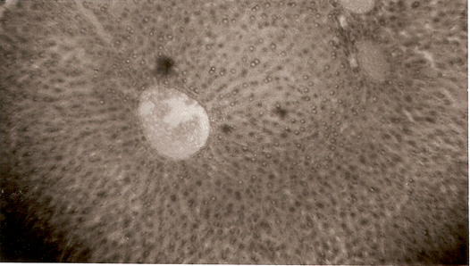
Figure 1 X 10 Transverse Section of Liver Lobule (hepatocytes) in Mice (Control group) Stain: Hematoxylin & Eosin
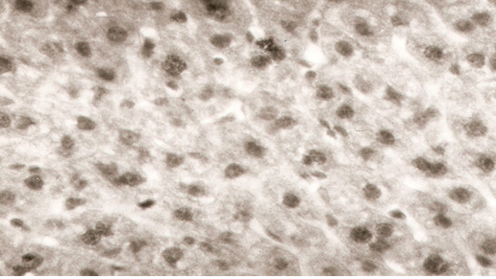

Figure 2 X 40 Transverse Section of Liver Lobule (hepatocytes) in Mice showing no particvlar changes in the hepatocytes (Low dose group) Stain: Hematoxylin & Eosin

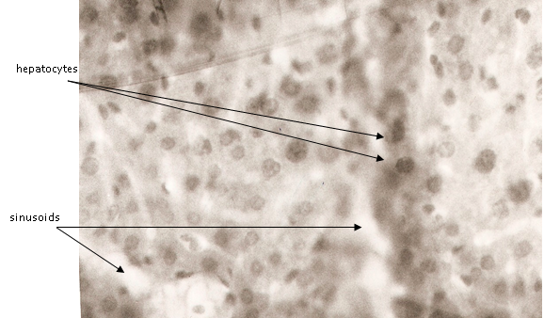Figure 3 X 40 Transverse Section of Liver Lobule (hepatocytes) in Mice showing abundant changes in the hepatocytes, such as increased size and dark appearance of the cytoplasm, increased size of the sinusoids. (Moderate dose group) Stain: Hematoxylin & Eosin

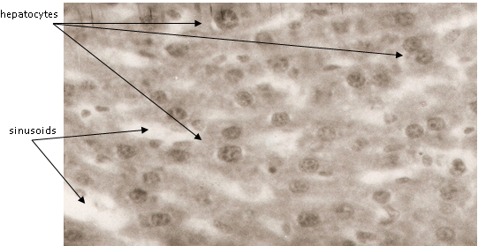
Figure 4 X 40 Transverse Section of Liver Lobule (hepatocytes) in Mice showing more abundant changes in the hepatocytes, such as increased size and dark appearance of the cytoplasm, increased size of the sinusoids. (High dose group) Stain: Hematoxylin & Eosin

