An Attempt to Utilize One Gel Double Staining Technique to Visualize DNA – Seminal Proteins Interactions

Mohammed Baqur Sahib Ahmed Al-Shuhaib* Ali Hmood Al-Saadi† Mahanem Mat Noor‡
*Dept. of Biology, College of Science for Women, University of Babylon, Hilla, Iraq.
†Dept. of Biology – College of Science, University of Babylon, Hilla, Iraq.
‡School of Biosciences and Biotechnology, Faculty of Science & Technology, University Kebangsaan, Malaysia (UKM).
*To whom correspondence should be addressed. e-mail; baquralhilly_79@yahoo.com

M J B

Abstract
The main goal of this research is to test the rate of success of a low cost double staining method in visualizing any DNA-seminal proteins interactions. After collection of rabbit’s ejaculate and removing sperm cells, ion exchange chromatography was used to separate seminal proteins on the basis of their charge. Positively charged seminal proteins were eluted, lyophilized, and involved in this study. After incubation of this eluted group with the DNA, band shift assay was applied on this group. The results were compared. According to the results of this study, we demonstrated the necessity of utilizing a double staining technique for the same band shift gel in order to ensure weather real or false band substitutions were obtained.
محاولة لاستخدام تقنية الهلام الواحد ذو الصبغتين في رؤية تداخلات الـ DNA مع بروتينات السائل المنوي
الخلاصة
ان الهدف الرئيسي لهذا البحث هو لاختبار مدى نجاح طريقة التصبيغ المزدوجة القليلة التكلفة في رؤية تداخلات الـ DNA مع بروتينات السائل المنوي. بعد جمع مني الأرانب وازالة الخلايا النطفية, تم استخدام كروماتوغرافيا التبادل الأيوني لفصل البروتينات المنوية على أساس شحنتها. تم استرداد البروتينات المنوية الموجبة الشحنة وتم تجفيدها وادخالها في هذه الدارسة. بعد حضن هذه المجموعة المستردة مع الـ DNA, تم تطبيق فحص ابدال الحزمة على هذه المجموعة. تم مقارنة النتائج. ووفقا للنتائج المستحصل عليها في هذه الدراسة, أثبت ضرورة استخدام تقنية التصبيغ المزدوجة في الهلام ذو الحزمة المبدلة وذلك لأجل معرفة فيما اذا حدث هنالك استبدال في موقع الحزمة أم لم يحدث.
ـــــــــــــــــــــــــــــــــــــــــــــــــــــــــــــــــــــــــــــــــــــــــــــــــــــــــــــــــــــــــــــــــــــــــــــــــــــــــــــــــــــــــــــــــــــــــــــــــــــــــــــــــــــــــــــــــــــــــــــــــــــــــــــــــــــــــــــــــــــــــــــــــــــــــــــــــــــــــــــــــــــــــــــــــــــــــــــــــــــــــــــــــــــــــــــــــــــــــــــــــــــــــــــــــــــــــــــــــــــــــــــــــــــــــــــــــــــــــــــــــــــــــــــــــــــــــــــــــــــــــــــــــــــــــــــــــــــــــــــــــــــــــــــــــــــــــــــــــــــــــــــــــــــــــــــــــــــــــ

Introduction
Seminal fluid of mammals contains several barriers that prevent the entry of the exogenous DNA into the sperm cells [1]. These barriers are identified to explore their inhibitory roles through multiple mechanisms, such as DNA hydrolytic (DNase) activity [2], or DNA neutralization activity [3], or by other mechanisms [4]. Several papers are described the anti-DNA entry mechanisms that usually available in seminal fluids of several mammals such as mice [5], hamster [6], bulls [2], and human [7]. Thus, it is usually possible to postulate that seminal fluid inhibitory proteins exert their inhibitory role(s) through their binding with the exogenous DNA. Accordingly, several extensive and technically demanded experiments are done in order to demonstrate such mode of interaction such as, Southwestern analysis or through radioactively labeled band shift assay gels [4].
In this paper, we try to utilize a simplified tool to deal with seminal proteins – exogenous DNA interaction, in which no sophisticated labeling technique used. Instead, a highly sensitive and low cost stain is used which may be comparable with several labeling technique to identify any band substitution or to demonstrate any change in the mode of seminal fluid after its binding with exogenous DNA.

Materials and Methods
Materials
Kit; PCR SuperMix (Invitrogen – Cat. # 0572-014), PageSilver™ Silver Staining Kit (Fermentas - Cat # K0681), Ladder; DNA size marker; MassRuler™DNA Ladder Mix (Fermentas – Cat. # SM0403), Protein size Marker; Protein low molecular weight size marker (Amersham – code: 17-0446-01), Oligos; 364 bp PCR fragment created from the amplification of GFP gene of gWizGFP vector (Aldevron– Cat. # 5006).
Experimental Animals; Eight sexually mature healthy white rabbits were included in this study. New Zeeland white rabbits were raised in the animal house in the school of bioscience and biotechnology / FST / UKM. They were individually housed under controlled conditions of temperature (19 – 21°C) and standard artificial light (12 hour light and 12 hours dark). A diet of grower rabbits pellets (ad libitum) and fresh water was provided. Animals were cared according to international standards management established for the care and use of laboratory animals in facilities approved by the University Kebangsaan Malaysia Animal Ethics Committee (UKMAEC).
Methods
Semen collection and seminal fluid separation: Rabbit's semen was collected by homemade artificial vagina; seminal fluid (supernatant) was separated from sperm cells (pellet) by centrifugation (3000xg for 3 min each) three times at room temperature [8]. Protein concentration of seminal fluid was measured by UV – visible spectrophotometer (Shimadzu – Japan). Variable concentrations of seminal proteins were incubated with gWizGFP vector at room temperature. Results were analyzed by double stained band-shift polyacrylamide gel electrophoresis.
Band shift assay of seminal fluid –DNA: 1µg gWizGFP vector was incubated with increasing concentrations of rabbit’s seminal fluid (ranging from 1, 2, 3, 4 and 5 µl) and completed to 30µl with sterile deionized water. The incubation was lasted for 60 minutes at room temperature. After incubation, several concentrations were made and analyzed on band-shift polyacrylamide gel according to Lin method [9]. Briefly, low molecular weight size marker, gWizGFP vector, as well as gWizGFP DNA – seminal fluid mixtures were applied in 5% band-shift – PAGE. The electrophoresis was applied at 200V at room temperature for 30 minutes. The gel then stained with silver staining kit (Fermentas - Cat # K0681).
Fractionation with ion exchange chromatography (IEC): Seminal fluid proteins were fractionated according to Teixereira et al., [10] and Villemure et al., [11] with some modifications.
A. Resin selection: 5 g DEAE cellulose (Sigma Aldrich – USA) was applied as anion exchanger for rabbit seminal fluid fractionation.
B. Regeneration of DEAE-cellulose: All of the preparative steps were conducted in 500ml capacity flask. DEAE-cellulose (anion exchanger) was purchased from Sigma. 5 g DEAE-cellulose was slowly added to 300 ml 0.1M sodium hydroxide (pH reached to 13). The sodium hydroxide solution was discarded and the resin was washed with double distilled water until pH reached to 8.0. Then the solution was replaced with 0.1 M hydrochloric acid (pH reached to 1.0). The resin was washed with double distilled water until pH reached to 3.0. The distilled water was discarded and replaced with 500mM 10X tris buffer pH 8.0. The 10X buffer was discarded and then the resin was equilibrated with 50 mM tris HCl pH 8.0. After removing more fines, the suspension of DEAE-cellulose resin was transferred into a glass column (2x20 Bio-Rad – USA). Resin –after its packing with 0.01M PBS – was stored in 4ºC until processed.
C. Loading sample: pH of DEAE cellulose effluent was checked up before seminal fluid was applied. Gravity flow was applied. One ml of seminal fluid containing about 3mg of protein was dissolved in 0.02 M phosphate buffer, pH 7.3, and loaded onto an ion exchange chromatography column (DEAE-cellulose, 2 x 20 cm), which was previously equilibrated with the same buffer.
D. Elution of positively charged proteins: The column was washed and eluted with 0.01M phosphate buffer pH 7.3. The column effluent was collected with manual fractionation, 3ml per fraction. Protein concentrations were spectrophotometrically determined.
Lyophilization of positively charged rabbit’s seminal fluid protein fractions: each five fractions 1 to 5, 6 to 10, 11 to 15, and 16 to 20 were freeze dried (Lyotrap – UK).
Band shift assay for Incubation of eluted and lyophilized positively charged seminal fractions - DNA: Fixed concentration (6µl) 364bp PCR fragment was incubated with different increasing concentrations of DEAE cellulose positively charged fractions (through 1µg, 5µg, and 10µg) for one hour at room temperature. After incubation, each sample – incubated and non-incubated sample –was analyzed on 5% band shift polyacrylamide gel. After electrophoresis band shift polyacrylamide gel was stained with two dyes, the first one was ethidium bromide staining solution (0.625 μg/ml) for 30 min. Picture was taken by photodocumentation unit (Alpha Innotech – USA). After staining with ethidium bromide, the same gel was stained by silver staining kit. Picture was taken by a digital camera (Sony – China). Ethidium bromide stained and silver nitrate stained gel pictures were compared.

Results and Discussion
Comparison between 364bps PCR fragment incubated and non-incubated rabbits seminal fluid on single and double stained band shift – PAGE: Five micrograms of seminal fluid was incubated with the same concentrations of PCR fragment (figure 1). Two activities was identifies in band shift PAGE; the first is the classic DNase activity, and the second is a slight DNA retardation activity.
Single and double stained Band shift PAGE assay: Although band shift PAGEs were originally designed to detect electrophoretic band dislocation in nucleic acids only and not in proteins [12], but the inclusion of double staining technique for the same gel could sometimes considered as an invaluable and helpful tool to give more data could not be provided by a single staining technique [13]. In figure (2) more data were provided by silver nitrate as a second stain for the same gel instead of using any commercially available and cost effective labeling methods [14, 15] since the sensitivity of staining with silver nitrate was equal to some staining techniques to the sensitivity of radioactive method [16].

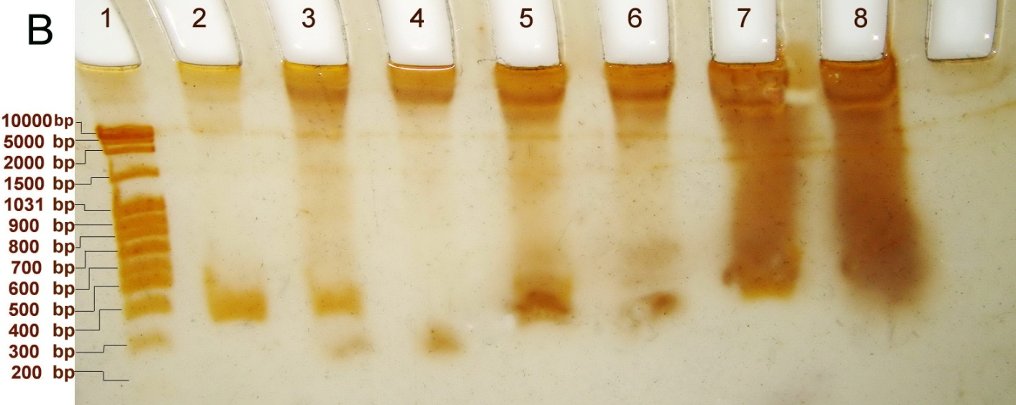
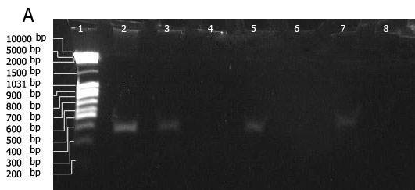
Figure 1 Comparison between 364bps PCR fragment incubated and non-incubated rabbits seminal fluid sample on ethidium bromide stained (A) and silver stained (B) band-shift assay polyacrylamide gel. Lane 1: 15µl DNA size marker (Fermentas). Lane 2: 3 µl 364bps PCR fragments (amplified from gWizGFP vector). Lane 3: 12.5 µl taken from incubation of 3 µl 364bp PCR product with 1 µg rabbit seminal fluid. Lane 4: 12.5 µl taken from 1 µg rabbit seminal fluid. Lane 5: 12.5 µl taken from incubation of 3 µl 364bp PCR product with 3 µg rabbit seminal fluid. Lane 6: 12.5 µl taken from 3 µg rabbit seminal fluid. Lane 7: 12.5 µl taken from incubation of 3 µl 364bp PCR product with 5 µg rabbit seminal fluid. Lane 8: 12.5 µl taken from 5 µg rabbit seminal fluid. bandshift-PAGE electrophoresis conditions: polyacrylamide concentration 5%. Voltage applied: 200 V (15.38 V/cm), run time: 30 min.

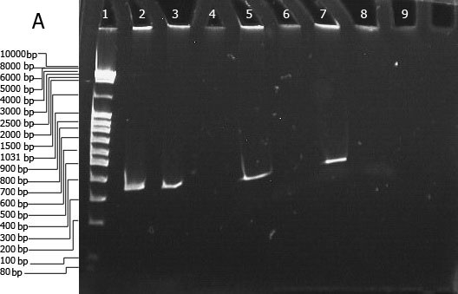
The exact location of shifted band with respect to electrophoresed seminal proteins was made known. In this figure, using only ethidium bromide was sufficient only to observe band substitution without providing further details. While, applying the additional silver nitrate dye identified only the electrophoretic repulsion of the positively charged fractions. By utilizing the second dye it was so easy to see how much repulsive forces were existed on the electrophoresed positively charged seminal fractions. Moreover, the second stain showed that there was proportional relationship between the amount of positively charged seminal fractions and the degree of repulsion noticed on the band-shift PAGEs. Therefore, instead of getting one piece of information of this run, three pieces of information were obtained. This double staining technique could identify DNA retardation extent, the degree of protein repulsive forces, as well as the relationship between DNA retardation and the degree of protein repulsive forces through the gel.

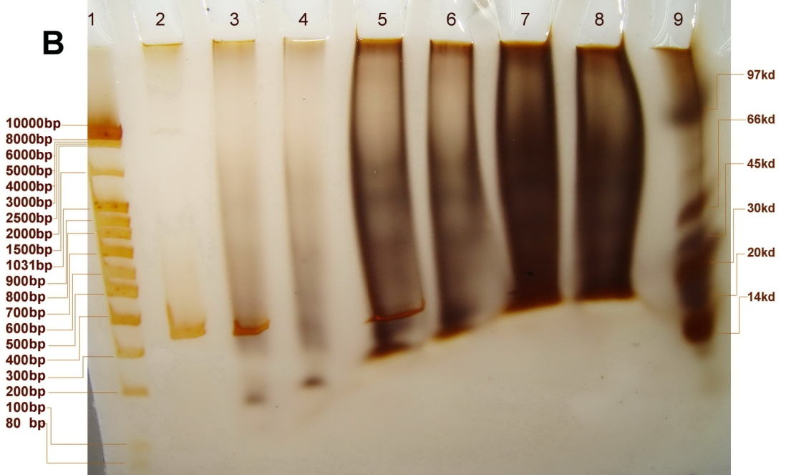

Figure 2 Comparison between 364bps PCR fragment incubated and non-incubated DEAE cellulose separated positively charged fractions on ethidium bromide stained (A) and silver nitrate stained (B) band-shift assay polyacrylamide gel. Lane 1: 15 µl DNA size marker (Fermentas). Lane 2: 6 µl 364bp PCR product. Lane 3: 15 µl taken positively charged seminal fractions. Lane 8: 15 µl taken from 10 µg lyophilized positively charged from incubation of 6 µl 364bp PCR product with 1 µg lyophilized positively charged seminal fractions. Lane 4: 15 µl taken from 1 µg lyophilized positively charged seminal fractions. Lane 5: 15 µl taken from incubation of 6 µl 364bp PCR product with 5 µg lyophilized positively charged seminal fractions. Lane 6: 15 µl taken from 5 µg lyophilized positively charged seminal fractions. Lane 7: 15 µl taken from incubation of 6 µl 364bp PCR product with 10 µg lyophilized seminal fractions. Lane 9: 8µl low molecular weight protein size marker (Amersham). bandshift-PAGE electrophoresis conditions: polyacrylamide concentration 5%. Voltage applied: 200 V (15.38V/cm), run time:30min.

Consequently, when such seminal fluid positively charged fractions were incubated with exogenous DNA, it was mistakenly demonstrated that a sort of band substitution was identified. This was occurred when only DNA binding stain (ethidium bromide) was used. But another conclusion was obtained when both DNA – protein binding stain (silver nitrate) was used. In case of using this second stain, it was demonstrated that the band substitution was just occurred as a result of DNA neutralization only because of the altered nature of these positively charged fraction. Despite the fact the band shift assay was not designed to give high resolution of proteins since it was specific for DNA only, but the necessity of using another dye was so mandatory to confirm the results obtained in the first DNA binding stain was used.

Acknowledgements
Special thanks to Ms. Qumaria (School of Bioscience and Biotechnology/Faculty of Science and Technology/University Kebangsaan Malaysia) for her unlimited technical support.

References
1. Lavitrano, M., Busnelli, M., Cerrito, M. G., Giovannoni, R., Manzini, S., and Vargiolu, A. (2006).Sperm-mediated gene transfer. Reproduction, Fertility and Development, 18, 19 – 23.
2. Tanigawa Y, Yoshihara K, Koide SS. (1975). Endonuclease activity in bull semen, testis and accessory sex organs. Biol. Reprod., 12: 464-70.
3. Camaioni, A., Russo, M.A., Odorisio, T., Gandolfi, F., Fazio, V.M., and Siracusa, G. (1992). Uptake of exogenous DNA by mammalian spermatozoa: Specific localization of DNA on sperm heads. Journal of Reproduction & Fertility 961: 203-212.
4. Zani M, Lavitrano M, French D, Lulli V, Maione B, Sperandio S, Spadafora C. (1995). The mechanism of binding of exogenous DNA to sperm cells: factors controlling the DNA uptake. Experimental Cell Researches 2 17: 57-64.
5. Carballada R, Esponda P. (2001). Regulation of Foreign DNA Uptake by Mouse Spermatozoa. Experimental Cell Research, 62, 104–113.
6. Sotolongo B., Huang T., Isenberger E., & Ward S. (2005). An Endogenous Nuclease in Hamster, Mouse, and Human Spermatozoa Cleaves DNA into Loop-Sized Fragments. Journal of Andrology, 26 (2); 272 – 280.
7. Singer R, Sagiv M, Allalouf D, Levinsky H, Servadio C. (1983). Deoxyribonuclease activity in human seminal fluid. Arch Androl; 10: 169-72.
8. Brackett BG, Boranska W, Sawicki W, Koprowski H. (1971). Uptake of heterolougous genome by mammalian spermatozoa and its transfer to ova through fertilization. Proceeding of the National Academy of Science USA; 68:353-357.
9. Lin, B. (1992) Gel shift analysis with human recombinant AP1 (c-jun): The effect of poly d(I-C) on specific complex formation. Promega Notes 37, 14–18.
10. Teixeira D., Melo L., Gadelha C., Cunha R., Bloch C., Rádis-Baptista G., Cavada B., and Freitas V. (2006). Ion-exchange chromatography used to isolate a spermadhesin-related protein from domestic goat (Capra hircus) seminal plasma. Genetic Molecular Researches, 5 (1): 79-87.
11. Villemure M., Lazure C. and Manjunath P. (2003).Isolation and characterization of gelatin-binding proteins from goatseminal plasma. Reproductive Biology and Endocrinology, 1 (39); 1 – 10.
12. Ausubel, F.M. et al. (1989) In: Current Protocols in Molecular Biology, Vol. 2, John Wiley and Sons, New York.
13. Kido, N., Ohta, M., and Kato, N. (1990). Detection of Lipopolysaccharides by Ethidium Bromide Staining after Sodium Dodecyl Sulfate-Polyacrylamide Gel Electrophoresis. Journal of Bacteriology 172: 1145-1147.
14. Bayarsaihan D., Soto R. J., and Lukens N. (1998). Cloning and characterization of a novel sequence-specific single-stranded DNA-binding protein. Biochemistry Journal 331, 447-452.
15. Millership J. J., Waghela P., Cai X., Cockerham A. and Zhu G. (2004). Differential expression and interaction o ftranscription co-activator MBF1 with TATA-binding protein (TBP) in the apicomplexan Cryptosporidium parvum. Microbiology; 150, 1207–1213.
16. Christensen M., Sunde L., Bolund L., Orntoft TF.(1999).Comparison of three methods of microsatellites detection. Scand. J. Clin. Lab. Invest. 59; 167–178.

