Fortified Topical Vancomycin Drops in the Treatment of Bacterial Keratitis

Alya`a Abood Kareem
College of Medicine, Kufa University, Kufa, Najaf, Iraq.

M J B

Abstract
Background:Bacterial keratitis is among the most important external ocular surface diseases because of its associated serious morbidity.Variable bacterial agents are implicated as causative agents and emerging bacterial resistance to the routinely used antibiotics should be always thought of. The aim of this study is to evaluate the role of fortified vancomycin drops in managing bacterial microbial keratitis.
Patients and methods: thirty seven patients with bacterial microbial keratitis were included in this study,19 patients(Group A) received the empirical monotherapy; ciprofloxacin eye drops and 18 patients(Group B) received the empirical dual therapy; fortified gentamicin plus cefuroxime eye drops.Response to treatment was monitored and non responding cases in the two groups received additional fortified vancomycin drops(50mg/ml).
Results: In group A, 14 patients (73.3%) showed positive response to the empirical treatment within two days and 5 (26.3%) did not. In group B, 12 patients (66.7%) responded well and 6 (33.3%) did not.The eleven non responding cases in both groups; A and B, were given topical vancomycin drops (50mg/ml) as an additional antibiotic. Eight of them (72.7%) were labeled to be good responders within the first 24 hours. The remaining three patients (27.3%) were not and two of them (18.2%) ended in vascularization and opacification of the cornea while the last one (9.1%) developed corneal perforation.
Discussion and conclusion: topical fortified vancomycin shows positive additive effect when added to the empirical mono or dual therapy regimens we usually use in the treatment of bacterial keratitis .It saved two thirds of the resistant infected eyes with a more potent effect when combined with the dual therapy regimen (P value <0.05) .
Recommendations: In view of the wide spread, often unjustified, use of topical antibiotics in our society and the expected microbial resistance we recommend considering adding this medication to the empirical regimen of the dual therapy (gentamicin and cefuroxime) or monotherapy (fluroquinolone) specialy in cases of chronic ocular surface disease and chronic use of antibiotic drops.
قطرات الفانكومايسين العينيه المركزة لعلاج التهاب القرنية البكتيري
الخلاصة
التهاب قرنية العين البكتيري من اهم الامراض العينية المسببة للمعاناة وبالاخص في مجتمعنا المعروف بكثرة استعمال قطرات العين من المضادات الحيوية وبدون وصفات طبية في اغلب الاحيان. ومع ازدياد احتمالية مقاومة البكتريا للعلاج التقليدي لمثل هذه الحالات تبرز الحاجة لاعتماد نظام علاجي جديد لضمان علاج اكثر فاعلية.
تمت دراسة استعمال عقار الفانكومايسين المحضر بقطرات عينية من محلول الزرق الوريدي كمادة مساعدة للعلاج التقليدي المعتمد لدينا واثبتت الدراسة فاعلية هذا العقار في مساعدة العقاقير المعتمدة سابقا وخصوصا عند وجود حالات مقاومة بكتيريه . لذا ينصح باعتماد قطرات الفانكومايسين في علاج الحالات المتقدمة والمتوقع معها وجود مقاومة بكتيرية وفي حالات المرضى المعتادين على الاستعمال المستمرأو المتكرر للمضادات الحيوية الموضعيه.
ــــــــــــــــــــــــــــــــــــــــــــــــــــــــــــــــــــــــــــــــــــــــــــــــــــــــــــــــــــــــــــــــــــــــــــــــــــــــــــــــــــــــــــــــــــــــــــــــــــــــــــــــــــــــــــــــــــــــــــــــــــــــــــــــــــــــــــــــــــــــــــــــــــــــــــــــــــــــــــــــــــــــــــــــــــــــــــــــــــــــــــــــــــــــــــــــــــــــــــــــــــــــــــــــــــــــــــــــــــــــــــــــــــــــــــــــــــــــــــــــــــــــــــــــــــــــــــــــــــــــــــــــــــــــــــــــــــــــــــــــــــــــــــــــــــــــــــــــــــــــــ

Introduction
Among the external ocular diseases, bacterial keratitis has received a great deal of attention because it is associated with serious morbidity.[1] It is a vision threatening disease that causes severe pain ,conjunctival hyperemia, anterior chamber inflammation and occasionally may lead to stromal melting and corneal perforation.[2] Urgent identification and eradication of the causative agent(s) is therefore required.[3] Microbial invasion may cause suppuration of the cornea and mask definite clinical features indicating the causative agents.[4] Almost any species of bacteria can infect the cornea if the integrity of the natural anatomic barrier is compromised and in the presence of particularly invasive bacteria such as P.aeruginosa and S.aureus, corneal perforation have been reported and can occur in less than 24 hours.[5] Microbial etiology of stromal microbial keratitis has a wide spectrum that varies somewhat with regards to the geographical locations according to the climatic conditions, predisposing factors and demographic characteristics of the patients.[3,4,6] in the developing countries, it is one of the leading causes of visual disabilities with non surgical trauma being the most important predisposing factor. While in the developed countries its incidence has increased during the last three decades with the wide spread use of contact lenses.[4, 7, 8] Other risk factors include ocular surface diseases and previous ocular surgery. Staphylococcus has been reported to account for 80% of all cases of bacterial keratitis in certain geographical areas, and nearly half of these infections are due to staphylococcus epidermidis.[9,10] In most cases, microbial keratitis can be controlled by commercially available antimicrobial ophthalmic agents after doing corneal scraping for diagnostic purposes.[2] Empiric treatment regimens, including monotherapy with a broad spectrum antibiotic (usually one of the quinolones) or dual therapy (cefuroxime and gentamicin) covering both gram positive and negative bacteria, are often proving effective in managing such cases.[11,12]
In Iraq, as well as in the Middle East, little information is available about stromal microbial keratitis and the effective first line recommended antibiotic treatment. Corneal scraping for diagnostic culture is seldom done and treatment is not based on microbial investigation.[4,8] The wide use of an antimicrobial agent increases risks of selective resistant to it.[13] in fact , about 30-50% of nosocomially acquired infections are resistant to agents such as aminoglycosides, cephalosporins, erythromycin, tetracycline hydrochl-oride, fusidic acid, rifampicin and quinolone.[9,13-15] Such facts definitely call for thinking about new line of treatment to be considered or added to the well established empirical protocol. The aim of this study is to evaluate the role and effectiveness of topical vancomycin drops in cases of bacterial keratitis that show no or inadequate response to the empiric antimicrobial therapy used routinely in our practice.

Patients and Methods
Thirty seven patients with stromal microbial keratitis of variable predisposing factors or causes were included in this case series study which was conducted in Kufa University Teaching Hospital from March 2008 till September 2010.
All patients had stromal corneal infiltrate and suppuration with signs of inflammation frequently with overlying ulceration. The study did not include cases of hypersensitivity keratitis (marginal keratitis, Mooren ulcer), suspected fungal infection indicated by history of trauma by organic materials and/or characteristics clinical features , very deep ulceration or eminent perforation.
All cases received empiric topical antibiotics.19 patients (group A) received the dual therapy regimen of fortified gentamicin drops (15mg/ml) and cefuroxime drops (50mg/ml) hourly while 18 patients (group B) received ciprofloxacin eye drops (0.3%) hourly as initial therapy.
To monitor the response to treatment the size of the suppuration, size and depth of the concurrent ulceration and anterior chamber reaction were checked under slit lamp visualization for each infected eye daily.
Cases that had slow or no response to the initial mono- or dual therapy after 48 hours of initialization of medication were subjected to an additional topical antibiotic;vancomycin. Topical vancom-ycin drops in a concentration of (50mg/ml) were prepared by reconstituting the parenteral antibiotic with sterile injection water and refrigerated at 4◦C in dark. This was added to the previous prescription with a frequency of instillation of one drop every two hours. The responses were checked and recorded for each eye daily.
Statistical analysis was done using the frequency and percentage. Chi square test was used to study the significance of the differences with a P value of 0.05 considered as the upper limit for statistical significance (95% confidence limit).
Results
Thirty seven patients with presumed bacterial microbial keratitis of variable predisposing factors were included in this study. The mean age of the studied patients was 38.7±8.3 years with a range of 8-72 years. Twenty one patients ( 56.8 %) were male and sixteen (43.2%) were female. Figures 1 and 2 demonstrate age and sex distribution of our patients.
Table1 and figure 3 shows the distribution of the patients according to the predisposing factors.
Group A patients (19 eyes, 51.4%) received the dual regimen of fortified gentamicin drops (15mg/ml) and cefuroxime drops (50mg/ml) every one hour as empirical dual therapy whereas group B patients (18 eyes, 48.6 %) received topical ciprofloxacin drops (0.3%) hourly as mono therapy. In group A, 14 patients (73.3%) showed positive response within two days and 5 (26.3%) did not. In group B, 12 patients (66.7%) responded well and 6 (33.3%) did not. P value according to Chi square test was >0.5(no significance difference).Table 2 and figure 4.
The risk factors of the eleven resistant cases for the initial antibiotic therapy in the two groups are shown in table 3.
The eleven non responding cases in both group A and B were given topical vancomycin drops (50mg/ml) as an additional antibiotic. Eight of them (72.7%) were labeled to be good responders within the first 24 hours with no significance difference between the two groups (P >0.1). The remaining three patients (27.3%) did not improve upon the addition of a thrd antibiotic topically, two of them (18.2%) ended in vascularization and opacification of the cornea while the last one (9.1%) developed corneal perforation.Table 4 and figure 5.

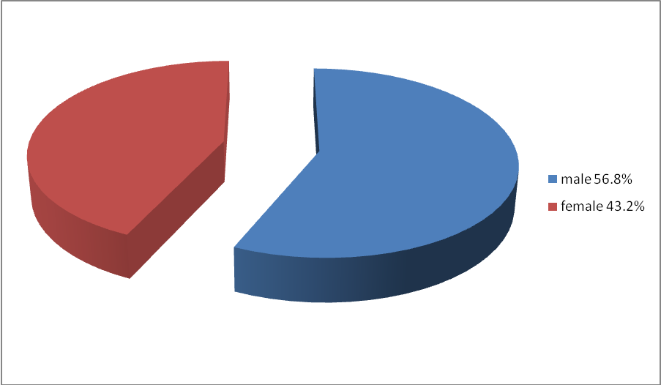Figure 1 Sex distribution of the studied patients
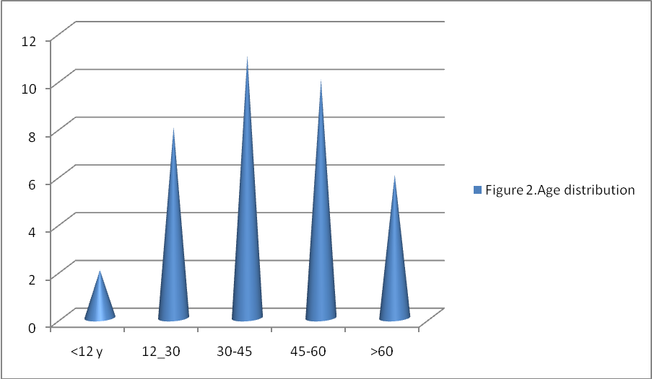Figure 2 Age distribution of the studied patient
Table 1 predisposing factors for bacterial keratitis in the studied patients
Risk factors | No.of patients(%) | Male patients | Female patients
Trauma and foreign body | 12(32.45%) | 10 | 2
Chronic anterior surface disease and dry eye | 11 (29.7%) | 4 | 7
Manipulation by inexperienced person | 7 (18.9%) | 5 | 2
Postoperative keratitis | 3 (8.1%) | 1 | 2
Stitch abscess | 2 (5.4%) | 1 | 1
Contact lens | 2 (5.4%) | 0 | 2
Total | 37 (100%) | 21 | 16

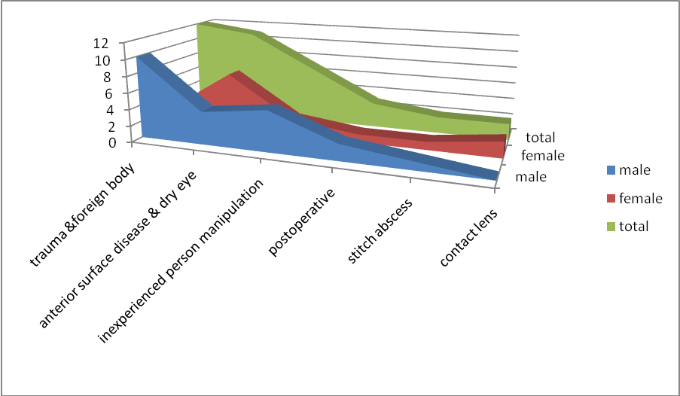Figure 3 Predisposing factors for bacterial keratitis in the studied patients
Table 2 Response to treatment according to the treatment groups
Treatment groups | No. of patients | Good responders | Bad responders
Group A (mono therapy) | 19 | 14 | 5
Group B (dual therapy) | 18 | 12 | 6
Total | 37 | 26 | 11
P >0.5
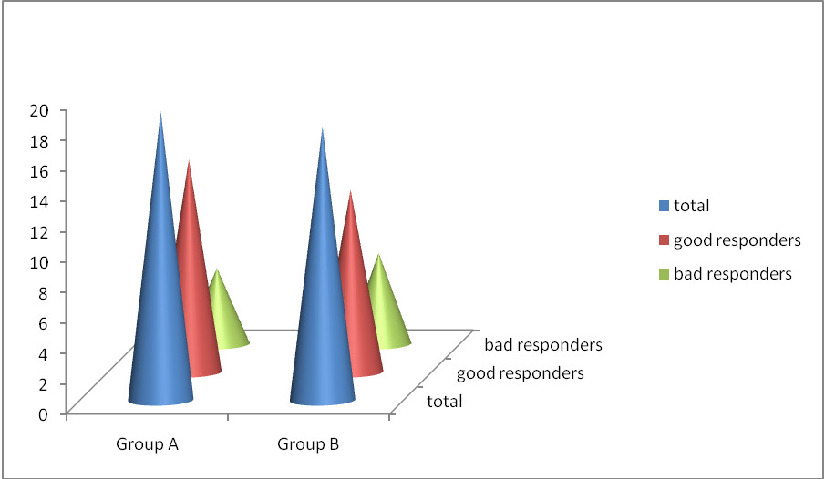Figure 4 Response to the empiric treatment regimens in the two groups of patients
Table 3 predisposing factors for resistant cases of bacterial keratitis
Predisposing factor | No. of cases
Chronic eye surface disease | 8
Inexperienced person | 1
Contact lens | 1
Postoperative endophthalmitis | 1
total | 11

Table 4 Response after adding vancomycin for the resistant cases
Treatment groups | Total | Additive effect | Non additive effect
Group A | 5 | 4 | 1
Group B | 6 | 4 | 2
Grand total | 11 | 8 | 3
P>0.1
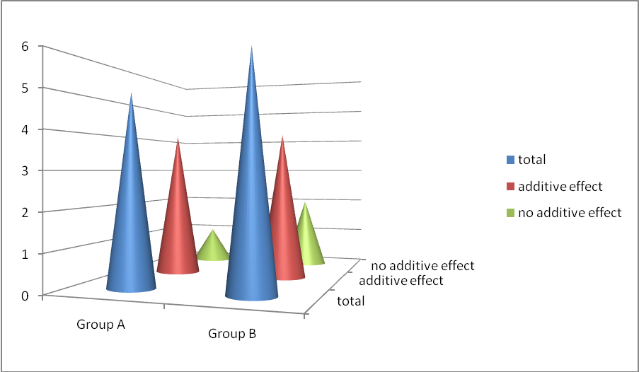Figure 5 Response of the resistant cases in the two treatment groups after adding vancomycin.

Discussion
Failure to implant standard management protocol for infectious keratitis at first contact is a major factor contributing to ocular morbidity.[16] Clinicians should be aware that strains of some bacteria, eg staphylococci, extremely resistant to gentamicin and/or ciprofloxacin may cause keratitis.[9,13,17] Staphylococci are the commonest bacterial etiological agent for microbial keratitis in our society in which the over use of the commonly available ophthalmic agents like ciprofloxacin and gentamicin is well known. Thinking about the above two facts should drive our attention to look for a pharmacological agent to be used when we face a patient with an unfavorable response to the empirical antibiotic therapy that we usually refer to during the first few hours of commencing our treatment.
Vancomycin is a semi synthetic member of the beta lactamase resistant penicillins family. As multiresistant bacteria proliferate, vancomycin is, in fact, a potent agent. It is bactericidal to most gram positive bacteria by binding to structural precursors of the bacterial cell wall. For Gram negative enterococci it is a bacteristatic agent but the synergistic combination with gentamicin produces a bactericidal effect. It is a useful alternative for multiresistant organisms.[18] Although topical vancomycin(ointment) has been used successfully to treat methicillin resistant staphylococcal blepharo-conjunctivitis, [9] unfortunately commercially available forms of vancomycin are not available for the treatment of keratitis.[2] Vancomycin was found to penetrate the cornea well and appeared to concentrate within the corneal stroma at levels that exceed the minimum inhibitory concentration for most key corneal patrhogens.In patients with corneal bacterial infiltrates ,in which the epithelial layer is damaged, stromal penetration of vancomycin is even higher and subconjunctival injection of the drug achieves therapeutic concentrations of the drug in the aqueous.[10] The 5% vancomycin solution (50mg/ml) proved to be potent and can have stable physical properties for up to 14 days after preparation from parenteral antibiotics by reconstituting them with sterile injection water and refrigeration at 4 °C in the dark.[19]
In regions where bacterial keratitis is predominant, the initial therapy is either fluroquinolone monotherapy or fortified antibiotics dual therapy. [4,20]In our study, treatment was started empirically for all the patients with the mono- or dual therapy protocols (ciprofloxacin or gentamicin plus cefuroxime respectively). Microbiological investi-gations were not performed for all the patients because gram stain smears are not very dependable for therapeutic decision in bacterial keratitis and also because of the relatively low positive yield of cultures. Actually only 3 patients in our series had dependable culture results out of 17 smears and scrapings that were performed. Some of the patients were already on topical antibiotics when received and that was one of the possible causes for negative microbial investigations. In view of the strong possibility of microbial resistance to the commonly available antibiotics specially in societies like ours, where you can find unauthorized or inexperienced medical personnel prescribing and overprescribing topical antibiotics for patients who find it easier to reach such persons than to consult a specialist, non responding cases of microbial keratitis are actually emerging. One should think of modifying the usual empirical regimen we depend on in our practice. In group A, 5 patients out of 19 (26.3%) didn`t show favorable response within the first 48 hours of starting the empirical dual therapy and in group B the slow responders were 6 out of 18 (33.3%).Responses were recorded daily depending on the changes in the size and depth of corneal ulcerations, size of suppuration, anterior chamber reactivity and the patient`s complaint.Statistically the difference in the two groups responses was not significant with a P value >0.5 .For all the non or slow responding cases, topical vancomycin drops were added at a concentration of 50mg/ml and was used as an additional therapy to the previously used regimens. It was helpful in achieving good positive additive effect in 8 out of 11 patients (72.7%) within the first 24 hours. If we compare the additive effect of vancomycin on the two groups we find that apparently group A non responding patients did better than those from group B but with a P value >0.1 the difference was considered non significant. Our sample is considered a small one and including more cases in such study would be more informative in this regards. Nevertheless, the results are promising because saving about two thirds of the eyes with microbial keratitis caused by resistant bacteria to the traditionally used medication is a good result (72.7%). Vancomycin accelerated the improvement and saved the eyes of two thirds of resistant cases with bacterial keratitis. The remaining one third of the resistant keratitis in our series ended by corneal opacification and vascularization (2 cases) and perforation (one case).
Sotozono and his coworkers concluded in their study that factors associated with ocular colonization by antibiotic resistant staphylococci were long term use of antibiotics and/or steroids and hospitalization.[21]Studying the resistant cases we encountered in the two groups of medications and in the two phases of treatment shows that most of the cases,8 patients (73%) were those with a history of chronic external surface diseases, namely old trachoma and/ or dry eye, those are expected to be chronic users of the commonly available topical medications and might have resistant bacterial colonization on their external ocular surfaces. One patient was a recent contact lens user who have shared her lens with a friend and another patient was a victim of a traditional healer who claims to have the skills of foreign body removal.The last unlucky patient was a pseudophakic patient with an acute postoperative endopthalmitis and keratitis. It was the contact lens induced and the postoperative resistant keratitis that ended with opacification and vascularization. The perforated cornea was the fate of an old lady with trachoma complicated by trachiasis and dry eye with many recurrent attacks of keratitis.Pflug-felder and coworkers have found that the interaction between vancomycin and gentamicin on gram positive endophthalmitis isolates was additive or synergistic depending on the bacterial species.[22] Currently it is still wise to reserve vancomycin administration for the treatment of corneal ulcers where cultures and sensitivities demonstrate gentamicin resistant gram positive organisms.[9] If we consider the fact of non scientific use of topical antibiotics and the ease of obtaining them, we can judge that chronic complainers often find it easy to use common commercially available drops such as gentamicin or ciprofloxacin and for that reason emergence of resistant strains of bacterial pathogens are anticipated in their vicinity. Thus we recommend considering the use of accurately prepared fortified vancomycin topical solution as an additive agent to the traditionally used mono or dual regimens in our practice while dealing with microbial keratitis especially in cases of chronic anterior surface diseases and for those with the habits of unjustified frequent use of topical medications.

References
1.Dart JK,Stapleton F,Minassion D.Contact lens and other risk factors in microbial keratitis.Lancet .1991;338:650.
2.Hiroshi Eguchi ,Hiroshi Shiota ,Susumu Oguro ,Toshio Kasama.The inhibitory effect of vancomycin ointment on the manifestation of methicillin resistant staphylococcal keratitis in rabbits. J infect Chemother .2009;15:279:283.
3.Mills R.Corneal scraping and combination antibiotic therapy is indicated.Br J Ophthalmol 2003;87:1167-9.
4.Faiz I Al Shakarchi.Initial therapy for suppurative microbial keratitis in Iraq.Br J Ophthalmol 2007;91:1583-7.
5.Shaefer F,Bruttin O,Zografos L,et al.Bacterial keratitis:a prospective clinical and microbial study.Br j Ophthalmol ..2003;85:842-7.
6.Musch DC,Sugar A, Meyer RF.Dermographic and predisposing factors in corneal ulceration.Arch Ophthamol .1983;72:926-30.
7.Saeed Aymen.Risk factors,microbial findings and clinical outcomes in cases of microbial keratitis admitted to tertiary referral center in Ireland.Cornea .April 2009; 28(3):285-292.
8.Faiz I.Al Shakarchi.Dermographic and social study of patients with bacterial keratitis in Iraq.Iraqi Journal of preventive medicine. 2004; 1 (2):118-124.
9.Daniel F Goodman ,John D gottsch.Methicillin resistant staphylococcus epidermidis keratitis treated with vancomycin.Arch ophthalmol. 1988;106:1570-2.
10.M Cahane ,J G Ben Simon, I S Barequet ,et al.Human corneal stromal tissue concentration after consequative doses of topically applied 3.3% vancomycin.Br J Ophthalmol. 2004;88:22-24.
11. Jack J Kanski. Clinical ophthalmology,cornea. Sixth ed. 2007; 9; 258-259.
12.American Academy of Ophthalmology, the eye MD association. Section 8,External disease and cornea.2007-2008;179-183.
13.Robert PY, Adenis JP.Comparative review of topical ophthalmic antibacterial preparations.Drugs. 2001;61(2):175-85.
14.Kowalski RP,Dahaliwal DK,Karenchak LM,et al.Gatifloxacin and moxifloxacin:an in vivo susceptibility comparison to levofloxacin,ciprofloxacin and ofloxacin using bacterial keratitis isolates.Am J Ophthalmol.2003;136(3):500-5.
15.Goldstein MH,Kowalski RP,Gordon YJ.Emerging fluroquinolone resistance in bacterial keratitis: a 5-year review.Ophthalmology.1999;106(7):1313-8.
16. Vajpaee RB,Dada Tnuj, Saxena Rohit,et al. Study of the first contact ma;nagement profile of cases of infectious keratitis: a hospital based study.Cornea. 2009;19(1):52-56.
17. Mader Thomas H, Maher Kathryn L,Stulting R.Gentamicin resistance in staphylococcal corneal ulcers.Cornea.1991;10(5):62-6.
18. Wilhelmus kirk R.Vancomycin revived.Cornea.1982;1(2):103-104.
19.Lin Jane Ming,Tsai Yi-Yu, Fu Ya-Lin.The fixed combination of fortified vancomycin and amikacin ophthalmic solution-VA solution:In vitro study of potency and stability.Cornea.2005;24(6):717-721.
20.Gangopadhyay n,Daniell m,Weih L,et al.Fluroquinolone and fortified antibiotics for treating bacterial corneal ulcers.Br J Ophthalmol 2000;84:378-84.
21.Sotozono Chie,Inagaki Kayoko,Fujita Atsuko,et al.Methicillin resistant staphylococcus aureus and methicillin resistant staphylococcus epidermidis infections in the cornea. Cornea. 2002; 21:s94-s101.
22.Pflugfelder SC,Hernandez E,Fliesler SJ,et al.Intravitreal vancomycin:retinal toxicity,clearance and interaction with gentamicin.Arch Ophthalmol. 1987: 105: 831-837.

