M J B
Staphylococcus aureus and Escherichia coli Experimental Induced Septic and Cryptic Arthritis

Ibrahim M. Shnawa Qasim N. Thewaini Afraa H. Omran

Biology Dept. , College of Science, University of Babylon, Iraq.

Abstract
Models for lapin septic arthritis and cryptic arthritis were developed. Joint infection was determined using several criteria such as sluggishness, loss of appetite, loss of weight, joint swelling, lamness and histopathology. These criteria were applied using two infection routes: the intravenous (IV) and intrarticular( IAI).
Infection through the intravenous route showed marked joint swelling cell wall defective rather than intact state. It failed to induce both, lameness and loss of appetite with minimal weight loss of around 50gm. In the intrarticular route, however, there were appetite loss, weight loss, mild sluggishness and marked joint swelling in CWD rather than intact . Intact Staphylococcus aureus in IV was arthropathic but by IAI was non-arthropathics. Cell wall defective Escherichia coli was arthropathic in both IV and IAI. Both intact and CWD E.coli were arthropathic by IAI .
Thus human arthropathic E.coli isolates showed lapin arthropathy both as intact and cell wall defective but in CWD state there were more severe clinical outcomes, while, human arthropathic S.aureus isolates showed lapin arthropathy in cell wall defective state but not in intact state .
الخلاصة
تم في هذه الدراسة تطوير موديلات من الارنب لكل من التهاب المفاصل القيحي والتهاب المفاصل المتخفي . وقد تحقق من حصول خمج المفاصل عن طريق عدة قرائن مثل بطء الحركة وفقدان الشهية وفقدان الوزن وانتفاخ المفاصل والعرج والفحص النسيجي المرضي . الخمج عبر الوريد قد بين انتفاخ مفاصل ملحوظ في الكائنات المتخفية اكثر من البكتريا السوية وفشل بتوليدالعرج وفقد الشهية مع فقدان وزن واطئ اما في حالة الخمج عبر المفاصل فقد كان هنالك فقد للشهية وفقد للوزن وبطء حركة وانتفاخ مفاصل ملحوظ في البكتريا المتخفية اكثر مما عليه في البكتريا السوية. وكانت المكورات العنقودية مسببة لخمج المفاصل عبر الوريد وليس عبر المفصل . في حين ان اشيريكيا القولون كانت ممرضة عبر الوريد وعبر المفصل وبحالة الشكل المتخفي والشكل السوي من البكتريا .
اذن ، السلالة المستحصلة من مفاصل الانسان لاشيريكيا القولون كانت ممرضة للارنب بحالة كونها متخفية او سوية .الا ان المرض كان اشد بحالة الشكل المتخفي .في حين بينت المكورات العنقودية مرض المفصل في الارنب بحالة الشكل المتخفي وليس بالشكل السوي .
ــــــــــــــــــــــــــــــــــــــــــــــــــــــــــــــــ

Introduction
Laboratory animal models are useful for several biologic, pathologic as well as immunologic purposes of which memication of pathogenesis of infectious agents is one male and female mice as well as male rats were mostly the experimental laboratory animal model used for the demonstration of pathogenesis of septic and cryptic arthritis[1-6]. In the present work, however, it has been tried to put forword a lapin model possibly helpful for the demonstration of septic bacterial arthritis as an analogy to human septic and cryptic arthritis .

Materials and Methods
- Arthropathic organisms :
Normal and cell well defective S.aureus as well as normal and cell wall defective E.coli isolates were elected from :
- Clinically proven septic arthritis .
- Marked swollen joints
- Monocytic infiltrate in synovial fluid
- Culture negative .
2- Preparation of the infectious doses
The intact was bacterial suspensions which were prepared and adjusted to the density of 3x10⁸/ml(7). Cell wall defective suspensions matching 3x10⁸/ml prepared as in 8,9,10 and histopathology sectioning, staining, mounting were performed as in (11).
3- Animals :
Rabbits O. cuniculus was brought from local market, adapted for housing conditions for two weeks and kept thoughtout the experimentation period and they were grouped into two groups each for ten. Then each group was subgrouped into five subgroups four as a test group and one as a control group (Table -1).
4- Parameters for infectivity evolution :
These parameters were as in the following :
- sluggishness
- loss of appetite
- lameness
- histopathology
- weight loss
- swelling of joints
- direct examination
- resolution

Table 1 Laboratory Animals as Regimens

Groups /Sub groups | No of animals | Organism | Dose
Intravenous
 | 2 | C.W.D S. aureus | 0.8x3x10⁸/ml
 | 2 | intact S. aureus | 0.8x3x10⁸/ml
 | 2 | C.W.D. E coli | 0.8x3x10⁸/ml
 | 2 | intact E.coli | 0.8x3x10⁸/ml
 | 2 | saline | 0.8 ml
intraarticular
 | 2 | C.W.D S. aureus | 0.2x3x10⁸ml
 | 2 | intact S. aureus | 0.2x3x10⁸ml
 | 2 | C.W.D. E coli | 0.2x3x10⁸ml
 | 2 | intact E.coli | 0.2x3x10⁸ml
 | 2 | saline | 0.2 ml

Results
1- Sluggishness :
Rabbits, infected with CWDB have shown moderate sluggishness. Intact bacteria induced mild sluggishness and controls showed no evidence of sluggishness.
2- Loss of appetite
Apparently, the four infected animals showed no evidence of loss of appetite in those rabbits infected through intra-articular route which showed mild symptoms of loss of appetite .
3- Loss of weight :
Animals inoculated through IV route with both intact and cell wall defective bacteria were showing weight loss of 43-93 gms. Meanwhile, rabbits infected by CWDB through intra–articular route were showing weight loss of ـ 250 gms and these infected with intact bacteria were ranging around ـ 100 gms ( Tables : 2 and 3).
~
~
4- Joint swelling :
4-1- Intravenous infections :
Severe joint swellings were noted among rabbits with cell defective S.aureus with two death instances. In comparison, cell wall defective E.coli has shown in comparison with cell wall defective E.coli has shown moderate joint swelling. Both of which were more severe than those infected with intact S.aureus and E.coli (Table 3) .
4-2- Intra – articular infections:
Intact cell wall defective E.coli infected rabbits showed joint swelling, but the more severe was that induced by CWDB. Meanwhile, CWD S.aureus showed moderate swelling of the joints in comparison to the lack of swelling noted among intact S.aureus infected rabbits ( Table 3)
- Lameness :
5-1- Intravenous :
No evidence for lameness can be noted among IV infected rabbits with both of cell wall defective and intact S.aureus as well as E.coli (Table 3 and fig. A and B).

Table 2 Effect of experimental infection on animal weight during experimentation period .

Mode of injection | Average of weight for two rabbits before the experiment /gm | Average of weight for two rabbits before the experiment /gm | Average of weight loss/ gm
CWDEc / IV  CWD Sa / IV | 1575  1285 | 1523  1224 | 52  61
CWDEc/ IA  CWDSa/ IA | 1500  1437 | 1258  1310 | 242  127
CW Ec / IV  CW Sa / IV | 1425  1327 | 1332  1259 | 93  68
CW Ec / IA  CW Sa / IA | 1197  1100 | 949  934 | 246  180
Control / IV | 1345 | 1302 | 43
Control / IA | 1580 | 1530 | 50
CWD : Cell wall defective
CW : Cell walled
Ec :E.coli
Sa : Staphylococcus aureus
IV: Intravenous injection
IA: Intra–areticular injection

Table 3 Arthritis determination criteria in experimental animal model
 | Criteria | S.aureus |  |  |  | E. coli |  |  |  | Control
 | Criteria | IV |  | IAI |  | IV |  | IAI |  | Control
 | Criteria | CW | CWD | CW | CWD | CW | CWD | CW | CWD | Control
 | Loss of ape tite | N | N | LA | LA | N | N | LA | LA | Control
 | Loss of weight | 68* | 61 | 180 | 123 | 93 | 52 | 246 | 242 | 43/50
 | Sluggishness | + | ++ | + | + | + | ++ | + | + | n
 | Joint swelling | + | ++ | - | ++ | + | + | ++ | ++ | n
 | Death | n | D | n | n | n | n | D | n | n
 | Lamness | n | n | + | n | n | n | ++ | + | n

N = Normal apetite + = doubted
LA = Loss apetite D = Death
+ = Mild * = weight loss in grams
++= moderate n= Normal

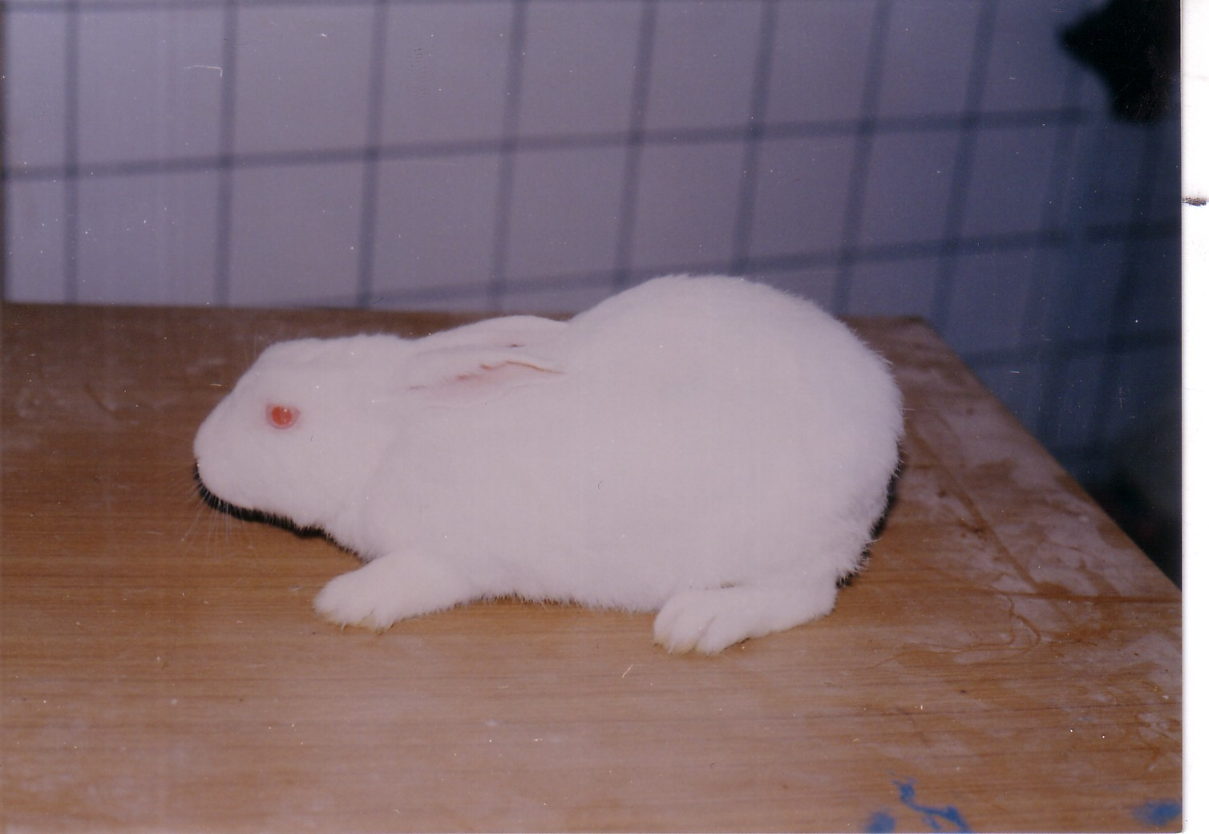

Figure 1-A The control animal without lameness

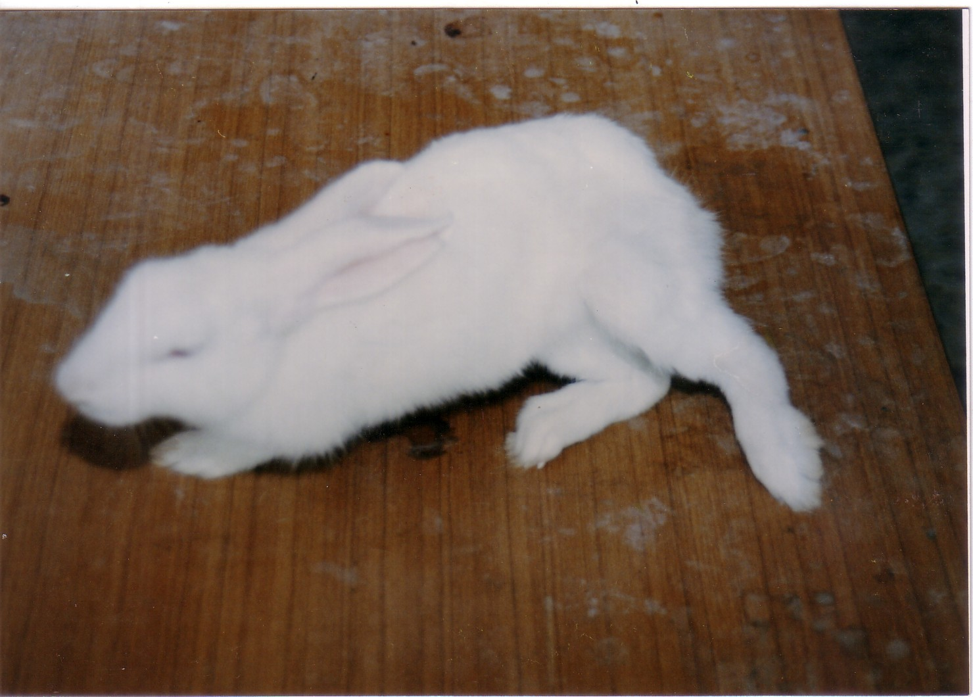

Figure 1-B The infected animal with lameness state .

5-2- Intra-articular (IAI)
Intact and cell wall defective E.coli infected rabbits (IAI) have shown the same degree of lameness. Cell wall defective S.aureus induced mild lameness, while intact S.aurens fails to induce such reaction
- Direct Geimsa and Gram stained synovial fluid films:-
6-1- Intravenous:
Cell wall defective S.aureus and E.coli infected synovial fluid showed partial and complete defectiveness of the wall along with inflammatory cells. S.aureus showed single, diplo and clusters of partially swelled and completely swelled spheres. E.coli however, have showed partially swollen and completely swollen cylinders. Intact E . coli infected synovial fluid showed intact cells with inflammatory responses, while those for intact .S. aureus showed no evidence for cocci but with inflammatory cells .
6-2 Intrat-aarticular:
CWD S. aureus and E.coli IAI synovial fluid showed partial and completely defective bacteria along with inflammatory cells. Rabbits infected with intact E.coli showed normal intact rods along with inflammatory cells while there was no evidence for intact normal cocci along with inflammatory cells in rabbit infected with intact S.aureus .
6-3 Controls:
Control synovial fluids showed neither inflammatory cells nor bacterial bodies.
- Histopathology
7-1- intravenous:
Nil intravenous reactions were noted among all of E.coi , S.aureus as well as control groups. It was noted worthing to mention an intracellular odema noted among CWD S.aureus together with vascular congestion in the synovial membranes (figs.2A & 2B).
7-2- Intra-articular:
Most of the tissues of the synovial membranes have shown severe inflammatory cell infiltrate except the synovial membrane of animals infected with intact S. aureus (figs .3A and 3B).

8:Reisolation :Cell wall defective S.aureus and E.coli were reisolated from intrarticularly infected rabbits mostly .

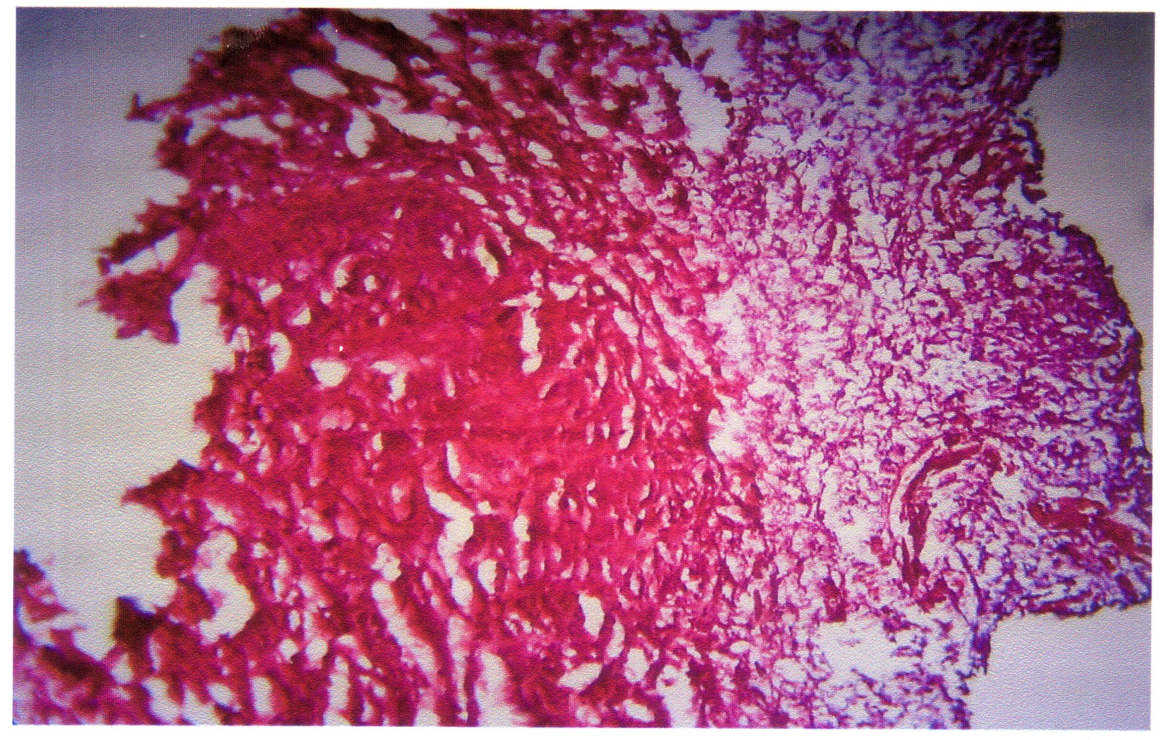

Figure 2A Tissue infected with cell wall defective S. aureus revealed simple intercellular odema ( intravenously )

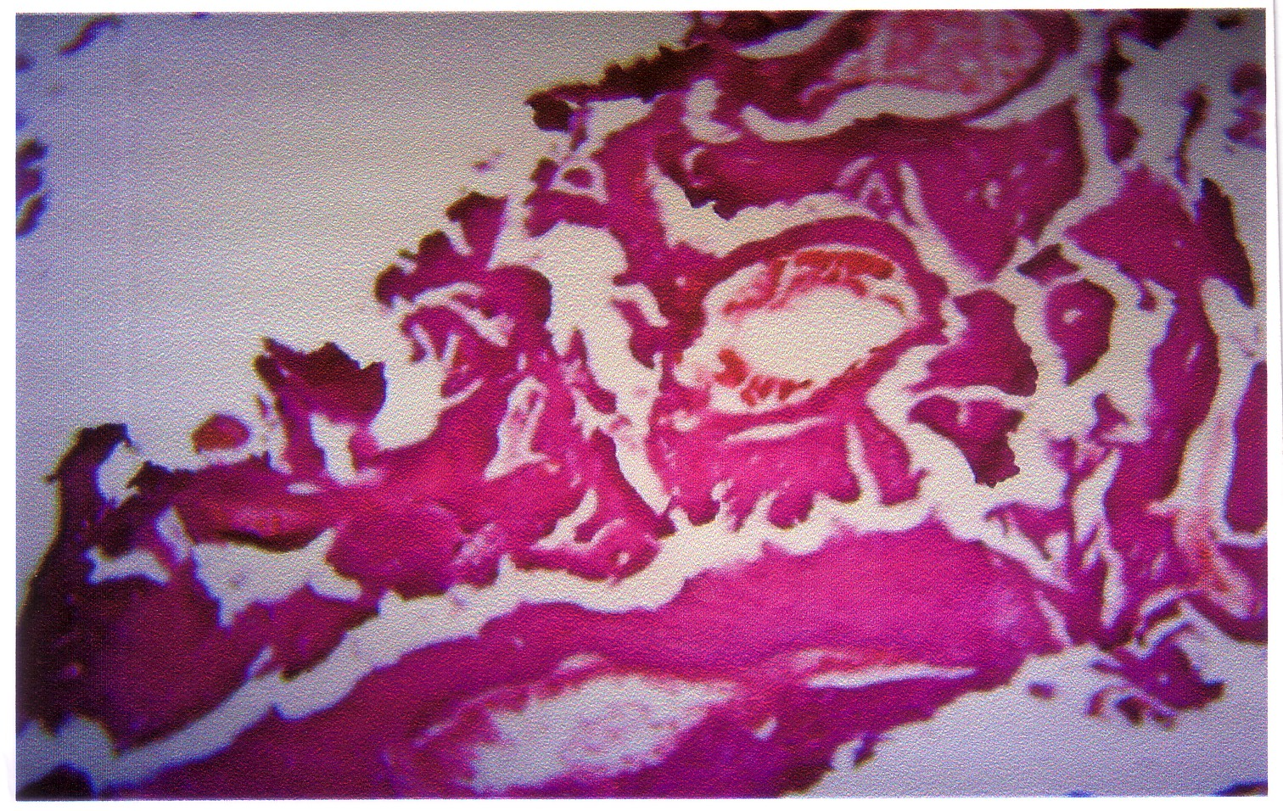

Figure2B Tissue infected with cell wall defective E .coli revealed blood haemorage and vascular conjustion ( intravenously)

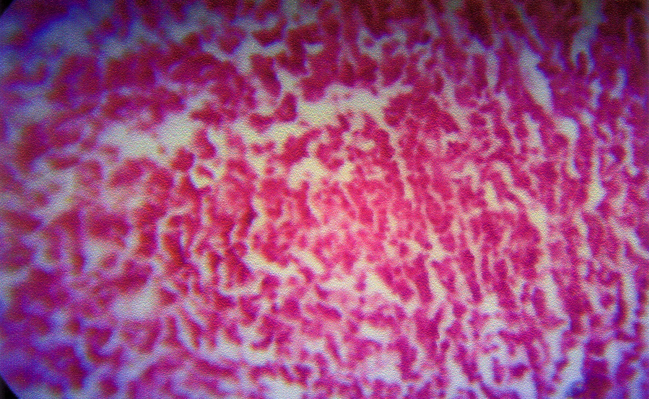

Figure 3A Tissue infected with intact S.aureus intra-articularly .

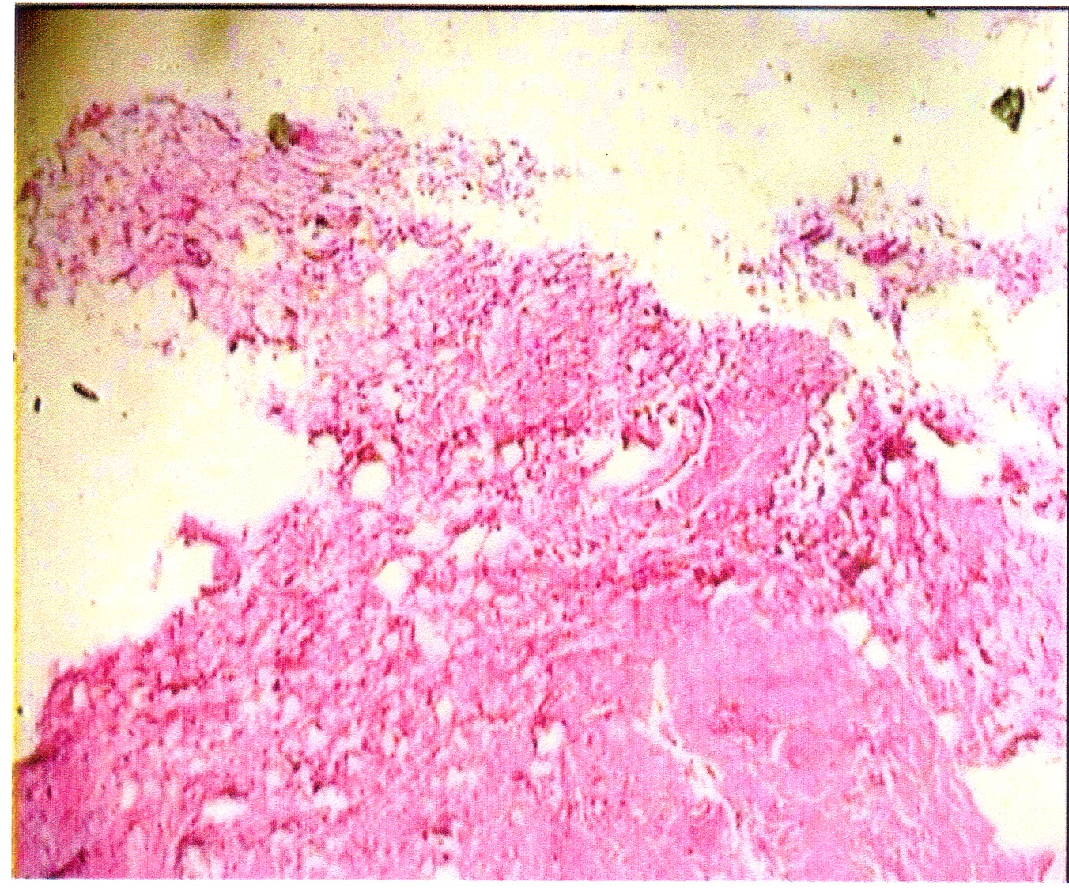

Figure 3B Tisue of control rabbets with no chages

Discussion
During bacteremia and / or septicemia caused by an infection at site, outside of the joint, organism and/ or their toxic products are deposited in or on the synovial membrane and the organisms may proliferate to cause septic arthritis .When they do grow, the infection could spread to the joint space then spread to the bone and cartilage. Such situation, an inflammation of the synovial membrane is quickly established and results in a marked increase in leukocyte in the synovial fluid . The pathogenic findings are varied and depends on the duration of infection , nature of the pathogen and resistance of the host. Early in the infection, only inflammatory changes in the synovium are seen. Late in the course of untreated septic arthritis destruction of joint structures is marked. To make an analogy to this in laboratory animals, researchers have put forward murine model of septic arthritis in the present work; lapin model is being reported [15] .
The model gave plan for septic and other for cryptic arthritis the former kind by infection with an intact organism via IV and IAI and the latter represented by cell wall defective organism via IV and IAI in rabbits [1-3,15].
The most prominent indications for arthritis are loss of weight, joint swelling and lameness. All of these indications were noted by these lapin models but with variable grades of clinical manifestations [2-4,12-14]. The human arthropathic bacterial isolates were found to have the same potential in lapin but with different grades. Both of infection routes and the organisms were found valid for production of the expermental disease in rabbit but in variable grades [14]. CWD isolates were showing more sever clinical manifestations than the intact organisms, a finding which came in agreement with that of some workers [2,3,12,14]. Chocks postulates were fulfilled and the infectious organisms resulted in pathogenic changes in the synovial membranes are concomitant with septic arethritis and cryptic arthritis respectively [2,5,9,15,17].
Thus in conclusion one may point out the followings :
1-Experimental infected animals should have both joint swelling and lameness in variable degrees .
2- The experimental cryptic arthritis infections were of more severe than septic arthritis model
3- Human arthropathic E . coli & S. aureus were proved of lapin arthropathic potentials
4- The infection course of clinical manifestation, histopathology changes as well as the resulting studies support Koch's postulation on one hand and septic as well as cryptic arthritis on the other hand in a lapin model.

References
- Austin, G.E.(2005) Elimination of Arthritis pain and inflammation forover two years with a single 90 minute Topical 14% Gallium Nitrate Treatment case reports and review of actions of Gallium III. Medical hypothesis Med J ,5 (6) : 1136-1141.
- Hultgren , O. ; Eugster, H , P. ; Sedgwick , T. D. ; Kamer, H. & Tarkowski , A. (1998a) TNF / lymphotoxin , double mutan mice resist septic arthritis. But display Increased mortality in response to staphylococcus. J. immunol., 161:5937-5942 .
- Hultgren , O.; kopf , M. & Tarkowski ,A.(1998 b) Staphylococcus aureus induced septic arthritis and septic death is Decreased in IL -4deficient mice: Role of IL-4 as promotor for bacterial growth. J. Fmmunol.160; 5082 ,5087.
- Sakurai, A.; Okahashi, N. ; Nakegawa, I.; kawabata , A. ; Atsuo , O. , T. & Hamada , S. (2003) Streptococcus pyogenes infection induces septic arthritis with increased production of receptor activator of NG – KB ligand. IAI . 71(10),6019 -6026.
- Campo ,G.M.; Avenosa, A.; Campo, S. ;Ferlazzo A.M. ; Altavilla , D.& Galatroni A. (2003) .Efficacy of treatment with glycosamin on experimental collagen – induced arth ritis in rats. Arthritis Research & therapy ,5 (3) 22,23 .
- Puliti ,M. ;Hmolstan, C.; Verwaerde C.; Bisteni F. ; Orefici G.Tissi and L.(2002) Regulatary role of interleukin -10 in experimental group B Streptecoccal arthritis. IAI 70(6):2862-2868.
- Banker ,D.D. (1980)In modern practice in Immuni –zation ,3th ed .banker D.D. (ed) Popular Prokashan Private Ltd ,Bomby .p: 189-191.
- Shnawa,I.M.; Thewaini Q.N.and Al Sultani, N.A.(2006) Cryptic bacterial Pneumniae .Bab.Med.J.
- Cruickshank, R.; Dugnid, J.P.; Morinion and swain RHA (1975) Medical Microbiology practicc of Medical Microbiology Vol.2. 12th ed Churchill–Livingstone London .
- AL Nasery, Q.N.T (2002) Biology of cell wall defective organisms associated with persistent pyuria . Ph .D . Thesis .Babylon University .
- Baneroft, J. D. & Stevens, A. C.(1982) Theory and practice of histological techniques. Churchill Livingstone N.Y.117.
- Sakiniene,E. & Collins , L.(2002)Combined antibiotic and free radical tap treatment combating Staphylococcus aureus induced septic.arthritis Arthritis Res.(3) :196-200.
- Hultgren ,O. ; Kopf , M. & Trakowski, A. (2001) Leptin in septic arthritis : decreased levels during infection and amelioration of disease activity upon its administration . Arthritis Res. , 3 (6):389-394.
- Compbell , L.; Rich , M. J. ; Biscof , R. J. ; Dunn ,A. R. ; Grail , D.& Hamilton, J.A.(1998) Protection from collagen – induced arthritis in granulocyte – maerophage colony – stimulating factor – deficient mice. J. Immunol. 161 : 3639-3644.
- Deng, G., M. ; Nilsson, I. M.; Vedrengh ,M. Collins , L.V. & Trakowski , A.(1999)Intra – articularly localized bacterial DNA containing GPG motifs induces arthritis Nat. Med., (6) =702-705.
- Frasnelli ,M.E. ; Taurssio ,D. ; Chabot zpeclat ,V.; Busso, N. &Alexander, S.O.(2005).TLR2 modulates inflammation on in zymosa- induce arthritis in mice. Arthritis Res. Ther. , 7 : 370-379 .
- Jorgensen , C. ; Apparailly ,F. ; Sany, T. (1999) Immunological evaluation of cytokine and anticytokine immunotherapy in vivo : what have we learnt ?Ann. Rheum Dis. , 58 :136-141.
- Bernetiene , E.; Plamer, G. ; Talabot-Ayer, D. ;Aubert , L.M. ; & Gabay , G.(2004) Delayed resolution of acute inflammation during zymosan arthritis in lepton- deficient mice. Arthritis Res. Ther.,( 3) : 256-263.
- Southgate, L.; Lockie, C.; Heard , S. and wood , M.(1997) , Infections of the bone and joints. In infection Oxford Geniral Pracfice Series 40 Oxford Medical Publications ,332-343.

