MODELING AND ANALYSIS OF A HELICAL MACHINED SPRINGS

Sami Ali Nama
Lecturer - Engineering Technical College – Baghdad (ccscsami@yahoo.com)

ABSTRACT
This paper investigates the linear static and modal analysis of a helical machined spring using the finite element method with the aid of SolidWorks software. A comparison between a conventional helical spring with rectangular cross section area and a machined helical spring was performed. A helical spring with square cross section area was modeled with different spring index, while for the machined helical spring two cases were modeled, one with different slot hole diameter and the other with different end extension length. Results obtained were verified with different analytical formulas for shear stress, deflection and natural frequency. There was a good agreement between the theoretical and numerical results, the maximum deviation in shear stress, deflection and the fundamental natural frequency of the numerical results were (3.6%), (2.6%) and (0.19%) respectively. For the machined helical spring it was concluded that the tangent hole configuration is better than the center hole configuration and changing the extension length has no considerable effect on spring characteristics. The machined spring with any slot hole and any extension length is better than the identical helical spring with rectangular cross section.

نمذجة وتحليل النوابض الحلزونية المشغلة

سامي علي نعمه
مدرس - الكلية التقنية الهندسية - بغداد
الخلاصة
تبحث هذه الورقة التحليلات الخطية الستاتيكية وتحليلات التذبذب للنوابض الحلزونية المشغلة باستخدام طريقة العناصر المحددة وبمساعدة التطبيق SolidWorks مع اجراء مقارنة بين نابض حلزوني ذو مقطع مربع ونابض حلزوني مشغل. تم تمثيل نموذج نابض حلزوني ذومقطع مربع ذو مؤشرات نابض مختلفة بينما في حالة النابض الحلزوني المشغل تم نمذجة حالتين ، واحدة باستخدام ثقوب مجرى مختلفة الاقطار والاخرى باستخدام طول امتدادات نهاية مختلف. وتم التحقق من النتائج باستخدام صيغ تحليلية مختلفة لاجهاد القص ، الانحناء ، والتذبذب الطبيعي. اثبتت الدراسة تطابقا جيدا بين النتائج النظرية والتحليلية حيث كانت قيم الانحراف لنتائج اجهاد القص ، الانحناء، والتذبذب الطبيعي هي (3.6%) ، (2.6%) و (0.19%) على التوالي. استنتج من الدراسة ان النابض المشغل ذو الثقب المماس للمجرى افضل من النابض المشغل ذو الثقب المركزي للمجرى وان زيادة طول امتداد النهاية لايؤثر على مواصفات النابض. وبصورة عامة فان النابض المشغل افضل من نظيره النابض الحلزوني ذو المقطع المربع.
Keywords:
Helical spring, machined spring, finite element method, SolidWorks.

NOMENCLATURE

A = correction factor accounts for curvature and direct shear.
a = wire thickness (mm).
B = constant
b = wire width (mm).
C = spring index
D = spring mean diameter (mm).
E = Young’s modulus (N/mm²)
G = shear modulus (N/mm²).
$K$ = Spring rate (N/mm)
$M$ = Spring mass (Kg)
n = No. of spring turns.
P = applied load (N).
r = spring mean radius (mm).
$ψ$ = Coefficient given by diagrams as a function of ratios (D/b) and (a/b).
$τ_{max}$ = maximum shear stress (N/mm²)
$δ_{max}$ = maximum deflection (mm)

1- INTRODUCTION
Springs are fundamental mechanical elements used for different purposes and have different shapes like helical, conical, flat, or, elliptical. They can be used to apply force, torque, or moment on an element in a machine or as impacts and shocks absorber. Springs consist of wires of circular, square or rectangular cross-section shapes. Springs with square or rectangular cross section are not commonly used because of space limitation.
Machined springs shown in (Fig.1) are similar in function to wire wound springs, but they have been developed as a solution for multi-objective design and are manufactured in a different way. The desired slot is cut with CNC machines in a metallic tube to produce the required helical path and provide the desired elasticity for the spring. Machined springs are versatile with the ability of adding additional features like threads, clamps and fixing holes to the end of them so they can be used for compression, tension, torsion, lateral bending, and lateral translation applications. The specified end-attachments enable the machined spring to be integrated into a single multi-functional component as shown in (Fig. 2). With machined springs, perpendicularity, parallelism, and very precise, linear deflection rates can be achieved so that they can be used as flexible couplings. In addition, multiple-start spring coil configurations can be machined. Finally different materials can be used to manufacture the machined spring including plastics.
[Salwiski and Michalczyk, 2006] studied the stress analysis of helical machined springs with closed ends using the finite element method approach. They concluded that the stress value obtained from the theoretical formulas are smaller than the real value because they assume that the spring deformation is influenced by only torsion stress and the spring is loaded symmetrically. [Krzysztof M., 2006] proposed a mathematical model to calculate the maximum stress generated in the slotted spring. This model takes into account the effect of the stress concentration coefficient and the effect of stress distribution coefficient on the maximum stress.
[V. Gnateski, 2012], proposed a vibration damping device which consist of a slotted spring body extended along an axis with a coaxial shaft within the spring body. The slots provide flexible movement of spring body. Motion damping occurs within the internal bore. [L. N. Garcia, 2012] introduced a coupling mechanism which includes a cylindrical housing with top and bottom ends. The housing includes slots adjacent these top and bottom ends allowing the ends of the housing to be compressed. Pair of threaded screw cavities that extend horizontally through the housing, one near the top end and the other near the bottom end are used for securing the spring within the housing. [Ahmed et al, 2013] used the finite element approach to investigate the static and dynamic characteristics of the slotted cylinder spring. A comparison between two types of springs was conducted, one is a slotted cylinder spring with three slots and the other is with four slots. They concluded that the stiffness and natural frequency of the spring with four slots is higher than that with three slots. [Calderon and Perez, 2013] performed a study to compare the advantage and efficiency of machined spring compared with a conventional wire spring using material and process selection as comparison variables. They concluded that the machined spring is better than the wire spring for specific application. [T. Englert, 2014], proposed a slotted spring that is used as a compensating coupling for torque transmitting. The coupling consists of a long tubular base body with multiple slots distributed over the circumference and in the longitudinal direction. More slots are in the radial direction from an outer surface to an inner surface of the sleeve-shaped main body. The transverse slots are filled with an elastomeric. When this coupling is used to connect a shaft and a tool, it can compensate the alignment errors between the shaft and the tool. [Ahmed et al, 2014] represented an analytical and theoretical study to compare the stiffness, natural frequency and mode shapes of helical and slotted cylinder springs. They found that the stiffness of the slotted cylinder spring increases with increasing the number of slots for each section. The natural frequency of the slotted spring was higher than that of the helical spring.

In the present work, the helical spring with square cross section was modeled to investigate its static and modal analysis using the finite element method with the aid of SolidWorks software. Different analytical formulas for shear stress, deflection and fundamental natural frequency were used to validate the proposed model. The helical machined spring was also modeled and analyzed to study the effect of the slot hole diameter and the end extension on the shear stress, deflection and natural frequency.

2- ANALYTICAL PART
To validate SolidWorks simulation, the static and modal analysis results of the proposed models will be compared with some of the references where researchers present static analysis of helical spring with coil of rectangular cross section. Most of these references assume that the load is applied symmetrically and the spring can twist around its axis. The formulas are different only in the value of the constants that are accompanying them which affects their accuracy.
For a spring having squared cross section, small pitch angle, and index greater than three, [Wahl, 1979] proposed the following formulas to calculate the maximum shear stress ($τ_{max}$) and maximum deflection ($δ_{max}$).

$$τ_{max}= A \frac{4.8 P r}{a^{3}} ……………………..(1)$$

$$δ_{max}= \frac{44.6 P r^{3} n}{G a^{4}} \left(\frac{C^{2}- 1}{C^{2 }– 0.69}\right) ………(2)$$
Where:
$$A=1+ \frac{1.2}{C}+ \frac{0.56}{C^{2}}+ \frac{0.5}{C^{3}}$$

[Khurmi, 2005] presented the following formulas:
$$τ_{max}= B \frac{2.4 P D}{a^{3}} ………………..(3)$$

$$δ_{max}= \frac{5.568 P D^{3} n}{G a^{4}} ……………………(4)$$
Where:
$$B= \frac{4C-1}{4C-4}+ \frac{0.615}{C}$$

[Ashish, 2013] adopted the following formulas for spring with square helical coil:
$$τ_{max}= \frac{4.8 P D^{0.75}}{a^{2.75}} …………………….(5)$$

$$δ_{max}= \frac{5.66 P D^{3} n}{G a^{4}} …………………….(6)$$
[Ponomarev, 1980] gives approximating formulas for maximum shear stress and maximum deflection in helical spring with rectangular cross section wire as follows:
$$τ_{max}= ψ \frac{PD}{ab \sqrt{ab}} …………………….(7)$$

$$δ_{max}= \frac{5.567 P D^{3} n}{G a^{4}} …………………(8)$$
Where $ψ$ is a Coefficient given by diagrams as a function of ratios (D/b) and (a/b).

Springs are usually operates in a rapid reciprocating loading environment such as engines and die presses; this means the need to calculate the natural frequency of the spring to avoid the resonant conditions. Dimensions, material, and type of end support of spring must be chosen in such a manner that insures a vibration frequency that is different and far from the applied force frequency. Machined springs can also be used as a coupling in rotating machines, so it is important to investigate their modal analysis.
For a square cross section helical spring with one end fixed and the other end free, the natural frequency along the spring length (axial direction) equals [Shigley et al, 2004]:
$$f= \frac{i}{4} \sqrt{\frac{K_{A}}{M}} i=1,2,3 …(9)$$
K_{A} is the axial spring rate and M is the spring mass.
$$K_{A}= \frac{k_{2} G b a^{3}}{n D^{3}}$$
K₂ is a Constant given by graphs and depends on ratio (a/b).

The second and third natural frequencies are lateral vibration frequencies; they are about 1.0 to 1.5 times higher than axial frequency [Kelly, 1992], while the fourth natural frequency is torsional frequency. The fifth natural frequency is the second harmonic axial frequency and is found by using i=2 in equation 9.
For a spring with circular cross section, the lateral spring rate (K_{L}) is:
$$\frac{1}{K_{L}}= \left[\frac{l^{2} \left(2G+E\right)}{6G}+ D^{2}\right] \frac{8 n D}{d^{4} E}$$
l is the spring length (mm).
And the torsional spring rate (K_{T}) is:
$$K_{T}= \frac{E d^{4}}{46 n D}$$

3- NUMERICAL MODELING
Modeling and simulation helps in analyzing different parts and assemblies before producing an expensive physical prototype. SolidWorks simulation add-in is a finite element analysis (FEA) application used to simulate the proposed design and predict its behavior against applied working conditions. SolidWorks simulation can be used for different analysis such as stress, frequency, buckling, thermal and optimization simulations.
In the present work, machined helical spring is considered to be used as a coupling to transmit rotational motion between two shafts. For this purpose, four types of springs were modeled. A helical spring with square cross section coil, a helical machined spring with a center hole at the end of the slot, a helical machined spring with a tangent hole at the end of the slot, and finally a helical machined spring with different end extension lengths.

3-1 Helical spring
The helical spring with square cross section was modeled to match the machined helical spring that will be used as a coupling using the following parameters: wire side length a=b =10mm, pitch=12mm, 6 turns. Material Steel AISI-1045, E=205 GPa, G=80 GPa, Density=7850 Kg/m³. Springs with different mean diameters (40 to 100 mm) were modeled to obtain different spring indices.
To study the effect of the spring index, the spring is considered fixed at the lower end while the upper end is constrained so that it moves only along the vertical axis of the spring. For stress and deflection analysis, a static study was conducted with a load of 100N applied on the upper end. The spring was meshed with a second order tetrahedral element Solid mesh. Each element consist of 10 nodes and this permit element edges and surfaces to deform in second order (curved) manner as shown in (Fig. 3), and this in turn provide better mapping of curved surfaces as in helical spring. A convergence check based on vonMises stress was performed to determine the optimum mesh parameters, element size=3mm was chosen which provides (32561) elements, (52179) nodes. For modal analysis, same parameters of the static study were used without applying the load.

3-2 Helical machined spring
The coupling was modeled as a helical machined spring with the following parameters: Mean diameter= 40mm, wire side length a=b =10mm, pitch=12mm, 6 turns, spring index=4. Material Steel AISI-1045, E=205 GPa, G=80 GPa, Density=7850 Kg/m³.
To study the effect of slot hole diameter, a hole was added to the end of the machined spring slot in two different configurations, center and tangent as shown in (Fig. 4). The distance between the slot center and spring end was 9mm. Different hole diameters (2 to 7mm) were modeled for each configuration to study the effect of slot hole diameter and its configuration on spring stress and deflection.
The spring is considered fixed at the lower end. The cylinder is constrained from moving along the radial direction so that it moves only downwards along the vertical axis of the spring. For stress and deflection, a static study was conducted with a load of 100N applied on the upper end. For modal analysis, same parameters of the static study were used without applying the load to obtain the natural frequency of the machined spring. For the center hole configuration, the spring was meshed with Solid mesh (4points), element size=3mm, (60818) elements, (37637) nodes. For the tangent hole configuration, the spring was meshed with Solid mesh (4points), element size=3mm, (61068) elements, (37842) nodes.
To study the effect of end extension, another machined helical spring was modeled as shown in (Fig. 5). This spring is provided with an extension that will be used for mounting purpose. Different end extension lengths (9 to 29 mm) were modeled to study the effect of extension length on spring characteristics. The hole at the end of the slot was 2mm diameter and the other parameters are same as the previous one. Again the spring is considered fixed at the lower end. The cylinder moves only downwards along the vertical axis of the spring. For stress and deflection, a static study was conducted with a load of 100N applied on the upper end. The spring was meshed with Solid mesh (4points), element size=3mm, (75030) elements, (47005) nodes. For modal analysis, same parameters of the static study were used without applying the load.

4- RESULTS AND DISCUSSION
4-1 Helical spring with square cross section
The numerical results obtained from SolidWorks software for the helical spring with square cross section were determined for different spring index. These results were verified with the different analytical formulas for shear stress, deflection and fundamental natural frequency. The variation of maximum shear stress at different spring index is shown in (Fig. 6), while the variation of maximum deflection at different spring index is listed in (Table 1). It can be seen that there is a good agreement between the theoretical and numerical results. The maximum deviation in shear stress and deflection of the numerical results are (3.6%) and (2.6%) respectively.
(Fig. 7) shows the variation of fundamental natural frequency at different spring indices. It can be noticed that as the spring index increase, the natural frequency decrease and this is due to the decrease in spring stiffness and strength. The optimum mean diameter for this study is 40mm which gives a spring index of 4. (Fig. 8 and 9) represent the first five mode shapes for helical spring with different spring index. These mode shapes are similar for all the spring indices.

4-2 Helical machined spring
For the helical machined spring, the effect of slot hole diameter and slot hole configuration on shear stress, deflection and frequency are shown in (Table 2).
It was observed that the maximum shear stress decreases with increasing the slot hole diameter. The slot end can be treated as a notch that will act as a stress concentration region. When notches are necessary, removal of material near the notch can improves the strength of the member by alleviating stress concentration effects, therefore when adding an extra hole to the slot end, the notch is retained and the stress concentration reduced. For the center hole configuration, a hole of up to 6mm can be added to the slot with a reduction in the value of maximum stress up to 14%. For the tangent hole configuration, a hole of up to 4mm can be added to the slot with a reduction in the value of maximum stress up to 15%.
A small variation was noticed in the deflection of the spring when increasing the slot hole diameter. When changing the hole diameter from 2 to 7 mm, the maximum deflection for the center hole configuration was 0.2138mm while the maximum deflection for the tangent hole configuration was 0.2104mm and this indicates that the tangent hole configuration is better than the center hole configuration. The maximum deflection of the machined spring for both configurations is better than the helical spring with rectangular cross section which has a maximum deflection of 0.265mm.
The fundamental natural frequency decreases with increasing the slot hole diameter, this is due to the decrease in spring stiffness. When changing the hole diameter from 2 to 7 mm, the fundamental natural frequency for the center hole configuration was 450Hz while the fundamental natural frequency for the tangent hole configuration was 456.44Hz and this indicates that the tangent hole configuration is better than the center hole configuration. The fundamental natural frequency of the machined spring for both configurations is better than the helical spring with rectangular cross section which has a fundamental natural frequency of 199.35Hz. (Fig. 10 and 11) represent the effect of slot hole diameter on natural frequency for different modes for both center and tangent configurations.
The effect of extension length on shear stress, deflection and frequency are shown in (Table 3). For the maximum shear stress, there is an increase in its value at the beginning, but this increase become with less effect at longer extension. This can be considered as an advantage that allows for adding additional features to the end of the spring without affecting the resulting shear stress.
Changing the extension length has no considerable effect on maximum deflection or the fundamental natural frequency. Again the machined spring with any extension length is better than the identical helical spring with rectangular cross section.

5- CONCLUSIONS
In view of the results obtained during this research, it can be concluded that:
- SolidWorks can be used effectively for modeling and analyzing the helical spring with square cross section and different configurations of helical machined spring.
- The maximum value of stress was at the inner portion of the spring and this is due to the coil curvature
- The machined helical spring is better than the identical helical spring with rectangular cross section
- The tangent slot hole configuration is better than the center slot hole configuration.
- Long extensions can be added to the ends of the machined helical spring without effecting the shear stress, deflection and fundamental natural frequency of the spring.
Table 1- Variation of spring deflection (mm) at different spring index
(Helical spring with square cross section)
D mm | Index | Wahl | Khurmi | Ashish | Ponomarev | SolidWorks
40 | 4 | 0.262 | 0.267 | 0.272 | 0.267 | 0.265
50 | 5 | 0.516 | 0.522 | 0.531 | 0.522 | 0.520
60 | 6 | 0.895 | 0.902 | 0.917 | 0.902 | 0.900
70 | 7 | 1.425 | 1.432 | 1.456 | 1.432 | 1.432
80 | 8 | 2.130 | 2.138 | 2.173 | 2.138 | 2.142
90 | 9 | 3.036 | 3.044 | 3.095 | 3.044 | 3.057
100 | 10 | 4.168 | 4.176 | 4.245 | 4.176 | 4.193

Table 2- Effect of slot hole diameter on shear stress and deflection (machined spring).
Hole diameter (mm) | τ_{max} (N/mm²) |  | δ_{max} (mm) |  | f (Hz)
 | center | tangent | center | tangent | center | tangent
2 | 14.953 | 14.953 | 0.2085 | 0.2085 | 458.71 | 458.71
3 | 14.845 | 14.475 | 0.2093 | 0.2090 | 457.65 | 458.19
4 | 13.741 | 12.717 | 0.2102 | 0.2093 | 456.27 | 457.73
5 | 13.636 | 12.814 | 0.2112 | 0.2097 | 454.59 | 457.24
6 | 12.828 | 12.811 | 0.2125 | 0.2101 | 452.52 | 456.79
7 | 12.858 | 12.847 | 0.2138 | 0.2104 | 450.00 | 456.44

Table 3- Effect of extension length on shear stress, deflection and frequency (machined spring).
Length (mm) | τ_{max} (N/mm²) | δ_{max} (mm) | f (Hz)
9 | 14.953 | 0.2085 | 458.71
13 | 16.717 | 0.2072 | 458.47
17 | 16.100 | 0.2068 | 458.42
21 | 17.623 | 0.2065 | 458.35
25 | 16.196 | 0.2063 | 458.32
29 | 16.256 | 0.2063 | 458.29

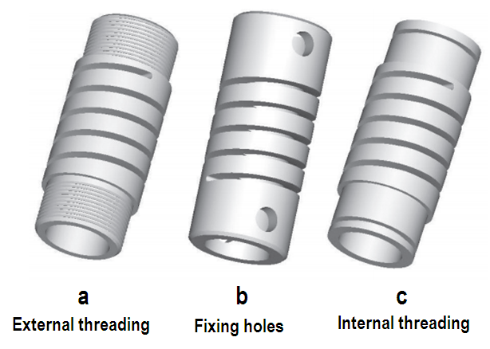

Figure (1) machined springs with different mounting methods
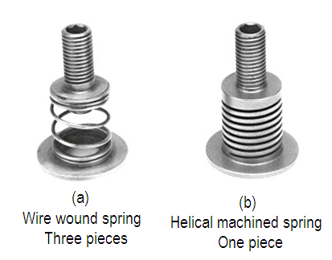

Figure (2) Integrated machined spring.

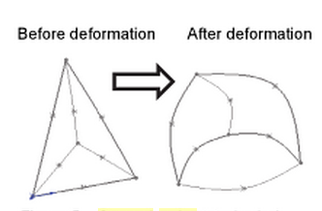

Figure (3) Second order tetrahedral element

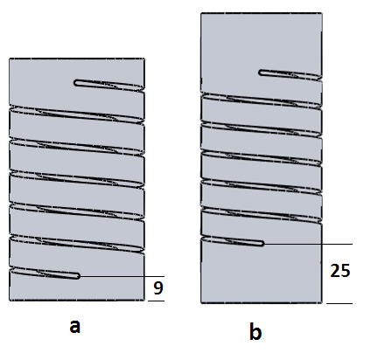

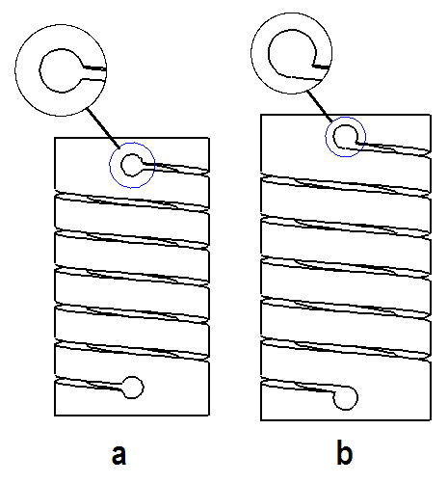

Figure 5: machined spring with different end extension length. (a- 9mm), (b- 25mm)
Figure 4: machined spring with different slot hole. (a- Center), (b- tangent)

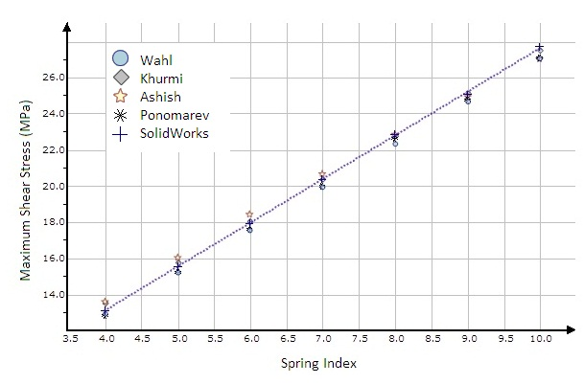

Figure 6: Variation of maximum shear stress at different spring index
(Helical spring with square cross section)

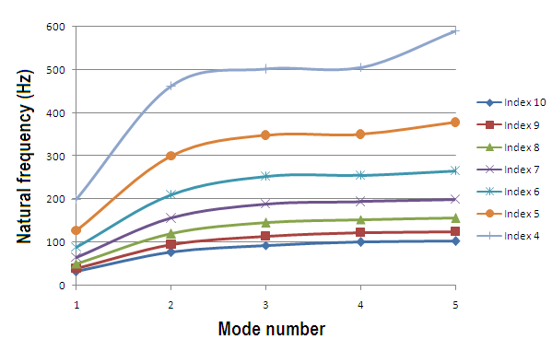

Figure 7: Natural frequencies for different spring index
(Helical spring with square cross section)

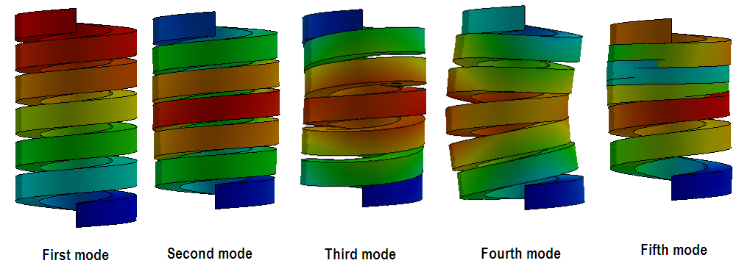

Figure 8: mode shapes for helical spring (spring index = 4)

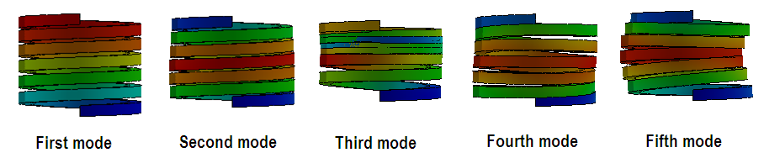

Figure 9: mode shapes for helical spring (spring index = 10)

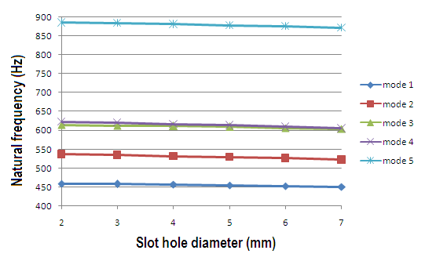

Figure 10: Effect of slot hole diameter on natural frequency for different modes.
(Machined helical spring, center configuration)
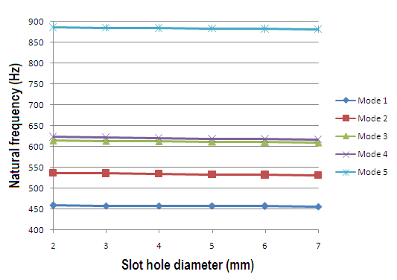

Figure 11: Effect of slot hole diameter on natural frequency for different modes.
(Machined helical spring, tangent configuration)

RERERENCES

- Ahmed I. R., Hani A. A., Kadhim M. M., “Static and Dynamic Characteristics of Slotted Cylinder Spring”, Int. J. Eng. Res. & Tech., V. 2, Issue 12, 2013, pp 3860-3871
- Ahmed I. R., Hani A. A., Kadhim M. M., “Compression and impact characterization of helical and slotted cylinder springs”, Int. J. Eng. & Tech., V. 3, Issue 2, 2014, pp 268-278
- Ashish M. Choube, D. V. Bhope, “Stress and Buckling Analysis of Helical Coil”, International Journal of Innovative Technology and Research(IJITR), Vol. 1, No. 6, 2013, pp. 570-573.
- Juan de Dios Calderon and Carlos Perez, “On the General Characterization of Machined Springs and Their Manufacturing Processes”, ASME Int. Mech. Eng. Congress and Exposition, V12: Systems and Design, California, USA, November 15–21, 2013
- Kelly, A. D., Knight, C. E., "Helical Coil Suspension Springs in Finite Element Models of Compressors", International Compressor Engineering Conference, 1992, Paper 870.
- Khurmi R. S., Gupta J. K., “A textbook of Machine Design”, 14th ed., 2005
- Krzysztof M., “Stress Analysis in Slotted Springs”, Mechanics, Vol. 25, No. 3, 2006, pp 131-134.
- L. N. Garcia, “Spring-Loaded Helical Coupling Mechanism”, United States Patent Application Publication, Pub. No.: US 2012/0231892 A1, Pub. Date: Sep. 13, 2012.
- Ponomarev S., “Calculation of the Elastic Elements of Machine and Devices”, (in Russian), 1980
- Salwinski J., Michalczyk K., “Stress Analysis in Helical Springs with Closed End Coils Machined from Cylindrical Sleeves”, Mechanics, Vol. 25, No. 4, 2006, pp. 169-172
- Shigley J., Mischke C., Thomas B., “Standard Handbook of Machine Design”, 3rd ed., McGraw-Hill, 2004.
- T. Englert, “Compensating Coupling for Transmitting Torques”, United States Patent Application Publication, Pub. No.: US 2014/0228132 A1, Pub. Date: Aug. 14, 2014.
- V. Gnateski, “Slotted Spring Vibration Isolator”, United States Patent Application Publication, Pub. No.: US 2012/0049422 A1, Pub. Date: Mar. 1, 2012.
- Wahl A. M., “Mechanical Springs”, 2nd edition, McGraw-Hill Inc., New York, 1979

