INTRODUCTION
Carbon fiber reinforced aluminum matrix composites have high specific strength, high specific stiffness, high thermal conductivity and low coefficient of thermal expansion (CTE). Aluminum-carbon fiber composites have attractive properties for a variety of automotive and aerospace applications [Zhang Yun-he,2006- Daoud A,2005 - Lee Woei-shyan,2000 ].
There is a great deal of research work on the tensile strength of carbon fiber reinforced aluminum at room temperature [E. Hajjari,2010- Ahmed A,2011- Sheng-Han LI,2004- Yuanxin Zhou,2010- Yuanxin Zhou,2003], but information on behavior of these metal matrix composites at low temperatures are rather scarce. [Panchakshari H.V,2012] focused on the effect of deep cryogenic treatment on the microstructure, mechanical and fracture properties of Al6061/Al₂O₃ metal matrix composites (MMCs) at -196 °C for different time duration. The modification of microstructure of MMCs due to cryogenic treatment shows significant improvement in mechanical properties of the MMCs. [Myung-Gon Kim,2007] studied the tensile properties of a T700/epoxy composite material at room temperature (RT), -50 °C, -100 °C and -150 °C. They concluded that tensile modulus tends to increase as temperature decreases. The amount of percentage increase of tensile modulus was found to be about 16% more at -150 °C than at (RT). The reason of this increase was attributed to the brittleness of the fibers at low temperatures. [Majerski,2012] tested carbon fiber reinforced polymer (CFRP) to examine the tensile properties at temperatures (153, 223, and 295 ⁰K). They found that the tensile modulus increases as the temperature decreases, but the increase in the range of 153 and 223 ⁰K was smaller than that in the range of 223 to 295 ⁰K which amount to 9%. The explanation of this increase may be due to a sharp increase in fiber brittleness at these low temperatures [Myung-Gon Kim,2007]. [Myung-Gon Kim,2007] found that the strength of non-cycled specimens decreased about 9% more at -150 °C than RT for graphite/epoxy composite. [Majerski,2012] observed that the tensile strength is decreased about 7% at 223K compared to (RT) and about 8% at 153K for carbon fiber/epoxy laminates. On the other hand, [Reed and Golda,1994] reported an increase in tensile strength of a unidirectional carbon/epoxy laminate at low temperatures. The reduction in tensile strength may be caused by several factors such as a brittle matrix or an increase in residual stress in the composite material [Majerski,2012]. Other researchers explained the reasons of reduction in tensile strength due to increase in the size of fibers in the radial direction and shortening in the direction of the longitudinal axis, while matrix expands in all directions [Majerski,2012- Timmerman J.F,2002- Suendra Kumarr M.,2008].
This study aims at evaluate the tensile properties of carbon fiber multilayer configurations with aluminum composites laminates at low and room temperatures.
EXPERIMENTAL PROCEDURE:
Composite Materials:
The composite material laminates used in this study are carbon fiber reinforced aluminum alloy. Composite Materials have been fabricated in china. The basic structural components were: woven carbon fiber (3K) and unidirectional carbon fiber (UD) in three different fiber orientations (0°/90° for woven carbon fiber and /0°/, /90°/ for unidirectional) as a reinforcement and aluminum (3003) alloy as matrix. Fig. (1) shows these types of carbon fibers. Table (1) illustrates the locations and orientations of each sample laminates (4 layers of carbon fibers and 2 layers of aluminum). The production of these composite materials is carried out by using high temperature and vacuum pressure in Vacuum Bag Oven process. Composite laminates were laid down from the prepreg carbon fiber and aluminum foil and cured in a hot press inside the oven. Heating up to 190 °C with a heating rate of 3 °C/min. Vacuum pressure was 30 bar. After an applied holding time of 60 minutes, the pressure was released and the composite was allowed to cool to room temperature.
Test Specimens:
The specimens for tensile testes were cut from standard sheet (400*500*0.85 mm³) by a CNC milling machine according to the standard test method for tensile properties of fiber reinforced metal matrix composites ASTM D3552[ASTM,2002]. Tensile test specimens were cut from transverse direction. The strain rate for all tensile tests was 0.0015 s⁻¹. Fig. (2) shows the shape and dimensions of the tensile test specimen.
Tensile Test Rig:
The tensile tests were performed in a Testometric M500 test machine as shown in Fig. (3-a). The maximum load capacity of the test machine is 25kN. An environment chamber was attached to the tensile test rig and sealed with an insulation material as in Fig. (3-b). The chamber has the ability to cool down its temperature to -30 ºC.
(a)
Cooling Chamber:
During the test, a pressurizing device was used to control the cooling time from room temperature (RT) to required temperature. It consists of two boxes. The first box is cooling room and the second box contains the cooling equipment. The cooling chamber parts are: compressor, double evaporator, heat exchanger pipes (condenser), fan, thermostat and refrigerant feron type. The cooling rate was 2 °C /min. The temperature inside the cooling room was calibrated by thermocouple. A delay time of about 15minutes was used to homogenize temperature through the whole thickness of the specimen. Fig. (4) shows the grips of the tensile machine inside the cooling room.

RESULTS AND DISCUSSION:
The results of tensile modulus and strength in the (y) direction, see figure (1), for the three types of composite materials mentioned in Table (1) and for four different temperatures, are presented in Table (2).
The tensile modulus and strength are shown as a function of temperature in Fig. (5) and (6) respectively. The results are based on the arithmetic average of three testing specimens.
Tensile Modulus:
Tensile modulus was determined by taking a slope of stress-strain curves of tensile test. The results show that as the temperature decreases, the tensile modulus slightly increases. The maximum increase occurred at -30 °C compared to the room temperature (RT) values for all orientations studied. The S₃ laminates arrangement and orientation, where all the four carbon fiber reinforcing laminates were of the unidirectaion type, possessed the highest tensile modulus. Table (3) summarizes the amount of the percentage increase with decreasing temperature.
Tensile Strength:
Referring to table (2) and figure (6), it is noted that the tensile strength decreased as compared to (RT) for samples (S₁) and the significant decrease occurs only at -30 °C. For samples (S₂), the tensile strength did not significantly change with temperature except at -15 °C where the lowest value was recorded. The tensile strength for sample S₃ increased with decreasing temperature except at -30 °C where the tensile strength was the lowest. Here again the S₃ laminate orientation with only unidirectional carbon fibers possessed the highest tensile strength which was between (2.8- 3.5) times the tensile strength of the S₁ orientation. This is attributed to the reason that, unidirectional carbon fibers are proportional manner (parallel) to the axis of tensile force. In the case of samples S₁, S₂ misalignment axis with respect to the tensile load axis will be occur due to different in fibers type and orientation causing the earlier failure in these composite samples.

CONCLUSIONS:
In this investigation, the tensile modulus and strength of carbon fiber-aluminum matrix composite materials of three types with constant volume fraction were studied at RT, zero °C, -15 °C and -30 °C. The conclusions of this study are:
- It was found that the tensile modulus of the considered laminates slightly increase with decreasing temperature. The maximum increase was observed at -30 °C for all the types of sample orientations.
- Tensile strength tends to decrease as temperature decreases down to -30 °C for sample S₁ and S₂, where the reinforcement included laminates of woven carbon fibers, while it increases for sample S₃, where the reinforcement contained laminates of only unidirection carbon fibers, from (RT) to -15 °C and then decreases at -30 °C.
- The S₃ laminate orientation with only unidirecion carbon fibers possesses the highest tensile strength .


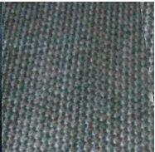
Unidirectional carbon fiber
Woven carbon fiber
Y
x
(b)
(a)

Figure (1) (a) Woven carbon fiber and (b) Uinidirection carbon fiber.

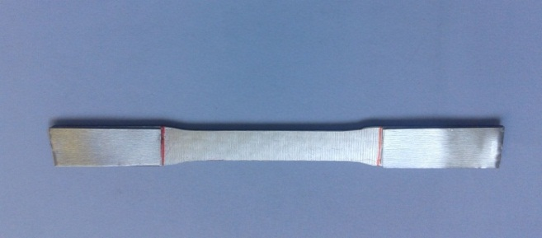
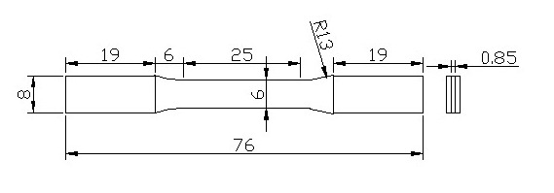

Figure (2): Tensile specimen of composite material according to ASTM D3552
(all dimensions in mm).

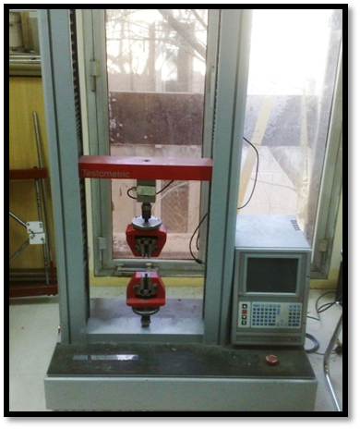
(b)
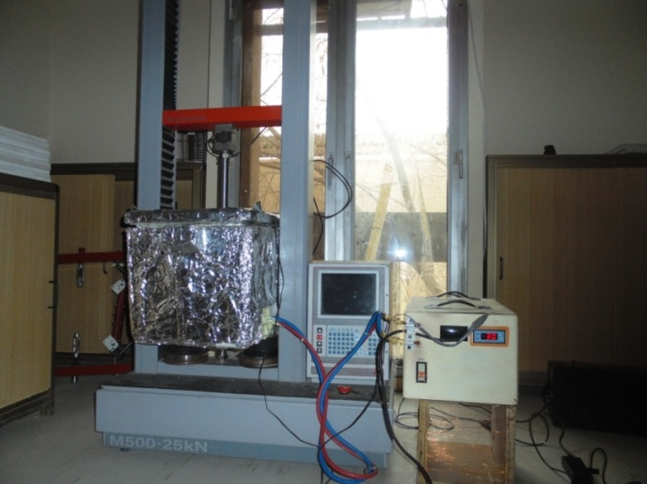
Cooling chamber
Cooling equipment
Tensile rig

(b)
(a)

Figure (3): (a) tensile test machine, (b) Cooling chamber attached to the tensile test rig.

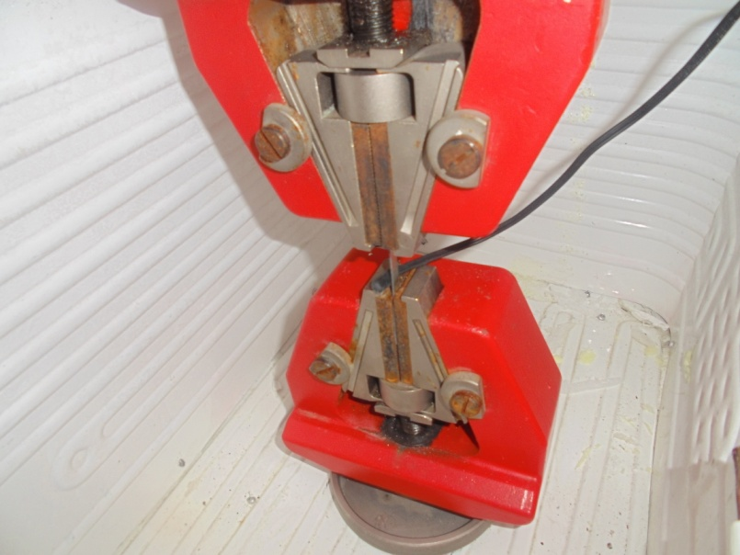
Cooling chamber

Grips of Tensile machine
Sensor attached with specimen

Figure (4): Grips of the tensile machine inside the cooling room.

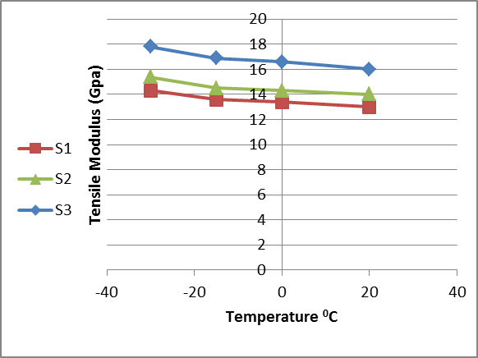

Figure (5): Tensile modulus as a function of temperature for three different orientations of composite materials.

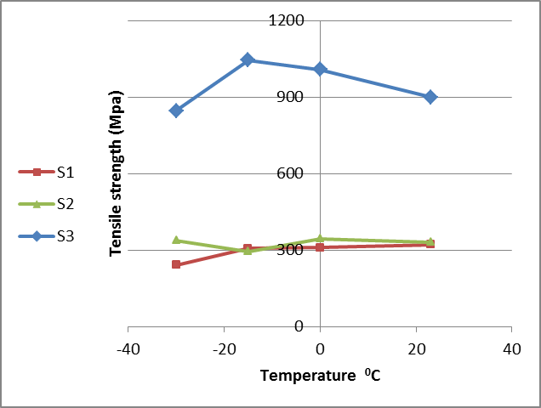

Figure (6): Tensile strength against temperature for three different orientations of composite materials.

Table (1): The three samples composite sheets with different laminate orientations.

Sample  Ref. | Configuration | V_{f}  % | Number of reinforcement layer | Orientation of reinforcement
S₁ | [Al/3K/UD/3K/UD/Al] | 60 | 4 | 0°/90°- 0°- 0°/90°- 0°
S₂ | [Al/3K/UD/UD/3K/Al] | 60 | 4 | 0°/90°- 0°- 0°- 0°/90°
S₃ | [Al/UD/UD/UD/UD/Al] | 60 | 4 | 90°- 0°- 0°- 90°

Table (2): Tensile modulus and strength of three composite materials at different temperatures: (a) RT, (b) zero °C, (c) -15 °C, (d) -30 °C.

(a)
Samples at room temperature (RT)
S₁ |  | S₂ |  | S₃
Tensile modulus  GPa | Tensile strength  MPa | Tensile modulus  GPa | Tensile strength  MPa | Tensile modulus  GPa | Tensile strength  MPa
13  12.5  13.5 | 381  300  282 | 14  14.5  13.5 | 309  361  326 | 16  16.5  15.5 | 900  905  895
Average of readings
13 | 321 | 14 | 332 | 16 | 900

(b)
Samples at zero temperature
S₁ |  | S₂ |  | S₃
Tensile modulus  GPa | Tensile strength  MPa | Tensile modulus  GPa | Tensile strength  MPa | Tensile modulus  GPa | Tensile strength  MPa
12.9  13.5  13.8 | 318  304  309 | 14.15  14.21  14.6 | 377  322  333 | 16.4  16.6  16.8 | 962  1061  1003
Average of readings
13.4 | 310.33 | 14.32 | 344 | 16.6 | 1008.67

(c)
Samples at -15 ⁰C
S₁ |  | S₂ |  | S₃
Tensile modulus  GPa | Tensile strength  MPa | Tensile modulus  GPa | Tensile strength  MPa | Tensile modulus  GPa | Tensile strength  MPa
13.2  13.5  14.1 | 308  310  303 | 14.3  14.5  14.7 | 300  290  296 | 16.6  16.9  17.2 | 1057  1044  1031
Average of readings
13.6 | 307 | 14.5 | 295.33 | 16.9 | 1044

(d)

Samples at -30 ⁰C
S₁ |  | S₂ |  | S₃
Tensile modulus  GPa | Tensile strength  MPa | Tensile modulus  GPa | Tensile strength  MPa | Tensile modulus  GPa | Tensile strength  MPa
13.8  14.2  14.9 | 210  275  240 | 15.1  15.6  15.7 | 344  334  335 | 17.6  17.8  18 | 848  830  860
Average of readings
14.3 | 241.67 | 15.4 | 337.67 | 17.8 | 846

Table (3): The percentage increase in tensile modulus for the three samples.

Sample | Temperature  (°C ) | Tensile modulus  (GPa) | Increase in tensile modulus  (%)
S1 | RT | 13 | ----
S1 | 0 | 13.4 | 3
S1 | -15 | 13.6 | 4.6
S1 | -30 | 14.3 | 10
S2 | RT | 14 | ---
S2 | 0 | 14.32 | 2.2
S2 | `-15 | 14.5 | 3.57
S2 | -30 | 15.4 | 10
S3 | RT | 16 | ----
S3 | 0 | 16.6 | 3.75
S3 | -15 | 16.9 | 5.62
S3 | -30 | 17.8 | 11.25

REFERENCES : -

- Zhang Yun-he, Wu Gao-hui, Chen Guo-qin, Xiu Zi-yang, Zhang Qiang, Wang Chun-yu. "Microstructure and Mechanical Properties of 2D Woven Grf/Al Composite", Transactions of Nonferrous Metals Society of China, 16, (Special 3), pp. 1509−1512, (2006).

- Daoud A. "Microstructure and Tensile Properties of 2014 Al Alloy Reinforced with Continuous Carbon Fibers Manufactured by Gas Pressure Infiltration", Materials Science and Engineering A, 391, pp. 114−120, (2005).

- Lee Woei-shyan, Sue Wu-chung, Lin Chi-feng. "The Effects of Temperature and Strain Rate on The Properties of Carbon-Fiber-Reinforced 7075 Aluminum Alloy Metal-Matrix Composite", Composites Science and Technology, 60, pp.1975−1983, (2000).

- E. Hajjari , M. Divandari, A.R. Mirhabibi, "The Effect of Applied Pressure on Fracture Surface and Tensile Properties of Nickel Coated Continuous Carbon Fiber Reinforced Aluminum Composites Fabricated By Squeeze Casting", Materials and Design, 31, pp. 2381–2386, (2010).

- Ahmed A. Moosa, Kahtan K. Al-Khazraji, Osama S. Muhammed, "Tensile Strength of Squeeze Cast Carbon Fibers Reinforced Al-Si Matrix Composites", Journal of Minerals & Materials Characterization & Engineering, Vol. 10, No.2, pp.127-14, (2011).

- Sheng-Han LI and Chuen-Guang Chao, "Effects of Carbon Fiber/Al Interface on Mechanical Properties of Carbon-Fiber-Reinforced Aluminum-Matrix Composites", Metallurgical and Materials Transactions A, Volume 35A, pp. 2153-2160, July (2004).

- Yuanxin Zhou, Ying Wang, Shaik Jeelani, Yuanming Xia, "Experimental Study on Tensile Behavior of Carbon Fiber and Carbon Fiber Reinforced Aluminum at Different Strain Rate", International conference on the applications of traditional & high performance materials in harsh environment, March 24-25, United Arab Emirates, (2010).

- Yuanxin Zhou, Wang Yang, Yuanmin Xia, P.K. Mallick, "An experimental study on the tensile behavior of a unidirectional carbon fiber reinforced aluminum composite at different strain rates", Materials Science and Engineering A362, pp. 112–117, (2003).

- Panchakshari H.V, Girish D.P,M Krishn," Effect of Deep Cryogenic Treatment on Microstructure, Mechanical and Fracture Properties of Aluminium-AL₂O₃ Metal Matrix Composites", International Journal of Soft Computing and Engineering (IJSCE), Volume 1, Issue 6, pp. 340-346, (2012).

- Myung-Gon Kim, Sang-Guk Kang, Chun-Gon Kim, Cheol-Won Kong, "Tensile Response of Graphite/Epoxy Composites at Low Temperatures", Composite Structures 79, pp. 84–89, (2007).

- Krzysztof Majerski, Barbara Surowska, Jarosław Bieniaś, "Tensile Properties of Carbon Fiber/Epoxy Laminates at Low and Room Temperatures", Composites theory and practice, 12, No. 3, pp. 182-185, (2012).

- Reed R.P., Golda M., "Cryogenic Properties of Unidirection Composites", Cryogenics, 34 (11), pp. 909-928, (1994).

- Timmerman J.F., Matthew S Tillman , Brian S Hayes, James C Seferis, "Matrix and Fiber Influences on the Cryogenic Microcracking of Carbon Fiber/Epoxy Composites", Composites part A, Volume 33, Issue 3, pp. 323-329, (2002).

- Suendra Kumarr M., Sharma N., Ray B.C., "Mechanical Behavior of Glass/Epoxy Composites at Liquid Nitrogen Temperature", Journal of reinforced plastics and composites, 27 (9), pp. 937-944, (2008).

- Standard Test Method for Tensile Properties of Fiber Reinforced Metal Matrix Composites, ASTM D 3552 – 96 (2002).

