ان الميزة من استخدام هذه الأساليب هو أضافة دوال تقريبية تم استخدامها في حل النموذج الرياضي للنظام العتبة، والذي لا تتطلب تقسيم العنصر إلى عدد كبير من العناصر كما هو متبع في برامج التحليل بالعناصر المحددة ، ولكن سيعتمد كل عنصر كعنصر واحد مع نقطتين، بداية ونهاية على التوالي، وفي هذه الحالة يسمح للارتباط السهل بين العتبات وستلبي الشروط الهندسية المحيطة.
تم استخدم طريقة التحليل بالعناصر المحدودة في تحليل النموذج المبرمج للنظام، والذي تم برمجته باستخدام لغة البرمجة الفورتران، وكانت خطوات الحل والنتائج تجري وتستحصل عدديا.
كلمات رئيسية : العناصر المحدودة، طريقة التباين، الاهتزازات، الحركة البطيئة للاحمال ،هيكل الجمالون.
1.MATHEMATICAL REPRESENTATION
As a computational model, a part of beams system with space model is considered, and its coordinates are shown in fig(1) [ Serazutdinov M.N.1991]. It is assumed that the material properties of the beam is isotropic, and the elastic deformation according to Hooke's law is valid with a small displacements in the beam system, the normal and shear stresses were acted, all of these assumptions are accepted hypotheses in the beam cross-section area before and after the deformation.[Abrahem H.A, Serazutdinov M.N.2011]. On the basis of accepted hypotheses the following formulas for solving the displacement and rotation angles of the points in the cross-section area of the beam can be obtained [Chunga J.,Yoob H.H.,2002]:

(1)

where : - vector of the displacement components and rotation angles in an arbitrary point on the beam in the coordinate system ; - vector of the displacement components and rotation angles of the beam axis ; – the arc length of the beam axis; - main central axes of inertia of the cross section area of the beam.
Deformations of the beam are determined by the deformations of the beam axis by the formulas [Serazutdinov M.N.,1991]:

, (2)

Deformations of the beam axis found from the relations of Clebsch [Korenev B.G., Rabinovich I.M.,1972]:

(3)
,

Where: - longitudinal strain and shear angles; - changes in curvature and torsion (twisting and bending deformations) of the beam axis ;, - torsion and curvature of the beam axis.
Based on the generalized Hooke's law and imposed hypotheses, the following engineering correlations in strength of materials between the stress and strain is valid:

(4)

Where: – the modulus of elasticity and the shear modulus.
To solve the problem, Hamilton variation principle, ( the actual motion of the system for the interval time [t0, t1] satisfies the variational equation) was used [Reddy J. N.,2002]:
. (5)
Where: - variation potential and kinetic energy of the beam system; - variation of the external forces.
Potential and kinetic energy of the beam are determined by formulas [Chunga J.,Yoob H.H., Reddy J. N.,2002] :

,. (6)
Where: ; - density and volume of the beam material.
1.1Method of solution :
Substituting (2) - (4) into (6) and integrating over the beam cross-section area, and the potential and kinetic energy can be represented as:
$α_{p}{\text{GJ}}_{k} {\left(ϕ_{1,S}−k_{3}ϕ_{2}+k_{2}ϕ_{3}\right)}^{2}+α_{y}\text{GA}{\left(u_{3,S}−k_{2}u_{1}+k_{1}u_{2}+ϕ_{2}\right)}^{2}+α_{z}\text{GA}{\left(u_{2,S}−k_{1}u_{3}+k_{3}u_{1}−ϕ_{3}\right)}^{2}]\text{ds}$
(7)

(7)
(8)
Where : , - area and the length of beam; - main central moments of inertia of the beam cross-section area and the moment of inertia at torsion; - constant coefficients that take into account unequal distribution of shear stress in the beam cross-section area and depending on the shape of the cross section of the beam . In these formulas, the kinetic energy of the added terms, taking into account the effect of concentrated mass, and the displacements attached at the points of the beam axis .
The second integral in the kinetic energy takes into account the effect of a concentrated mass , which begins to move in the initial time from point with the coordinate ₀ with a speed less than the vibrated speed of structure, where is the Dirac delta function [Fryba, L.,1999].
The variation of the kinetic energy in equation (5) can be found by using equation (8), with the time integral of integrating by parts method, then after the corresponding transformations for the variation , the following expression is obtained:

$δK=−\int_{L}{[ρA\left({\overset{¨}{u}}_{1}{δu}_{1}+{\overset{¨}{u}}_{2}{δu}_{2}+{\overset{¨}{u}}_{3}{δu}_{3}\right)+{ρJ}_{y}{\overset{¨}{ϕ}}_{2}{\text{δϕ}}_{2}+{ρJ}_{z}{\overset{¨}{ϕ}}_{3}{\text{δϕ}}_{2}+{ρJ}_{k}{\overset{¨}{ϕ}}_{1}{\text{δϕ}}_{1}]\text{ds}−}$
$\frac{1}{2}\int_{L}{m \left({\overset{¨}{u}}_{1}{δu}_{1}+{\overset{¨}{u}}_{2}{δu}_{2}+{\overset{¨}{u}}_{3}{δu}_{3}\right) δ^{}\left(s−s_{0}−v_{0}t\right) \text{ds}}−\frac{1}{2}\sum_{k=1}{m_{k}\left({\overset{¨}{u}}_{1k}{δu}_{1k}+{\overset{¨}{u}}_{2k}{δu}_{2k}+{\overset{¨}{u}}_{3k}{δu}_{3k}\right)}$ (9)

Derivation of this formula takes into account that the mass moves with a slow sufficiently speed in comparison with speed of movement of beam elements, caused by the vibration, and the second integral of this connection of time derivative has dropped in the Dirac delta function [Wu, J.-J.,etal, 2000].
To solve the problem beams system is divided into elements (fig.1), which the axis are smooth curves. A global coordinate system is introduced for the entire structure, and the local coordinate system for each beam , where the coordinate line directed along the axis of the beam , lines coincide with the principal central axes of inertia of the beam cross-section area .
For each beam the required unknowns of the displacement vector are accepted in , specified in the global coordinate system . This vector is represented as [Abrahem H.A, Serazutdinov M.N.2011]:

, (10)
Where: - vector of unknown function of time ;
; - coordinates of the beginning and end of axis of the beam . The shape functions have the form :

; .

By varying the number of terms in the expression (10), possible to get the approximating functions of different orders [Shyong W.U., 2013]. If we define the values of the required unknown functions at the node points, then we have , .

Consequently, the coefficients determine the values ​​of the displacement vector, respectively, the starting and ending points of the beam axis at moment of time , this situation allows for easy connected beams and satisfy . the geometrical boundary conditions. Thus, if , it will start connection condition -th beam with ends –th beam. In order to satisfy, for example, the boundary condition at the end of the rigid support -th beam, that is the condition of , should be put . Components move in the local coordinate system calculated and transferred into the global coordinate system by relations [Zhuchao YE, Huaiha Chen, 2009]:

, (11)
Where:
- direction cosine matrix with local coordinate system in the global coordinate system .
For each beam , equation (10,11,7 and 9) were solved together to get a system of ordinary differential equations derived from unknown functions as shown:
:
(12)
Where: - mass matrix and the stiffness matrix of beams system; - unknown functions vector; - unknown acceleration vector; - vector of the right side, depending on the external load.
In the case of free vibrations ,action of external loads is not considered. Vector of unknown functions can be represented as in order to calculate the eigenvalue and make the right side equal to zero for forces with function of time, and the system of equations (12) takes the form :
$\left[D\right]\left\{B^{c}\right\}+ω^{2}\left[M\right] \left\{B^{c}\right\}=0$,
where - unknown constants vector, - eigenvalue.
This equation is containing a time response , which determines the position of the moving mass . At a specific time values , the eigenvalues can obtain and their own forms for different positions of the moving mass. To solve this problem, a method of Rayleigh-Ritz is used[Zhongxiao Jia and G. W. Stewart,2011].
To solve the problems in the case of forced vibration the Newmark method is used [Zhuchao YE, Huaiha Chen,2009, Shyong W.U.,2013].

2.RESULTS AND DISCUSSION: -
A truss structure has taken for testing this method (Fig.2), It is assumed that all beams have the same cross- section area, and a slow-moving mass moves horizontally, starting at the left upper hinge to the right along the upper beam, with the following numerical parameters: , , d=8cm, , .
The minimum eigenvalues (ω) is found in (table 1), depending on the position s of the slow-moving mass m on the structure, the results are shown a minimum value, where the mass m is located in middle between two nods, and the mode shape of vibrations is shown in (Fig.3), which indicated the deformed and undeformed elements of the structure.
The maximum values ​​of stress is shown in (table 2), which is produced at point of mass location s, at the time where this mass is located in this position.
For more applications by using this method, the non-symmetrical structure is taken (Fig.4) and the solution is done, minimum eigenvalues (ω) is shown in (table 3), and the mode shape of vibrations is shown in (Fig.5).
The changing of the shape (circular ,square and rectangular ) of beams cross-section area with the same total value of its area, and the changing values of mass weight (10,20 and 30)kg, are investigated and the results are shown in (Fig.6 and Fig.7 ) respectively, for both types of structures.
The algorithms of method is programmed by the Fortran power station program and the flow chart (fig.8) represented its general description.

3.CONCLUSIONS :-
Numerical results have been obtained on the basis of the variational principle, Hamilton method using specific approximating functions , which has developed an algorithm using with a combinations of relations between the Rayleigh-Ritz method and the Newmark method, which is going to give a good model of beams systems with slow- moving concentrated masses. A computer program written in FORTRAN language was used to solve the governing equations of the present work.
The minimum eigenvalues in the symmetrical truss structure is located and repeated in the second symmetrical part of truss, but it was not repeated in the non-symmetrical truss structure, and its matched by the same position with the highest values ​​of frequency and stresses concentration, which gives a good indication of positions failure.
In general the best shape (circular , square and rectangular ) of the beam cross-section area in (symmetrical and non- symmetrical ) truss structure was the rectangular, but in symmetrical more safety and recommended.
The increasing of mass weight was given decreased in eigenvalues and increasing in stresses concentration in the mass positions on the truss structure, but in the symmetrical truss structure more safety and recommended. In general the non- symmetrical truss structure was more dangerous in all the test of this method.
We recommend that the study should not be taken high velocity of mass in the model and if will take a long period of time, there can be a loss of precision solutions.

Table.(1) the results of eigenvalues with respect to the position of the slow-moving mass

Table.(2) the results of equivalent stress with respect to the position of the slow-moving mass

s (cm) mass position | 0 | 25 | 50 | 75 | 100 | 125 | 150 | 175 | 200 | 225 | 250 | 275 | 300 | 325 | 350 | 375 | 400
ω (Hz)  eigenvalues | 25,3 | 12,0 | 9,55 | 13,5 | 41,5 | 13,9 | 10,2 | 13,4 | 35,9 | 13,4 | 10,2 | 13,9 | 41,5 | 13,5 | 9,55 | 12,0 | 25,3

(cm)mass position | 0 | 25 | 50 | 75 | 100 | 125 | 150 | 175 | 200 | 225 | 250 | 275 | 300 | 325 | 350 | 375 | 400
(МPа) stress | 0,03 | 1,99 | 3,18 | 1,59 | 0,05 | 1,64 | 2,63 | 1,68 | 0,08 | 1,68 | 2,63 | 1,64 | 0,05 | 1,59 | 3,18 | 1,99 | 0,03
Table.(3) the results of eigenvalues with respect to the position of the slow-moving mass

s (cm) mass position | 0 | 25 | 50 | 75 | 100 | 125 | 150 | 175 | 200
$ω$ (Hz) eigenvalues | 35,5 | 10,0 | 6,44 | 5,60 | 5,50 | 5,79 | 6,97 | 11,4 | 35,4
s (cm) mass position |  | 225 | 250 | 275 | 300 | 325 | 350 | 375 | 400
$ω$ (Hz) eigenvalues |  | 13,1 | 10,1 | 13,7 | 35,4 | 12,2 | 8,99 | 11,6 | 35,4

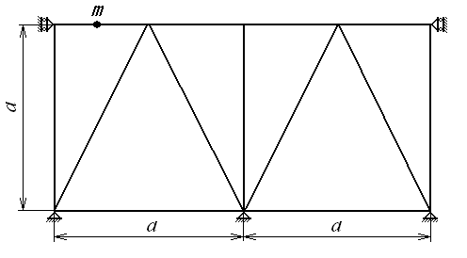
Fig.(2) 2D truss symmetrical structure

λ_{i}

S_{i}
y_{i}
z_{i}
x
~
z
~
y
~
Fig.(1) beams system with space model

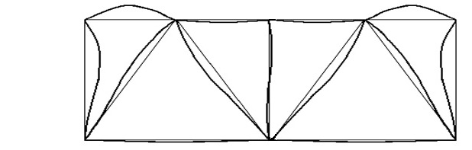
undeformed shape

Deformed shape

Fig.(3) the mode shape of vibrations in symmetrical structure .

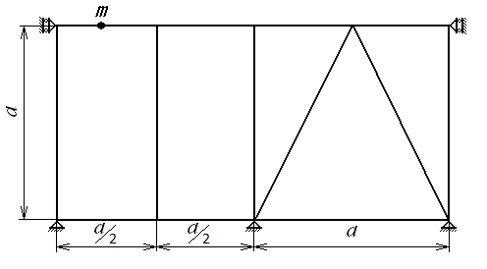
Fig.(4) 2D truss non-symmetrical structure

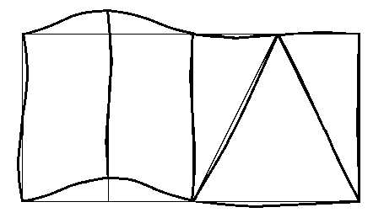
undeformed shape

Deformed shape

Fig.(5) the mode shape of vibrations in non-symmetrical structure .

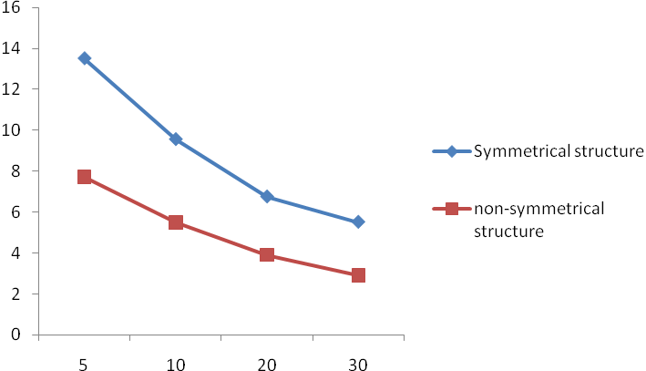
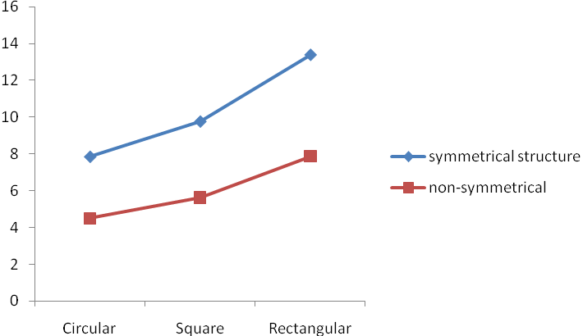
Fig.( 6 ) effect of beam cross-section area on
natural frequency
Mass (Kg)

Fig.(7 ) effect of mass weight on natural frequency
(Hz)
cross-section area
(Hz)

Data entry on the beam:
1) geometric. Character.
2) mechanical. characteristics
3) supporting systems.
4) loads.
The numbering of the beams and joints
Setting the location for the moving mass m
START
Formation of the stiffness matrix and the mass matrix of the vector
IF Ksz ≥ 0
Yes
No
Free Vibrations , Solving the system of equations by Rayleigh-Ritz method

Forced Vibrations, Solving the system of equations by Newmark method

Determination of the eigenvalues and Eigen functions forms.
Determination of the equation under force vibrations with time of effecting force .

Print the results
(positions, eigenvalues ,stress, displacements ,moments ,velocity of positions, force values on nodes )
Changing the position of the mass m
IF position =beam length
END
Yes
No
Fig.(8) Flowchart of the computer program

REFERENCES:
Abrahem H.A, Serazutdinov M.N.,” Calculation of the carrying-load capacity in strengthened beam structures under stress condition “, Journal for mechanical and materials Engineering , Special Issue ,3rd Conference of Engineering College ,Univercity of Babylon- Iraq 23-24 March 2011.

Chunga J.,Yoob H.H., “ Dynamic analysis of a rotating cantilever beam by using the FEM ”, Journal of Sound and Vibration, Volume 249, Issue 1, 3 January 2002, p 147–164.

Fryba, L., Vibration of solids and structures under moving loads. 3rd ed. 1999, London: Thomas Telford.,p.15-16.

Reddy J. N,” Energy Principles and Variational Methods in Applied Mechanics”,2nd Ed,2002,p.112-114

Srazodinov M.N., calculation method of curved beams , Proceedings of Higher Education in construction and architecture. - 1991. - № 5. – p. 104 - 108.

Shyong W.u.,” Analytical and Numerical Methods for Vibration Analyses
”, Wiley, 2013, p.659-668

Korenev B.G., Rabinovich I.M., ” Guide to the dynamics of structures”, Stroyizdat, 1972. – p.308-313.

Wu, J.-J., A.R. Whittaker, and M.P. Cartmell, Use of finite element techniques for calculating the dynamic response of structures to moving loads. Computers and Structures, 2000. 78(6): p. 789-799.

Zhongxiao Jia and G. W. Stewart,” An analysis of the Rayleigh-Ritz method for approximating eigenspaces”,Journal: Math. Comp. 70 (2001),p. 637-647

Zhuchao YE, Huaiha Chen, “ Vibration analysis of a simply supported beam under moving mass based on moving finite element method “, Mech. Eng. Chine 2009, 4(4): p.397-400.

