Darwish and Sayigh [1988] analyzed wind energy potential in Iraq. Data in eleven locations inside Iraq and six locations in neighboring countries were used in the study. They found that one sixth of Iraq enjoys annual wind speed greater than 5 m/s.
Fayadh M. et, al, [2010] estimated the global solar radiation on horizontal surfaces in three sites in IRAQ namely Hadith, Samara and Beji using normalized clearness index and normalized sunshine duration. They found that Haditha, received radiation on the plane surface higher than for Beji and Samara while the diffuse radiation behaved conversely with Samara showing the highest value.

Al-Hilphy A.R.S. [2013] performed a theoretical and practical study for incident solar radiation intensity in Basrah, south of IRAQ during the years2006 and 2011. He found that the maximum solar radiation reaches about 1000 W/m².
Acquiring these metrological data helps in taking the right decision where to build solar fields or wind turbine fields to obtain the maximum possible energy.
The aim of this project is to collect as maximum as possible data over a period of many years in Babylon province of Iraq which can be used in further studies of renewable energy.

DATA COLLECTION STATION
A WATCHDOG 2000 series weather station is used in this study. The station is installed at Babylon University site on the roof of a two story building so that no high building or other possible obstacles affect the data accuracy specially wind speed and direction. Fig (1) shows a photo of the station. The station collects the metrological parameters shown in table 1.
All these data are collected instantaneously at the end of a pre set period of time. The data are fed to a PC through an interface cable. The period between each two successive readings can be varied through the station. In the present study the data are collected at each 10 min period. A sample of these data is shown in appendix A.

RESULTS AND DISCUSSION
There is a huge quantity of data collected over the year 2011 and can not presented in this paper. A sample of the data is presented in appendix A reflecting its major features.
Fig (2) shows the variation of maximum daily solar radiation during the months Jan. to June. The fig shows that the solar radiation in Jan is the lowest and increases until it reaches more than 1000 W/m² in June.
Fig (3) shows the maximum daily solar radiation during months from July to December of the year 2011.Both figures 1 and 2 show that the maximum daily solar radiation occurs during the summer months of the year and reaches a maximum value of more than 1000 W/m². This value of solar radiation is very suitable for using solar radiation either for heating applications or for electricity generation.
It is clear from figs (2 and 3) that the months from May to August (summer season) enjoy a maximum solar radiation of about 1000 W/m² which means a very good potential of power. During winter months the maximum solar radiation is around 500 W/m² which is still a good potential of power.
Fig (4) shows the average monthly solar radiation during the year 2011. The fig shows that the maximum value of the average solar radiation occurred in Aug. (562.13 W.m⁻²) and the minimum occurred in Jan. (292.668 W.m⁻²). These results show that the annual average solar radiation is 443.6 W.m⁻² which is equivalent to 19.16 MJ.m⁻²day⁻¹. By performing a simple calculation assuming 15% conversion efficiency from solar energy to electrical energy and an area of one square kilometer solar field a power of 443.6 MW can be produced.
Fig (5) shows the monthly averaged wind speed. It is seen from this fig that the maximum monthly averaged wind speed is 5.1 km/hr (1.4178 m/s) in June and the minimum is 2.1 km/hr (0.5838 m/s) in Dec. These wind speeds are not encouraging since it is less than the threshold wind speed required for power generation. However this might not be true for other regions of Iraq specially in the western parts where there is open deserts.
Fig (6) shows a comparison of daily solar radiation of two days (24 July and 24 Jan.). The comparison shows that there is a large difference in solar radiation between summer and winter. The fig also shows that the sunshine period is longer in summer than winter.
Fig (7) shows variation of hourly air temperature during a summer day and a winter day. The fig shows that there is a large difference in air temperature between summer and winter. This is due to the higher solar radiation during summer than in winter as shown in fig (6).
Fig (8) shows a comparison of hourly wind speed in summer day with that in winter day. The comparison reveals that the wind speed in summer day is higher specially in the morning and in the evening where it reaches to about 11 km/hr. It must be mentioned that this speed occurs during very short durations only.
Fig (9) shows the hourly variation of relative humidity for a summer day and a winter day. The fig shows that the relative humidity is higher in winter. The relative humidity during night times is higher for both days due to low temperature.
For the last couple of years very small amount of rain was recorded in Iraq. The maximum amount of rain recorded in Babylon province for any day during 2011 was 0.2 mm.

CONCLUSIONS
The following conclusions can be drawn from this work;
1-Maximum solar radiation reaches to more than 1000 W/m².
2-The maximum monthly average solar radiation is about 562W/m² during summer months.
3-Even in winter season there is a good quantity of solar radiation. The minimum monthly average solar radiation is about 293W/m².
4-There is a very good potential to utilize solar energy for electricity generation.
5-The maximum monthly average wind speed is 5.1 km/hr which is not encouraging for electricity generation.

Table 1 Metrological Parameters Measured by the WATCHDOG 2000 Series Weather Station

Metrological parameter | Units
Solar radiation | W/m²
Air temperature | ºC
Wind speed | km/hr
Wind gust | km/hr
Wind direction | Deg.
Relative humidity | %
Rain quantity | mm

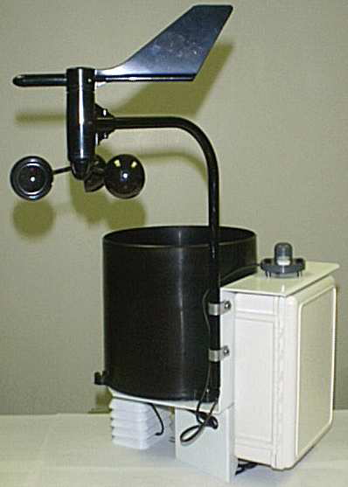

FIG (1) A WATCHDOG 2000 SERIES WEATHER STATION

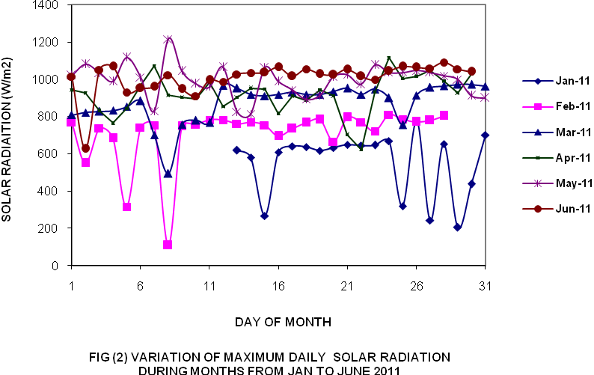

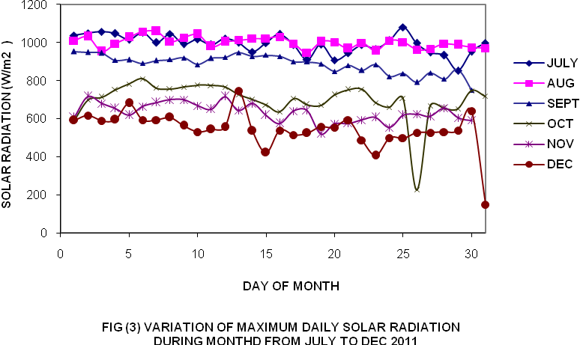

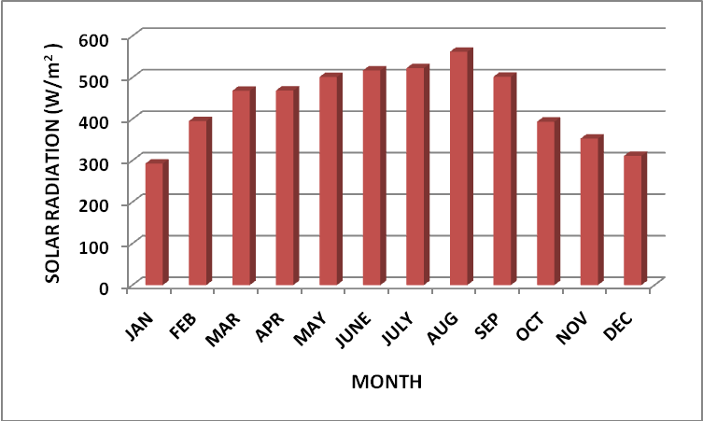
FIG (4) MONTHLY AVERAGE SOLAR RADIATION DURING 2011

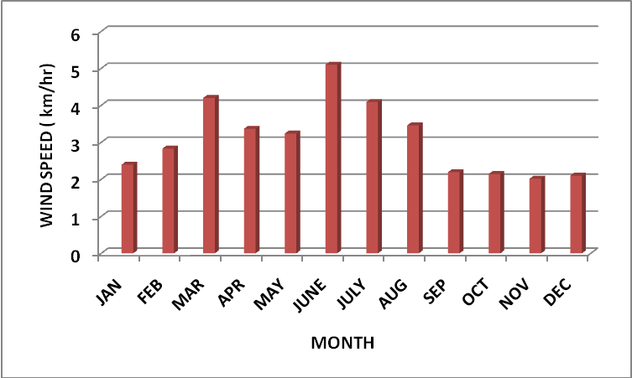

FIG (5) MONTHLY AVERAGE WIND SPEED DURING 2011

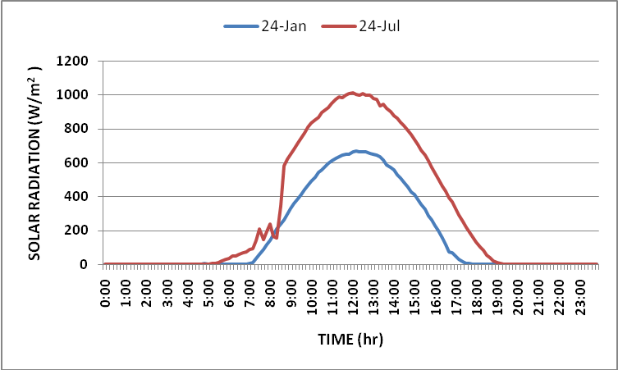

FIG (6) COMPARISON OF HOURLY SOLAR RADIATION
FOR A SUMMER DAY AND A WINTER DAY

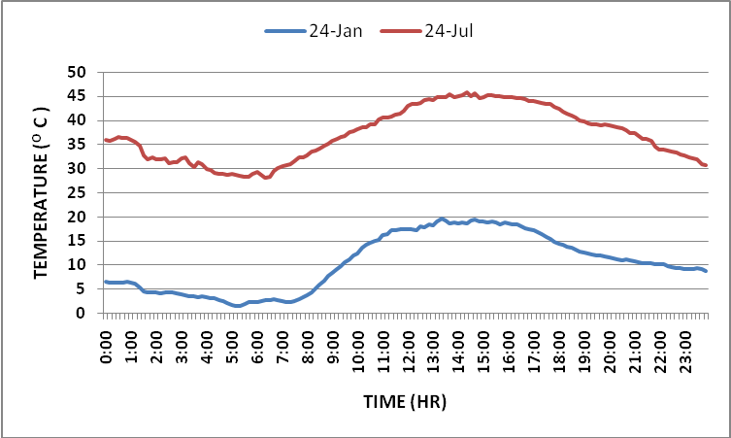
FIG (7) COMPARISON OF HOURLY AIR TEMPERATURE
FOR A SUMMER DAY AND A WINTER DAY

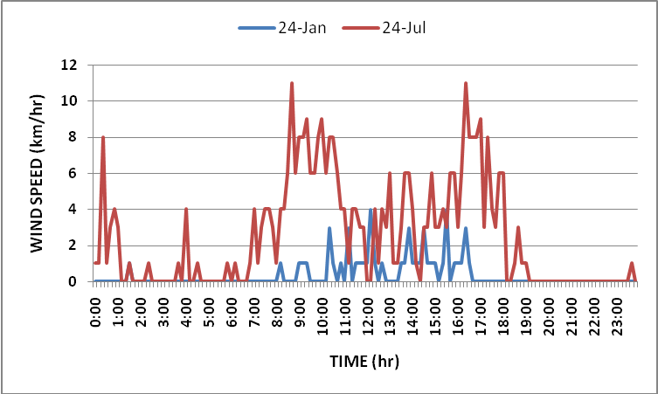
FIG (8) COMPARISON OF HOURLY WIND SPEED
FOR A SUMMER DAY AND A WINTER DAY

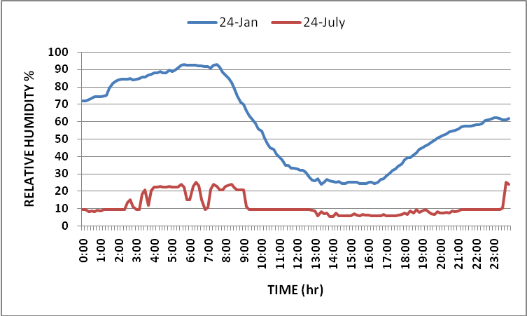
FIG (9) COMPARISON OF HOURLY RELATIVE HUMIDITY
FOR A SUMMER DAY AND A WINTER DAY

REFERENCES :-

UDO.S.O
Contribution to the relationship between solar radiation and sunshine duration in the tropics: a case study of experimental data at Ilorin, Nigeria.
Turk Phys 26, pp229-236, 2002

Ali Naci CELIK
Analysis of Ankaras exposure to solar radiation: evaluation of the distribution parameters using long term hourly measured global solar radiation data.
Turkish J. Eng. Env. Sci. 30, pp 115-126, 2006

El-Sebaii A. and Trabea A.A.
Estimation of global solar radiation on horizontal surface over Egypt
Egypt J. of Solid, vol 28, No.1, pp 163-175 ( 2005).

IIyas, S.Z., et, al.
Estimation and comparison of diffuse solar radiation over Pakistan.
Int. Sci. J. for Alternative Energy and Ecology. Vol 47, No,3, pp 109-111, 2007.

Stefan Beaker
Calculation of direct and diffuse solar radiation in Israel
Int. J. Climatol, 21, pp 1561-1576, 2001.

Abdul-Wahid.N. et, al
" Estimation and Comparison of Diffuse Solar Radiation Over Iraq" , Kufa journal , Vol. 1, No 2, pp 153-174, (2010).

Sayigh A.A.M
Solar Energy Engineering, Academic Press, New York, 1977.

Darwish A.S.K. and Sayigh A.A.M.
“Wind energy potential in Iraq.” Solar & Wind Technology 1988;5(3):215-220.

Fayadh M. et, al.
Estimation of Global Solar radiation on Horizontal Surface over Haditha, Samara and Beji in Iraq.
The Pacific Journal of Science and Technology. Vol. 11, No. 1, pp 73-82, May 2010.

Al-Hilphy A.R.S.
A Theoretical and Practical Study for Incident Solar Radiation Intensity in Basrah Province (South of Iraq).
IOSR Journal of Engineering, Vol. 3, Issue 9, pp 25-35 (2013).

Appendix A Sample of Recorded Data

Date and Time SRD HMD TMP RNF WND WNG WNS
2011-07-13 10:50 931.0 5.3 45.6 0.0 247 11 8
2011-07-13 11:00 945.0 5.3 45.8 0.0 249 9 3
2011-07-13 11:10 960.0 5.3 46.1 0.0 251 11 8
2011-07-13 11:20 965.0 6.5 46.6 0.0 286 11 1
2011-07-13 11:30 982.0 6.2 46.9 0.0 262 11 3
2011-07-13 11:40 978.0 5.3 47.1 0.0 242 11 3
2011-07-13 11:50 984.0 5.9 47.6 0.0 241 11 0
2011-07-13 12:00 1000.0 5.3 47.7 0.0 254 11 4
2011-07-13 12:10 997.0 6.7 47.8 0.0 272 9 6
2011-07-13 12:20 993.0 5.9 47.9 0.0 248 12 0
2011-07-13 12:30 989.0 5.6 47.7 0.0 245 11 4
2011-07-13 12:40 992.0 5.9 48.4 0.0 261 14 3
2011-07-13 12:50 974.0 7.0 48.4 0.0 268 11 1
2011-07-13 13:00 961.0 5.3 48.2 0.0 242 12 6
2011-07-13 13:10 948.0 5.3 48.4 0.0 273 12 4
2011-07-13 13:20 945.0 6.5 48.8 0.0 289 14 3
2011-07-13 13:30 932.0 7.0 48.5 0.0 290 11 3
2011-07-13 13:40 919.0 6.7 48.7 0.0 272 11 3
2011-07-13 13:50 896.0 5.6 48.4 0.0 255 11 6
2011-07-13 14:00 884.0 5.3 48.6 0.0 245 9 4
2011-07-13 14:10 853.0 5.9 48.6 0.0 259 12 0
2011-07-13 14:20 830.0 6.7 48.9 0.0 251 8 1
2011-07-13 14:30 804.0 5.6 48.9 0.0 272 9 0
2011-07-13 14:40 775.0 6.2 49.1 0.0 307 9 6
2011-07-13 14:50 756.0 5.6 49.4 0.0 331 12 3
2011-07-13 15:00 723.0 5.6 49.1 0.0 334 12 3
2011-07-13 15:10 692.0 5.9 49.3 0.0 327 11 4
2011-07-13 15:20 651.0 9.0 49.3 0.0 351 8 3
2011-07-13 15:30 618.0 5.6 49.1 0.0 324 8 4
2011-07-13 15:40 594.0 5.9 49.1 0.0 331 11 3
2011-07-13 15:50 556.0 5.6 49.0 0.0 293 11 1
2011-07-13 16:00 516.0 5.9 48.8 0.0 314 8 3
2011-07-13 16:10 479.0 6.2 48.8 0.0 310 9 0
2011-07-13 16:20 450.0 5.6 49.3 0.0 310 4 3
2011-07-13 16:30 409.0 6.2 49.2 0.0 334 8 1
2011-07-13 16:40 381.0 5.9 48.8 0.0 282 9 4
2011-07-13 16:50 341.0 5.6 48.4 0.0 273 3 0
2011-07-13 17:00 309.0 5.9 48.4 0.0 273 3 1
2011-07-13 17:10 273.0 5.9 48.5 0.0 272 0 0
2011-07-13 17:20 235.0 6.2 48.2 0.0 272 1 0
2011-07-13 17:30 204.0 5.9 47.7 0.0 272 1 0
2011-07-13 17:40 174.0 6.2 47.4 0.0 272 0 0
2011-07-13 17:50 148.0 6.5 47.3 0.0 272 0 0

