the main components. The traditional fixed-speed turbines are stall regulated while the new, variable speed turbines are pitch-regulated [Anders Ahlstrom 2002].
Many complex engineering systems are equipped with several actuators that may inﬂuence their static and dynamic behavior. Systems with more than one actuating control input and more than one sensor output may be considered as multivariable systems or multi-input multi-output (MIMO). The control objective for multivariable systems is to obtain a desirable behavior of several output variables by simultaneously manipulating several input channels [Tomas Petru 2001]. Optimal control design is one choice for many MIMO systems, LQG is an optimal control problem whose name is derived from the fact that it assumes a linear system, quadratic cost function, and Gaussian noise. The widely used LQG control law is one of the robust control methods due to its ease to implement, simple structure and good robustness. LQG optimized control try to obtain the minimum control error with the minimum control energy. It originally divided into two parts: optimized controller LQ and optimized Kalman filter, the controller based on which owns poor stability margin.
Many different closed loop designs have been proposed in the literature including high order sliding mode control [Brice B. and Mohamed E. 2009], LQR control [Trung-Kien Pham 2012 ], inverse system control approach [Geng Yang 2005], optimal control and fuzzy control [Ali M.and Imam R. 2011] , and Nonlinear Control [Boubekeur and Houria S. 2005].
This paper describes physical modeling, system identification for wind turbine and introducing state space model and simulation using MATLAB environment. The robust stability analysis of wind turbine with state feedback implement on the LQG technique.

List of symbols
Viscosity constant of low and high speed shaft,
Moment of inertia of rotor,
Moment of inertia of generator
, Spring constant of low and high speed shaft
Generator electromagnetic torque,
Generator torque reference,
Turbine torque,
Wind speed,
Generator angular speed,
Turbine angular speed,
Air density,
, Angular position of the rotor and the generator, rad.

2. AERODYNAMIC MODEL

A wind turbine obtains its power input by converting some of the kinetic energy in the wind into
a torque acting on the rotor blades. The amount of energy which the wind transfers to the rotor depends on the wind speed, the rotor area, blade design and the density of the air. The wind turbine power is equal to the product of the torque and the rotational speed.
The wind turbine rotor performance can be evaluated as a function of the coefficient of torque. An aerodynamic torque developed by wind turbine is expressed as follows [M.J.Balas 2006]:

Where, represent the wind turbine torque coefficient. It is a function of the tip speed ratio, as well as the blade pitch angle. The tip speed ratio is defined as the ratio of tip speed of the turbine blades to the wind speed and is given by

3. WIND TURBINE MODEL

A more complex wind turbine system, consisting of two such system, is shown in Fig.(1). The two systems are coupled through a gear box. The transmission system consists of the main bearing, high-speed shaft, gearbox, low-speed shaft, and a generator. The gear box inertia is typically much
smaller than the generator inertia, which means it will have no dynamic influence for lower frequencies, it is thus not specifically modeled but can be assumed included in the generator. Assume the turbine torque rotor equal to the aerodynamic torque, the wind turbine rotor dynamics, together with the generator inertia, are characterized by the following differential equations [P. Novak 1995]:

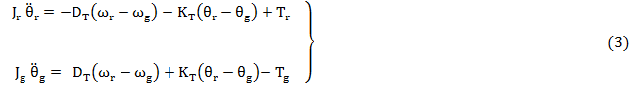

Where;

The gearbox ratio is defined as
Speeds and torques of the turbine rotor and the generator can be determined for each simulation time step by solving Eqn.(3), using a state-space approach. The state-space equations are [ Johan Florescu 2008]:
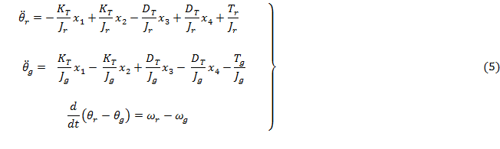

For controller synthesis purpose, the global model can be linearized around an operating point, linearizing the expression of turbine torque at given operating point 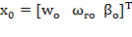 , as follows [P. Schaak 2004]

Where,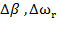, and represent deviations from the chosen operating point. Selection of the operating point is critical to preserving aerodynamic stability in this system and the linearization coefficients and are given by:

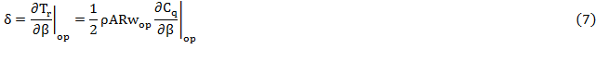

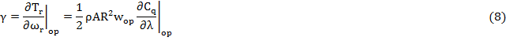

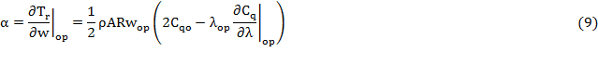
Blade pitch actuator can be modeled as a first-order dynamic system. The dynamic behavior of the pitch actuator is described by the following differential equation [Geng Yang 2012, Mohit 2011];

Where, is time constant, β and the actual and desired pitch angle, respectively.
The wind turbine system is described in the following state-space as;

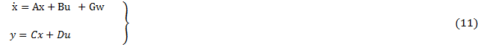

State vectors are defined by 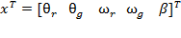 , and 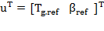
And state matrices A, C, and D are given by:

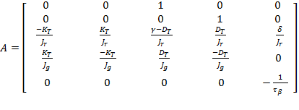, 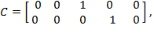 D = 0

Setting

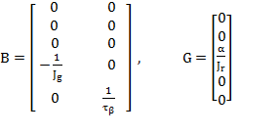

4. LQG CONTROLLER DESIGN

LQG control is a modern technique for designing an optimal dynamic regulator. It has been developed for both continuous and discrete system and permits the consideration of the disturbances in the system and noise as well, during the measurement of its output [Fereidoon S. and Kazem Jafari 2012, Xingjia Yao and Guangkun Shan 2009].
The objective here is to adjust the output around zero, the system is affected by disturbances and is controlled by the vector , the controller is receiving measurements which include noise, as shown in Fig.(2).

The state space equation describing the system is:

Where, and are the system disturbance and the measurement noise, and the associated covariance matrices are defined as:

Where,denotes the statistical expectation and zero correlation (white).
The problem is then to devise a feedback control law which minimize the cost function

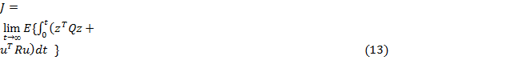

Where, is some linear combination of states variable, and
are weighting matrices.
The solution to the LQG problem is prescribed by the separation principle, which states that the optimal result is achieved by adopting the following procedure. First, obtain an optimal estimate of the state , optimal in the sense that is minimized, and then use this estimate as if it was an exact measurement of the state to solve the deterministic linear quadratic control problem.
The solution to the ﬁrst sub-problem that of estimating the state is given by Kalman filter theory. Which is seen to have the structure of a state observer; it is distinguished from other observers by the choice of gain matrix.The Kalman filter gain is given by [Joha Wiley and Sons Ltd 2007]:

Where, satisfies algebraic Ricatti equation

And ,

The second sub-problem is to ﬁnd the control signal which will minimize the cost:

On the assumption that

The solution to this is to let the control signal be the linear function of the states, as

Where, is the feedback matrix gain, and derived from
Where, satisfies another algebraic Ricatti equation

And

5. SIMULATION AND RESULT

The wind turbine parameters used for the simulations are taken from [A.D. Wright 2004].They were adapted to the purpose of this paper, whose main features are illustrated in Table 1. If we assume that the measurable outputs are the angular speed of wind turbine rotor and generator, the matrixes A, B, and C are;

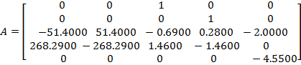

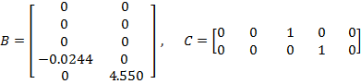

The state weighting matrix Q , and the control weighting matrix R are chosen by use Bryson's rule often, this choice is just the starting point for a trial and error iterative design procedure aimed obtains desirable properties for the close loop system. For the weighting matrices:

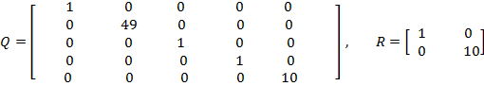

The gain matrix of state feedback controller is obtained as

Compute the Kalman filter gains,, the process noise and measurement noise, are white Gaussian random sequence with zero mean. Kalman filter is an optimal estimator when dealing with Gaussian white noise. To eliminate some of the undesirable phenomena, we suggested a good choosing of the noise covariance data that is dominantly rich to eliminate steady shift error, the following covariance's matrices as:

The Kalman filter gain
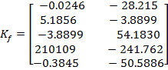

Base from where, the time histories of disturbance wind speed and white noise are shown in Figs.(3) and (4) respectively[A.D. Wright 2004].In the present case, the resulting state response of the closed-loop control system are illustrated in Figs.(5),(6) and (7). We can see that, the LQG controller is able to achieve the multiple objectives of state estimator within nominal values under the effect of fluctuating wind speed and white noise. The outputs of the system { and } for different control technique (LQR and LQG) are shown in Figs. (8) and (9) respectively. We show that, the output of the system is stable at time of operation of wind turbine, while the control signal { and } remain in the acceptable values for the controller used, and shown in Figs.(10) and (11).Finally the time response of the output of the system are shown in Figs.(12) and (13), the value of peak overshoot of rotor speed in response is and settling time is sec for two different technique method used. Therefore the system is better in terms of peak overshoot and settling time. In view of the result, the LQG design for wind turbine system state estimation which makes the high quality of the control process even in the wind disturbance and white noise. The simulation results validate that the LQG controller has good follow performance, not large fluctuation and improves load response remarkably.

6. CONCLUSIONS
This paper describes of an optimal control design for a variable speed wind turbine. LQG technique is able to achieve the multiple objectives of regulating angular speed. The wind turbine system in this research has already been controlled to track the desired angular speed and the improving mechanical power quality. The use of both control actions has shown that one can achieve a good tracking of torque and pitch references while keeping the angular speed close to its nominal value, with acceptable control signal. Simulation study has been done in MATLAB environment; show that both LQR and LQG are capable to control this system successfully; however that LQR produced better response compared to a LQG technique at wind disturbance and white noise.

Table 1. Technical specification of the wind turbine model

Variable name | Symbol | Value | Unit
Nominal power | ---- | 0.75 | MW
Rotor speed |  | 21.5 | r.p.m
Air density |  | 1.225
Wind speed | w | 16
Turbine radius |  | 35
Generator inertia |  | 40.983
Rotor inertia |  | 213.89
Tip speed ratio |  | 7.2 | -----
Mechanical coupling damping coefficient |  | 59.835
Mechanical coupling stiffness coefficient |  | 10993.96
Time constant |  | 0.2197 | sec

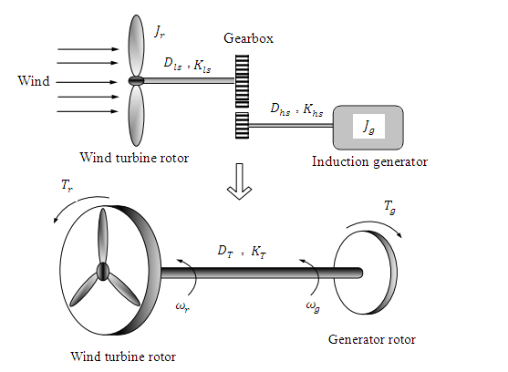

Fig. (1). Model of wind turbine
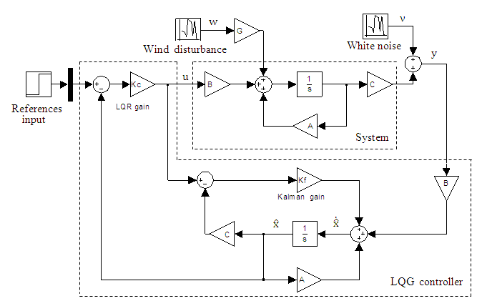

Fig.(2). Block diagram of wind turbine with LQG controller

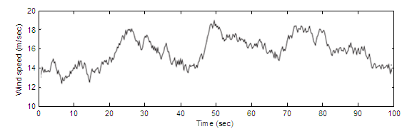

Fig.(3). Wind speed variation with time

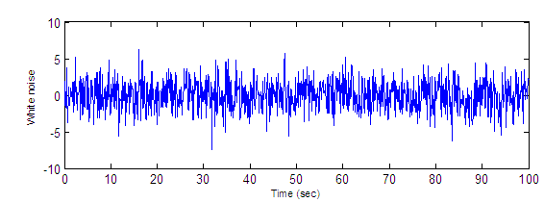
Fig.(4). White noise variation with time

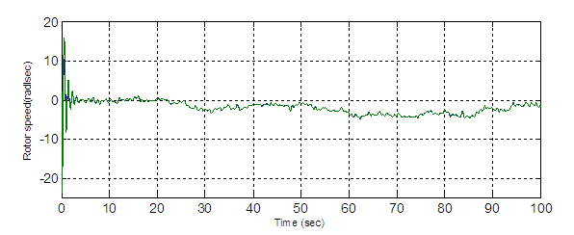

Fig.(5). State estimator of rotor speed, variation with time for wind turbine

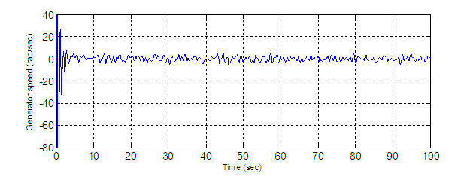
Fig.(6). State estimator of generator speed,variation with time for wind turbine

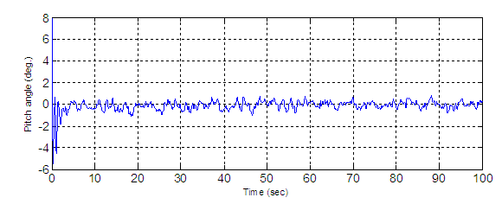
Fig.(7). State estimator of blade pitch angle, variation with time for wind turbine

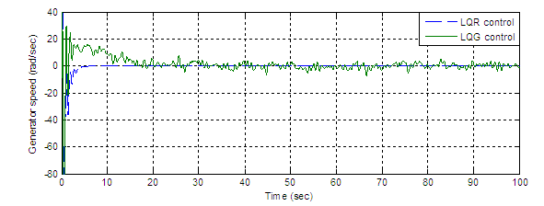
Fig.(8). Variation of generator speed of wind turbine with time for different control
technique

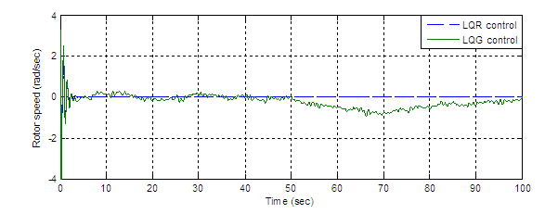
Fig.(9). Variation of rotor speed of wind turbine with time for different control
technique

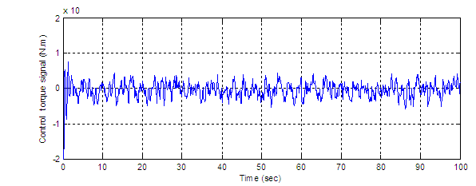
Fig.(10). Time history of control torque signal, for wind turbine

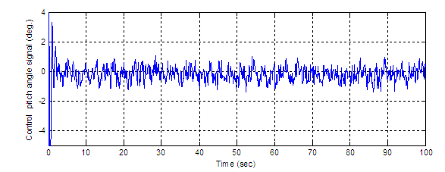
Fig.(11). Time history of control pitch angle signal, for wind turbine

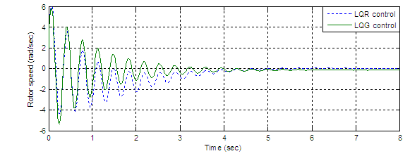
Fig.(12). Simulation of time response for the rotor speed at different method used

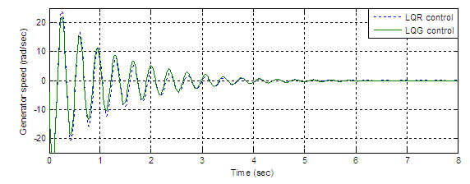
Fig.(13). Simulation of time response for the generator speed at different method used

REFERENCES

A.D. Wright, “ Modern Control Design for Flexible Wind Turbines ”, NREL Report No.
TP-500-35816, National Renewable Energy Laboratory, 2004.

Ali Musyafa Negara, and Imam Robandi,’’ Design Optimal of Adaptive Control and Fuzzy
Logic Control on Torque- Shaft Small Scale Wind Turbine ’’, Canadian Journal on
Electrical and Electronics Engineering Vol. 2, No. 6, June 2011.

Anders Ahlstrom, ” Simulating Dynamical Behavior of Wind Power Structure ’’, Licentiate
Thesis, Stockholm, 2002.

Boubekeur Boukhezzar and Houria Siguerdidjane,” Nonlinear Control of Variable Speed
Wind Turbines Without Wind Speed Measurement ”, IEEE, European Control Conference
2005.

Brice Beltran, Tarek Ahmed-Ali, and Mohamed El ,’’ High-Order Sliding-Mode Control of
Variable-Speed Wind Turbines’’, IEEE Transactions on Industrial Electronics, Vol. 56,
No.9,2009.

Fereidoon Shabaninia and KazemJafari,” Using LQG/LTR Optimal Control Method to
Improve Stability and Performance of Industrial Gas Turbine System”, International
Scholarly Research Network,2012

Geng Yang, Hua Geng,’’ Inverse-System Control Approach for Variable-Speed Variable
Pitch Wind Generator’’, Department of Automation, Tsinghua University, Beijing, China,
2005.

John Florescu,” State-Space PD Feedback Control ”, World Academy of Science, Australia,
2008.

Joha Wiley and Sons Ltd ,“ Robust Control Design an Optimal Control Approach ”,
University of Alberta, 2007.

M.J.Balas,’’Testing State-Space Controls for the Controls Advanced Research Turbine ”,
University of Wyoming Conference Paper NREL/CP-500-39123, January 2006.

Mohit Singh ,’’ Dynamic Models for Wind Turbines and Wind Power Plants’’, The
University of Texas at Austin,NREL,May 31,2011.

P. Novak, T. Ekelund, I. Jovik, and B. Schmidtbauer ,’’ Modeling and Control of Variable
Speed Wind-Turbine Drive System Dynamics’’,IEEE Control Systems Conference, Sweden,
1995

P. Schaak and T.G. van Engelen,’’ Torque Control for Variable Speed Wind Turbines’’,
Energy Research Centre of the Netherlands, NOVEMBER 2004.

Thomas Ackermann and Lennart Soder,” An Overview of Wind Energy Status 2002 ’’, Royal
Institute of Technology, Teknikringen 33, S-10044 Stockholm, Sweden,2002.

Tomas Petru,’’ Modeling of Wind Turbines for Power System Studies ”, University of
Technology, Thesis, Sweden, 2001.

Trung-Kien Pham, Yoonsu Nam, Hyungun Kim, Jaehoon Son,’’ LQR Control for a Multi-MW Wind Turbine’’,World Academy of Sciene Engineering and Technology,2012.
.
Xingjia Yao, Shu Liu and Guangkun Shan, ” Pitch Regulated LQG Controller for
Variable Speed Wind Turbine ’’, International Conference on Intelligent Human-Machine
Systems 2009.

