NOMENCLATURE
AAE average absolute error, %
k ratio of specific heats, cp/cv
M molecular weight, kg/kgmol
n isentropic index
P_{d} discharge pressure, kPa
P_{pr} pseudo-reduced pressure
P_{s} suction pressure, kPa
R_{u} universal gas constant, 8.314 kJ/(Kg mol K⁻¹); R= R_{u}/M
T temperature, K
T_{d} discharge temperature, K
T_{pr} pseudo-reduced temperature
T_{R} reduced temperature
T_{s} suction temperature, K
Z observed compression ratio (observed compressibility factor)
Zc calculated compression ratio (calculated compressibility factor)
ρ density, kg m⁻³

INTRODUCTION
P-V-T measurements for gases under pressure started in the later of the 19th century; upsurge measurement occurred for natural gasses, led by the work of Sage et al.(1940) on their API projects .Out of this study came the compressibility factor (compression factor Z) chart made by Standing and Katz (1945) with the advice assistance of G.G Brown and D. Holocomb .The basis for the correlation of the data used with this chart is Van der Waal theorem of corresponding of stage; substance should have similar properties at corresponding conditions normalized to some basic properties like the critical temperature and pressure , The use of reduced pressure P_{r} (actual pressure divided by critical pressure) , and reduced temperature T_{r} (actual temperature divided by critical temperature (absolute)),to determine compressibility factors brought reasonable but not exact correlations (Katz,1959 ).The original Standing and Kats chart covered pressure to P_{R}=15 or about 10000 psi (68.9 Mpa).The chart was extended to P_{R}=30 for the Handbook (Katz,1959).
Standing and Katz1 (1942) presented a generalized compressibility factor chart. The chart represents compressibility factors of sweet and dry natural gas as a function of pseudo-reduced pressure (P_{pr}) and pseudo reduced temperature (T_{pr}). This chart is generally reliable for sweet natural gases with minor amounts of non-hydrocarbons. It is one of the most widely accepted correlations in the oil and gas industry. The Standing and Katz (SK) chart was developed using data for binary mixtures of methane with propane, ethane, butane, and natural gases having a wide range of composition. None of the gas mixtures had a molecular weight in excess of 40. For low molecular weight gases, it was found that the Z-factor estimated from the SK chart has an error in the order of 2 to 3%. However, for gas mixtures whose molecular weight is greater than 40, the SK chart provides inaccurate Z-factors. Methods for estimating gas compressibility factors normally are used when a reservoir fluid-depletion study is not available. This practice is acceptable for retrograde gases if the gas condensate is lean; however, if the gas is rich, the reserves may be seriously underestimated if the two phase compressibility factor is not used. The compressibility factor chart (SK) is applicable to most gases encountered in petroleum reservoirs and provides satisfactory prediction for all engineering computations. The calculated volume of gases containing only minor amounts of non-hydrocarbon can be accurate within 97%. Standing and Katz correlation for compressibility factor is valid only for dry-gas systems. Corrective methods are introduced to account for the presence of high molecular weight gases (C7⁺) and to extend the range of application of the SK chart (Sutton, 1985). Retrograde gas condensate reservoirs experience liquid fallout during depletion below the dew point. The two-phase compressibility factor accounts for the formation of a liquid phase. After several decades of existence, the SK chart is still widely used as a practical source of the Z-factor for natural gas.5. Several empirical correlations for calculating the Z-factor have been developed. These correlations are the following (Adel et al ,2001):
(1) Pappey
(2) Hall-Yarborough
(3) Dranshuk-Abou-Kassem
(4) Dranchuk-Purvis-Robinson
(5) Hankinson-Thomas-Philips
(6) Brill and Beggs
TaKacs (Adel et al ,2001) used 180 values of the Z-factor from the SK chart to review the accuracy of the first five correlations. He concluded that the Dranchuk-Abou-Kassem correlation is the best one to fit the SK chart. For the six correlations the average absolute errors are within ranges 6- 28% (Adel et al ,2001).
Compression factor (Compressibility factor) is a useful thermodynamic property for modifying the ideal gas law to account for the real gas behavior (Smith, 2005). In general, deviation from ideal behavior becomes more significant the closer a gas is to a phase change, the lower the temperature or the larger the pressure. Compressibility factor values are usually obtained by calculation from equations of state (EOS), such as the Virial equation which take compound specific empirical constants as input. For a gas that is a mixture of two or more pure gases (air or natural gas, for example), a gas composition is required before compressibility can be calculated. A good knowledge of the compression factor Z is necessary for the reliable determination of the mass flow of the natural gas transferred through pipelines .Because of the very large mass flow, it is desirable that compression factor can be measured or calculated with a good accuracy. Alternatively, the compressibility factor for specific gases can be read from generalized compressibility charts (Cengel, 1988) that plot as a function of pressure at constant temperature see Fig.1.

One of the main objectives of the current work is to find a simplified generalized formula to calculate the compressibility factors.

THEORY
Many gas compression calculations performed by hand-held analyzers and PLCs (programmable logic controllers) use P-V data based on ideal gas models. For ideal gases, the pressure, temperature, and density are related by:
(All pressures and temperatures must be in absolute units.) If the compression process for an ideal gas is isentropic, the following equation relates suction and discharge pressure and temperature:
where k is the ratio of specific heats, cp/cv.
Ideal gas models work for most gases at low pressures. However, in the range of conditions encountered in EOR (Enhanced Oil Recovery) applications, gases do not always behave ideally. A compressibility factor, Z, can be added to the ideal gas law as a correction, such that:
Alternately, a more complicated EOS can be used to model gas behavior. Analyzers and PLCs often use the Redlich-Kwong EOS for its simplicity and speed of calculation.
The compression process in a reciprocating compressor is often treated as isentropic. The isentropic compression equation is often inaccurate when k is used in the exponent, but its form is useful for flow and power calculations. Therefore, k is often replaced by a variable called n (isentropic index), as in eq.(4) below. The value of n is calculated using the P-V card from an analyzer, or from pressure and temperature values taken from entropy charts for isentropic compression.
From a thermodynamic perspective, any EOS that can generate values for Z can also be used to directly calculate the entropies and enthalpies required to model isentropic compression (Span and Wagner (1996) and Ref Prop software created by NIST(2002)) . However, for most EOS models, such calculations require time-intensive iterative processes that may be beyond the capability of a PLC or portable analyzer. Furthermore , many programs written for these devices already use equations that require values of Z and n. This paper will therefore present simplified correlation for Z.
The compressibility factor is a ubiquitous concept in measurement. It arises in many industry practices and standards. Unfortunately the mathematical methods and data associated with it obscure some of the basic ideas behind it. The purpose of this paper is to suggest a formula for correlating compressibility factor Z with relative critical properties

FORMULA DEVELOPMENT
A multiple regression analysis is required to develop a functional relationship between compression factor Z, with the corresponding reduced temperature T_{R} and reduced pressure P_{R}. Applying a computer program; (Statistica software program version 5) to the data obtain by Wilcox et. al.(2009) , Cengel (1988) and Yuns (1990) lead to the development of a general formula for the compression factor predictions, the equation is ;

Z =C₁ + (C₂+C₃T_{R}+C₄T_{R}²+C₅T_{R}⁻⁶)(C₆+C₇ P_{R}+C₈P_{R}⁴+C₉P_{R}/T_{R}+C₁₀(T_{R}/P_{R})^{C11}) (5)

This equation is valid for reduced temperature range;1-5 and reduced pressure 0.5-6.5 where C₁ to C₁₁ of eq.(5) are listed in Table 1 .
The procedure of applying Statistica software program version 5 to fit eq.(5) is as follow:

1) STATISTICA Help Index

To choose a topic, point to it and click the left-mouse-button, or press TAB to highlight the underlined topic and press ENTER.
Toolbars
Pull-down Menus
Graphics
Data Management
Statistics (Index of all Modules)
Statistical Advisor
General Conventions
Keyboard Commands
Mouse Conventions
Customizing STATISTICA
Exchanging Information (Data, Graphs) with other Applications
STATISTICA Command Language (SCL)
STATISTICA BASIC (Programming Language(
Glossary
References

2) STATISTICA Statistics
Elementary Concepts Log-Linear Analysis
ANOVA/MANOVA Multidimensional Scaling
Basic Statistics Nonlinear Estimation
Canonical Analysis Nonparametrics
Cluster Analysis Process Analysis
Data Management Quality Control
Discriminant Function Analysis Reliability & Item Analysis
Experimental Design Survival Analysis
Factor Analysis Time Series and Forecasting
Linear Regression SEPATH (Structural Equation Modeling)
See also, STATISTICA File Server Megafile Manager

3)Nonlinear Estimation – Index
Introductory Overview
Startup Panel
User-Defined Regression
Syntax
Logistic Regression
Probit Regression
Exponential Growth Regression
Breakpoint Regression
Parameter Estimation
Results
4)Nonlinear Estimation Procedures
Least Squares Estimation
Loss Functions
Weighted Least Squares
Maximum Likelihood
Maximum likelihood and probit/logit models
Function Minimization Algorithms
Start Values, Step Sizes, Convergence Criteria
Penalty Functions, Constraining Parameters
Local Minima
Quasi-Newton Method
Simplex Procedure
Hooke-Jeeves Pattern Moves
Rosenbrock Pattern Search
Hessian Matrix and Standard Errors

Click on the following topics for overviews of the common nonlinear regression models and evaluation of the fit of the data to the nonlinear model.
Common Nonlinear Regression Models

5) Evaluating the Fit of the Model

Nonlinear Estimation Procedures - Quasi-Newton Method
As you may remember, the slope of a function at a particular point can be computed as the first-order derivative of the function (at that point). The "slope of the slope" is the second-order derivative, which tells us how fast the slope is changing at the respective point, and in which direction. The quasi-Newton method will, at each step ,evaluate the function at different points in order to estimate the first-order derivatives and second-order derivatives. It will then use this information to follow a path towards the minimum of the loss function.

RESULTS AND DISCUSION

From open literature ,Hashim et. al. (2009) developed compressibility factor correlation function of reduced temperature and pressure. This correlation offers flexibility for estimating Z for a wide range of reduced temperatures (T_{R}=1-5) and reduced pressure (P_{R}= 0.5- 6.5). The present work has an improvement for this correlation in percentage error and in number of correlation constants.
The average absolute error of the proposed correlation (eq.(5)) is 4.6 % for 169 data points while the corresponding Hashim et al is 4.9 of 180 data points with significant local errors (more than 20%). Limited works are available in literate of correlating simple formula of the compressibility factor Z with critical prosperities. These suggested correlations become more difficult and complicated for the wide range of relative critical properties.
Fig.2 to Fig.12 shows the graphical comparisons of the observed compressibility factor Z and calculated compressibility factor Z from eq.(5) for all reduced temperature ranges (1, 1.05, 1.1, 1.2, 1.3, 1.4, 1.5, 1.6, 1.8, 2, 2.5,3.5 and 5) and reduced pressures range (0.5-6.5). Table 2 shows the average percentage error of the observed compressibility factor Z with the corresponding calculated one for each range of reduced temperature and reduced pressure (that are summarized in Fig.2 to Fig.12).
Table 2 have a significant errors of applying proposed formula eq.(5) for ; T_{r} <1.2 and P_{r} range 0.5-6.5.
The agreement in Table 2 is reasonably good except in the case of No.1 and 2 for values of T_{R}= 1 and 1.05. These significant errors in cases No.1 and 2 are due to that gases temperature values approximately near critical temperature values (i.e. near the saturation line and phase change (gas to liquid phase)). The agreement between the present correlation (eq.(5)) and the measured values of the compressibility factor Z is excellent despite some small discrepancy at P_{R}=0.5. These cases are presented in Figs. 2,3 and 4, while more accurate data are available for these figures for P_{R} > 3. In Fig. 5 to Fig.12, the results show a tendency to decrease deviation between measured compressibility factor Z and the corresponding calculated Z_{c}. In other words, more ideal behavior for the gas at higher temperature values (i.e. higher T_{R} values). Fig. 7,8 and 9 have a smaller error ranges for compressibility factor prediction for reduced temperature; T_{R} values 1.5, 1.6 and 2.0.

CONCLUSIONS
A formula has been generalized to permit calculation of the compression factor as reduced temperature T_{R} and reduced pressure P_{R}. The new correlations offers flexibility for estimating compression factor for a wide range of reduced temperature; T_{R}=1-5 and reduced pressure; P_{R}=0.5- 6.5.
This paper presents a simplified model for compressibility factor that is functionally equivalent to the more complex models available today. This correlation provides accurate and computationally reliable prediction of the compression factor (Z) with an average absolute error 4.6 % for 169 data points.

Table 1: Constants of eq.(5)
C₁ | C₂ | C₃ |  | C₄ |  | C₅
1.0140 | -440.650 | 258.4585 |  | -26.4235 |  | -89.4936
C₆ | C₇ | C₈ | C₉ |  | C₁₀ | C₁₁
0.00000035 | -0.00046 | 1.0 | -1.57841 |  | 1.58061 | -0.99940

Table 2: Shows the average percentage error of the observed compressibility factor Z with the corresponding calculated one for each range of reduced temperature and reduced pressure that are summarized in Fig.2
No. | Fig. no. | T_{r} | Pr | Number of data point | AAE%
1 | 2 | 1 | 0.5~6.5 | 13 | 9.8
2 | 3 | 1.05 | 0.5~6.5 | 13 | 10
3 | 4 | 1.1 | 0.5~6.5 | 13 | 7.0
4 | 5 | 1.2 | 0.5~6.5 | 13 | 6.6
5 | 6 | 1.3 | 0.5~6.5 | 13 | 5.1
6 | 7 | 1.4 | 0.5~6.5 | 13 | 3.8
7 | 8 | 1.5 | 0.5~6.5 | 13 | 2.5
8 | 9 | 1.6  1.8 | 0.5~6.5  0.5~6.5 | 13  13 | 2.7  1.0
9 | 10 | 2.0  2.5 | 0.5~6.5  0.5~6.5 | 13  13 | 1.2  2.4
10 | 11 | 3.5 | 0.5~6.5 | 13 | 3.9
11 | 12 | 5.0 | 0.5~6.5 | 13 | 3.2
 | All the data points | 1~5 | 0.5~6.5 | 169 | 4.6

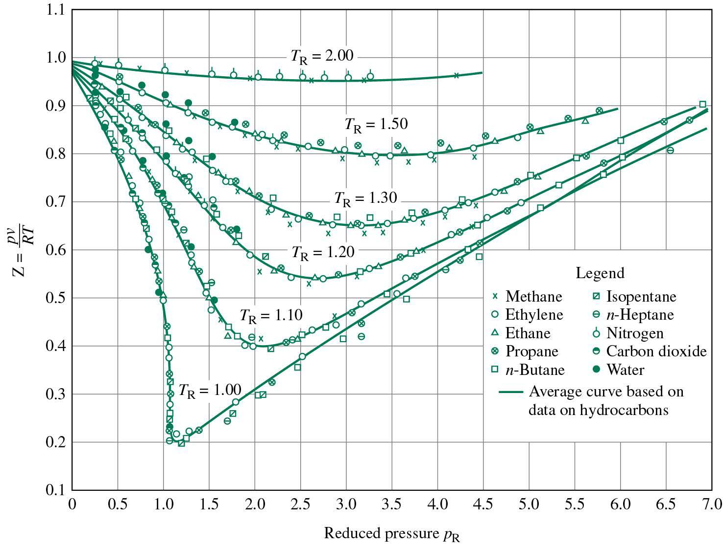
Fig.1 : Generalized compressibility factor chart (Cengel, 1988)

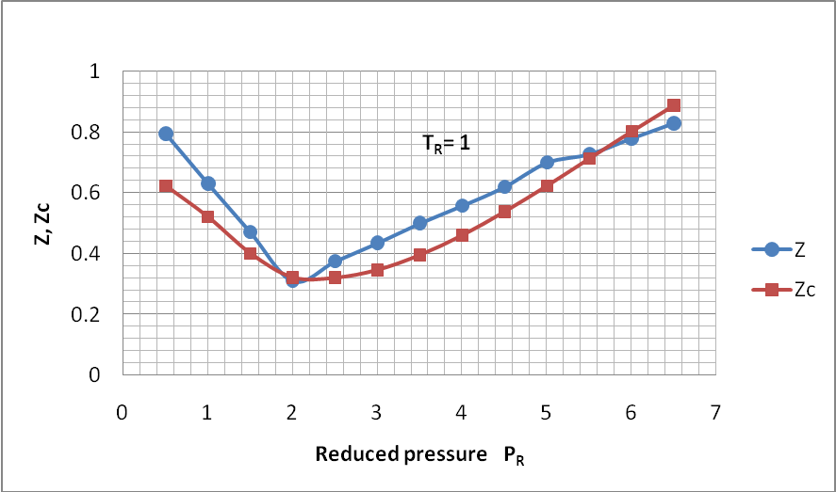
Fig.2 : Comparisons of observed Z and calculated Z_{c} at T_{r}=1

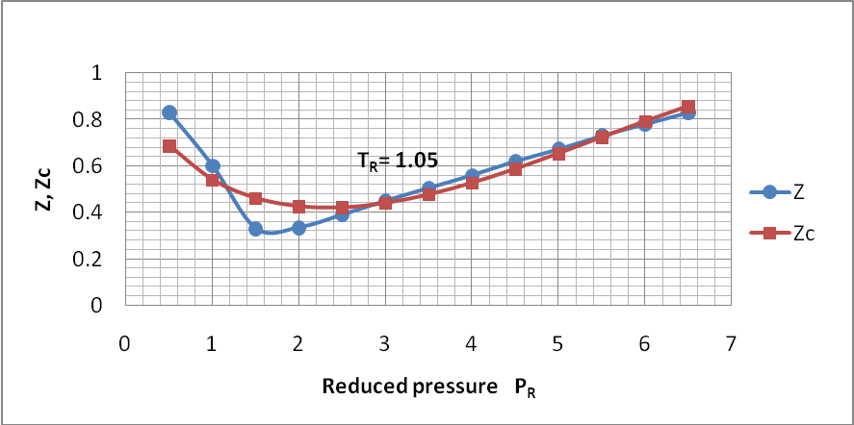
Fig.3 : Comparisons of observed Z and calculated Zc at Tr=1.05

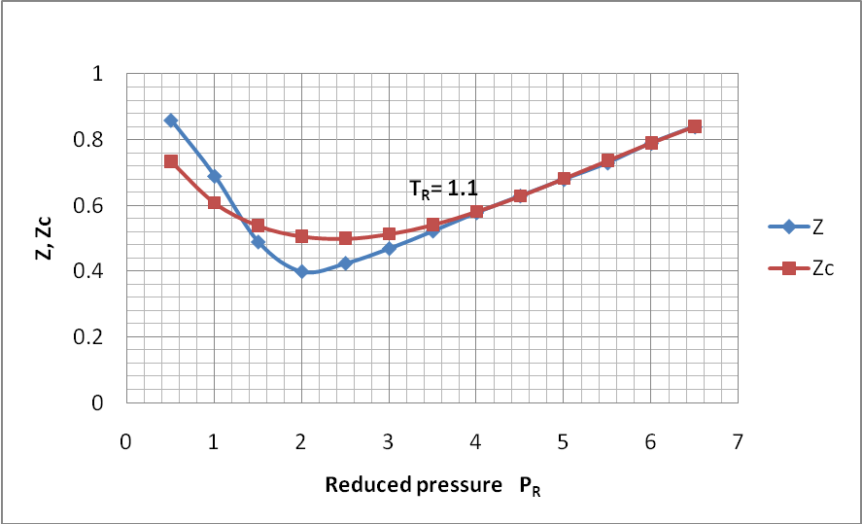
Fig.4 : Comparisons of observed Z and calculated Z_{c} at T_{r}=1.1

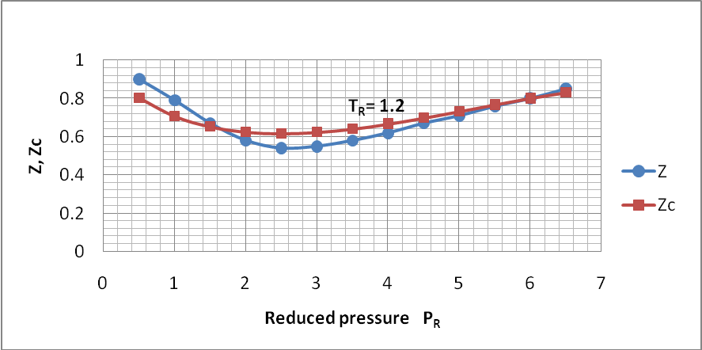
Fig.5 : Comparisons of observed Z and calculated Z_{c} at T_{r}=1.2

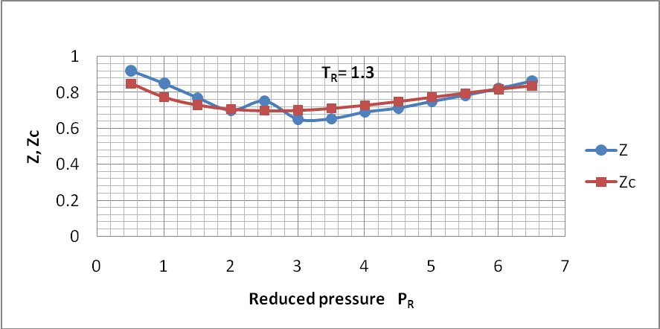
Fig.6 : Comparisons of observed Z and calculated Z_{c} at T_{r}=1.3

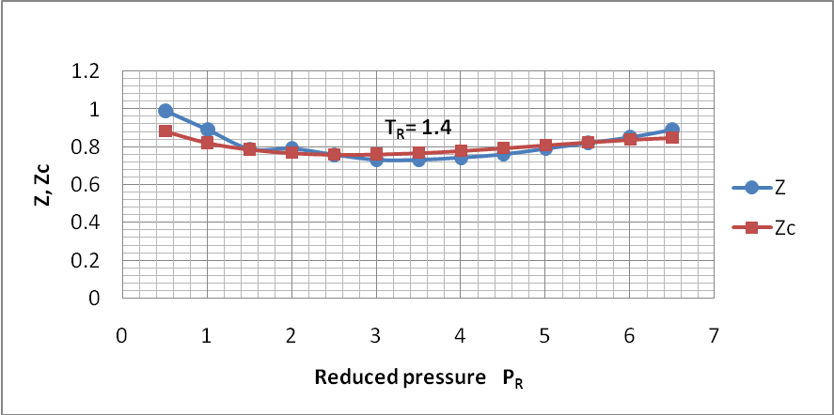
Fig.7 : Comparisons of observed Z and calculated Z_{c} at T_{r}=1.4

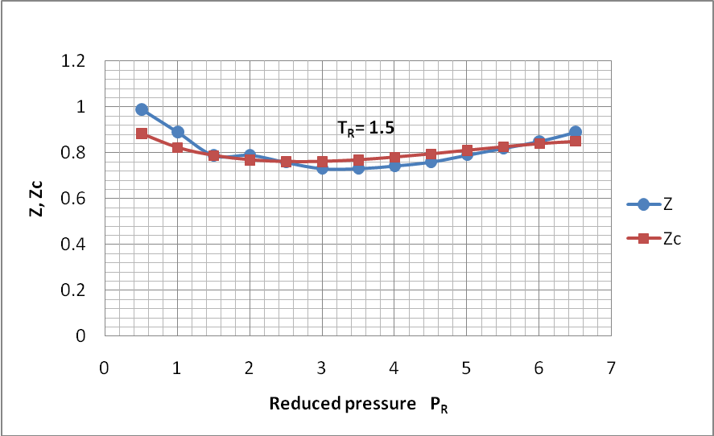
Fig.8 : Comparisons of observed Z and calculated Z_{c} at T_{r}=1.5

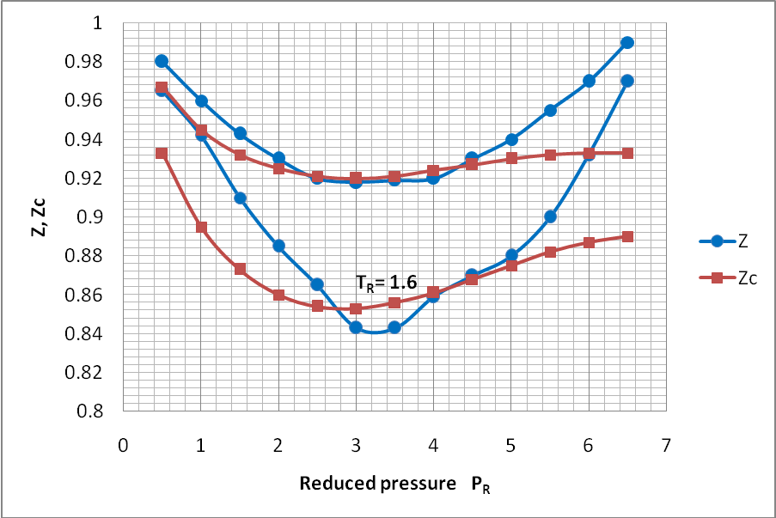
Tr = 1.8
Fig.9 : Comparisons of observed Z and calculated Z_{c} at T_{r}=1.6 and 1.8

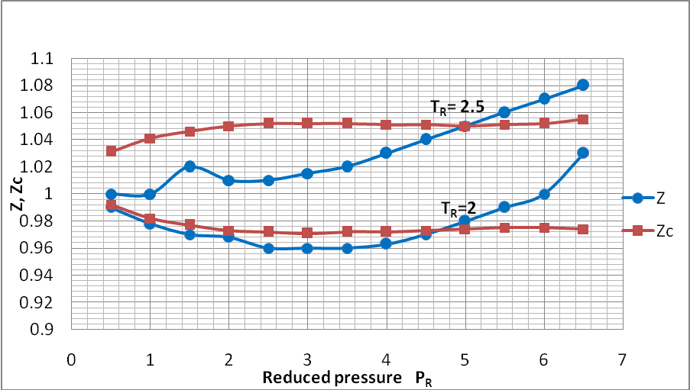
Fig.10 : Comparisons of observed Z and calculated Z_{c} at T_{r}=2 and 2.5

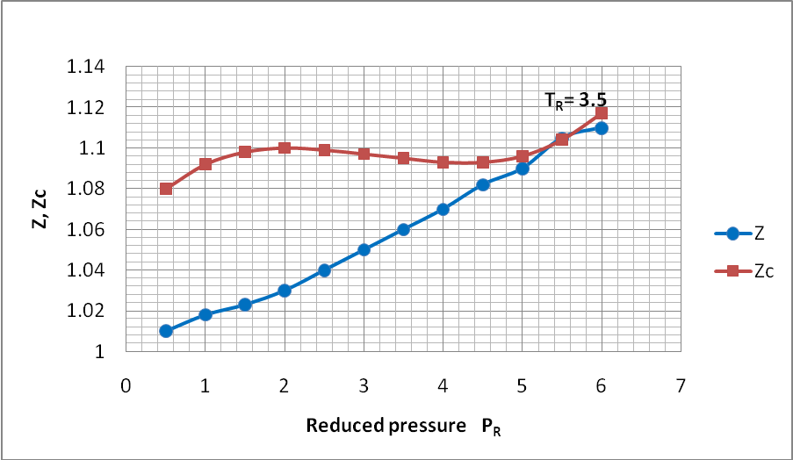
Fig.11 : Comparisons of observed Z and calculated Z_{c} at T_{r}=3.5
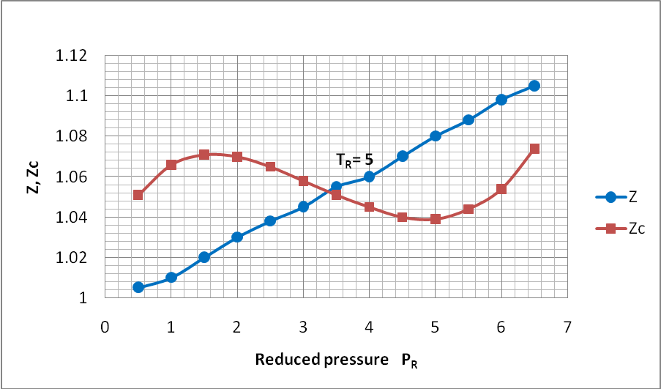

Fig.12 : Comparisons of observed Z and calculated Z_{c} at T_{r}=5

REFERENCES
Adel M. Elsharkawy, Yousef S. Kh. S. Hashem, and Abbas A. Alikhan " Compressibility Factor for Gas Condensates", Energy & Fuels, 15, 807-816,( 2001)

Cengel, Y. A and Boles, M. A. " Therodynamics: an Engineering Approch", 3rd ed., WCB/ McGraw-Hill Boston, 1988.

Hashim E. T , A. A Saleh "Generalized Formula for Compressibility Factor Z "Petroleum Science Technology, vol. 27, no. 13, pp. 1503-1509, (2009)

Katz, D.L.Sliepceevich, C.M..Condensate may occupy apparent negative volume in a gas reservoir. Oil weekly 116 (13):30. (1945)

Katz,D.L.,Cornell,D.,Kobayashi,R.,Poettmann,F.H.,Varry,J.A.,Elenbaas,J.R.,Weinang,C.F..Handbook of natural Gas Engineering. New York: McGraw-Hill Publishing Company. (1959)

National Institute of Standards and Technology (NIST). “REFPROP” software, Version 7, (2002). http://www.nist.gov/srd/nist23.cfm

Sage, B.H., Budenholzer, R.A., Lacey, W.N..Phase equilibrium in hydrocarbon systems methane –n-butane system in gaseous and liquid region . Ind. Eng. Chem.52:1262. (1940)

Smith, J.M. et al.. Introduction to Chemical Engineering Thermodynamics (Seventh Edition ed.). McGraw Hill. ISBN 0-07-310445-0. page73 (2005)

Span, R. and Wagner, W., “A New Equation of State for Carbon Dioxide Covering the Fluid Region from the Triple-Point Temperature to 1100 K at Pressures up to 800 MPa”, J. Phys. Chem. Ref. Data, Vol. 25, No. 6, pp. 1509-1596 (1996).

Standing, M. B.; Katz, D. L. Density of Natural Gases. Trans. AIME, 146, 140-149 (1942)

Sutton, R. P. Compressibility Factors for High Molecular Weight Reservoir Gases. Paper SPE 14265, presented at the SPE Annual Technical Meeting and Exhibition, Las Vegas, NV, Sept. 22-25, (1985).

Wilcox, M. and Brun, K., “Guideline for Field Testing of Reciprocating Compressor Performance”, Gas Machinery Research Council and Southwest Research Institute, Release 1.0, November (2009).

Yunus, A.C.and M.A.Bolecs, "Thermodynamics engineering approach ", McGraw-Hill, USA (1990).

