INTRODUCTION :

Grease is a mixture of a fluid lubricant, a thickeners and additives. The fluid lubricant that performs the actual lubrication can be petroleum (mineral oil), synthetic oil, or vegetable oil (Edward Brunet, Jr., P.E.,1999). Common thickeners are the fatty acid soaps of lithium, calcium, sodium, aluminum, and barium in concentration of 8-25 wt. % (McCarthy,1972), or inorganic non soap thickeners. Additives enhance performance and protect the grease (Edward Brunet, Jr., P.E.,1999).
Grease has a wide number of characteristics and features, because of which it is used in a variety of industrial applications. The important properties, which affect the characteristics of grease, are amount and type of thickener, physical characteristics and oil viscosity, additives and low or high temperature performance.
Grease is a lubricant which has thickened in order that it remains in contact with the moving surfaces and not leak out under gravity or centrifugal action, or be squeezed out under pressure (Vold, J. Marjorie, and Vold, Robert D., 1952) .
A physical examination of soap thickened grease shows it to be of fibrous nature. The fiber structure will depend predominantly upon the type of soap used and the method of manufacture (Billelt, M.,1979).
The length and diameter of individual fiber will control the characteristics of the final grease structure (Polishuk, A. T.). The fiber length may be short which results in smooth buttery texture. Alternatively, the fiber length may be long which will results in a stringy type texture (Billelt, M.,1979).
Nelson in 1952 thickened lubricating oil with 10 to 25 percent of high molecular weight wax acids to form grease like product which was said to act as a rust-preventive. Also, the addition of approximately 6 percent of acids, derived from the oxidation of petroleum fractions, to " Bentone "- thickened lubricating greases in order to prevent corrosion when the lubricating in service (Nelson, John Walker,1952).
Richard L. Nailen in 2002 stated that grease is a familiar substance, commonly used as a lubricant. The conditions of its use-speed, load, and nature of moving parts, moisture, and chemical environment, temperature-dictate grease composition. He showed that electrically conductive grease containing metallic filler can mitigate the problem of arcing within ball bearings subject to current flow when motors operate from transistorized variable-frequency inverters. However, bearing wear may occur more rapidly when such grease is used (Nailen, Richard L.,2002).
Couronne et.al in 2003 found that the correlation between tribological behavior of grease and its composition and structure. A tribological investigation was conducted to various 20 lubricants. The following parameters were studied; base oil, soap, and presence of additives (Mazuyer, etal, 2003).
Theo et.al in 2007 discussed that the grease cannot satisfy the requirements of high performance lubricants without using the benefit of modern additive, such as corrosion inhibitor, antiwear, and extreme pressure additive (Mang, Theo, and Dresel, Wilfried,2007) .
Ronald Hughes in 2013 stated that there are different types of grease which called soap thicked mineral oils, such as Sodium, Barium, Lithium, Calcium, and Aluminum grease. The best one is the calcium grease, because its water content begins to dry out, and the soap and oil separate, but it is not suited to be used where temperature above 160 ºF. Also, this grease does not dissolve in water (Hughes, Ronald L., Senior Consultant,2013).

COMPOSITION OF GREASE :-

1. Fluid Lubricant
Base oils (liquid phase) are the major components in grease formulation and, exert considerable influence on behavior of grease.
In formulating grease, a base oil viscosity is usually chosen that is similar to that which would normally be chosen if the equipment were oil lubricated (Lubrizol Technology Education, 2008).
The most important property of any lubricant is viscosity. The higher the viscosity the thicker the oil and the thicker the film of the oil that clings to a surface. Depending upon the service for which it is used, the oil needs to be very thin and free-flowing or thick with a high resistance to flow (Gary, James. H., and Handwerk, Glenn. E.,2003) .
Compatibility of lubricating oils with other ingredients, most often the gellants, may determine the choice of a fluid or use of certain oil blends (Gary, James. H., and Handwerk, Glenn. E.,2003) .
Synthetic oil could be made to be a suitable for petroleum or specially made to substitute for lubricant oil such as mineral oil refined from petroleum (Herguth Laboratories,2012). It is quite common practice to blend lubricating oils of different viscosities to arrive the composite fluids which will have the characteristics desired in finished lubricating grease.

2. Thickeners
The thickener may be any of a number of materials that include soaps, such as those formed by the saponification of a fatty material with an alkali, non-soap chemical compounds, such as those based on a urea derivative, and inorganic materials, such as those made from certain clays (i.e., montorillonites) (Hobosn,1975).
A. Soap Base Thickener
The principle ingredients in creating soap are a fatty acid and an alkali. Fatty acids can be derived from animal fat (Edward Brunet, Jr., P.E.,1999). The most common alkalies used are the hydroxides from earth metals such as, calcium, aluminum, lithium, and sodium. Soap is created when a long-carbon-chain fatty acid reacts with the metal hydroxide. This type of thickener is dispersed in its base fluid; it gives the grease its physical character. Soap thickeners not only provide consistency to grease, they affect desired properties such as water and heat resistance and pumbability.
B. Non Soap Base Thickener
It is probably sufficient to define these as any grease made with gelling agents other than metal soaps (Brithwaite, E. R.,1967) . Non soap gelling agents are essentially inorganic, that include carbon black, silica and organophilic clays. The organic non soap gelling agents include sodium octadecyl terephthalamate, aryl-subtituted urea, copper phthalocyanines and indanthrene (Brithwaite, E. R.,1967) .

3. Additives
Additives can play several roles in lubricating grease. These primarily include enhancing the existing desirable properties, suppressing the existing undesirable properties, and imparting new properties. The most common additives are oxidation inhibitors, corrosion inhibitors, extreme pressure, antiwear, viscosity index improver and friction modifiers such molybdenum disulfide or graphite.

TYPES OF GREASES :-

1. Calcium Soap Grease
It is one of the earliest known greases and is water resistant and mechanically stable. Calcium soap grease usually has a low dropping point; typically 95 ºC.
High temperatures cause a loss of water and a consequent weaking of soap structure, and therefore the use of this grease is limited to a maximum temperature of about 60 ºC (Speight, James. G.,2002) .
2. Sodium Soap Grease
It is fibrous in structure and is resistant to moderately high temperature but not to water. Sodium soap grease has a higher dropping point (175 ºC) than that of calcium grease (Speight, James. G.,2002) .
3. Aluminum Soap Grease
It is smooth, transparent grease with poor shear stability but excellent oxidation and water resistance, but tends to have poor mechanical stability and so is not suitable for rolling bearings (Speight, James. G.,2002).
4. Lithium Soap Grease
It is normally smooth in appearance but may exhibit a grain structure. Lithium soap grease offers both the water resistance higher than of calcium soap grease and high-temperature properties rather than of sodium soap grease (Speight, James. G.,2002).
5. Mixed Soap Grease
It is generally manufactured by saponifying the fatty material with mixed alkalis derived from different metals. One of the soaps usually predominates and determines the general character of the greases while the other modifies the structure in some way. This results, for example, in changes in texture and improved mechanical stability (Denis, J., Briant, J., and Hipeaux, J. C.,1998) .
6. Complex Soap Grease
It is formed when two dissimilar acids are attached to the same metal molecules, thus restricting complexes to only polyvalent metals (Mc Bai, James. W.,1943) . There are several types of complex grease, such as, calcium complex grease, aluminum complex grease, and lithium complex grease.
7. Non Soap Grease
Two non-soap greases are present. One is organic, and the other inorganic, as follow,
A-Polyurea
It is the most important organic non soap thickener. It is a low-molecular weight organic polymer produced by reacting amines with isocyanates, which results in an oil soluble chemical thickener (Edward Brunet, Jr., P.E.,1999).
B-Organo – Clay
It is the most commonly used inorganic thickener. Its thickener is modified clay, insoluble in oil in its normal form, but through complex chemical processes, converts to platelets that attract and hold oil. Organo – Clay thickener structures are amorphous and gel-like rather than the fibrous, crystalline structures of soap thickeners. This grease has excellent heat resistance since clay does not melt (Edward Brunet, Jr., P.E.,1999).

EXPERIMENTAL WORK :-

The effect of type and concentration of oil-base stock on the properties of greases, and their impact on bearing pressure, wear resistance, drop point, and work penetration were studied.

1. Materials
The greases used in the experimental work are produced in Al-Daura refinery, which are; lithium soap grease, calcium soap grease, and sodium soap grease. Table (1) shows the main characteristics of these greases used in the experimental work according to ASTM methods.
Three types of oil-base stock used, which are 40, 60, and 150, and selected because of widely used in commercial production of lubricating oil and greases. These base stocks were furnished by Al-Daura Refinery. Table (2) illustrates specifications of the used base - stock oils. The number of color is an indication of the color of the base stock oil being used according to ASTM.

EXPERIMENTAL PROCEDURE
A-Four Ball Welding Test
This test aimed, to find the force required to cause metal surfaces to weld after subjected to friction under high pressure, using lubricating grease to be tested. ASTM D-2596 method was used, with the apparatus four-ball extreme pressure lubricant tester. The ball pot was filled completely with the grease to be tested. The three steel test balls were embedded in the grease. The lock ring was carefully placed over the three balls. The weight tray and weights were placed on the horizontal arm in the correct notch for a base test load of 80 Kg_{f}.
B-Four-Ball Wear Test
The aim of this test is to find the ability of metal surfaces to wear after rubbing one another, using lubricating grease in certain temperature and specific load. ASTM D-2266 method was used, with the apparatus four-ball wear tester. A small amount of the grease was placed in the ball cup sufficient to the fill the void between the three balls to be inserted in the ball cup and the balls were locked in position into the ball cup. The diameter of the affected areas caused by friction was measured using the provided microscope.
C-Dropping Point Test
This test covers the determination of the dropping point of lubricating grease; this point is being the temperature at which the first drop of material falls from the cup. So the dropping point is the temperature, at which the grease passes from a semi solid to a liquid state, under the conditions of the test. ASTM D-2265 method was used. Dropping point assembly manufactured by KOEHLER instrument used as a tester.

D-Work Penetration Test
This test measured the consistency of lubricating grease by penetration of the standard cone. ASTM D-217 method was used, with the apparatus of penetration tester manufactured by the Nomal Analis Company, France. A penetrometer shall be capable of indicating depth in tenths of a millimeter, since cone shaft rapidly released, and allowed to drop for 5.0 ± 0.1 sec. The penetration was read and recorded from the indicator.

RESULTS AND DISCUSSION
In many cases, the grease is subjected to outside oil, or oil may be added, to improve its properties and increase its storage time. According to that, three samples of stock oil were tested based on the viscosity of each type to find its effect on grease properties.
A-Base Stock Oil 40
A stock oil 40 was gradually added, on a weight percentage basis, to the greases used in this work and the four-ball welding test was carried out and the results are shown in fig.(1), Also, a comparison of the effect of this addition on the load carrying for lithium, calcium, sodium, and lithium-calcium greases is shown in this figure. It is clear that the lithium-calcium grease has a higher load carrying than lithium grease, and the lithium grease was higher than as sodium grease. The increase in the weight percentage of stock oil 40 will decrease the load carrying, and this will start at 10 % percentage for all types of greases.
The explanation for these two above phenomena as follow; all solids will act as a thickening agent in a liquid lubricant and form grease depends on its ability to remain suspended and to exert inter-particle forces, which will keep the system in relative equilibrium. The increase in the wt. % of stock oil additive will increases the volume of liquid phase that will increases the liquefaction of the grease, and change the structure of the grease. This will decrease the load carrying of each grease, and this change will be different from one grease to another. The grease with lower load has a great change in his structure, and will lose its ability & properties.
The effect of wt. % of stock oil 40 on the ball wear was clearly shown in fig. (2). The calcium grease has higher ball wear than sodium grease, and this has higher ball wear than lithium grease, and this has higher than lithium-calcium grease. The increase in the wt. % of stock oil will increase the ball wear for all types of greases. The explanation for this phenomenon is as follow; a physical examination of soap thickened grease shows it to be of fibrous nature, these greases consist of layers of double molecules placed end-to-end, hydrocarbon-to-hydrocarbon, and carboxyl group to carboxyl group. This is indicating the distribution of molecules in soap fiber. The length and diameter of individual fiber will control the characteristic of the final grease structure. The fiber length may be short which results in smooth buttery texture, and this will shown in calcium grease, which is weak grease. Alternatively, the fiber length may be long which will result in a stringy type structure, as in the other greases, in which one is better than the other according to length of the fibers.
The effect of wt. % of stock oil 40 on the drop point of lithium, calcium, sodium, lithium-calcium greases, with the comparison of the effect of this additive on the drop point of these greases are clearly shown in fig. (3). It was noticed that this additive has a small or nearly negligible effect on the drop point of each types of grease being tested. Also, it was noticed that the lithium grease has higher drop point than sodium grease, and this has higher drop point than calcium grease, but both lithium and lithium-calcium greases have approximately the same drop points, while the calcium grease has a lower drop point than all the other greases.
The effect of wt. % of stock oil 40 on work penetration is shown in fig. (4). The work penetration of each of lithium, calcium, and lithium-calcium grease is approximately the same. Only the sodium grease has higher work penetration than the other. The increase in wt. % of stock oil 40 will increase the work penetration of each types of greases, and nearly to 20 %, these greases start to loss their properties.
The explanation for effect of stock 40 additive on a drop point and work penetration of the four types greases tested as follow; the shear or working of the grease causes break down of the structure with the result that stiff grease assume the properties of lower consistency grease. Thus, the addition of wt. % of stock oil 40 does not greatly decrease the drop point for all greases but the calcium grease is the weak grease, while for its effect on penetration, the increase in the wt. % of this additive will decrease the consistency of grease, and increase penetration. Accordingly, the sodium grease has less consistency.

B-Base-Stock Oil 60
The effect of base stock oil 60 on four-ball welding has shown in fig. (5). It was indicated that the addition of base stock oil 60 will approximately increase the load carrying than base stock oil 40, since stock oil 60 has a higher viscosity than stock oil 40. Generally, the addition of this stock oil has the same trend of addition of base stock 40, since the increase of wt. % of stock 60 in all types of greases will decrease the load carrying. The lithium-calcium grease has higher load carrying than the lithium grease, and this has higher load carrying than the sodium grease, and finally the sodium grease has higher load carrying than calcium grease. Since, the increase in the wt. % of stock 60 will change the structure and texture of grease, and become less stiff. This will reduce the load carrying, but it is different between one grease and another. This shows a differ load carrying for each grease.
The effect of wt. % of base stock 60 on wear resistance has clearly shown in fig. (6). The values of wear in this case is little smaller than the values of wear using base stock 40.Also,it was seen that the addition of stock 60 will increase the wear for each types of grease.
The calcium grease has higher wear than the sodium grease, and the sodium grease has higher wear than lithium grease, and this grease will has higher wear than the lithium-calcium grease. Since, the length of the fiber control the properties of greases, the long fiber grease will resist the wear.
The effect of base stock 60 on drop point of each type of greases has shown in fig. (7). The addition of stock oil 60 will increase slightly the drop point of each type of greases than using stock oil 40, since it has higher viscosity than stock 40.
The lithium and the lithium-calcium grease have approximately the same drop points. But, calcium grease is the lower, because the change in the texture different from one grease to another with the increase of wt. % of stock oil 60.
The effect of wt. % of base stock 60 on work penetration is clearly shown in fig. (8).The values of work penetration of greases with stock oil 60 are slightly lower than that with stock oil 40. The increase in the wt. % of base stock 60 will increase the work penetration of each type of greases. The sodium grease has higher work penetration than the calcium grease, and the latter has higher work penetration than lithium grease, and the lithium-calcium grease, which have the same values. This is due to that the addition of stock 60 will reduce the consistency of all greases, thus penetration will increases. Thus sodium grease has low consistency, thus it has higher penetration.
C-Base stock 150
The effect of wt. % of stock oil 150 on the four-ball welding has shown in fig. (9). The values of load carrying of lithium, calcium, and sodium greases were higher than that with stock oil 40, since the viscosity of stock oil 150 is higher than both of stock oil 40, and stock oil 60. But the increase in the wt. % of stock oil 150 does not has a significant effect on load carrying of individual grease.
When the addition reaches 25 % no significant change in properties was noticed. The values of wear resistance of all types of greases using base stock 150 are clearly shown in fig. (10). These values are nearly of those values of greases with stock oil 40. Also, it was noticed that, when the addition reaches 25 % no significant change in properties. The drop points of greases with stock oil 150 were nearly close to that of greases with base stock of 40, and 60 which were clearly shown in fig. (11). It was noticed also that when the addition reaches 25 %, no significant change in properties.
The effect of wt.% of base stock 150 on the work penetration of all types of greases is clearly shown in fig.(12). The increase of wt. % of this additive will increase the work penetration of all types of greases. The sodium grease has a higher work penetration than the others. The increase in the wt. % of stock oil 150 will decrease the consistency of the grease, and this will increase the penetration of the grease.
The drop point of lithium grease using stock oil 150 was higher than drop point of this grease using stock oil 60, which was higher than that of lithium grease with base stock 40, till a weight percentage of 90; then the drop point of lithium grease will be the same using either base stock 40, or 60, or 150. This is clearly shown in fig. (13).
The work penetration of lithium grease using stock oil 40 is higher than that using base stock 60, and the latter has higher work penetration than that using base stock 150. Also, the increase in the wt. % of base stock will decrease the work penetration of this grease. This phenomenon was shown in fig. (14).

CONCLUSIONS :-

The following conclusions were drawn from this research:-
1-The addition of base stock oils (40, 60, and 150) to soap greases will decrease some of the properties, i.e., load carrying, wear resistance, drop point, and worked penetration, at 20 % of stock oil 40, at 30 % of stock oil 60, and no significant change of stock oil 150.
2-As the viscosity of fluid lubricant increases, the change in properties of greases will be less.
3-The increase in the wt. % of stock oil 40 will result in, firstly, deceases the load carrying for all types of grease, secondly increases the ball wear, thirdly decreases the drop point, and fourthly increases the work penetration.
4-The increase in the wt.% of stock oil 60 will result in, firstly decreases load carrying, secondly increases the ball wear, thirdly increases the drop point, and fourthly increases the work penetration.
5-No significant change in grease properties when the addition of stock oil 150 reaches 25 % wt., but before this wt. %, has the same effect of stock oil 40, and 60 on the properties.

Table (1) Characteristics of used lubricating greases
(Al-Daura Refinery Product Guide, 1979) .

Specifications | Lithium soap | Calcium soap | Sodium soap
Worked penetration (mm⁻¹) | 270 | 273.8 | 334.2
Drop point (°C) | 202 | 100 | 150
Copper corrosion test (24 h at 100°C) | 2a | 1a | 2a
Four-ball weld load (kg_{f}) | 400 | 160 | 250
Four-ball wear test (wear scar diameter mm) | 0.31 | 0.65 | 0.566
Texture | Soft | Soft | Fibrous
Color | Brown | Yellow | Green

Table (2 ) Specifications of Base Stock Oils
(Al-Daura Refinery Product Guide, 1979) .

Specifications | Stock 40 | Stock 60 | Stock 150
Viscosity (cSt)  At 40 °C  At 100 ° C | 13 – 17  3 – 3.5 | 60 – 90  8 - 10 | 460 minimum  30 – 35
Viscosity Index | 95 minimum | 95 minimum | 93 minimum
flash Point ( °C ) | 165 minimum | 220 minimum | 260 minimum
Pour Point (°C ) | -12 maximum | -6 maximum | -3 maximum
Color | 0.5 | 1.5 | 3

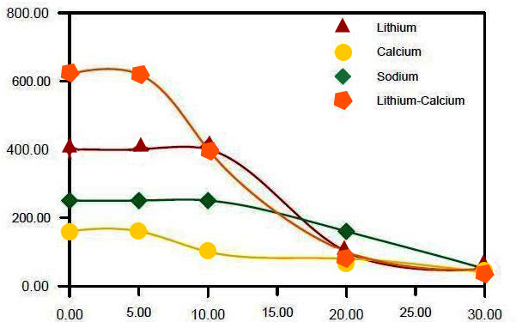
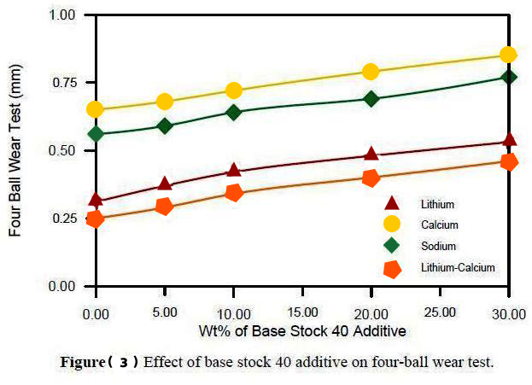
Load (Kgf)
Ball Wear (mm)
Ball Wear (mm)

Figure (2) Effect of base stock 40 additive on four – ball wear test
Figure (1) Effect of base stock 40 additive on four – ball welding

test

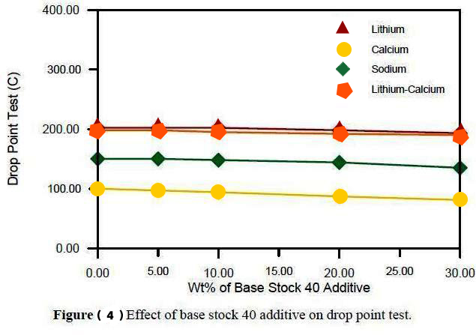
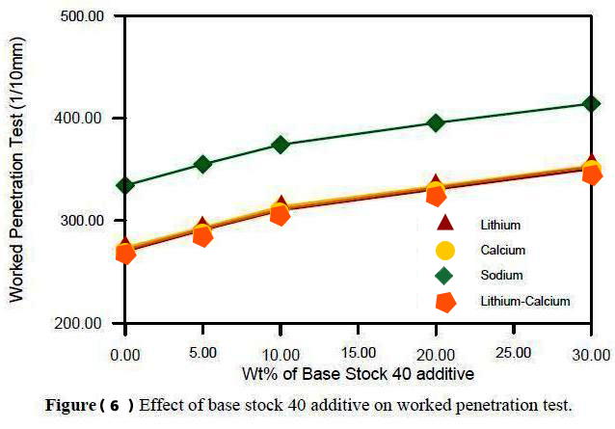
Worked Penetration (1/10mm)
Drop Point (C)
Drop Point (°C)

Figure (3) Effect of base stock 40 additive on drop point test.
Figure (4) Effect of base stock 40 additive on worked penetration test.

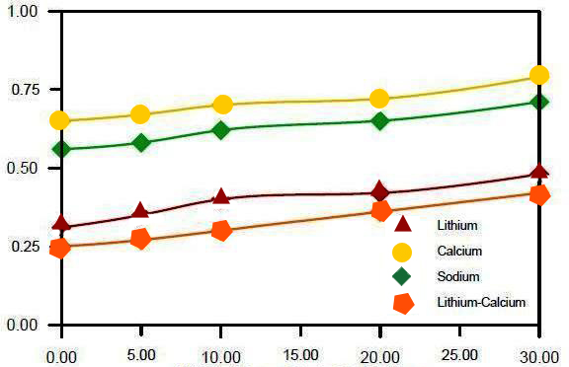
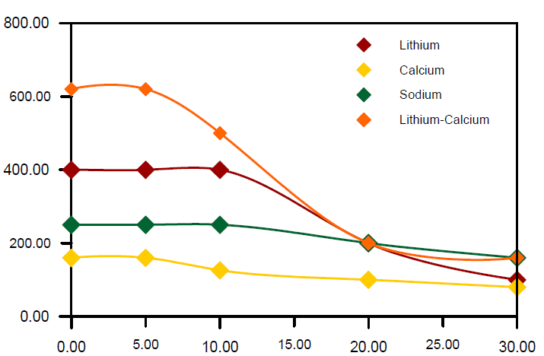
Ball Wear (mm)
Load (Kgf)

Figure (5) Effect of base stock 60 additive on four – ball welding test.

Figure (6) Effect of base stock 60 additive on four –ball wear test.

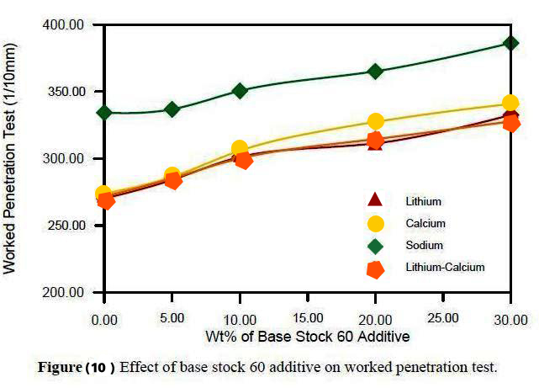
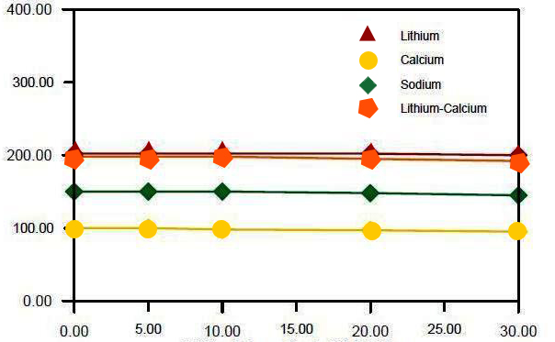
Drop Point (C)
Worked Penetration (1/10mm)

Figure (7) Effect of base stock 60 additive on drop point test.

Figure (8) Effect of base stock 60 additive on worked penetration test.

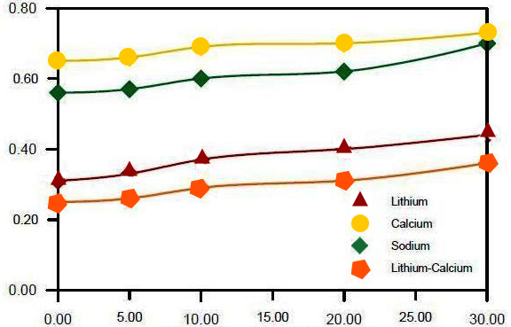
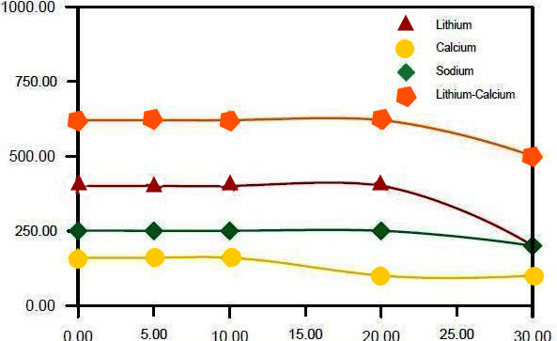
Ball Wear (mm)
Load (Kgf)

Figure (9) Effect of base stock 150 additive on four-ball welding test.

Figure (10) Effect of base stock 150 additive on four-ball wear test.

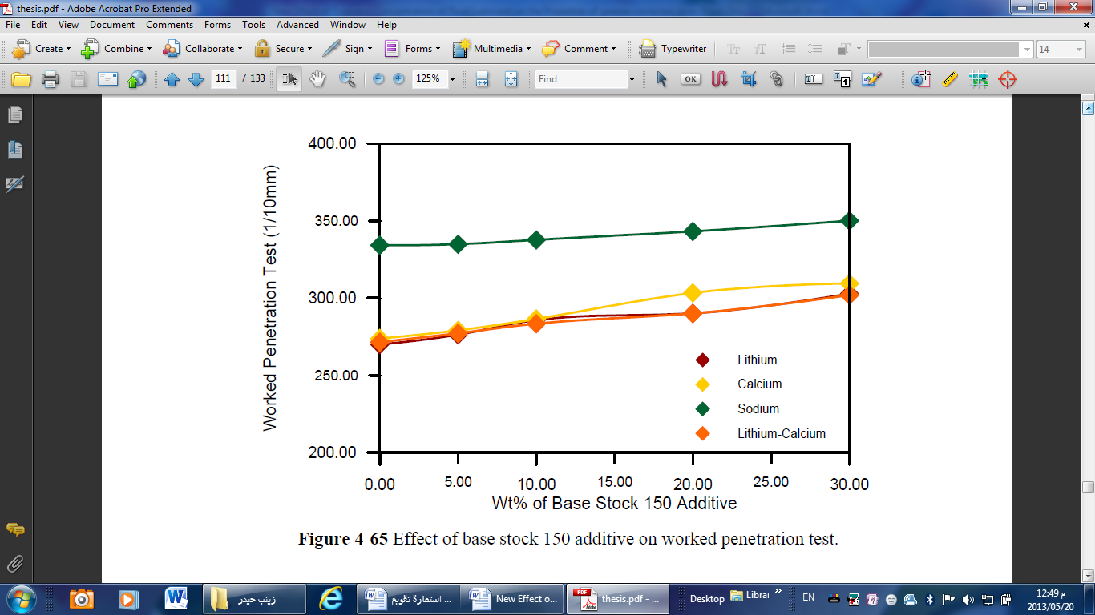
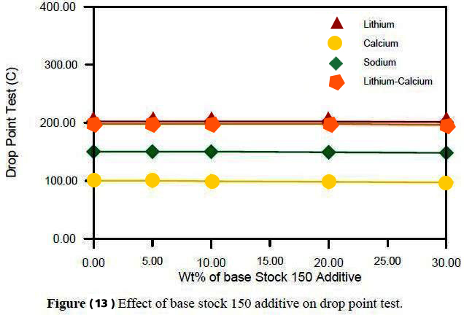
Worked Penetration (1/10mm)
Drop Point (°C)

Figure (11) Effect of base stock 150 additive on drop point test.

Figure (12) Effect of base stock 150 additive on worked penetration test.

Drop Point (°C)
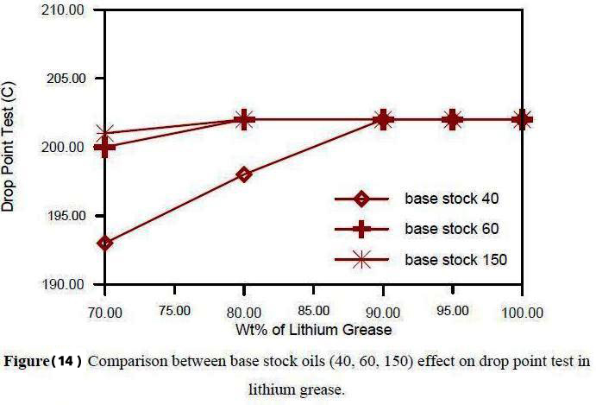
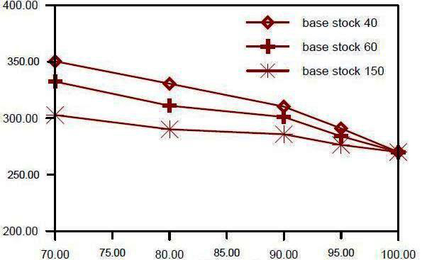
Drop Point (°C)
Worked Penetration (1/10mm)

Figure (13) Comparison between base stock oils (40, 60,150) effect on drop point test in lithium grease.

Figure (14) Comparison between base stock oils(40,60,150) effect on worked penetration test in lithium grease.

CONCLUSIONS :

REFERENCES :-

Al-Daura Refinery Product Guide, 1979.

Billelt, M., "INDUSTRIAL LUBRICATION", A Practice Hand Book, England, Pergamon, First Edition, 1979.

Brithwaite, E. R., “LUBRICATION AND LUBRICANTS”, Elsevier Publishing Company, Amsterdam, 1967.

Denis, J., Briant, J., and Hipeaux, J. C., “LUBRICANT PROPERTIES ANALYSIS AND TESTING”, 1998.

Edward Brunet, Jr., P.E., "Lubrication – Grease", Course No. MA – 2003, Continuing Education Engineers, Houston, Texas, 28 February 1999. PDH engineer.com, administrator@PDH engineer.com.

Gary, James. H., and Handwerk, Glenn. E., "PETROLEUM REFINING : TECHNOLOGY AND ECONOMICS", New York : Marcel Dekker, Chemical Processing and Engineering, Volume 5, Fourth Edition 2003.

Herguth Laboratories, Inc., "TRIBOLOGY STUDIES LUBRICATION AND MATERIALS", SGS Herguth Laboratories, San Francisco Area, 2012. herguth.info@sgs.com

Hobosn," MODERN PETROLEUM TECHNOLOGH", John Wiley & Sons Inc., Vol. 1, 1975.

Hughes, Ronald L., Senior Consultant, "UNDERSTANDING THE BASIC OF GREASE", Proact For Industry, Reliability Center, Inc., 2013.

Lubrizol Technology Education, "LUBRICATING GREASE", Produced by ICIS, Wickliffe, Ohio, United States, 2008. www.Lubrizol.com.

Mang, Theo, and Dresel, Wilfried, "LUBRICANTS AND LUBRICATION", Wiley-VCH, Second Edition, 2007, P. 88.

Mazuyer, I. Couronne, D., Vergne, P., Dinh, N. Truong, and Girodin, D.,"Effect of Grease Composition and Structure on Film Thickeners in Rolling Contact" LMC, I.E.T, UMR CNRS/INSA 5514, 20 Avenue Einstein, 69621 Villeurbanne Cedex France, 2003.

Mc Bai, James. W., and Bolduam, O. E. A., and Ross, Sydney, "X – Ray Diffraction of Sodium Laurate, Palmitate and Stearate at Room Temperature", J. Am. Chem. Soc., Volume 65, issue (10), October 1, 1943, P 1873 - 1876.

McCarthy, P. R., "Lubrication – Grease", NASA Symposium, Cleveland, January 1972.

Nailen, Richard L., "Grease: WHAT IT IS; HOW IT WORKS", Barks Publication, Inc, April 2002.

Nelson, John Walker, U.S. Patent 2590786, March 25, 1952.

Polishuk, A. T., "LUBRICATION ENGINEERING", Vol.19, No. (2), 1963.

Speight, James. G., "HANDBOOK OF PETROLEUM PRODUCTS ANALYSIS", Wiley – Interscience (A John Wiley & Sons, Inc., Publication, Hoboken, New Jersey) Chapter 13, Grease, 2002, P 291 - 304.

Total al Lubrifiants," GREASE TECHNICAL GUIDE CHARACTERISTICS AND TESTS", 2012, 16 rue de la Republique F 92922 Paris La Defense Cedex , (www.lubricants.total.com).

Totten, George. E.; West Brook, Steven R.; Shah, Rajesh J., eds., "FUELS AND LUBRICANTS HANDBOOK: TECHNOLOGY, PROPERTIES, PERFORMANCE AND TESTING", ASTM Manual Series, Volume 1, 2003.

Vold, J. Marjorie, and Vold, Robert D., "Lubrication and Lubricants", J. Inst. Petroleum Technology, Vol. 38, 1952, P155-163.

