1-INTRODUCTION
Shot peening is a cold working process in which the surface of a part is bombarded with small spherical media called shot. Each piece of shot striking the metal acts as a tiny peening hammer imparting a small indentation or dimple on the surface. In order for the dimple to be created, the surface layer of the metal must yield in tension (Fig. 1) [Metal Improvement Company 2005].
Below the surface, the compressed grains try to restore the surface to its original shape producing a hemisphere of cold-worked metal highly stressed in compression (Fig. 2) [ Jack Champaigne 2001]. It can be produce a large compressive stress magnitude at the surface typically about (75%) and moderate depth of compression (typically about 0.25 mm)[ H.Y.Maio 2010 , H.Luony 2010].
Shot peening is ideal for high strength materials such as aluminum alloys (series 2000, 7000) which traditional have been decades in the aircraft industry. Where compressive stress is directly correlated to a material tensile strength [Metal Improvement Company 2005].
[ Dr. Muna 2008 ] had studied the effect of the time of shot peening with steel ball of 1.25 mm in diameter on fatigue strength of low carbon steel (1020 AISI) butt joints welded by metal arc welding shielded with CO₂ gas (MAG). The results showed that all the shot times of (10,20,30 ) minutes have improved the fatigue strength and the best strength has been achieved at the 20 minutes because of the high compressive stress induced by the shot peen process and in addition to the dendritic microstructure in the weld zone . [ Arshed et al. 2007] had studied the effect of shot peening parameters such as size ,nozzle pressure ,nozzle distance ,impingement angle and exposure time on high strength aluminum alloy AA2024 . The results showed that shot peening can be applied to increase fatigue life of the aluminum alloy under optimum conditions. [Ali et al. 2007], measured the strain hardening as a function of depth from the surface on shot peened aluminum alloy friction stir welding (FWS) components. The results indicate an increase in hardness at the center of the weld, the thermo – mechanical effected zone (TMAZ), and the parent material. However the hardness depth did not exceed 0.4 mm from the surface. The strain hardening which can be explained by the generation of dislocations under the effect of the plastic deformation from peening , is likely to increase the flow resistance of the material to plastic deformation.[ Omer Hatamleh 2008], studied the effect of peening on mechanical properties in friction stir welded 2195 aluminum alloy joints . The results of an experimental study concerning the increase in mechanical properties from the laser peening was mainly attributed to strain hardening which can be explained by the generation of dislocations under the effect of plastic deformation from the high energy laser peening.

2- EXPERIMENTAL WORK
AA2024- T4 aluminum alloy was chosen to conduct this research. It was thermally treated (solution heat treated and naturally aged to a substantially stable condition [Howard B.Cary 1979]. The chemical composition (Nominal & Actual ) of the above alloy is shown in (Table 1,2), while (Table 3,4) shows its mechanical properties.
Aluminum alloy was shot peened using Sintogic device model STB-OB the motor has (1435 r.p.m ) (Fig . 3 ) .Average shot peening balls diameter was ( 2.7 mm).All specimens( un-peened & peened ) were prepared as a tensile test specimens according to ASTM B557M84 (Fig . 4) [ASTM 1981 ].
With using universal testing machine type WP -300 , tensile tests were performed before and after shot peening at different times ( 5 ,10 , 15 , 20 and 30) minutes ( 3 specimens for each condition ).

3- RESULT AND DISCUSSION

(3-1) Tensile Test
Results of tensile test are presented in (Table 5 ) and depicted in (Fig. 5). They showed that σu and σy continue to increase with peening time up to 15 minutes , then decreased. The tensile strength increased to 505 MPa compared to 480 MPa for the unpeened specimen with an increment of about 3.6%. Also yield strength increased from 345 to 455 MPa with about 2.8% increment. The ductility is more effected than tensile and yield strength, where elongation percentage decreased from 22.5% to 13.7%. The improvement in the mechanical behavior is derived from the compressive residual stresses that is introduced into near surface of components [N.Barry 2009]. Surface integrity changes introduced by shot peening mainly induced work hardening due to the increase in dislocation density , gives the surface layers higher ultimate , yield strength and hardness that lower ductility [Y.K.Ga. 2011]. The tensile strength to the yield strength ratio is in the range of 1.41 - 1.43 ,i.e the aluminum alloy remains with same behavior [ M.M.Rahman 2009 ].

(3-2) Strain Hardening Factor (n) and Strength Factor ( k)
To determined the strain hardening factor (n) and strength factor (k) values, true stress- strain curves are plotted for six conditions ( as received and peened). A log – log plot for these curves was used as shown in ( Fig. 6 ). With increasing peening time , a slight change (less than 0.8%) in n-value was noticed. For 15 minutes peening it was increased from 0.24 to 0.26 as shown in (Fig. 7), i.e, the alloy is cyclically hardened, where typically , metals with a high monotonic strain – hardening exponent (n > 0.2 ) will harden where as those with a low monotonic strain hardening exponent (n> 0.1) will cyclically soften [ L.Pook 2007] .The increasing of k-value is similar to large extent to that of n-value with 13% at 15 minutes peening and decreased to 6% at 30 minutes peening.
The increment in (n & k ) values gives clear indication that the AA2024 – T4 alloy tend to harden upon peening for all exposure times . Finaly it was found that our results are greatly agreed with that demonstrated by [ Jose S.R. et al 2008], that the performance of controlled shot peening , depends on the balance between its beneficial compressive residual stress and strain hardening .

4 – CONCLUSION
1- Maximum benefit for tensile stress σu & σy for AA2024- T4 is at 15 minute shot peening time.
2- Strain hardening exponent (n) is slightly increase with increasing peening time and remain within the range of cycling hardening.
3- The strain hardening factor (n =0.26) and strength factor (k = 910 MPa) were maximum at 15 minute shot peening time.
4- Maximum percentage of elongation 22.7% was obtained at 30 minute peening time .
5- A good balance between beneficial compressive residual stress and strain hardening obtained from this alloy.

(Table 1) Nominal chemical composition
of AA2024-T4 aluminum alloy [ ASTM 1981 ].

%Al | %Cu | %Mg | %Mn | %Fe | %Zn | %Si | Element  Material
Bal. | 3.8 – 4.9 | 1.2 – 1.8 | 0.3 - 0.9 | 0.5 | 0.25 | 0.5 | Nominal chemical composition

(Table 2) Actual chemical composition
of AA2024-T4 aluminum alloy.

%Al | %Cu | %Mg | %Mn | %Fe | %Zn | %Si | Element  Material
Bal. | 4.31 | 1.47 | 0.606 | 0.301 | 0.029 | 0.267 | Actual chemical composition

(Table 3) Nominal mechanical properties
of AA2024-T4 aluminum alloy[ ASTM 1981 ].

Strain Hardening (n ) (MPa ) | Strength Factor  ( k) (MPa) | El% | σy (MPa) | σu (MPa) | Properties
- | - | 20 | 325 | 470 | Nominal properties

(Table 4) Experimental mechanical properties
of AA2024-T4 aluminum alloy.

Strain Hardening (n ) (MPa ) | Strength Factor( k) (MPa) | El% | σy (MPa) | σu (MPa) | Properties
0.24 | 805 | 22.4 | 342 | 487 | Experimental properties

( Table 5 ) Results of tensile test

Properties  Condition | Eng. Tensile strength (MPa) | Eng. Yield strength (MPa) | σu/σy | Elongation
Nominal [ASTM 1981 ] | 470 | 325 | - | 20
Without peening | 487 | 345 | 1.41 | 22.5
Peening (5 minutes) | 495 | 350 | 1.415 | 18.2
Peening(10 minutes) | 502 | 350 | 1.435 | 16.1
Peening(15 minutes) | 505 | 355 | 1.42 | 13.7
Peening(20 minutes) | 498 | 350 | 1.42 | 13.9
Peening(30 minutes) | 480 | 340 | 1.41 | 22.7

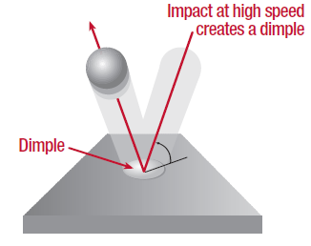
(Fig. 1) Mechanical yielding at point of impact[Metal Improvement Company 2005 ] .

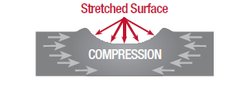
(Fig. 2) Compression resist fatigue cracking [Jack Champaigne 2001 ]

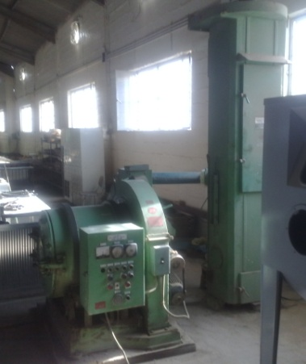

( Fig. 3 ) Shot peening device .

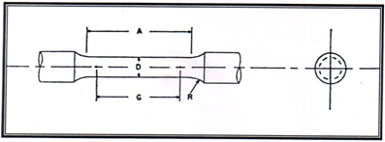

G-Gage length (20±0.04) , D- Diameter ( 4±0.05) R-Radius of fillet (4mm) min. , A-Length of reduced section (24mm)

(Fig. 4 ) Specimen geometry and dimensions.

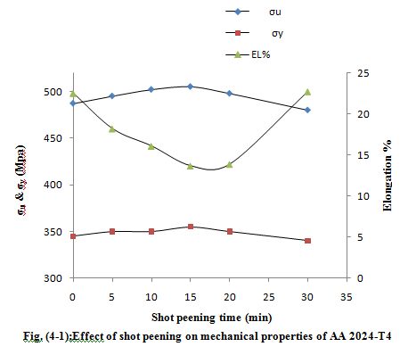

(Fig. 5 ) Effect of shot peening on mechanical properties of AA 2024 -T4.

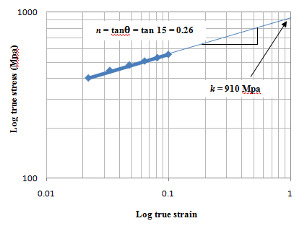

(Fig. 6 ) ( n & k) Factors of 15 minute exposure.

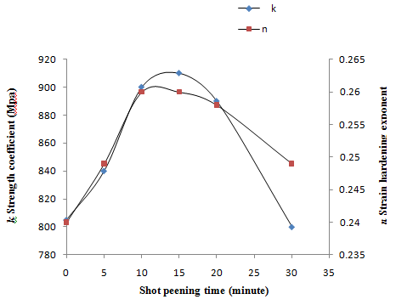

(Fig. 7) ( n &k) Factors versus peening time curves

5 - REFERENCES
- Ali, C.A.An, M.W. Rodopoulos , P. Brown ,A. O `Hara , S,".Levers and Gradiner" , Int.J. Fatigue 29 , pp. 1531-1545, August- 2007.
- Arshad Mehmood and M.M. I. Hammoude " Effect of Shot Peening on The Fatigue Life of 2024 Aluminum Alloy " , University of Engineering & Technology Taxila – Pakistan , pp.1-12, 2007.
- ASTM, " Annula Book of Standard Nonferrous Metal Product" , Section 2 , vol. 2, 1981.
- Dr . Muna ," Effect of Shot Peening on Fatigue Strength of Welded Joints For Low
Carbon Steel ", Journal of Engineering Technology,vol.26, no.3, 2008.

- H. Luony , M.R.Hill, " The Effect of Laser Peening and Shot Peening on High Cycle Fatigue in 7050-T7451 Aluminum Alloy” Materials Science and Engineering, A527 , , pp. 699- 707, 2010.
- Howard B. Cary, “Modern Welding Technology”, Prentice – Hall, USA ,PP432-434 ,1979.
- H.Y.Miao , D. Demers, "Experimental Study of Shot Peening and Stress Peen Forming" ,Journal of Materials Processing Technology, vol. 210, Issues 15,. 2010.
- Jack Champaigne, " Shot Peening Overview ", Shotpeener.com.,2001.
- Jose S.R. Alfonse A.G., Antonio G.M., " Surface Roughness and Residual Stresses on the Fatigue Life of Shot Peened Components : Theoretical Determination " , Ingenieria Mecanica Ydesarrolio , Vol. 3 ,No.1, pp17-20 ,2008.
- L.Pook , "Metal Fatigue What It Is, Why It Matters", Published by Springer ,2007.
- Metal Improvement Company , " Shot Peening Application" , 9th edition, pp1-60 , 2005.
- M.M. Rahman , K.Kadirgama ,M.M.Noor , M.R.M.Rejib and S.A.Kesulai , " Fatigue Life Prediction of Lower Suspension Arm Using Strain – Life Approach " , European Journal of Scientific Research , vol. 30 no.3, pp437-450, 2009.
- N. Barry, S.V. Hainsworth, M.E.Fitzpartick, " The Effects of Shot Peening on The Fatigue Behavior of Cast Magnesium A8" , Materials Science and Engineering A507, 2009.
- Omar Hatmleh ," Effects of Peening on Mechanical Properties in Friction Stir Welded 2195 Aluminum Alloy Joints " , Journal Homepage: www.elsevier. Com/ locate/ msea, pp168-176, 2008.
- Y.K.Ga . , " Improvement of Fatigue Properties in 7075 – T7451 Aluminum Alloy by Laser Peening and Shot Peening " , Materials Science and Engineering ,A528, pp3833-3828, 2011.

