- INTRODUCTION :-

Particulate matter is the term for solid or liquid particles found in the air. Some particles are large or dark enough to be seen as soot or smoke. Others are so small they can be detected only with an electron microscope. Because particles originate from a variety of mobile and stationary sources (diesel trucks, woodstoves, power plants, etc.), their chemical and physical compositions vary widely. Particulate matter can be directly emitted or can be formed in the atmosphere when gaseous pollutants such as So2 and NOx react to form fine particles.(EPA, 2014)

The term "dust" can be defined simply as particles of soil that have become airborne. As a general rule, dust consists mainly of soil particles finer than 0.074 millimeter (i.e., passing the No. 200 sieve as described in ASTM E 11). Dust is produced whenever the outside force(s) acting on a soil particle exceeds the force(s) holding it in place. Dust may occur naturally from the force of wind although the production of dust is accelerated in areas of soil experiencing actual physical abrasion caused by the environment or man’s activities. (Basham and Wright, 2014)

Dust from unpaved roads is not only a nuisance but creates a safety hazard by reducing the driver’s visibility. Dust also affects the health of road users and increases wear-and-tear on vehicles. Dust is always considered an intruder at campsites and picnic areas. In some areas there are regulations that limit the amount of particulate allowed in the atmosphere. Fine particles, including dust, act to help hold the surface of unpaved roads together. With a loss of fine particles from the roadway, there is an increase in roadway surface raveling and maintenance costs. These fines are smaller than what the eye can see and pass through the 75 μm (No. 200) sieve (Bolander and Yamda, 1999).

- DUST EMISSIONS FROM ROAD TRAFFIC :-

Road trafﬁc is the main source for PM10 (mass concentration of particles 10 min aerodynamic diameter) in urban areas . For road traffic, emission inventories of PM10 often exclude suspended road dust, although it makes a substantial contribution to PM10 in urban areas.

The variations observed correlated quite well, and the discrepancies are likely a result of variations in dust load on the road surface perpendicular to the driving direction that cause variations in the measurements depending on slightly different paths driven.( Etyemezian, Hendrickson and Barton,2003).

In practice, quantiﬁcation of real-world road dust emissions is complicated because of the many different factors that might affect the emissions. Sanding has been found to increase the PM10 emissions because of (a) the addition of PM10 contained in sand,(b) creation of PM10 due to wear of sand granules, and (c) creation of PM10 due to enhanced wear of the road surface.( Kupiainen and Tervahattu, 2004 )

- HEALTH AND ENVIRONMENTAL EFFECTS:

In 1987, EPA replaced the earlier Total Suspended Particulate (TSP) air quality standard with a PM-10 standard. The new standard focuses on smaller particles that are likely responsible for adverse health effects because of their ability to reach the lower regions of the respiratory tract. The PM-10 standard includes particles with a diameter of 10 micrometers or less (0.0004 inches or one-seventh the width of a human hair). EPA's health-based national air quality standard for PM-10 is 50 µg/m3 (measured as an annual mean) and 150 µg/m3 (measured as a daily concentration). Major concerns for human health from exposure to PM-10 include: effects on breathing and respiratory systems, damage to lung tissue, cancer, and premature death. The elderly, children, and people with chronic lung disease, influenza, or asthma, are especially sensitive to the effects of particulate matter. Acidic PM-10 can also damage human-made materials and is a major cause of reduced visibility in many parts of the U.S. New scientific studies suggest that fine particles (smaller than 2.5 micrometers in diameter) may cause serious adverse health effects. As a result, EPA is considering setting a new standard for PM-2.5. In addition, EPA is reviewing whether revisions to the current PM-10 standards are warranted.( EPA, 2014)

- SAMPLING OF DUST :-

The sampling of dust was by using a vacuum instrument had the shape as shown in figure (1), a case study took in (80 street / Hilla) so the instrument worked at days in this street and it collected the dust emission cause of traffic volume, also recorded the traffic condition like vehicles numbers and vehicles speed.
The vacuum instrument included a filter with opening less than 1*10⁻⁴ mm and with inlet opening with 10 cm diameter and also had a plastic tank to collect the dust the can pass the filter. The instrument inflow of air was about 200 cubic foot per minutes.
When the collection of dust completed, we cover the vacuum instrument by plastic container and moved it with care for not to lose any dust particles.
Then inside closed room with no wind movement, open the instrument and then used a very soft brush with very slow brushing to collect the dust in the container inside the instrument, then we had the way of washing the filter on a suitable pan and then heated the pan to about 105 Cº so that the evaporation made the dust separated from water.
After this procedure, doing weight the whole dust and recorded this as (wd). also a sample from the monitoring place (80 street/ Hilla) took and prepared it for Hydrometer test to find the distribution of particles size.

- MONITORING AND CALCULATION RESULTS :-

A camera video install in the side of test road to monitor the traffic, Table (1) shows
( total numbers of vehicles ,total PM-10, vehicles speeds, numbers of vehicles and percentage of each speed group and PM-10 according to numbers and vehicles speeds) in each observation. As noted in the table all the results of dust emission out of range with international PM-10 specification (150 ug/m³ Item 3 )

The monitoring included the data of (vehicles numbers , vehicles speeds, dust percent in air and time period of observation). Conversion of these data to charts explain the results in figure (2) and others. From the six observations on the case study (80th street), the number of total vehicles can be show in figure (2).
The vehicles speeds included three ranges (20-40/ 40-60/ 60-80) km/hr as shown in figure (3).
Figure (4) explained the vehicles speeds affection on the PM-10. PM-10 emissions regard as a function of number and vehicles speeds , and there is increasing in emission levels with increasing vehicle′s speeds although the last had lesser number in the test. Hence , there is a converge in magnitude of PM-10 emissions caused by (40-60) km/hr and (60-80) km/hr of vehicles speeds and less value of emission caused by (20-40) km/hr speeds.

This grading in speed was the same in the relationship between the values of PM-10 and the vehicles speed and the figures (5 to 8) show equation models that relate PM-10 emissions with numbers and vehicles speeds for the test road.

Figure (6) below explained the PM-10 values caused from the speed range (40-60) km/hr. Then the figure (7) showed the PM-10 values caused from the speed range (60-80) km/hr. Figure (8) showed increased emission levels with increasing vehicles momentum in the case study (80th street).

6. ROAD SHOULDERS AND DUST EMISSION PROBLEM:

For satisfying clear vision about the problem of dust emission, a sample of soil from the side of the road collected and doing analysis the fine particles contents (grain distribution) by hydrometer test method according to ASTM D422 and the results was as as shown in figure(9).
From this figure it can noticed that the PM-10 percent in the road shoulders equal to 14.5% , so it can contributed to air pollution .

7. SOLUTION TO REDUCE DUST EMISSIONS IN PAVED ROADS

A/ By Using Dust Abatement

Fine particles, including dust, act to help hold the surface of paved roads together. With a loss of fine particles from the roadway, there is an increase in roadway surface raveling and maintenance costs.
It can be reduced or eliminated dust emissions from the roadway; Dust suppressants are one of many possible methods to control dust.(Bolander,1999)
Also the plant cover and road cleaning can be decrease the amount of dust emission. Dust suppressants work by either agglomerating the fine particles, adhering/binding the surface particles together, or increasing the density of the road surface material. They reduce the ability of the surface particles to be lifted and suspended by either vehicle tires or wind. There are a wide variety of dust suppressants have been proven to reduce the amount of suspended road dust because of their hygroscopic properties, thereby creating a wetted surface. (Norman and Johansson,2006) Road surface wetness inﬂuences PM10 concentrations close to densely operated roads
(Johansson and Bringfelt,2005).
It can be divided the dust palliative into seven basic categories: water, water absorbing products, petroleum based products electrochemical products, polymer products, and clay additive products.
Typical suppressants in each category are:

Water | Electrochemical Products  - enzymes  - ionic products  - sulfonated oils
Water Absorbing Products (deliquescent/hydroscopic)  - Calcium chloride brine and flakes  - Magnesium chloride brine  - sodium chloride (salt) | Synthetic Polymer Products  - polyvinyl acetate  - vinyl acrylic
Organic Petroleum Products  - asphalt emulsions  - cutback asphalt (liquid asphalt)  - dust oils  -modified asphalt emulsions | Clay Additives  - bentonite  - montmorillonite
Organic Nonpetroleum Products
- animal fats
- lignosulfonate
- molasses/sugar beet
- tall oil emulsions
- vegetable oils

B/ By Using Types of Tires
------
PM10 emissions are very different depending on the type of tire used, Z in Figure 10 included a summer tire (Nokian Z), a nonstudded winter tire (Nokian Hakkapeliitta Rsi; hereafter also referred to as the “friction tire”),and a studded winter tire (Nokian Hakkapeliitta 4),this tires have dimensions 235/60R16.

These tires will be referred to in the text by their type as “studded,” “non studded,” and “summer” tires, with the use of studded tires enhancing road surface wear, which increases PM10 concentrations, especially during dry road conditions. (Norman and Johansson,2006,Hussein and Hansson,2008)

if studded tires are used (Hussein and Hansson,2008, Hagen and Schaug,2005), The quality of Studless winter tires are lamellar nonstudded tires and have a softer tread compared with the summer tires. Studded tires have studs distributed in a certain order on the tire surface to further enhance the tire grip on road surfaces.
Because of the suction pad effect, non studded tires cause greater PM10 concentrations than studded tires. The reason is that non studded tires have more tread lamellas and are composed of softer rubber material than studded tires. When the lamellas touch the road surface air between the lamellas is pressed out, and when the lamellas get unfastened, air is “sucked” between the lamellas. Loose PM is consequently lifted from the road surface and suspended in the ambient air.
In the laboratory measurements, the PM10 generation due to direct road wear is more important compared with the suspension of accumulated road dust particles. In the ﬁeld, a larger fraction of the PM10 generation is likely due to the suspension of accumulated PM. This may affect the ratio of studded versus non studded tires because tires with studs cause much larger road.

8. CONCLUSION

From the relationships showed in ﬁgures it is apparent that vehicle speed and numbers play an important roles in the magnitude of the emissions.

- results demonstrate that vehicle speed is an important factor with respect to paved roadway PM10 emission for the vehicles. The effect of speed on emissions is linear, and emissions normalized to the fastest speed obtained for the test road.

- The research showed substantial large-scale variations of emission levels along the road, likely depending on the momentum of vehicles, and the correlations factor was 96%.
- The research refer to the type of tires used have a substantial inﬂuence on the emission. The summer tire have much lower suspension than the winter tires (a nonstudded tire and a studded tire).
The magnitude of the emissions was controlled primarily by vehicles speeds and vehicles numbers, both of which had linear effects on the emissions. This suggests and improves that emissions are linearly dependent on a vehicle’s momentum.

Table(1) shows data collected and calculates for each observation

PM-10 ug/m³ (function to numbers and vehicles speeds) | Vehicles Percentage | Vehicles Numbers | Vehicles Speeds Groups  (km/hr) | PM-10  ug/m³ | Total Vehicles Numbers | Observations
62*** | 30%** | 492 | 20-40 | 424 | 1638 | 1
145 | 35% | 573 | 40-60 | 424 | 1638 | 1
217 | 35% | 573 | 60-80 | 424 | 1638 | 1
126 | 35% | 921 | 20-40 | 682 | 2632 | 2
287 | 40% | 1053 | 40-60 | 682 | 2632 | 2
269 | 25% | 653 | 60-80 | 682 | 2632 | 2
196 | 40% | 1410 | 20-40 | 883* | 3524 | 3
393 | 40% | 1410 | 40-60 | 883* | 3524 | 3
294 | 20% | 704 | 60-80 | 883* | 3524 | 3
222 | 48% | 1563 | 20-40 | 804 | 3056 | 4
277 | 30% | 977 | 40-60 | 804 | 3056 | 4
305 | 22% | 716 | 60-80 | 804 | 3056 | 4
132 | 38% | 900 | 20-40 | 642 | 2367 | 5
281 | 40% | 956 | 40-60 | 642 | 2367 | 5
229 | 22% | 521 | 60-80 | 642 | 2367 | 5
253 | 55% | 1764 | 20-40 | 761 | 3208 | 6
231 | 25% | 802 | 40-60 | 761 | 3208 | 6
277 | 20% | 642 | 60-80 | 761 | 3208 | 6

* it can be calculate the PM-10 form this information:
Weight of dust= wd (g)
Air flow inlet= Af (cfm cubic foot/ min) (Depending on motor power)
Time of testing = t (minutes)
Then the formula derive as follow:
PM-10 (ug/m³) = (wd *10⁶)/ (Af * t *0.02831)
Af = 200 cfm for this instrument (known from manufacturer)

As application to this formula, the third monitoring period was two hours, then collected and weight, (wd) was about 0.599 g:
PM-10= 0.599*10⁶/(200*120*0.02831)= 883 ug/m³

** 492/1638=0.30 =30/100
*** 492+(573*2)+(573*3)=3357
PM-10 for speed group (20-40)=( (492 *424)/3357)=62.14 ug/m³
PM-10 for speed group (40-60)=( (573*2*424)/3357)=144.74 ug/m³
PM-10 for speed group (60-80)=( (573*3*424)/3357)=217.11 ug/m³

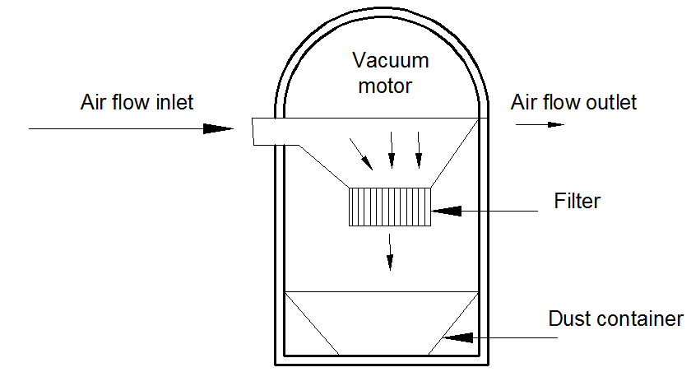
Fig (1): Vacuum instrument for dust sampling

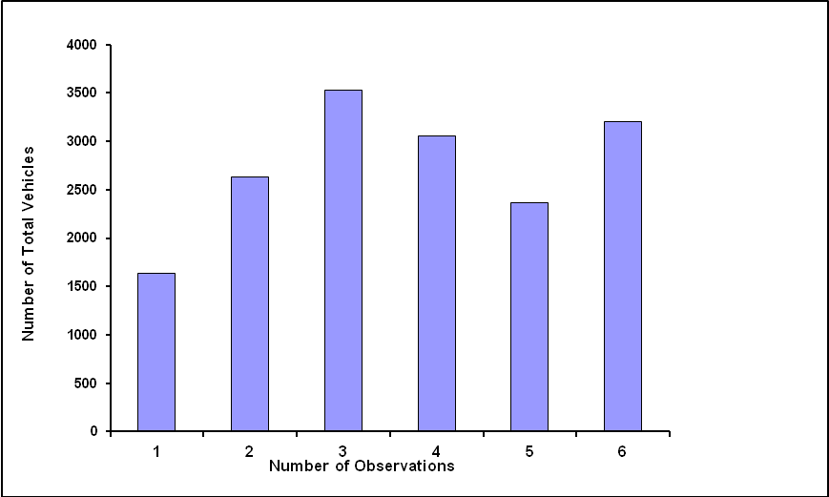

Fig (2): Shows vehicles numbers by number of observations

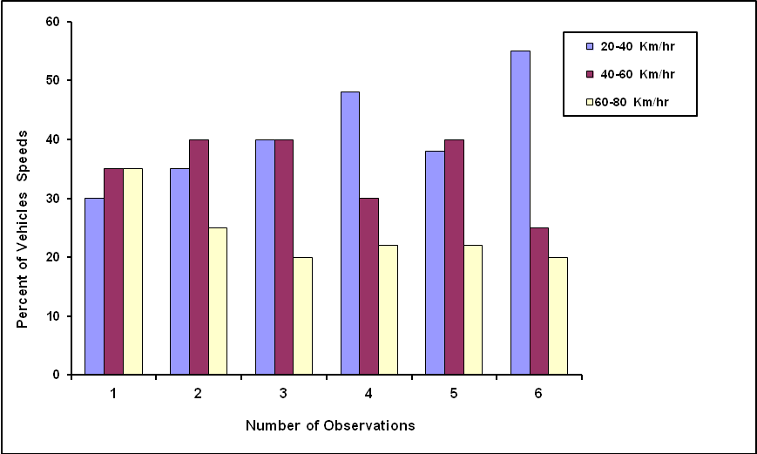

Fig (3): Shows vehicles speed by number of observations

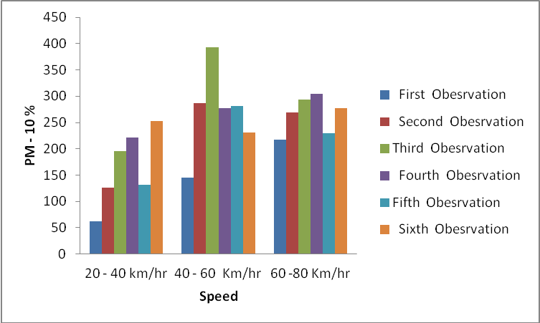

Fig (4):Shows dust emission from vehicles speeds

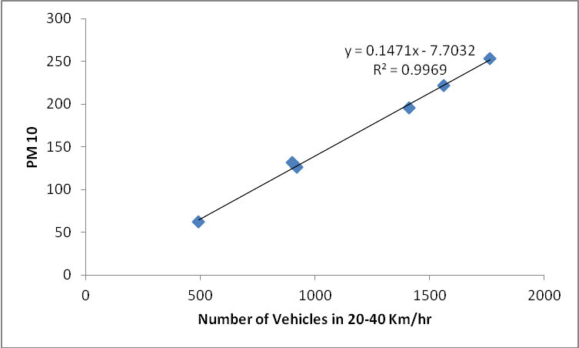

Fig (5): shows emission levels by vehicles speeds in 20-40 km/hr

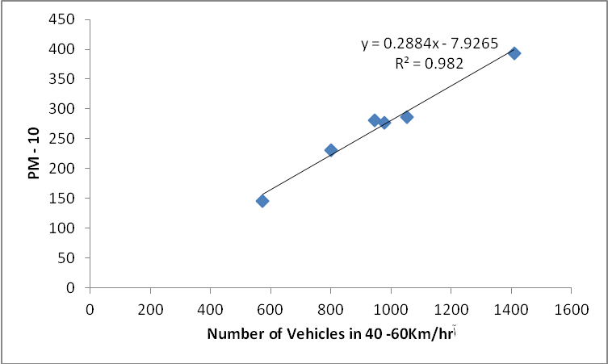

Fig (6): shows emission levels by vehicles speeds in 40-60 km/hr

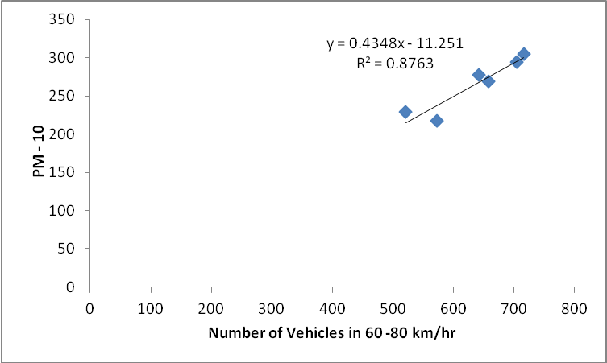

Fig (7): shows emission levels by vehicles speeds in 60-80 km/hr

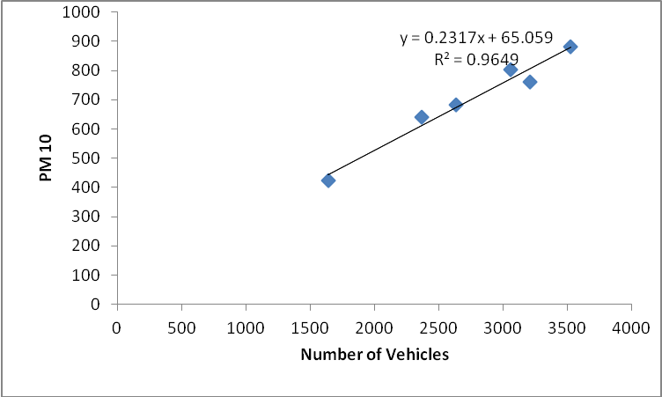

Fig (8): showed emission levels by vehicles momentum

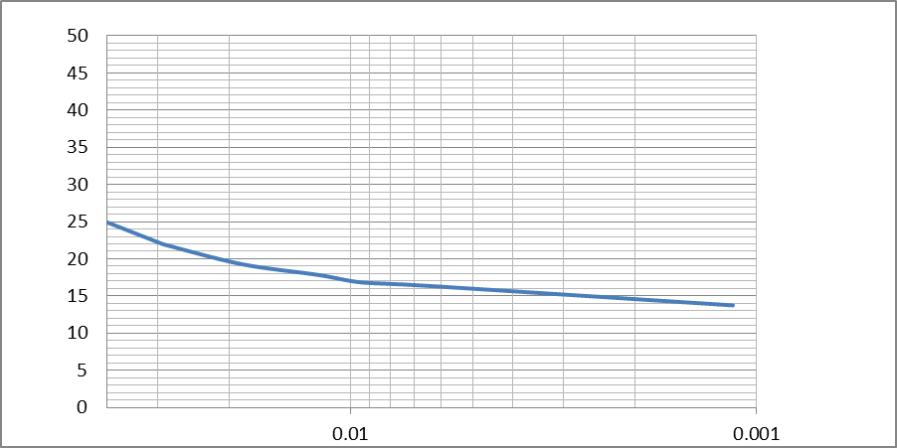
% Fine Particles

PM-10 threshold

Diameter of Particles (mm)

Fig (9): showed results of analysis the fine particles contents
by hydrometer test method

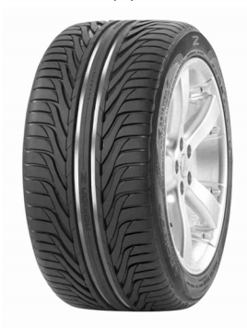
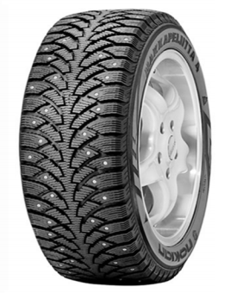
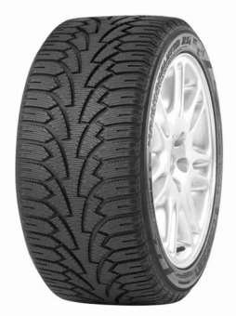

(a) summer (b) non studded (c) studded tires

Fig(10) The tires elected for treat dust emissions:
(a) summer
(b) nonstudded (studless winter tire
(c) studded tires

REFRENCES :-

Bolander, P. “Laboratory Testing of Nontraditional Additives for Dust Abatement and Stabilization of Roads and Trails,” Transportation Research Board, Proceedings from the Seventh International Conference on Low-Volume Roads, 1999.

Donald Basham; James W. Wright; Kathleen Ferguson; Get W. Mot; Dust Control For Roads, Airfields and Adjacent Area, Unified Facilities Criteria (UFC), U.S. Department of Defense, 2014, UFC 3-260-17.

Environmental Protection Agency (EPA) http://www.epa.gov/airtrends/aqtrnd95/pm10.html at 1/8/2014

Gustafsson, M.; Blomqvist, G.; Gudmundsson, A.; Dahl, A.; Swietlicki, E.; Bohgard,M.; Lindbom, J.; Ljungman, A. Properties and Toxicological Effects of Particles from the Interaction Between Tyres, Road Pavement and Winter Traction Material; Sci. Total Environ. 2008, 393, 226-240.

Hagen, L.O.; Larssen, S.; Schaug, J. Speed Limit in Oslo Effect on Air Quality of Reduced Speed on RV4 (in Norwegian); NILU OR 41/2005; Norwegian Institute for Air Research: Kjeller, Norway, 2005.

Hussein, T.; Johansson, C.; Karlsson, H.; Hansson, H.-C. Factors Affecting Non-Tailpipe Aerosol Particle Emissions from Paved Roads:On-Road Measurements in Stockholm, Sweden; Atmos. Environ. 2008,42, 688-702.

Kuhns, H.; Etyemezian, V.; Green,M.; Hendrickson, K.;McGrown,M.;Barton, K.; Pitchford, M. Vehicle-Based Road Dust Emission Measurement. Part II: Effect of Precipitation, Wintertime Road Sanding, and Street Sweepers on Inferred PM10 Emission Potential from Paved and Unpaved Roads; Atmos Environ. 2003, 37, 4573-4582.

Kupiainen, K.; Tervahattu, H. The Effect of Traction Sanding on Urban Suspended Particles in Finland; Environ. Monitor. Assess. 2004, 93, 287-300.

Kupiainen, K.J.; Tervahattu, H.; Ra ¨isa ¨nen, M.; Ma ¨kela ¨, T.; Aurela, M.;
Hillamo, R. Size and Composition of Airborne Particles from Pavement Wear, Tyres, and Traction Sanding; Environ. Sci. Technol. 2005,39, 699-706.

Norman, M.; Johansson, C. Studies of Some Measures to Reduce Road Dust Emissions from Paved Roads in Scandinavia; Atmos. Environ.
2006, 40, 6154-6164.

Omstedt, G.; Johansson, C.; Bringfelt, B. A Model for Vehicle-Induced Non-Tailpipe Emissions of Particles along Swedish Roads; Atmos. Environ. 2005, 39, 6088-6097.

Peter Bolander; Alan Yamda; Dust Palliative Selection and Application Guide;San Diams, Technology and Development Center, California, USA 1999,.

