يمكن الأسنتنتاج ان الشبكة العصبية يمكن ان تستخدف بنجاح لغرض ايجاد اقل قيمة للكثافة التيار المستخدمة لحماية الصلب الكاربوني.
كلمات رئيسية:
التآكل، انابيب الصلب الكاربوني ، الشبكة العصبية ذات دالة الأساس النصف قطري

INTRODUCTION
Corrosion is an electrochemical reaction based on universal laws of nature. All metallic structures corrode, steel, for example is a man-made substance produced from iron oxide. The energy added in the refining process is unstable given a suitable environment; steel will release this energy and return to its natural state of iron ore (Uhlig and Winston, 1985).
Many researcher focus on Galvanic cathodic protection uses anodes which have a natural potential more reactive than that of the structure being protected (Stephen, 1999; White and Sofge, 1992). For steel structures, magnesium and zinc have proven practical for buried applications, while aluminum and zinc are used to protect marine structures. It is also possible to use an external power source to impress current on a relatively inert material such as cast iron, graphite or mixed metal oxide anodes; this method is called impressed current cathodic protection (Uhlig and Winston, 1985). Sami and Ghalib (2008a) studied cathodic protection system for low carbon steel pipe. This system was used to investigate the influence of various conditions on the minimum cathodic protection current that would provide a full cathodic protection for steel tube immersed in sea water. The variable conditions studied are concentration of (0.01-3.5%) NaCl, temperature (30-50°C), distance between pipe (cathode) and graphite electrode (anode) of (10-20) cm and PH solution of (5.0-9.0) using a selected range of these conditions, the experimental results indicated that the cathodic protection current density increases with increasing temperature, concentration and PH respectively. The current density also slightly increases with an increase in distance between cathode and anode. Intelligent control is now becoming a common tool in many engineering and industrial applications. It has the ability to comprehend and learn about plants, disturbances, environment and operating conditions (Miller et al., 1990; Rumethart et al., 1986). Some examples of the factors to be learned are plant characteristics such as its static and dynamic behaviors (White and Sofge, 1992; Dayhoff, 1990).
In this study, the cathodic protection method for corrosion prevention requires identification of the minimum current density that gives the full corrosion protection with the presence of certain environment variables was proposed. The RBFNN used to identify this minimum current density taking the environment variables as input and using the practical results data for the learning process. This can be done by creating a mathematical model for the process and choosing the best neural network architecture, decision function and learning algorithm for this application.

MATERIALS AND METHODS

Material:
The material used in this work is low carbon steel pipe (ASTM A179-84a) type as X60 of 3 cm outside diameter and 2 cm in side diameter. Analysis of these specimens was carried out using (spectrometer DV.4) in Nasser Company. Table 1 shows the nominal and the analytical chemical compositions of the carbon steel pipe.

Solution:
The solution was prepared experimentally in different concentrations of (0.01, 0.1, 1, 2 and 3.5%) by adding different weights of (0.1, 1, 10, 20 and 35) gm sodium chloride NaCl to 1 L of distilled water. The NaCl purity = 99.55%, supplied by BDH Ltd. was used in the experiment.

The proposed method and Experimental procedure:
The tube specimen was cut with dimensions 10 cm length and 3 cm outside diameter and these specimens were used for all impressed current cathodic protection procedures.
The electrolyte was stirred by using mechanical stirrer to obtain a homogenous solution and then using the heater controller in the bath to set the solution at the required temperature and after achieving the temperature homogenization, the experiments were started.
Before starting each run, the cross sectional area of one end of the specimens closed using a rubber stopper then covered by thermal silicon to ensure that no water enter the inner tube surface and the other end isolated using plastic tube. The electrical connection (connection point) then fixed into plastic stand and passed through the above plastic tube. An auxiliary electrode entered the electrolyte at 5cm from solution surface level then the electrical circuit (ICCPS) was connected as shown in Fig. 1.
After switching on the electrical circuit and supplying the Ecorr of (-850 mV Vs SCE) from potentiostat the impressed current was recorded atintervals of 1 min over a period of 20 min by using the digital ammeter. The experiments were ended when the (i_{cp}) reached the steady state value giving the best value of impressed current cathodic protection.
In order to obtain the effects of the studied parameters on (ICCPS) like temperature, distance between cathode and anode, electrolyte concentration and PH, the above procedures were repeated for each run, but this was done after the glass bath was emptied from the used solution and washed by distilled water to ensure that no salt was left in the glass bath.

RBFNN model for cathodic protection:
From the examples ANN captures the domain knowledge (De La Mata-Moya et al., 2007). ANN can handle continuous as well as discrete data and have good generalization capability as with fuzzy expert systems. An ANN is a computational model of the brain. They assume that computation is distributed over several simple units called neurons, which are interconnected and operate in parallel thus known as parallel distributed processing systems or connection systems. Implicit knowledge is built into a neural network by training it. Several types of ANN structures and training algorithms have been proposed.
The basic form of RBF architecture involves entirely three different layers. The input layers is made n, of source nodes while the second layer is hidden layer of high enough dimension which senses a different purpose from that in a multilayer perception. The output layer supplies the response of the network to the activation patterns applied to the input layer. The tram formation from the input layer to hidden is nonlinear whereas the transformation from the hidden from unit to the output layer is linear. The transfer function for a radial basis neuron is:

………………………………..1

This function calculates a layer’s output from its net input. For effective current predicting of cathodic protection, the selection of proper inputs and outputs of ANN, structure of the network and training of it using appropriate data should be done with utmost care. In the present study, inputs are selected as four inputs these are (concentration C%, temperature T, distance between cathode and anode D and pH solution) and it have one output which is the predicted cathodic protection current density as shown in Fig. 2.

RESULTS
The experiment results were used to train the neural network which have been constructed and trained using 25 data samples from the experimental data and 5 samples were used for generalization test of the trained neural network (Sami and Ghalib, 2008b) as shown in Table 2.
The third step was the generalization test for the neural network. The generalization test means to test the neural network on data samples other than those data samples used in the learning process and to check the performance of the neural network on these data. In our case, we used 5 data samples taken from the experimental results for the generalization test. This neural network was simulated using the scientific and engineering package MATALB® 7.2.

DISCUSSION
The proposed network structure consists of four nodes at input layer and 8 nodes at the hidden layer and one in the output layer.
As aforementioned the network output has been compared with new set of 5 samples in order to examine the performance of the proposed network. Fig. 3 shows the regression plot to compare the experimental data against the corresponding predicted RBFNN output, and Table 3 gives the experimental data and the RBFNN results.
From Fig. 3 it can be seen that the network outputs is slightly differ from those collected from experiments, and a linear correlation can be observed. The computed Mean Absolute Error (MAE) is (0.189525 μA cm⁻²) and the maximum absolute error is (0.52116 μA cm⁻²) which represent (1.7 % error) form the corresponding experiment reference.
From the above discussion the proposed RBFNN could be considered reliable to give the required current density for the cathodic protection system of carbon steel pipe. This will reduce the cost and time required make experiments.

CONCLUSION

In the present study the Radial Basis Function Neural Network (RBFNN) has been proposed for cathodic system protection to obtain the current density. Some concluded remarks could be made.

- The proposed network is reliable to be used to predict the current density for cathodic system protection of carbon steel pipe at different application conditions.
- The proposed network structure consists of 4 nodes at input layer and 8 nodes at the hidden layer and one node in the output layer.
- The 25 sample of experimental data were used to train the networks and another 5 samples were used to test the network.
- The results showed that the mean absolute error is (0.189525 μA cm−2) and the maximum absolute error is (0.52116 μA cm−2) which represent (1.7 % error) form the corresponding sample.

Table 1 the nominal and the analytical chemical compositions of the carbon steel pipe

Chemical composition | C % | Mn % | P % | S % | Cr % | Ni % | Mo % | V % | Cu % | Fe %
A nominal | 0.199 | 1.95 | 0.016 | 0.018 | 0.015 | 0.007 | 0.008 | 0.004 | 0.024 | Rem.
Analytical | 0.191 | 1.95 | 0.014 | 0.015 | 0.015 | 0.003 | 0.008 | 0.003 | 0.028 | Rem.

Table 2 Experimental i_{cp} at E_{cp} (-850 mV)

NaCl C (%) | T (°C) | D (cm) | pH | i_{cp} (μA cm⁻²)
3.5 | 30 | 10 | 9 | 26.648
2 | 30 | 20 | 8.5 | 24.84
1 | 30 | 15 | 7 | 24.091
0.1 | 30 | 10 | 6.5 | 24.222
0.01 | 30 | 10 | 5 | 23.553
0.01 | 30 | 20 | 5 | 23.919
3.5 | 35 | 15 | 9 | 33.129
2 | 35 | 20 | 8.5 | 32.726
1 | 35 | 10 | 7 | 30.761
0.1 | 35 | 20 | 6.5 | 29.918
0.01 | 35 | 15 | 5 | 29.228
0.1 | 35 | 10 | 7 | 29.001
3.5 | 40 | 20 | 9 | 40.787
2 | 40 | 15 | 8.5 | 39.267
1 | 40 | 10 | 7 | 38.825
0.1 | 40 | 15 | 6.5 | 37.511
0.01 | 40 | 10 | 5 | 36.922
1 | 40 | 20 | 7 | 39.115
3.5 | 45 | 10 | 9 | 45.949
2 | 45 | 20 | 8.5 | 44.713
1 | 45 | 15 | 7 | 43.883
0.1 | 45 | 20 | 6.5 | 43.125
0.01 | 45 | 15 | 5 | 42
2 | 45 | 10 | 8.5 | 44.018
3.5 | 50 | 10 | 9 | 52.641
2 | 50 | 15 | 8.5 | 51.405

Table 3 Comparison between experimental and RBFNN
C (%) | T (°C) | D (cm) | pH | i_{cp} (μA cm⁻²)  experimental | i_{cp} (μA cm⁻²)  RBFNN
3.5 | 30 | 10 | 9.0 | 26.648 | 26.534987
1.0 | 30 | 15 | 7.0 | 24.091 | 24.109870
1.0 | 35 | 10 | 7.0 | 30.761 | 30.239840
0.1 | 45 | 20 | 6.5 | 43.125 | 43.297650
3.5 | 50 | 20 | 9.0 | 53.157 | 53.278930

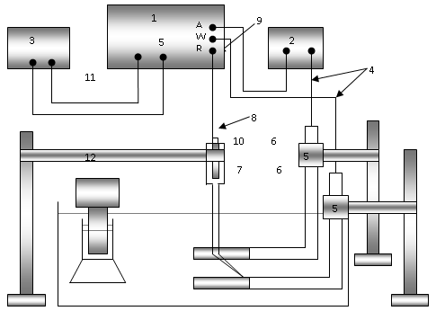

Fig. 1 Experimental setup of cathodic protection (ICCPS), (1) potentiostat; (2) voltmeter; (3) ammeter, (4) connecting wires; (5) stands; (6) pipe plastic; (7) cathode; (8) lugging capillary; (9) Saturated Calomel Electrode (SCE); (10) anode; (11) heater; (12) water bath of distilled water.

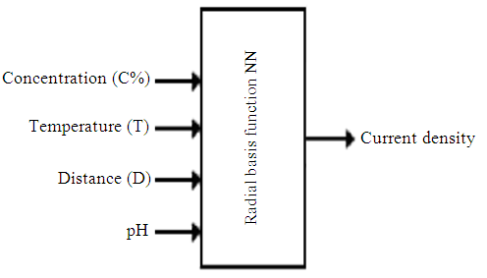

Fig. 2 RBFNN model control

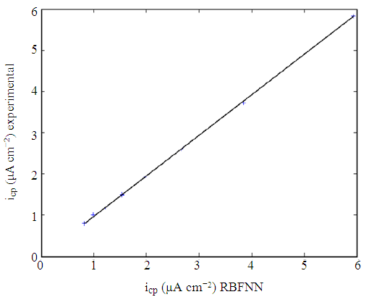

Fig. 3 Comparison of RBFNN with the experimental output

REFERENCES

Dayhoff, J.E., 1990. Neural Network Architectures: An Interdiction. Van Nostrand Reinhold, New York. ISBN: 0442207441, pp: 259.

De La Mata-Moya, D., P. Jarabo-Amores, M. Rosa- Zurera, R. Vicen-Bueno and J.C. Nieto-Borge, 2007. Neural network based approaches for detecting signals with unknown parameters. Proceeding of the IEEE International Symposium on Intelligent signal Processing, Oct. 3-5, IEEE Xplore Press, Alcala de Henares, pp: 1-6. DOI: 10.1109/WISP.2007.4447634

Miller, W.T., R.S, Sutton and P.J. Werbos, 1990. Neural Networks for Control. 1st Edn., MIT Press, Cambridge, MA., ISBN: 9780262132619, pp: 524.

Rumethart, D.E., J.L. McClelland, 1986. Parallel Distributed: Processing Exploration in the Micro Structure of Cognition. Vol. 1, MIT Press, Cambridge, MA., ISBN:0-262-68053-X, pp: 547.

Sami, A.A. and A.A. Ghalib, 2008a. Variable conditions effect on polarization parameters of impressed current cathodic protection of low carbon steel pipes. Eng. Technol., 26: 1-12. http://uotechnology.edu.iq/tec_magaz/volume2620 08/No6/Researches/5.pdf

Sami, A.A. and A.A. Ghalib, 2008b. Application of artificial neural network for cathodic protection oflow carbon steel pipes. Eng. Technol. J., 26.

Stephen, K.L., 1999. Electrochemistry. Simon Fraser University.

Uhlig, H.H. and R.W. Revie, 1985. Corrosion and Corrosion Control. 3rd Edn., Wiley-Interscience, ISBN: 10: 0471078182, pp: 464.

White, D.A. and D.A. Sofge, 1992. Handbook of Intelligent Control: Neural, Fuzzy, and Adaptive Approaches . Van Nostrand Reinhold, New York. ISBN: 0442308574, pp: 250.

