INTRODUCTION

The composite plates have high stiffness-to-weight ratio, and flexible anisotropic property which can be tailored through variation of the fiber orientation and stacking sequence, Fiber-reinforced laminated composites are finding increasing applications, and therefore, the stress and deformation characteristics of composite plates are receiving greater attention.
With the increased application of composites in high performance aircraft, the studies involving the assessment of the dynamic response of laminated composite-structure designers are also increased.
Much of the previous research in the analysis of composite plates is limited to linear problems, and many of them were based on the classical thin-plate theory, which neglects the transverse shear deformation effects.
Librescu et al. 1990, presented the dynamic loading conditions considered here include sine, rectangular and triangular pulses while spatially, they are considered as sinusoidally distributed. The results obtained as per a higher-order plate theory are compared with their first order transverse shear deformation and classical counter-parts.Reddy 1982, presented numerical results for deflections and stresses showing the effect of plate side-to-thickness ratio, aspect ratio, material orthotropy, and lamination scheme.
Cederbaum and Aboudi 1989, applied the first-order as well as two high-order shear deformation theories for the investigation of the laminated plate’s response.
Khdeir and Reddy 1991, used the exact solutions of rectangular laminated composite plates with different boundary conditions are studied.The Levy-type solutions of the classical first-order and third-order shear deformation theories are developed using the state-space approach.
Bose and Reddy 1998, presented a unified third-order laminate plate theory that contains classical, first-order and third order theories as special cases are presented. Analytical solutions using the Navier and Levy solution procedures are presented.
Reddy and Chao 1981, obtained the numerical results of deflections and stresses for rectangular plates for various boundary conditions, loading, staking and orientation of layers, and material properties.
In this work the analytical solution for displacement and stresses of laminated plates in bending subject to dynamic loading is presented. The investigations deal with the analytical solution of composite plates subjected to time dependent loading, therefore,

EQUIVALENT SINGLE LAYER THEORIES (ESL)

In the “ESL” theories, the displacements or stresses are expanded as a linear combination of the thickness coordinate and undetermined functions of position in the reference surface,

$φ_{i}(x,y,z)=\sum_{j=0}^{N_{i}}{φ_{j}^{i}(x,y)Z^{j}}$, for i=1,2,3. (1)
Where N_{i} are the number of terms in the expansion. φ_{i}^{j} can be either displacements or stresses.

Classical Laminated Plates Theory (CLPT)

The displacement filed of laminated plates are, Rao 1999,
$\begin{aligned}u_{1}(x,y,z,t)=u(x,y,t)−Z\frac{∂w}{∂x} \\ u_{2}(x,y,z,t)=v(x,y,t)−Z\frac{∂w}{∂y} \\ u_{3}(x,y,z,t)=w(x,y,t)\end{aligned}$ (2)
Where (u,v,w) are the displacements, along the coordinate lines, of a material point on the xy-plane.
The equations of motion are,

$\begin{aligned}N_{x,x}+N_{\text{xy},y}=I_{1}\text{.}u_{,\text{tt}}−I_{2}\text{.}W_{,\text{xtt}} \\ N_{\text{xy},x}+N_{y,y}=I_{1}\text{.}v_{,\text{tt}}−I_{2}\text{.}W_{,\text{ytt}} \\ M_{x,\text{xx}}+2\text{.}M_{\text{xy},\text{xy}}+M_{y,\text{yy}}+q(x,y)= \\ I_{1}\text{.}W_{,\text{tt}}+I_{2}\text{.}u_{,\text{xtt}}+I_{2}\text{.}v_{,\text{ytt}}−I_{3}\text{.}W_{,\text{xxtt}}−I_{3}\text{.}W_{,\text{yytt}}\end{aligned}$ (3)
Where,
$I_{1}=\sum_{k=1}^{n}{\int_{z_{k−1}}^{z_{k}}{ρ^{(k)}\text{dz}}}$ (4)
For ρ^{(K)} being the material density of K^{th} layer.
The laminate constitutive equations can be expressed in the form,

$\begin{aligned}\left[N_{i} | \right] \\ \end{aligned}$ (5)
Where,

ε_{x}=u_{,x} , ε_{y}=v_{,y} , γ_{xy}=u_{,y}+v_{,x} , K_{x}=w_{,xx} , K_{y}=-w_{,yy} , K_{xy}=-2 w_{,xy} (6)

The A_{ij}, B_{ij,} D_{ij} (i,j =1,2,6 ) are the respective inplane, bending –inplane coupling, and bending or twisting, respectively,

$(A,B,D)=\sum_{k=1}^{n}{\int_{z_{k−1}}^{z_{k}}{{\bar{Q}}^{(k)}(1,Z,Z^{2})\text{dz}}}$ (7)
Here Z_{m} denotes the distance from the mid-plane to the lower surface of the K^{th} layer.
Eqs. (3) and (5) can be conveniently expressed in the operator form as,

$\left[L\right]\left[Δ\right]+\left[f\right]=\left[M\right]\left[\overset{¨}{Δ}\right]$ (8)

Where,
M₁₁ =I₁ , M₁₂=0 , M₁₃=-I₂ d_{x} , M₂₂=I₁ , M₂₃=-I₂ d_{y} , M₃₃=I₁ –I₃ (d_{xx}+d_{yy}).
[∆]=[u v w]^{T} ,[f]=[0 0 q(x,y,t)]^{T}.
And,
L₁₁=A₁₁ d_{xx} +2 A₁₆ d_{xy} +A₆₆ d_{yy} , L₁₂=A₁₂ d_{xy} +A₁₆ d_{xx} +A₂₆ d_{yy} +A₆₆ d_{xy} ,
L₁₃=-B₁₁ d_{xxx} -B₁₂ d_{xyy} -3 B₁₆ d_{xxy} - B₂₆ d_{yyy} -2 B₆₆ d_{xyy} , L₂₂=2A₂₆ d_{xy} +A₆₆ d_{xx} +A₂₂ d_{yy} ,
L₂₃=-B₁₆ d_{xxx} –3 B₂₆ d_{xyy} –2B₆₆ d_{xxy} –B₁₂ d_{xxy} –B₂₂ d_{yyy} ,
L₃₃= -D₁₁ d_{xxxx} -2 D₁₂ d_{xxyy} –4 D₁₆ d_{xxxy}–4 D₂₆ d_{xyyy} –4 D₆₆ d_{xxyy} –D₂₂ d_{yyyy} . (9)
First-OrderShear Deformation Theory (FSDT)

This theory accounts for linear variation of inplane displacements through the thickness,

u₁(x,y,z,t)=u(x,y,t)+Z ψ_{x}(x,y,t)
u₂(x,y,z,t)=v(x,y,t)+Z ψ_{y}(x,y,t)
u₃(x,y,z,t)=w(x,y,t) . (10)
Where, t is the time; u₁ , u₂ , u₃ are the displacements in x,y,z directions, respectively; and ψ_{x} and ψ_{x} are the slopes in the xy and yz planes due to bending only.

The equations of motion are,

N_{x,x}+N_{xy,y}=I₁ u_{,tt} +I₂ψ_{x,tt}
N_{xy,x}+N_{y,}y=I₁ v_{,tt}+ I₂ψ_{y,tt}
N_{xz,x}+N_{yz,y}+q(x,y,t)=I₁w_{,tt}
M_{x,x}+M_{xy,y} -N_{xz}=I₂ u_{,tt} +I₃ψ_{x,tt}
M_{xy,x}+M_{y,y}- N_{yz} =I_{2 v,tt}+ I₃ψ_{y,tt} (11)

Where,
$(I_{1},I_{2},I_{3})=\sum_{k=1}^{n}{\int_{z_{k−1}}^{z_{k}}{ρ^{(k)}(1,Z,Z^{2})\text{dz}}}$ (12)
The laminated constitutive equations can be expressed in the form,

$\left[\begin{matrix}N \\ M\end{matrix}\right]=\left[\begin{matrix}A & B \\ B & D\end{matrix}\right]\left[\begin{matrix}ε \\ K\end{matrix}\right],\left[\begin{matrix}N_{\text{yz}} \\ N_{\text{xz}}\end{matrix}\right]=\left[\begin{matrix}k_{\text{44}}^{2}A_{\text{44}} & k_{\text{45}}^{2}A_{\text{45}} \\ k_{\text{45}}^{2}A_{\text{45}} & k_{\text{55}}^{2}A_{\text{55}}\end{matrix}\right]\left[\begin{matrix}γ_{\text{yz}} \\ γ_{\text{xz}}\end{matrix}\right]$ (13)

Where,
ε_{x}=u_{,x} , ε_{y}=v_{,y} , γ_{xy}=u_{,y}+v_{,x} , γ_{yz}=ψ_{y}+w_{,y} , γ_{xz}=ψ_{x}+w_{,x} , K_{x}=ψ_{x,x} , K_{y}=ψ_{y,y} , K_{xy}=ψ_{x,y} +ψ_{y,x}
(14)
And,K_{45,} K₄₄ and K₅₅ are correction factors.
Eqs. (11) and (13) can be conveniently expressed in the operator form as,

$\left[L\right]\left[Δ\right]+\left[f\right]=\left[M\right]\left[\overset{¨}{Δ}\right]$ (15)

Where,
[∆]=[u v w ψ_{x}ψ_{y}]^{T} , [F]=[0 0 q(x,y,t) ]^{T} .
And,M₁₁=M₂₂=M₃₃ =I₁ , M₄₄ =M₅₅ =I₃ , M₁₄ =M₂₅=I₂ ,and other terms of M_{ίj}=0 (for ί≠j).
And, [L] is given as,

L₁₁=A₁₁d_{xx}+2A₁₆d_{xy}+A₆₆d_{yy} , L₁₂=A₁₂d_{xy}+A₁₆d_{xx}+A₂₆d_{yy}+A₆₆d_{xy} , L₁₃=0

L₁₄=B₁₁d_{xx}+2B₁₆d_{xy}+B₆₆d_{yy}, L₁₅=B₁₂d_{xy}+B₁₆d_{xx}+B₂₆d_{yy}+B₆₆d_{xy}

L₂₂=2A₂₆d_{xy}+A₆₆d_{xx}+A₂₂d_{yy} , L₂₃=0 , L₂₄=B₁₆d_{xx}+B₆₆d_{xy}+B₁₂d_{xy}+B₂₆d_{yy}
L₂₅=2B₂₆d_{xy}+B₆₆d_{xx}+B₂₂d_{yy} , L₃₃=2A₄₅d_{xy}+A₅₅d_{xx} , L₃₄=A₅₅d_{x}+A₄₅d_{y} , L₃₅=A₄₅d_{x}+A₄₄d_{y}
L₄₄=D₁₁d_{xx}+2D₁₆d_{xy}+D₆₆d_{yy}-A₅₅, L₄₅=D₁₂d_{xy}+D₁₆d_{xx}+D₂₆d_{yy}+D₆₆d_{xy}-A₄₅
L₅₅=2D₂₆d_{xy}+D₆₆d_{xx}+D₂₂d_{yy}-A₄₄.

ACTUAL DISPLACEMENTS FOR SIMPLY-SUPPORTED LAMINATED PLATE

Cross-Ply Laminated Plate

The general actual displacements for cross-ply laminated plate are, Bose and Reddy 1998,

$\begin{aligned}u(x,y,t)=\text{cos}αx\text{.} \text{sin}β y\text{.} u(t)=\bar{u}(x,y)\text{.} u(t) \\ v(x,y,t)=\text{sin}αx\text{.}\text{cos}β y\text{.} v(t)=\bar{v}(x,y)\text{.} v(t) \\ w(x,y,t)=\text{sin}αx\text{.}\text{sin}β y\text{.} w(t) =\bar{w}(x,y)\text{.} w(t) \\ ψ_{x}(x,y,t)=\text{cos}αx\text{.}\text{sin}β y\text{.} ψ_{x}={\bar{ψ}}_{x}(x,y)\text{.} ψ(t) \\ ψ_{y}(x,y,t)=\text{sin}αx\text{.}\text{cos}β y\text{.} ψ_{y}(t)={\bar{ψ}}_{y}(x,y)\text{.} ψ_{y}(t)\end{aligned}$ (16)
Angle-Ply Laminated Plate

The general actual displacements for Angle-ply laminated plate are,

$\begin{aligned}u(x,y,t)=\text{sin}αx\text{.}\text{cos}βy\text{.}u(t)=\bar{u}(x,y)\text{.} u(t) \\ v(x,y,t)=\text{cos}αx\text{.}\text{sin}βy\text{.}v(t) =\bar{v}(x,y)\text{.} v(t) \\ w(x,y,t)=\text{sin}αx\text{.}\text{sin}βy\text{.}w(t)=\bar{w}(x,y)\text{.} w(t) \\ ψ_{x}(x,y,t)=\text{cos}αx\text{.}\text{sin}βy\text{.}ψ_{x} ={\bar{ψ}}_{x}(x,y)\text{.} ψ(t) \\ ψ_{y}(x,y,t)=\text{sin}αx\text{.}\text{cos}βy\text{.}ψ_{y}(t) ={\bar{ψ}}_{y}(x,y)\text{.} ψ_{y}(t)\end{aligned}$ (17)

GENERAL SOLUATION FOR EQUATIONS OF MOTION

The general equations of motion are,

$\left[L\right]\left[Δ\right]+\left[f\right]=\left[M\right]\left[\overset{¨}{Δ}\right]$ (18)

By substituting the actual displacements, eq. (16) or (17), into eq. (18), than by premultiplying the result by [$\bar{Δ}$(x,y)]^{T} and integral of xy, we get,

$\left[M\right]\left[\overset{¨}{Δ}\right]+\left[K\right]\left[Δ\right]=\left[F\right]$ (19)

Where,
$$\left[\bar{Δ}(x,y)\right]={\left[\begin{matrix}\bar{u}(x,y) & \bar{v}(x,y) & \text{.}\text{.}\text{.}\text{.}\text{.}\text{.}\text{.}\text{.}\text{.}\text{.}\text{.}\text{.}\text{.}\text{.}\text{.}\text{.}\text{.}\text{.}\end{matrix}\right]}^{T}$$
And [M] and [K] are mass and stiffness matrices, respectively; [∆(t)] and [F] are displacement of time and load vector, respectively.

Cross-Ply Laminated Plate

Depending on the used theory, substitution eq. (16) into eq. (18) , get,

$\left[M\right]\left[\overset{¨}{Δ}\right]+\left[K\right]\left[Δ\right]=\left[F\right]$ (20)

Where,[M], [K], [∆(t)] and [F] as, for (FSDT),
K₁₁=α²A₁₁+β²A₆₆ , K₁₂=αβ(A₁₂+A₆₆) , K₁₃=0 , K₁₄=α²B₁₁ , K₁₅=0 , K₂₂=α²A₆₆+β²A₂₂, K₂₃=0
K₂₄=0 , K₂₅=β²B₂₂ , K₃₃=α²A₅₅+β²A₄₄ , K₃₄=αA₅₅ , K₃₅=βA₄₄ , K₄₄=α²D₁₁+β²D₆₆+A₅₅
K₄₅=αβ(D₁₂+D₆₆) , K₅₅=α²D₆₆+β²D₂₂+A₄₄
And ,[M] as in eq. (15)
[∆(t)]=[u(t) v(t) w(t) ψ_{x}(t) ψ_{y}(t)]^{T} , $F(t)={\left[\begin{matrix}0 & 0 & \bar{q}(t) & 0 & 0\end{matrix}\right]}^{T}$.
Where,
$$\bar{q}(t)=\frac{4}{\text{ab}}\int_{0}^{b}{\int_{0}^{a}{\text{sin}αx\text{.}\text{sin}βy\text{.}q(x,y)\text{.}\text{dx}\text{.}\text{dy}}\text{.}f(t)}$$
The [M] and [K] matrix for symmetric cross-ply are as for antisymmetric cross-ply for subjected (B_{ij}= E_{ij}=G_{ij}=0).

Angle-ply Laminated Plate

Depending on the used theory, substitute eq. (17) in to eq. (18), get,

$\left[M\right]\left[\overset{¨}{Δ}\right]+\left[K\right]\left[Δ\right]=\left[F\right]$ (21)
Where, [M], [K], [∆(t)] and [F] as, for (FSDT), for anti-symmetric angle-ply laminated plates,
K₁₁=α²A₁₁+β²A₁₆ , K₁₂=αβ(A₁₂+A₆₆) , K₁₃=0 , K₁₄=2αβB₁₆ , K₁₅=α²B₁₆+β²B₂₆
K₂₂=α²A₆₆+β²A₂₂ , K₂₃=0 , K₂₄=α²B₁₆+β²B₂₆, K₂₅=2αβB₂₆ , K₃₃=α²A₅₅+β²A₄₄ , K₃₄=αA₅₅
K₃₅=βA₄₄ , K₄₄=α²D₁₁+β²D₆₆+A₅₅ , K₄₅=αβ(D₁₂+D₆₆) , K₅₅=α²D₆₆+β²D₂₂+A₄₄ .
And, [F] and [∆(t)] as in equation (20).
And, M₁₁=M₂₂=M₃₃=I₁ ,M₄₄=M₅₅=I₃ ,M_{ij}=0 for i≠j .

STIFFENED LAMINATED PLATES

To achieve a uniform distribution over the entire section consisting of plate and ribs, the spacing of the ribs must be small in comparison with whole span.A typical orthotropic element stiffened eccentrically with open ribs in x and y-directions is shown in Fig. 1.

Classical Plate Theory (CLPT)

The refined analysis of such a plate, the governing differential equations are expressed in terms of the displacements, u, v, and w, of the middle surface of the plate in the directions x, y, and z, respectively.
The force and moment relations for stiffened laminated plate are, Troitsky (1976),

$\left[\begin{matrix}N \\ M\end{matrix}\right]={\left[\begin{matrix}N \\ M\end{matrix}\right]}_{\text{un}\text{.}\text{st}\text{.}\text{pl}\text{.}}+{\left[\begin{matrix}N \\ M\end{matrix}\right]}_{\text{st}\text{.}\text{pl}\text{.}}$ (22)

Where, ${\left[\begin{matrix}N \\ M\end{matrix}\right]}_{\text{un}\text{.}\text{st}\text{.}\text{pl}\text{.}}$ are force and moment relations for un stiffened laminated plate, and${\left[\begin{matrix}N \\ M\end{matrix}\right]}_{\text{st}\text{.}\text{pl}\text{.}}$ are force and moment relations for stiffened plate as,

$\left[\begin{matrix}N_{x} \\ N_{y} \\ M_{x} \\ M_{y}\end{matrix}\right]=\left[\begin{matrix}A_{\text{11}}^{\text{st}\text{.}} & 0 & B_{\text{11}}^{\text{st}} & 0 \\ 0 & A_{\text{22}}^{\text{st}} & 0 & B_{\text{22}}^{\text{st}} \\ B_{\text{11}}^{\text{st}} & 0 & D_{\text{11}}^{\text{st}} & 0 \\ 0 & B_{\text{22}}^{\text{st}} & 0 & D_{\text{22}}^{\text{st}}\end{matrix}\right]\left[\begin{matrix}ε_{x}^{(0)} \\ ε_{y}^{(0)} \\ Κ_{x} \\ Κ_{y}\end{matrix}\right]$ (23)
For,$\left(A_{\text{11}}^{\text{st}},B_{\text{11}}^{\text{st}},D_{\text{11}}^{\text{st}}\right)=\int_{Z_{i−1)x}^{\text{st}}}^{Z_{i)x}^{\text{st}}}{\frac{t_{x}}{b_{x}}E_{x}^{\text{st}}\left(1,Z,Z^{2}\right)\text{dz}} , \left(A_{\text{22}}^{\text{st}},B_{\text{22}}^{\text{st}},D_{\text{221}}^{\text{st}}\right)=\int_{Z_{i−1)y}^{\text{st}}}^{Z_{i)y}^{\text{st}}}{\frac{t_{y}}{b_{y}}E_{y}^{\text{st}}\left(1,Z,Z^{2}\right)\text{dz}}$
Where, $E_{x}^{\text{st}}\text{and}E_{y}^{\text{st}}$ are modules of elasticity of stiffeners in x and y-directions, respectively.
Then, by substituting equation (22) in to equations of motion, we get [M] and [K] matrices as,
[M]=[M]_{st.}+[M]_{un.st.} and [K]=-[L], for [L]=[L]_{st} +[L]_{un.st}.
Where, [M]_{un.st.} ,[L]_{un.st.} are mass and stiffness matrices for un stiffened laminated plate, and [M]_{st.},[L]_{st.} are mass and stiffness matrices for stiffeners determined as,

$\begin{aligned}L_{\text{11}}^{\text{st}}=A_{\text{11}}^{\text{st}}d_{\text{xx}},L_{\text{12}}^{\text{st}}=0,L_{\text{13}}^{\text{st}}=−B_{\text{11}}^{\text{st}}d_{\text{xxx}}, L_{\text{22}}^{\text{st}}=A_{\text{22}}^{\text{st}}d_{\text{yy}} , L_{\text{23}}^{\text{st}}=−B_{\text{22}}^{\text{st}}d_{\text{yy}}, \\ L_{\text{33}}^{\text{st}}=−D_{\text{11}}^{\text{st}}d_{\text{xxxx}}−D_{\text{22}}^{\text{st}}d_{\text{yyyy}} \\ M_{\text{11}}^{\text{st}}=I_{1}^{\text{st})x},M_{\text{12}}^{\text{st}}=0,M_{\text{13}}^{\text{st}}=−I_{2}^{\text{st})x}d_{x}, M_{\text{22}}^{\text{st}}=I_{1}^{\text{st})y} , M_{\text{23}}^{\text{st}}=−I_{2}^{\text{st})y}\text{dy}, \\ M_{\text{33}}^{\text{st}}=I_{1}^{\text{st})x}+I_{1}^{\text{st})y}−(d_{\text{xx}}+d_{\text{yy}})(I_{3}^{\text{st})x}+I_{3}^{\text{st})y})\end{aligned}$ (24)
Where,
$$(I_{1}^{\text{st})x},I_{2}^{\text{st})x},I_{3}^{\text{st})x})=\int_{Z_{i−1)x}^{\text{st}}}^{Z_{i)x}^{\text{st}}}{ρ_{x}^{\text{st}}}(1,Z,Z^{2})\text{dz}, \text{and}, (I_{1}^{\text{st})y},I_{2}^{\text{st})y},I_{3}^{\text{st})y})=\int_{Z_{i−1)y}^{\text{st}}}^{Z_{i)y}^{\text{st}}}{ρ_{y}^{\text{st}}}(1,Z,Z^{2})\text{dz}$$
(25)
For $ρ_{x}^{\text{st}}\text{and}ρ_{y}^{\text{st}}$ are the density of stiffeners in x and y-directions respectively.

First-Order Shear Deformation Theory (FSDT)

The force and moment relations for stiffened laminated plate are,

$\left[\begin{matrix}N \\ M\end{matrix}\right]={\left[\begin{matrix}N \\ M\end{matrix}\right]}_{\text{un}\text{.}\text{st}\text{.}\text{pl}\text{.}}+{\left[\begin{matrix}N \\ M\end{matrix}\right]}_{\text{st}\text{.}\text{pl}\text{.}}$ , and,$\left[\begin{matrix}Q_{y} \\ Q_{x}\end{matrix}\right]={\left[\begin{matrix}Q_{y} \\ Q_{x}\end{matrix}\right]}_{\text{st}\text{.}\text{pl}\text{.}}+{\left[\begin{matrix}Q_{y} \\ Q_{x}\end{matrix}\right]}_{\text{un}\text{.}\text{st}\text{.}\text{pl}\text{.}}$ (26)

Where, [N], [M] as in equations (22) , ${\left[\begin{matrix}Q_{y} \\ Q_{x}\end{matrix}\right]}_{\text{un}\text{.}\text{st}\text{.}\text{pl}\text{.}}$ are shear force for un stiffened laminated plate and${\left[\begin{matrix}Q_{y} \\ Q_{x}\end{matrix}\right]}_{\text{st}\text{.}\text{pl}\text{.}}$ are shear force for stiffeners as,

${\left[\begin{matrix}Q_{y} \\ Q_{x}\end{matrix}\right]}_{\text{st}\text{.}\text{pl}\text{.}}=\left[\begin{matrix}A_{\text{44}}^{\text{st}\text{.}} & 0 \\ 0 & A_{\text{55}}^{\text{st}\text{.}}\end{matrix}\right]\left[\begin{matrix}γ_{\text{yz}} \\ \text{xz}\end{matrix}\right]$ (27)

For,

$$A_{\text{44}}^{\text{st}\text{.}}=\int_{Z_{i−1)x}^{\text{st}\text{.}}}^{Z_{i)x}^{\text{st}\text{.}}}{G^{\text{st})x}}\frac{t_{x}}{b_{x}}\text{dz}, A_{\text{55}}^{\text{st}\text{.}}=\int_{Z_{i−1)y}^{\text{st}\text{.}}}^{Z_{i)y}^{\text{st}\text{.}}}{G^{\text{st})y}}\frac{t_{y}}{b_{y}}\text{dz}$$

Where, G^{st)x} and G^{st)y} are shear modules of elasticity of stiffeners in x and y-directions, respectively.
Then, by substituting equation (26) into equations of motion, Eq. (11), we get [M] and [K] matrices as,

[M]=[M]_{st.}+[M]_{un.st.} and [K]=-[L], for [L]=[L]_{st} +[L]_{un.st}.

Where, [M]_{un.st.} ,[L]_{un.st.} are mass and stiffness matrices for un stiffened laminated plate, and [M]_{st.},[L]_{st.} are mass and stiffness matrices for stiffeners determined as,

$$\begin{aligned}L_{\text{11}}^{\text{st}}=A_{\text{11}}^{\text{st}}d_{\text{xx}},L_{\text{14}}^{\text{st}}=B_{\text{11}}^{\text{st}}d_{\text{xx}}L_{\text{22}}^{\text{st}}=A_{\text{22}}^{\text{st}}d_{\text{yy}}, L_{\text{25}}^{\text{st}}=B_{\text{22}}^{\text{st}}d_{\text{yy}} , L_{\text{33}}^{\text{st}}=A_{\text{55}}^{\text{st}}d_{\text{xx}}+A_{\text{44}}^{\text{st}}d_{\text{yy}}, \\ L_{\text{34}}^{\text{st}}=A_{\text{55}}^{\text{st}}d_{x}L_{\text{35}}^{\text{st}}=A_{\text{44}}^{\text{st}}d_{y}, L_{\text{44}}^{\text{st}}=D_{\text{11}}^{\text{st}}d_{\text{xx}}−A_{\text{55}}^{\text{st}},L_{\text{55}}^{\text{st}}=D_{\text{22}}^{\text{st}}d_{\text{yy}}−A_{\text{44}}^{\text{st}}, \text{and}\text{other}\text{term}\text{of}L_{\text{ij}}=0 \\ \text{and},M_{\text{11}}^{\text{st}}=I_{1)x}^{\text{st}} , M_{\text{14}}^{\text{st}}=I_{2)x}^{\text{st}},M_{\text{22}}^{\text{st}}=I_{1)y}^{\text{st}},M_{\text{25}}^{\text{st}}=I_{2)y}^{\text{st}}, M_{\text{33}}^{\text{st}}=I_{1)x}^{\text{st}}+I_{1)y}^{\text{st}},M_{\text{44}}^{\text{st}}=I_{3)x}^{\text{st}}, \\ M_{\text{55}}^{\text{st}}=I_{3)y}^{\text{st}} , \text{and}\text{other}\text{term}\text{of}M_{\text{ij}}=0\text{.}\end{aligned}$$
MODAL ANALYSIS

For a system with (n) coordinates or degrees of freedom, the governing equations of motion are a set of (n) coupled ordinary differential equations of second order. The solution of these equations becomes more complex when the degree of freedom of the system (n) is large and/or when the forcing functions are non-periodic. In such cases, a more convenient method known “Modal analysis” can be used to solve the problem.
The equation of motion of a multi-degree of freedom system under external forces are given by,Singiresu 1995,

$\left[M\right]\left[\overset{¨}{Δ}\right]+\left[K\right]\left[Δ\right]=\left[F\right]$ (28)

To solve equation (28) by modal analysis, it is necessary first to solve the eigenvalue problem and find the natural frequencies ω₁,ω₂, ……, ω_{n} and the corresponding normal weighted modal$\left[\tilde{P}\right]$.
The solution vector of equation (28) can be expressed by a linear combination of the normal weighted modal,

$\bar{Δ}(t)=\left[\tilde{P}\right]{\vec{q}}_{p}(t)$ (29)

Where,${\vec{q}}_{p}(t)=\left[\begin{matrix}q_{p_{1}}(t) \\ q_{p_{2}}(t) \\ ⋮ \\ q_{p_{N}}(t)\end{matrix}\right]$ (30)

Where $q_{p_{1}}(t)$, $q_{p_{2}}(t)$,…..,$q_{p_{n}}(t)$are time-dependent generalized coordinates, also known as the “principal coordinates or modal participation coefficients”.
By substituting equation (29) into equation (28) , than, premultiplying throughout by ${\left[\tilde{P}\right]}^{T}$, get,

${\overset{¨}{q}}_{p}(t)+\left[⋱ω^{2}⋱\right]q_{p}(t)={\vec{Q}}_{p}(t)$ (31)

Where,

$\left[I\right]={\left[\tilde{P}\right]}^{T}\left[M\right]\left[\tilde{P}\right],\left[⋱ω^{2}⋱\right]={\left[\tilde{P}\right]}^{T}\left[K\right]\left[\tilde{P}\right]$ and ${\bar{Q}}_{p}(t)={\left[\tilde{P}\right]}^{T}\vec{F}(t)$

Equation (31) denotes a set of (n) uncoupled differential equations of second order,

${\overset{¨}{q}}_{p_{i}}(t)+ω_{i}^{2}q_{p_{i}}(t)=Q_{p_{i}}(t)$ (32)

COMPUTER PROGRAMMING

The computer programs designed in this work are concerned with solving the dynamic problems for composite laminated plates using any theory for laminated plates. The computer programs constructed herein are coded in “Fortran Power Station 4.0” language, the following flow chart of the dynamic program ,as shown in Fig. 2.

RESULTS AND DISCUSSION

Un-Stiffened Plates

The case study discussed here is a un-stiffened laminated simple supported plate Fig. 3. with dimensions and material properties give below using the first-order shear deformation theory (FSDT) and applying the suggested analytical solution and finite element method.
Fig. 4.shows a comparison of the present work solutions by Analytical and finite elements method with the numerical solution of Reddy, J. N. (1982)they are given for two layer simply supported cross-ply laminated plate subjected to sinusoidal Pulse loading (q(x,y,t)=P(x,y), for P(x,y)=q_{o} sin($π$x/a)sin($π$y/b) ,qo=10 N/cm²) and the properties of plate,
E₂=2.1*10⁶ N/cm², E₁/E₂=25, G₁₂=G₁₃=G₂₃=0.5E₂, ρ=800 Kg/m³, ν=0.25, a=b=25 cm , h=5 cm.
Fig. 5.shows a comparison of the present work with the numerical solution of Reddy, J. N. (1982)they are given for simply supported two layer cross-ply laminated plate subjected to sinusoidal Pulse loading (q(x,y,t)=P(x,y), for
P(x,y)=q_{o} sin($π$x/a)sin($π$y/b) ,qo=10 N/cm²) ,for properties of plate:-
E₂=2.1*10⁶ N/cm², E₁/E₂=25, G₁₂=G₁₃=G₂₃=0.5E₂, ρ=800 Kg/m³, ν=0.25, a=b=25 cm , h=1 cm.
The following properties were using for simply supported Laminated Plates ,in Figs. 6, 7, and 8, for qo=10 N/cm² ,t_{o}=0.0005 sec, simply supported laminated plates,
E₂=2.1*10⁶ N/cm², E₁/E₂=25, G₁₂=G₁₃=G₂₃=0.5E₂, ρ=1500 Kg/m³, ν=0.25.
a=b=25 cm , h=5 cm .
Fig. 6. represents the variation of central transverse deflection with time for antisymmetric cross-ply (0/90/0/…) laminated plates under sinusoidal variation loading (plus q(x,y,t)=P(x,y) ,Ramp loading q(x,y,t)=P(x,y) t/t_{o} and sine loading q(x,y,t)=P(x,y) sinπt/t_{o} ) for qo=10 N/cm² ,t_{o}=0.0005 sec ) solutions by analytical and (F.E.M).The deflection due to pulse loading higher in magnitude than the other loading because the pulse load subjected suddenly with constant value with time.
Fig. 7. represents the variation of central transverse deflection with time for Antisymmetric cross-ply (0/90/0/…) laminated plates under sinusoidal (P(x,y)=q_{o} sin($π$x/a)sin($π$y/b)) and uniform (P(x,y)=q_{o} ) plus loading solutions by analytical and (F.E.M). The deflection due to uniform load higher in magnitude than the deflection due to sinusoidal loading.
Fig. 8. represents the variation of central transverse deflection with time for angle-ply and cross-ply laminated under sinusoidal Ramp loading solution by analytical and (F.E.M). The (0/90/…) laminated higher in magnitude than the (45/-45/…) laminated because at (θ=45⁰/-45⁰/…) the extension and bending stiffnesses A₁₆, A₂₆, D₁₆ and D₂₆ appear to have a significant effect while at (θ=0⁰/90⁰/…)the extension and bending stiffnesses A₁₆, A₂₆, D₁₆ and D₂₆ are zero.
The following properties were used for simply supported Laminated Plates, Figs. (9 to 14),
E₁=130.8 Gpa, E₂=10.6 Gpa, G₁₃=G₂₃=6 Gpa ,G₂₃=3.4 Gpa , ρ=1580 Kg/m³, ν=0.25.
a=b=1 m h=0.02 m, and q_{o}=10 kn/m² t_{o}=0.05 sec.
Fig. 9. represents the effect of the degree of othotropy (E₁/E₂) (E₂=10.6 Gpa) on the deflection with time of simply supported antisymmetric cross-ply laminated plates subjected to sinusoidal plus loading solution by analytical and (F.E.M). From the figure, increasing the material orthotropy ratio (E₁/E₂) will decreases the deflection. Fig. 10. shows the effect of the aspect ratio (a/b) on the deflection of the simply supported antisymmetric cross-ply laminated plates(a=1 m) subjected to sinusoidal Ramp loading solution by analytical and (F.E.M). From the results, the increase of (a/b) ratio increases the deflection.
Fig. 11. shows the effect of the (a/h) ratio on the deflection of the simply supported antisymmetric cross-ply laminated plates (a=1 m)subjected to sinusoidal sine loading solution by analytical and (F.E.M). From the results, the increase of (a/h) ratio increases the deflection of laminated plates.Fig. 12. shows the effect of the number of layer of simply supported antisymmetric cross-ply laminated plates on the deflection of plate subjected to sinusoidal Pulse loading solution by analytical and (F.E.M) . The central deflection of laminated plates decreases with increasing number of layers.
Fig. 13. shows the effect of the lamination angle (θ⁰) on the deflection of simply supported antisymmetric angle-ply laminated plates under sinusoidal ramp loading solution by analytical and (F.E.M). It is apparent from the results that the deflection decreases with increasing the angle of laminated.Fig. 14. shows the effect of the number of layer of simply supported antisymmetric angle-ply laminated plates on the deflection of plate subjected to sinusoidal sine loading solution by analytical and (F.E.M). The central deflection of laminated plates decreases with increasing number of layers.
The following properties were used for simply supported laminated plates, for analytical solutions, in figs. 15 to 20, qo=10 kn/m² ,t_{o}=0.05 sec, simply supported,
E₁=130.8 Gpa ,E₂=10.6 Gpa ,G₁₂=G₁₃=6 Gpa, G₂₃=3.4 Gpa ,ρ=1580 Kg/m³, ν=0.28.
a=b=1 m ,h=0.02 m.
Fig. 15. represents the stress-x in each layer, at the middle of layers, with time for four layers Antisymmetric cross-ply (0/90/0/…) laminated plates under uniformly ramp loading q(x,y,t)=q_{o} t/t_{o} for qo=1 N/cm² ,t_{o}=0.05 sec), at x=a/2, y=b/2. The maximum value of σ_{x} is at layer-1 and the stress-x are antisymmetric about the middle plane. Fig. 16. represents the stress-x in layer-1, at the middle of layer, with time for different number of layer for Antisymmetric cross-ply (0/90/0/…) laminated plates under uniformly ramp loading q(x,y,t)=q_{o} t/t_{o} for qo=1 N/cm² ,t_{o}=0.05 sec), at x=a/2, y=b/2. The value of σ_{x} at layer-1 increase with increase the number of layers
Fig. 17. represents the effect of the lamination angle(θ⁰) on theσ_{x} at layer-1 for four layers antisymmetric angle-ply laminated plates under uniformly ramp loading, at x=a/2, y=b/2. From the results the σ_{x} decreases with the increase of the angle of laminated to the 45⁰ ,the minimum value at 45⁰ and the maximum value at 0⁰.Fig. 18. represents the comparison of stress-x with stress-y at layer-1 for four layers antisymmetric cross-ply laminated plates for difference E₁/E₂ under uniformly pulse loading, at x=a/2, y=b/2. From the results, stresses-x are more than stresses-y at E₁/E₂≠1 and Stress-x equal stress-y for E₁/E₂=1.
Fig. 19. represents the comparison stress-x with stress-y at layer-1 for four layers antisymmetric cross-ply laminated plates for difference aspect ratio under uniformly ramp loading, at x=a/2, y=b/2. From the results, stresses-x are more than stresses-y.
Fig. 20. represents the stress-y in layer-1, at the middle of layer, with time for different number of layer for Antisymmetric cross-ply (0/90/0/…) laminated plates under uniformly sine loading q(x,y,t)=q_{o} sin(πt/t_{o}) for qo=1 N/cm² ,t_{o}=0.05 sec), at x=a/2, y=b/2. The value of σ_{y} at layer-1 decreases with the increase of the number of layers.

Stiffened Laminated Plates

The case study discussed here is a stiffened laminated simple supported plate Fig. 1. with dimensions and material properties give below using the first-order shear deformation theory (FSDT) and applying the suggested analytical solution and finite element method.
The following properties were used for simply supported stiffened laminated plates, in Figs. 21. to 27, qo=10 kn/m² ,t_{o}=0.05 sec, dynamic numerical and analytical solution:
E₁=130.8 Gpa ,E₂=10.6 Gpa ,G₁₂=G₁₃=6 Gpa, G₂₃=3.4 Gpa ,ρ=1580 Kg/m³, ν=0.28.
a=b=1 m ,h=0.02 m.
And, for stiffeners:
E_{st')x}=E_{st)y}=E₁ ,G_{st.)x}=G_{st)y}=G₁₂ ,h_{x}=h_{y}=0.025 m, t_{x}=t_{y}=0.0025 m,ρ_{st)x}=ρ_{st)y}= ρ.
Comparison of the stiffened laminated plates with the un stiffened laminated plate are shown in Fig. 21 , for cross-ply two and four layer for un stiffened laminated and two and four layer, and three stiffeners in x and y-directions for stiffened laminated plates, subjected to sinusoidal pulse loading.
Fig. 22. shows the effect of the number of stiffeners of the four layer antisymmetric cross-ply stiffened laminated plates subjected to sinusoidal pulse loading. The figure shows that the increase of the numbers of stiffeners decreases the deflection of stiffened laminated plates.
Fig. 23. shows the effect of (E_{st}/E₁) ,( for E_{st)x}=E_{st)y} and E₁=130.8 Gpa) for four layer and four stiffeners of stiffened laminated plates subjected to sinusoidal pulse loading. From the figure, the deflection of stiffened laminated plates decreases with increase (E_{st.}/E₁) ratio, decreases with increase E_{st.} .
Fig. 24. shows the effect of the higher to width (h_{s}/t_{s}), ratio of stiffeners ,(for h_{s}=h_{x}=h_{y}=.025 m and t_{s}=t_{x}=t_{y}) for four layer and four stiffeners cross-ply stiffened laminated plates subjected to sinusoidal Ramp loading. From the figure, the deflection of stiffened plates increase with increases (h_{s}/t_{s}) ratio, increase with decreases t_{s} .
Fig. 25. represents the effect of the distance of stiffeners in x and y directions on the central deflection for four layer antisymmetric cross-ply stiffened laminated plates under sinusoidal pulse loading. From the results, the deflection decrease with decrease the distances of stiffeners.
Fig. 26. represents the effect of the aspect ratio for different distance of stiffeners in x and y directions on the central deflection for four layer antisymmetric cross-ply stiffened laminated plates under sinusoidal pulse loading.
Fig. 27. shows the effect of the higher of stiffeners to the thickness of Laminate (h_{s}/h_{p}) ratio, (h_{s}=h_{x}=h_{y} and h_{p}=h=0.02 m), for four layer and three stiffeners cross-ply stiffened laminated plates subjected to sinusoidal sine loading. The figure showed that the deflection or stiffened laminated plates decreases with increase (h_{s}/h_{p}) ratio, decreases with increase h_{s} .
The following properties were using for simply supported laminated plates, in figs. 28 to 32, qo=10 kn/m² ,t_{o}=0.05 sec, dynamic analytical solution:
E₁=130.8 Gpa ,E₂=10.6 Gpa ,G₁₂=G₁₃=6 Gpa, G₂₃=3.4 Gpa ,ρ=1580 Kg/m³, ν=0.28.
a=b=1 m ,h=0.02 m.
And, for stiffeners:- E_{st')x}=E_{st)y}=E₁ ,G_{st.)x}=G_{st)y}=G₁₂ ,h_{x}=h_{y}=0.025 m, t_{x}=t_{y}=0.0025 m,ρ_{st)x}=ρ_{st)y}= ρ.
Fig. 28. represents the effect of the distance of stiffeners in x and y directions on the stress-x in layer-1 for four layer antisymmetric cross-ply stiffened laminated plates under uniformly ramp loading, at x=a/2, y=b/2. From the results, the stress-x decrease with decrease the distances of stiffeners.
Fig. 29. represents the stress-x in layer-1, at the middle of layers, with time for four layers Antisymmetric cross-ply (0/90/0/…) stiffened laminated plates for difference number of stiffeners in x and y directions under uniformly sine loading, at x=a/2, y=b/2. From the results, the stress-x decrease with increase the number of stiffeners.
Fig. 30. represents the stress-x in layer-4, at the middle of layers, with time for four layers Antisymmetric cross-ply (0/90/0/…) stiffened laminated plates for difference number of stiffeners in x and y directions under uniformly sine loading, at x=a/2, y=b/2. From the results, the stress-x decrease with increase the number of stiffeners.
Fig. 31. represents the comparison σ_{x} for stiffened with unstiffened laminated plates in each layer for four layer antisymmetric cross-ply for stiffeners in x and y directions under uniformly sine loading, at x=a/2, y=b/2. The stresses-x for stiffened plates are less than that corresponding of unstiffened plate.
Fig. 32. represents the comparison σ_{y} for stiffened with unstiffened laminated plates in each layer for four layer antisymmetric cross-ply for stiffeners in x and y directions under uniformly sine loading, at x=a/2, y=b/2. The stresses-y for stiffened plates are less than that corresponding of unstiffened plates.

CONCLUSIONS

- The suggested analytical solution is a powerful tool for un-stiffened laminated plated subjected to time depended loading, by solution the general differential equations of motion of (FSDT) for laminated plated by using separation method for differential equation and model analysis method foe forced vibration.
- The presented work showed that the increasing the numbers of layers for laminated, the angle of fibers, the modules of elasticity E₁ more than E₂, the aspect ratio, the thickness of laminated decreases the deflection of laminated plates.
- The presented work shows that the increasing the aspect ratio or angle of fibers decreases the stress-x, and the increase of number of layer or the E₁/E₂ ratio increases the stress-x. And the increase of the number of layers or the E₁/E₂ ratio decreases the stress-y.
- The presented work shows that increasing the number of stiffeners, the higher, the width, and the modules of elasticity of stiffeners decreases the deflection of stiffened laminated plates. And the increasing the numbers of stiffeners decreases the stress in each layer for stiffened laminated plates.

z
y
x
b
a
b_{y}
b_{x}
t_{y}
t_{x}
h_{y}
h_{x}
h
Mid-plane
Z _{i-1)x}
Z _{i)x}
Z _{i-1)y}
Z _{i)y}

Fig. 1. Dimensions and Directions of Stiffened Laminated Plates.

Start
Open Files
Read input data (Properties of Laminated Plate and stiffeners ).

Solve For Cross-Ply Laminated Plates.

Calculate Stress-Strain Relation of lamina ,[Q] Matrix.
Read input data (Dimensions of Laminated Plate and stiffeners).

Loop N=N_{s} ,N_{f} ,∆N
Loop I=1,N,1
Calculate Stress-Strain Relation of laminated,
Matrix.
Calculate Resultants Stress Relation of Laminated, [A_{ij}], [B_{ij}],…Matrices. Eq.(7)

I=1
Calculate [K] and [M] Matrices of Laminated Plate and stiffeners. Eq.(20)

Calculate The Frequencies and The Mode Shapes of Laminated Plate, by Subroutine Program. Eq.(28)

Calculate Deflection and Stress of Laminated Plate, by Subroutine Program. Eq.(29)

∆N
Solve For Angle-Ply Laminated Plates.

Loop I=1,N,1
Loop N= N_{s} ,N_{f} ,∆N
Loop θ=0,90, ∆θ
Calculate Stress-Strain Relation of laminated,
Matrix.
Calculate Resultants Stress Relation of Laminated, [A_{ij}], [B_{ij}],...Matrixes. Eq.(7)

I=1
Calculate [K] and [M] Matrixes of Laminated Plate and stiffeners. Eq.(21)

Calculate The Frequencies and The Mode Shapes of Laminated Plate, by Subroutine Program. Eq. (28)

Calculate Deflection and Stress of Laminated Plate, by Subroutine Program. Eq.(29)

∆θ
∆N
End

Fig. 2. Flow Chart for Computer Program of Dynamic Solution for Laminated Plates.

a
b
2
Fibers
Z,3
y
x
1
h
Matrix

Fig. 3. Dimensions and Directions of Un-Stiffened Laminated Plate.

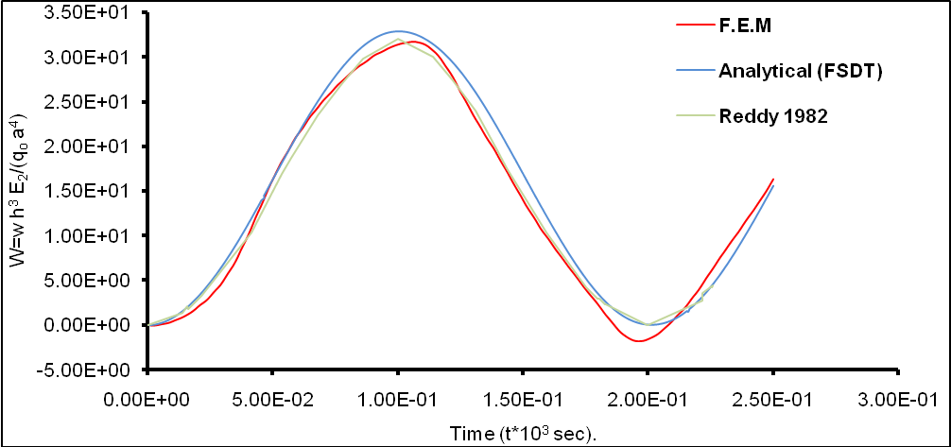

Fig. 4. Central deflection due to Sinusoidal Pulse loading for two Layer.

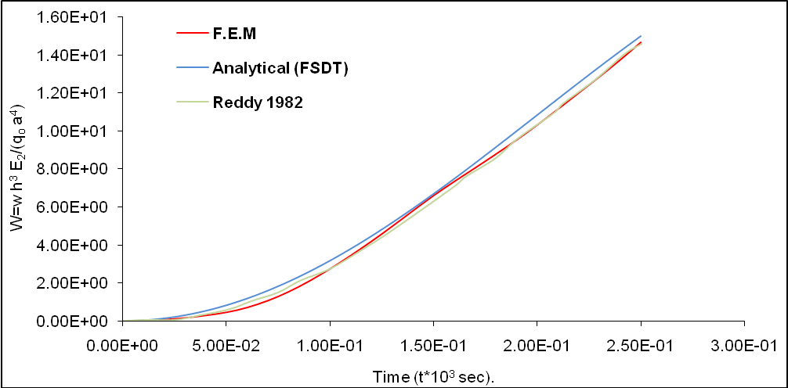

Fig. 5. Central deflection due to Sinusoidal Pulse loading for two Layer.

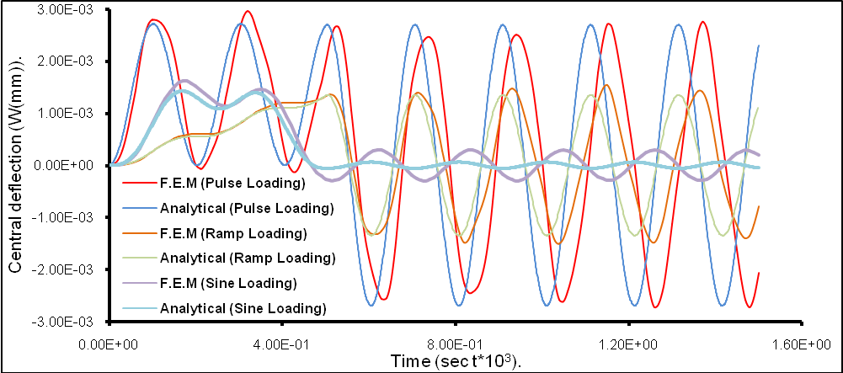

Fig. 6. Central Deflection for Variant dynamic Load for sinusoidal Load (n=4).

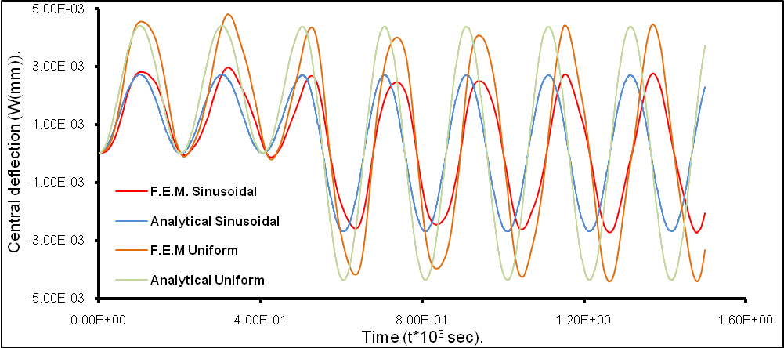

Fig. 7. Central deflection due to Variant d Pulse loading (n=4).

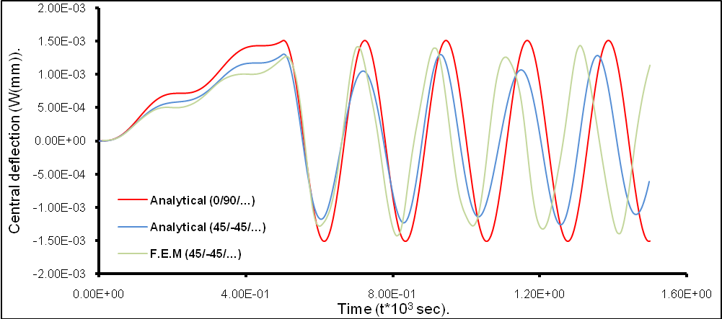

Fig. 8. Central deflection due to Sinusoidal Ramp Loading (n=4).
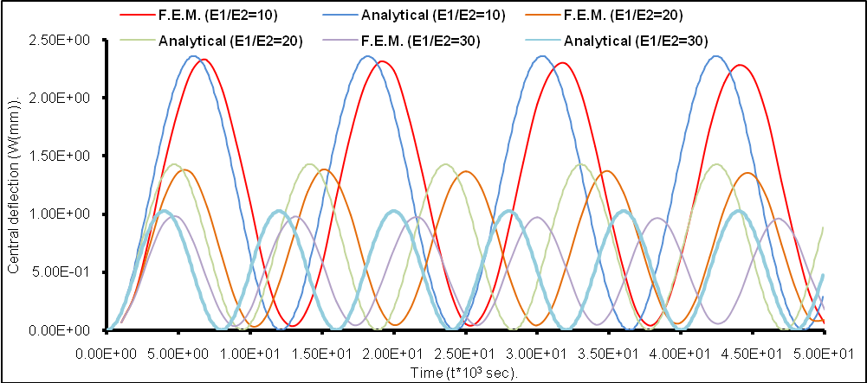

Fig. 9. Central deflection due to Sinusoidal Pulse loading for N=4.

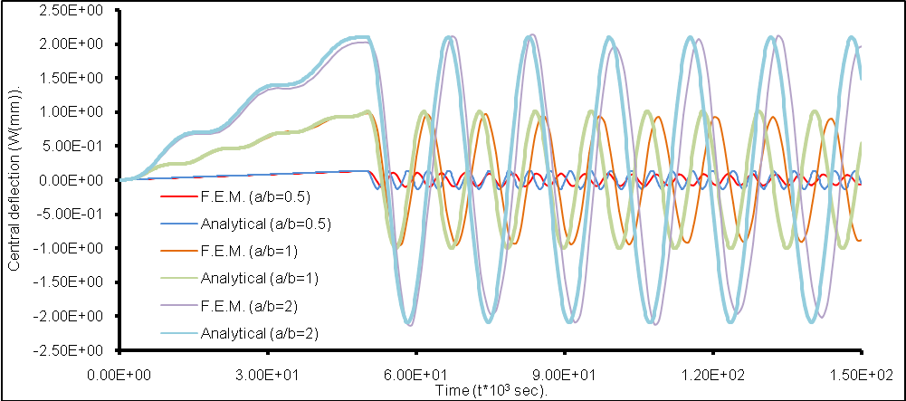

Fig. 10. Central deflection due to Sinusoidal Ramp Loading for (N=4).

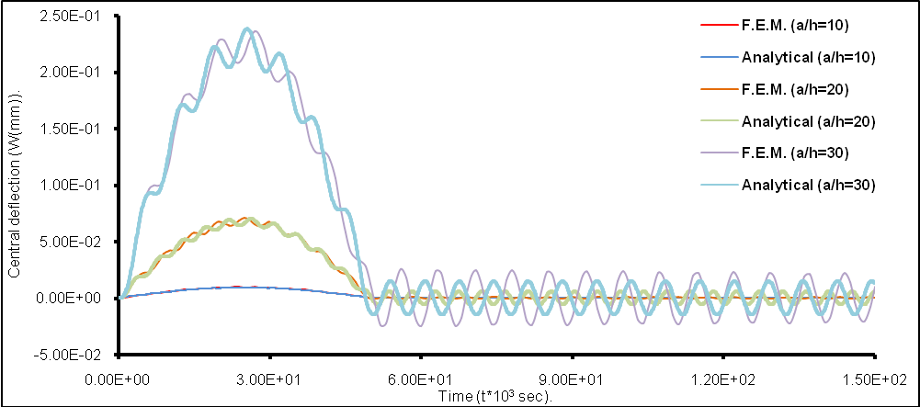

Fig. 11. Central deflection due to Sinusoidal Sine Loading for (N=4)
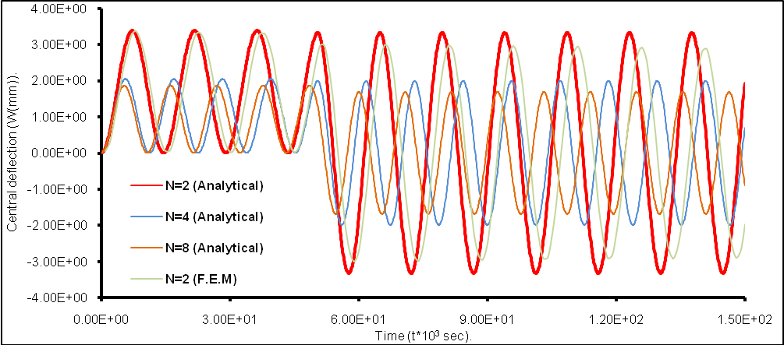

Fig. 12. Central deflection due to Sinusoidal Pulse loading for (0/90/…) plates.

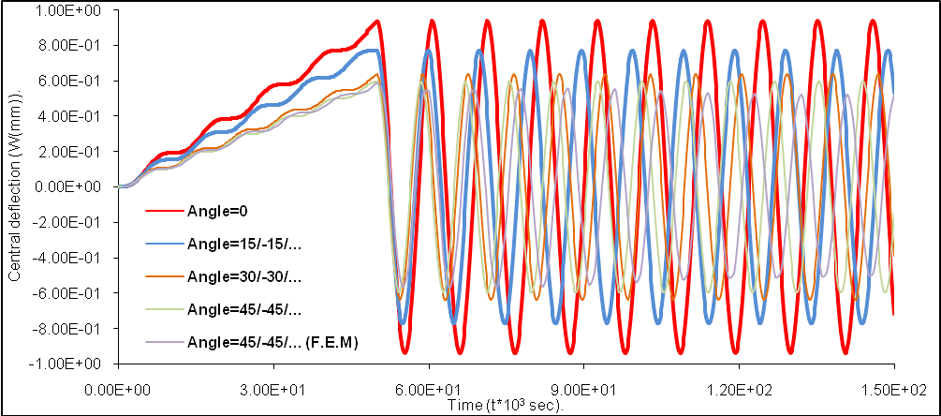

Fig. 13. Central deflection due to Sinusoidal Ramp Loading for (N=6).

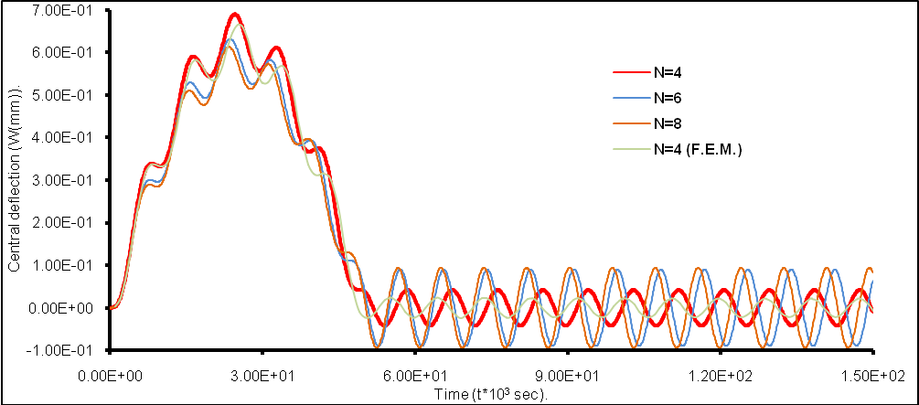

Fig. 14. Central deflection due to Sinusoidal Sine Loading for (θ=45/-45/…).

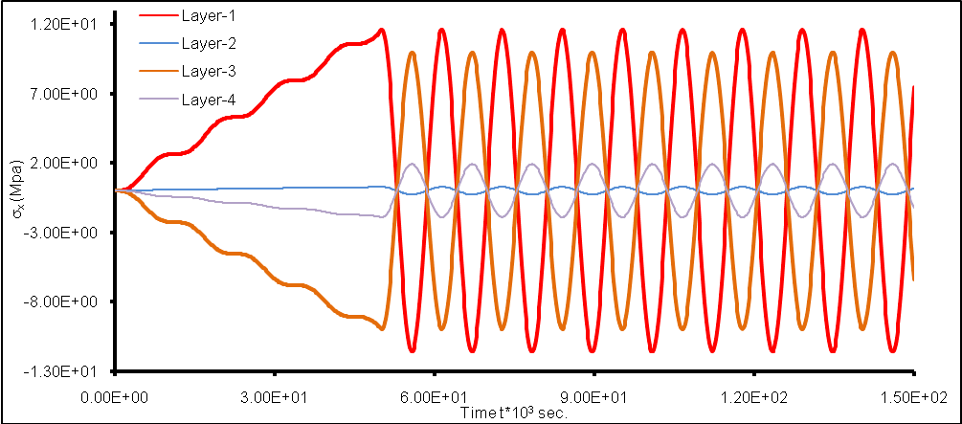

Fig. 15. Stress-x in each Layer due to Uniform Ramp Loading for (N=4).

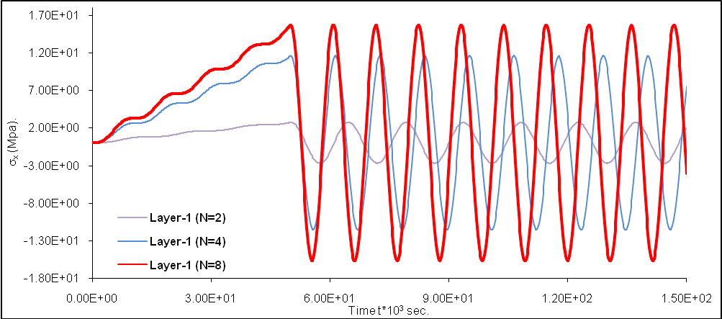

Fig. 16. Stress-x in Layer-1 due to Uniform ramp Loading.

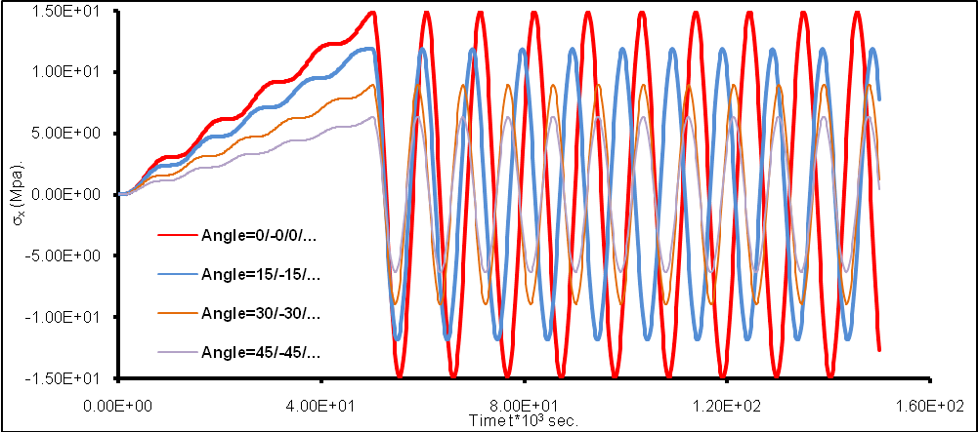

Fig. 17. Stress-x at Layer-1 due to Uniform Ramp Loading for N=4.

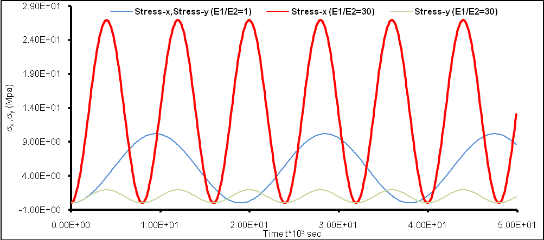

Fig. 18. Stress-x and Stress-y in Layer-1 due to Uniform Pulse loading for N=4.

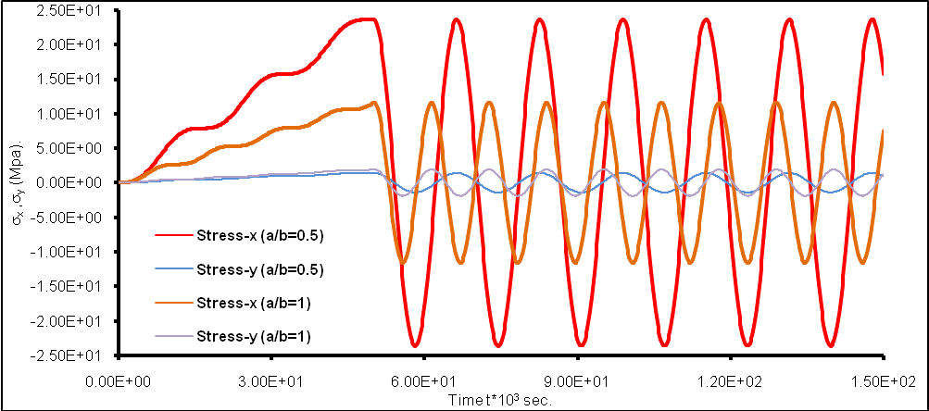

Fig. 19. Stress-x and Stress-y in Layer-1 due to Uniform Ramp loading for N=4.

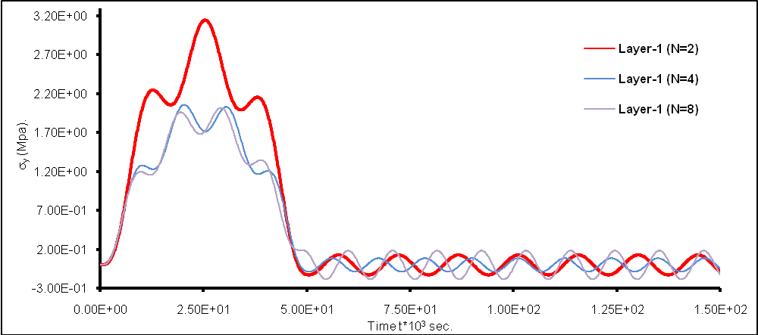

Fig. 20. Stress-y in Layer-1 due to Uniform sine loading.
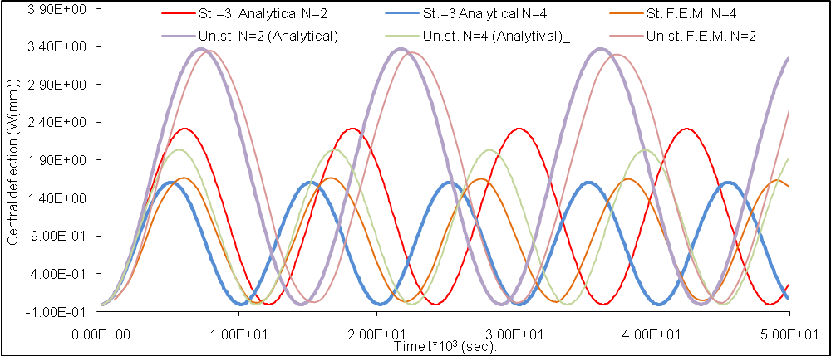

Fig. 21. Comparison of Central Deflection for Stiffened and Un-stiffened Cross-Ply Laminated plates

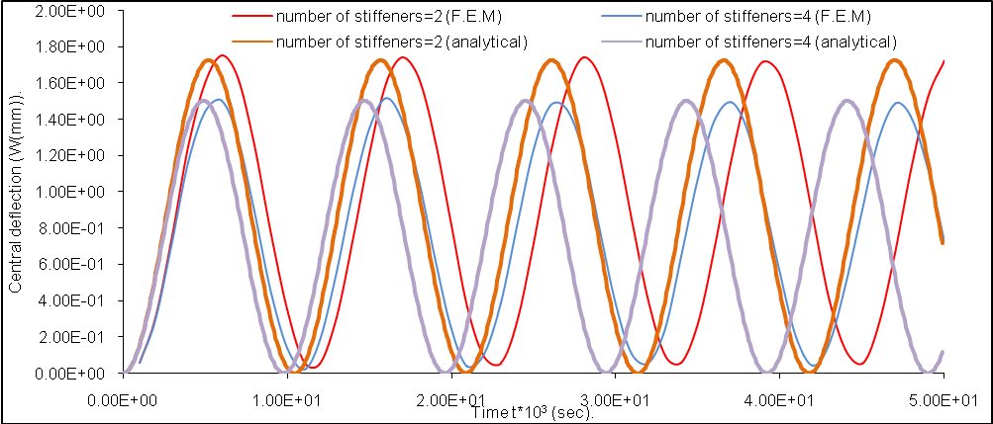

Fig. 22. Central deflection for stiffened Laminated Plates due to sinusoidal pulse loading for cross-ply laminated plates.

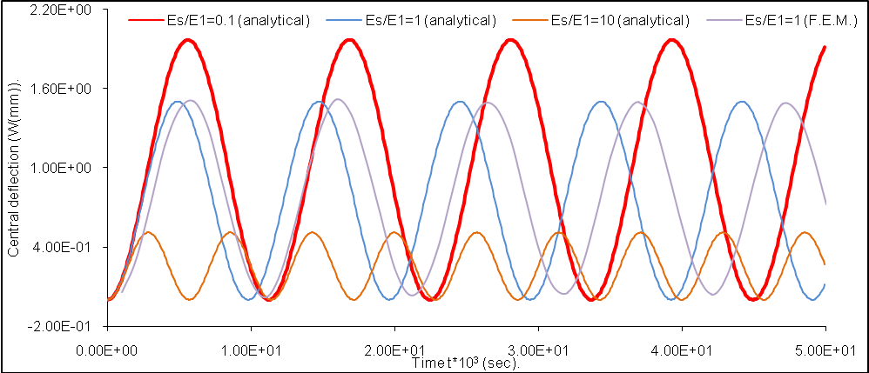

Fig. 23. Central deflection for stiffened Laminated plates due to sinusoidal pulse loading for cross-ply laminated plates.
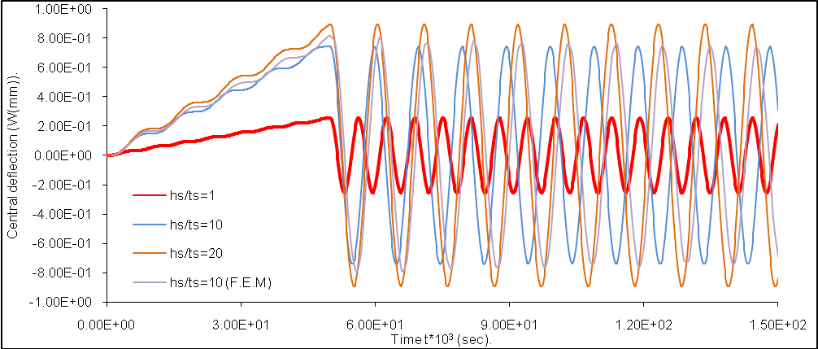

Fig. 24. Central deflection for stiffened plates due to sinusoidal Ramp loading for
cross-ply laminated plates.

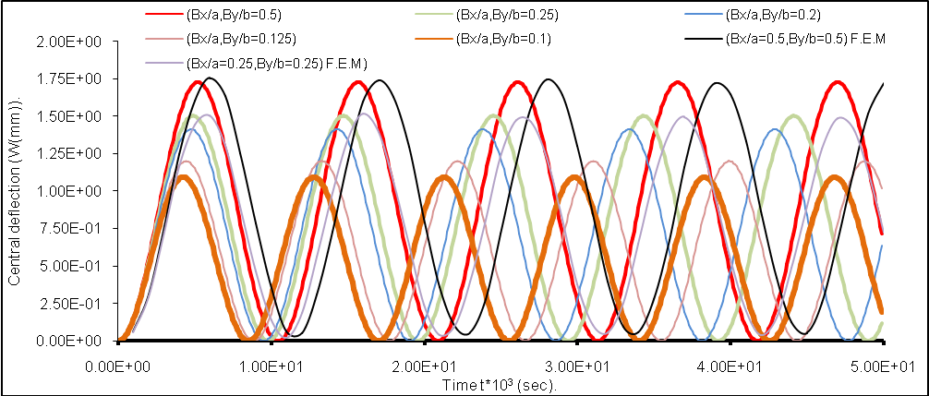

Fig. 25. Central deflection due to Sinusoidal Pulse Loading for stiffened cross-ply laminated plates for N=4 (a/b=1).

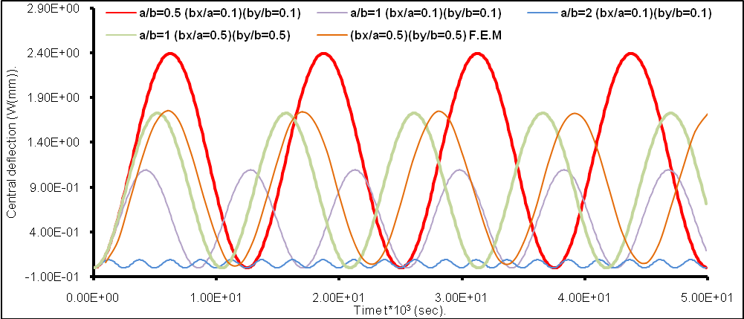

Fig. 26. Central deflection due to Sinusoidal Pulse Loading for stiffened
laminated plates for N=4.
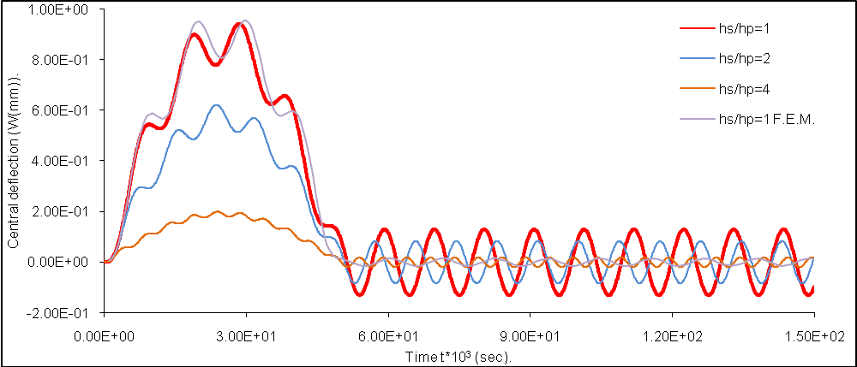

Fig. 27. Central deflection for stiffened plates due to sinusoidal sine
loading for cross-ply laminated plates.
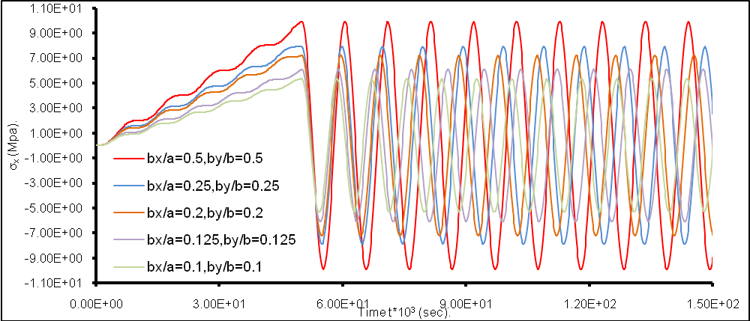

Fig. 28. Stress-x in Layer-1 due to Uniform Ramp loading for
stiffened laminated plates for N=4.

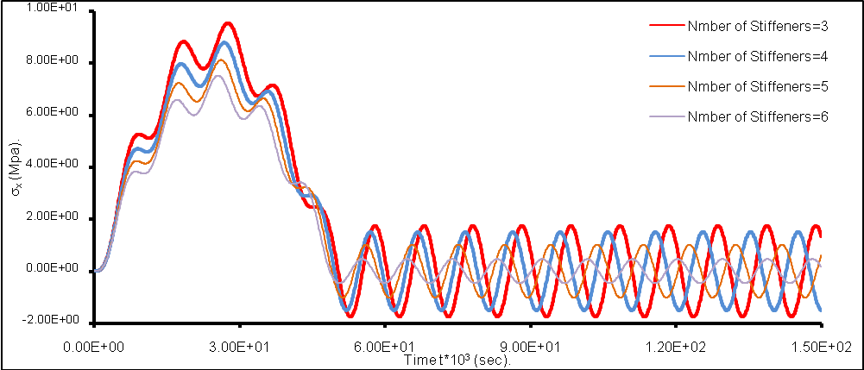

Fig. 29. Stress-x in Layer-1 due to Uniform sine loading for
stiffened laminated plates for N=4.
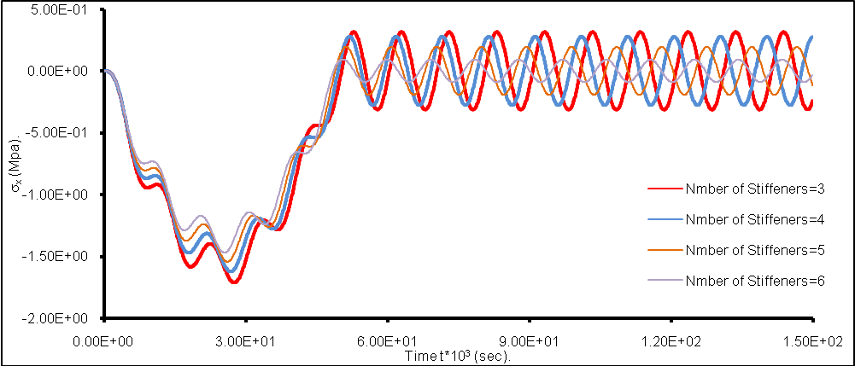

Fig. 30. Stress-x in Layer-4 due to Uniform sine loading for
stiffened laminated plates for N=4.
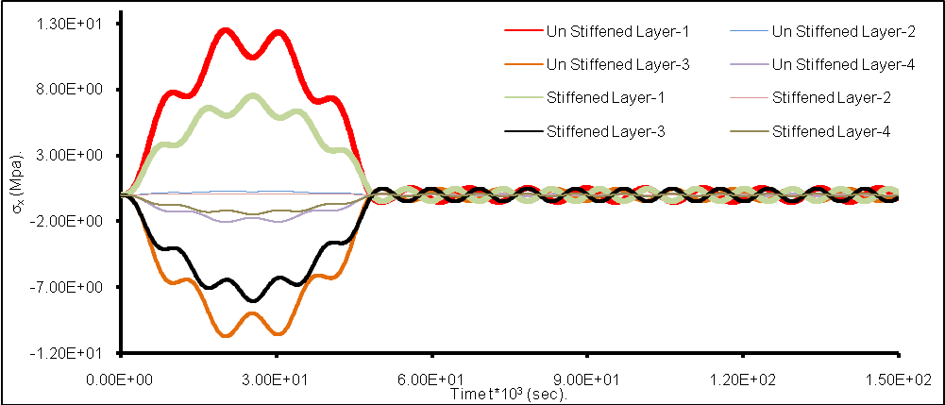

Fig. 31. Stress-x in each Layer due to Uniform sine loading for
stiffened laminated plates for Stiffeners=6.

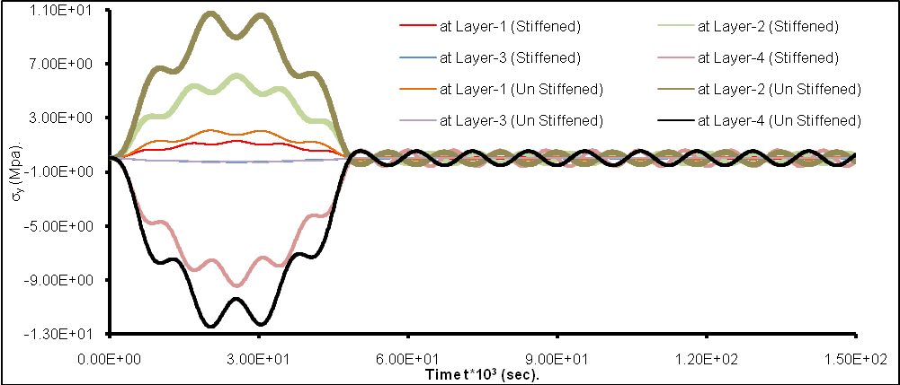

Fig. 32. Stress-y in each Layer due to Uniform sine loading for
stiffened laminated plates for Stiffeners=6.
REFERENCES

Bose, P. and J.N. Reddy (1998) “Analysis of Composite Plates Using Various Plate Theories Part I: Formulation and Analytical Solutions “J. Structural Engineering and Mechanics ,Vol. 6 ,No. 6 , 583-612 .

Cederbaum, G. and Aboudi (1989) “Dynamic Response of Viscoelastic Laminated Plates “ J. sound and Vibration Vol. 133 ,No. 2,8, (September).

Khdeir, A. A. and J. N. Reddy (1991) “Analytical Solutions of Refined Plate Theories of Cross-Ply Composite Laminates “ J. Pressure Vessel Technology ,ASME Vol. 113 ,(November).

Librescu ,L., A. A. Khdeiv and J. N. Reddy (1990) “Further Results Concerning The Dynamic Response of Shear Deformable Elastic Orthotropic Plates” ZAMM. Z. Angew Math. Mech. 70 part 1 ,23-33.

M. Al_Waily "Analysis of Stiffened and Un-Stiffened laminated Plates Subjected to Time Dependant Loading" M.Sc. Thesis Submitted to the Mechanical Engineering Department, College of Engineering, Kufa University, 2005.

Reddy, J. N. and W. C. Chao (1981)“Non-Linear Bending of Thick Rectangular ,Laminated Composite Plates “J. Non-Linear Mechanics ,Vol. 16 ,No. 314.

Reddy, J. N. (1982)“On The Solutions To Forced Motions of Rectangular Composite Plates“ J. Applied Mechanics ,ASME ,Vol. 49

Rao, J. S. (1999)“Dynamics of Plates“ Narosa Publishing House , Book.

Singiresu S.Rao (1995)“Mechanical Vibrations “Addison-Wesley Publishing Book company.

Troitsky, M. S. D.Sc. (1976)“Stiffened Plates Bending, Stability and Vibrations “ Elsevier Scientific Publishing Book Company.

