PREPARATION AND CHARACTERIZATION OF PMMA-ABS BLENDS

Dr Imad Ali Disher Al-Hydary^{A} Dr L. M. Manocha^{B} Dr P. M. George^{C}
Lecturer,
Department of Electrochemical Engineering,
College of Engineering,
University of Babylon,
Babil, Iraq.
Professor and Head,
Department of Materials Science,
Sardar Patel University,
Vallabh Vidyanagar 388 120
Gujarat, India.
Assistant Professor and Head
Department of Mechanical Engineering,
BVM College of Engineering,
Vallabh Vidyanagar 388 120
Gujarat, India.

________________________________________________
ABSTRACT
In order to achieve both the good stiffness and strength, PMMA-ABS blend have been developed. The physical and mechanical properties of PMMA-ABS blend were examined. It has been found that the experimental and theoretical densities of the blend matched perfectly. Rockwell hardness is found to decrease linearly with increasing the ratio of ABS in the blend as ABS is softer than PMMA. However, at ratio of 70% of ABS the hardness was less than that for pure ABS. This is may be due to the effect of partial immiscibility of the two polymers that can be noticed through the visual test. The mechanical properties, i.e. compressive and flexural strength of the blend, found to be enhanced, up to limit, with increasing the ratio of ABS. Moreover, for all these properties, the blend exhibits higher mechanical properties than that for its two constitutes. It has been found that the blend with the ratio of 55% ABS produces the best combination of the stiffness and the strength.

الملخص
بهدف الحصول على مادة لدائنية ذات جساءة ومقاومة عاليتين درست الخواص الفيزيائية والميكانيكية لخليط لدائني مكون من (PMMA-ABS). وجد ان الكثافة النظرية والعملية للخليط المحضر تتطابقان بشكل تام مما يؤشر على جودة ذوبانية مكونات الخليط في بعضهما. وجد ان صلادة روكويل للخليط تنخفض بشكل خطي بزيادة نسبة المكون ABS كونه اكثر ليونة من المكون PMMA. يمتلك الخليط الحاوي على 70% من المكون ABS صلادة اقل من تلك التي يمتلكها ABS نفسه وذلك يعود ربما الى وجود عدم ذوبانية قليلة بين المكونين الامر الذي يمكن ملاحظته من خلال الفحص البصري للخليط. لوحظ ان الخواص الميكانيكية للخليط والتي تشمل مقاومة الضغط ومقاومة الانحناء تتحسن بزيادة نسبة المكون ABS حيث يمتلك الخليط على خواص اعلى من تلك الخاصة لمكونيه. ووجد ان الخليط الحاوي على نسبة 55% من ABS يمتلك افضل جمع بين الجساءة والمقاومة من بين العينات ذات النسب الاخرى.

KEYWORDS
Poly Methyl Methacrylate, Acrylonitrile Butadiene Styrene, Polymers Blend, Mechanical Properties of Polymers.

INTRODUCTION
Poly-methyl-methacrylate (PMMA) polymer is very well-known polymer. It was widely studied and used. It is well known that PMMA has high stiffness, however, it has low mechanical strength especially when it has scratched surface. Acrylonitrile butadiene styrene (ABS) polymers are commonly described as tough and hard. In ABS polymers, the toughness and the impact strength are caused by the presence of butadiene [Basdekis 1964].
Although the concept of blending polymers is not new, in recent years, the interest in polymers blends has been arising again. This is because of the increasing demands for engineering plastics and specialty polymers [Mason 1976 and Olabisi 1979]. When the desired properties for specific demand can be realized by physically blending of two or more polymers, there is an obvious economic advantage. This is due to the fact that the time required to develop a new blend is commonly half of that required for developing new plastics materials [Paul 1978 and Utracki 1989]. Thus, the concept of physically blending of two or more existing polymers to obtain new products or for solving problem is attracting widespread interest and commercial utilization [Cooper 1977].
The comparison of the mechanical properties of the PMMA and ABS shows that each of these polymers has its own advantages which are not available for the other, e.g., the PMMA has superior compression strength and hardness while the ABS have higher flexural strength and fracture toughness.
Based on these notes, the idea of making PMMA-ABS blends have been developed to get the benefits of combining the advantages of the two systems in a new PMMA-ABS blend.

EXPERIMENTAL METHOD
The desired amount of each polymer was dissolved, separately, in acetone at 50°C under stirring with a ratio of 5ml of acetone per 1g of polymer. The two solutions were mixed and stirrered for additional 2 h. Then after, distilled water was added drop by drop to the mixture of the solutions to get paste-like material. The paste was collected and dried in oven at 80°C for 24 h. The dried paste crashed into powder form using mortar and pestle.
The composition of the blend was varied over a wide range of ABS. It was varied to cover 10%, 25%, 40%, 55%, and 70% ABS weight percents.
Hot-pressing method was used to make 5 cm diameter pellets from the blend powders, a steel die and manual hydraulic press with controlled heating unit were used for this purpose. The applied pressure was 11 MPa and the heating rate was approximately 1.5°C/min. After heating up to 165°C, the sample allowed to cool under pressing to 100°C then it was cooled to room temperature using an electric fan.
The samples were cut to the desired dimension using a manual saw followed by surface grinding and polishing using SiC-paper (600 up to 1200) and alumina powder (1, 0.3, and 0.05 µm) respectively.
Scanning electron microscope observation has made on the microstructure of the samples as well as the fractured surfaces after the mechanical testing. The samples were coated with Pt-Pd alloy by Ion Sputter E-1010. Microstructural analysis was performed with S-3000N scanning electron microscopy, SEM (Hitachi, Japan). FTIR test was done for the samples to study the bonding between the two components of the blend using FTIR-8300 spectrometer (Shimadzu, Japan).
In order to get an idea about the defects in the microstructure of the blend, a comparison between the measured and estimated density have been carried out. The experimental density of the samples was measured using Mettler Toledo (AG204, Switzland) densitometer. The theoretical density of the blend (ρ_{B}) was estimated through the density of ABS (ρ_{ABS}), the density of PMMA (ρ_{PMMA}), and the percent of each of them using the following equation:
$ρ_{B}=\frac{1}{\left(\frac{\text{ABS}\text{\%}}{ρ_{\text{ABS}}}\right)+\left(\frac{\text{PMMA}\text{\%}}{ρ_{\text{PMMA}}}\right)}$ (1)

The samples were subjected to ultimate-point compressive and tensile strength measurements using universal test instrument (Instron 5500R, USA) with a 150 kN load cell. Tests were performed on (3 mm x 7 mm x 10 mm) samples at a crosshead speed of 0.5 mm/min in case of compressive test, and (3 mm x 7 mm x 40 mm) bars at a crosshead speed of 0.5 mm/min in case of tensile test with span of 21mm. Ultimate point 3-point bending strength of (3 mm x 7 mm x 40 mm) bars was also measured with a 10 N load cell. The span of the 3-point bending fixture was set at 20 mm. The crosshead speed was set at 0.5 mm/min. The samples were tested for Rockwell Hardness (RHR) using digital Rockwell hardness tester (TRSD M/P, India).
Differential scanning calorimetry (DSC) studies were performed on the prepared blends using Mettler DSC-20 calorimeter to find the effect of the blending on the glass transition temperature of the polymers.

RESULTS AND DISCUSSION
Fig. 1 shows the microstructure of PMMA-ABS blend samples with different ABS content. It can be easily seen that the microstructure composes of two different phases the first appearing like a matrix in which the second phase is implanted. However, it is not true to say that each one of these phases represent one of the two polymers consisting of the blend because each one of them, i.e. PMMA and ABS, have microstructure similar to the observed microstructure of the blend as shown in Fig. 2 This suggests that the observed two phases are not real phases. These virtual phases may develop in the SEM image because of the charging of the surface of the polymeric sample as it is non-conductive materials. When the amount of charging is different, the samples can appeared with different phases. It is well known that the charge accumulates on the hills of the surface rather than its holes.
Fig. 3 shows the FTIR spectra for PMMA-ABS blends, the bands belonging to PMMA were observed as follow:
The bands at 2949 cm⁻¹ and 2937cm⁻¹ belong to methylene stretching vibrations and assigned to asymmetric and symmetric CH₂ stretching vibrations, the bands at 2995 cm⁻¹, 2949cm⁻¹, and 3026 cm⁻¹ are attributed to ester methyl stretching vibrations, and the band at 1732 cm⁻¹ is arise from carbonyl vibration [Lipschitz 1987]. The broad peak ranging from 1260-1000 cm⁻¹ can be
explained owing to the C-O (ester bond) stretching vibration. The broad band from 950-650 cm⁻¹ is due to the bending of C-H [Balamurugan 2004].
The bands belong to ABS were observed as follow:
The main characteristic bands of butadiene (966 cm⁻¹), styrene (1492 cm⁻¹), and acrylonitrile (2237 cm⁻¹) were observed in addition to the peaks of ABS 3060, 1600, 1508, 1452, 825 cm⁻¹ (benzene ring), 2237 cm⁻¹ (^{V}-C≡N) and 1637 cm⁻¹ (^{V}>C=C<), 966, and 754 cm⁻¹ (ω=CH) and 1732 cm⁻¹ (C=O) [Qi 2005, Polli 2009, and Farsani 2009].
By comparing this spectra with that for ABS, Fig.4.A, and PMMA, Fig. 4.B, the following sets of changes in the spectra of blend can be observed:
- The ABS peaks at 1523 cm⁻¹, 1539 cm⁻¹, 1558 cm⁻¹, and 1595 cm⁻¹ got disappeared.
- New peaks at 1878 cm⁻¹ and 3060 cm⁻¹ were observed.
- Shifting of the most peaks of PMMA and ABS and variation in the intensities of absorption bands.
These observations confirm the interaction between the PMMA and ABS functional groups.
Fig. 5 shows a comparison between the experimental and theoretical densities of the prepared PMMA-ABS blends. It is obvious that the experimental and theoretical densities have excellent matching indicating that the micro structure of the blends is free from porosity and cracks. The SEM observations confirm this result.
Differential scanning calorimeter curves of the PMMA-ABS blends containing 55% and 70% ABS are shown in Fig. 6. The blend with 55% ABS exhibits two heat flow changes the first starts at 75.5°C up to 84.3°C with a mid-point of 79.9°C corresponding to the glass transition temperature (Tg) of ABS. The second flow starts at 98.1°C and ends at 106.8°C with a mid-point of 102.5°C corresponding to the glass transition temperature of PMMA. The presence of two glass transition temperatures indicates that the two polymers are not fully miscible with each other. The appearance of the samples confirms this result as the miscible blends are usually clear while the prepared blends were opaque. However, when the ABS% increases up to 70%, the glass transition of PMMA tends to be vanished while that for ABS shifted up to 89.2°C. This indicates that with increasing ABS percent the two polymers tend to be more miscible as the miscible blends exhibit a single Tg intermediate between those of the individual components. However, the zoom of the curves in the area of PMMA glass transition shows the presence of heat flow indicating that the two polymers are not fully miscible.
It has been observed that upon the addition of ABS to the blend, the melting point increases. The melting point of the sample containing 55% ABS is 136.5°C while that for the sample with 70% ABS is 143°C. These values are higher than the melting point of ABS and lower than that of PMMA, and both of them are less than the temperature used in hot pressing process. This confirms that i) the samples were fully melted during the preparation process, and ii) the goodness of miscibility of the two polymers.
Fig. 7 shows the change of Rockwell hardness of the PMMA-ABS blends containing different percent of ABS. It is clearly appeared that Rockwell hardness decreases with the increment of ABS percentage. This is because of the lower hardness of the ABS as compare with PMMA. However, the linearity of the hardness-ABS percent relationship indicates the homogeneity of the prepared blend.
Fig. 8 shows the change in mechanical strength of the PMMA-ABS blends base on the percent of ABS. Compressive strength (Fig.8.A) and flexure strength (Fig.8.B) have nearly the same profile while the tensile strength is different (Fig.8.C). Though such cases are relatively rare, it have been observed that synergistic improvement in properties, exceeding the value for either polymer alone, is achieved by PMMA-ABS blending.
Fig. 9 shows the modulus of elasticity of the PMMA-ABS blends in case of compression, flexural, and tensile loading. Generally, the modulus of the samples increases with increasing the ABS percent indicating the enhancement of the stiffness of the blends. This improvement is due to the interaction between the PMMA and ABS chains, as proved by FTIR and DSC studies, which reduces the movement flexibility of these chains.

CONCLUSION
In the preparation conditions described in this work, PMMA and ABS aren’t fully miscible; however, they have high degree of miscibility and homogeneity. These miscibility and homogeneity have a great effect on the mechanical properties of the blend which shows a synergistic improvement in the mechanical properties. Based on the results of the mechanical tests of the blends, the blend with 55% ABS was found to give the best combination between the stiffness and the strength.

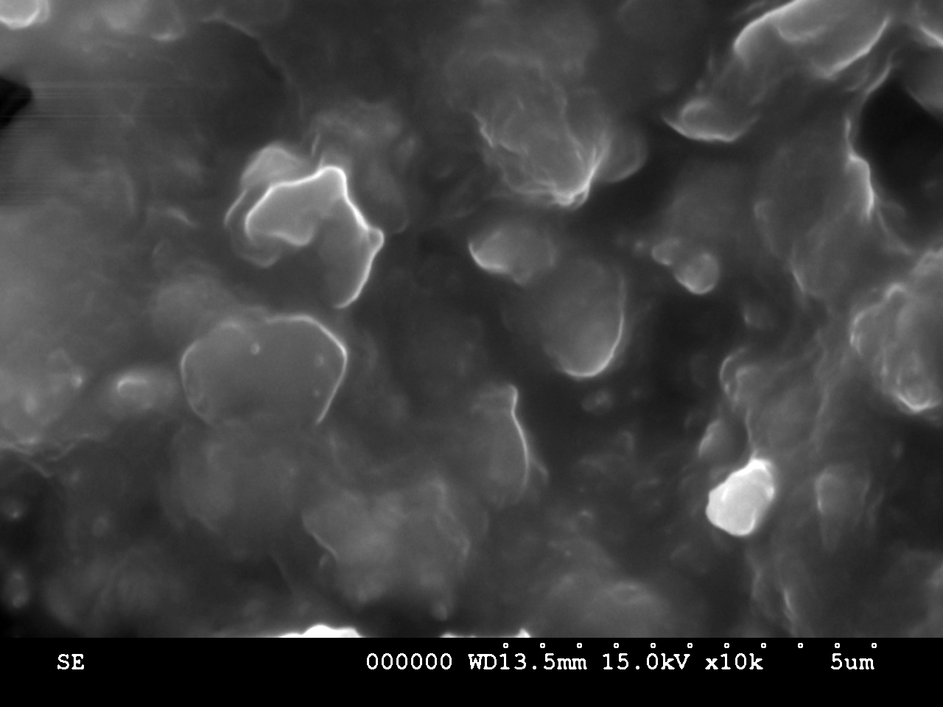
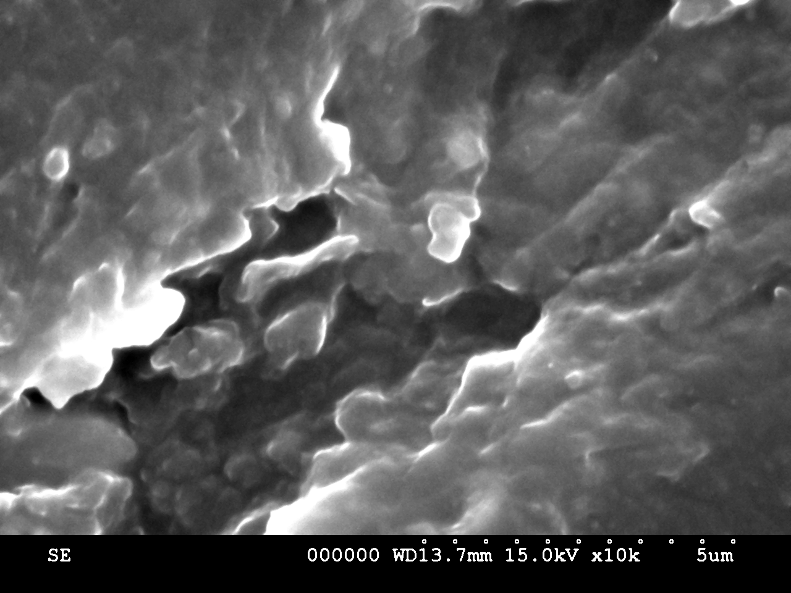
(A)
(B)

Figure 1 SEM images of PMMA/ABS blend containing A) 10% ABS, and B) 70% ABS

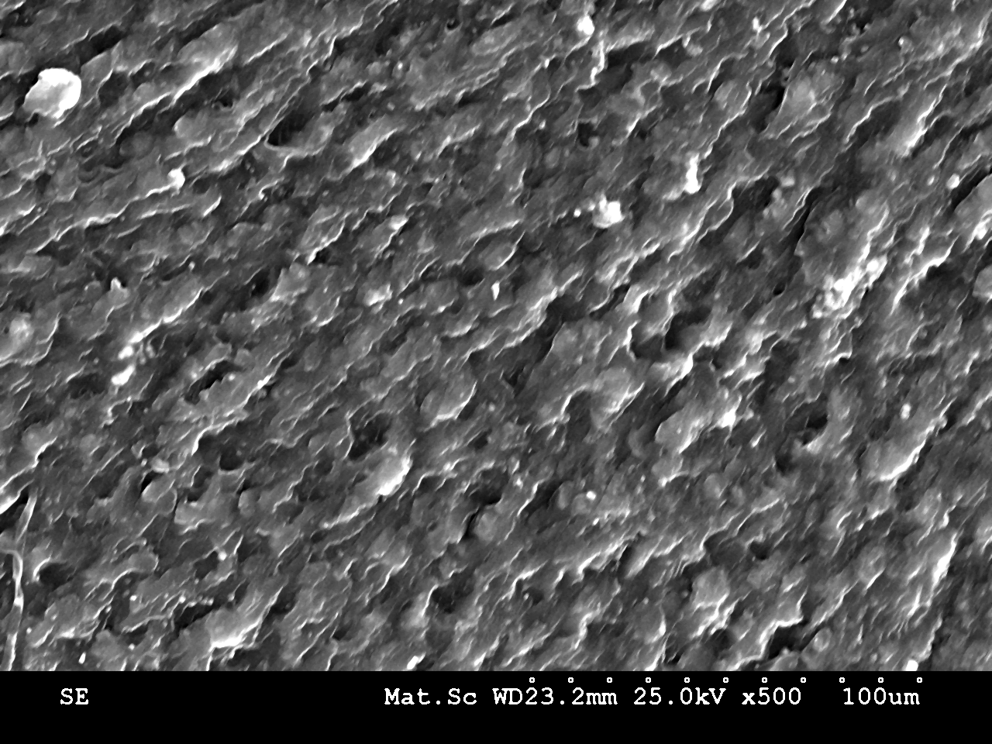
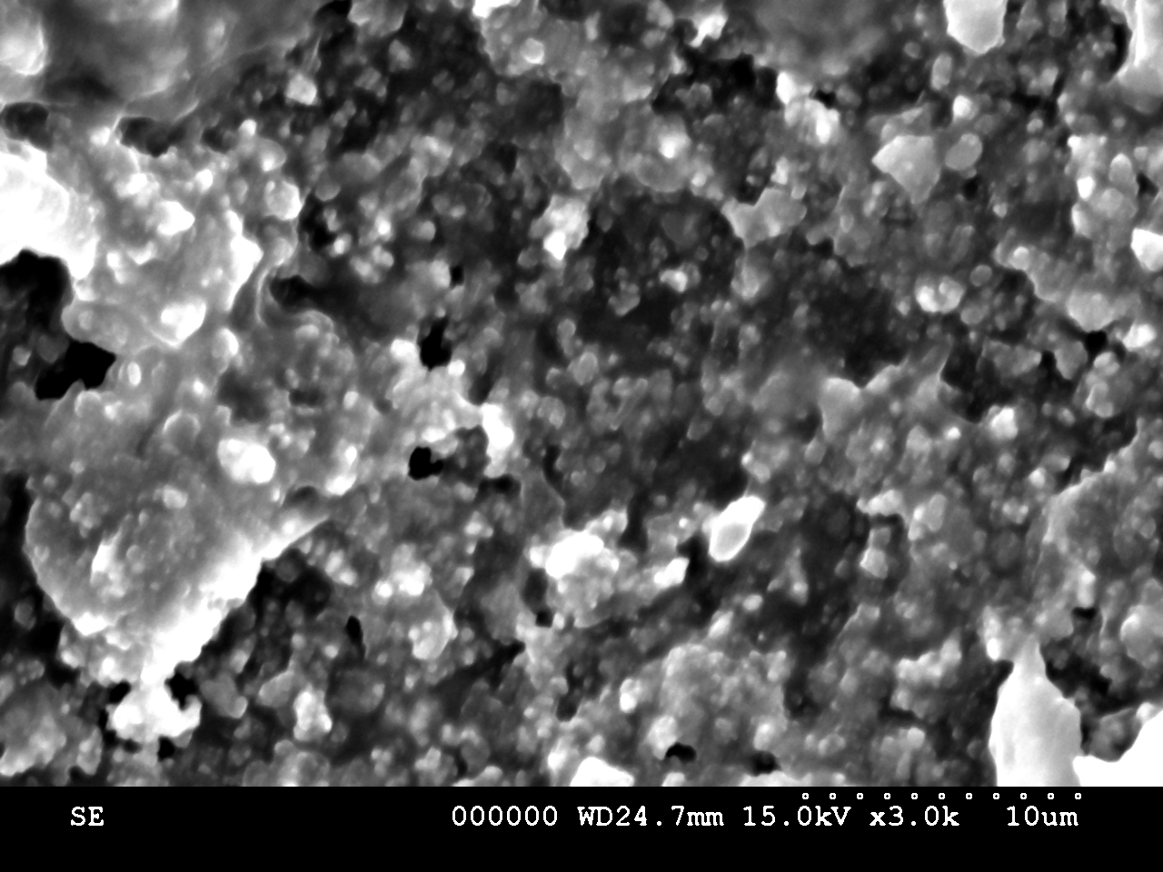
(A)
(B)

Figure (2): SEM images of A) 100% PMMA, and B) 100% ABS
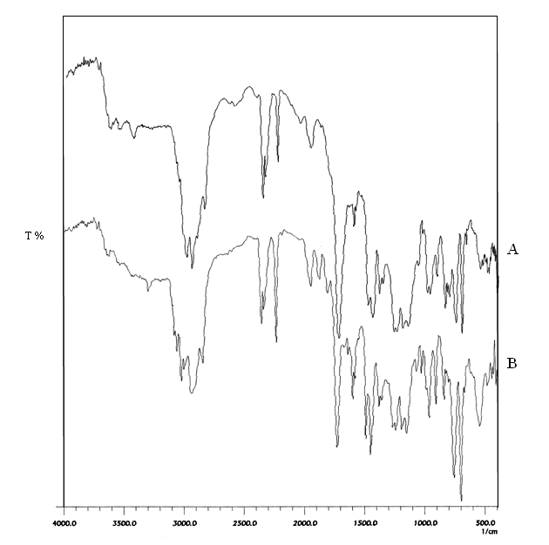

Figure 3. FTIR spectra PMMA-ABS blends with A) 10 ABS%, and B) 70% ABS

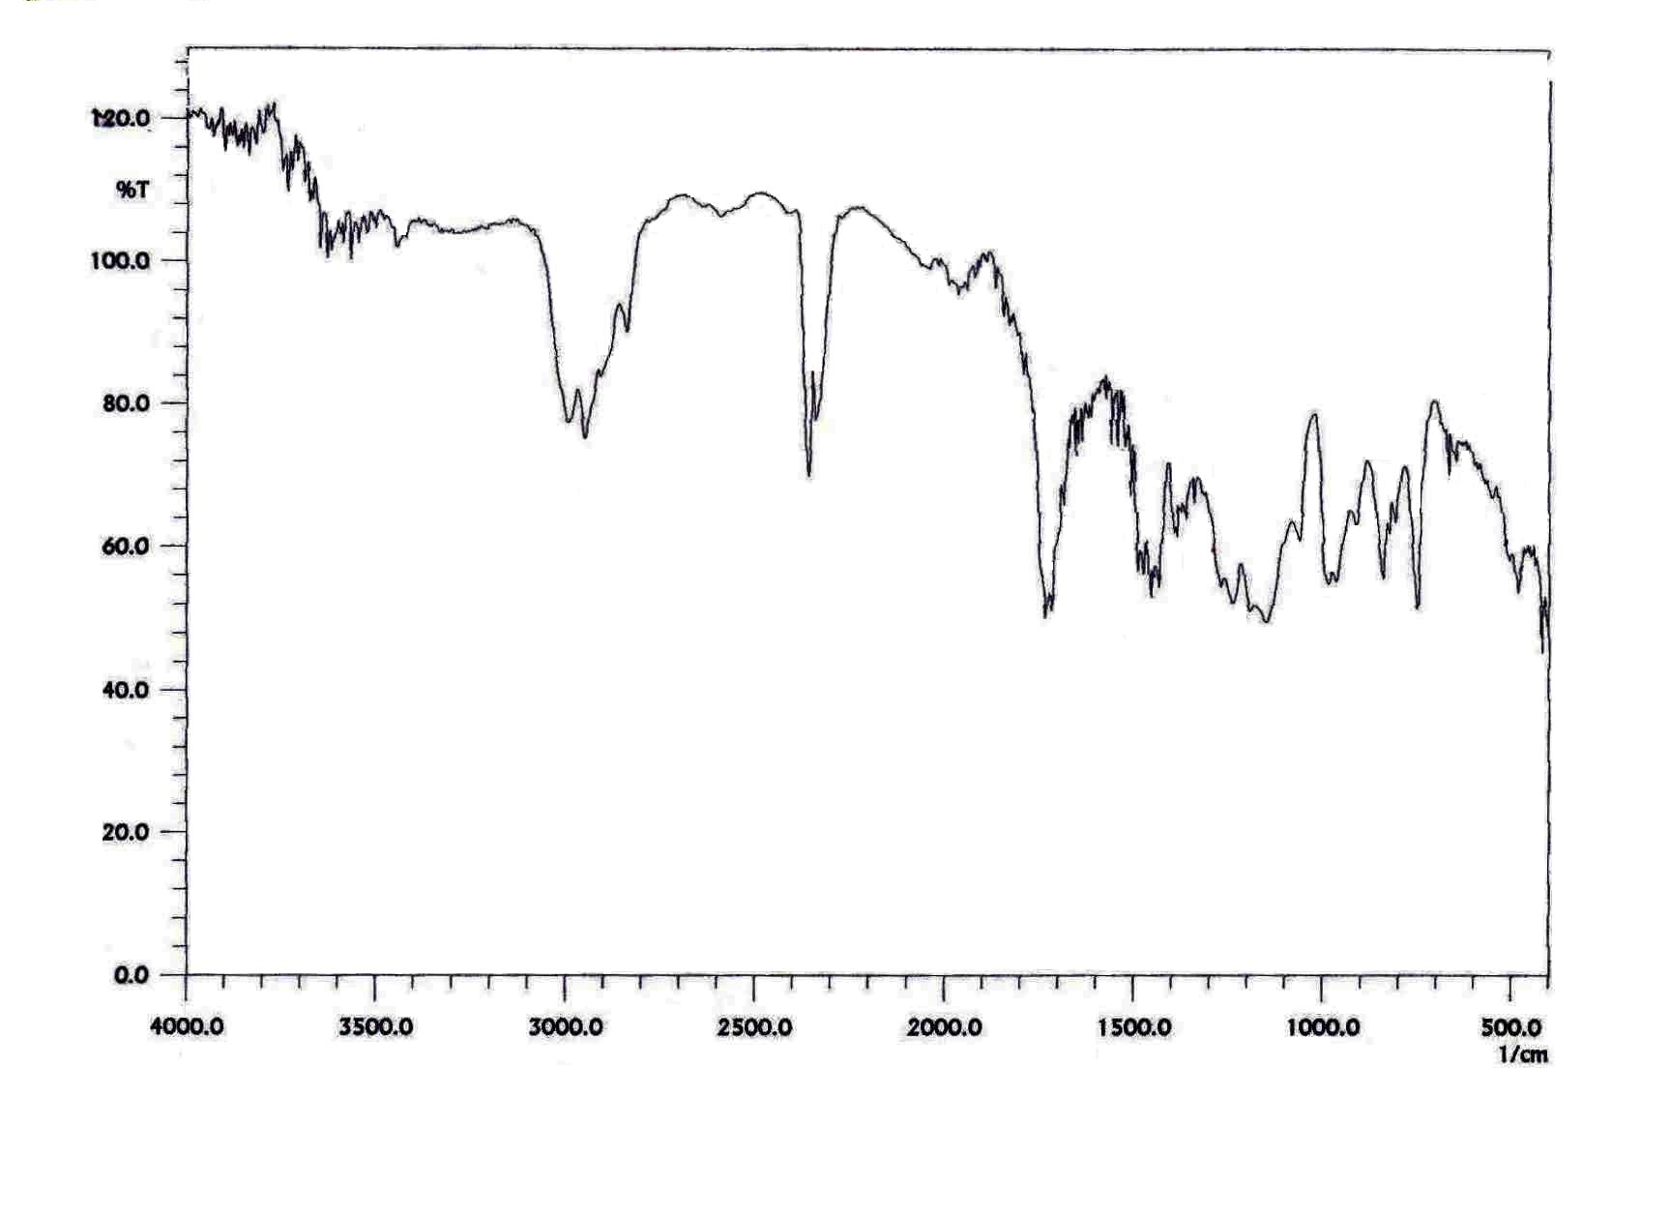
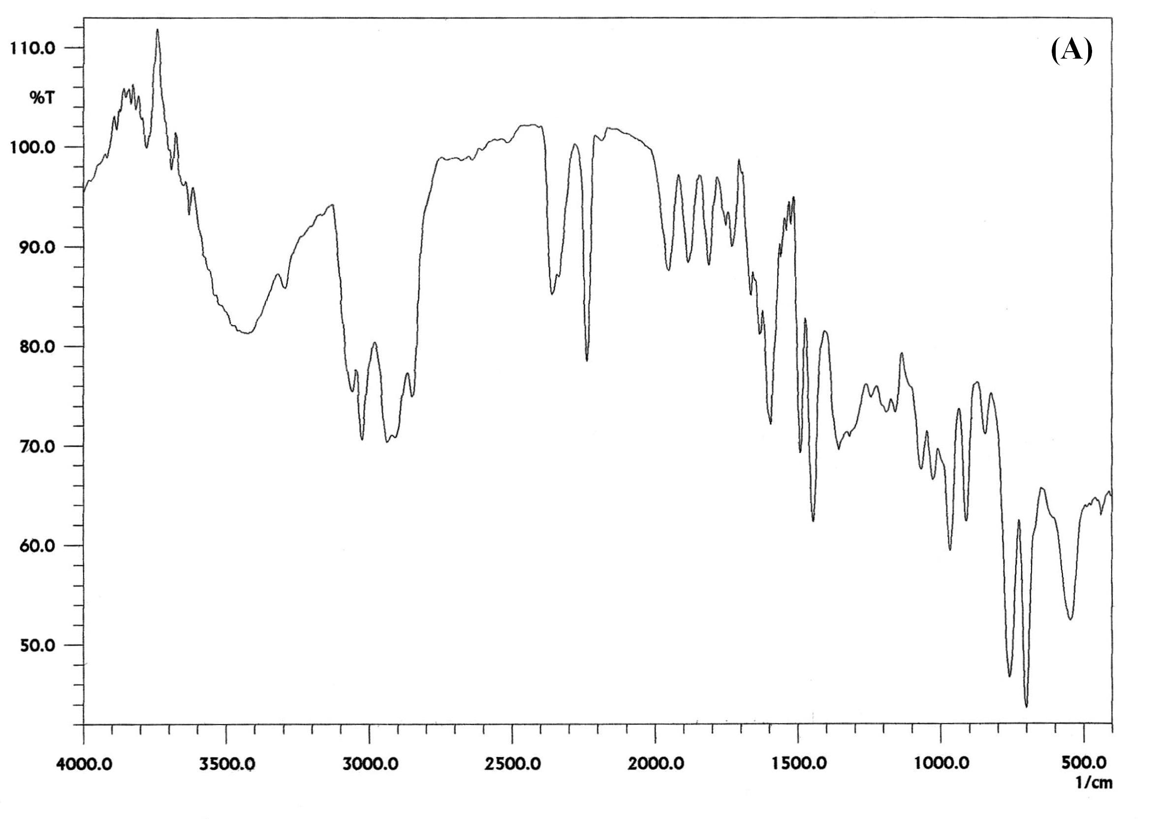
(B)

Figure (4): FTIR spectra of A) 100 ABS%, and B) 100% PMMA

Figure (5): Variation of experimental and theoretical densities of PMMA-ABS blends with ABS percentage
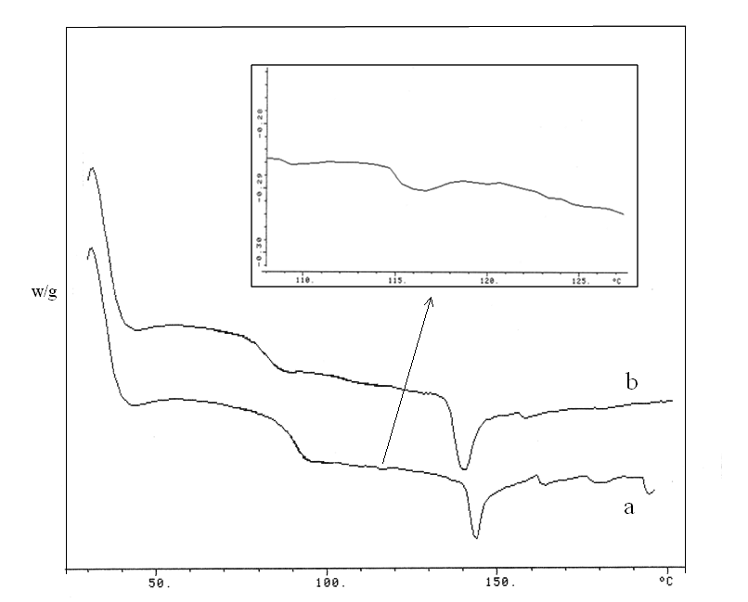
Figure (6): DSC thermograms for PMMA-ABS blend containing: a) 55% ABS and b) 70% ABS.
Figure(7): The R-scale Rockwell hardness (RHR) of the PMMA-ABS blends

Figure (8):Mechanical strength of PMMA-ABS blends A) Compressive strength, B) Flexure strength, and C) Tensile strength
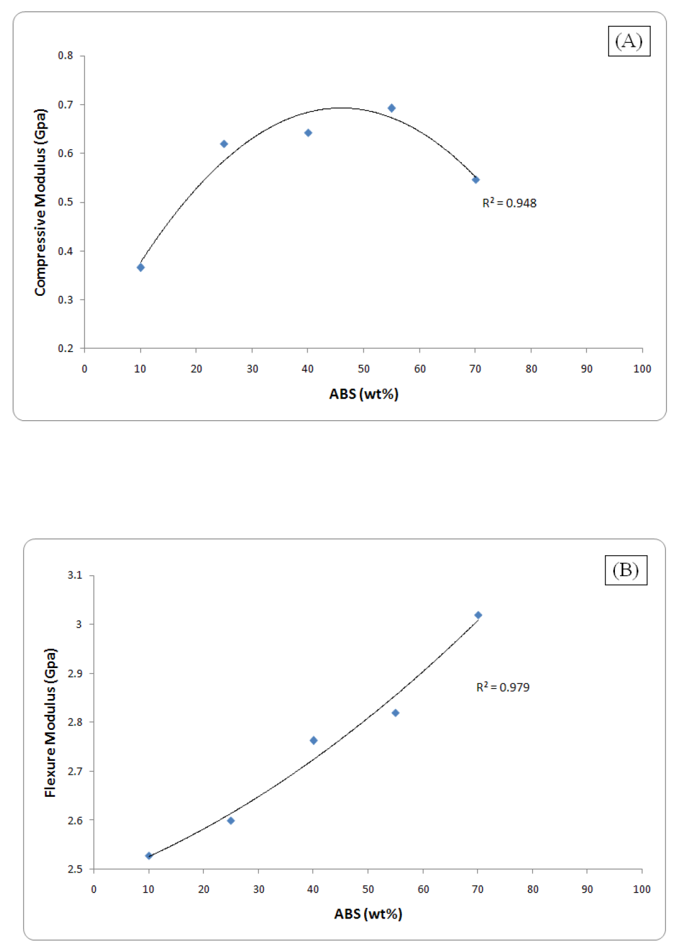

Figure (9): Modulus of elasticity of PMMA-ABS blends in case of A) Compressive, B) Flexure, and C) Tensile

REFERENCES
Balamurugan A., S. Kannan, V. Selvaraj and S. Rajeswari, Trends Biomater. Artif. Organs, 18 (1), 41-45 (2004).

Basdekis C. H., ABS Plastics, Van Nostrand Reinhold, New York. (1964).

Cooper S. L., G. M. and Estes eds., Multiphase Polymers, Adv. Chem. Ser., 176: pp 367, (1977).

Farsani R. E., S. Raissi, A. Shokuhfar, and A. Sedghi, World Academy of Science, Engineering and Technology, 50: pp 430-433, (2009).

Lipschitz I., Polym-Plast Technol Eng., 19, 53 (1982).

Mason J. A., and L. H. Sperling, Polymer Blends and Composites, Plenum Press, New York, (1976).

Olabisi O., L. M. Robeson, and M. T. Snow, Polymer–Polymer Miscibility, Academic Press, New York, (1979).

Paul D. R., and Neuman S. eds., Polymer Blends, Vols. 1 and 2, p. 201. Academic Press, New York, (1978).

Polli H., L. A. M. Pontes, A. S. Araujo, J. M. F. Barros, and V. J. Fernandes, Journal of Thermal Analysis and Calorimetry, 95 (1): pp131–134, (2009).

Qi R., Z. Chen, C. Zhou, Polymer, 46: pp4098–4104, (2005).

Utracki L. A., Polymer Alloys and Blends, Hanser Publishers, Munich, Germany, (1989).

