___________________________________________________
PREDICTING OF TORSIONAL STRENGTH OF REINFORCED CONCRETE BEAMS USING ARTIFICIAL NEURAL NETWORK
Abdalkader A. Mohammed Assistant lecturer, Dept. Of Civil Engineering, Mosul University
Email: - abdnwsa2010@gmail.com.
__________________________________________________
ABSTRACT
In this paper, the artificial neural networks (ANNs) model in predicting the torsional strength of reinforced concrete (RC) beams is done. Experimental data of 85 rectangular RC beams under pure torsion from an existing database in the literature were used to develop ANN model. The input parameters affecting the torsional strength were selected as dimensions of beams, spacing of stirrups, dimensions of closed stirrups, yield strength of stirrup and longitudinal reinforcement, steel ratio of stirrups, steel ratio of longitudinal reinforcement and concrete compressive strength. A back propagation neural network (BPNN) with the log-sigmoid activation function is adopted due to its accuracy of prediction. In addition to the ANN model is compared with well-known the building codes provisions for the design of RC beams under pure torsion. The study shows that the ANN models give reasonable predictions of the ultimate torsional strength of RC beams better than existing equations for torsion.
KEY WORD: Artificial neural network, Back propagation, Reinforced concrete beam, Torsional Strength.
التنبؤ بمقاومة اللي للعتبات الخرسانية المسلحة بأستخدام
الشبكات العصبية الاصطناعية
عبد القادر علي محمد
مدرس مساعد /قسم الهندسة المدنية
جامعة الموصل
الخلاصة
في هذا البحث تم عمل نموذج الشبكات العصبية الاصطناعية (ANNs) للتنبؤ بمقاومة اللي للعتبات الخرسانية المسلحة. تم استخدام النتائج العملية لـ85 عتبة خرسانية مسلحة مستطيلة المقطع تحت حمل اللي الصرف من الدراسات السابقة لتطوير نموذج الشبكات العصبية. المعاملات المدخلة المؤثرة على مقاومة اللي هي ابعاد العتبات، المسافات بين حلقات تسليح القص، ابعاد حلقات تسليح القص المغلقة، اجهاد الخضوع لحلقات تسليح القص والتسليح الطولي، نسبة تسليح حلقات القص والتسليح الطولي، ومقاومة انضغاط الخرسانة. تم اعتماد الشبكة العصبية ذات الانتشار الخلفي مع دالة التفعيل من النوع (log-sigmoid) وذلك لدقتها في التنبؤ. بالاضافة الى ذلك نموذج الشبكة العصبية قورن مع معادلات المدونات العالمية لتصميم العتبات الخرسانية المسلحة تحت اللي الصرف. هذه الدراسة بينت انه نموذج الشبكات العصبية يعطي تنبؤ موثوق لمقاومة اللي القصوى للعتبات الخرسانية المسلحة افضل من المعادلات الموجودة للي.
الكلمات الدالة: الشبكات العصبية الاصطناعية، الانتشار الخلفي، العتبات الخرسانية المسلحة، مقاومة اللي.
1. INTRODUCTION
Torsional moment develops in structural concrete members as a result of asymmetrical loading or member geometry, or as a result of structural framing. For example, spandrel beams built integrally with the floor slab are subject to torsional moment resulting from the restraining negative bending moment at the exterior end of the slab.[ Khaldoun 2006] The restraining moment is proportional to the torsional stiffness of the spandrel beam. In complex structures such as helical stairways, curved beams, and eccentrically loaded box beams, torsional effects dominate the structural behavior. Torsional moment tends to twist the structural member around its longitudinal axis, inducing shear stresses. However, structural members are rarely subjected to pure torsional moment. In most cases, torsional moments act concurrently with bending moment and shear forces. As shown in Fig. 1.
During the first half of the twentieth century, structural codes were silent regarding torsion design. Torsion was looked at as a secondary effect that was covered in the factor of safety considered in the design. Demand for more complex structures, improved methods of analysis, new design approaches, and the need for more economical design required a better understanding of the behavior of reinforced concrete members subjected to torsion. In the second half of the twentieth century, research activities helped engineers understand many aspects of behavior of concrete members under torsion.[ Mahmoud 2005]
Many application of neural networks in civil engineering, Vanluchene and Sun, proposed the first prototype application of neural networks as a tool for structural design in 1990 (Vanluchene and Sun, 1990). Several applications of neural networks in civil engineering problems such as: modeling the capacity of pin-ended RC columns [Chuang 1998], prediction of shear strength of RC deep beams [Sanda 2001], size effect on shear strength of reinforced concrete beams [Andres 2004], predicting structural properties of Elasto-Plastic plates [Abdul-Razzak 2006], predicting nonlinear response of uniformly loaded fixed plates[Abdul-Razzak, 2007], predicting thickness of rectangular plates[Abdul-Razzak 2008], parameter identification in elasto-plastic plates[Yousif 2009], and prediction of strength of concrete mix [Yousif 2009].
In this paper the principal aims are to develop multi-layered feed-forward neural networks trained with the back propagation algorithm to model the nonlinear relationship between different influencing parameters and the torsional strength of reinforced concrete beams, and to conduct a parametric study to establish the importance of different input parameters on the behavior of reinforced concrete beams under pure torsion load using the trained ANN.
2. TORSIONAL STRENGTH OF REINFORCED CONCRETE BEAMS
According to the current torsion provision of ACI-318-2008, meaningful additional torsional strength T_{n} of RC beams can be achieved only by using both closed stirrups and longitudinal steel bars while the torsion moment resisted by the concrete compression struts is assumed as zero. Thus the concrete contribution is ignored; there is no advantage in using higher concrete strengths in resisting ultimate torsion. The torsional strength T_{n} is given as follows:
(1)
In the eq. (1) cotθ can be assumed as
(2)

(3)
(4)
(5)

In eqs. (1) and (2), A_{o} is the gross area enclosed by the shear flow path that can be equal to 0.85 A_{sh}, where A_{sh} is the area enclosed by the center of stirrups, θ is the angle of compression diagonals, f_{yl} is the yield strength of longitudinal torsional reinforcement, f_{yv} is the yield strength of closed stirrups, A_{l} is the total area of longitudinal torsional reinforcement, p_{h} is the perimeter of centerline of outmost closed transverse torsional reinforcement, s is the spacing of stirrups and A_{t} is the cross-sectional area of one-leg of closed stirrup.
According to the European Standard Eurocode-2002, torsional strength shall be calculated with three ways and the minimum result is chosen.
3. NEURAL NETWORK MODELING BACKGROUND
Multilayer feed-forward neural network model is the most widely used network for its efficient generalization capabilities [Andres 2004, Abdul-Razzak 2006, and Yousif 2009]. Fig.2 presents typical multi-layer feed-forward neural networks.
This type of neural network consists of an input layer, one or more hidden layer(s) and an output layer. Layers are fully connected by arrows, and comprise a number of processing units, the so-called nodes or neurons. The strength of connections between neurons is represented by numerical values called weights. Each neuron has an activation value that is a function of the sum of inputs received from other neurons through the weighted connections [Abdul-Razzak 2006, Sanda 2001]. The optimum number of hidden layers and the number of neurons in each hidden layer is problem specific. Therefore, trial and error should be carried out to choose an adequate number of hidden layers and the number of neurons in each hidden layer [Gomes 2004, Yousif 2007].
A Back propagation is the most successful and widely used in neural network applications. In this method, the input is propagated from the input layer through the hidden layers to the output layer. The network input is connected to every neuron in the first hidden layer while each network output is connected to each neuron in the last hidden layer. In this case this would call full connection ANN. The network weights were originally set to random values and new values of the network parameters (weights) are computed during the network training phase. The neurons output are calculated using
(6)
Where O_{i} is the output of the neuron i, I_{j} are the input of j neurons of the previous layer, W_{ij} are the neuron weights, b_{i} is the bias for the modeling show (Equ.5), and F is the activation function. The activation function is the portion of the neural network where all the computing is performed. The activation function maps the input domain (infinite) to an output domain (finite). The range to which most activation functions map their output is either in the interval [0, 1] or the interval [-1, 1]. There are several activation functions used over the years, however, the most common activation functions belong to five families as follows [14,15]: (1) linear activation function; (2) step activation function; (3) ramp activation function; (4) sigmoid activation function; and (5) Gaussian activation function. Figure 2 shows a typical neural network with one hidden layer.
The network error is then back propagated from the output layer to the input layer in which the connection weights are adjusted. This process is repeated until the error is minimized to a preference level [Chuang, 1998]. The error incurred during the learning can be expressed as Mean squared error and is calculate using Eq. (2)
(2)
(7)

Where t is the target value, y is the output value.
4. NEURAL NETWORK DESIGN and TRAINING
The use of ANN provides an alternative way to estimate torsional strength of RC beams. In this work 85 sets of data were extracted from experimental tests conducted by Previous Publishing papers [Hsu1968, Rasmussen 1995, Koutchoukali 2001, Fang 2004]. The test specimens were of solid rectangular beams which were subjected to pure torsion and none of them were deep beams. The ranges of torsional strength of samples are 9.0 to 239.0 kN.m, while those of input data are shown in Table1. To train the ANN models, first, the entire training data file is randomly divided into training and testing data sets. 72sets were used to train the different network architectures. The remaining 13 patterns were used for testing to verify the prediction ability of each trained ANN model. As shown in Table (2). The multi-layer feed forward back-propagation technique is implemented to develop and train the neural network of current study where the sigmoid transform function adopted. A good prediction for these cases is the ultimate verification test for the ANN models. These tests have to be applied for (input and output) response within the domain of training. Preprocessing of data by scaling was carried out to improve the training of the neural network. To avoid the slow rate of learning near the end points specifically of the output range due to the property of the sigmoid function, the input and output data were scaled between the interval 0.1 and 0.9. The scaling of the training data sets was carried out using the following equation:
(3)

The back-propagation learning algorithm was employed for learning in the MATLAB program [MATLAB R2009b]. Each training of the network consisted of one pass over the entire 85 training data sets. The 13 testing data sets were used to monitor the training progress. Different training functions available in MATLAB program were experimented for the current application. The scaled conjugate gradient (SCG) techniques built in MATLAB proved to be efficient training function, and therefore, was used to construct the NN model. This training function is one of the conjugate gradient algorithms that start training by searching in the steepest descent direction (negative of the gradient) on the first iteration. The network architecture or topology is obtained by identifying the number of hidden layers and the number of neurons in each hidden layer. The network learns by comparing its output for each pattern with a target output for that pattern, then calculating the error and propagating an error function backward through the neural network. To use the trained neural network, new values for the input parameters are presented to the network. The network then calculates the neuron outputs using the existing weight values developed in the training process. Table 2 shows the properties (architectures and parameters) of ANN model.

5. ARCHITECTURE OF NEURAL NETWORK
In this work a multilayered feed-forward neural network with a back-propagation algorithm was adopted. The ANN was developed using the popular MATLAB software package [MATLAB R2009b]. To train the ANN models, first the entire experimental data file was randomly divided into training and testing data sets. The seventy-two patterns were used to train the different network architectures. The remaining thirteen patterns were used for testing to verify the prediction ability of each trained ANN model. The network model was constructed. The model has six input parameters and one output parameter.
The rationale behind this is to study the significance of parameter on torsional strength of reinforced concrete beams. The models has two hidden layers with twelve nodes each, and output layer with one node giving torsional strength of reinforced concrete beams. Since the sigmoid function is used as transfer function, the inputs as well as the output are scaled in the range of (0.1–0.9). The convergence of the models in training is based on minimizing the error of tolerance for mean squared (MSE) error during the training cycles and monitoring the overall the performance of the trained networks by comparing the outputs. The architecture of the developed ANN model and its properties are shown in Table (2).
6. RESULTS AND DISCUSSION
The predictions of the ANN model as compared to the experimental values are shown in Fig. 3 for both training and testing data set. The coefficient of correlation (R) was equaled to 0.98, and 0.96 for both training and testing data set, respectively. Table (3) represents the details of test data which used in ANN model and the ratio of experimental torsional strength (Exp.) with computed values from analytical equations ACI-model, and EUR-model. In addition to suggested ANN model. The accuracy of the predicted ANN values of the torsional strength is shown in Fig. (3a-b), this model, predict the training sets and testing sets quite well. The coefficients of correlation (R) were equaled to 0.96, 0.9 and 0.73 for the ANN model, ACI model, and EUR model, respectively. Also the indexes of determinate (R2) were equaled to 0.9, 0.7, and 0.8 for the ANN model, ACI model, and EUR model, respectively. In addition to the coefficient of variation (COV) was equaled to (0.21) for the ANN model, compared to COV equal to 0.44 and 0.27 for the ACI model, and EUR model, respectively, and the standard deviation was equal to (0.27) for the ANN model, compared to COV equal to 0.5 and 0.25 for the ACI model, and EUR model, respectively. From these results, it can be seen that the neural network model predict the torsional strength more accurately than other two models and concluded that the neural network model can successfully predicted the torsional strength for reinforced concrete beams. On the other hand, the ANN model shows least scattering of the results.

7. PARAMETRIC STUDY
One of the advantages of neural network models is that parametric studies can be easily done by simply varying one input parameter and all other input parameters are set to constant values. Through parametric studies, it can verify the performance of model in simulating the physical behavior of reinforced concrete beams, due to the variation in a certain parameter values.
7.1. Effect of Beam Depth.
The effect of beam depth on torsional strength is illustrated in the Fig. (4). Regardless of other parameters the figure show that the torsional strength of the reinforced concrete beams increases in (45%) with increasing the beam depth from 300 mm, to 500mm for the compressive strength was equaled to 20MPa. Also the figure indicated that the increases rate of the torsional strength which reach (19%) when the compressive strength of the beam changes from 20MPa, to 50MPa, for the beam depth equal to (300mm). This fact is due to the effect of slender coefficient becomes clearer when the depth increased.
7.2. Effect of Main Reinforcement Ratio (ρ_{l}).
Fig. (4) Shows the effect of main reinforcement ratio on the torsional strength of the reinforced concrete beams. The range of main reinforcement ratio values were 1.0% to 3%, and the range of compressive strength values were 20 to 50MPa. It can be seen that the torsional strength increase with increasing the main reinforcement ratio, and its effects become more obvious as the main reinforcement ratio increases. When the main reinforcement ratio increases from 1.0% to 3%, the torsional strength increases by (42%) for compressive strength equal to 20MPa, while torsional strength increase in rate (20.3%) when the compressive strength of the beam changes from 20MPa, to 50MPa, the main reinforcement ratio equal to (3%).
7.3. Effect of Secondary Reinforcement Ratio (ρ_{s}).
Fig. (5) Illustrated the relationship between the torsional strength and the secondary reinforcement ratio (ρ_{s}) of reinforced concrete beams for different values of compressive strength. The ranges of secondary reinforcement ratio were 1% to 3%. When the other parameters kept constant as shown in figure below, the torsional strength increases with increase of the secondary reinforcement ratio. Thus, the secondary reinforcement ratio increase from 1% to 3%, given rate of increase in torsional strength is (33.8%), and (37.1%) for the reinforced concrete beams with compressive strength 20MPa, and 50MPa, respectively.

8. CONCLUSIONS
In this study, the ANN model was developed to simulate the behavior of reinforced concrete beams. A back-propagation neural network (BPNN) was used. The measured experimental values are compared with the torsional strength calculated from ANN model, the ACI318-08 code formula and EUR code formula. A parametric study was carried out to explain the effects of various parameters on the behavior of reinforced concrete beams. It can be concluded from this study the following:
- The ANN model is stronger and valid to simulate the behavior of reinforced concrete beams, the ANN predictions are accurate provided that the input data are within the ranges used for training the network.
- ANN algorithm is an effective and inexpensive tool for carrying out parametric study among several parameters that affect physical phenomenon in engineering as demonstrated for the case of torsional strength of reinforced concrete beams.
- From parametric study the beam depth, main reinforcement ratio and secondary reinforcement ratio are the major factors effect on the behavior of reinforced concrete beams. Also, from the parametric study the compressive strength of concrete is slight effective on the torsional strength of reinforced concrete beams.

Table (1) Ranges of input parameters in database
Input Parameters | Ranges
Input Parameters | Minimum | maximum
h (mm) | 254.00 | 508.00
d (mm) | 216.00 | 470.00
b (mm) | 152.40 | 350.00
f_{yl} (MPa) | 310.00 | 638.00
f_{ys} (MPa) | 319.00 | 672.00
f_{c}’ (MPa) | 14.55 | 109.80
x (mm) | 114.30 | 300.00
y (mm) | 216.00 | 470.00
(s) (mm) | 50.00 | 216.00
ρ_{l} ( %) | 0.40 | 3.16
ρ_{t} ( %) | 0.402 | 3.20

Table (2) Testing data set
Beam No. | H | b | f_{y} | f_{ys} | f_{c}’ | x | y | s | ρ_{l} | ρ_{t} | T_{EXP} | T_{ANN} | Error
Beam No. | (mm) | (mm) | (MPa) | (MPa) | (MPa) | (mm) | (mm) | (mm) | (%) | (%) | (kN.m) | (kN.m) | X100
B1 | 380 | 255 | 314 | 341 | 27.58 | 216.0 | 343.0 | 152.40 | 0.53 | 0.54 | 22.26 | 30.63 | 27.32
B8 | 380 | 255 | 322 | 320 | 26.75 | 216.0 | 343.0 | 57.00 | 0.53 | 2.61 | 32.54 | 58.60 | 44.48
M5 | 380 | 255 | 335 | 331 | 28.00 | 216.0 | 343.0 | 83.00 | 2.67 | 1.81 | 89.60 | 71.27 | 25.72
J1 | 380 | 255 | 328 | 346 | 14.34 | 216.0 | 343.0 | 152.40 | 0.53 | 0.54 | 21.46 | 29.41 | 27.03
G4 | 508 | 255 | 326 | 321 | 28.27 | 216.0 | 470.0 | 114.00 | 1.20 | 1.20 | 64.85 | 73.06 | 11.24
N2 | 305 | 152 | 331 | 338 | 30.41 | 130.3 | 282.7 | 50.00 | 1.11 | 1.13 | 14.46 | 18.40 | 21.41
K4 | 495 | 152 | 344 | 340 | 28.62 | 114.3 | 457.2 | 86.00 | 2.26 | 2.28 | 35.00 | 57.42 | 39.04
B30.1 | 275 | 160 | 620 | 665 | 41.70 | 120.0 | 235.0 | 90.00 | 1.30 | 1.40 | 16.62 | 23.54 | 29.40
B70.2 | 275 | 160 | 614 | 656 | 76.90 | 120.0 | 235.0 | 90.00 | 1.30 | 1.40 | 20.74 | 29.26 | 29.11
B9UR1 | 305 | 203 | 386 | 373 | 75.00 | 155.0 | 257.0 | 108.00 | 0.83 | 0.96 | 21.10 | 25.78 | 18.16
H-06-06 | 500 | 350 | 440 | 440 | 78.50 | 300.0 | 450.0 | 100.00 | 0.60 | 0.60 | 92.00 | 117.04 | 21.39
H-07-16 | 500 | 350 | 500 | 420 | 68.40 | 300.0 | 450.0 | 90.00 | 1.60 | 0.70 | 144.50 | 141.80 | 1.90
N-14-10 | 500 | 350 | 500 | 360 | 33.50 | 300.0 | 450.0 | 80.00 | 1.00 | 1.40 | 125.00 | 124.81 | 0.16

Table (3) Properties of ANN model
11-22-22-1 | Architecture
0.01 | Performance function in terms of MSE
(LM) Levenberg–Marquardt | Learning Algorithm
Logsig- Logsig- Logsig | Activation Function

Table (4) Comparison with test results
Beam No. | fc’  (MPa) | T_{EXP}  (kN.m) | T_{ANN}  (kN.m) | T_{ACI}  (kN.m) | T_{EUR}  (kN.m) | T_{ANN} / T_{EXP} | T_{ACI} / T_{EXP} | T_{EUR} / T_{EXP}
B1 | 27.58 | 22.26 | 30.63 | 22.26 | 16.98 | 1.38 | 1.00 | 0.76
B8 | 26.75 | 32.54 | 58.60 | 79.90 | 17.42 | 1.80 | 2.46 | 0.54
M5 | 28.00 | 89.60 | 71.27 | 56.76 | 91.28 | 0.80 | 0.63 | 1.02
J1 | 14.34 | 21.46 | 29.41 | 22.59 | 17.74 | 1.37 | 1.05 | 0.83
G4 | 28.27 | 64.85 | 73.06 | 54.91 | 62.38 | 1.13 | 0.85 | 0.96
N2 | 30.41 | 14.46 | 18.40 | 21.59 | 12.73 | 1.27 | 1.49 | 0.88
K4 | 28.62 | 35.00 | 57.42 | 39.69 | 43.62 | 1.64 | 1.13 | 1.25
B30.1 | 41.70 | 16.62 | 23.54 | 27.98 | 20.40 | 1.42 | 1.68 | 1.23
B70.2 | 76.90 | 20.74 | 29.26 | 27.60 | 20.20 | 1.41 | 1.33 | 0.97
B9UR1 | 75.00 | 21.10 | 25.78 | 18.48 | 13.62 | 1.22 | 0.88 | 0.65
H-06-06 | 78.50 | 92.00 | 117.04 | 79.77 | 67.80 | 1.27 | 0.87 | 0.74
H-07-16 | 68.40 | 144.50 | 141.80 | 84.61 | 204.56 | 0.98 | 0.59 | 1.42
N-14-10 | 33.50 | 125.00 | 124.81 | 116.70 | 127.85 | 1.00 | 0.93 | 1.02
COV |  |  |  |  |  | 0.21 | 0.44 | 0.27
SD |  |  |  |  |  | 0.27 | 0.5 | 0.25

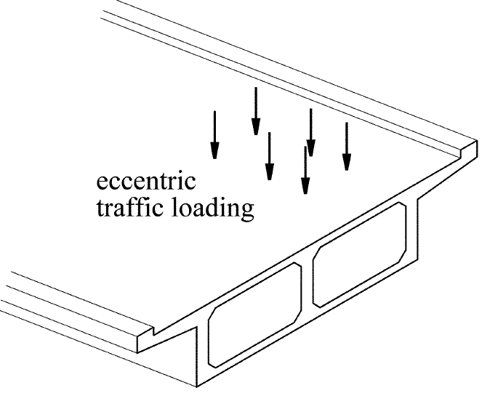
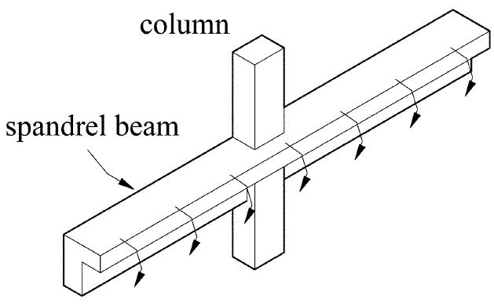
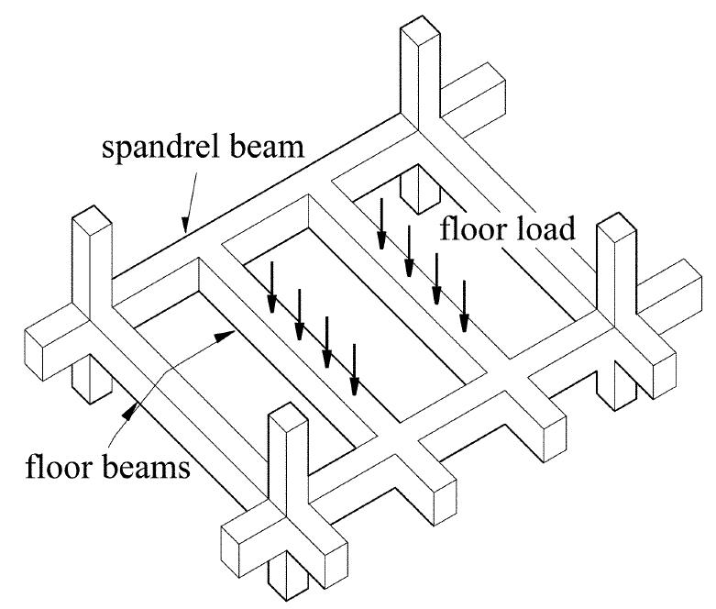
Fig.1 Examples of torsion load in reinforced concrete members. [1]

Fig. (2) Typical neural network model

Input
Layer
Output
Layer

Hidden layer

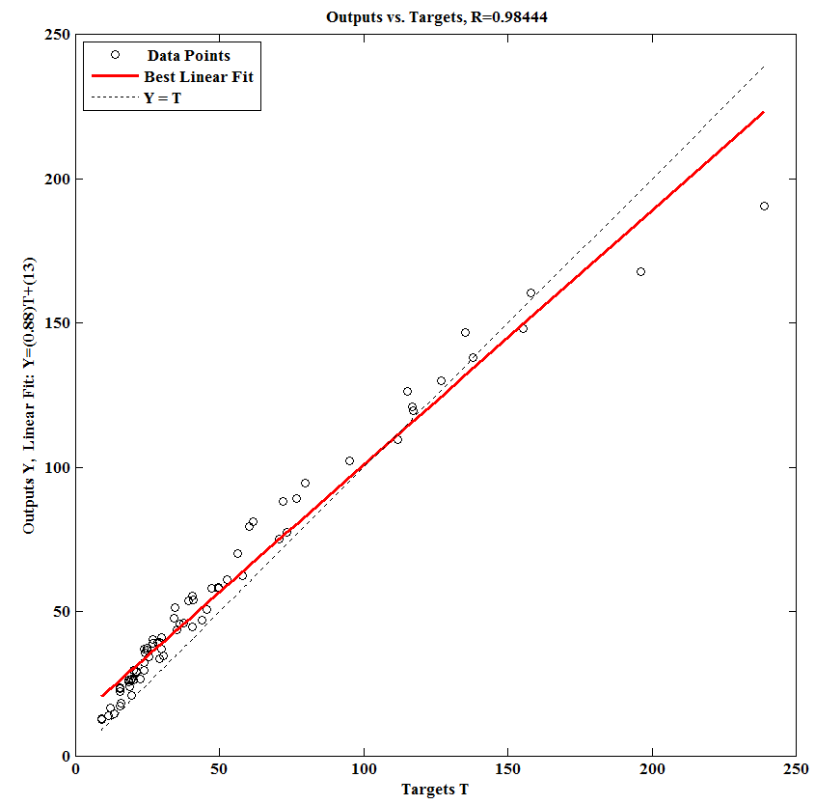

R=0.98
T_{u} Predicted (kN.m)

a. ANN predicted training data set.

T_{u} Experimental (kN.m)

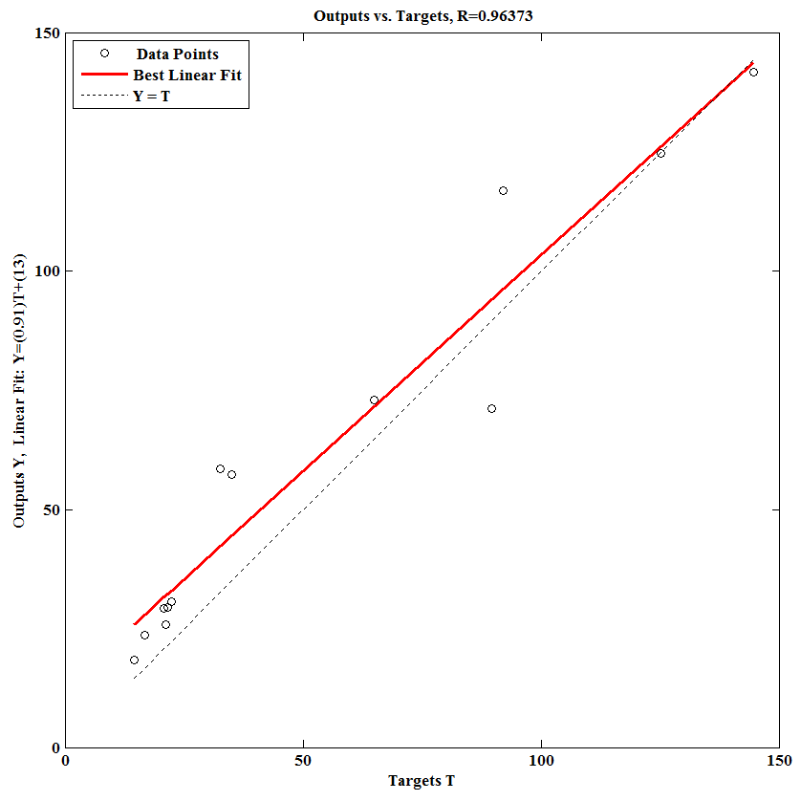
T_{u} Predicted (kN.m)
Fig.(3) Comparison of experimental and predicted torsional strength a). ANN predicted training data set, b). ANN predicted testing data set.
b. ANN predicted testing data set.
T_{u} Experimental (kN.m)
R=0.96

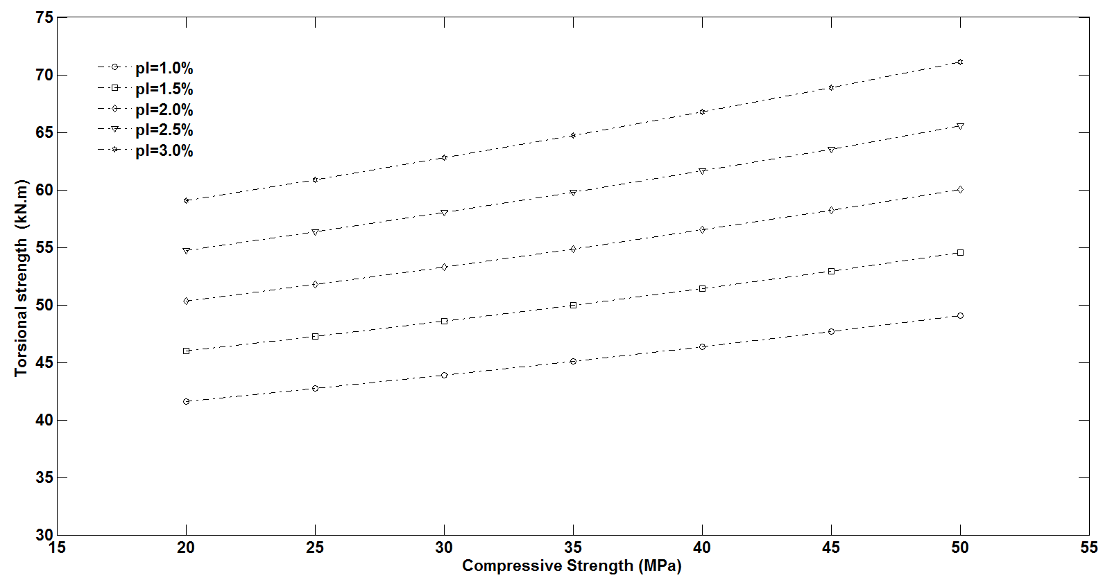
Fig. (5) Torsional strength versus compressive strength for different values of longitudinal reinforcement (ρ_{l}).
Compressive strength (MPa)
Torsional strength (kN.m)

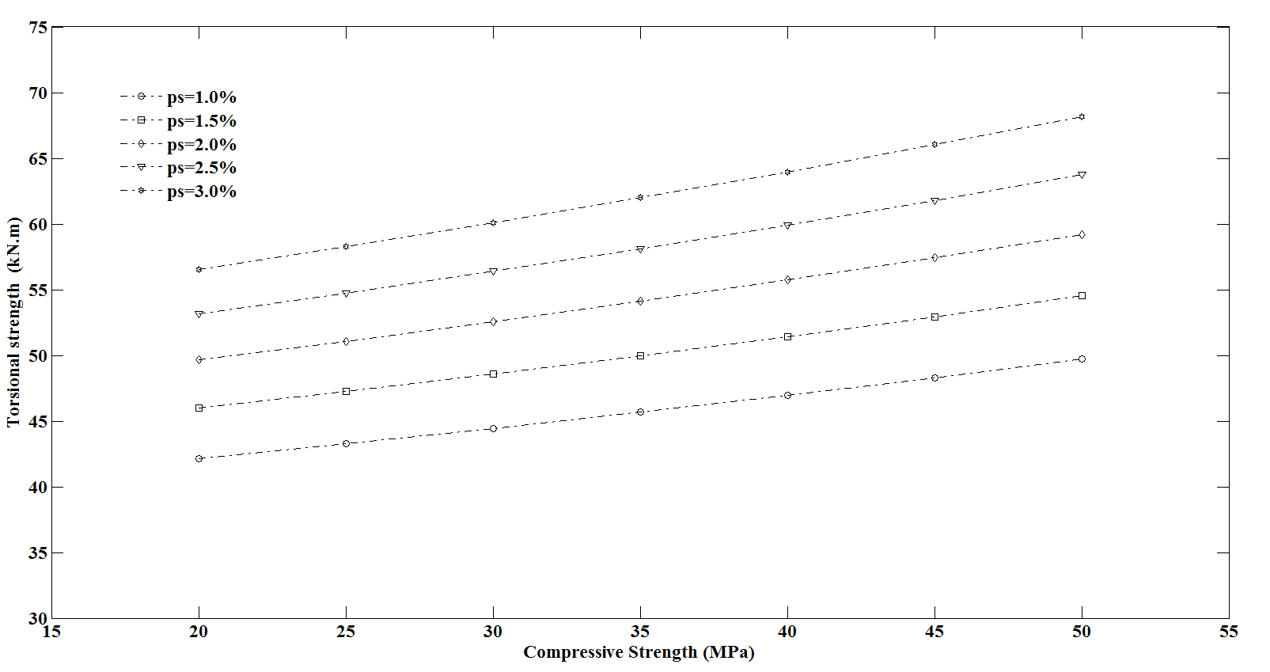
Fig. (5) Torsional strength versus compressive strength for different values of transverse reinforcement (ρ_{s}).
Compressive strength (MPa)
Torsional strength (kN.m)

REFRENCES
A. A. Abdul-Razzak and S. T. Yousif, (2006), “Artificial Neural Network Model for Predicting Structural Properties of Elasto-Plastic Plates”., Fourth Jordanian Civil Engineering Conference,Structural-Geotechnical Engineering and Construction Management, 10-13 April (2006) Amman and Dead Sea, Jordan".
A. A. Abdul-Razzak and S. T. Yousif, (2007), “Artificial Neural Network Model for Predicting Nonlinear Response of Uniformly Loaded Fixed Plates." Eng. & Technology, Vol.25, No.3, 2007, pp 334-348.
A. A. Abdul-Razzak and S. T. Yousif, (2008), “Artificial Neural Networks Model for Predicting Thickness of Rectangular Plates”, International Conference on Innovative and Smart Structural Systems for Sustainable Habitat (INSHAB -2008) .Coimbatore,03-05 January 2008.
ACI Committee 318-08, “Building Code Requirements for Structural Concrete (ACI 318-08) and Commentary (ACI 318R-08),” American Concrete Institute, Farmington Hills, Mich., 2008.
Andres W. C. Oreta, (2004), “Simulating Size Effect on Shear Strength of RC Beams without Stirrups Using Neural Networks”, Engineering Structures, Vol. 26, No.1, 2004, PP 681–691.
Chuang P. H., Goh ATC, Wu X., (1998), “Modeling the capacity of pin ended slender reinforced concrete columns using neural networks”. Journal of Structural Engineering, ASCE 1998.
European Standard. Eurocode 2. Design of concrete structures, prEN, 1992-1-1, Draft for stage 49, Commission of the European communities, European Committee for Standardization; 2002.
Fang I. K., Shiau JK. (2004), “Torsional behavior of normal and high strength concrete beams. ACI Structural Journal, V. 101, No. 3, May-June 2004, pp. 304–313.

Gomes H. M., Awruch A.M., (2004) “Comparison of Response Surface and Neural Network with Other Methods for Structural Reliability Analysis”, Struct. Saf. Vol. 26 ,2004, pp. 49–67.
Hsu TTC. (1968), “Torsion of structural concrete-behavior of reinforced concrete rectangular members. Torsion of structural concrete, SP-18, ACI, Farmington Hills. Mich; 1968. p. 261–306.
Khaldoun N. R., and Michael P. C., (2006), “Compatibility Torsion in Spandrel Beams Using Modified Compression Field Theory”, ACI Structural Journal, V. 103, No. 3, May-June 2006.
Koutchoukali N. E., Belarbi G., (2001), “Torsion of high strength reinforced concrete beams and minimum reinforcement requirement”. ACI Structural Journal, V. 98, No. 4, July-August 2001, pp.462–9.
Mahmoud E. K., and Basile G. R., (2005), “ Torsion Design of Structural Concrete Based on ACI 318-05”, Professional Development Series, Portland Cement Association. Sep. 2007.
Rasmussen L. J, Baker G. (1995), “Torsion in reinforced normal and high strength concrete beams. Part-I: an experimental test series”. ACI Structural Journal, V. 92, No.24, Jan.-Feb. 1995, pp.56–62.
S. T. Yousif and A. A. Abdul-Razzak, (2007), “Analysis of Elsto-Plastic Plates using Artificial Neural Networks” , The Ninth International Conference on the Application of Artificial Intelligence to Civil, Structural and Environmental Engineering., Malta 18-21 September 2007.
S. T. Yousif and A. A. Abdul-Razzak, (2009), “Parameter Identification in Elasto-Plastic Plates using Neural Networks”, Proceedings of the Third International Conference on Modeling Simulation and Applied Optimization (ICMSAO'09), Sharjah, U.A.E January 20-22 2009.
S. T. Yousif and S. M. Abdullah, (2009), “Artificial Neural Networks Model for Predicting Compressive Strength of Concrete”. Tikrit Journal of Eng. Sciences ,Vol.16 , No.3 ,September 2009, pp.55 - 63.
Sanad A, Saka M. P., (2001) “Prediction of Ultimate Shear Strength of Reinforced Concrete Deep Beams using Neural Networks. Journal of Structural Engg.”, ASCE vol. 127 ,No. 7, 2001, pp. 2495-2505.
The math works, MATLAB R2009b, 24 Prime way, Natick, MA 01760-1500, USA, 2009.
Vanluchene R. D.,and Sun .R, ,(1990), “Neural Networks in Structural Engineering”. Microcompter in Civil. Engineering, No. 5, PP.207-215.

SYMBOLS
B | Width of beam, m.
D | Effective depth of beam, mm
f_{yl} | Yielding strength of main reinforcement. MPa
f_{ys} | Yielding strength of secondary reinforcement. MPa
f_{c}’ | Concrete compressive strength. MPa
 | Overall depth of beam, mm.
(s) | Spacing between bars. mm
T_{ACI} | Torsional strength calculated by ACI code equation. kN.m
T_{ANN} | Torsional strength predicated by ANN model. kN.m
T_{EXP} | Experimental torsional strength. kN.m
T_{EUR} | Torsional strength calculated by Euro code equation. kN.m
x (mm) | horizontal distance between closed stirrups c/c. mm
y (mm) | vertical distance between closed stirrups c/c. mm
ρ_{l} | Main reinforcement ratio. (%)
ρ_{h} | Secondary reinforcement ratio. (%)

