OPTIMUM COST DESIGN OF REINFORCED CONCRETE BEAMS USING GENETIC ALGORITHMS
Rabi' M Najem
Assistant Lecturer
University of Mosul

Salim T. Yousif
Assistant Prof.
University of Mosul

ABSTRACT
This paper presents the application of Genetic Algorithms for the optimum cost design of reinforced concrete beams based on ACI Standard specifications. The produced optimum design satisfies the strength, serviceability, ductility, durability and other constraints related to good design and detailing practice. While most of the approaches reported in the literature consider the steel reinforcement and the cross-sectional dimensions of the beam as the variables taking into account the flexural only, in this research the dimensions and reinforcing steel were introduced as a design variable, taking into account flexural, shear and torsion effects on the beam. The constant parameters include the number of bays, span’s lengths, support conditions, loads, material properties and unit costs. The forces, moments and deformations needed in the GA constraints will be found from analysis. The beam dimensions are corrected to the nearest 25 mm and the areas of longitudinal and transverse steel obtained from the design are converted into a least weight detailing of steel reinforcements. This is achieved by generating a database of reinforcement templates containing different available reinforcement bar diameters in a pre-specified pattern, satisfying the user specified bar rules and other bar spacing requirements. The optimum design results are compared with those in the available literature, and the results are presented. It is concluded that the proposed optimum design model yields rational, reliable, economic and practical designs.
KEY WORDS
Optimization, Genetic Algorithm, Optimum Cost Design, Reinforced Concrete.
التصميم الأمثل للكلفة للعتبات الخرسانية ألمسلحة باستخدام الخوارزمية الجينية
د. سالم طيب يوسف
أستاذ مساعد
جامعة الموصل
ربيع مؤيد نجم
مدرس مساعد
جامعة الموصل

الخلاصة
الهدف من هذه الدراسة هو أيجاد التصميم الامثل للكلفة للجسور ألمسلحة ذات المقاطع مستطيلة الشكل. ليس كالعديد من البحوث السابقة التي تم فيها ايجاد التصميم الامثل للابعاد ومن ثم حساب باقي المتغيرات
بل تم ادخال حديد التسليح كمتغير رئيسي بطريقة قابلة للتنفيذ، مؤخذ بنظر الاعتبار تأثير كل من القص واللي على الجسر. الثوابت المحددة مسبقاً لحل هذه المسالة هي : الابعاد الهندسية الممثلة للمنشأ ، عدد الفضاءات ، طول كل فضاء ، حالات الاسناد ، الاحمال ، خصائص المواد ووحدات الكلفة للمواد المستخدمة في التصميم . يخضع الجسر المصمم الى مجموعة من المحددات الخاصة بالعزم والقص واللي والهبوط ، والتي تحدد عن طريق ACI 318 – 2008 . ويتم الحصول على الحل الأمثل باستخدام مجموعة البرامج الفرعية ضمن برنامج Matlab لاستحداث الدالة التي تفي بالمحددات الخاصة بالمسألة وعن طريقها يتم ايجاد التصميم الامثل. تم تحليل المنشأ مسبقاً للحصول على العزوم وقوى القص واللي المطلوبة لحل المسألة . وتم استحداث قاعدة بيانات لتمثيل جميع المقاطع الناتجة من عملية التصميم وفق ACI 318 – 2008 بأستخدام أبعاد المقطع وتوزيع حديد التسليح ضمن ذلك المقطع وعملية انتقاء قضبان التسليح الملائمة وتموضعها داخل كل مقطع بالاضافة لحلقات القص واللي كمتغيرات تصميمية عند الحل لايجاد التصميم الامثل للكلفة.
INTRODUCTION
Traditional design activity, even using computers, is based on postulating, appraising and modifying potential solutions in order to arrive at an acceptable form. Design by optimization employs numerical models of decision-making processes in order to generate direct prescriptive information on the nature of good solutions for the satisfaction of specified objectives. To some extent, it reverses the design process. Such procedures provide the potential for better design by encompassing a much wider range of possibilities, and offer the designer an opportunity to examine the implications of subjective decisions on the specified objectives.
Optimization theory coupled with cheap computational power provides the practical possibility to improve upon the design process without the need for impractical, more complex analysis.
Material cost is an important issue in designing and constructing reinforced concrete structures. The main factors affecting cost is the amount of concrete and steel reinforcement required. It is, therefore, desirable to make reinforced concrete structures lighter, while still fulfilling serviceability and strength requirements.
Many researchers have investigated the optimum design of RC beams. Kanagasundaram S. and Karihaloo B. L., 1991, introduced the quality of concrete ( crushing strength ) as a design variable in addition to the usual flexural, shear, geometry and deflection constraints, for finding the minimum cost design of a reinforced concrete multi-span beam with rectangular and T-sections using sequential linear programming and sequential convex programming techniques.. They found that by treating the crushing strength of concrete as a design variable, the minimum cost design use shallower sections and a much higher strength mix but are still marginally cheaper to construct.
Balling R. J. and Yao X., 1997, present a comparative study of optimization of three dimensional RC frames with rectangular columns, and rectangular, T, or L-shape beams according to the ACI code (ACI, 1989) using one, two, and four-story frames subjected to vertical and lateral loads, and employing the sequential quadratic programming or a gradient-based method.
Coello C. A. et al., 1997, present the cost optimum design of singly reinforced rectangular beams using Genetic Algorithms. They considered the sectional dimensions and the area of tensile reinforcement as variables in their optimum design model.
The genetic algorithm was used to find the optimal solution of reinforced concrete frames by Lee C., and Ahn J., 2003. Each frame was represented by a three string chromosome, one for the beam’s group and the other strings for the column's group. It was found that the genetic algorithm can be applied to the discrete optimization of three – dimensional reinforced concrete frames.
The reinforcing steel bar number and the number of the bars or topology of the reinforcement were used by Camp C. V., et al. 2003, as a design variable with the width and the thickness of the sections, for the design of reinforced concrete frames using the genetic algorithm and a penalized objective function for forming an unconstrained problem in order to introduce feasibility into the fitness of the solution.
Gorindaraj V. and Ramasamy J. V. 2005, used the genetic algorithm to find the minimum total cost of a reinforced concrete continuous beam due to concrete, steel and frame work subjected to the depth – width constraint, flexural constraint, shear constraint and deflection constraint. The distinctive feature of this paper is that the cross sectional dimensions of the beam alone are considered as variables thereby considerably reducing the size of the optimization problem with the elimination of steel reinforcement as a variable by generating a reinforcement template.
Barakat S. A. and Altoubat S., 2009, used the evolutionary-based optimization procedures for designing conical and cylindrical reinforced concrete water tanks. The Finite Element Method in conjunction with the optimization method is used in the analysis and design of the RC water tanks. A general study of the effect of the designing method, the reinforcing bar sizes, the water tank wall inclination and the material relative (unit) cost on the optimum design were illustrated in this paper. They found that for cylindrical water tanks, the total costs are more than that for conical water tanks of the same capacities by 20%_30% when using the ( WSD ) method and by 18%_40% when using ( SD ) method, and the results obtained from the tests, and the sensitivity analysis indicated that the robust search capabilities of Shuffled Complex Evolution ( SCE ) are well suited for solving the structural design problem of optimizing conical and cylindrical water tanks.
Most of the works were formulated and focused on to optimize the cross-sectional dimensions in addition to the quantity of steel reinforcement. However, the reinforcement design includes the specification of many details beyond the determination of an area of steel such as the selection of bar diameters and the number of bars, the longitudinal distribution of a group of bars that have the same size and length, the positioning of bars at critical sections, determination of curtailment points, specification of the size and spacing of stirrups. As the cost, flexural strength, shear and torsion strength of a member is a function of both the reinforcement detailing and dimensions of the member, detailing of reinforcement should also be considered while optimizing the member dimensions.
The objective of this research is to design low-cost reinforced concrete beams that satisfy the limitations and specifications of the American Concrete Institute (ACI) Building Code and Commentary considering flexural strength, shear and torsion strength of a member using a genetic algorithm (GA), Global Optimization Tool Box 3, 2003.

GENETIC ALGORITHM IN STRUCTURAL OPTIMIZATION
Genetic Algorithms (GA) are search methods that are based on evolutionary theory, which can be used to find an optimum of an objective function. It is a method for solving both constrained and unconstrained optimization problems that are based on natural selection. The genetic algorithm repeatedly modifies a population of individual solutions. At each step, the genetic algorithm selects individuals randomly from the current population to be parents and uses them to produce the children for the next generation. Over successive generations, the population "evolves" toward an optimal solution. The genetic algorithm can be applied to solve a variety of optimization problems that are not well suited for standard optimization algorithms, including problems in which the objective function is discontinuous, non-differentiable, or highly nonlinear, Chan E., 1997.
It is important to note that the GA provides a number of potential solutions to a given problem and the choice of final solution is left to the user. In cases where a particular problem does not have one individual solution, then the GA is potentially useful for identifying these alternative solutions simultaneously. The goal in any optimization problem is to find the best solution(s) to the problem. In order to apply a genetic algorithm, one must choose a suitable data structure to represent the possible solutions. Such representations can be viewed as points in the search space of all possible solutions to the optimization problem. The data structure of genetic algorithms consists of one or more chromosomes. Single chromosomes are usually employed and are typically strings of binary bits, and so the term string is often used instead. Each string is consisted of a number of subcomponents called genes. However, genetic algorithms are not restricted to bit-string representations. Various possible representations exist, which include real numbers and high level computer programs. Variable length representations are also possible.
The basic operators essential to genetic algorithms consist of three stages, reproduction is a process in which individual strings are selected based on their fitness. The fitness of an individual is determined by the objective function of the problem. Since the optimization goal is to maximize the objective function, strings with higher fitness should have a higher probability of contributing one or more off-springs in the next generation.
Simple GAs perform proportionate selection, which assigns each individual string in the population a probability of selection Ps. This selection probability ps(i) of the ith string in the population is simply the ratio of the string fitness f (i) to the overall population fitness, Chan E., 1997. A total of n strings are selected for furthering processing according to the probability distribution based on Ps(i). The simplest implementation of proportionate selection is Roulette-Wheel selection, Fig 1. This selection chooses individuals by simulating n spins of a roulette wheel which has one slot for each string in the population. The size of each slot is proportional to the selection probability of the string.

Fig 1 - Roulette-Wheel Representation

After reproduction, the n selected strings undergo Crossover and Mutation. These two operators are the basic search mechanisms of genetic algorithms. Crossover and mutation operators create new strings from strings, which have survived after the selection process. Crossover operators take two strings and generate two new individuals based on certain rules. For instance, single-point crossover and double-point crossover Fig 2. The simple single-point crossover operator takes the two parents and generates two offsprings by cutting and splicing. The cutting is performed at a randomly chosen location along the string for each parent with some crossover probability PC(i) then the end parts are swapped and spliced to each initial part as follows:
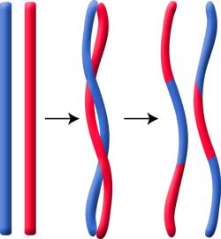
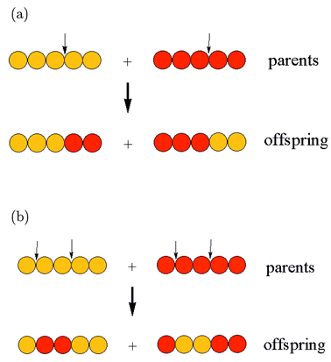
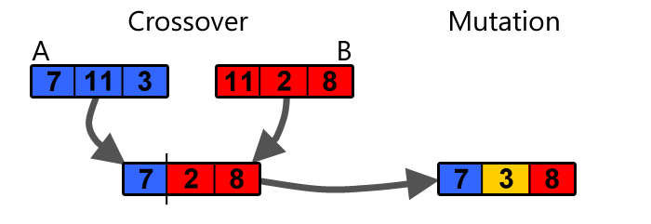
10001001110010010
01010001001000011

10001001101000011
01010001010010010

Fig 2 – Single and double point crossover operator followed by mutation

OPTIMUM DESIGN OF REINFORCED CONCRETE BEAM

Objective Function
In this study, the design criterion is the cost of the reinforced concrete beams. The objective is to minimize the cost without violating the constraints. The cost of the beams includes the cost of the concrete and the cost of the reinforcing steel. The total cost of the reinforced concrete beam is:

F = V_{c} C_{c} + W_{s} C_{s} ( 1 )

where V_{c} is concrete volume and W_{s} is reinforcement weight while C_{c} and C_{s} are unit cost of concrete and reinforcement respectively.

Design Variables And Design Parameters
The design variables were the width of the section, the depth of the section, and the number of bars or topology of the reinforcement. An advantage of using the rebar number as a design variable is that both the cross-sectional area and the diameter are intrinsic properties.
In this case, values associated with a rebar number variable can be used to compute the total cross-sectional area of the steel reinforcement, As, the flexural capacity of a section, and to determine if a reinforcement pattern is consistent with design geometry. The reinforcement topology variable can define both the number and pattern of reinforcement bars within a section.

ACI Code Beam Constraints
A reinforced concrete beam must have a structural capacity greater than the factored applied loading and meet specifications defined in the ACI Code. If the shear or moment capacity is below the required strength, the beam is penalized. In addition, the ACI Code has restrictions and limitations on the cross-sectional geometry of a beam and the position and quantity of steel reinforcement. Structural designs that do not satisfy the ACI Code have their fitness values (structural cost) penalized by an amount that quantitatively reflects the degree of constraint violation.
Many researchers used the dimensions only as design variables, and then the reinforcement ratio was calculated depending on these variables, Govindaraj V. and Ramasamy J. V., 2005, then it was topology optimized, on the contrary, of this research, which used not only the reinforcement ration as a design variable in addition to the dimensions ( which will give the minimum cost ) but also including the effect of shear and torsion on these optimum dimensions beside many other constraints. These constraints were used in order to specify the main variables in such a case where they can resist the applied loads ( in many ways ), and also to stay within the limits of the used code, in order to make the optimal solution more realistic and applicable.
The first constraint eq.( 2 ) was used to make the three variables $ρ$, b and d
( reinforcement ratio, beam width and beam effective depth ) of the section carry the smallest values that can resist the applied moment on that section. While eqs. ( 3) & (4 ) represent the constraints that were used to prevent the reinforcement ration from exceeding the maximum value nor becoming below the minimum value specified according to the code

$\frac{k∗w∗L^{2}}{0\text{.}9(ρ∗b∗d∗\text{fy}∗(d−\frac{({ρ∗b∗d∗\text{fy}}/0\text{.}\text{85}∗{\text{fc}}^{−}∗b)}{2}))}−1≤0$ ( 2 )

$1−\frac{ρ}{ρ_{\text{min}}}≤0$ ( 3 )

$\frac{ρ}{ρ_{\text{max}}}−1≤0$ ( 4 )

Eq. ( 5 ) was used to guarantee that the optimum section will not have depth less than the depth that control the elastic deflection, considering effects of cracking and reinforcement on member stiffnes, Building Code Requirements, 2008.

$1−\frac{h}{h_{\text{min}}}≤0$ ( 5 )

In order to make the dimensions more realistic, eqs. ( 6 ) & ( 7 ) were used to keep the ration of the optimum depth to the optimum with between ( 1.5 ) & ( 2.5 ), (specified by the designer ).

$1\text{.}5−\frac{h}{b_{w}}≤0$ ( 6 )

$\frac{h}{b_{w}}−2\text{.}5≤0$ ( 7 )

While keeping the dimensions of the optimum width between ( 200 mm ) &
( 500 mm ), and the optimum depth between ( 300 mm ) & ( 1250 mm ), have been used through the eqs. ( 8 ) & ( 9 ), also ( specified by the designer ).

$(1−\frac{b_{w}}{\text{200}\text{mm}}≤0) \text{and} (\frac{b_{w}}{\text{500}\text{mm}}−1≤0)$ ( 8 )

$(\frac{h}{\text{1250}\text{mm}}−1≤0) \text{and} (1−\frac{h}{\text{300}\text{mm}}≤0)$ ( 9 )

To reduce unsightly cracking, and to prevent crushing of the surface concrete due to the inclined compressive stresses due to shear and torsion, eq. ( 10 ) was used to limit the optimum dimensions within this condition.

$\frac{\sqrt{{\left(\frac{V_{u}}{b_{w}d}\right)}^{2}+{\left(\frac{T_{u}P_{h}}{1\text{.}7A_{\text{oh}}^{2}}\right)}^{2}}}{φ\left(\frac{V_{c}}{b_{w}d}+0\text{.}\text{66}\sqrt{{\text{fc}}^{−}}\right)}−1≤0$ ( 10 )

And finally, eqs. ( 11 ) & ( 12 ) was used for the reinforcement topology through the section, considering the minimum spacing between the chosen bars, Building Code Requirements, 2008.
$(1−\frac{\text{Bar}−\text{Spacing}}{\text{Bar}−\text{Diameter}}≤0) \text{or} (1−\frac{\text{Bar}−\text{Spacing}}{\text{25}\text{mm}}≤0)$ ( 11 )

$(1−\frac{\text{Layer}−\text{Spacing}}{\text{25}\text{mm}}≤0)$ ( 12 )

Sections Database
A predefined database was adopted in this study to represent the flexural reinforcement. After the optimum flexural reinforcement is found through ( $ρ_{\text{opt}},b_{\text{opt}}$ and $d_{\text{opt}}$ ), an arrangement of the reinforcing bars which gives the nearest largest area of steel to the optimum one, is chosen to represent the reinforcement for that section. The reinforcement bars used in this database contains almost all the bar sizes that could be used, such as #12, #16, #20, #22, #25, #28, #32 and #35, which was used through different distributions divided in three groups.
Group no. 1, contains all the possible distributions of the same bar size that could be fitting in that section, taking into account the clear side cover and dividing the rest distance on ( bar no. -1 ), and comparing the clear distance between the bars with the used bar diameter or 25 mm to keep it with the code limits. see Fig 3. also the distributed bars will be in a symmetrical way through the layer.
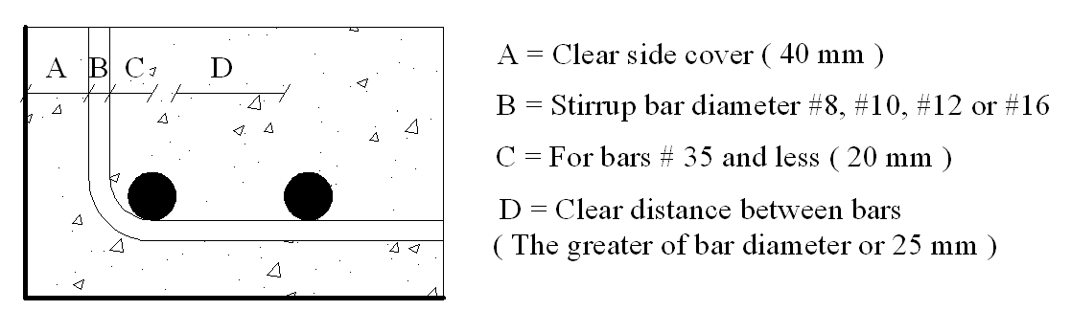
Fig 3 - Typical section of spacing details

While the group no. 2, contain all the possible distributions of two different bar sizes, but not differ more than one bar size between them according to the ACI Code, also considering all the limitations of the spacing for group no. 1.
Finally, group no. 3 represent a combination of the group no. 1 and group no. 2, but the distribution of the reinforcing bars will be through two layers not less than 25 mm separated apart, Building Code Requirements, 2008.
For the case of shear and torsion, after finding the optimum transverse reinforcement of them, the stirrups will be chosen from a database contains bar sizes of #8, #10, #12 or #16, considering which bar size and distribution for a specified section that will give the nearest value to the optimal solution. As for the longitudinal torsion reinforcement, after finding the value of Al, it will be divided into many layers depending on the depth of the section with clear spacing between each two layer not more than 300 mm, and then the bottom layer will be added to the flexural reinforcement and the suitable distribution of bars will be chosen for that section.
Still there is one problem needed to be solved, which is the difference between the optimum dimensions and the applicable dimensions. The optimum dimensions that were found using the genetic algorithm is not applicable, and it should be fixed into a round applicable number. Normally, those rounded dimensions will be to the nearest 25 mm, leaving four possible sections that will be near the optimum section. After finding the optimum depth and width, those applicable sections will be decreasing both the optimum depth and the optimum width, increasing both of them, decreasing the optimum depth and increasing the optimum width or increasing the optimum depth and decreasing the optimum width. One of those four sections represent the nearest applicable section to the optimum one, and it will be found through checking the fitness of all of them. The section that will give the least cost will be chosen.

NUMERICAL EXAMPLES
Three different cases having different material properties of cantilever beams were designed using the genetic algorithm. To check the adequately of the solution, first, the beams were loaded with different loads causing a different moment at the critical sections. Figs 6, 7 and 8, and Tables 1, 2 and 3 show the values of the optimal solution ( minimum cost ) for each case labeled as GA solution. Furthermore, it can be noticed that the cost will rise by reducing the dimensions of the beam and increasing the reinforcement ratio or increasing the dimensions and reducing the ratio. All the other section which was designed according to the ACI Code 310 - 2008 labeled as ACI (#). The sections were chosen not to violate the depth to the width ratio of the limit ( 1.5 <= ( Height / Width ) <= 2.5), nor to be very small and then designed as under reinforced section.
As it can be seen from Figs 6, 7 and 8 the GA solution is one of many other solutions done using the ACI method which shared relations that satisfy a certain case of load and geometry but differ from it by having the minimum cost design which was obtained directly by GA method instead of ACI method (which based on try and error).
Second, the beams were loaded in addition to the first case by a uniform torque, and considering the shear in designing each section, then additional constraint eq. ( 13 ) used to reducing unsightly cracking, and to prevent crushing of the surface concrete caused by the inclined compressive stresses due to shear and torsion, the overall dimensions of each section were limited by:

$\sqrt{{\left(\frac{V_{u}}{b_{w}d}\right)}^{2}+{\left(\frac{T_{u}P_{h}}{1\text{.}7A_{\text{oh}}^{2}}\right)}^{2}}≤φ\left(\frac{V_{c}}{b_{w}d}+0\text{.}\text{66}\sqrt{{\text{fc}}^{−}}\right)$ ( 13 )

This constraint will increase the dimensions of the optimal designed beam as shown in Tables ( 4 ) , ( 5 ) and ( 6 ).

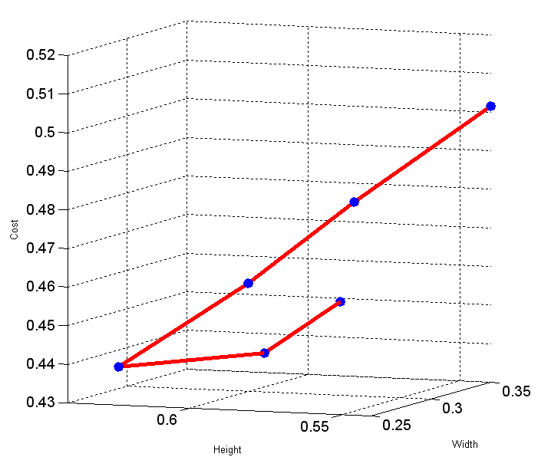
Fig 6 – Optimum cost for a specified section having : Mu = 450 kN . m / m , r = 75 ,
fy = 276 MPa , fc⁻ = 25 MPa.
ACI (1)
ACI (2)
ACI (3)
GA
ACI (4)
ACI (5)
Width(m)
Hight(m)
Cost*Cc
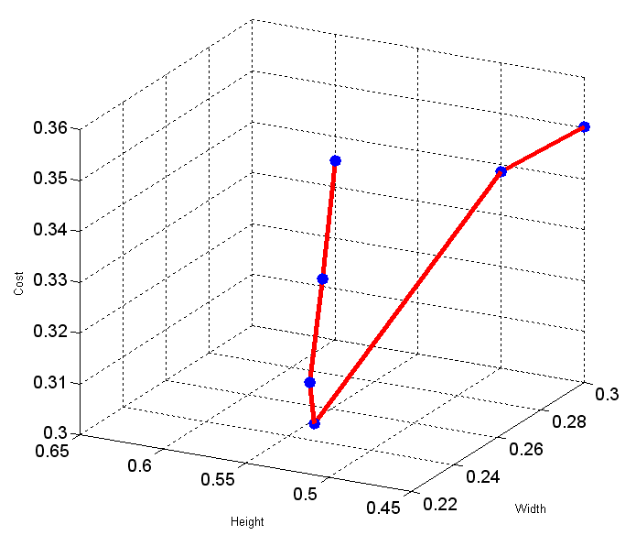
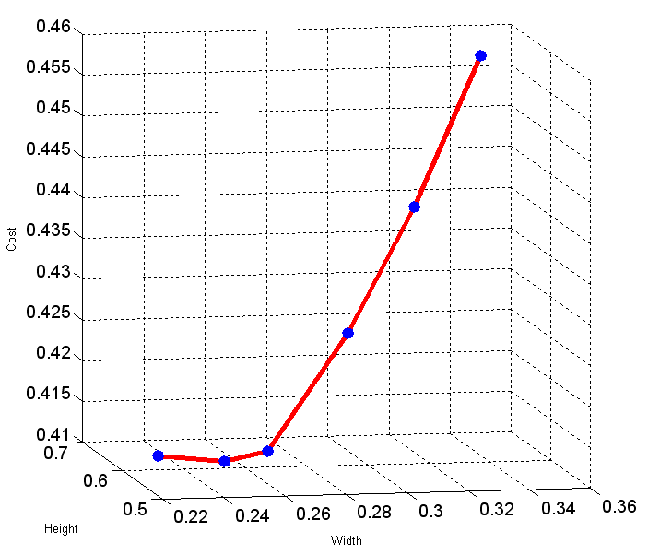
Fig 7 – Optimum cost for a specified section having : Mu = 360 kN . m / m , r = 75 ,
fy = 400 MPa , fc⁻ = 30 MPa.
ACI (1)
ACI (2)
ACI (3)
GA
ACI (4)
ACI (5)
Width(m)
Hight(m)
Cost*Cc
Fig 8 – Optimum cost for a specified section having : Mu = 600 kN . m / m , r = 75 ,
fy = 400 MPa , fc⁻ = 40 MPa.
ACI (1)
ACI (2)
ACI (3)
GA
ACI (4)
ACI (5)
Width(m)
Hight(m)
Cost*Cc
Table 1 - Design and cost of rectangular section with : Mu = 450 kN . m / m ,
r = 75 , fy = 276 MPa , fc⁻ = 25 MPa.

Design Method | Beam Width  ( m ) | Effective Depth  ( d ) ( m ) | Reinforcement Ratio ( rho ) | Material Cost*Cc($/m) | GA Cost Over Saving Percent
ACI ( 1 ) | 0.35 | 0.54 | 0.0205 | 0.5011 | 14.456%
ACI ( 2 ) | 0.325 | 0.575 | 0.0193 | 0.4773 | 9.122%
ACI ( 3 ) | 0.3 | 0.6 | 0.0192 | 0.4574 | 4.572%
GA | 0.2788 | 0.6344 | 0.0183 | 0.4374 | 0.0%
ACI ( 4 ) | 0. 25 | 0.575 | 0.0265 | 0.4447 | 1.669%
ACI ( 5 ) | 0.25 | 0.55 | 0.0297 | 0.4591 | 4.961%

Table 2 - Design and cost of rectangular section with : Mu = 360 kN . m / m ,
r = 75 , fy = 400 MPa , fc- = 30 MPa.

Design Method | Beam Width  ( m ) | Effective Depth  ( d ) ( m ) | Reinforcement Ratio ( rho ) | Material Cost*Cc($/m) | GA Cost Over Saving Percent
ACI ( 1 ) | 0.3 | 0.6 | 0.0101 | 0.3344 | 9.892%
ACI ( 2 ) | 0.275 | 0.575 | 0.0122 | 0.3195 | 4.995%
ACI ( 3 ) | 0.25 | 0.55 | 0.015 | 0.3076 | 1.084%
GA | 0.2373 | 0.5307 | 0.0173 | 0.3043 | 0.0%
ACI ( 4 ) | 0.3 | 0.5 | 0.0151 | 0.3389 | 9.712%
ACI ( 5 ) | 0.3 | 0.45 | 0.0194 | 0.3504 | 15.15%

Table 3 - Design and cost of rectangular section with : Mu = 600 kN . m / m ,
r = 75 , fy = 400 MPa , fc- = 40 MPa.

Design Method | Beam Width  ( m ) | Effective Depth  ( d ) ( m ) | Reinforcement Ratio ( rho ) | Material Cost*Cc($/m) | GA Cost Over Saving Percent
ACI ( 1 ) | 0.35 | 0.7 | 0.0103 | 0.457 | 11.138%
ACI ( 2 ) | 0.325 | 0.675 | 0.0121 | 0.4391 | 6.785%
ACI ( 3 ) | 0.3 | 0.65 | 0.0144 | 0.4238 | 3.064%
GA | 0.2684 | 0.6086 | 0.0189 | 0.4112 | 0.0%
ACI ( 4 ) | 0.25 | 0.575 | 0.0234 | 0.4114 | 0.049%
ACI ( 5 ) | 0.225 | 0.55 | 0.0297 | 0.4131 | 0.462%

Table 4 - Design and cost of rectangular section with: Mu = 500 kN . m / m ,
Vu = 0.25 kN , Tu = 0.05 kN . m , r = 75 , fy = 400 MPa , fc- = 40 MPa.

Design Method | Beam Width  ( m ) | Effective Depth  ( d ) ( m ) | Reinforcement Ratio ( rho ) | Material Cost*Cc($/m) | GA Cost Over Saving Percent
ACI ( 1 ) | 0.35 | 0.85 | 0.0057 | 0.4462 | 16.077%
ACI ( 2 ) | 0.325 | 0.775 | 0.0074 | 0.4127 | 7.362%
ACI ( 3 ) | 0.3 | 0.7 | 0.01 | 0.3869 | 0.650%
GA | 0.2884 | 0.5719 | 0.0163 | 0.3844 | 0.0%
ACI ( 4 ) | 0.275 | 0.45 | 0.0304 | 0.4228 | 9.90%
ACI ( 5 ) | 0.25 | 0.4 | 0.0486 | 0.4804 | 24.974%

Table 5 - Design and cost of rectangular section with Mu = 360 kN . m / m ,
Vu = 0.2 kN , Tu = 0.045 kN . m , r = 75 , fy = 276 MPa , fc- = 25 MPa.

Design Method | Beam Width  ( m ) | Effective Depth  ( d ) ( m ) | Reinforcement Ratio ( rho ) | Material Cost*Cc($/m) | GA Cost Over Saving Percent
ACI ( 1 ) | 0.375 | 0.9 | 0.0051 | 0.4893 | 22.724%
ACI ( 2 ) | 0.35 | 0.85 | 0.006 | 0.4524 | 13.469%
ACI ( 3 ) | 0.325 | 0.775 | 0.0078 | 0.4199 | 5.317%
GA | 0.2971 | 0.5911 | 0.0155 | 0.3987 | 0.0%
ACI ( 4 ) | 0.275 | 0.525 | 0.0224 | 0.4038 | 1.279%
ACI ( 5 ) | 0.25 | 0.5 | 0.0284 | 0.4073 | 2.157%

Table 6 - Design and cost of rectangular section with Mu = 450 kN . m / m ,
Vu = 0.15 kN , Tu = 0.04 kN . m , r = 75 , fy = 400 MPa , fc- = 30 MPa.

Design Method | Beam Width  ( m ) | Effective Depth  ( d ) ( m ) | Reinforcement Ratio ( rho ) | Material Cost*Cc($/m) | GA Cost Over Saving Percent
ACI ( 1 ) | 0.35 | 0.85 | 0.0052 | 0.4343 | 18.145%
ACI ( 2 ) | 0.325 | 0.8 | 0.0063 | 0.4036 | 9.793%
ACI ( 3 ) | 0.3 | 0.75 | 0.0079 | 0.377 | 2.557%
GA | 0.281 | 0.5556 | 0.0166 | 0.3676 | 0.0%
ACI ( 4 ) | 0.275 | 0.5 | 0.022 | 0.3812 | 3.7%
ACI ( 5 ) | 0.25 | 0.5 | 0.0244 | 0.3692 | 0.435%

CONCLUSIONS
The Genetic Algorithm proved that it a sufficient method for finding the optimum solution smoothly and flawless, especially for cases that handling many complicate constraints such as reinforced concrete beams subjected to many loads as moments and shear with torsion, considering the limits of the design code.
The presence of shear and torsion as design constraints through the genetic algorithm procedure in designing the section, will increase the designed dimensions of the beam and that is to reduce the unsightly cracking and to prevent crushing of the surface concrete, which leads to rising the cost of the designed section.
There are no easy ways to find the optimal cost design for the shear and torsion stirrups with their distribution through the span. That is because they changed distance from the support and the difference will give to the moments and shear with torsion forces, and this will give that section a different optimum solution from the exact next section.
A problem will appear through selecting the right section for the optimal solution of a specified section, that is the selected optimal section might have the main reinforcement distributed through two layers which causes a major difference between the bars sizes of the layers, although the database takes into consideration not to use more than two different bar sizes and the difference between them should not be more than one size, and this is for a one layer reinforcement. But sometimes it found that adding two small bars in a different layer than the one already exists which has a larger sized bars will lead to the optimal solution. And this problem cannot be overcome by choosing a smaller bars for the first layer and a larger bars for the second layer in order minimizing the difference between the two layer’s bar size, because the biggest size ( if it wasn’t all of it ) of the reinforcing steel should be as far as it could from the upper face of the section in order to produce a larger moment to resist the applied loads.
Therefore, the obligating to the code requirements is not necessary useful by taking optimization into considerations all the times, especially through some odd cases such as finding the optimum solution exactly with many constraints controlling it.

REFERENCES

- Adeli H. and Sarma K. C.; “Cost Optimization of Structures “; John Wiley & Sons Ltd., ( 2006 ).
- Balling R. J. and Yao X.; “ Optimization of Reinforced Concrete Frames “; Journal of Structural Engineering, ( 1997 ), ASCE, 123(2), pp. 193 –202.
- Barakat S. A. and Altoubat S.; “Application of Evolutionary Global Optimization Techniques in The Design of RC Water Tanks “; Engineering Structures, ( 2009 ), Vol. 31, pp. 332-344.
- Building Code Requirements For Structural Concrete ( ACI 318 M – 08 ), Reported by ACI Committee 318.
- Camp C. V., Pezeshk S. and Hansson H.; “ Flexural Design of Reinforced Concrete Frames Using a Genetic Algorithm “; Journal of Structural Engineering, ( 2003 ), Vol. 129, No. 1, pp. 105 - 115.
- Chan E.; “ Optimal Design of Building Structures Using Genetic Algorithm “; California Institute of Technology, Report No. EERL 97 – 06, Pasadena California, ( 1997 ).
- Chipperfield A., Fleming P., Pohlheim H. and Fonseca C.; “ Genetic Algorithm Tool Box for Use With Matlab “; version 1.2, Department of Automatic Control and Systems Engineering, University of Sheffield.
- Coello C. A., Christiansen A. D. and Hernandez F. S.; “ A Simple Genetic Algorithm For The Design of Reinforced Concrete Beams “; Engineering with Computers, ( 1997 ), Vol. 13, pp. 185 – 196 .
- Global Optimization Tool Box 3 “ User’s Guide “; The MathWorks Inc., (2010)

- Govindaraj V. and Ramasamy J. V.; “ Optimum Detailed Design of Reinforced Concrete Continuous Beams Using Genetic Algorithm “; Computers and Structures, ( 2005 ), Vol. 84, pp. 34 – 48.
- Kanagasundaram S. and Karihaloo B. L.; “ Minimum – Cost Reinforced Concrete Beams and Columns “; Computers and Structures, ( 1991 ), Vol. 41, No. 3, pp. 509 – 518.
- Lee C., and Ahn J.; “ Flexural Design of Reinforced Concrete Frames by Genetic Algorithm “; Journal of Structural Engineering, ( 2003 ), Vol. 129, No. 6, pp. 762 – 774.

