EXPERIMENTAL STUDY TO SHOW THE EFFECT OF COPPER AND NICKEL ADDITIONS ON THERMAL PROPERTIES OF PURE ALUMINUM USE NORMAL PROBABILITY PLOT
Zuher Hassan Abdullah
Technical Institute of Babylon
Assist. Professor

Thamir K. Salim
College of Eng - University of Tikrit
Lecturer

___________________________________________________

ABSTRACT
In this research, an experimental work has been conducted to show the effect of adding of copper (Cu) and nickel (Ni) on the thermal properties of pure aluminum (AL) which were density of alloy, specific heat at constant volume (Cv), thermal conductivity (k) and thermal diffusivity$(α)$.Ten alloys have been prepared by changing percentages addition of copper and nickel to pure aluminum and the percentages are (5,10,15,20&25%). The effect of an average deviation and variability on the thermal properties after an addition of copper and nickel through use of normal probability plot.
The results shows as that copper addition percentage is increased lead to, increasing the alloy density by (57.7%), the thermal conductivity by (15.78%), decreasing the specific heat by (14.3%) and thermal diffusivity by (14.4%).
Also as the nickel addition percentage is increased cause, increasing the alloy density by (67.3%), and decreasing the thermal conductivity by (18.6%),the specific heat by (11.8%) and the thermal diffusivity by (44.8%).
Through this study it was found that the best addition is 25% (Cu) addition percentage for pure aluminum, gives highest thermal properties (Cv,k,$α$) compared with the same addition percentage of nickel . The greater average of deviation was the property of the specific heat when adding nickel and the greater variability was the property of the thermal conductivity when adding nickel.

Key Words: Thermal properties, Aluminum, Copper, Nickel

دراسة عملية لبيان تأثير إضافة النحاس والنيكل على الخواص الحرارية للألمنيوم النقي باستعمال مخطط الاحتمال الطبيعي
زهير حسن عبد الله
المعهد التقني / بابل
أستاذ مساعد
ثامر خلف سالم
كلية الهندسة- جامعة تكريت
مدرس

الخلاصة:
تم في هذا البحث أولاً, دراسة عملية لبيان تأثير إضافة عنصري النحاس والنيكل على الخواص الحرارية للألمنيوم النقي وهي كثافة السبيكة, السعة الحرارية النوعية بثبوت الحجم (C_{v}) ومعامل التوصيل الحراري (k) ومعامل الانتشار الحراري ($α$). لقد تم تحضير عشرة سبائك معدنية وذلك بتغير نسب إضافة كل من النحاس والنيكل على الألمنيوم النقي وكانت النسب هي (%5,%10,%15,%20,%25). ثانياً, بيان تأثير معدل الانحراف والمتغيرية على الخواص الحرارية بعد إضافة النحاس والنيكل من خلال استعمال مخطط الاحتمال الطبيعي.
بينت النتائج المستحصلة انه بزيادة نسب إضافة النحاس إلى الألمنيوم النقي تسبب زيادة كثافة السبيكة بنسبة (%57.7 ), وتزداد معامل التوصيل الحراري بنسبة (%15.78 ), ونقصان السعة الحرارية النوعية بنسبة (%14.3 ), وكذلك نقصان معامل الانتشار الحراري بنسبة (%14.4 ). وأظهرت الدراسة أيضاً انه بزيادة نسب إضافة النيكل إلى الألمنيوم النقي تؤدي إلى زيادة كثافة السبيكة بنسبة (%67.3 ), ونقصان معامل التوصيل الحراري بنسبة (%18.6), ونقصان السعة الحرارية النوعية بنسبة (% 11.8), وكذلك تقل معامل الانتشار الحراري بنسبة (%44.8 ).
خلال هذه الدراسة وجد أولاً, أفضل إضافة هي (25%CU) للألمنيوم النقي والتي أعطت أعلى خواص حرارية (,Cv,k$α$) مقارنة بسبيكة (AL-25% Ni). ثانياً, أكبر معدل للانحراف هو لخاصية السعة الحرارية عند إضافة النيكل وأكبر متغيرية هي لخاصية التوصيل الحراري عند إضافة النيكل.
الكلمات الدالة : الخواص الحرارية, ألمنيوم , نحاس, نيكل

1- INTRODUCTION

Aluminum divided by purity to aluminum high-purity, where the proportion of aluminum (99.999 % Al) and purity of commercial aluminum (99 % Al), and aluminum is characterized high resist corrosion by increase purity, also connected of high heat and electricity , an ability upon good formation , low resistance and does not heat treatment in the case of purity. The commercial aluminum used to manufacture constructions and the parts are loaded (such as facilities on roofs of ships and electric wires, capacitors, structures of clocks, chips, exhibits art, doors, frames, and containers domestic). While, the aluminum of high purity is used to manufacture of chips products connected to the electricity and chemical industry[I.G. Brodova,2002]. Aluminium has the chemical symbol Al, atomic number 13, and atomic weight 26.98. The isotope with mass number 27 is the only stable isotope. It is a soft, light, gray metal that resists corrosion when pure in spite of its chemical activity because of a thin surface layer of oxide. It is nonmagnetic and no sparking. Its density is 2.6989 kg/cm³, melting point 669.7°C and boiling point 1800°C. Its electrical resistivity is 2.824 μΩ-cm at 20°C, with temperature coefficient 0.0039°C⁻¹, the same as copper's. Its thermal conductivity is 2.37 W/cm-K at 300K, and the linear coefficient of expansion is 23.86 x 10⁻⁶°C⁻¹ [R. Mathiesen,2006].
[Y. PLEVACHUK,2008] In this work, study of thermophysical properties (density, viscosity, and electrical conductivity) of liquid Al-4 wt pct Cu, Al-20 wt pct Cu, Al-30 wt pct Cu, and AlCu4TiMg alloys have been measured in a wide temperature range. The anomalies with respect to the concentration dependence of the electrical conductivity are explained in terms of the s-d hybridization model. A comparison with data and scaling relations available in the literature is given.
[MANUEL V.,2008] study addition effect of Three Al-Ni hypoeutectic alloys were directionally solidified under upward unsteady-state heat flow conditions. Primary (k1) and secondary (k2) dendrite arm spacings were measured along the castings for all alloys and correlated with transient solidification thermal variables. A combined theoretical and experimental approach was used to quantitatively determine such thermal variables, i.e., transient metal/mold heat-transfer coefficients, tip growth rates, thermal gradients, tip cooling rates, and local solidification time. The article also focuses on the dependence of dendrite arm spacings on the alloy solute content. Furthermore, the experimental data concerning the solidification of Al-1.0, 2.5, and 4.7 wt pct Ni alloys are compared with the main predictive dendritic models from the literature. Where the used symbols in mathematical equations can be summarized as shown in the table (1).

2- THEORETICAL PROCEDURE
2-1 Accounts of Specific Heat

The theoretical basis for this experiment is a thermal balance of the system by calculating the electric power that stores within the system and the first law of heat, the energy is added to the system must be equal to the energy gained by the different materials in the system. specific heat of metals Is calculated in two phases.
(Phase I) prior to the sample, and are as follows:
mass and specific heat of the various components of the device (Nv)is calculated using the first law for dynamic temperature [F.P.Incropera,2000].
Where energy is added:
The heat gained by the vessel was calculated from the following equation [R.M, Lumley,2006].

Where:
$\text{Nv}=m_{v}∗C_{v}$

$N_{\text{averge}}=\frac{\sum{\text{Nv}}}{4}$

temperature heat gained from the water was calculated from the following equation [MANUELV.,2008].

Where:
$m_{w}=ρ_{w}∗L∗W∗H$
(Phase II): After putting the sample:
specific heat of metals used (Qa) Is calculated using the first law of dynamics and heat making use of equations (2,3,4) [F.P.Incropera,2000].

Where:
$C_{\text{averge}}=\frac{\sum{C_{\text{va}}}}{4}$

2-2 Accounts of Thermal Conductivity

Heat form of energy transition, moving from the area with a high temperature to the region of low temperature in several images, namely, (conduction, convection, radiation), heat was transferred to one or more of these images. The transfer of heat conduction, has created the world Fourier law observed from which the heat transmitted through the middle of a directly proportional with temperature difference and the space perpendicular to the direction of heat flow (A), and inversely with the length of the distance traveled by the temperature [Y. Plevachuk,2008].

And that the constant of proportionality is the thermal conductivity (k), which is a property of properties of the center carrier indicates its ability to deliver heat [R. Mathiesen,2006].

To calculate the value of the constant (k), we rearrange equation (8) to get the new formula, namely [F.P. Incropera,2000].

Where:
$A={π∗d^{2}}/4$

The rate of heat protractor (q) can be calculated as follows:- transmitted through the metal equal to rate of heat gained by the electric heater[MANUELV.,2008].

thermal diffusion coefficient was calculated from the following equation [I.G. Brodova,2002].

3- NORMAL PROBABILITY PLOT

A normal probability plot plots observed data value if the distribution of the random variable is normal. We will be content in reading normal probability plots constructed using the statistical software package, Minitab. In Minitab, if the points plotted lie within the bounds provided in the graph, then we have reason to believe that the sample data come from a population that is normally distributed. for each point obtain probability axis location using formula (12), where P_{i} is the percentile rank of the ith order statistic in a sample of size n [ Steve,2005, Robert L.,2003].

4- EXPERIMENTAL WORK
Due to the development of alloys and their use in all fields of life, our consisting to carry out a study to determine the effect of Cu and Ni to pure aluminum on the thermal properties of the alloy.
4-1 Method of Preparation Samples
Samples were prepared as follows:
1- wires of pure aluminum purity of 99.98 was used, cutters, and then put them in the oven for the fusion process and heated to a temperature (750 Cº) to ensure the full fusion, and then the addition of remover slag fugitive gases for the purpose of obtaining fused free of any defects.
2- Add powder, copper or nickel to the molten aluminum and a good move for the purpose of full homogeneity, and then the process of casting in metal mold.
3- Casting process were conducted five times for each alloy and different proportions of copper or a nickel (5%, 10%, 15%, 20%, 25%).
4- casted bars was obtained with diameter (3 cm) and length (25 cm), these bars were machined with turning the existence of the coolant and cut into several samples diameter (2.5 cm) and length (6 cm) for both alloys.
5- refinement and smoothing processes were carry out to obtain upon models with regular shapes and smooth surfaces.
4-2 Used Devices
4-2-1 A device for Measuring Specific Heat
The device used to measure the specific heat Consists of the pot metal and substance of an alloy of aluminum galvanized installed with the inside of heated electric and mixer to ensure the distribution of a homogeneous temperature and the group isolated thermally isolate the full use of thermal wool and placed inside a box of wood and to measure the water temperature dual-mode heat type (T) in the water located in the vessel (Figure 1) shows us a photograph of the user's device Method of conducting the experiments to measure the specific heat.
1- As certain the level of the water in the device.
2- Weight of a piece of metal to be measuring the specific heat of it. 3- Measure temperature of water, which will be for all parts of the group. 4- Pass the electric current and voltage and measuring the amount of current. 5- measure the time in which it resides rise in temperature by three degrees the stopwatch.
4-2-2 A device for Measuring Thermal Conductivity
The device used to measure the thermal conductivity Consists of two pieces of copper placed inside two pieces of Teflon as a buffer. As well as an electric heater, be controlled by thermal regulator (thermostat), and the amount of heat transmitted from the heater to the alloy is placed between two pieces of copper can be controlled by the voltage regulator. Were using water to cool the end of the sample to ensure the heat transfer in one direction is the axis of the cylinder, and measured temperatures by eight thermocouples type (T), placed three of them before the sample and the other three after the sample and two on the sample surface after the hole on the Teflon insulation and the user, to ensure that thermal losses. As shown in Figure (2), which shows us a photograph of the user's device. Method of conducting the experiments to measure the heat conductivity:
1. Put the sample between the poles of copper and Teflon insulated material.
2. Operation of the electrical heater, placed under a single polar copper and control electrical power within organized by the use of three voltages were (15,25,35 volt), to calculate the rate of thermal conductivity of the alloy accurately.
3. Measurement the power entering the heater and the voltage and current by measurements placed in the device.
4. After the arrival of the electric heater to the required level and stability of temperatures after reaching the state of stability for the time period (30 minutes) take readings of the twin themes on the surface of the sample only, and is due not to our use of bisexual six placed before and after the sample is a different metal alloy being placed between two metal made of copper and thus a difference in thermal conductivity caused by an error in the measurements.

5- RESULTS and DISCUSSION
● Tables (2,3) show the process that tests were conducted for each of the following variables:
1 - thermal conductivity and specific heat was calculated of pure aluminum.
2 - percentage change was added from copper to aluminum, five percentages 5%, 10%, 15%, 20% and 25% and calculated the thermal properties of each percentage.

3- percentage change was added from nickel to aluminum, five percentages 5%, 10%, 15%, 20% and 25% and calculated the thermal properties of each percentage.

● The final results of thermal properties were presented of the figures (3-6), we have taken note of the figures (3-6) as follows: -
1. Coefficient of thermal conductivity (k), specific heat (Cv) and the thermal diffusion coefficient$(α)$ were high for pure aluminum, due to the lack of distortion of each of the lattice and free electrons, which makes the abundance of free electrons used to their full number in heat transfer
.
2. We have noted that the addition of a nickel to pure aluminum, each of the thermal properties of the three$(k,\text{Cv},α)$ less because of the entry as a nickel for each of the distortion of free electrons and the lattice but the density of the alloy increases.
3. That the addition of a copper to pure aluminum works to reduce all of properties $(\text{Cv},α)$. This works the same element of the distortion of nickel, but We have noted increasing all of properties thermal conductivity (k) and density of the alloy.

● The final results of normal probability plots were presented of the figures (7-10), we have taken note of the figures (7-10) as follows: -
1- average deviation of the density and variability when add a nickel was more than the rate of deviation and variability when add copper.

2- the rate of deviation of the thermal conductivity when add copper and nickel was equal, but the variability thermal conductivity was larger when add a nickel.
3 - the rate of deviation and variability of the specific heat when add copper was greater than the rate of deviation and variability when add a nickel.
4- The rate of deviation of the thermal diffusivity when add copper was more than the rate of deviation of the thermal diffusivity when add a nickel, but the variability of thermal diffusivity was larger when add a nickel.

6- CONCLUSIONS
1 -The pure aluminum has a coefficient of thermal conductivity and specific heat because of the abundance of free electrons and on the contrary, the addition of any item to the pure metal will hold these free electrons and reduces thermal properties $(\text{Cv},α)$.
2 -The addition of copper to pure aluminum will increase both of density of the alloy by (% 57.7), and coefficient of thermal conductivity by (% 15.78), and decreased of specific heat by (14.3%), and thermal diffusion by (% 14.4).
3 -The addition of nickel to pure aluminum will increase density of the alloy by (% 67.3), and the decreased of thermal conductivity by (18.6%), Specific heat by (% 11.8), and thermal diffusion by (% 44.8).

4-The tendencies in the normal probability plots are linear. So it is reasonable to that all populations are normal. However, the slopes appear to be quite different.

5- greater average of deviation was the property of the specific heat when adding nickel and the greater variability was the property of the thermal conductivity when adding nickel.

Table (1) definitions of used symbols in mathematical equations [R. Mathiesen,2006]

Units | Definitions of used symbols | used Symbols
m² | Sectional area of ​​the vertical section of the sample on the direction of heat transfer | A
J/g.ºC | Specific heat capacity of the sample with constant of volume | C_{va}
J/g.ºC | Specific heat capacity of components of the device | C_{v}
J/g.ºC | Specific heat capacity of water | C_{w}
Cm | diameter of, the sample | D
kJ/kg | Height water in the pot metal | H
A | Current | I
W/m.ºC | Coefficient of thermal conductivity | k
Cm | length of the metal container | L
G | Mass of the sample | m_{a}
G | Mass of the components of a conductivity | m_{v}
G | Mass of water | m_{w}
Watt | Power device fitted to the conductivity | q
J | Power device fitted to the specific heat | Qi
J | Heat gained by the container and hardware components | Qv
J | heat gained by water | Qw
J | Heat gained by the sample | Qa
ºC | Temperature | T
Volt | Potential difference (voltage) | V
Cm | length of the distance traveled by the heat (length of the sample) | x
M | Showing the pot metal | W
g/cm³ | Density | $$ρ$$
ºC | Difference of the temperature | $$ΔT$$
m²/sec | Thermal diffusion coefficient | $$α$$

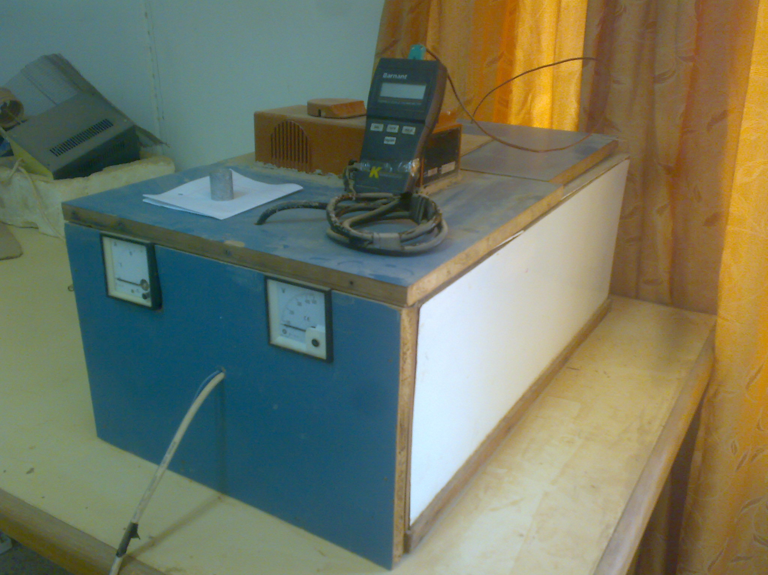
2
1
5
3
6
4
7
Figure (1) photo of a device for measuring specific heat describes the used devices in the research: 1- measure the current. 2- measure the voltage. 3- basin water. 4- double heat. 5- the test sample. 6- the remote control with heater and fan. 7- A device for measuring temperature.

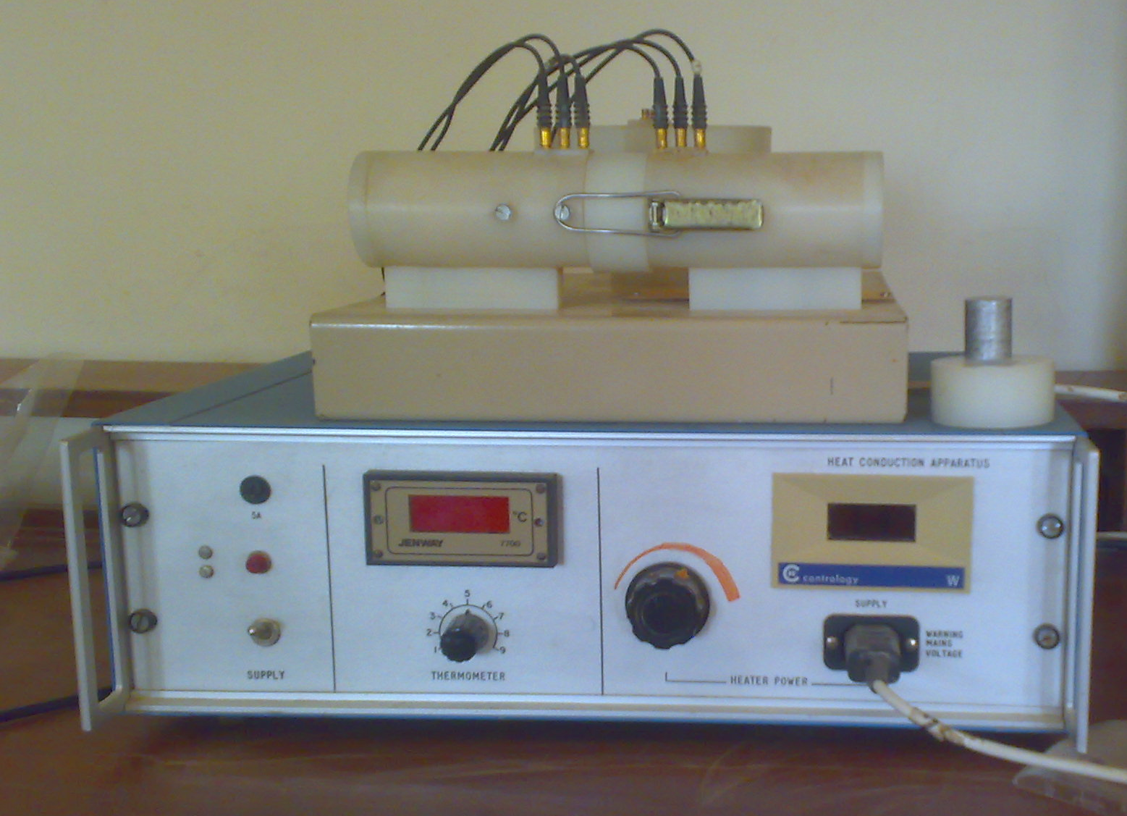
3
1
2
4
6
5
7
8
9
Figure (2) a photograph of the device for measuring thermal conductivity describes the used devices in the research: 1- Power key. 2- a digital scale with temperature. 3 - control of the thermocouples. 4 - voltage regulator. 5 - measure of power. 6 - test sample with Teflon. 7 - Teflon isolated copper electrodes. 8 - Place the test sample. 9 – Thermocouples.

Table (2) Effect Of Copper Addition On Thermal Properties Of Pure Aluminum

$α$  M²/s*10⁶ | C  j/g.c | K  w/m.c | Density  g/cm³ | Alloy
97.5 | 0.896 | 236 | 2.702 | AL-pure
92.84 | 0.87 | 243.45 | 3.014 | AL+5%Cu
89.27 | 0.845 | 250.9 | 3.326 | AL+10%Cu
86.71 | 0.819 | 258.35 | 3.638 | AL+15%Cu
84.75 | 0.794 | 265.8 | 3.95 | AL+20%Cu
83.48 | 0.768 | 273.25 | 4.262 | AL+25%Cu
14.4% | 14.3% | 15.78% | 57.7% | Percentage %

Table (3) Effect Of nickel Addition On Thermal Properties Of Pure Aluminum

$α$  M²/s*10⁶ | C  j/g.c | K  w/m.c | Density  g/cm³ | Alloy
97.5 | 0.896 | 236 | 2.702 | AL-pure
86.75 | 0.87 | 227.24 | 3.011 | AL+5%Ni
77.42 | 0.85 | 218.47 | 3.32 | AL+10% Ni
69.5 | 0.831 | 209.71 | 3.63 | AL+15% Ni
63 | 0.81 | 201 | 3.94 | AL+20% Ni
53.82 | 0.79 | 192.18 | 4.52 | AL+25% Ni
44.8% | 11.8% | 18.6% | 67.3% | Percentage %
2
2.5
3
3.5
4
4.5
5
0
0.05
0.1
0.15
0.2
0.25
0.3
Density (%Cu)
Density (%Ni)
Thermal conductivity (%Cu)
Thermal conductivity (%Ni)

Thermal conductivity
Density
270
290
230
250
210
170
190
Additional Percentages of Cu and Ni
150
0
0.05
0.1
0.15
0.2
0.25
0.3
Additional Percentages of Cu and Ni
Figure (3) Effect Of Copper and nickel Additions On density Property Of Pure Aluminum

Figure (4) Effect Of Copper and nickel Additions On Thermal conductivity Property Of Pure Aluminum

0.76
0.78
0.8
0.82
0.84
0.86
0.88
0.9
0.92
0
0.05
0.1
0.15
0.2
0.25
0.3
Specific heat (%Cu)
Specific heat (%Ni)

Specific heat
Thermal diffusivity (%Cu)
Thermal diffusivity (%Ni)

Thermal diffusivity
110
100
80
90
Figure (6) Effect Of Copper and nickel Additions On specific heat Property Of Pure Aluminum

Additional Percentages of Cu and Ni
40
50
60
70
0
0.05
0.1
0.15
0.2
0.25
0.3
Figure (5) Effect Of Copper and nickel Additions On Thermal diffusivity Property Of Pure Aluminum

Additional Percentages of Cu and Ni

Figure (7) normal probability plot of the density

Figure (8) normal probability plot of the thermal conductivity

Figure (9) normal probability plot of the specific heat

Figure (10) normal probability plot of the thermal diffusivity

7- REFERENCES
F.P. Incropera and D.P. Dewit,2000," Fundamentals of Heat and Mass Transfer", Wiley, New York, NY.

I.G. Brodova, P.S. Popel, and G.I. Eskin,2002," Liquid Metal Processing Applications to Aluminium Alloys Production", Taylor & Francis, New York, NY.

MANUEL V. CANTE and AMAURI GARCIA,2008," Microstructural Development in Al-Ni Alloys Directionally Solidified under Unsteady-State Conditions", The Minerals, Metals & Materials Society and ASM International.

Robert L. Mason,2003," Statistical Design and Analysis of Experiments With Applications to Engineering and Science" Second Edition, by John Wiley & Sons, Inc.

R. Mathiesen, L. Arnberg, P. Bleuet, and A. Somogyi,2006," Metall. Mater", Trans. A, vol. 37A.

R.M, Lumley, R.G, O'Donnel, D.R, Gunasegaram, M. Girord,2006,"Heat Treating Progress", Materials Science and Engineering A,Vol.18, No.11.

Steve Miller,2005," Experimental Design and Statistics", SECOND EDITION, London and New York by Routledge.

Y. Plevachuk and V. Sklyarchuk,2008,"Density, Viscosity, and Electrical Conductivity of Hypoeutectic-Cu Liquid Alloys" The Minerals, Metals & Materials Society and ASM International.

