________________________________________________________________________

EFFECT OF ELASTIC DEFORMATION ON TURBULENT LUBRICATION BASIM A. ABASS OF MISALIGNED PLAIN JOURNAL BEARINGS
Basim A. Abass Soadad N. Ghani
BabylonUniversity Al-Kofa University
________________________________________________________________________
Abstract:
An investigation to the turbulent lubrication performance of journal bearing considering journal misalignment and bearing elastic deformation has been established and validated through this work. Oil film pressure, side leakage flow rate, friction coefficient and misalignment moments at variant journal misalignment and bearing elastic deformation are calculated based on the modified Reynolds equation to include the effect of turbulent flow of oil due to high speeds of journal .Suitable models for journal misalignment and bearing elastic deformation have been used and included to the oil film thickness. Some of the results obtaind through this work have been compared with that obtained by the other workers and found to be in agood agreemnt. It has been shown that the combined effect of the bearing shell elastic deformation and the journal misalignment has a considerable effect on the bearing parametres and can not be neglected.

Keywords: Elastic Deformation, Turbulent Lubrication, journal bearing.

تأثير الانفعالات المرنة على التزييت المضطرب للمحامل الغير متلامسة المحامل
الخلاصة
تم في هذا البحث، دراسة اداء التزييت المضطرب للمسند المقعدي مع الاخذ بنظر الاعتبار عدم تطابق المحاوروالتشوه المرن لجسم المقعد.تم احتساب ضغط الزيت ومعدل الجريان ومعامل الاحتكاك والعزم الناتج عن اللاتمحور عن طريق حل معادلة رينولدز المحورة لتاخذ بنظر الاعتبار تاثير الجريان المضطرب للزيت نتيجة السرعة العالية للمحور الدوار. تم اعتماد نماذج رياضية مناسبة لدراسة اللاتمحور والتشوه المرن لجسم المقعد من خلال تضمينها لمعادلة سمك طبقة الزيت. تمت مقارنة بعض النتائج المستحصلة خلال هذا البحث مع تلك المنشورة لباحثين اخرين ووجدت في حالة تطابق جيد.لوحظ خلال هذا البحث ان المركب لللاتمحور والتشوه المرن لجسم المسند المقعدي تاثير معتبر على اداء المسند والتي لايمكن اهمالها.
Introduction:
Journal bearings are used extensively where rotating machinery operates at high speed. In many cases, because of the small clearance ratio, lubricant flow becomes laminar. Under certain special conditions , such as bearings of large dimensions (large clearance) or when a fluid with a low kinematic viscosity is used as lubricant , turbulence may also occur at moderate velocities currently used in the design of hydrodynamic bearing . Theoretical analysis of turbulent lubrication dated back to 1965 when Constantinescu develops a theory of turbulent lubrication [1]. The behavior of journal bearings under turbulent lubrication condition has been investigated by many researchers [2-10]. Constantinescu and Galetuse [2] utilized the possibilities of improving the accuracy of the evaluation of inertia forces in laminar and turbulent films .Robert and Hinton [3]applied the short plain journal bearing assumption to experimentally investigate the pressure distribution in super laminar journal bearings. Capone et.al [4] examined the influence of turbulence on the shaft in non laminar lubrication regime. Hashimoto and Wada [5] utilized a method to solve turbulent lubrication problems of sector – shaped , tilting – pad thrust bearings incorporating thermal and elastic deformation of the pad . Wilcok and Pinkus [6] calculated the dynamic coefficients of fluid film journal bearings under turbulence and viscosity variation conditions. Safar et.al [7] presented an analysis of the performance characteristics for a misaligned full journal bearing operating in turbulent regime.Nikolakopoulos and Papadopoulos [8] analyzed the hydrodynamic Newtonian lubrication for misaligned journal bearings.Bouard et-al [9] compared the results of three turbulent models with the experimental data .Hashimoto [10] showed the applicability of the modified Reynolds equation developed by Hashimoto and Wada to high –speed journal bearing analysis by comparing the theoretical results with the experimental ones . Mokhiamer et .al [11] studied the effect of bearing elastic deformation on the performance of a journal bearing lubricated with couple stress fluid .Wang et.al [12] performed several tests for predictions of flow field of various turbulent lubrication models. Arghir and Frene [13] studied the problems of high Reynolds number lubrication i.e turbulent regime and inertia effects.The effect of turbulence on the performance of a four – lobe pressure dam bearing has been investigated by Bhushan et .al [14]. Maneshian and Nassab [15] used computational fluid dynamic techniques to estimate the thermohydrodynamic characteristic, of infinite length journal bearings with turbulent lubrication flow .
In the present work the combined effect of journal misalignment and bearing elastic deformation has been investigated when the bearing working under the condition of turbulent lubrication. The modified Reynolds equation according the Constantinescu turbulent model was used together with the oil film thickness equation in cluding the effect of journal misalignment model similar to that used by Jang and Al-Khonsary [16 ] and bearing shell elastic deformation , to investigate and predict numerically the combined effect of these parameters on the performance of plane journal bearing working under turbulent flow lubrication.
Governing equation:
The modified Reynolds equation according to Constantinescu turbulent model [17] for steadily loaded journal bearing for finite length can be written as .
$\frac{∂}{∂θ}[\frac{{\overline{h}}^{3}}{k_{x}}\text{.}\frac{∂\overline{P}}{∂θ}]+(\frac{r}{L})^{2}\text{.}\frac{∂}{∂z}[\frac{{\overline{h}}^{3}}{k_{z}}\text{.}\frac{∂\overline{P}}{∂z}]=\frac{1}{2}\text{.}\frac{∂\overline{h}}{∂θ}$ (1)
Where $\overline{h}=\frac{h}{c}$ : is non dimensional nominal oil film thickness.
$\overline{P}=\frac{P}{μ_{\text{in}}\text{.}U}\text{.}\frac{c^{2}}{R}$: is non dimensional oil film pressure.
k_{x} and k_{z} are the turbulent resistance coefficients which can be evaluated as:
k_{x}= f(R_{e}) and k_{z}= f(R_{e})
Where $R_{e}=\frac{U\text{.}h}{υ},$ is the local Reynolds number .
Appropriate values of k_{x} and k_{z} are given by the following relationships [17]
$k_{x}=\text{12}+0\text{.}\text{026}(R_{e})^{0\text{.}\text{865}}$ (2)
$k_{z}=\text{12}+0\text{.}\text{0198}(R_{e})^{0\text{.}\text{741}}$ (3)
The oil film thickness can be evaluated as:
$\bar{H}=\bar{h}(θ,Z)+δ$ (4) Where $\bar{h}(θ,Z)$ is the non-dimensional oil film thickness component in which the misalignment effect is included, while 𝛿 is the term accounts for the elastic deformation of the bearing shell .
The journal misalignment model similar to that used by Jang and Khonsari [16] adopted through this work. The oil film thickness can be evaluated as:
$\bar{h}=1+$Є_{o}cos(θ-φ_{o})+Є'($\bar{Z}$-0.5)cos(θ–α-φ_{o}) (5)
Where :
Є_{o} and φ_{o} are the eccentricity vectors of the journal at the axial center line of the bearing.
Є' : the magnitude of the projection of the complete journal center – line on the mid-plaine.
Є'_{max}: the maximum possible value of Є’ (for which the journal and the bearing will come into metal – to – metal contact). From geometrical considerations, see figure (1), Є'_{max} can be computed from the following relation ship [16 ].
Є'_{max}= 2*[(1- Є_{o}² sin² α)^{1/2} - Є_{o} $\left|\text{cos}α\right|$] (6)

𝚹
Φ_{o}
e'_{max}
Front
Rear
C
O
C₁
C₂
e_{o}
α
e'
Y
Z
Front
Rear
L/2
L/2
O
C₁
C
H(𝜭,Z)
C₂
Y
M_{y}
X
M_{x}

Figure(1): Schem of misaligned journal bearing [16]

α : the angle between the journal rear center line projection and the eccentricity vector Є_{o}.
To include the effect of bearing shell elastic deformation on the oil film thickness , the model used by Saber and el-Gamal [18] has been adopted through this work . It has been shown that for bearings with small thickness and poisons ratio ranging between 0.3 and 0.4 ,a simple model of the following formcan be used:
$δ=C_{o}\overset{−}{P}=[\frac{μ\text{.}ω\text{.}R{\text{.}}_{r_{{}_{{}_{b}}}}\text{.}t\text{.}(1−ν^{2})}{C^{3}\text{.}E}]\text{.}\overset{−}{P}$ (7)
The boundary conditions for equation (1) are .
(a). Pressure at the edges of bearing is assumed to be atmospheric
$$\overset{−}{P}(θ,0)=0$$
$\overset{−}{P}(θ,1)=0$ (8)
(b). The well known Reynolds boundary conditions has been adopted through this work.
${\overset{−}{P}}_{(θ≥θ_{c},Z)}=(\frac{∂\overset{−}{P}}{∂θ})|_{θ=θc}=0$ (9)
Where 𝜭_{c} is the angle at which oil cavitation occurs, i.e the flow becomes liquid gas or the angle at which the oil film pressure becomes negative.
Solution technique:
The determination of pressure field in the lubricant film consists of the numerical solution of Reynolds equation together with suitable boundary conditions using finite difference method. The Reynolds equation is presented in its finite difference form. A rectangular mesh of (m-1) sections in (𝚹) and (n-1) sections in (Z) direction to give a mesh size of (m*n) has been constructed to cover the fluid film in the bearing clearance. The value of the pressure at each nodal point can be evaluated by iteratively solving Reynolds and oil film thickness equations. The following iterative procedure is used to calculate the bearing performance characteristics:-
1- Input the bearing data and initial values of different variables to the computer program.
2- Calculate the initial value of the attitude angle.
3- Assume initial oil film pressure field.
4-Calculate the oil film thickness with suitable misalignment and elastic deformation models.
5- Calculate the pressure distribution by solving the Reynolds equation (equation 1) .
6- Compare the new values of pressure with the old one.
7- If there is no convergence a new oil film pressure field is generated using a suitable under relaxation factor. Go to step (5). The iterations are stopped when the convergance criterion was reached. An error of 0.01% is adopted in this work.
8- A new attitude angle is calculated and compared with the old one.
9- if the difference between the old and the new values of the attitude angle is greater than one degree the compute a new pressure field until the difference between the last two values reachs less than one degree.
10- Calculate the bearing performance parameters.
Calculation of Bearing Parameters:
The load parameter components W_{r} and W_{t} parallel and normal to the line of centers respectively are given by:
$\overline{W_{r}}=\int_{0}^{1}{\int_{0}^{2π}{\overline{P\text{.}}}}\text{Cos}(θ)\text{.}dθ\text{.}\overline{\text{dZ}}$ (10)

$\overline{W_{t}}=\int_{0}^{1}{\int_{0}^{2π}{\overline{P\text{.}}}}\text{Sin}(θ)\text{.}dθ\text{.}\overline{\text{dZ}}$ (11)
Where:
$\overline{W_{r}}$: radial component of load carrying capacity
$\overline{W_{t}}$: tangential component of load carrying capacity

The total load carrying capacity can be evaluated as :
$\overline{W}=\sqrt{\overline{W_{r}^{2}}+\overline{W_{t}^{2}}}$ (12)

The attitude angle between the load line and the line of centers can be expressed as:

$φ={\text{tan}}^{−1}\left(\frac{\overline{W_{t}}}{\overline{W_{r}}}\right)$ (13)
The characteristics in steady running of journal bearing with specified design are usually expressed non-dimensionally as functions of a single parameter called the Sommerfeld Number [19]. It is often referred to as the bearing characteristic number. The Sommerfeld Number can be mathematically represented as :

$S_{m}=\frac{μ\text{.}ω\text{.}L\text{.}R}{πW}(\frac{R}{C})^{2}$
(14)

But, the angular velocity of the shaft (rad/sec) is equal to
$ω=\frac{2πN}{\text{60}}$
Where
N= the shaft rotational speed in (rpm).
Therefore, the sommerfeld number (S_{m}) can be rewritten as:
$S_{m}=\frac{2\text{.}μ\text{.}N\text{.}L\text{.}R}{\text{60}W}(\frac{R}{C})^{2}$ (15)
Where,
W=$U\text{.}L\text{.}μ\text{.}(\frac{R}{C})^{2}\overline{W}$
For a given pressure distribution, the pressure gradient ($\frac{∂P}{∂θ}$) can be evaluated numerically and hence the viscous shear stress (𝛕  ) can be calculated as:
$τ=μ\text{.}(\frac{U}{h})\text{.}τ_{c}+(\frac{h}{2})\text{.}\frac{∂P}{∂X}$ (16)
The value of 𝛕_{c} can be estimated [20 ] as :
$τ_{c}=1+0\text{.}\text{0023}\text{.}(\text{Re})^{0\text{.}\text{855}}$ (17)
Integration of such shear stress along the journal circumferences gives directly the frictional drag as follows:
$F=\int_{0}^{L}{\int_{0}^{θ_{c}}{τ\text{.}dθ\text{.}\text{dz}}}$ (18)
The coefficient of friction can then be evaluated as :
$f=\frac{F}{W}$ (19)
The amount of flow that needs to be replenished to maintain a full film can be expressed as :
$Q=\frac{2}{μ}\int_{0}^{θ_{c}}{\frac{h^{3}}{k_{z}}}\text{.}\frac{∂P}{∂Z}|_{Z=L}dθ$ (20)
The journal bearing configuration in Figure(1) requires the application of external moments for steady - state operation. The required torque for steady – state operation is calculated directly from the pressure distribution. The torques about axes shown in Figure(3-2) are defined in dimensionless form as [16].
$\overline{M_{X}}=\int_{0}^{1}{\int_{0}^{2π}{\overline{P\text{.}}}}(\overline{Z}−\frac{1}{2})\text{.}\text{Cos}(θ)\text{.}dθ\text{.}\overline{\text{dZ}}$ (21)
$\overline{M_{Y}}=\int_{0}^{1}{\int_{0}^{2π}{\overline{P\text{.}}}}(\overline{Z}−\frac{1}{2})\text{.}\text{Sin}(θ)\text{.}dθ\text{.}\overline{\text{dZ}}$ (22)
the total misalignment moment in dimensionless form can be evaluated as :

Results and discussion:
Table (1) shows the list of the input variables used in the computer simulations. The effect of bearing misalignment on the performance of the journal bearing lubricated with turbulent lubrication was considered by using different values of the degree of shaft misalignment (Dm=0.25 and 0.75) while the effect of the bearing shell elasticity was discussed by using different values of elastic coefficients (C_{o}=0, 0.02 and 0.05).To verify the theoretical predictions, some of the results obtained through this work are compared with that published by other workers. Figures(1-3) show comparison between some of the results obtained in this work with that obtained by constantinscu (1962) and Capon et.al (1983). It is clear from these figures that the results are in agood agreement. The elastic deformation of the bearing shell affects the oil film pressure as shown in figure(4). It can be shown that a lower pressure is attained for the bearing with elastic shell of higher elastic coefficients. It can also be seen that the bearing working at higher misalignment coefficients has higher oil film pressure. The oil film pressure distribution for a bearing with elastic shell of different elastic coefficients and three vales of Reynolds number are shown in figure(5). Higher pressure values have been obtained for the bearing working at higher Reynolds number, for a given elastic coefficient. The next set of the curves presents the influence of elasticity and misalignment coefficients on the maximum oil film pressure as shown in figure (6). A lower values of maximum oil film pressure is obtained for the bearing with higher elastic coefficients, while higher values of oil film pressure have been attained for the bearing with higher degree of misalignment coefficients. It can be seen from figure (7) that bearing working at higher values of Reynolds number has a maximum oil film pressure for a bearing with elastic shell of spesific elastic coefficient. Figure (8) presents the influence of eccentricity ratio on the coefficient of friction for different values of elastic and misalignment coefficients. The figure shows that the bearing with higher elastic coefficient has higher coefficient of friction . The coefficient of friction decreases as the bearing works at higher misalignment coefficient. This can be attributed to the increase in the load carrying capacity of the bearing. Figre(9) shows that neither the elastic deformation nor the misalignment coefficients have a significant effect on the attitude angle. The dimensionless oil side leakage for different values of elastic and misalignment coefficients is given in figure (10). As a direct consequence of the higher pressure in axial direction due to the working of the bearing at higher misalignment coefficient leads to higher side leakag. It can also be seen that the side leakage decreases as the bearing elastic coefficient increases which leads to a reduced oil film pressure.The bearing parameter (Somerfeld number) seems to decrease as the bearing works with a shell of higher values of elasticity coefficient as shown in figure (11).This can be attributed to the decreased load carrying capacity in this case. Figure (12) shows that the bearing misalignment moment followed the pressure variation since it strongly depends on the oil film pressure.

Conclusions:
From the results presented it can be concluded that the elastic deformation has a cosiderable effet on the oil film pressure distribution. The pressure decreases as the bearing has an elastic bearing shell having higher values of elasticity coefficient. Also it appears that the load carrying capacity of the bearing increases as the bearing works at higher degree of bearing misalignment. It can also be cocluded that neither the bearing elastic deformation nor the misalignment coefficients have a significant effect on attitude angle of the bearing.

.

Figure(2):Comparison between the result obtained in this work with that obtained in [1]

Figure (3): Comparison between the results obtained in this work with that obtained in[1]

Figure(4): Comparison between the results obtained in this work with that obtained in[4]
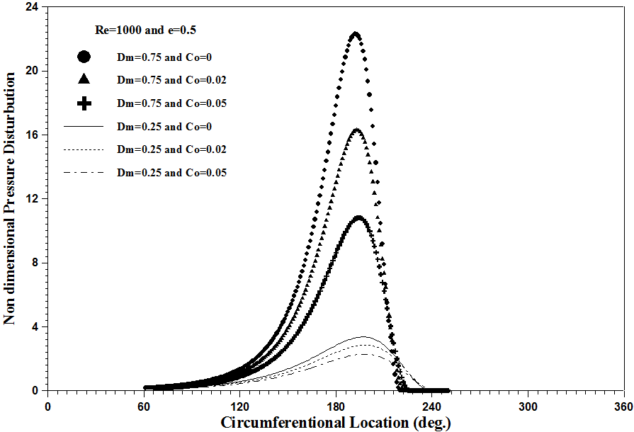

Figure(5): Circumferential pressure distribution for a bearing with different degree of misalignment and elasticity coefficients.

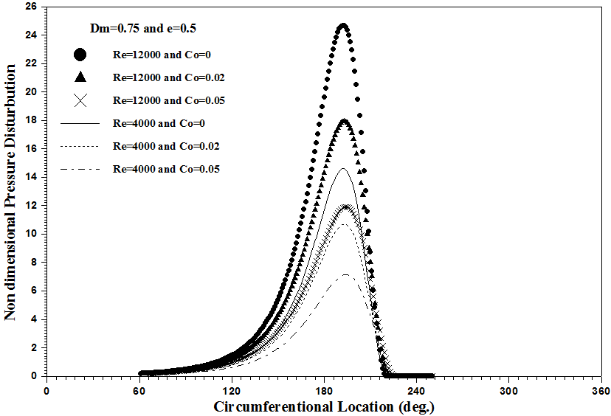

Figure(6): Circumferential pressure distribution for a bearing working at different Reynolds number and elasticity coefficients.
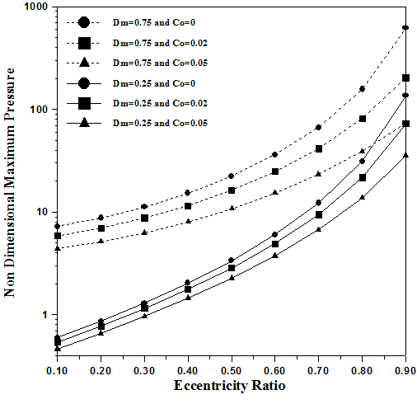

Figure(7):Non dimensional maximum pressure against eccentricity ratio for a bearing working at different misalignment and elastic coefficients.
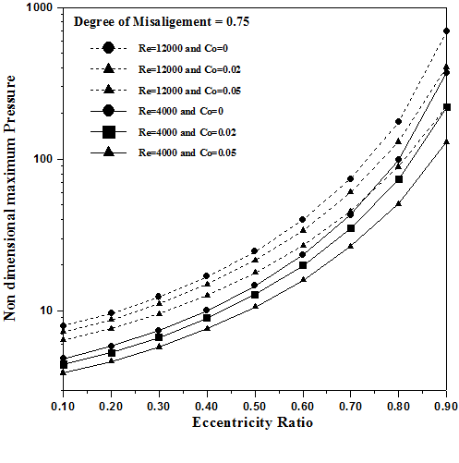

Figure(8): Non diamensional maximum pressure for a bearing working at different Reynolds number and elasticity coefficients.

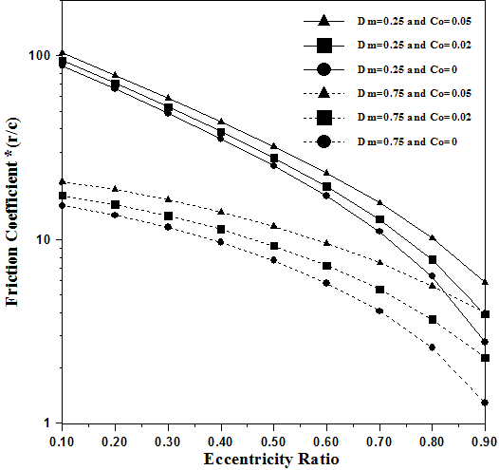

Figure(9): Friction coefficient against eccentricity ratio for a bearing working at different misalignment and elasticity coefficients.

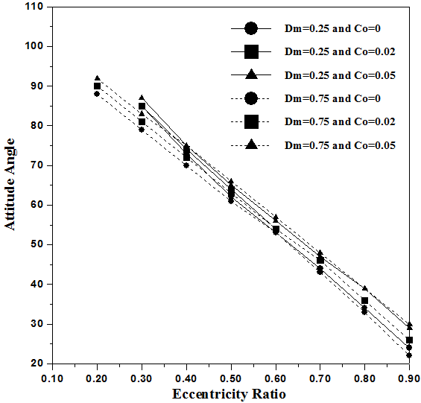

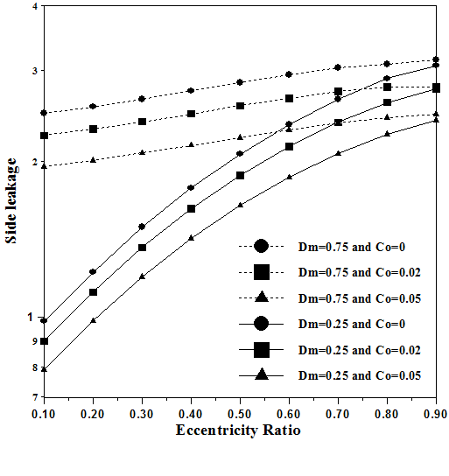
Figure(10): Attitude angle against eccentricity ratio for different misalignment and elasticity coefficients.

Figure(11): Side Leakage flow against eccentricity ratio for different misalignment and elasticity coefficients.

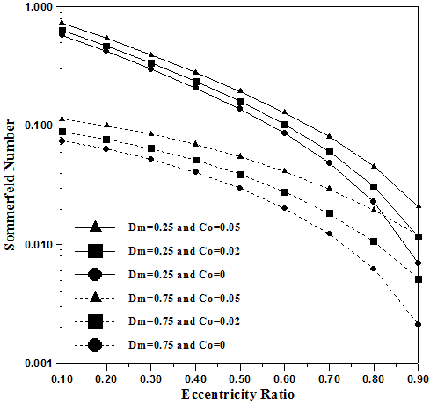

Figure(12): Sommerfeld number against eccentricity ratio for different misalignment and elasticity coefficients.
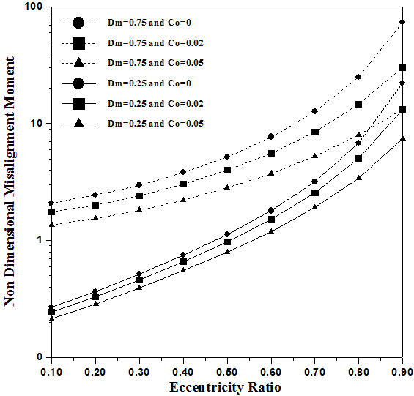

Figure(13):Non dimensional misalignmentmoment against eccentricity ratio for different misalignment and elasticity coefficients.

Table(1): Journal bearing and oil parameters used []
Properties | Values
Inlet lubricant viscosity 𝛍_{o} , Pa. s | 0.0236
journal radius (R), m | 0.0368
External bearing radius (r_{bout}), m | 0.1
Bearing length (L)   m  | 0.0368
Radial clearance (C), m | 0.00075
Rotation speed (N), rpm | 25000
Inlet lubricant pressure(p_{s}), N/m² | 70000
Eccentricity ratio( 𝝐) | (0.1-0.9)

References:
[1]Constantinescu, V. N., "Analysis of bearings operating in turbulent regime", ASME, Journal of Basic Engineering, Vol. 84, No.1, May 1962, PP 139-151.
[2] Constantinescu, V. N., and Galetuse, S., "On the possibilities of improving the accuracy of the evaluation of inertia forces in laminar and turbulent films", ASME, Journal of Lubrication Technology, January 1974, PP 69-79.
[3] Roberts, J. B., and Hinton, R. E., " Pressure distributions in a superlaminar journal bearing", ASME, Journal of Lubrication Technology, Vol.104, April 1982, PP 187-196.
[4]Capone, G., D'Agostino, V., and Russo, M., " Performance of finite journal bearings in non laminar lubrication regime", Tribology International, Vol.16, No. 2, April 1983, PP 85-88.
[5]Hashimoto, H., and Wada, S. "Turbulent lubrication of tilting pad thrust bearings with thermal and elastic deformations", Transactions of the ASME, Vol.107, January 1985, PP 82-86.
[6]Wilcock, D. F., and Pinkus, O. " Effects of turbulence and viscosity variation on the dynamic coefficients of fluid film journal bearings", Transactions of the ASME, Vol.107, April 1985, PP256-262.
[7]Safar, Z. S., Elkotb, M. M., and Mokhtar, D. M., "Analysis of misaligned journal bearings operating in turbulent regime", ASME, Journal of Tribology, Vol.111, April 1989, PP215-219.
[8]Nikolakopoulos, P. G., and Papadopoulos, C. A., " Non-linearities in misaligned journal bearings", Tribology International, Volume 27, Issue 4, August 1994, Pages 243-257.
[9]Bouard, L., Fillon, M., and Frene, J. " Comparison between three turbulent models – application to thermohydrodynamic performances of tilting pad journal bearings", Tribology International Vol.29, No.1, 1996, PP11-18.
[10]Hashimoto, H., "Surface roughness effect in high speed hydrodynamic journal bearings", Transactions of the ASME, Vol.119, October 1997, PP 776-780.
[11]Mokhiamer, U. M., Crosby, W. A., and El-Gamal, H. A., " A study of a journal bearing lubricated by fluids with couple stress considering the elasticity of the liner", Tribology International, Vol.224, 1999, PP 194-201.
[12]Wang, Y., Zhang, C., Wang, Q. J., and Lin, C., "A mixed TEHD analysis and experiment of journal bearings under severe operating conditions", Tribology International Vol.35, 2002, PP 395-407.
[13]Archir, M., and Frene, J., "Problems of high Reynolds number lubrication: the turbulent regime and the inertia effects", Université de Poitiers, France, 2001.
[14]Bhushan, G., Rattan, S. S., Mehta, N. P., " Effect of turbulence on the performance of a four-lobe pressure dam pressure", IE(I) Journal, Vol.87, January 2007, PP. 18- 23.
[15]Maneshian, B., and Nassab, S. A. G., " Thermohydrodynamic analysis of turbulent flow in journal bearings running under different steady conditions", Vol. 223, No. 8, 2009, PP. 1115-1127.
[16]Jang, J. Y., and Khonsari, M. M., "On the behavior of misaligned journal bearings based on mass-conservative thermohydrodynamic analysis", ASME, Journal of Tribology, Vol.132, January 2010, PP 011702-1 to 011702-13.
[17] Constantinescu, V. N., " Theory of turbulent lubrication ", Proc. Lubrication and Wear, Houston, 1965, PP. 153-213.
[18]Saber, E., and El-Gamal, H., " Effect of Elastic Deformation of the Journal Bearing Shell on its Dynamic Stability", Solid Mechanics and Its Applications, Volume 134, Part 3, 2006, PP.121-131.
[19]Constantinescu, V. N., "Analysis of bearings operating in turbulent regime", ASME, Journal of Basic Engineering, Vol. 84, No.1, May 1962, PP 139-151.
[20] Rajasekhar E. Nicodemus, Satish C. Sharma,” Study of worn hybrid journal bearing system with different recess shapes under turbulent regim”, Journal of Tribology ,vol.132,2010, pp.041704-1- 041704-12.

