_________________________________________________________________
USING OF ANSYS PROGRAM TO CALCULATE THE MECHANICAL PROPERTIES OF ADVANCED FIBERS REINFORCED COMPOSITE

Salim J. Abbas  Technical Inst-Babylon  Assist Lecturer | Moslem M. Ali  Technical Inst-Babylon  Assist Lecturer | Ali I. Al-Mosawi  Technical Inst-Babylon  Lecturer

_________________________________________________________________
Abstract:
Mechanical properties of vinyl ester resin reinforced with different weight percentage (20%,40%,60%) glass fibers was studied theoretically using Ansys program version (11) and these properties included tensile and flexural strength. The standard specification (ISO-R-527)+(ASTM D790) were used to fabricant the tensile and flexural test samples respectively by Ansys program. The theoretical results shows that high tensile and flexural strength value for vinyl ester resin after reinforcing with glass fibers due to high elastic modulus for these fibers and this strength will increase with increasing percentage of fibers, which agree with the experimental results obtained from tensile test .

Keywords: Mechanical properties , Vinyl ester resin, Fiber-reinforced composites .
إستعمال برنامج Ansys لحساب الخواص الميكانيكية لمادة مركبة متقدمة مقواة بالألياف

علي إبراهيم الموسوي  المعهد التقني – بابل  مدرس | مسلم محسن علي  المعهد التقني – بابل  مدرس مساعد | سليم جاسم عباس  المعهد التقني – بابل  مدرس مساعد

الخلاصة:
الخواص الميكانيكية لراتنج الفنيل أستر المقوى بنسب وزنية مختلفة (%60,%40,%20) من ألياف الزجاج تم دراستها في هذا البحث بشكل نظري بإستخدام برنامج (Ansys Version 11) وقد شملت هذه الخواص كل من مقاومة الشد ومقاومة الإنثناء . أُعتمدت المواصفات القياسية (ISO-R-527) + (ASTM D790)في تصنيع نماذج إختبار الشد والإنثناء على التوالي ببرنامج (Ansys) .
لقد بينت النتائج النظرية التي تم الحصول عليها إرتفاع قيمة مقاومة الشد ومقاومة الإنثناء لراتنج الفنيل أستر بعد تقويته بألياف الزجاج نتيجة لإرتفاع معامل مرونة هذه الألياف وتزداد هذه المقاومة مع زيادة نسبة التقوية بالألياف ،والذي يتفق مع النتائج العملية التي تم الحصول عليها من الإختبارات العملية.

الكلمات الدالة : الخواص الميكانيكية ، راتنج الفنيل أستر ، المادة المركبة المقواة بالألياف .

INTRODUCTION
A composite is commonly defined as a combination of two or more distinct materials, each of which retains its own distinctive properties, to create a new material with properties that cannot be achieved by any of the components acting alone. Using this definition, it can be determined that a wide range of engineering materials fall into this category [Hull,Clyne,1997]. The reinforcing phase material may be in the form of ﬁbers, particles, or ﬂakes . The matrix phase materials are generally continuous. Examples of composite systems include concrete reinforced with steel and epoxy reinforced with graphite ﬁbers, etc [Mallick,2007]. The composite material however , generally possesses characteristic properties , such as stiffness , strength , weight , high-temperature performance , corrosion resistance , hardness , and conductivity that are not possible with the individual components by themselves . Analysis of these properties shows that they depend on (1) the properties of the individual components; (2) the relative amount of components; (3) the size ,shape ,and distribution of the discontinuous components; (4) the degree of bonding between components; and (5) the orientation of the various components [E.P.DeGarmo etal,2008] . Vinyl ester, is a resin produced by the esterification of an epoxy resin with an unsaturated monocarboxylic acid. The reaction product is then dissolved in a reactive solvent, such as styrene, to a 35 - 45 percent content by weight. It can be used as an alternative to polyester and epoxy materials in matrix or composite materials, where its characteristics, strengths, and bulk cost intermediate between polyester and epoxy[Michel,2007].
[G.Morom etal,1986] studied the effect of hybrid fibers (Carbon/Kevlar) on the impact strength of epoxy resin. also [Ali,2009] investigated the effect of changing the reinforcement percentage by fibers on Mechanical properties, for composite material consists of conbextra epoxy (EP-10) resin reinforced by biaxial woven roving kevlar fibers. [Azhdar,1992] studied the impact fracture toughness of fiber reinforced epoxy resin.[Abbas etal,2009] studied effect the change of reinforcement percentage of fibers on the thermal and mechanical properties for polymeric composite material consist of conbextra epoxy (EP-10) resin reinforced by biaxial woven roving S–type glass fibers.

TENSILE STRENGTH .
A tensile test is a fundamental mechanical test where a carefully prepared sample is loaded in a very controlled manner while measuring the applied load and the elongation of the sample over some distance. Tensile strength or ultimate strength is defined as the maximum load that results during the tensile test, divided by the cross-sectional area of the test sample. Therefore, tensile strength, like yield strength, is expressed in Mpa. Tensile tests are used to determine the modulus of elasticity, elastic limit, elongation, proportional limit, reduction in area, tensile strength, yield point, yield strength and other tensile properties [9]. Tensile strength can be obtain from the following formula :
………………………………….(1)

where :
σ = tensile strength (N/m²)
P = test load (N)
A = cross section area of sample (m²)

FLEXURAL STRENGTH .
Flexural strength is an object’s ability to bend without obtaining any major deformities. A standard experiment called the three-point test can calculate an object’s flexural strength. For example, a rectangular slab of concrete is placed on two parallel platforms. Then another object applies load on the central part of the concrete, between the platforms, and gradually increases pressure until the concrete breaks. The flexural strength of concrete is estimated based on the weight of the load that collapses the concrete, the distance between the platforms and the width and thickness of the object being tested. An object’s flexural strength also correlates with its tensile strength, or the object’s ability to be stretched without significantly changing its shape. When an object is made to bend, it is also somehow stretched, although only in a localized area. In occupational fields such as construction and engineering, knowing a material's flexural and tensile strengths is important in order to make sure that the material is strong enough to use in structures. Hard but brittle objects, such as wood concrete, alloys and plastic, are used more often in construction than elastic and ductile objects such as rubber, gold or silver, so it is more important to evaluate the former’s flexural and tensile strengths [9]. Flexural strength can be obtain from the following formula :
(2)

where :
F = Maximum load (N)
S = Distance between loading points (mm)
b = Sample width (mm)
t = Sample thickness (mm)

In theory, an object’s flexural and tensile strengths would be in similar ranges if there is homogeneity in the materials used, meaning that the substances used are mixed in equally. If the substances are not uniformly mixed, then the flexure and tensile strengths might drastically vary in different areas of the object. Another factor that can change an object’s flexural and tensile strengths is defects. For example, a rope with torn fibers might increase its tensile strength, as the fibers can stretch longer, but it might decrease its flexural strength, especially when load is applied on the area where the fibers are weakest.

WORK PROCEDURE .
In this research, Ansys program version (11) was used to calculate tensile strength value for vinyl ester resin before and after reinforced with different weight percentage from woven roving glass fibers (20%,40%,60%) . Specific Properties for both resin and fibers was input in database of Ansys program , as well as standard shape of samples , and applied different amount of loads to make a theoretical emulation to experimental tensile and flexural test , and then draw the obtained data after applied the loads . Table .1 show the specifications used to draw test samples .
Following a short description to materials used :
1- Vinyl Ester Resin type Deraken 510-a40 with (1.21g/cm³) density .
2- unidirectional glass fibers E-type (0°) with (2.6g/cm³) density .
3- Test samples: standard specification (ISO-R-527)was used with rectangular section .
4-Flexural Strength Samples : (ASTM-D790) was used as a rectangular shape(10mm×135mm) .

RESULTS & DISCUSSION .
Fig.1 presents the tensile strength to vinyl ester resin before reinforcement , where we observed that , low tensile strength for this resin when exposed to loads , because of in general the resins considered a brittle materials , which accepted with experimental results obtained by [Ali,2009].
After reinforcing by fibers this property will be improved greatly as shown in Fig.2 which represent the tensile strength to vinyl ester resin after reinforcing with (20%) glass fibers , where the strength of resin will increased due to the fibers will withstand the maximum part of loads and by consequence will raise the strength of composite material and this also accepted with experimental results obtained by [Abbas etal,2009]. The tensile strength will be increased as the fibers percentage addition increased as illustrated in Fig.3 and Fig.4 which represent tensile strength to vinyl ester resin after reinforcing with (40%) and (60%) from glass fibers respectively . These fibers will be distributed on large area in the resin which will be improved tensile strength greatly [Kiichi etal,2009]. Flexural Strength :as mentioned above ,the resin is brittle , therefore its flexural strength is low before reinforcement as shown in Fig .5 . But after added the fibers to this resin the flexural strength will be raise to the producing material because the high modulus of elasticity of these fibers will helps to carry a large amount of loads and raise this strength as illustrated in Fig.6 , Fig.7 and Fig.8 which represent tensile strength to vinyl ester resin after reinforcing with (20%) , (40%) and (60%) from glass fibers respectively [Ali,2009].

CONCLUSIONS .
From the obtained results we get :
- Low tensile and impact strength of vinyl ester resin .
- Improvement of mechanical properties after reinforcement by glass fibers .
- Increased tensile and impact strength with increasing fibers percentage .
Table .1 : Specifications used to draw test samples
No of Nodes | No of Element | Type of Element | Model
10961 | 3922 | Solid 185 Geometry , 8 Nods ,3-D Modeling | Linear | Tensile
10290 | 5145 | Solid 185 Geometry , 8 Nods ,3-D Modeling | Linear | Flexural

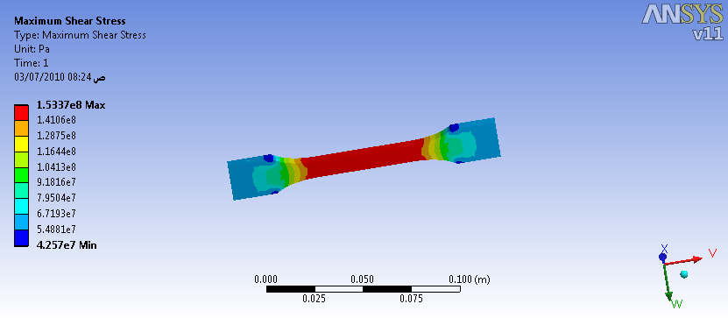
Fig.1 : Tensile strength to vinyl ester resin before reinforcement

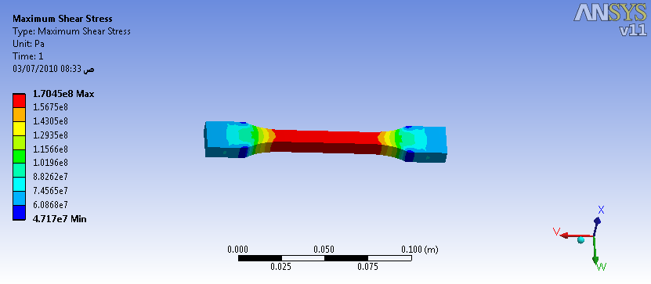
Fig.2 : Tensile strength to vinyl ester resin after reinforcing with (20%) glass fibers

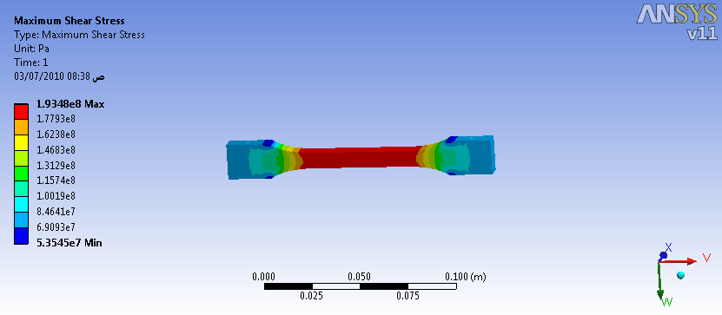
Fig.3 : Tensile strength to vinyl ester resin after reinforcing with (40%) glass fibers

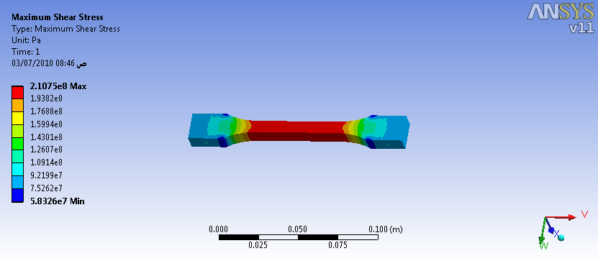
Fig.4 : Tensile strength to vinyl ester resin after reinforcing with (60%) glass fibers

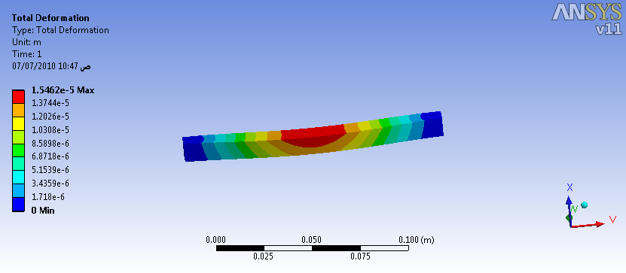
Fig.5 : Flexural strength to vinyl ester resin before reinforcement

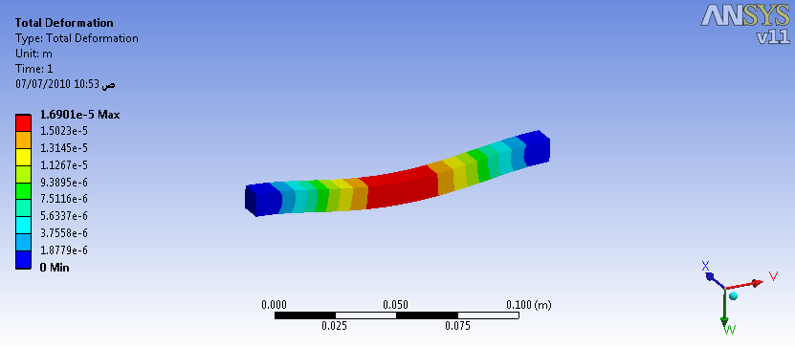
Fig.6 : Flexural strength to vinyl ester resin after reinforcing with (20%) glass fibers

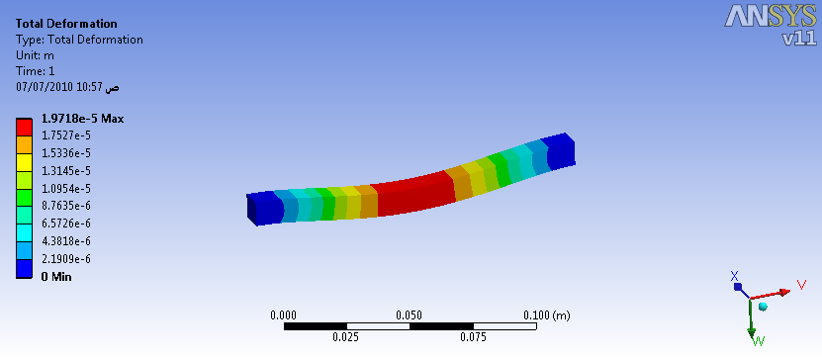
Fig.7 : Flexural strength to vinyl ester resin after reinforcing with (40%) glass fibers

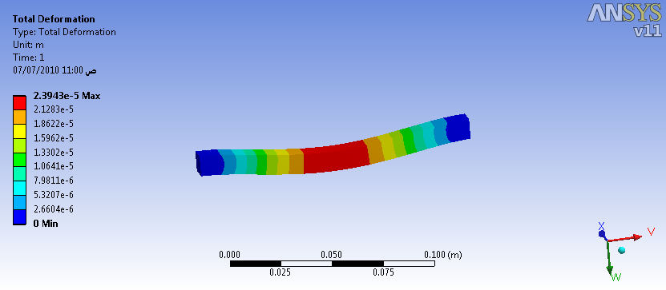
Fig.8 : Flexural strength to vinyl ester resin after reinforcing with (60%) glass fibers

REFERENCES .
Abbas A. Al-Jeebory, Ali I.Al-Mosawi “Effect of percentage of Fibers Reinforcement on Thermal and Mechanical Properties for Polymeric Composite Material ” , The Iraqi Journal for mechanical and materials Engineering , Special Issue ,1st Conference of Engineering College , 2009. pp70-82.
Ali I. Al-Mosawi “Study of Some Mechanical Properties for Polymeric Composite Material Reinforced by Fibers ” , Al-Qadessiyah Journal For Engineering Science , Vol 2 , No 1. , 2009. pp.14 – 24 .
Azhdar B.A. “Impact Fracture Toughness of Fiber Reinforced Epoxy Resin” ,M.SC Thesis ,U.O.T ,1992 .
D ,Hull , T .W, Clyne “An Introduction to Composite Materials” ,2nd Edition , Cambridge University Press ,1997.
E.P.DeGarmo, J.T. Black, and R.A. kohser “ Materials and processes in Manufacturing ” , 10th Edition , John Wiley & Sons , 2008.
G.Morom ,E.Drukkler ,A. Weinberg ,and J.Banbaji “Impact behavior of Carbon / Kevlar Hybrid Composites” , Composites ,Vol 17 ,No 2 ,1986 .pp150-153.
Kiichi Hasegawa, Hiroshi Hirano, Joji Kadota, Masahiro ABE, Satoshi Matsuda, Hajime Kishi, and Atsushi Murakami “Properties of GFRP Using Matrix Resin of Epoxy/ Acrylate Interpenetrating Polymer Network” , Journal of the Society of Materials Science, Japan Vol.54 No.4 . , 2009 .pp.447 – 452 .
Mallick ,P.K. “Fiber-Reinforced Composites: Materials, Manufacturing, and Design” ; 3rd Edition , CRC Press, Nov,2007.
Michel Biron “ Thermoplastics and Thermoplastic Composites ” , 1st Edition, Elsevier ,2007.

