________________________________________________EVALUATION THE EFFECT OF CEMENT KILN DUST ADDITION ON ABSORPTION AND SOME MECHANICAL PROPERTIES OF THE CONCRETE
Nadia. M. Al - Abdalay
M. Sc. CE Asst . Lecture
Najaf Techn. Inst. Civil Department
_________________________________________________
ABSTRACT
The goal of the present work is to investigate the effect of adding Cement kiln Dust ( CKD ), produced from Kufa cement plant on some properties of concrete. Four different concrete mixes were prepared, with 0%, 5%, 10% and 15% CKD by weight of cement was replaced. Two methods were used to study the absorption, the full immersion and the capillary rise. The effect of absorption on some properties of concrete (compressive, tensile, flexural) strength were studied. The compressive strength of concrete specimens decreased with the increasing of the quantity of CKD. However, there was no significant difference in the compressive strength of 0 and 5% CKD cement concretes. A similar trend was noted in the splitting, flexural tensile strength and concrete absorption. The performance of concrete with 5% CKD was almost similar to that of concrete without CKD.
Key word :properties of cement kiln dust, concrete absorption, capillary rise.
تقييم تأثير إضافة غبار مرسبات السمنت على امتصاص وبعض الخواص الميكانيكية للخرسانة
نادية العبدلي
مدرس مساعد
المعهد التقني / النجف
الخلاصة:- هدف هذا البحث إلى دراسة تأثير إضافة غبار مرسبات السمنت المنتج محليا من معامل سمنت الكوفة على بعض خواص الخرسانة. تم تحضير أربع خلطات خرسانية (15%,10%,5%,0% ) من غبار مرسبات السمنت كنسبة من وزن السمنت. استخدمت طريقتين للدراسة الامتصاص ( الامتصاص الكلي , امتصاص بالخاصية الشعرية ) ودراسة تأثير الامتصاص على بعض خواص الخرسانة ( الانضغاط , الشد ، الانثناء) . تقل مقاومة الانضغاط للخرسانة مع زيادة كمية غبار السمنت , بينما لا يوجد فرق ملحوظ بين مقاومة الانضغاط للخلطة المرجعية والخلطة الحاوية على غبار السمنت بنسبة 5% , لوحظ نفس السلوك للشد والانثناء والامتصاص, سلوك الخرسانة الحاوية على غبار السمنت بنسبة 5% مشابه إلى سلوك الخرسانة بدون غبار السمنت .
Introduction:
One of the most important problems in the construction of underground structures such as basements and underground stores is the leakage of the underground water to the structure. The designer of such structures, therefore, must give this problem proper attention. The designer must inspect the soil investigation results of the site and examine the water table fluctuations. Furthermore, he must examine the quality of under-ground water, such as the chemical properties and the depth below natural ground level ( Abdul-Rehada,1977) . Concrete absorbs water because surface tension in capillary pores in the hydrated cement paste "pulls in" water by capillary suction. Water - proofing admixtures aim is to prevent this penetration of water into concrete. Their performance is very much dependent on whether the applied water pressure is low, as in the case of rain (other than driven by wind ) or capillary rise, or whether a hydrostatic pressure is applied, as in the case of water - retaining structures or structures such as basements in water logged ground. A filler is a very finely - ground material, of about the same fineness as Portland cement, which, owing to its physical properties, has a beneficial effect on some properties of concrete, such as workability, density, porosity, capillarity, bleeding, or cracking tendency ( Neville, 1995 ).
A large quantity of dust, commonly known as cement kiln dust(CKD), is produced during the production of Portland cement. With modern manufacturing techniques, it is technically possible to introduce most of the CKD back into the clinker-making process. However, it is not done due to the high alkali content in the CKD. Most international specifications restrict the alkali content in cement to less than 0.6% to avoid the possibility of alkali-aggregate reaction (Aidan and Trevor, 1995).

( Khatiba, and Mangat, 1995 ) studied the absorption characteristics of concrete as function location relative to casting position. In that research three different concrete mixes were prepared, the control mix in which no cement replacement material was added, and mixes where 22% and 9% by weight of cement was replaced with fly ash and silica fume respectively. Mixes were cast in 100 mm cube moulds and cured at 20 ºC and 45 ºC using a variety of different curing regimes with respect to relative humidity and curing time to simulate concretes in hot and temperate climates. After curing, sliced samples were taken from various locations (faces) of the cube to determine their absorption. Two methods were used to study the absorption characteristics, the shallow immersion and the capillary rise. A large variation in absorption values existed between the upper surface during casting of the concrete cubes, the base and the sides. The absorption value of the complete un sectioned cube (100 mm) is similar to that of sectioned side face. A near-linear relationship exists between the two absorption methods.
(Shoaib et al. 2000) evaluated the influence of CKD substitution on the mechanical properties of concrete. Materials used in that research were ‘‘untreated” raw CKD which was collected from electrostatic precipitators, OPC, BFS, and sulfate resisting Portland cement (SRPC). It was reported that with increasing quantity of CKD, generally, the ultimate compressive as well as tensile strengths decreased for OPC concrete specimens; a slight increase in strength was observed for BFSC and SRPC. Further, it was found that the high limit for substitution was not more than 30% for SRPC, and 20% for BFSC, and 10% for OPC.

(Chan and Wu 2000) stated that the durable concrete could be made with 25 percent of cement replaced with inert materials such as silts and clays .Up to this level , the compressive strength was slightly lower than that of the control mix . They also indicated that the inert materials could give more micro - filler effect and nucleation sites for cement hydration.

(Al - Harthy et al. 2003) Investigated the effect of CKD on the flexural strength and toughness of concrete mixtures at the ages of 3,7,and 28 days. Test results indicated that at 28 days and at water-binder ratio of 0.5, the reduction in flexural strength for up to 6% for CKD substitution levels up to 25%, whereas it was 20% for 30% CKD substitution. Similarly, at water – binder ratio of 0.6, there was no significant decrease (3)% in flexural strength for up to 10% CKD substitution, whereas 13- 29 % reduction in flexural strength was observed for CKD substitution levels beyond 10%. At water – to – binder ratio of 0.7,there was significant reduction in flexural strength of 26- 37 % for CKD substitution levels of 5-30 %. At water – to – binder ratio of 0.6, there was a 16% reduction in the toughness at 5% CKD level, and then it decreased to 47% for 30% CKD level. At a eater – to – binder ratio of 0.7, the reduction in toughness varied between 275 and 55% depending upon the CKD substitution; and concrete mixtures containing lower percentages ( 5%) of CKD produced close flexural strength and toughness values to the control mix, especially at a water- to- binder ratio of 0.5.
(Maslehuddin , et al. 2008) In that study, CKD was incorporated in ASTM C 150 Type I cement. It was reported that CKD does not adversely affect the properties of cement. There was no increase in the water requirement for maintaining a required slump due to the addition of CKD. The initial and final setting times of CKD cement mixtures decreased slightly but they were well within the ASTM C 150 requirements. Autoclave expansion increased but it was less than the maximum ASTM C 150 requirement of 0.8%. The early-age (3 and 7 days) and 28-day compressive strength of CKD cement mortar was higher than that of Type I cement mortar, and the shrinkage strain increased with an increase in the quantity of CKD.

(Kalil, 2008 ) studied the influence of water proofing admixture of stearate type on the water reduction of concrete mix (1:2:4) by volume for a given workability, (50±5) mm slump was investigated. Resulted showed this admixture has a little influence on the water reducer also the same influence on the compressive strength of concrete at various ages ( 7, 28, 60 and 90 ) days. The efficiency of this admixture at different doses in reducing the total water absorption of concrete and the absorption of water by the capillary action was also examined. Results revealed that this admixture is not effective in reducing the water absorption for all doses used in this work compared with reference mix without admixture.

Experimental Work
Materials
1- Cement:
Ordinary Portland cement ( O.P.C ) manufactured by united cement company commercially known (TASLUJA- BAZIAN) was used throughout this study. This cement comforted to the Iraqi specification NO.5 /1984.
The chemical composition and physical properties are presented in Table ( 1 ).

Table ( 1 ) Physical analysis and chemical composition of the cement
Physical Properties | Test Results | I.Q.S.5: 1984 Limits
Setting Time :  Initial hrs ; min  Final hrs ; min | 2;00  6.0;00 | ≥45 min  ≤10hrs
Compressive Strength MPa  3-days  7-days | 18  26 | ≥15  ≥23

Oxide | % | I.Q.S. 5: 1984 Limits
CaO  SiO₂  Al₂O₃  Fe₂O₃  MgO  K₂O  Na₂O  SO₃  Loss On Ignition (L.O.I)  Lime Saturation Factor (L.S.F) Insoluble residue (I.R)  Free lime (F.L) | 62.5  20.30  5.55  4.20  2.5  0.75  0.35  2.41  1.7  0.81  0.4  0.67 | _  _  _  _  < 5.0  < 2.8  < 4.0  0.66 - 1.02  < 1.5 %  _
Compound Composition | % | I.Q.S. 5: 1984 Limits
C₃S  C₂S  C₃A  C₄AF | 50  20.48  4.0  13.17 | _  _  _  _

2- Fine Aggregate:
Natural sand from Baher _ al Najaf region was used. The results of physical and chemical properties of the sand are listed in Table ( 2 ). Its grading is conformed to the IQS No. 45/ 1984. Zon.3.

Table ( 2 ) Grading and physical properties of the sand

Sieve size( mm) | Passing % | I.Q.S.45:1984  Limits Zone ( 3)
10  4.75  2.36  1.18  0.6  0.3  0.15 | 100  97  88  79  75  29  5 | 100  90-100  85-100  75-100  60-79  12-40  0-10
Physical Properties | Test Results | I.Q.S.45 1984 Limits
Specific gravity  Absorption %  Sulfate content ( SO₃ ) %  Clay % | 2.6  1.6  0.42  2.1 | _  _  ≤ 0.5  ≤3.0
3- Coarse Aggregate:
Rounded of 14 mm maximum size from AL-Nebai quarry was used as a coarse aggregate in all mixes The coarse aggregate is complying with IQS NO. 45 / 1984. Table ( 3 ) shows the grading and some physical properties of the coarse aggregate.
Table ( 3 ) Grading and physical properties of the coarse aggregate.
Sieve size (mm) | Passing % | I.Q. S NO 45 : 1984 Limits
14  10  5  2.36 | 96.5  73.4  7.9  0 | 90 – 100  50 – 85  0 – 10  0
Physical Properties | Test Results | I.Q. S NO 45 : 1984 Limits
Specific gravity ( S.G)  Absorption %  Sulfate Content (SO3) %  Clay % | 2.65  0.5  0.03  0.5 | _  _  ≤0.1  ≤1.0

4- Water:- Tap water was used for mixing and curing of the concrete.

5- Cement Kiln Dust (CKD):-
Cement kiln dust was collected from Kufa cement factory and used in this research. Three ratio (5,10,15%) by weight of cement were used. The dust was stored in dry place and passed through U.S. sieve N.300 (0.6mm) before used. The chemical properties of the dust are shown in Table ( 4 ).

Table ( 4 ) Chemical properties of CKD

Oxide | %
Cao  SiO₂  Al₂O₃  Fe₂O₃  MgO  K₂O  Na₂O  SO₃  Cl⁻¹  Loss On Ignition (L.O.I) | 42.02  14.1  4.20  2.5  2.45  3.23  1.66  2.47  4.12  17

Mixing Procedure:-
To obtain the required workability and homogeneity of the concrete mix. Concrete is mixed in tilting laboratory mixer with a capacity of 0.05m³. Before starting to mix, it is necessary to keep the mixer clean, moist and free from previous mixes. adding half of fine and coarse aggregate to the mixer, after that the cement and the remained fine and coarse aggregate added and mix the dry material for 1 minute. The 1/3 water was added and mixing for 1.5 minute. Then, the filler ( cement kiln dust ) and remaining 2/3 of the water added and mixed for 1.5 minute. The mixture is then discharged, tested and cast; the total time of mixing was about 4 minutes. Different mixes were prepared by varying the amount of cement kin dust. The details of the design mix according to BS. 5328 part 2: 1991 are given in Table ( 5 ).

Table ( 5 ) Mix Design

Mix Designation | Cement kg/m³ | CKD kg/m³ | Sand kg/m³ | Gravel kg/m³ | Water kg/m³ | w/p ratio | Slump (mm)
NR | 385 | - | 700 | 1000 | 200 | 0.52 | 80
N5 | 356.75 | 19.25 | 700 | 1000 | 200 | 0.52 | 53
N10 | 346.50 | 38.50 | 700 | 1000 | 200 | 0.52 | 37
N15 | 327.25 | 57.75 | 700 | 1000 | 200 | 0.52 | 17
Results and Discussions :
- Slump
The properties of fresh concrete are presented in Table (5 ) and test according to (ASTM C143). The results show the addition of CKD to concrete significantly lead to decrease the slump. This decrease is mainly due to the presence of the CKD in the blend, which does not contribute to the hydration reactions.

- Compressive Strength
The compressive strength test results of the concrete specimens ( average of three cubes 100 mm) were tested after ( 7, 28 ) days of curing in water and after measured the concrete absorption at one day, after one week and two weeks of immersion in water to evaluated the effect of absorption on compressive strength of concrete. A total number of 60 cubes were cast, the results test are shown in Table ( 6 ) and Fig ( 1 ). It is clear that the compressive strength increased with age in all the concrete mixes, the compressive strength of 0% and 5% CKD was similar. However, a decrease in compressive strength was noted in the concrete specimens incorporating 10% and 15% CKD over the reference mix without CKD. After (7,28) days of curing in water the compressive strength with 5% CKD was about 1% less than the reference mix without CKD at the same age and by about 2% when immersion in water from one day to two weeks, the compressive strength with 10% and 15% CKD was about ( 7 - 10 )% less than the reference mix without CKD and by about (5 -12 )% when immersion in water from one day to two weeks. This decreased can be attributed to the adverse effect of CDK which contain a high alkali.
The above results indicate that up to 5% CKD could be used as replacement of cement without apprehension of the reduction in the compressive strength. Higher replacement of cement with CKD may decrease the compressive strength compared to the reference concrete mix.

Table ( 6 ) Compressive Strength Results

Compressive Strength (MPa) |  |  |  |  | Mix Nation
After two week of immersion in water | After one week of immersion in water | After 1 day of immersion in water | 28 days | 7 days | Mix Nation
26.7 | 25.4 | 24.6 | 23.43 | 18.99 | NR
26.1 | 24.92 | 24 | 23.19 | 18.8 | N5
24.2 | 23.91 | 22.7 | 21.7 | 17.7 | N10
23 | 22.51 | 21.6 | 20.4 | 17.0 | N15

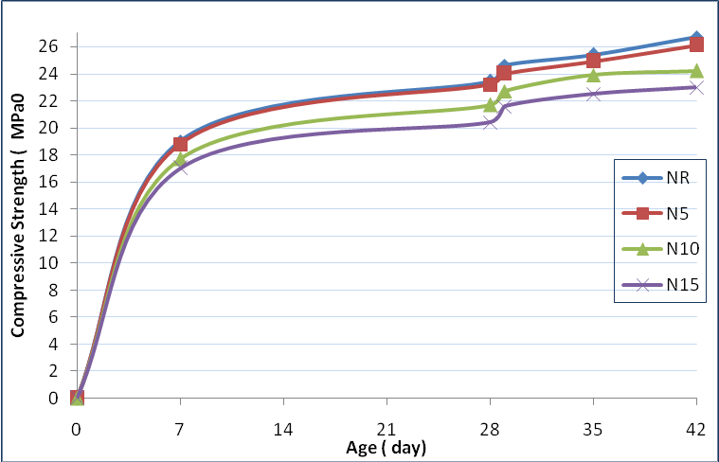
X2
X1
X3
X1 : after one day of immersion in water.
X2: after one week of immersion in water.
X3 :after two weeks of immersion in water.

Figure (1) Development of Compressive Strength for all mixes

- Splitting Tensile Strength.
The splitting tensile strength was determined according to the procedure outlined in BS. 1881:part 117:1983. A total number of 32 cylinders were cast. Each splitting tensile strength result was the average of strength for two specimens the concrete specimens ( cylinder 100 × 200 mm ) were tested after ( 28 ) days of curing in water, the remain cylinders dry in oven for ( 72 ± 2 ) hr and left in laboratory cooling ( 24 ± 0.5 ) hr, then immersion in water to determined the total absorption of concrete for one day, after one week and two weeks of immersion in water to evaluated the concrete absorption and the effect of absorption on splitting tensile strength of concrete, the results are shown in Table ( 7 ) and Fig ( 2 ).
From this results it can be observed that increasing the CKD ratio from zero to 15% by weight of the cement leads to the decreases the splitting tensile strength by about ( 7 – 29 ) % at 28 days ages, ( 4 - 29 )% when immersion concrete specimens one day to two weeks in water. This is due to the low initial volume of capillary voids in the mixes which decrease when increasing the CKD content.
Table (7) Splitting Tensile Strength Results

Splitting Tensile Strength (MPa) |  |  |  | Mix Nation
After two week of immersion in water | After one week of immersion in water | After 1 day of immersion in water | 28 days | Mix Nation
2.9 | 2.67 | 2.52 | 2.41 | NR
2.8 | 2.52 | 2.32 | 2.23 | N5
2.21 | 2.12 | 2 | 1.93 | N10
2.1 | 1.96 | 1.78 | 1.7 | N15

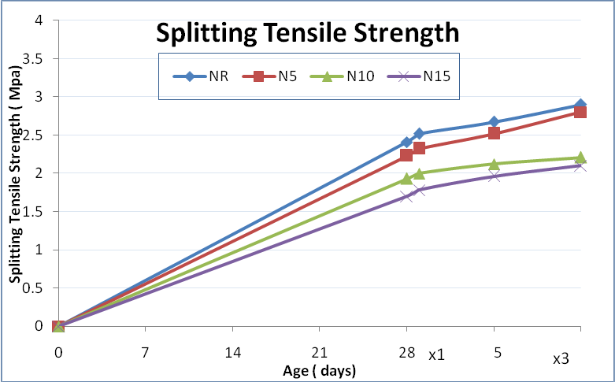
X2
X1 : after one day of immersion in water.
X2: after one week of immersion in water.
X3 :after two weeks of immersion in water
Figure ( 2 ) Development of Splitting Tensile Strength for all mixes
Flexural Strength
Concrete prisms of dimension(100×100×400)mm were cast according to BS.5328:y1990 procedure.
of rupture tested according to BS.1881:part 118:1983 using two point load test and calculated from the simple beam bending formula.
It is clear from results shown in Table ( 8 ) and Fig ( 3 ). The addition of CKD to the mixes ( 0 – 15% ) by weight of the cement leads to decreasing the flexural strength by about ( 6 – 28 %) for age 28 days, ( 5 - 30 %) when immersion concrete specimens for one day to two weeks in water.
Table ( 8 ) Flexural Strength Results

Flexural Strength (MPa) |  |  |  | Mix Nation
After two week of immersion in water | After one week of immersion in water | After 1 day of immersion in water | 28 days | Mix Nation
3.72 | 3.60 | 3.26 | 3.09 | NR
3.54 | 3.35 | 3.10 | 2.89 | N5
2.80 | 2.66 | 2.50 | 2.34 | N10
2.61 | 2.44 | 2.36 | 2.20 | N15

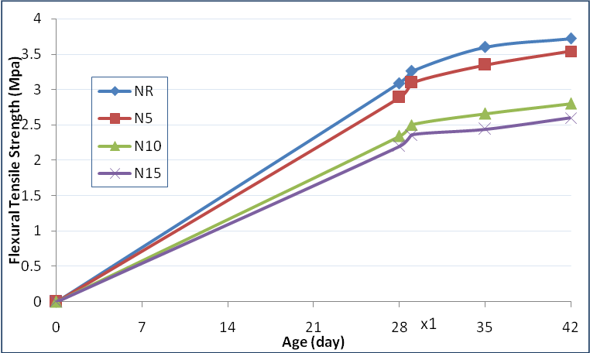
X2
X3

X1 : after one day of immersion in water.
X2: after one week of immersion in water.
X3 :after two weeks of immersion in water.
Figure ( 3 ) Development of Flexural Strength for all mixes

- Absorption
Two methods were used to study the absorption characteristics:
* The shallow immersion and the capillary rise. For each mix used two prisms (100×100×400) mm curing in water for 7 days then take out and put on the small side of prisms in pan content 2.5 cm of distilled water for 7 days. As can be seen in Plate ( 1 ), test had been done near reality transition water by capillary rise. The test results shown in Table ( 9 ). From this results it is clear that the increase in CKD ratio leads to increase in capillary rise concrete specimens with quantity of CKD (0 -15 )% by about ( 16 - 25 )%.
Total absorption: the total absorption was determined according to (B .S. 1881: PART 5: 1970) all mold ( cubes, cylinders, prisms) were dry in oven ( 105 ±5 ) cº for ( 72±2 ) hr and left in laboratory cooling (24±0.5) hr, then immersion in water to determined the total absorption of concrete for one day, after one week and two weeks of immersion in water as shown in Plate ( 2 ). The absorption calculated from the equation ( 1 ) and the results are shown in Table ( 10 )
W₂ – W ₁/ W₁ ) × 100 (1)
Where:
W1 = dry concrete weight
W2 = wet concrete weight

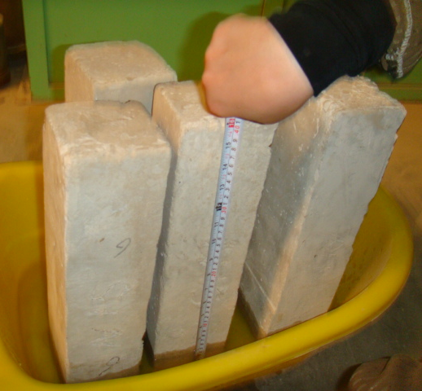
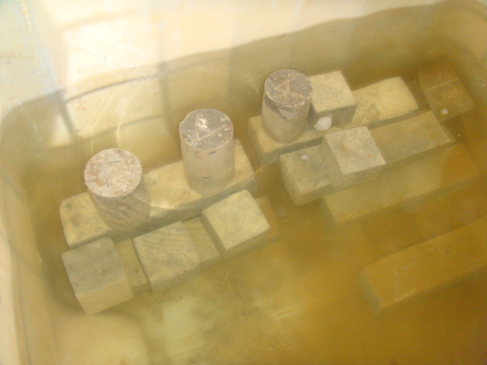

Fig (2) : Immersion of mold in water Fig (1) : Measure the water level of capillary rise
It is clear from the results absorption increased with an increase in the quantity of CKD in concrete, the increase in absorption of concrete due to the incorporation of CKD may be attributed to the increase in the chloride concentration contributed by the CKD.
Table ( 9 ) Concrete Absorption Results in capillary rise
Average of water height in capillary rise(mm) | Mix Nation
60 | NR
65 | N5
73 | N10
75 | N15

Table ( 10 ) Concrete Absorption Results

absorption % |  |  | Mix Nation
After two week of immersion in water | After one week of immersion in water | After 1 day of immersion in water | Mix Nation
3.4 | 2.99 | 2.1 | NR
4 | 3.5 | 2.9 | N5
5.42 | 5 | 4.4 | N10
6.12 | 5.6 | 4.9 | N15

Conclusions:
Based on the tests results of the present study the following conclusions can be draw:
- The compressive strength of concrete decreased with increasing quantity of CKD. However, the difference in the strength of 0% and 5% CKD cement concrete was not significant so.
- Splitting and flexural strength show a decreases for all ratio of CKD at age 28 days.
- The capillary rise increase with an increased in the quantity of CKD in concrete . However, the difference in capillary rise of 0% and 5% CKD cement concrete was not significant so.
- The absorption increased with an increase in the quantity of CKD in concrete . However, the difference in absorption of 0% and 5% CKD cement concrete was not significant so.
- It is advisable to restrict the quantity of CKD to 5% as a replacement of cement from strength properties.
References:
Abdul-Rehada, Salman Hussain, 1977. “Effect of Quality of Concrete on Waterproofing”, M.SC. Thesis, The University of Baghdad.
Aidan C, Trevor C. 1995 Cement kiln dust. Concrete (October):40–2.
Al - Harthy, A. S., Taha, R., and Al - Maamary, F., 2003. "Effect of Cement Kiln Dust (CKD) on Mortar and Concrete Mixtures", Construction and Building Materials.
B.S.1881: PART 5: 1970." Methods of testing Concrete for Other Than Strength: Test for Water Absorption", British Standards Institution, London,3pp.
Chan, W.W.J, and Wu, C.M.L., 2000 “ Durability of Concrete with High Cement Replacement” , Cement and Concrete Research , Vol.30 , No.6, June , pp.865-879.
Daous, M. A. 2004. "Utilization of Cement Kiln Dust and Fly Ash in Cement. P. O. Box 80204, Jeddah 21589, Saudi Arabia mdaous@kau.edu.sa. JKAU: Eng. Sci., vol. 15 no. 1, pp. 33-45 (1425 A.H./ 2004 A.D.)
El - Sayed, H. A., Gaber, N. A., Hanafi, S., and Mhran, M. A.,1991. "Reutilization of By-Pass Kiln Dust in Cement Manufacture", International Conference on Blended Cement in Construction, Sheffield, UK.
Khatib, J. M. and Mangat, P. S. (1995). "Absorption characteristics of concrete as function location relative to casting position". Cement and Concrete Research, 25 (5), 999-1010.
Kalil, A.R. 2008. " Influence of Locally Produced Waterproofing Admixture (Sternson 3000 on Concrete Absorption and Strength. Tecnlogy and engineering magazine.
Maslehuddin M, Al-Amoudi OSB, Shameem M, Rehman MK, Ibrahim M. 2008. Usage of cement kiln dust in cement products – research review and preliminary investigations. Constr Build Mater;22:2369–75.
Neville, A.M., “Properties of Concrete”, 1995. 4th Ed., Pitman Publishing London,.
Shoaib MM, Balaha MM, Abdel - Rahman AG.,2000. Influence of cement kiln dust substitution on the mechanical properties of concrete. Cem Concr Res;30(3):371– 7.

